بسم الله الرحمن الرحيم

An-Najah National University
Engineering Faculty
Computer Engineering Department



Graduation Project

Web Service Accounting System
AccounTech


Prepared by:
Murad Sulaiman
Mohammad Masoud

Instructors:
Dr.Loai Malhis. Dr.Raed AlQadi
Haya Sammaneh. Eng Anas Doamah

Introduction:

A web service accounting system is like any accounting system application but instead of saving the information in a local database the company actually get to save it at a server database with the space the company needs providing security for transacting the information.

Description:

We called our project customized web service accounting system , because the company can choose things like: disk space required, the time the company needs every day, the number of users allowed to use the account and the interface of there own page.

The project provides accounting services and reports for companies i.e. the essential accounting services.

The required steps of the company to start using AccounTech are simply signing up by creating new company, paying the money through Pay Pal, choosing disk space and time required, uploading company’s logo and choosing a theme and inserting the company users that allowed to access company’s information. Once the company fulfilled these steps they are ready to use AccounTech’s services.

Signing up:

The steps of signing up will be shown in pictures as follows:

Step 1:

Through the main page to the create new Company hyperlink

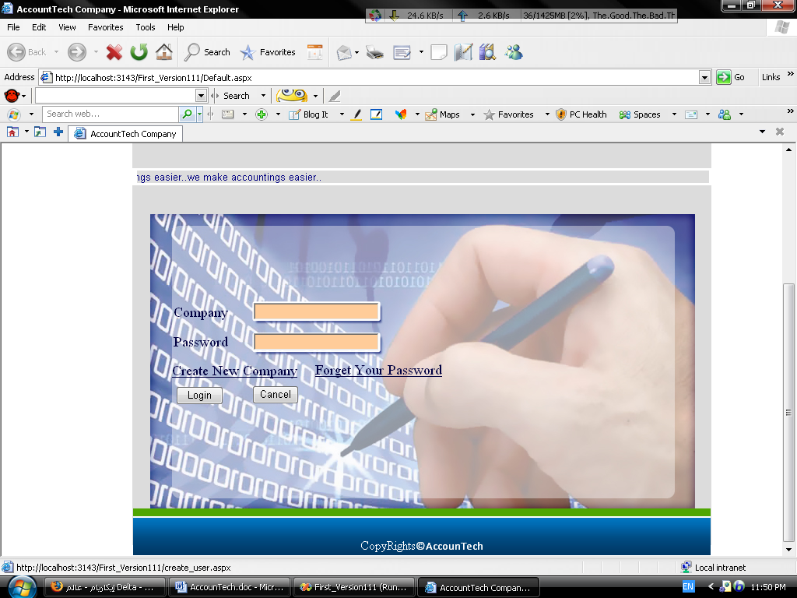

The create new company page will appear:

We used the Wizard control in order to create the creation wizard.

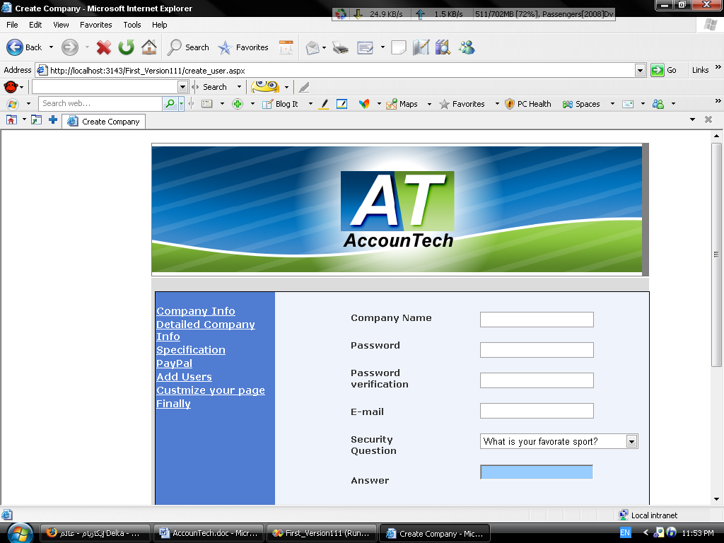

After filling the main information about the company we head to specifying disk space required, time of availability every day and number of allowed users.

The cost label is calculated first at the page load by an equation we put.

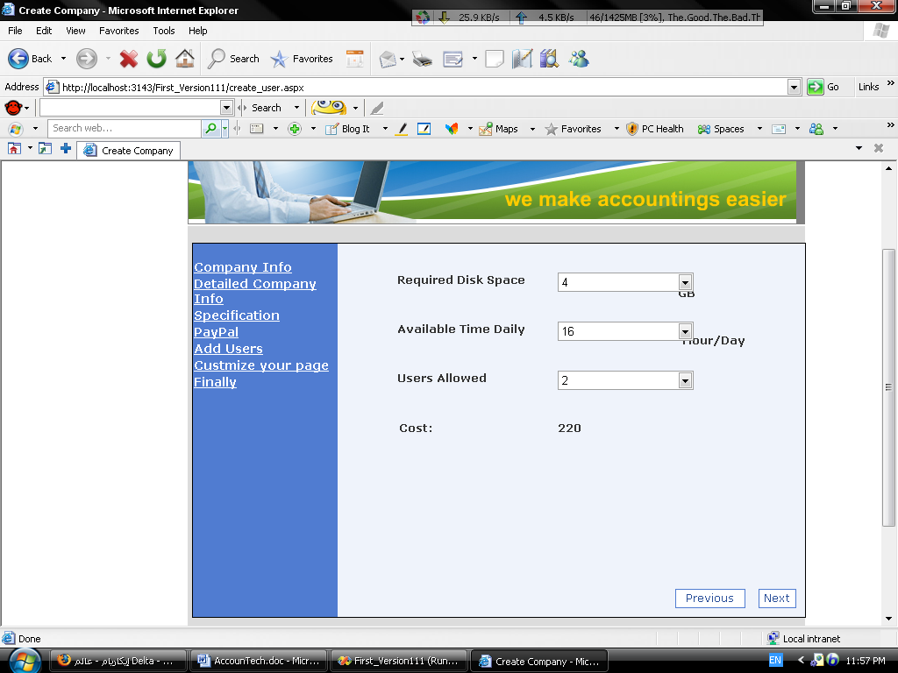

The cost will show the change immediately after changing any input.

Now by pressing next we head to the paying part we used Pay Pal because it provides developers with testing period to perform visual money transaction from the company to our account.

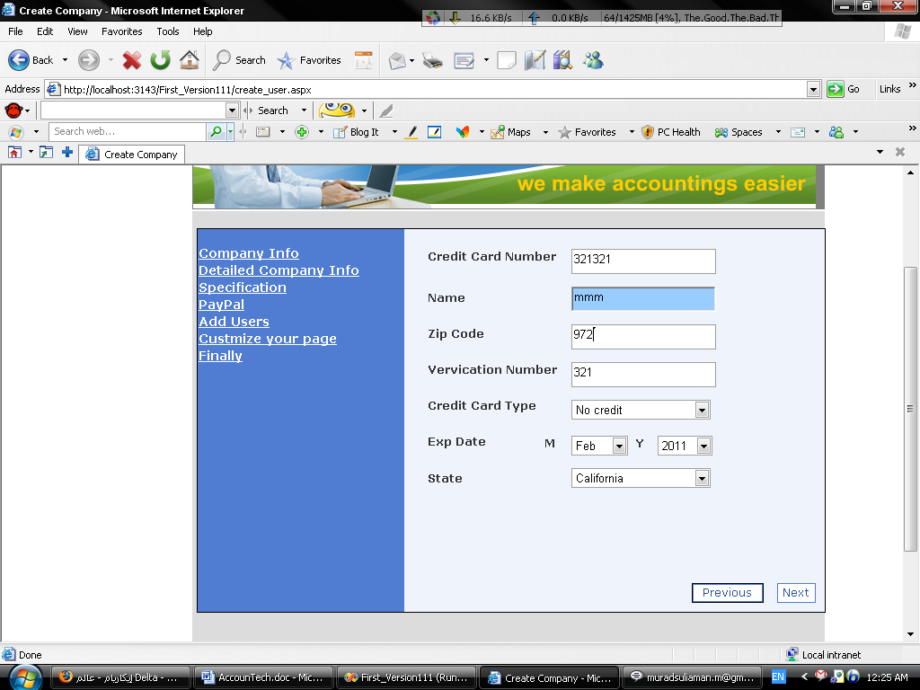

After performing the Pay Pal section now to the insert users section:

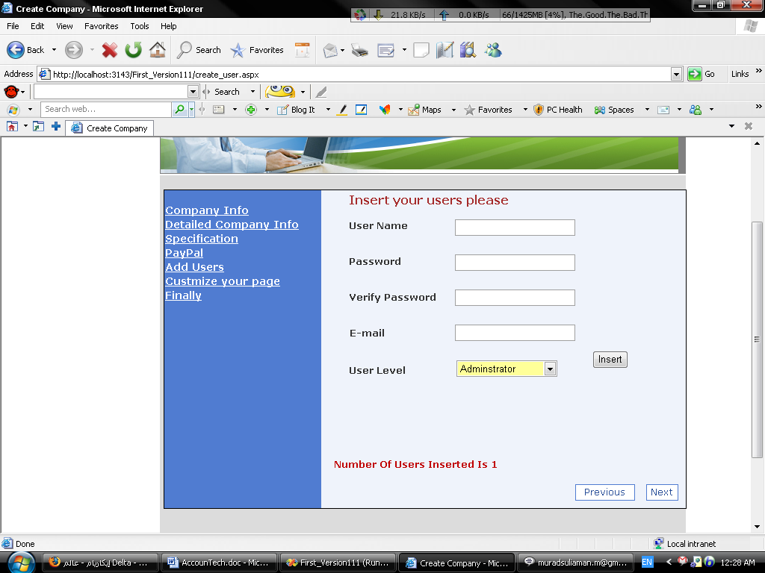

The company inserts as allowed users as paid for and move to the next section :

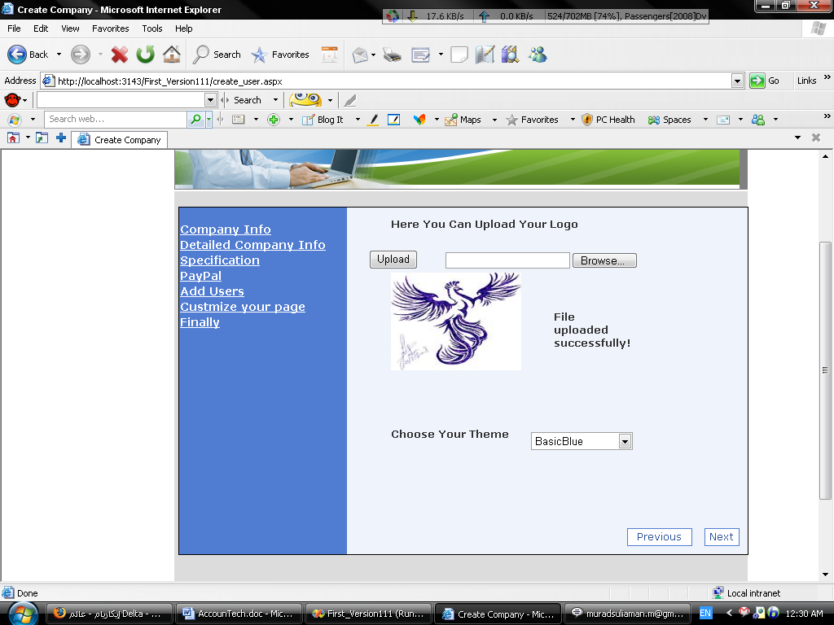

In this section the company can choose the theme and logo it wants.

That was the last step now the company can use AccounTech’s services.

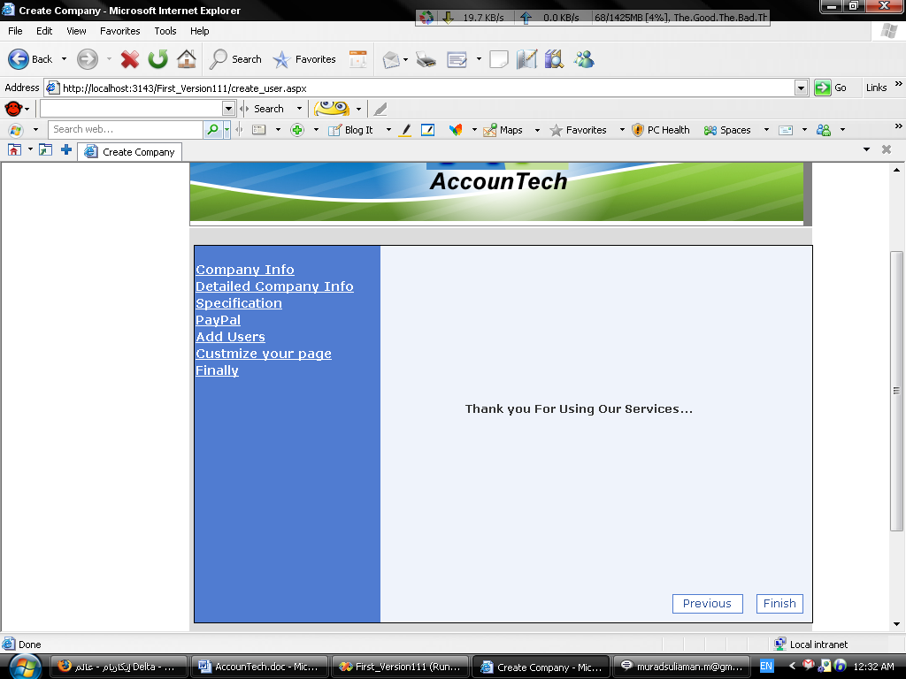

At this point all the information will be inserted into the data base and a data base for the company will be copied to its file and the time and folder size will be monitored using Ajax timers if the time exceeds the available paid for time and disk space.

After all that finally the company head can go to the main page and sign in immediately.

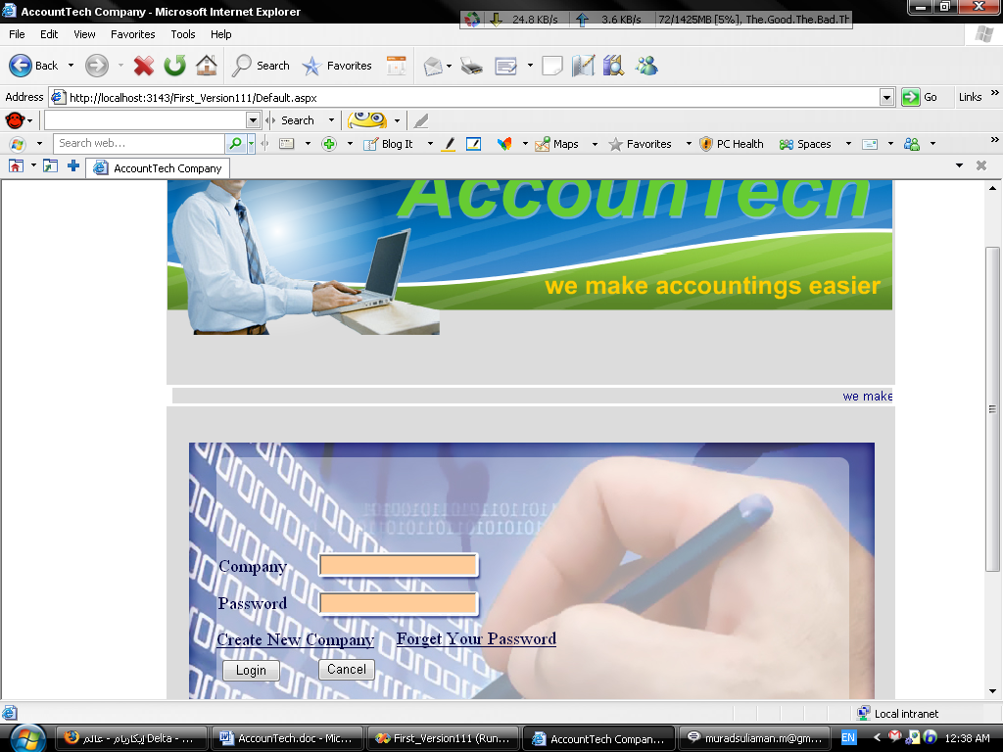

The first login page will go to the user login page and shows the disk space available and the time too.

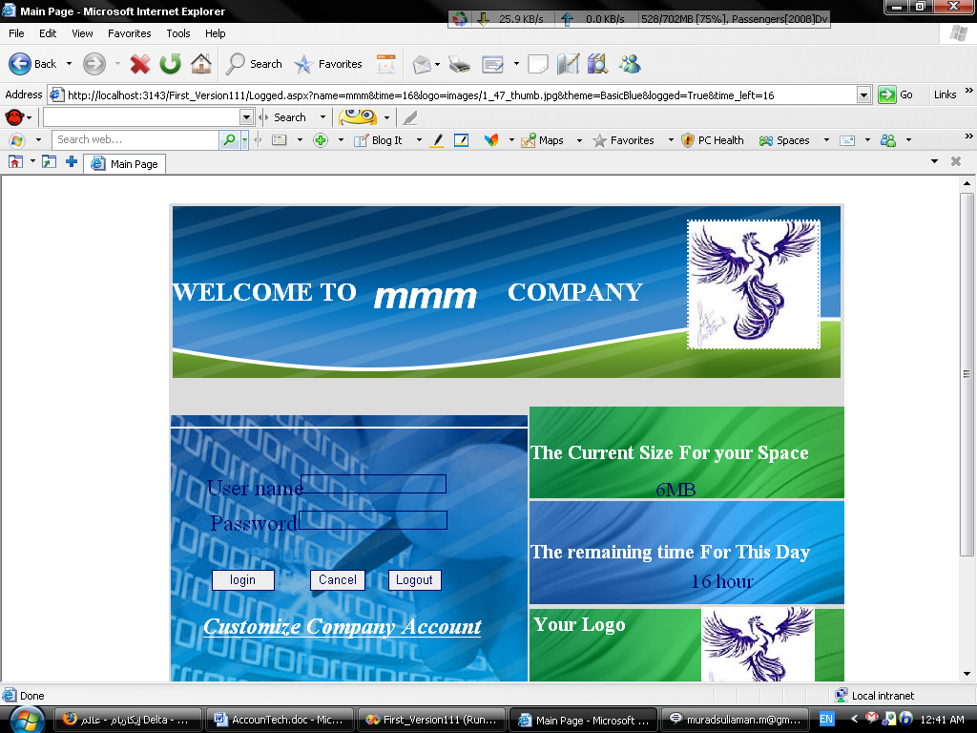

Now the company users can login…

The company can customize its own page like follows

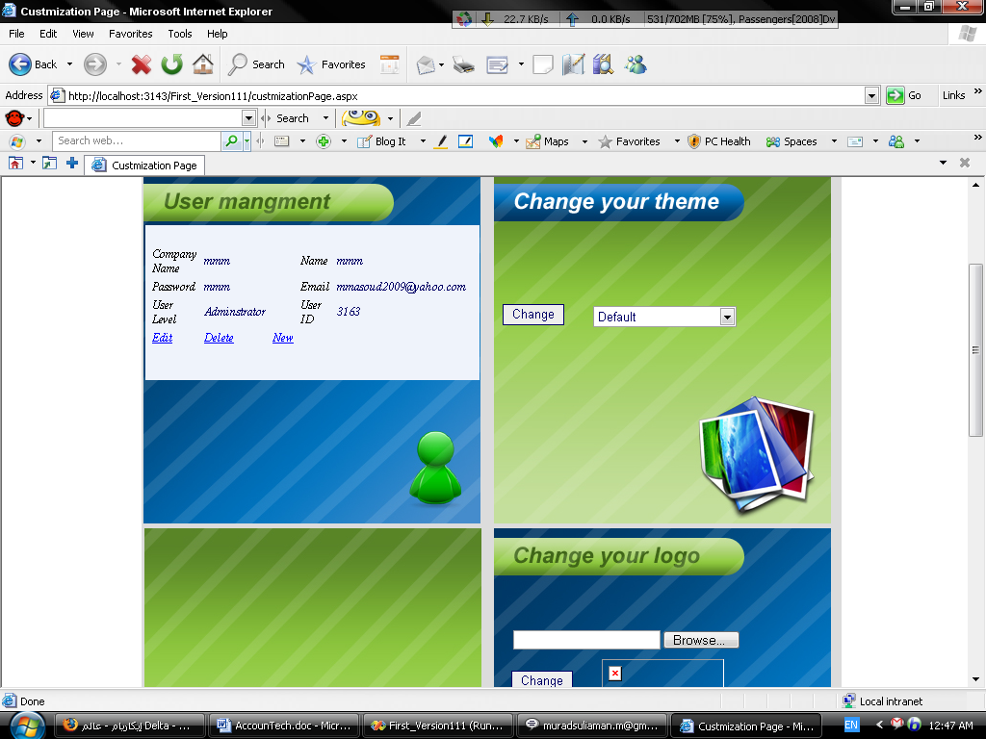
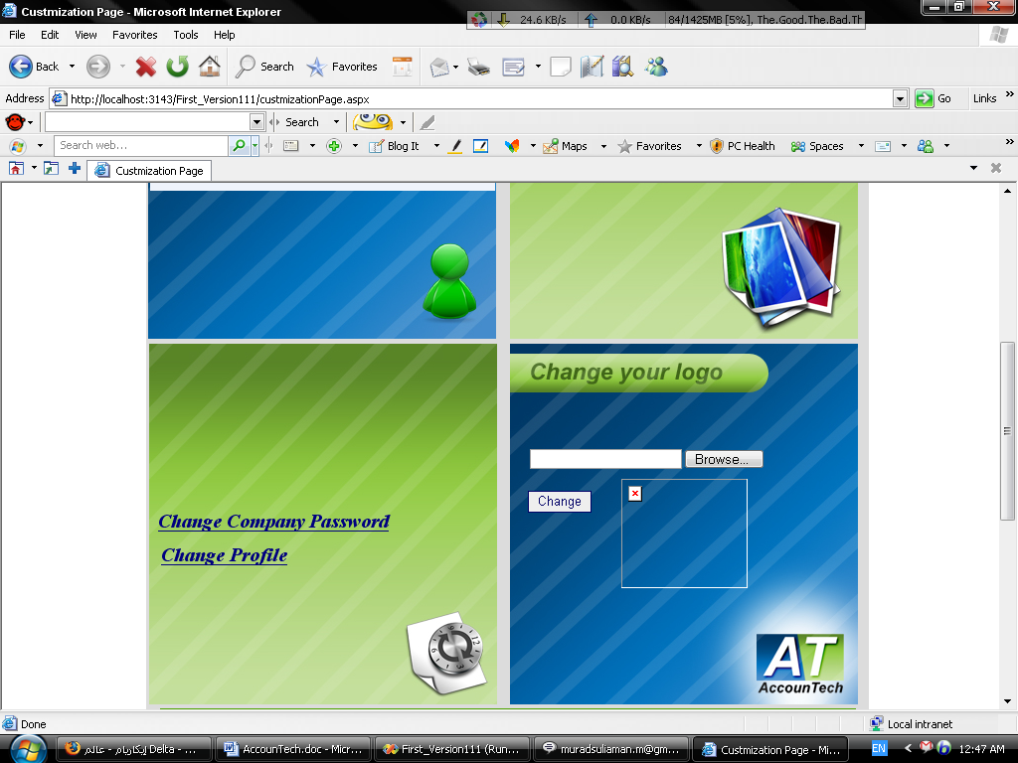

The company can change the password or the profile .

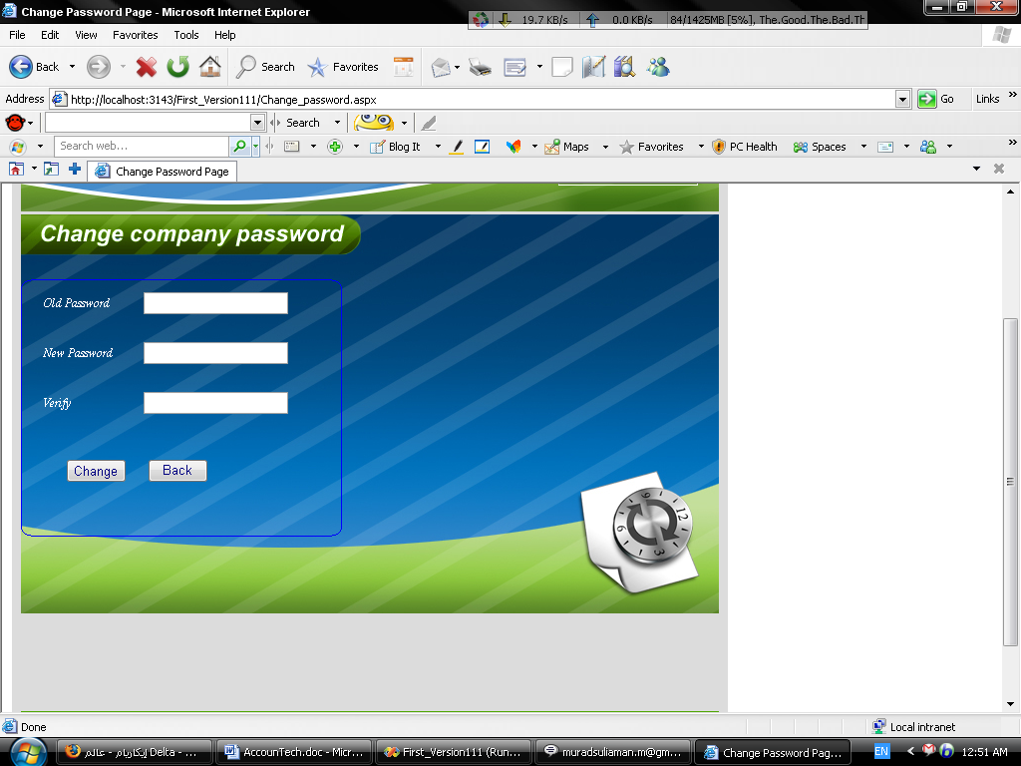

And change profile…

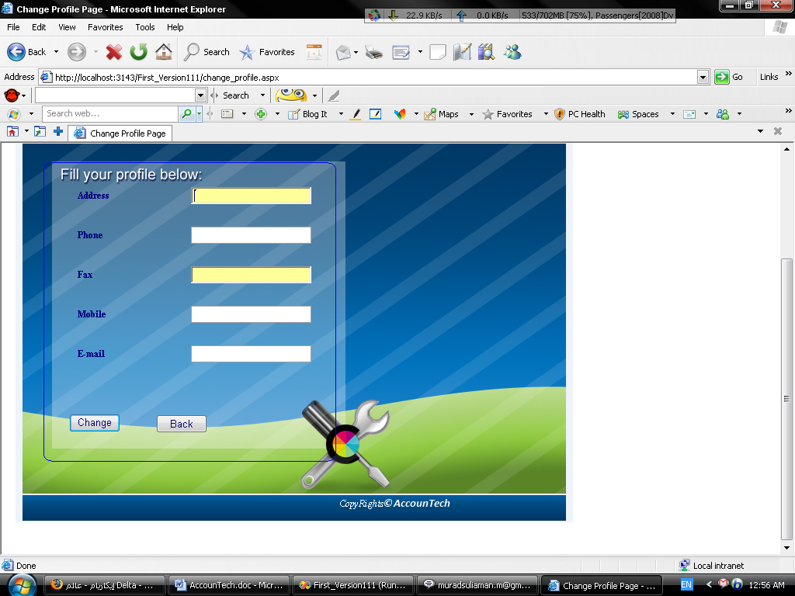

Now if the company forgets its password it easily can retrieve it an email message will reach the company with the password as soon as they fill the next form..

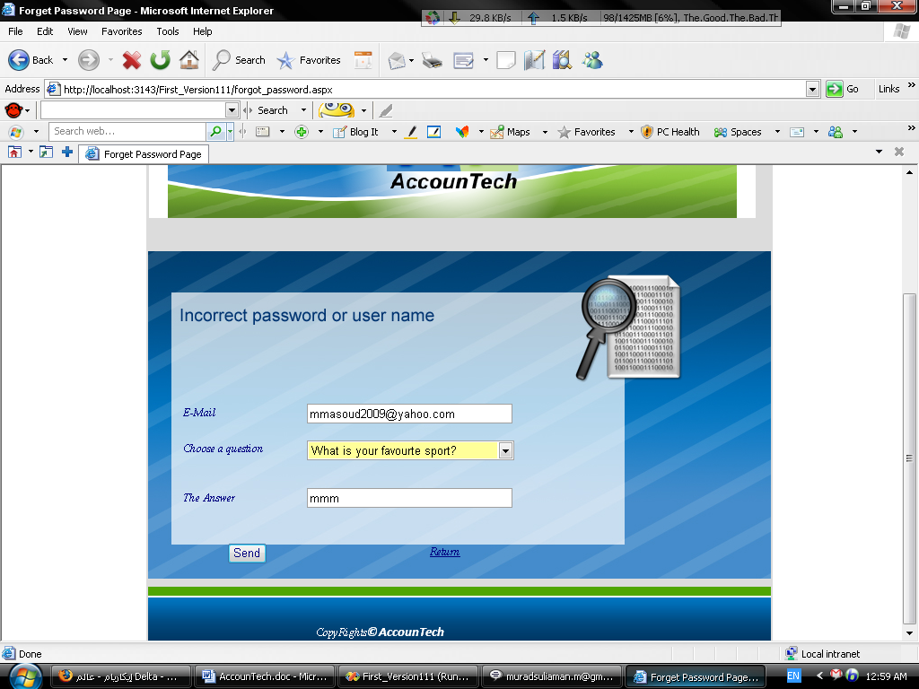

And press send…

Now lets head for the accounting side the heart of the project:

Accounting:

After logging in the next page will appear is the logged page which contains the company users login as follows :

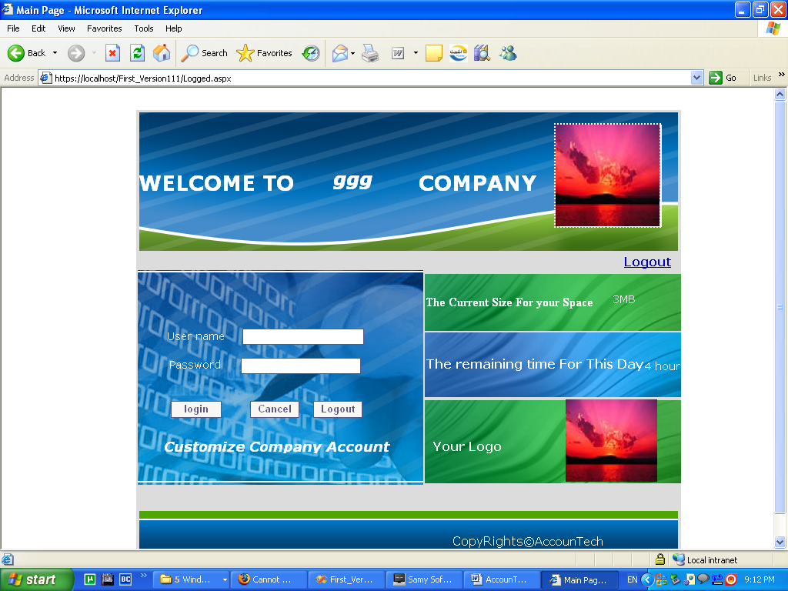

After logging in to the accounting page the next form will appear and the user will perform his privileges every company has its own data base in its own folder that size it can choose for it self.

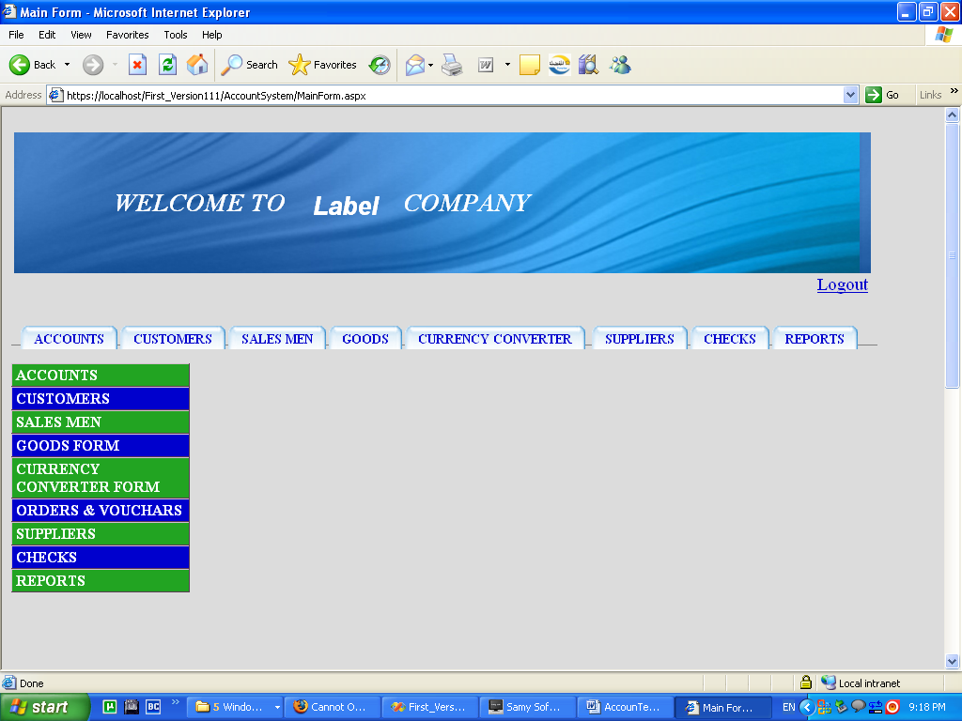
Now we will show the pages of the accounting project :
Hear we can add new account delete an account or edit the account

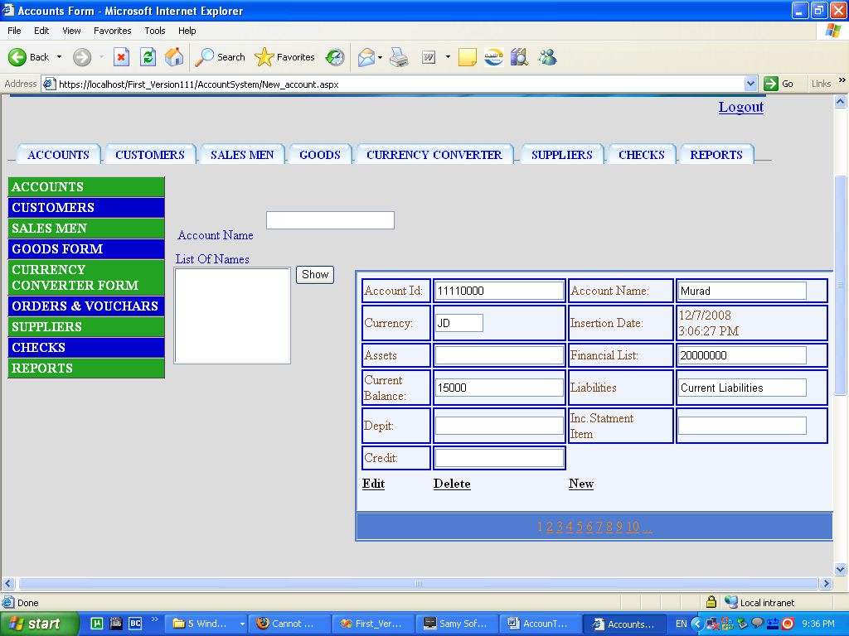
The customers form : to show the customers records for every company
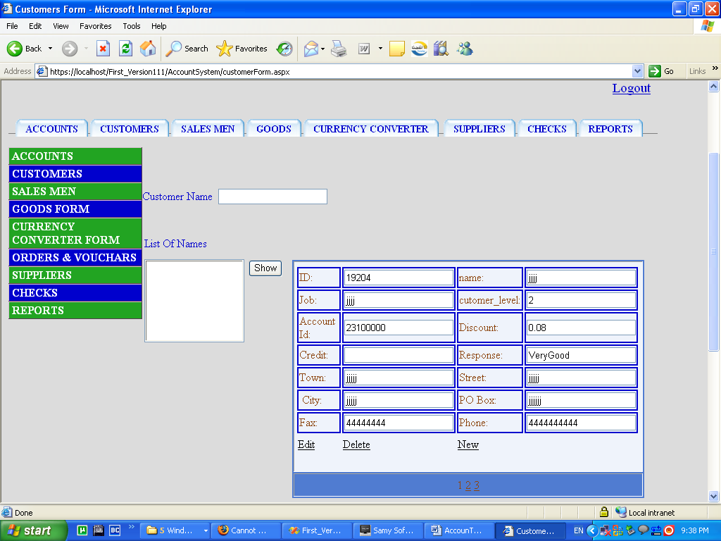

In the next form the sales men form were we can brows the sales man information how is he doing in work and other stuff:

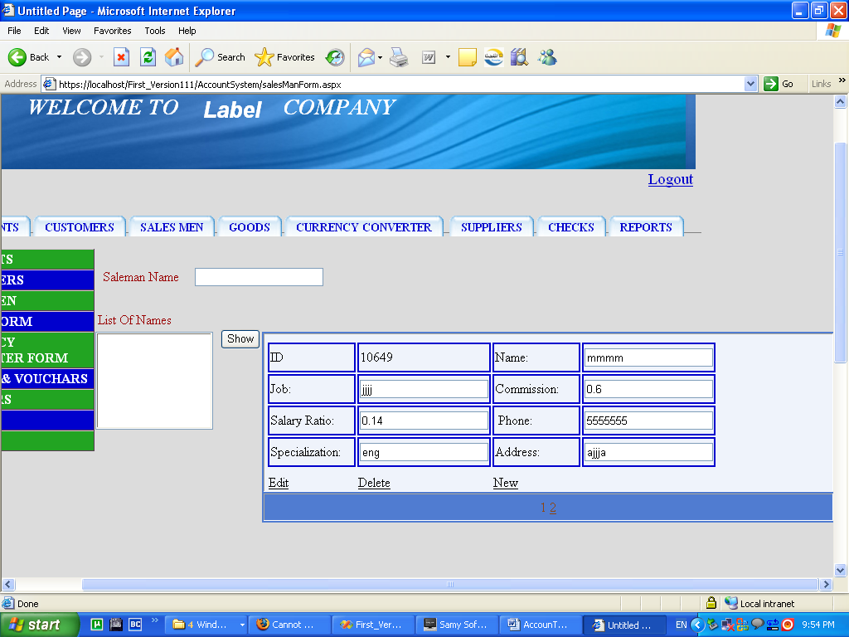

The next form shows the goods type by type the amount the price the supplier :
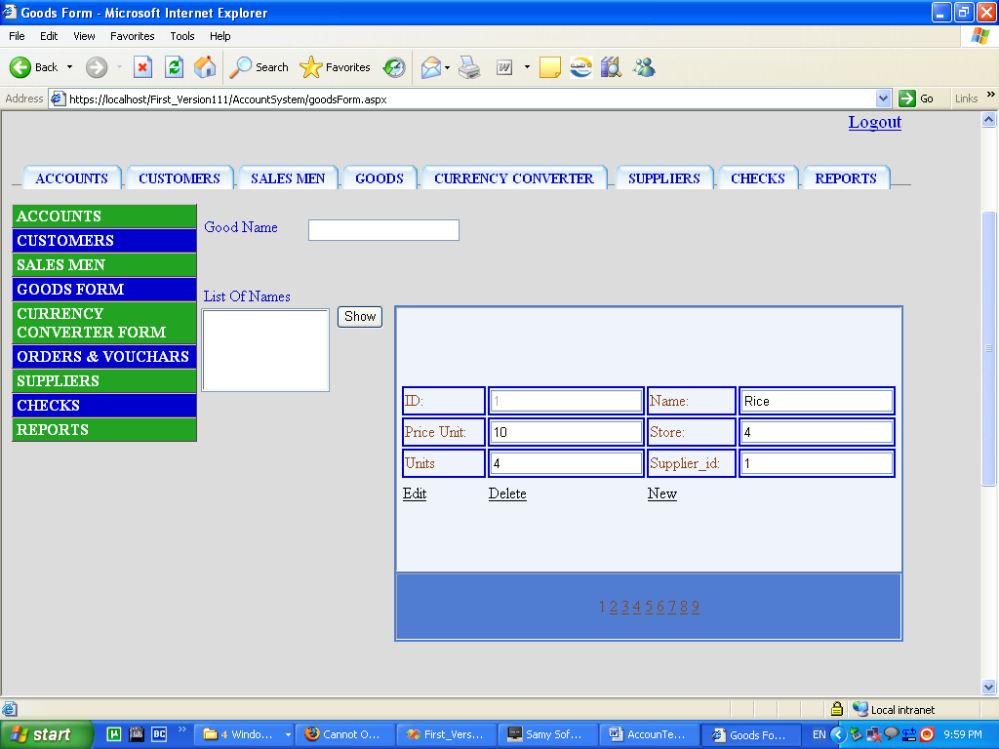

And to the currency exchanger page it connects to the web and brings the rate of changing:

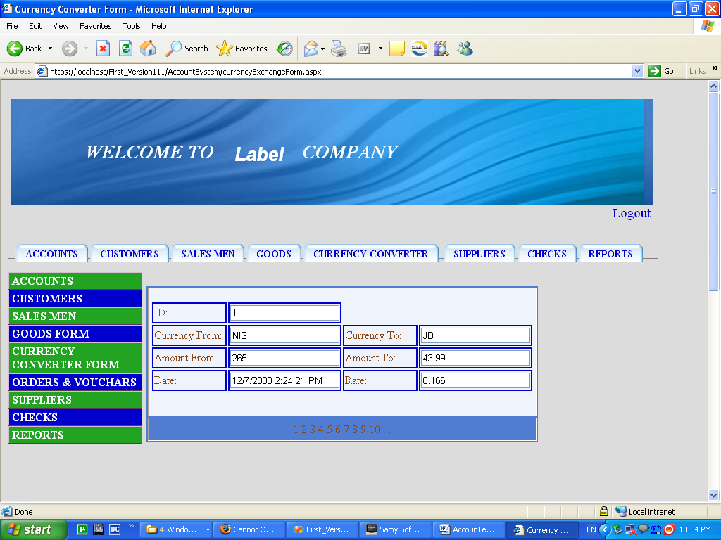

And the supplier information form:

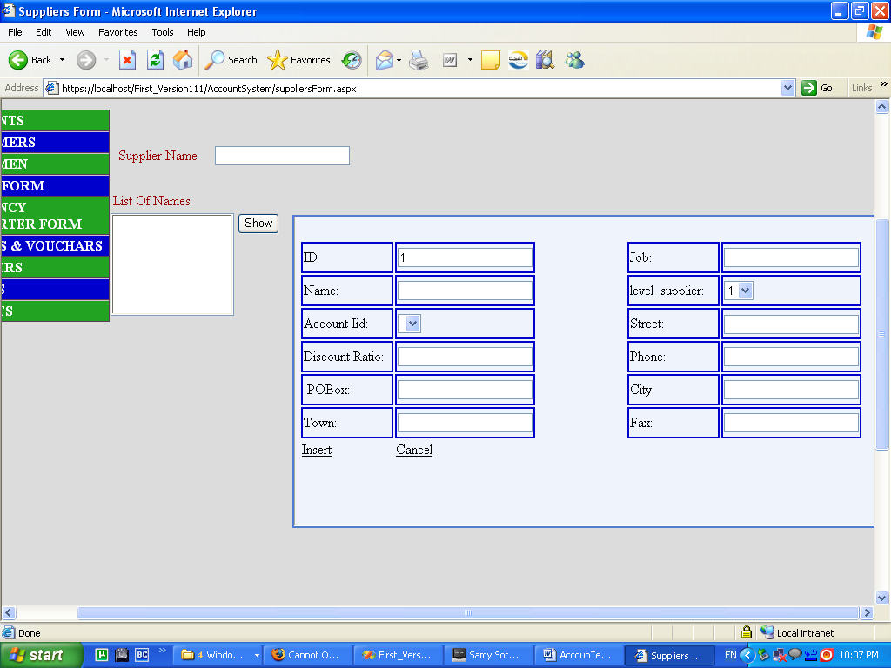

Now to the checks form were information about checks for the company can be added or found:

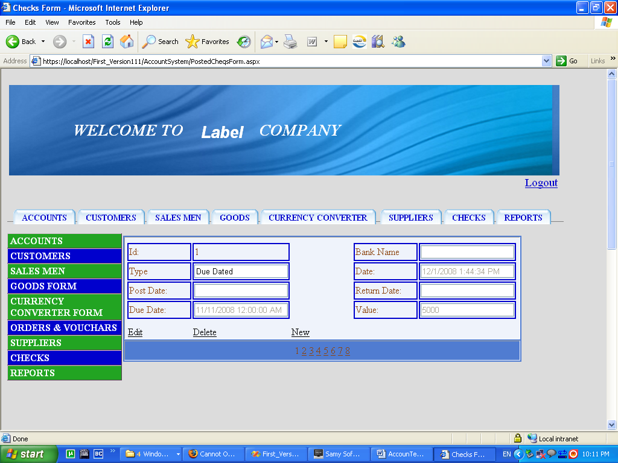

And the vouchers forms :

The payment vouchers:
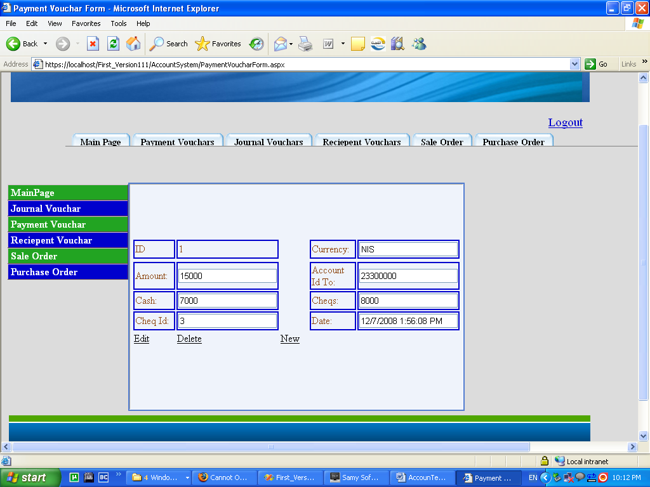

The journal vouchers:
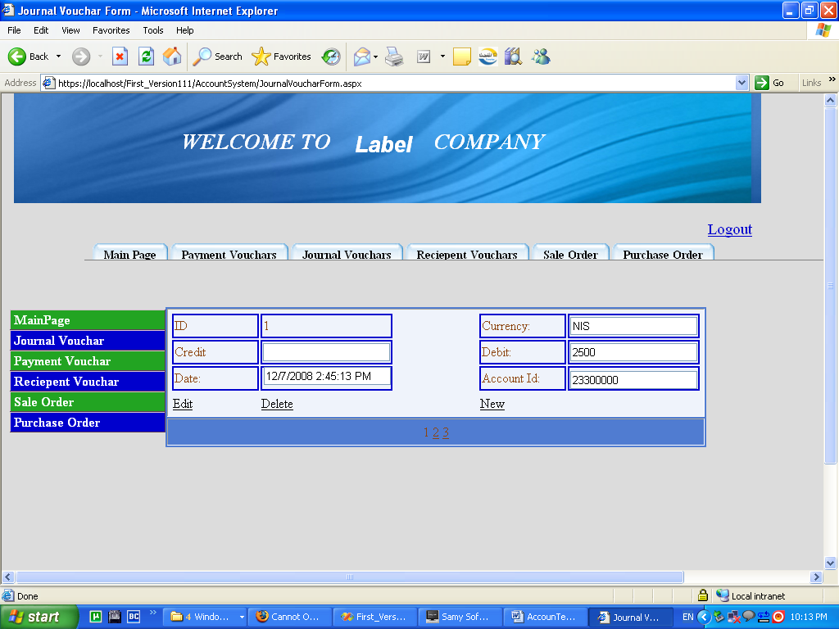

Recipient vouchers :
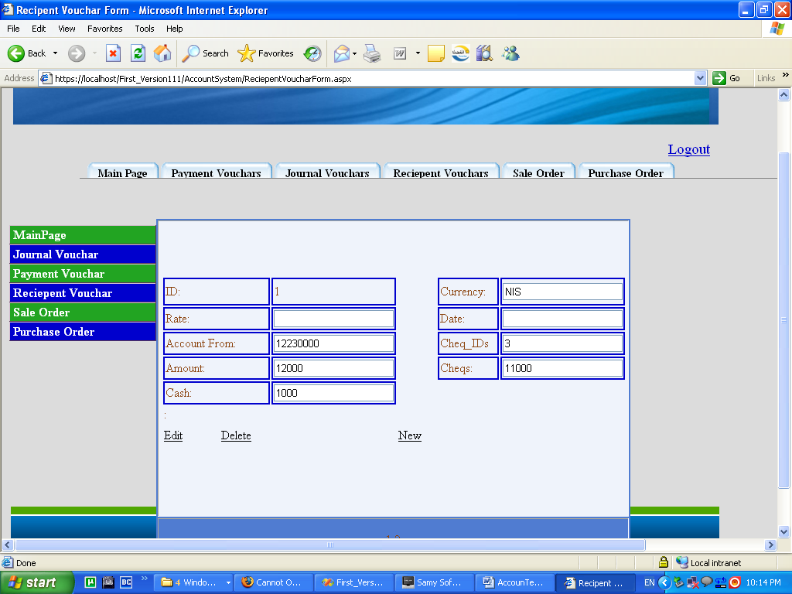

Sales order :
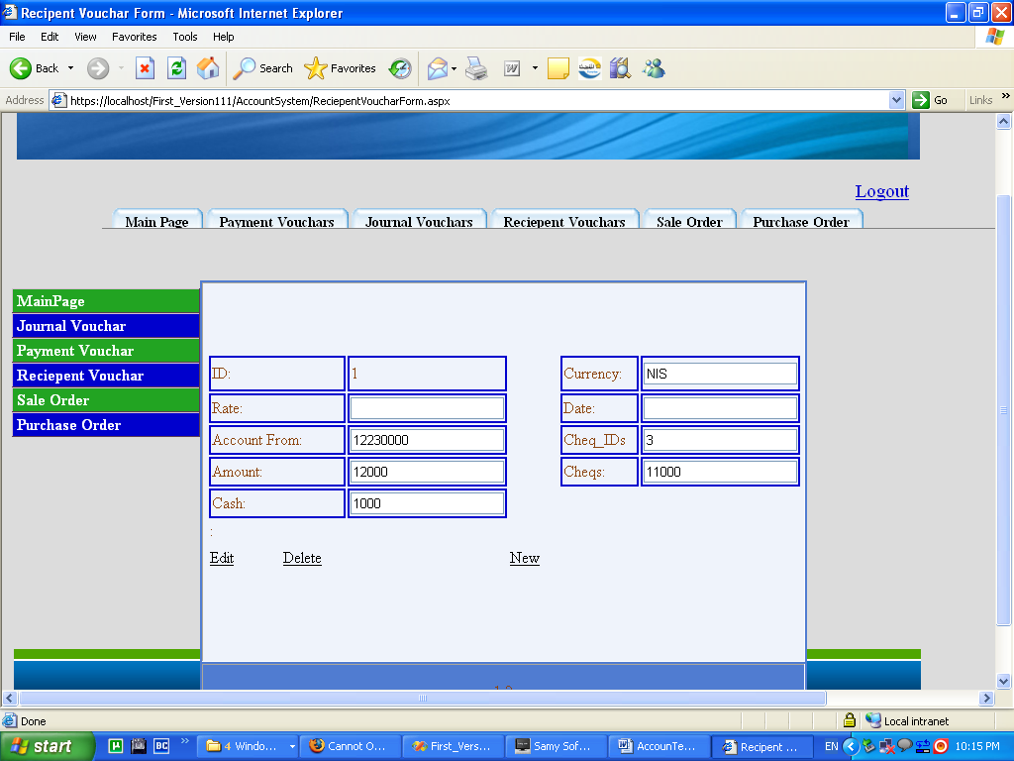

And purchase order:

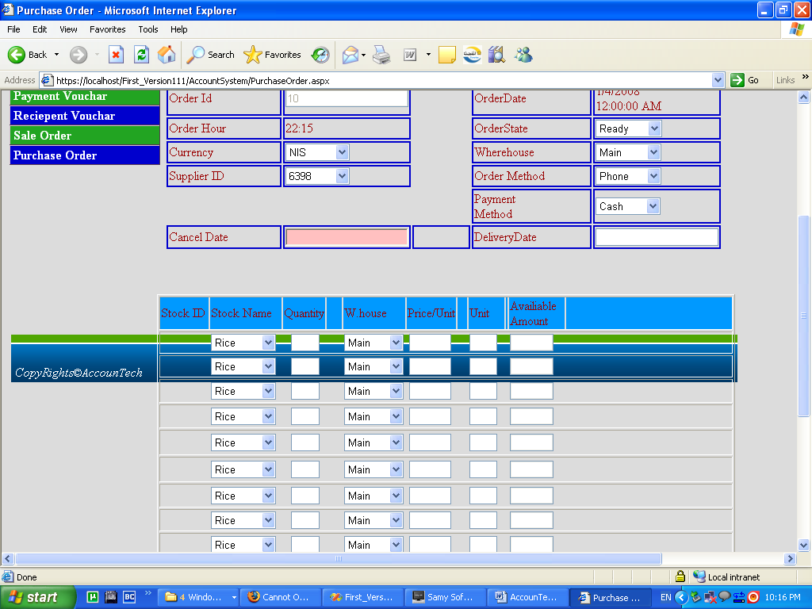

All that the company can do efficiently and they can output reports the company needs.

An example of the reports is the sales order reports:



