An-Najah National Univercity
Faculty of Engineering
Computer Eng Department

2'nd Graduation Project

Bluetooth Home Automation

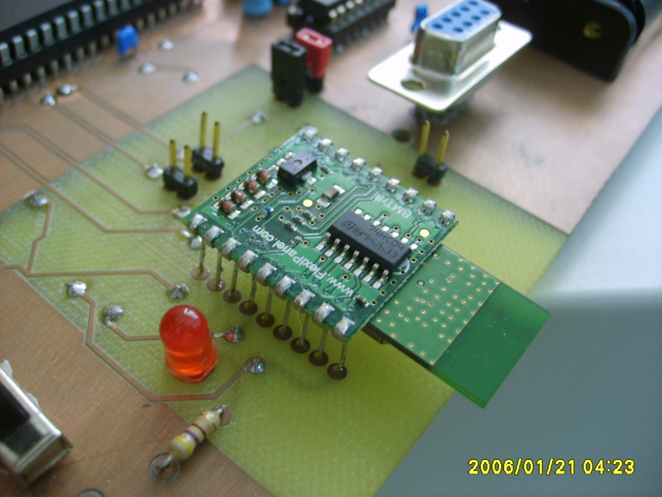

Done by:
Muna Qanadeelo
Enas Saleh

Wednesday 22-05-2007

Bluetooth Home Automation:

Abstract
Our project is a wireless controlling of a home component, this is the main Idea.
The wireless communication system is Bluetooth peering between a client (mobile station in our case) & a server(LinkMatik 2.0 : Bluetooth module) which is connected directly to pic16f778 controller.
The home component we try to controlled:
- 4 DC motor represent 2 doors, window & fan
- 4 lights
- Temperature sensor
- Real clock timer.
- LCD.

Introduction
Bluetooth is a radio standard and communications protocol primarily designed for low power consumption, with a short range (power-class-dependent: 1 meter, 10 meters, 100 meters) based on low-cost transceiver microchips in each device.
Bluetooth lets these devices communicate with each other when they are in range. The devices use a radio communications system, so they do not have to be in line of sight of each other, and can even be in other rooms, as long as the received transmission is powerful enough.
Class | Maximum Permitted Power  (mW/dBm) | Range  (approximate)
Class 1 | 100 mW (20 dBm) | ~100 meters
Class 2 | 2.5 mW (4 dBm) | ~10 meters
Class 3 | 1 mW (0 dBm) | ~1 meter
Bluetooth is implemented in a variety of new products such as phones, printers, modems, and headsets. Bluetooth is acceptable for situations when two or more devices are in proximity to each other and don't require high bandwidth. Bluetooth is most commonly used with phones and hand-held computing devices, either using a Bluetooth headset or transferring files from phones/PDAs to computers.
Bluetooth also simplifies the discovery and setup of services. Bluetooth devices advertise all services they provide. This makes the utility of the service that much more accessible, without the need to worry about network addresses, permissions and all the other considerations that go with typical networks.
Components:

Lights:
In our home we put 4 lights, we can turn them on & off separately, connecting them relay which separate the source of them ULN2003 for driving relay, of course the controlling is 4 pic pins by giving output high on them.

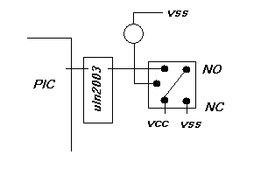

DC motors:
We control three motors in two direction each to represent the movements of doors and windows , need 2 pins each, 2 relays, driving from ULN.

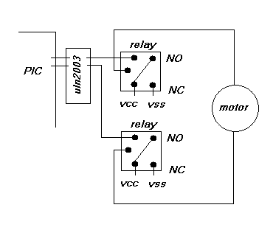

The other implement of motor is a FAN so it is one direction motor with several speeds, for this aim we need to use ccp1( PIN 17) to control duty cycle for the signal we give to the motor, no external component is needed.

Temperature sensor:
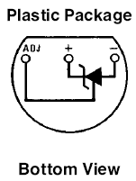
We used LM335 which gives 2.982v at 25 c using calibrating circuit as an input of pic ADC (Analog input)at pin A0 .
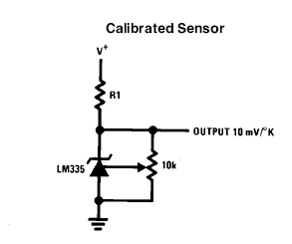

With 10mV change for every 1 & that the sensor operates from -40 to 100c the range of volt we take is 2.332V to 3.732, this range of change almost 1.4 v change for range of 150 degree is so small so we an amplifier to have arrange between 0 - 5 V.

We use LM324N amplifier with the following circuit:
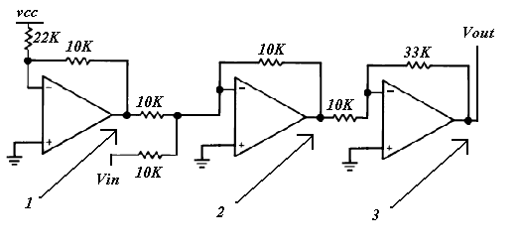
P1 = -5 / 2.2 V
P2 = - ( Vin – P1 )
Vout = P3 = P2 x 3.3

LMN335 package of 4 IC's:
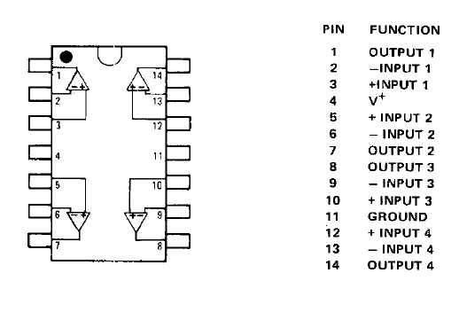
From above we used 2 external power supply, because this chip need Vout + 1.5 volt at pin 4, Vout – 1.5 at pin 11 at least, 15 & -15 as maximum.

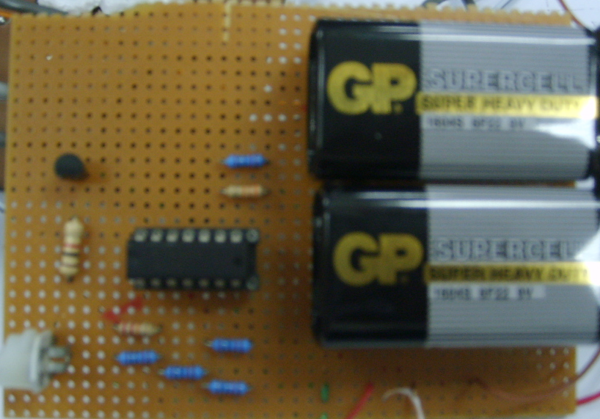

Real clock timer
We used DS1302(Trickle Charge Timekeeping Chip)
We choose this chip because it have a driver in PIC C, DS1302.c, the chip has the followingschematic:
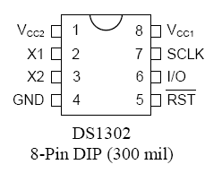

X1, X2 – 32.768 kHz Crystal Pins
GND – Ground
RST – Reset: connect to PIN B2
I/O – Data Input/Output : connect to PIN B3
SCLK – Serial Clock : connect to PIN B1
VCC2 – Power Supply P : 5V the main source if it is work VCC1 stops.
VCC1: 3V buttery it is better to be rechargeable or super capacitor in stead, its work to keep DS working when no power is supplied.

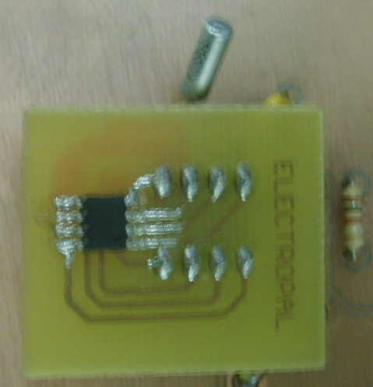

LCD:
We connect LCD to our project for displaying time, date, and temperature.
Bluetooth module:

Bluetooth 2.0 serial / audio transceiver with auto-connect modes and command interface (DIL).

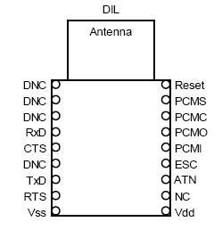

Pin Connections
Power ground reference.
Vdd 3.3V - 5V power supply (DIL version)
3.3V power supply (SO version)

Pin | Name Description
ATN | Attention output: In Auto-Slave and Auto-Master modes, output is high if connected, low if unconnected. In command mode, output is high if serial data on RxD is from a remote device, low if a command mode response.
ESC | input: A low to high transition causes the module to revert to the mode where it  accepts commands rather than transmits transparent data.
CTS | Clear To Send: Flow control input to LinkMatik 2.0. When low, LinkMatik 2.0 will output data on the TxD line.
DNC | Do not connect
NC | Not connected
Reset | Reset – Low to operate, high for at least 10ms to reset
RTS | Flow control output from LinkMatik 2.0. When high, do not send data to LinkMatik 2.0.
RxD | Serial data input to LinkMatik 2.0.
TxD | Serial data output from LinkMatik 2.0.
Vss | Power ground reference.
Vdd | 3.3V - 5V power supply (DIL version)

Radio Link / Antenna
The radio is a 2.4GHz Class I Bluetooth device with an integral antenna. To achieve 100m range, the corresponding Bluetooth device must also be Class I. There should be no PCB copper or components within 2cm of the antenna.

Serial Connections
The serial data default baud rate is 9600 baud standard active low format with 8 data bits, no
parity bit and 1 stop bit. Hardware flow control is supported. If no flow control is required, RTS
should be connected to CTS.
We implements this No Flow Control.

Operating Modes
There are three operating modes for LinkMatik 2.0:
- Auto-Slave Mode, where LinkMatik 2.0 allows other devices to connect to it we work in this mode.
- Auto-Master Mode, where LinkMatik 2.0 tries to connect to devices it is paired with.

- Command Mode, where LinkMatik accepts instructions from the host. Command mode is
also used for:
- Configuring Auto-Slave and Auto-Master settings such as baud rates
- Audio modes
- Connections to multiple devices
LinkMatik is shipped in Auto-Slave mode with the PIN code 9999 at the first time.

Schematic:

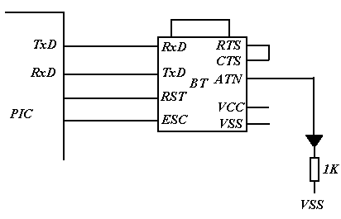

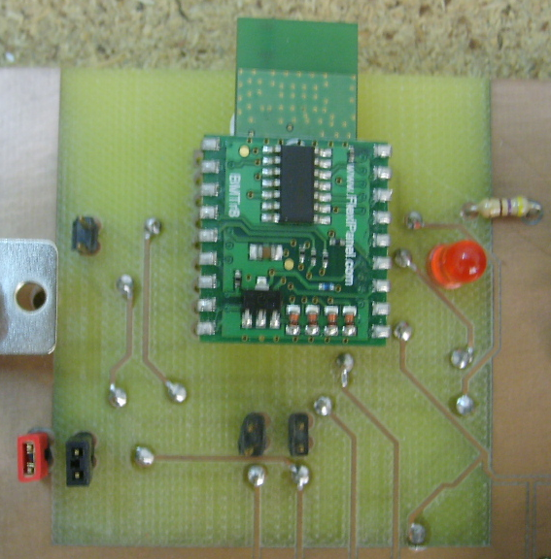

- ATN: we connect to LED to be easy to know if their a connection or not.
- RST, ESC to pic to change configuration using software.
- RTS & CTS are connected to gother.
- RxD, RxT: to PIC but through Jumpers because we also use these two pins at PIC with DB9 to connect physically with host.
- VCC : 3.3 – 5.0 V.

Finally This Is Our Project Top View:

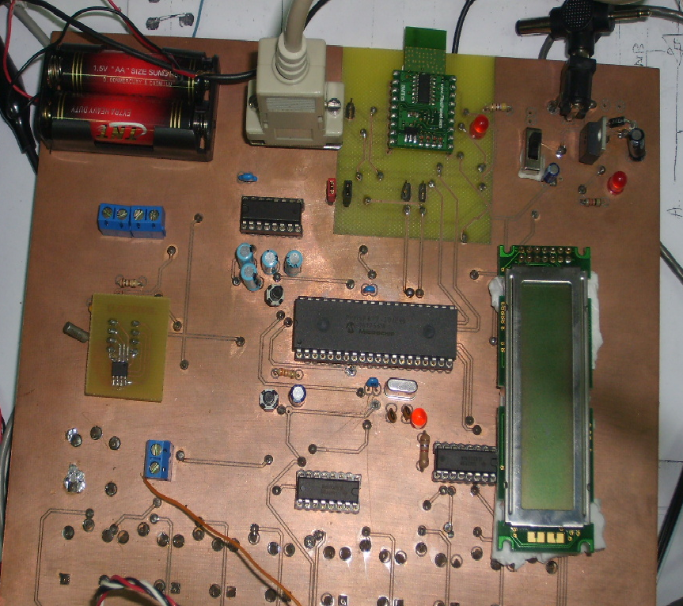

Button View:

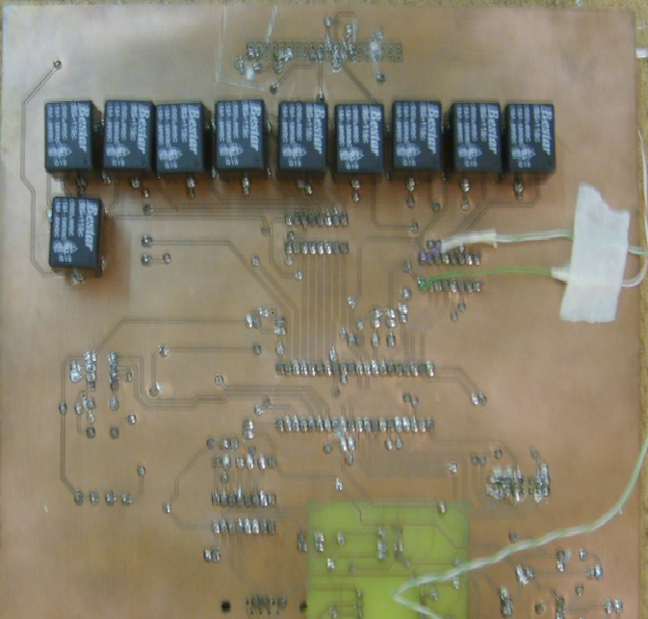

Software Application
Our application is J2ME mobile application using midlet application.
It searches for all Bluetooth devices around it for a distance nearly 10m.
Then it will search for all services for a device that you select.
The following functions is used for search for Bluetooth devices and services .
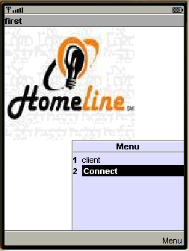
private void bluetoothDiscovery() {
try {
localDevice = LocalDevice.getLocalDevice();
String address = localDevice.getBluetoothAddress();
String name = localDevice.getFriendlyName();

} catch (BluetoothStateException e) {
printString("BluetoothStateException: " + e);
return;
}
discoveryAgent = localDevice.getDiscoveryAgent();
try {
discoveryAgent.startInquiry(DiscoveryAgent.GIAC, this);
} catch (BluetoothStateException e) {
printString("Exception (b3): " + e);
}
printString("return from bluetoothDiscovery()");
}

public void deviceDiscovered(RemoteDevice btDevice, DeviceClass cod) {
int major = cod.getMajorDeviceClass( );
int minor = cod.getMinorDeviceClass( );
int services = cod.getServiceClasses( );
int classIdentifier = major | minor | services;
try {
printString("friendlyName: " + btDevice.getFriendlyName(false));
printString("address BT: " + btDevice.getBluetoothAddress());
printString(" Major class: 0x" + Integer.toHexString(major));
printString(" Minor class: 0x" + Integer.toHexString(minor));
printString(" Service classes: 0x" + Integer.toHexString(services));
printString(" Class identifier: 0x"+ Integer.toHexString(classIdentifier));
printString(" Class identifier: "+ Integer.toBinaryString(classIdentifier));
one=btDevice;
menue_append(btDevice.getFriendlyName(false));
bluetoothDevices.put(btDevice.getFriendlyName(false), btDevice);
printString("devicesFound" +bluetoothDevices.size());
} catch (Exception e) {
printString("Exception (b4): " + e);
}

}
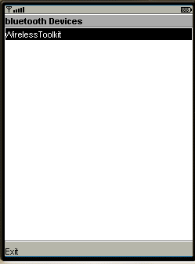
private void searchServices(RemoteDevice device) {
UUID[] searchList = {RFCOMM};//,TCS,HIDP,UDP,TCPL2CAP,SDP,RFCOMM,
// UUID[] searchList = new UUID[] { uuid };
int[] attributes = {SERVICE_NAME,SERVICE_DESC,PROVIDER_NAME,SERVICE_RECORD_HANDLE, SERVICE_CLASSID_LIST,
SERVICE_RECORD_STATE, SERVICE_ID,
PROTOCOL_DESCRIPTOR_LIST, BROWSE_GROUP_LIST,
LANGUAGE_BASED_ATTRIBUTE_ID_LIST,
SERVICE_INFO_TIME_TO_LIVE, SERVICE_AVAILABILITY,
BLUETOOTH_PROFILE_DESCRIPTOR_LIST, DOCUMENTATION_URL,
CLIENT_EXECUTABLE_URL, ICON_URL, VERSION_NUMBER_LIST,
SERVICE_DATABASE_STATE};
try {
printString("Searching " + device.getBluetoothAddress( )
+ " for services");
trans = this.discoveryAgent.searchServices(null, searchList, device, this);
printString("Service Search " + trans + " started");
}
catch (BluetoothStateException ex) {
printString( "BluetoothStateException: " + ex.getMessage( ) );
}
}

public void servicesDiscovered(int transID, ServiceRecord[] servRecord) {
StreamConnection conn = null;
for (int i = 0; i < servRecord.length; i++) {
printString("Found service " + servRecord[i].getConnectionURL(
ServiceRecord.NOAUTHENTICATE_NOENCRYPT, false));
urlConn=servRecord[i].getConnectionURL(ServiceRecord.NOAUTHENTICATE_NOENCRYPT, false);
service_append(urlConn);

}
printString("services discovered");
}

public void serviceSearchCompleted(int transID, int respCode) {

service_show();

}

public void inquiryCompleted(int discType) {

switch (discType) {
case DiscoveryListener.INQUIRY_TERMINATED:
printString("Search cancelled");
break;
case DiscoveryListener.INQUIRY_ERROR:
printString("Bluetooth error");
break;
case DiscoveryListener.INQUIRY_COMPLETED:
printString("before calling searchServices..1");
try {
printString("before calling searchServices..2");
menue_show();

} catch (Exception exception) {
printString("search services not called");
}
printString("Device search complete");
break;
default:
printString("Unanticipated result: " + discType);
}
}
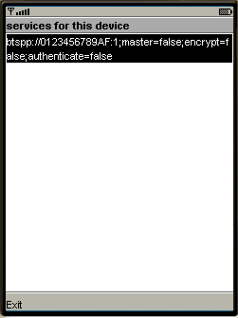
Class Connect :
class Connect extends Thread {
Midl m;
String urlConn;
public Connect(Midl m ,String urlConn)
{
this.m =m;
this.urlConn=urlConn;
}
public void run()
{
try
{
m.service=(StreamConnection)Connector.open(urlConn);
int n=0;
int ch;
byte[] imgData = null;
m.output = m.service.openDataOutputStream();
String mssg ="m";
m.output.write(mssg.getBytes());
m.output.flush();

// Tracer.outln("write", text);
m.input = m.service.openDataInputStream();
while ((n = m.input.read()) != -1) {
m.RX_msg=m.RX_msg+(""+(char)n);
System.out.println("from midlet fn"+m.RX_msg);
}
// m.home.setString(msg);
m.home.repaint();
// m.input.close();

}
catch (IOException e2) {
// printString("exception") ;
}
}
Then Graphics Interface for home is displayed after connection is completed.

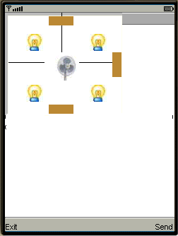

public void paint(Graphics g) {
g.setFont(Font.getFont(Font.FACE_SYSTEM, Font.STYLE_ITALIC, Font.SIZE_MEDIUM));
g.setColor(0xC3C3C3);
g.fillRect(0,0,166,145);
g.setColor(0xFFFFEA);
g.drawRect(4,4,161,141);
g.setColor(0xFFFFFF);
g.fillRect(5,5,160,140);
g.setStrokeStyle(Graphics.SOLID);
g.setColor(0x000000);
g.drawLine(5,70,55,70);
g.drawLine(161,70,105,70);
g.drawLine(80,0,80,55);
g.drawImage(im,30, 30, Graphics.LEFT | Graphics.TOP);
g.drawImage(im, 120, 30, Graphics.LEFT | Graphics.TOP);
g.drawImage(im, 30, 102, Graphics.LEFT | Graphics.TOP);
g.drawImage(im, 120, 102, Graphics.LEFT | Graphics.TOP);
g.drawImage(im1, 71, 61, Graphics.LEFT | Graphics.TOP);
g.setColor(0xB68234);
g.fillRect(152,56,13,35);
g.fillRect(62,5,35,13);
g.fillRect(62,130,35,13);
g.setStrokeStyle(Graphics.DOTTED);
g.setColor(0x000000);
switch (keyCode) {
// select an element on the display.
}

