Chapter 1

Introduction

1.0 Introduction

Public services centers are considered one of the most important for measuring modern services quality, which enable the owners of companies and institutions to monitor and improve the quality of services provided. Their importance lies in their role in providing a direct link with clients and expectations built on them, where the applicant expects fast, accurate and more convenient services.
To create a public services center, it is necessary to carry out detailed studies to reach a cost-effective design, since it is unreasonable to design a center with a large number of staff and service providing stations in order to ensure customer satisfaction. In such cases, establishment and operating expenses may exceed expected revenues.
Public services centers’ designing difficulties come from the variability in clients’ arrival rate which leads to suitable working load to the center’s capacity at some working hours or the working load will overcome the working capacity or the working capacity will exceed the clients services working load more than enough. The first possibility is considered as an ideal case with is desired by the centers’ managers whereas the second one represents the worst case which will negatively affect the quality of services provided and lead to disgruntled clients, but according to the last one, the services provided will be costly and economically infeasible. So that, it is needed to study and analyze the public services centers accurately to have a new design with minimum establishment and operating expenses and at the same time to guarantee the highest possible level of services quality.
The public services centers differs from one to another according to their level of complexity which is based mainly on the nature of interrelationships and dependability between service providing stations and the value of changing in arrival and services providing rates which constitute the main factors in designing and operating centers.
In such design cases, all study and analytical methods rely on calculating the arithmetic mean of clients arrive and services provided in a certain unit of time. The most familiar tools and sciences consider such cases are Operations Research “OR” and Queuing Theory which stayed the only ways to study and analyses similar systems until the establishment what is called Simulation. Due to the rapid technology development especially in computers, simulation has become a more effective that enable the researches to perform hundreds or thousands of mathematical operations in few seconds or minutes. An important feature in systems simulation methods is their ability to consider systems in a real manner, taking into account variability changes and deal with systems dynamically (Not static analysis).
Also systems simulation methods are considered as a main tool in decision support systems that help their users to recognize the system understudy, specify its weakness points, and suggest some improvement ideas to overcome them which saves time and effort and reduces risks of implementing inappropriate improvement activities.

Chapter Two

Systems Analytical Approaches

(Man is a tool using animal…Without tools he is nothing, with tools he is all)

Thomas Carlyle

2.1Queuing theory & queuing lines

Queuing theory is used to study the phenomenon of waiting in lines. Some people use the information gathered from queuing theory in order to determine how to best serve customers and so prevent them from waiting in line longer than they have to. The theory allows researchers to analyze several things such as arriving in line, waiting in line, and the time it takes to service customers. This allows them to gather and derive information on a customer’s waiting time, the expected amount of customers that will be in a line, the probability of a customer encountering a line, as well as other data. This information is used in order to find ways to reduce lines and wait time.
Applications of queuing theory are used in many aspects of business, customer service, commerce, industry, healthcare, and engineering. Customer service applications can especially make use of the information gathered by queuing theory. This information can be used in order to make decisions on the kind of resources needed to provide service for customers. The data can be also being applied to call centers, network server queuing, telecommunications, and traffic flow. It can even be used to dictate what type of line customers will be standing in while waiting for different types of service.
There are several queuing disciplines that have been developed because of queuing theory—four of which are First in First out (FIFO), Last in First out (LIFO), Processor Sharing, and Priority. FIFO describes the practice of serving customers in the order they arrive in so that the person waiting longest is served first, while LIFO describes the practice of serving customers so that the person who comes in last leaves first, such as in the case of riding an elevator. Processor sharing serves customers at the same time to that the average waiting time for all customers is about the same. The Priority discipline serves the customer with the highest priority first. It is important to note that these disciplines can be applied to applications other than customer service.
Examples of how queuing theory works is present in many aspects of everyday life. At bank tellers and credit unions, one may see one line and multiple tellers. This happens to help ensure that one slow transaction does not hold up the entire line. Some stores open more registers if there are more than three people waiting in a line. There are also other stores that have roaming clerks. These clerks ring up purchases and give customers a number so that the cashier can complete the transaction quickly, thus reducing waiting times for all.

Types of queuing lines

There are four possible channels as shown in the figures bellow:

- 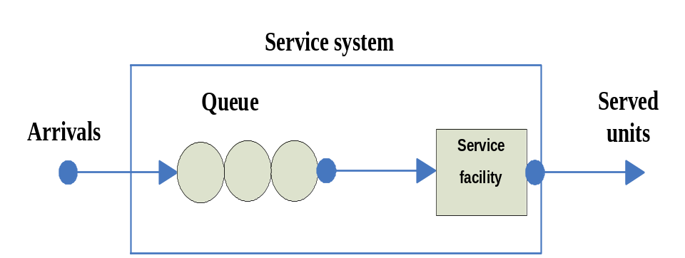Single-channel, Single-phase system.

Fig 2.1: Single-channel, Single-phase system

Ex: Ship unloading system (ship at sea →waiting ship line→ empty ship)

- 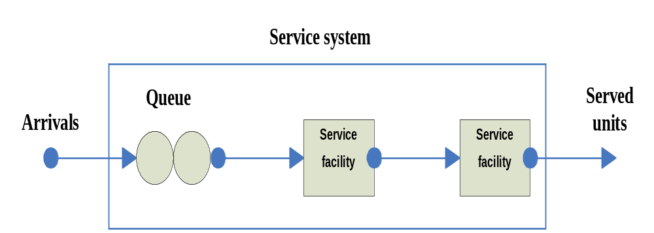Single-channel, Multi phase system.

Fig 2.2: Single-channel, Multi phase system

Ex: Macdonald’s drive through (car in area →waiting cars →cars and food)

- 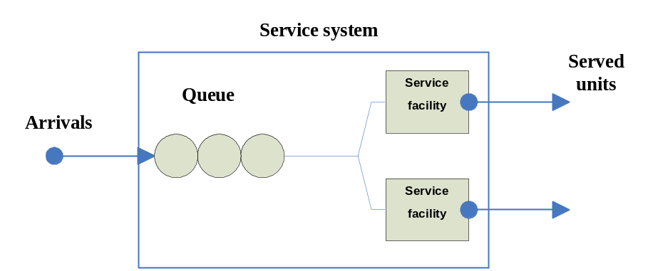Multi-channel, single phase system.

Fig 2.3: Multi-channel, single phase system
Ex: Bank customers wait in single line for one of several tellers.

- 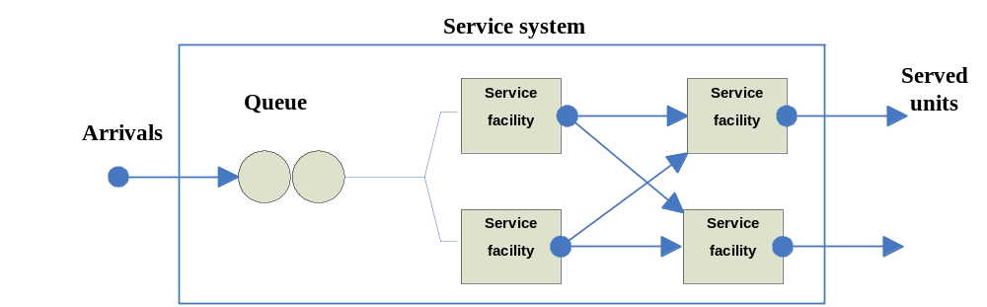Multi-channel, Multi-phase system.

Fig 2.4: Multi-channel, Multi-phase system

Ex: At launderette, customers use one of several washers, then one of several dryers.

Limitations

We have several reasons to exception the queuing theory and using simulation.

Queuing theory:
- Takes average of all variables.
- Based on assumption that service time is known.
- Service times are independent from one another.
- Service rate is known.
- Service rate is greater than arrival rate.
- Arrivals are served on first come first serve basis.
- Service times are described by the negative exponential probability distribution.
- Used for short term phenomenon and is deterministic.

2.2Operation Research

Operations research (O.R.) is the discipline of applying advanced analytical methods to help make better decisions.
By using techniques such as mathematical modeling to analyze complex situations, operations research gives executives the power to make more effective decisions and build more productive systems based on:
• More complete data
• Consideration of all available options
• Careful predictions of outcomes and estimates of risk
• The latest decision tools and techniques

You’ve probably seen dozens of articles and advertisement about solutions that claim to enhance your decision-making capabilities.
O.R. is unique. It's best of breed, employing highly developed methods practiced by specially trained professionals. It’s powerful, using advanced tools and technologies to provide analytical power that no ordinary software or spreadsheet can deliver out of the box. And it’s tailored to you, because an O.R. professional offers you the ability to define your specific challenge in ways that make the most of your data and uncover your most beneficial options.

To achieve these results, O.R. professionals draw upon the latest analytical technologies, including:
• Simulation giving you the ability to try out approaches and test ideas for improvement.
• Optimization narrowing your choices to the very best when there are virtually innumerable feasible options and comparing them is difficult.
• Probability and Statistics helping you measure risk, mine data to find
Valuable connections and insights, test conclusions, and make reliable forecasts.

2.3 Introduction to simulation

Business today face challenge of quickly designing and implementing complex production and service systems that are capable of meeting growing demands for quality, delivery , affordability , and service. With recent advances in computing and software technology, simulation tools are now available to help meet this challenge. Simulation is a powerful technology that is being used with increasing frequency to improve system performance by providing a way to make better design and management decisions. When used properly, simulation can reduce that risks associated with starting up a new operation or making improvements to existing operations.

Definition of Simulation
Simulation is the attempt to duplicate the features, appearance, and characteristics of a real system by building a mathematical model that comes as close as possible representing the reality of the system. The model will hen be used to estimate the effect of various actions.

Process of simulation

Simulation is essentially an experimentation tool in which a computer model of a new or existing system is created for the purpose of conducting experiments. The model acts as a surrogate for the actual or real-word system.

So:
- When we are talking about doing simulation, we mean the process of designing a model of a real system and conducting experiments with this model.
- It should be obvious now that simulation is not a solution tool by itself, but it is an evaluation tool.
- Simulation can work with inaccurate information, but it can not work with incomplete information.
- Simulation should be viewed as an extension of the mind that enables one to understand the complex dynamics of a system.

To use simulation in operation management manager should

To do an accurate simulation the manager should follows the next steps:
1. Define the problem.
2. Introduce the important variable associated with the problem.
3. Construct a numerical model.
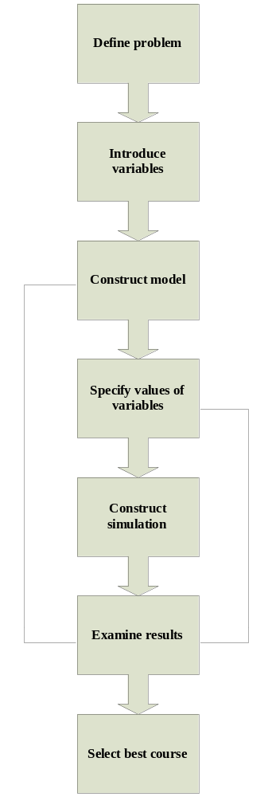4. Set up possible courses of action for testing.
5. Run the experiment.
6. Consider the results.
7. Decide what courses of action to take.

Fig 2.5: Process of simulation

Use of simulation

Simulation began to be used in commercial applications in the 1960s. Only in the last couple of decades simulation pained popularity as a decision making tool in manufacturing and service industries.
While the primary use of simulation is in decision support, it is by no means limited to applications requiring a decision. An increasing use of simulation is in the area of communication and visualization. As a decision support tool, simulation has been used to help plan and make improvements in many areas of both manufacturing and service industries.

When Simulation is Appropriate?
Not all system problems that could be solved with the aid of simulation should be solved using simulation. It is important to select the right tool for the task. For some problems, simulation may be overkill-like using a shotgun to kill a fly.
Simulation has certain limitations of which one should be aware before making a decision to apply it to a given simulation. It is not a panacea for all system-related problems and should be used only if the shoe fit. As a general guideline , simulation is appropriate if the following criteria hold true:
- When operational (logical or quantitative) decision is to be made .
- The process to be analyzed is well defined and repetitive.
- Activities and events are interdependent and variable.
- The cost impact of the decision is greater than the cost of doing simulation.
- The cost to experiment on the actual system is greater than the cost of simulation.

Advantages & disadvantage of simulation:

Simulation is a tool that has become widely accepted by managers for several reasons.

The main advantages of simulation are as follows:
1. Simulation is relatively straightforward and flexible.
2. It can be used to analyze large and complex real-world situations that cannot be solved conventional operations management models.
3. Real-world complications can be included that most OM models cannot permit. For example, simulation can use any probability distribution the user defines; it dose not require standard distribution.
4. Time compression is possible. The effect of OM policies over many months or years can be obtained by computer simulation in a short time.
5. Simulation allows "what-if" types of questions. Manager likes to know in advance what option will be most attractive. With computerized model, a manager can try out several policy decisions within a matter of minutes.
6. Simulation does not interfere with real-world system. It may be too disruptive, for example, to experiment physically with new policies or ideas in a hospital or manufacturing plant.
7. Simulation can study the interactive effects of individual components or variables in order to determine which ones are important.

The main disadvantages of simulation are as follows:
1. Good simulation models can be very expensive; they make many months to develop.
2. It is trial- and-error approach that may produce different solutions in repeated runs. It dose not generate optimal solution to problems (as dose linear programming).
3. Manager must generate all of the conditions and constraints for solutions that they want to examine. The simulation model dose not produces answers without adequate, realistic input.
4. Each simulation models is unique. Its solution and inferences are not usually transferable to other problems.

2.4 Monte Carlo simulation

When a system contains elements that exhibit chance in their behavior, the Monte Carlo method of simulation may be applied. The basis of Monte Carlo simulation is experimentation on chance (probabilistic) elements by means of random sampling.
Monte Carlo method breaks down into five simple steps:
- Setting up a probability distribution for important variables.
- Building a cumulative probability distribution for each variable.
- Establishing an interval of random numbers for each variable.
- Generating random numbers.
- Actually simulating a series of trials

2.5 Discrete event simulation “DES”

In discrete-event simulation, the operation of a system is represented as a chronological sequence of events. Each event occurs at an instant in time and marks a change of state in the system. And it is a great way to get a handle on the workings of a complex system. These simulations essentially let people see events before they happen.
Discrete event simulation works by taking a set of variables, and playing them out to logical ends. One can then see how such complicated places like airports, shipping docks and hospitals are likely to work. One can determine problem areas, and set about to solve issues of transportation or staff coordination before such issues even arise. Such a window on future possibilities can be of great help in the present.
A common exercise in learning how to build discrete-event simulations is to model a queue, such as customers arriving at a bank to be served by a teller. In this example, the system entities are CUSTOMER-QUEUE and TELLERS. The system events are CUSTOMER-ARRIVAL and CUSTOMER-DEPARTURE. (The event of TELLER-BEGINS-SERVICE can be part of the logic of the arrival and departure events.) The system states, which are changed by these events, are NUMBER-OF-CUSTOMERS-IN-THE-QUEUE (an integer from 0 to n) and TELLER-STATUS (busy or idle). The random variables that need to be characterized to model this system stochastically are CUSTOMER-INTERARRIVAL-TIME and TELLER-SERVICE-TIME.
A number of mechanisms have been proposed for carrying out discrete-event simulation; among them are the event-based, activity-based, process-based and three-phase approaches (Pidd, 1998). The three-phase approach is used by a number of commercial simulation software packages, but from the user's point of view, the specifics of the underlying simulation method are generally hidden.
Roughly speaking, there are three different kinds of systems: continuous systems, discrete systems and discrete-event systems.
- A continuous system is a system which state varies continuously in time. Such systems are usually described by a set of differential equations. For example, continuous systems often arise in chemical applications.
- A discrete system is a system which is observed only at some fixed regular time points. Such systems are usually described by a set of difference equations. An example of a discrete system is an inventory model in which we inspect the stock only once a week.
- The characteristic feature of a discrete-event system is that the system is completely determined by a sequence of random event times t1; t2; : : :, and by the changes in the state of the system which take place at these moments. Between these event times the state of the system may also change, however, according to some deterministic pattern. A first example of a discrete-event simulation was given in the previous section when we considered the two-machine production line. A second example of a discrete-event system is a single server queuing system.

Discrete-Event Simulation Method Steps
- Scheduled event- its time of occurrence can be determined before hand and can therefore be scheduled in advance- an activity that will take X amount of time (random, m, s).
- Conditional event- triggered by a condition being met rather than the passage of time- an order waiting for all of the individual items making up the order to be assembled.
- Events trigger the execution of logic associated with the Event.

Common Uses of discrete event simulation

DES can be used in several fields such as follows:
- Diagnosing process issues.
- Evaluating capital investment decisions.
- Hospital applications.
- Custom order environments.
- Lab test performance improvement ideas.

Chapter Three

DES Using ProModel Software

(When The only tool you have is a hammer, every problem begins to resemble a nail (

Abraham Maslow

3.0 DES Using ProModel Software

ProModel is discrete event simulation software, used for evaluating, planning or designing manufacturing, warehousing, logistics and other operational and strategic situations.
To understand how ProModel can help you, think of your facility as a collection of resources that are intended to function together in a cost-effective manner. Each person and piece of equipment is related to every other component (by coincidence or convenience). Together they define the way your facility works.

Building a Model
A model is defined in ProModel using simple graphical tools, data entry tables, and fill-in-the-blank dialog boxes. In ProModel, a model consists of entities (the items being processed}), locations (the places where processing occurs), resources (agents used to process and move entities), and paths (aisles and pathways along which entities and resources traverse). Dialogs are associated with each of these modeling elements for defining operational behavior such as entity arrivals and processing logic. Schedules, downtimes, and other attributes can also be defined for entities, resources, and locations.
Most of the system elements are defined graphically in ProModel. A graphic representing a location, for example, is placed on the layout to create a new location in the model. Information about this location can then be entered such as its name, capacity, and so on. Default values are provided to help simplify this process. Defining objects graphically provides a highly intuitive and visual approach to model building. The use of graphics is optional, and a model can even be defined without using any graphics, In addition to graphic objects provided by the modeling software, import capability is available to bring in graphics from other packing. This includes complete facility layouts created using CAD software such as AutoCAD.

Running the Simulation

When running a model created in ProModel, the model database is translated or compiled to create the simulation database. The animation in ProModel is displayed concurrently with the simulation. Animation graphics are classified as either static or dynamic. Static graphics include walls, aisles, machines, screen text, and other, and others. Static graphics provide the background against which the animation takes place. This background might be a CAD layout imported into the model. The dynamic animation objects that move around on the background during the simulation include entities (parts, customers, and so on) and resources (people, fork trucks, and so forth). Animation also includes dynamically updated counters, indicators, gauges, and graphs that display count, status, and statistical information.

Output Analysis

The output processor in ProModel provides both summary and detailed statistics on key performance measures. Simulation results are presented in the form of reports, plots, histograms, pie charts, and others. Output data analysis capabilities such as confidence interval estimation are provided for more precise analysis. Output from multiple replications and multiple scenarios can also be summarized and compared.
Averaging performance across replications and showing multiple scenario output side-by-side make the results much easier to interpret.

Chapter Four

Decision Support Systems “DSSs”

4.0 Decision Support Systems (DSS)

Decision Support Systems (DSSs) are a class of computerized information system that supports decision-making activities. DSSs are interactive computer-based systems and subsystems intended to help decision makers use communications technologies, data, documents, knowledge and/or models to complete decision process tasks.
A decision support system may present information graphically and may include an expert system or artificial intelligence (AI). It may be aimed at business executives or some other group of knowledge workers.

Typical information that a decision support application might gather and present would be:
- Accessing all information assets, including legacy and relational data sources.
- Comparative data figures.
- Projected figures based on new data or assumptions.
- Consequences of different decision alternatives, given past experience in a specific context.

There are a number of Decision Support Systems. These can be categorized into five types:
- Communication-driven DSS.
Most communications-driven DSSs are targeted at internal teams, including partners. Its purpose are to help conduct a meeting, or for users to collaborate. The most common technology used to deploy the DSS is a web or client server. Examples: chats and instant messaging soft wares, online collaboration and net-meeting
- Data-driven DSSs.
Most data-driven DSSs are targeted at managers, staff and also product/service suppliers. It is used to query a database or data warehouse to seek specific answers for specific purposes. It is deployed via a main frame system, client/server link, or via the web. Examples: computer-based databases that have a query system to check (including the incorporation of data to add value to existing databases.
- Document-driven DSSs.
Most data-driven DSSs are targeted at managers, staff and also product/service suppliers. It is used to query a database or data warehouse to seek specific answers for specific purposes. It is deployed via a main frame system, client/server link, or via the web. Examples: computer-based databases that have a query system to check (including the incorporation of data to add value to existing databases.
- Knowledge-driven DSSs.
Knowledge-driven DSSs or 'knowledgebase' are they are known, are a catch-all category covering a broad range of systems covering users within the organization setting it up, but may also include others interacting with the organization - for example, consumers of a business. It is essentially used to provide management advice or to choose products/services. The typical deployment technology used to set up such systems could be silent/server systems, the web, or software running on stand-alone PCs.
- Model-driven DSSs.
Model- driven DSSs are complex systems that help analyses decisions or choose between different options. These are used by managers and staff members of business, or people who interact with the organization, for a number of purposes depending on how the model is set up- scheduling, decision analyses… etc. These DSSs can be developed via software/ hardware in stand-alone PCs, client/ server systems, or the web.

Chapter Five

Field Work

(You can observe a lot just by watching)

Yogi Berra

5.1 Work Methodology

This project was accomplished completely according the following working methodology:
- All related and available literature has been reviewed in order to build a solid scientific background about simulation and its related topics.

These topics are about Queuing Theory, Monte Carlo Simulation Method, Discrete event Simulation "DSS", & Decision Support System.
- A comprehensive diagnostic study about CSC has been done to understand internal relationships, bonds, & available resources such as (Employee, Equipments, etc) with cooperation with CSC employees in order to build the ability of them to use & improve the DSS without external help.
- Needed relevant Data was collected, see appendix A and B.

Number of customers, their arrival rates, required serving time and the waiting time in queue before contacting the intended employee in the center. So several samples were collected in coordination with the employees.
- The DSS System was designed.

DSS system was designed depending on understanding the work mechanism & internal bonds between center elements and the collected information.
- The system was modified to simulate the real system as much as possible.
- Data entering & simulation was running.
- Collected data were fitted to suitable distributions and analyzed.
- Current situation was simulated so that the weak points & lack/surplus have been appeared.
- Proposed improvement Scenarios have been suggested and analyzed.

The new suggested developments proposals were developed in collaboration with the center's employees, and simulated it investigate their effects on the overall working system.
- Outcomes were evaluated, conclusions and recommendations were prepared for further future work.

5.2 Data Collection Methodology

Data collection is the most challenging and time-consuming task in simulation. For new systems information is usually very sketchy and roughly estimated.

But for existing systems there may be sufficient and organized historical data to sort through. Information is seldom available in a form that is directly usable in building simulation model. It nearly always needs to be filtered and massaged to get it into the right format and to reflect the projected conditions under which the system to be analyzed. Many data – gathering efforts end up with lots of data but little useful information.

Data should be gathered purposefully to avoid wasting not only the modelers of time but also the time of individuals who are supplying the data.

In order to study the current situation of CSC and to improve it we followed the following procedure:
- Defining the problem:
The most important problem faces the CSC is queuing lines, so that it was needed to study the resources of the center to find the main causes of this problem.
- Understanding the sequences of the processes in the center:
This step was very important in order to help us gathering the suitable information that we need to build the model using ProModel software.
- Performing data collection:
  - Data requirements (service time, arrival rate) were determined.
  - Data sources were identified.
  - The data were collected.
  - Needed assumptions were made where necessary.
  - Data were analyzed using Stat::Fit method, see appendix.
  - Data were documented and approved.

The following table shows the basic data which were taken from the stat::Fit and inserted to the Pro-Model software in order to build the model, see appendix C and D.

Table 5.1: Stat::Fit Results
Locations | Function Type | Beta (β)
Arrival rate | Exponential | 1.19223
Management
Sameh | Exponential | 8.88
Queries unit
Zhoor | Exponential | 1.21854
Receive transaction unit
Aisha | Exponential | 3.53714
Sabha | Exponential | 4.85238
Mhammad | Exponential | 4.17857
Huda | Exponential | 4.55191
Finish transaction unit
Deema | Exponential | 2.90517
Reem | Exponential | 2.89969
Ghassan | Exponential | 2.97744
Counting unit
Wafaa | Exponential | 1.62
Rasha | Exponential | 1.69014
Bank
Asmaa | Exponential | 2.0625
Communication
Saed | Exponential | 4.09296

Chapter Six
Building the DSS and achieved Results

(Every theory "Model" should be stated "build" as simply as possible, but not similar)
Albert Einstein

6.1 CSC General Description
Among its vision to improve its services and enhance the overall performance to render the best quality of services rendered to the public, a new section named: Customers’ Service Center has been created, considered among pioneer initiatives at the national level.
Since citizens’ satisfaction is the major goal that Nablus Municipality is keen to achieve, the municipal council envisaged creating the Customer’s Service Center as it believes the significance to improve the relation between the municipality and the local citizens through improving the overall performance by rendering high quality of services based on One Stop Concept. Using such methodology will ensure achieving all undertakings, saving time and effort to both citizens and staff at a time. It is an ideal tool for controlling the process of all undertakings through different departments and sections within the municipality through exclusive software which has been created and developed to achieve this goal. A group of staff member has been subject to an intensive training and became friendly users to this software as well the know-how of work mechanism with relevant departments.
Goals
- Receives all municipality undertakings in a unified destination.
- Facilitates and smooth the process of citizen's applications.
- Follow-up electronically the process of undertakings to avoid losses
- Ensures sound monitoring and control on all undertakings and finalize them in timely fashion.
- Minimizes burden of intensive and unorganized referrals to ensure a better performance of the center.
- Receives all types of complaints and addresses all needs of citizens.
- Achieves transparency and open door policy to all citizens by trouble shooting when meeting with mayor bi-weekly.
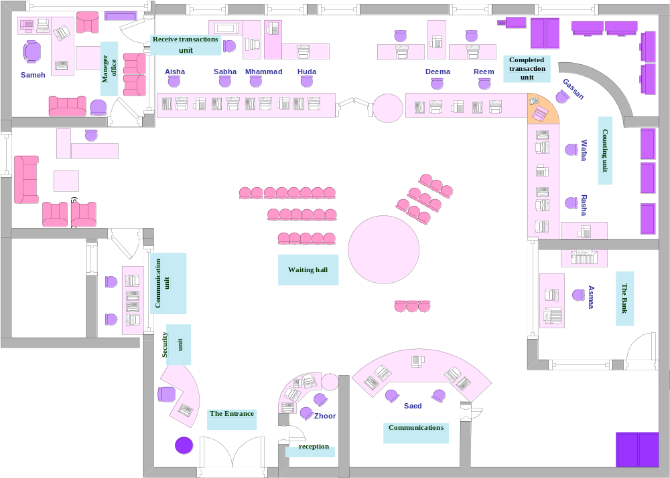

Fig 6.1: CSC layout

The Center comprises of the following units:
- Quires Unit: The aim of this unit is to answer any queries addressed by the citizens, provides guidance on means of applications and the relevant needed documents.
- Receive Transactions Unit: this unit receives all citizens' undertakings and provides the applicant with timetable receipt indicating estimated time of completion.
- Finished Transactions Unit: through this unit, the applicant can monitor and follow up the process of his/her application and receive the completed undertaking in timely fashion as referred to in the receipt.
- Accounting Unit: this unit is responsible for monitoring all financial transactions related to citizen's undertakings.
- Phone Information Unit: This unit is still in process and will be functioning in the near future. This unit will allow all citizens inquire on their undertakings and provide missing documents through approaching the center by phone.
- Meeting with the Mayor: This is allows easy access to all citizens to meet with mayor and discuss complaints directly.
In order to ensure comprehensive services to the public, the municipality in cooperation with the Jordan Bank is currently hosting a banking unit through which all municipal financial obligations could be settled to facilitate applicants’ mission. Moreover, another unit of Palestinian Telecommunication has also been initiated within the center for achieve comprehensive services in a unified place.

The Customers’ Service Center is currently using management and financial information and technology systems. The computerized system is an outcome of a creative product developed locally by the Programming and Development unit of Nablus Municipality. The Center is being managed and operated by 17 staff members (males & females) under the direct supervision of Mr. Sameh Assali, the Center’s Director, while enlisted within the organizational structure under the administrative department.

Sequence of operations in CSC center can be summarized as shown in the figure (6.2)

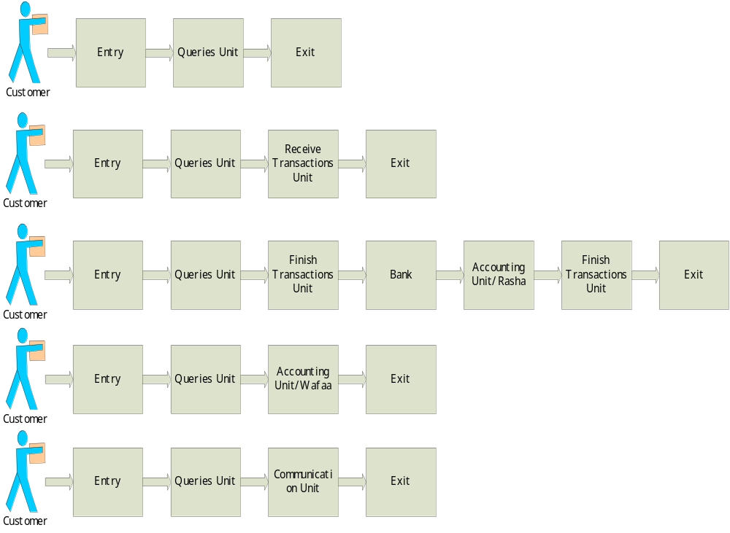

Fig 6.2: Sequences of processing in CSC center
6.2 Results and Discussion for the Current Situation

The table bellow represents the results of analyzing CSC current situation using Pro-Model software.
Table 6.1: Current situation of the CSC
Scenario No. |  |  |  |  | 1
Scenario Description |  |  |  |  | Current Situation
General Information
Simulation Time (hr) |  |  |  |  | 1800
Number of Replications |  |  |  |  | 5
Warm-up Time (hr) |  |  |  |  | 100
Simulation Results
Locations Results
Location |  | Capacity | Total Entries |  |  |  | Avg. time /entry(min) |  | Avg. contents |  | Max. contents |  | Utilization (%)
CSC Arrival Queue |  | INF | 90761 |  |  |  | 0.57 |  | 0.48 |  | 15.4 |  | 0
General Queue |  | INF | 78236 |  |  |  | 2.9 |  | 2.10 |  | 64.4 |  | 0
Communication Queue |  | INF | 11791 |  |  |  | 4.04 |  | 0.44 |  | 10.6 |  | 0
Receive Transactions Queue |  | INF | 16419 |  |  |  | 0.47 |  | 0.07 |  | 13.4 |  | 0
Finished Transactions Queue |  | INF | 54587 |  |  |  | 1.39 |  | 0.7 |  | 39.4 |  | 0
Cheques Queue |  | INF | 3639 |  |  |  | 0.71 |  | 0.02 |  | 5.2 |  | 0
Bank Queue |  | INF | 10842 |  |  |  | 1.49 |  | 0.15 |  | 6.8 |  | 0
Zhoor |  | 1 | 14518 |  |  |  | 1.23 |  | 0.16 |  | 1 |  | 16.47
Sameh |  | 1 | 3592 |  |  |  | 8.91 |  | 0.3 |  | 1 |  | 29.64
Aisha |  | 1 | 4273 |  |  |  | 3.53 |  | 0.14 |  | 1 |  | 13.96
Sabha |  | 1 | 4011 |  |  |  | 4.8 |  | 0.18 |  | 1 |  | 17.82
Mohammad |  | 1 | 4093 |  |  |  | 4.18 |  | 0.16 |  | 1 |  | 15.85
Huda |  | 1 | 4045 |  |  |  | 4.53 |  | 0.17 |  | 1 |  | 16.97
Deema |  | 1 | 18201 |  |  |  | 2.95 |  | 0.5 |  | 1 |  | 49.75
Reem |  | 1 | 18328 |  |  |  | 2.91 |  | 0.49 |  | 1 |  | 49.43
Ghassan |  | 1 | 18060 |  |  |  | 2.99 |  | 0.5 |  | 1 |  | 49.94
Wafaa |  | 1 | 3639 |  |  |  | 1.63 |  | 0.05 |  | 1 |  | 5.49
Rasha |  | 1 | 10843 |  |  |  | 1.7 |  | 0.17 |  | 1 |  | 17.07
Asmaa |  | 1 | 10843 |  |  |  | 2.35 |  | 0.24 |  | 1 |  | 23.61
Saed |  | 1 | 11790 |  |  |  | 4.08 |  | 0.45 |  | 1 |  | 44.51
Queuing Lines Results
Name |  |  |  | Empty (%) |  |  |  |  |  | Partially Occupied (%)
CSC Arrival Queue |  |  |  | 64.12 |  |  |  |  |  | 35.89
General Queue |  |  |  | 29.06 |  |  |  |  |  | 70.94
Communication Queue |  |  |  | 73.87 |  |  |  |  |  | 26.13
Receive Transactions Queue |  |  |  | 93.84 |  |  |  |  |  | 6.16
Finished Transactions Queue |  |  |  | 73.36 |  |  |  |  |  | 26.64
Cheques Queue |  |  |  | 97.73 |  |  |  |  |  | 2.27
Bank Queue |  |  |  | 87.88 |  |  |  |  |  | 12.13
Processing Locations Results
Name |  |  |  | Operating Time (%) |  |  |  |  |  | Idle Time (%)
Zhoor |  |  |  | 16.47 |  |  |  |  |  | 83.53
Sameh |  |  |  | 29.64 |  |  |  |  |  | 70.36
Aisha |  |  |  | 13.96 |  |  |  |  |  | 86.64
Sabha |  |  |  | 17.82 |  |  |  |  |  | 82.18
Mohammad |  |  |  | 15.85 |  |  |  |  |  | 84.15
Huda |  |  |  | 16.97 |  |  |  |  |  | 83.03
Deema |  |  |  | 49.75 |  |  |  |  |  | 50.25
Reem |  |  |  | 49.43 |  |  |  |  |  | 50.57
Ghassan |  |  |  | 49.94 |  |  |  |  |  | 50.06
Wafaa |  |  |  | 5.49 |  |  |  |  |  | 94.51
Rasha |  |  |  | 17.08 |  |  |  |  |  | 82.92
Asmaa |  |  |  | 20.75 |  |  |  |  |  | 76.39
Saed |  |  |  | 44.51 |  |  |  |  |  | 55.49
Entity Results
Total Exits | Avg. Time in Sys. (min) |  |  |  |  | Avg. Time Waiting (min) |  | Avg. Time in Operation (min) |  |  |  | Avg. Time Blocked (min)
90761 | 8.89 |  |  |  |  | 1.73 |  | 6.49 |  |  |  | 0.67

In the following, the most important results for this scenario are graphically [Fig 6.3 - Fig 6.5]
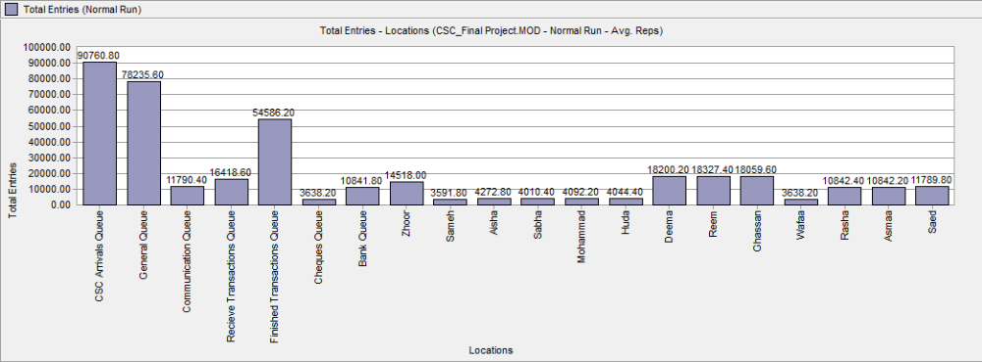

Fig 6.3: Total Entries vs. Locations

Fig 6.4: %Utilization vs. Location

Fig 6.4.1: Zhoor state vs. Hour

Fig 6.4.2: Sameh state vs. Hour

Fig 6.4.3: Aisha state vs. Hour

Fig 6.4.4: Sabah state vs. Hours

Fig 6.4.5: Mohammad state vs. Hours

Fig 6.4.6: Huda state vs. Hours

Fig

Fig 6.4.7: Deema state vs. Hours

Fig 6.4.8: Reem state vs. Hours

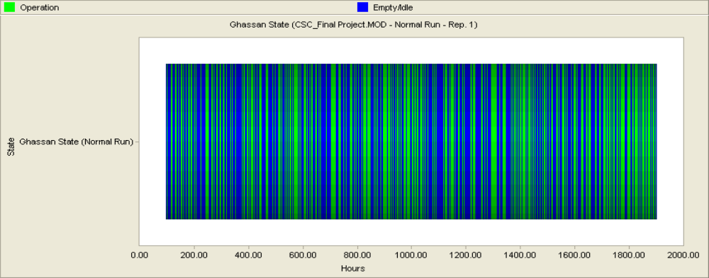

Fig 6.4.9: Ghassan state vs. Hours

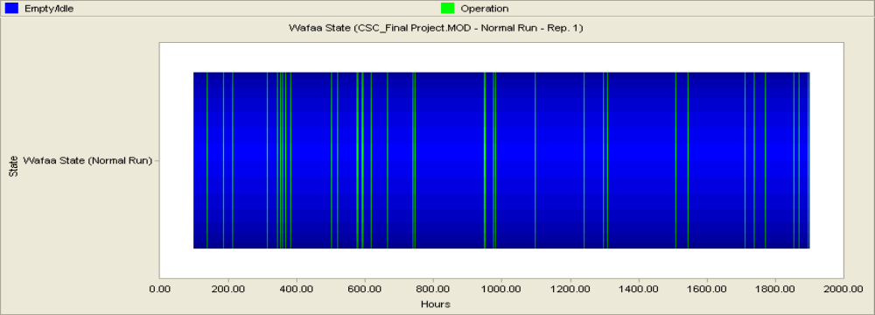

Fig 6.4.10: Huda state vs. Hours

Fig 6.4.11: Rasha state vs. Hours

Fig 6.4.12: Asmaa state vs. Hours

Fig 6.4.13: Saed state vs. Hours

Fig 6.5:%par Occupied vs. Queuing Lines

Results for Scenario Number One:
Achieved results from analyzing the first scenario can be summarized as:
- The average number of customers in the center queues varied between 0.0 and 3 customers which are very good especially when taking into consideration that the maximum average time required for each entry to be serviced is below 4.53 minutes.
- The maximum number of customer that may be in the center during the simulated period is 65 customers, and it is shown that the maximum number of customers in the queues was in the finished transactions queue which was 40 customers. So, it is clear that their is a relatively large working load in the finished transactions stations in comparison to other station.
- All of the finished transactions employees' utilization number is about 50%, and for all of the remaining center employees the utilization number varied between 5% and 30%.
- The average time per customer in the system was 8.89 minutes and this number should be compared with the municipality required policy.

6.3 Results and Discussion for Suggested Improvement Scenarios
Scenario no. 2

The table bellow represented the first improvement Scenarios to mitigate the pressure from finished transactions Unit.
Table 6.2: Support the finish transaction unit with the fastest employee from receive transaction unit
scenario No. |  |  |  |  | 2
Scenario Description |  |  |  |  | Support the finish transaction unit with the fastest employee from receive transaction unit
General Information
Simulation Time (hr) |  |  |  |  | 1800
Number of Replications |  |  |  |  | 5
Warm-up Time (hr) |  |  |  |  | 100
Simulation Results
Locations Results
Location |  | Capacity | Total Entries |  |  |  | Avg. time /entry (min) |  | Avg. contents |  | Max. contents |  | Utilization (%)
CSC Arrival Queue |  | INF | 90416.8 |  |  |  | 0.57 |  | 0.49 |  | 13.8 |  | 0
General Queue |  | INF | 77857 |  |  |  | 2.85 |  | 2.06 |  | 66 |  | 0
Communication Queue |  | INF | 11830.4 |  |  |  | 3.95 |  | 0.43 |  | 9.8 |  | 0
Receive Transactions Queue |  | INF | 16437.6 |  |  |  | 0.6 |  | 0.09 |  | 12.8 |  | 0
Finished Transactions Queue |  | INF | 54170 |  |  |  | 0.71 |  | 0.36 |  | 39.6 |  | 0
Cheques Queue |  | INF | 3672.6 |  |  |  | 0.7 |  | 0.02 |  | 4.6 |  | 0
Bank Queue |  | INF | 10795.2 |  |  |  | 1.52 |  | 0.15 |  | 7.2 |  | 0
Zhoor |  | 1 | 14396 |  |  |  | 1.21 |  | 0.16 |  | 1 |  | 16.19
Sameh |  | 1 | 3576.4 |  |  |  | 8.85 |  | 0.29 |  | 1 |  | 29.29
Aisha |  | 1 | 1362.3 |  |  |  | 2.91 |  | 0.37 |  | 1 |  | 36.66
Sabha |  | 1 | 5348 |  |  |  | 4.13 |  | 0.24 |  | 1 |  | 24
Mohammad |  | 1 | 5645.4 |  |  |  | 4.59 |  | 0.22 |  | 1 |  | 21.59
Huda |  | 1 | 5445 |  |  |  | 2.96 |  | 0.23 |  | 1 |  | 23.12
Deema |  | 1 | 13454.6 |  |  |  | 2.9 |  | 0.37 |  | 1 |  | 36.87
Reem |  | 1 | 13639.6 |  |  |  | 2.98 |  | 0.37 |  | 1 |  | 36.58
Ghassan |  | 1 | 13453.8 |  |  |  | 1.63 |  | 0.37 |  | 1 |  | 37.16
Wafaa |  | 1 | 3672.6 |  |  |  | 1.7 |  | 0.06 |  | 1 |  | 5.54
Rasha |  | 1 | 10795.4 |  |  |  | 2.35 |  | 0.17 |  | 1 |  | 17.01
Asmaa |  | 1 | 10795.2 |  |  |  | 1.09 |  | 0.24 |  | 1 |  | 23.53
Saed |  | 1 | 11830.8 |  |  |  | 4.13 |  | 0.45 |  | 1 |  | 44.82
Queuing Lines Results
Name |  |  |  | Empty (%) |  |  |  |  |  | Partially Occupied (%)
CSC Arrival Queue |  |  |  | 64.24 |  |  |  |  |  | 35.76
General Queue |  |  |  | 29.22 |  |  |  |  |  | 70.78
Communication Queue |  |  |  | 73.74 |  |  |  |  |  | 26.26
Receive Transactions Queue |  |  |  | 92.85 |  |  |  |  |  | 7.15
Finished Transactions Queue |  |  |  | 82.16 |  |  |  |  |  | 17.84
Cheques Queue |  |  |  | 97.73 |  |  |  |  |  | 2.27
Bank Queue |  |  |  | 87.91 |  |  |  |  |  | 12.09
Processing Locations Results
Name |  |  |  | Operating Time (%) |  |  |  |  |  | Idle Time (%)
Zhoor |  |  |  | 16.19 |  |  |  |  |  | 83.81
Sameh |  |  |  | 29.29 |  |  |  |  |  | 10.71
Aisha |  |  |  | 36.66 |  |  |  |  |  | 63.34
Sabha |  |  |  | 24 |  |  |  |  |  | 76.00
Mohammad |  |  |  | 21.59 |  |  |  |  |  | 78.41
Huda |  |  |  | 23.12 |  |  |  |  |  | 76.88
Deema |  |  |  | 36.87 |  |  |  |  |  | 63.13
Reem |  |  |  | 36.58 |  |  |  |  |  | 63.42
Ghassan |  |  |  | 37.16 |  |  |  |  |  | 62.84
Wafaa |  |  |  | 5.54 |  |  |  |  |  | 94.46
Rasha |  |  |  | 17 |  |  |  |  |  | 83
Asmaa |  |  |  | 20.67 |  |  |  |  |  | 76.47
Saed |  |  |  | 44.82 |  |  |  |  |  | 55.18
Entity Results
Total Exits | Avg. Time in Sys. (min) |  |  |  |  | Avg. Time Waiting (min) |  | Avg. Time in Operation (min) |  |  |  | Avg. Time Blocked (min)
90418.6 | 8.49 |  |  |  |  | 1.4 |  | 6.53 |  |  |  | 0.56
In the following, the most important results for this scenario are graphically [Fig 6.6 - Fig 6.8]

Fig 6.6: Total Entries vs. Locations

Fig 6.7: % Utilization vs. Locations

Fig 6.7.1: Zhoor state vs. Hour

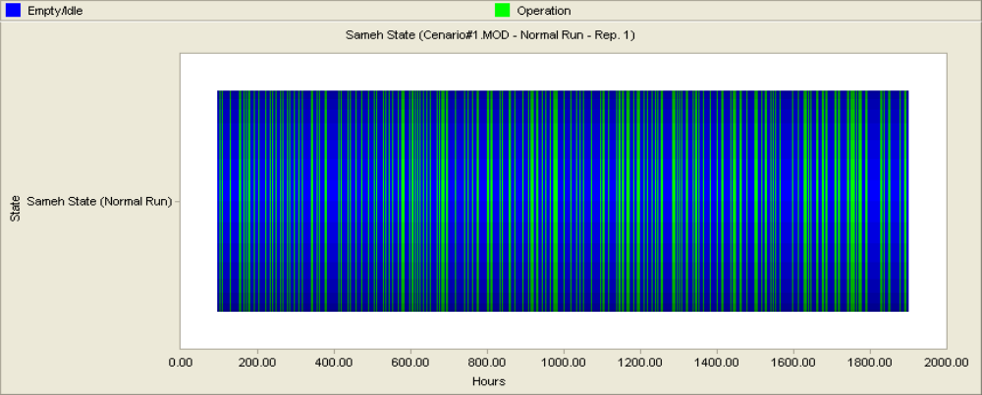

Fig 6.7.2: Sameh state vs. Hour

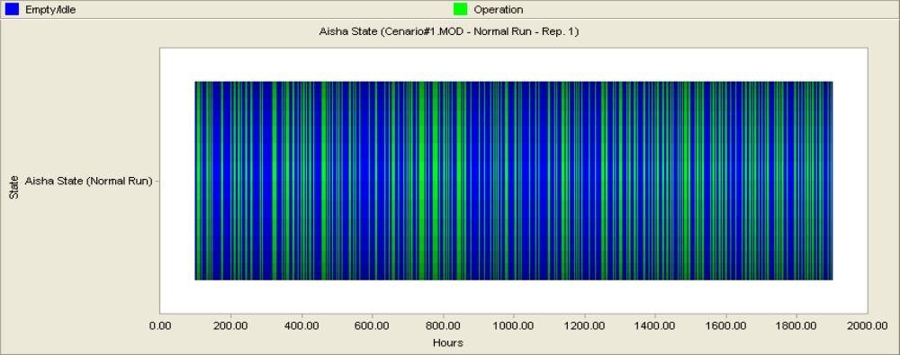

Fig 6.7.3: Aisha state vs. Hour

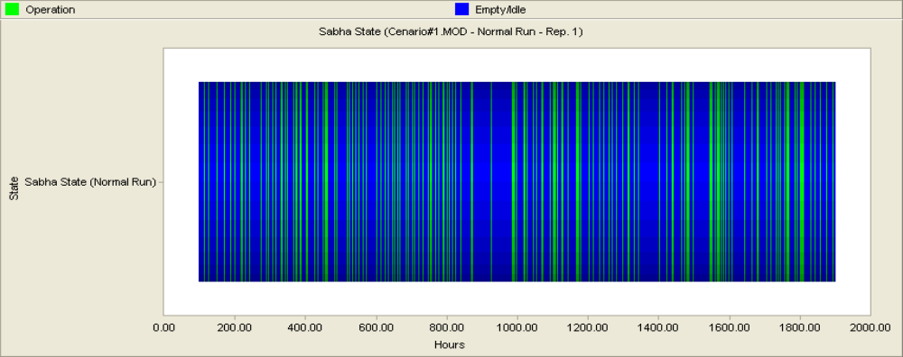

Fig 6.7.4: Sabha state vs. Hour

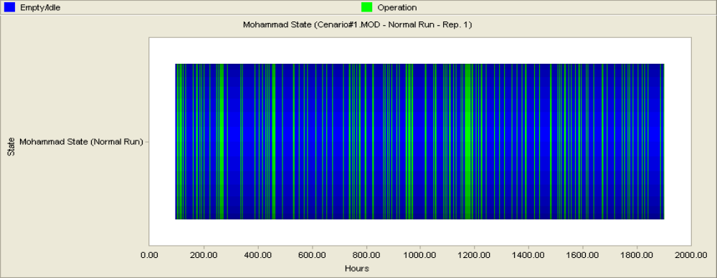

Fig 6.7.5: Mohammad state vs. Hour

Fig 6.7.6: Huda state vs. Hour

Fig 6.7.7: Deema state vs. Hour

Fig 6.7.8: Reem state vs. Hour

Fig 6.7.9: Ghassan state vs. Hour

Fig 6.7.10: Wafaa state vs. Hour

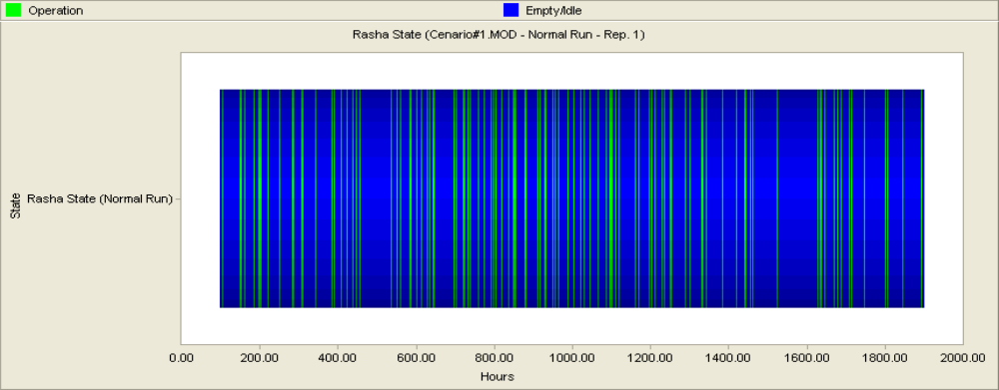

Fig 6.7.11: Rasha state vs. Hour
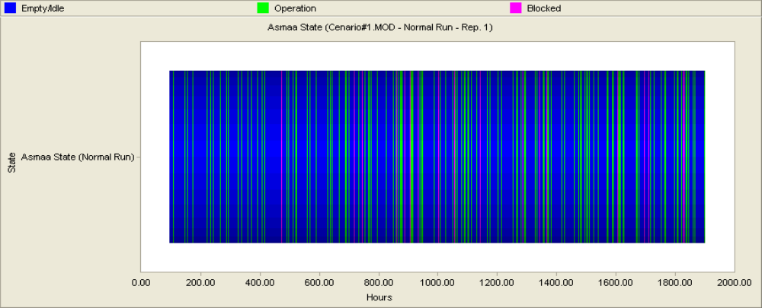

Fig 6.7.12: Asmaa state vs. Hour

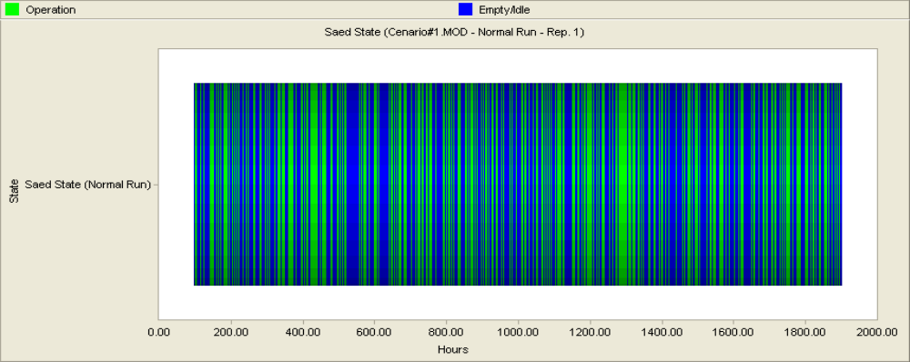

Fig 6.7.13: Saed state vs. Hour

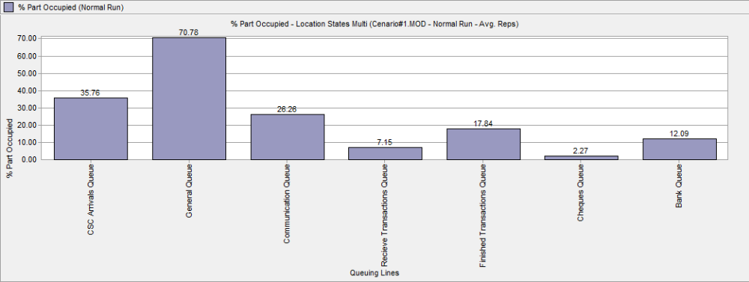

Fig 6.8: % Par occupied vs. Queuing Line

Results for Scenario Number two:
Achieved results from analyzing the first scenario can be summarized as:
- The average number of customers in the center queues varied between 0.0 and 3 customers which is very good especially when taking into consideration that the maximum average time required for each entry to be serviced is below 4.59 minutes.
- The maximum number of customer that may be in the center during the simulated period is 66 customers, and it is shown that the maximum number of customers in the queues was in the finished transactions queue which was 40 customers. So, it is clear that there is still a relatively large working load in the finished transactions stations in comparison to other stations, although we support it with an employee.
- All of the finished transactions employees' utilization number is about 38%, and for all of the remaining center employees the utilization number varied between 17% and 45%.
- The average time per customer in the system was 8.49 minutes and this number should be compared with the municipality required policy.

Scenario no. 3

In the next scenario we try to mitigate the damage from the receive transaction Unit and Support the Finished Transactions Unit at the same time.

Table 6.3: Mitigate the damage in the receive transactions unit by moving the slowest employee
Scenario No. |  |  |  |  | 3
Scenario Description |  |  |  |  | Mitigate the damage in the receive transactions unit by moving the slowest employee
General Information
Simulation Time (hr) |  |  |  |  | 1800
Number of Replications |  |  |  |  | 5
Warm-up Time (hr) |  |  |  |  | 100
Simulation Results
Locations Results
Location |  | Capacity | Total Entries |  |  |  | Avg. time /entry (min) |  | Avg. contents |  | Max. contents |  | Utilization (%)
CSC Arrival Queue |  | INF | 90520.2 |  |  |  | 0.57 |  | 0.48 |  | 13 |  | 0
General Queue |  | INF | 77996 |  |  |  | 2.9 |  | 2.09 |  | 69 |  | 0
Communication Queue |  | INF | 11791.8 |  |  |  | 4.02 |  | 0.44 |  | 10.4 |  | 0
Receive Transactions Queue |  | INF | 16307 |  |  |  | 0.55 |  | 0.08 |  | 12.4 |  | 0
Finished Transactions Queue |  | INF | 54391.2 |  |  |  | 0.71 |  | 0.36 |  | 35.6 |  | 0
Cheques Queue |  | INF | 3698.6 |  |  |  | 0.71 |  | 0.02 |  | 4.6 |  | 0
Bank Queue |  | INF | 10604.2 |  |  |  | 1.51 |  | 0.15 |  | 7.6 |  | 0
Zhoor |  | 1 | 14476 |  |  |  | 1.21 |  | 0.16 |  | 1 |  | 16.28
Sameh |  | 1 | 3598.2 |  |  |  | 8.88 |  | 0.3 |  | 1 |  | 29.6
Aisha |  | 1 | 5695.8 |  |  |  | 3.5 |  | 0.18 |  | 1 |  | 18.48
Sabha |  | 1 | 13521 |  |  |  | 2.99 |  | 0.37 |  | 1 |  | 37.37
Mohammad |  | 1 | 5355.8 |  |  |  | 4.21 |  | 0.21 |  | 1 |  | 20.89
Huda |  | 1 | 5256 |  |  |  | 4.54 |  | 0.22 |  | 1 |  | 22.10
Deema |  | 1 | 13596.6 |  |  |  | 2.95 |  | 0.37 |  | 1 |  | 37.15
Reem |  | 1 | 13753.2 |  |  |  | 2.9 |  | 0.37 |  | 1 |  | 36.91
Ghassan |  | 1 | 13530.2 |  |  |  | 2.99 |  | 0.37 |  | 1 |  | 37.45
Wafaa |  | 1 | 3698.6 |  |  |  | 1.62 |  | 0.06 |  | 1 |  | 5.53
Rasha |  | 1 | 10905 |  |  |  | 1.7 |  | 0.17 |  | 1 |  | 17.17
Asmaa |  | 1 | 10905 |  |  |  | 2.35 |  | 0.24 |  | 1 |  | 23.69
Saed |  | 1 | 11792 |  |  |  | 4.09 |  | 0.45 |  | 1 |  | 44.61
Queuing Lines Results
Name |  |  |  | Empty (%) |  |  |  |  |  | Partially Occupied (%)
CSC Arrival Queue |  |  |  | 64.18 |  |  |  |  |  | 35.83
General Queue |  |  |  | 29.10 |  |  |  |  |  | 70.90
Communication Queue |  |  |  | 73.8 |  |  |  |  |  | 26.20
Receive Transactions Queue |  |  |  | 93.22 |  |  |  |  |  | 6.78
Finished Transactions Queue |  |  |  | 82.07 |  |  |  |  |  | 17.93
Cheques Queue |  |  |  | 97.69 |  |  |  |  |  | 2.31
Bank Queue |  |  |  | 87.74 |  |  |  |  |  | 12.26
Processing Locations Results
Name |  |  |  | Operating Time (%) |  |  |  |  |  | Idle Time (%)
Zhoor |  |  |  | 16.28 |  |  |  |  |  | 83.72
Sameh |  |  |  | 29.6 |  |  |  |  |  | 70.40
Aisha |  |  |  | 18.48 |  |  |  |  |  | 81.52
Sabha |  |  |  | 37.36 |  |  |  |  |  | 62.64
Mohammad |  |  |  | 20.89 |  |  |  |  |  | 79.11
Huda |  |  |  | 22.10 |  |  |  |  |  | 77.9
Deema |  |  |  | 37.14 |  |  |  |  |  | 62.86
Reem |  |  |  | 36.91 |  |  |  |  |  | 63.09
Ghassan |  |  |  | 37.45 |  |  |  |  |  | 62.55
Wafaa |  |  |  | 5.53 |  |  |  |  |  | 94.47
Rasha |  |  |  | 17.17 |  |  |  |  |  | 82.83
Asmaa |  |  |  | 20.82 |  |  |  |  |  | 76.31
Saed |  |  |  | 44.61 |  |  |  |  |  | 55.39
Entity Results
Total Exits | Avg. Time in Sys. (min) |  |  |  |  | Avg. Time Waiting (min) |  | Avg. Time in Operation (min) |  |  |  | Avg. Time Blocked (min)
90520.4 | 8.47 |  |  |  |  | 1.44 |  | 6.46 |  |  |  | 056
in the following, the most important results for this scenario are graphically [Fig 6.9 - Fig 6.11]
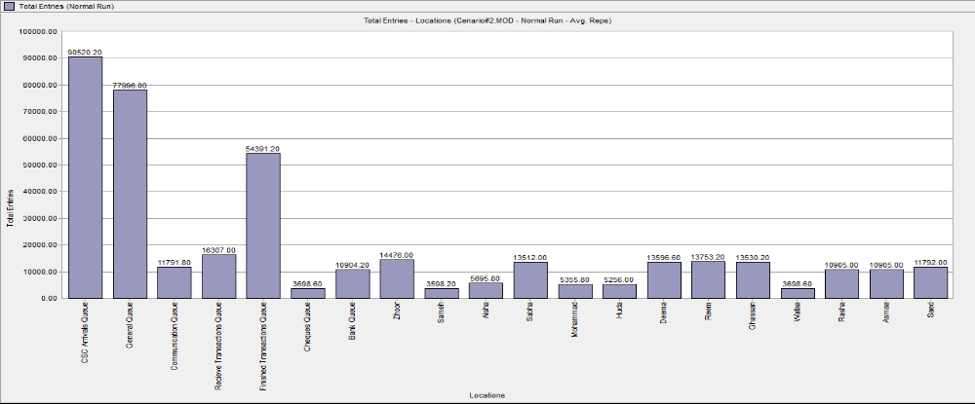

Fig 6.9: Total Entries vs. Locations

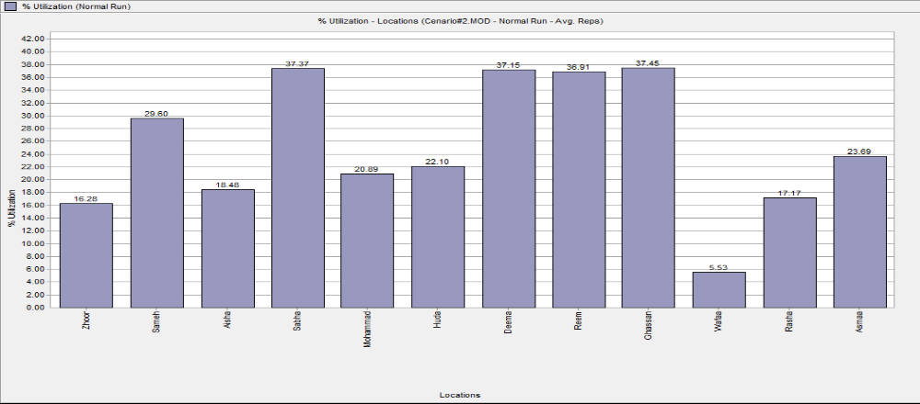

Fig 6.10: % Utilization vs. Locations

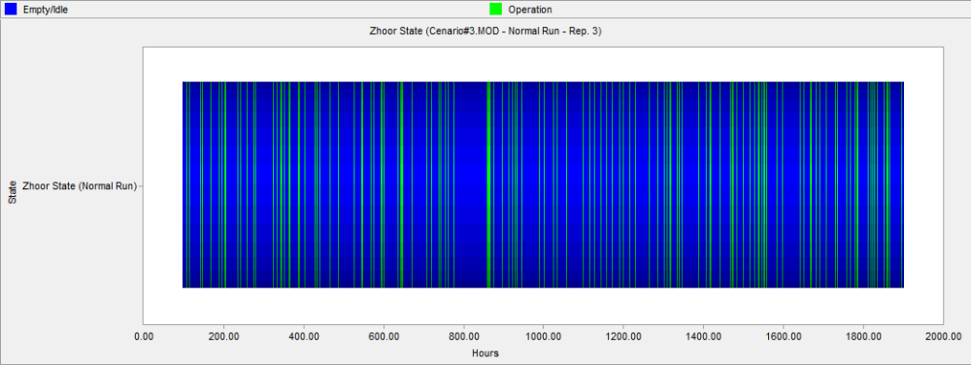

Fig 6.10.1: Zhoor state vs. Hours

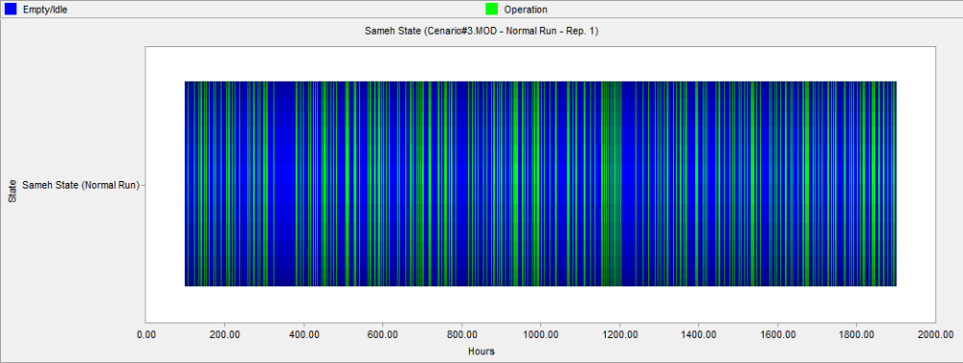

Fig 6.10.2: Sameh state vs. Hours

Fig 6.10.3: Aisha state vs. Hours

Fig 6.10.4: Sabha state vs. Hours

Fig 6.10.5: Mohammad state vs. Hours

Fig 6.10.6: Huda state vs. Hours

Fig 6.10.7: Deema state vs. Hours

Fig 6.10.8: Reem state vs. Hours

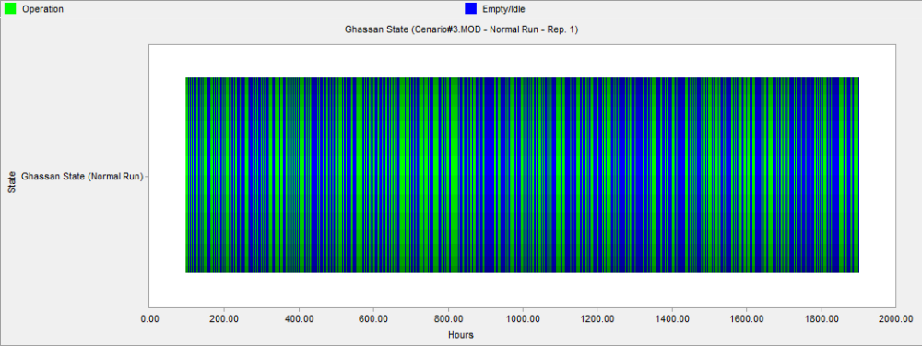

Fig 6.10.9: Ghassan state vs. Hours

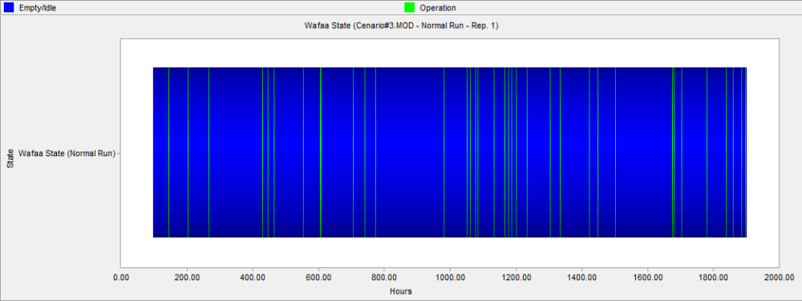

Fig 6.10.10: Wafaa state

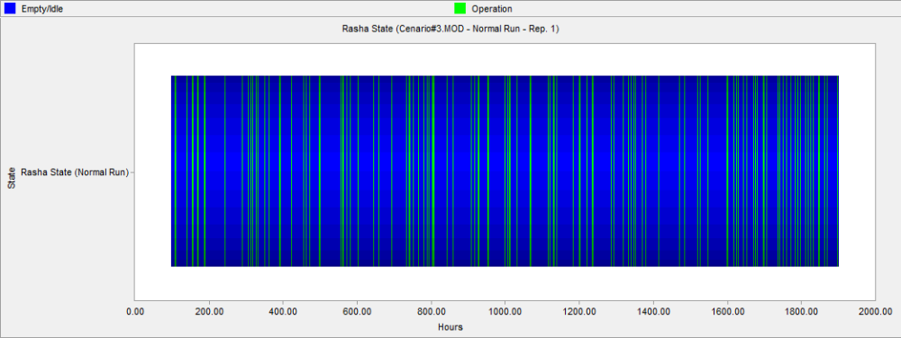

Fig 6.10.11: Rasha state vs. Hours

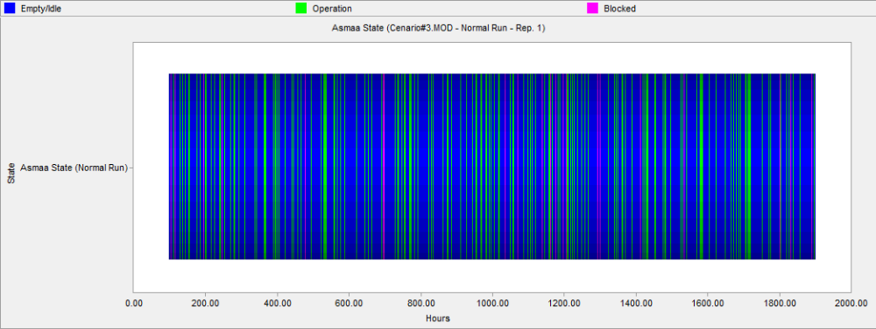

Fig 6.10.12: Asmaa state vs. Hours

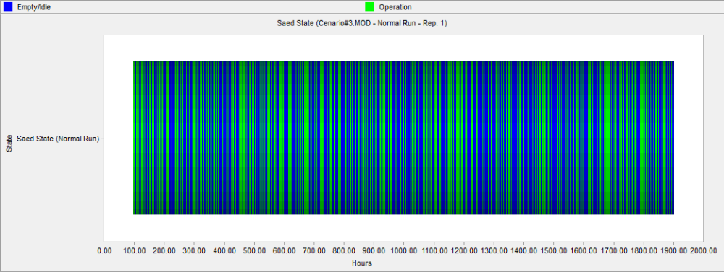

Fig 6.10.13: Saed state vs. Hours

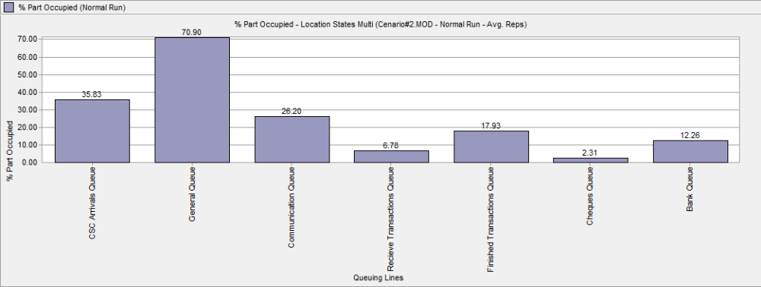

Fig 6.11:%par Occupied vs. Queuing Lines

Results for Scenario Number three:
Achieved results from analyzing the first scenario can be summarized as:
- The average number of customers in the center queues varied between 1 and 3 customers which is very good especially when taking into consideration that the maximum average time required for each entry to be serviced is below 4.54 minutes.
- The maximum number of customer that may be in the center during the simulated period is 69 customers, and it is shown that the maximum number of customers in the queues was in the finished transactions queue which was 36 customers. So, it is clear that there is still a relatively large working load in the finished transactions stations in comparison to other stations, although we support it with an employee.
- All of the finished transactions employees' utilization number is about 38%, and for all of the remaining center employees the utilization number varied between 6% and 45%.
- The average time per customer in the system was 8.47 minutes and this number should be compared with the municipality required policy.

Scenario no. 4

This scenario represented Receive Transactions Unit with two employees only
Table 6.4: Receive Transactions Unit with two employee only
Scenario No. |  |  |  |  | 4
Scenario Description |  |  |  |  | Transactions Unit with two employee only
General Information
Simulation Time (hr) |  |  |  |  | 1800
Number of Replications |  |  |  |  | 5
Warm-up Time (hr) |  |  |  |  | 100
Simulation Results
Locations Results
Location |  | Capacity | Total Entries |  |  |  | Avg. time /entry (min) |  | Avg. contents |  | Max. contents | Utilization (%)
CSC Arrival Queue |  | INF | 90605.2 |  |  |  | 0.57 |  | 0.48 |  | 13.8 | 0.00
General Queue |  | INF | 78175.0 |  |  |  | 2.90 |  | 2.10 |  | 69.4 | 0.00
Communication Queue |  | INF | 11726.8 |  |  |  | 4.03 |  | 0.44 |  | 11.0 | 0.00
Receive Transactions Queue |  | INF | 16445.4 |  |  |  | 1.03 |  | 0.16 |  | 14.8 | 0.00
Finished Transactions Queue |  | INF | 54473.6 |  |  |  | 1.42 |  | 0.72 |  | 42.2 | 0.00
Cheques Queue |  | INF | 3667.2 |  |  |  | 0.72 |  | 0.02 |  | 4.4 | 0.00
Bank Queue |  | INF | 10891.0 |  |  |  | 1.45 |  | 0.15 |  | 6.6 | 0.00
Zhoor |  | 1 | 14478.8 |  |  |  | 1.22 |  | 0.10 |  | 1.00 | 16.36
Sameh |  | 1 | 3587.2 |  |  |  | 8.95 |  | 0.30 |  | 1.00 | 29.71
Aisha |  | 1 | 8576.0 |  |  |  | 3.53 |  | 0.28 |  | 1.00 | 28.04
Mohammad |  | 1 | 7870.0 |  |  |  | 4.19 |  | 0.31 |  | 1.00 | 30.52
Deema |  | 1 | 18081.0 |  |  |  | 2.96 |  | 0.49 |  | 1.00 | 49.50
Reem |  | 1 | 18335.8 |  |  |  | 2.90 |  | 0.49 |  | 1.00 | 49.22
Ghassan |  | 1 | 18058.0 |  |  |  | 2.97 |  | 0.50 |  | 1.00 | 49.64
Wafaa |  | 1 | 3667.6 |  |  |  | 1.62 |  | 0.05 |  | 1.00 | 5.50
Rasha |  | 1 | 10890.6 |  |  |  | 1.69 |  | 0.17 |  | 1.00 | 17.02
Asmaa |  | 1 | 10891.0 |  |  |  | 2.33 |  | 0.24 |  | 1.00 | 23.51
Saed |  | 1 | 11726.6 |  |  |  | 4.10 |  | 0.45 |  | 1.00 | 44.54
Queuing Lines Results
Name |  |  |  | Empty (%) |  |  |  |  |  | Partially Occupied (%)
CSC Arrival Queue |  |  |  | 64.15 |  |  |  |  |  | 35.85
General Queue |  |  |  | 29.07 |  |  |  |  |  | 70.93
Communication Queue |  |  |  | 73.99 |  |  |  |  |  | 26.01
Receive Transactions Queue |  |  |  | 89.44 |  |  |  |  |  | 10.56
Finished Transactions Queue |  |  |  | 73.46 |  |  |  |  |  | 26.54
Cheques Queue |  |  |  | 97.70 |  |  |  |  |  | 2.30
Bank Queue |  |  |  | 87.92 |  |  |  |  |  | 12.08
Processing Locations Results
Name |  |  |  | Operating Time (%) |  |  |  |  |  | Idle Time (%)
Zhoor |  |  |  | 16.36 |  |  |  |  |  | 83.64
Sameh |  |  |  | 29.71 |  |  |  |  |  | 70.29
Aisha |  |  |  | 28.04 |  |  |  |  |  | 71.96
Mohammad |  |  |  | 30.52 |  |  |  |  |  | 69.48
Deema |  |  |  | 49.50 |  |  |  |  |  | 50.50
Reem |  |  |  | 49.22 |  |  |  |  |  | 50.78
Ghassan |  |  |  | 49.64 |  |  |  |  |  | 50.36
Wafaa |  |  |  | 5.50 |  |  |  |  |  | 94.50
Rasha |  |  |  | 17.02 |  |  |  |  |  | 82.98
Asmaa |  |  |  | 20.70 |  |  |  |  |  | 76.49
Saed |  |  |  | 44.52 |  |  |  |  |  | 55.46
Entity Results
Total Exits | Avg. Time in Sys. (min) |  |  |  |  | Avg. Time Waiting (min) |  | Avg. Time in Operation (min) |  |  | Avg. Time Blocked (min)
90603.0 | 8.93 |  |  |  |  | 1.79 |  | 6.42 |  |  | 0.72
In the following, the most important results for this scenario are graphically [Fig 6.12 - Fig 6.14]
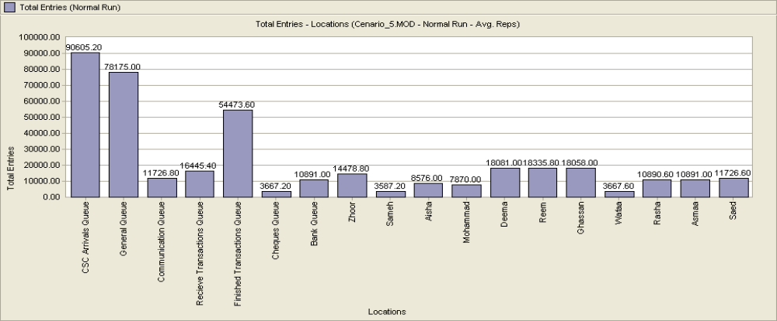

Fig 6.12: Total Entries vs. Locations

Fig 6.13:%Utilization vs. Locations

Fig 6.13.1: Zhoor status vs. Hours

Fig 6.13.2: Sameh state vs. Hours

Fig 6.13.3: Aisha state vs. Hours

Fig 6.13.4: Mhammad state vs. Hours

Fig 6.13.5: Deema state vs. Hours

Fig 6.13.6: Reem state vs. Hours

Fig 6.13.8:Wafaa state vs. Hours

Fig 6.13.7: Ghassan state vs. Hours

Fig 6.13.8: Wafaa state vs. Hours

Fig 6.13.11: Saed state vs. hours

Fig 6.13.9: Rasha state vs. Hours

Fig 6.13.10: Asmaa state vs. Hours

Fig 6.13.11: Saed state vs. Hours

Fig 6.14: %Part occupied vs. Queuing lines
Results for Scenario Number four:
Achieved results from analyzing the first scenario can be summarized as:
- The average number of customers in the center queues varied between 0.0 and 3 customers which is very good especially when taking into consideration that the maximum average time required for each entry to be serviced is below 4.19 minutes.
- The maximum number of customer that may be in the center during the simulated period is 70 customers, and it is shown that the maximum number of customers in the queues was in the finished transactions queue which was 42 customers. So, it is clear that there is still a relatively large working load in the finished transactions stations in comparison to other stations.
- All of the finished transactions employees' utilization number is about 50%, and for all of the remaining center employees the utilization number varied between 6% and 45%.
- The average time per customer in the system was 8.93 minutes and this number should be compared with the municipality required policy.

Scenario no. 5

The work pressure in CSC center increase in summer season by increasing of construction work, participation of water and electricity,…etc.
Table 6.5: Maximize Frequency (Arrival rate) = 0.596115
Scenario No. |  |  |  |  | 5
Scenario Description |  |  |  |  | Maximize Frequency(Arrival rate) = 0.596115
General Information
Simulation Time (hr) |  |  |  |  | 1800
Number of Replications |  |  |  |  | 5
Warm-up Time (hr) |  |  |  |  | 100
Simulation Results
Locations Results
Location |  | Capacity | Total Entries |  |  |  | Avg. time /entry (min) |  | Avg. contents |  | Max. contents |  | Utilization (%)
CSC Arrival Queue |  | INF | 181517.4 |  |  |  | 0.75 |  | 1.26 |  | 31.4 |  | 0
General Queue |  | INF | 156556.6 |  |  |  | 9.86 |  | 14.29 |  | 235 |  | 0
Communication Queue |  | INF | 23569.2 |  |  |  | 34.02 |  | 7.42 |  | 56.6 |  | 0
Receive Transactions Queue |  | INF | 32819.2 |  |  |  | 1.36 |  | 0.41 |  | 33.4 |  | 0
Finished Transactions Queue |  | INF | 109142.6 |  |  |  | 141.03 |  | 142.37 |  | 393.6 |  | 0
Cheques Queue |  | INF | 7415.8 |  |  |  | 1.18 |  | 0.08 |  | 9.8 |  | 0
Bank Queue |  | INF | 21858.0 |  |  |  | 3.32 |  | 0.67 |  | 12 |  | 0
Zhoor |  | 1 | 28912.4 |  |  |  | 1.22 |  | 0.33 |  | 1 |  | 32.61
Sameh |  | 1 | 7220.6 |  |  |  | 8.91 |  | 0.60 |  | 1 |  | 59.54
Aisha |  | 1 | 8965.0 |  |  |  | 3.51 |  | 0.29 |  | 1 |  | 29.17
Sabha |  | 1 | 7683.4 |  |  |  | 4.86 |  | 0.35 |  | 1 |  | 34.55
Mohammad |  | 1 | 8256.0 |  |  |  | 4.15 |  | 0.32 |  | 1 |  | 31.74
Huda |  | 1 | 7916.8 |  |  |  | 4.57 |  | 0.33 |  | 1 |  | 33.48
Deema |  | 1 | 36170.2 |  |  |  | 2.96 |  | 0.99 |  | 1 |  | 99.11
Reem |  | 1 | 36877.6 |  |  |  | 2.90 |  | 0.99 |  | 1 |  | 99.11
Ghassan |  | 1 | 35963.2 |  |  |  | 2.98 |  | 0.99 |  | 1 |  | 99.12
Wafaa |  | 1 | 7416.0 |  |  |  | 1.62 |  | 0.11 |  | 1 |  | 11.14
Rasha |  | 1 | 21856.4 |  |  |  | 1.69 |  | 0.34 |  | 1 |  | 34.15
Asmaa |  | 1 | 21857.2 |  |  |  | 2.56 |  | 0.52 |  | 1 |  | 51.76
Saed |  | 1 | 23558.0 |  |  |  | 4.09 |  | 0.89 |  | 1 |  | 89.13
Queuing Lines Results
Name |  |  |  | Empty (%) |  |  |  |  |  | Partially Occupied (%)
CSC Arrival Queue |  |  |  | 38.78 |  |  |  |  |  | 61.22
General Queue |  |  |  | 8.36 |  |  |  |  |  | 91.64
Communication Queue |  |  |  | 17.42 |  |  |  |  |  | 82.58
Receive Transactions Queue |  |  |  | 85.03 |  |  |  |  |  | 14.97
Finished Transactions Queue |  |  |  | 1.15 |  |  |  |  |  | 98.86
Cheques Queue |  |  |  | 94.7 |  |  |  |  |  | 5.93
Bank Queue |  |  |  | 63.96 |  |  |  |  |  | 36.04
Processing Locations Results
Name |  |  |  | Operating Time (%) |  |  |  |  |  | Idle Time (%)
Zhoor |  |  |  | 32.61 |  |  |  |  |  | 67.39
Sameh |  |  |  | 59.54 |  |  |  |  |  | 40.46
Aisha |  |  |  | 29.17 |  |  |  |  |  | 70.83
Sabha |  |  |  | 34.55 |  |  |  |  |  | 65.45
Mohammad |  |  |  | 31.74 |  |  |  |  |  | 68.26
Huda |  |  |  | 33.48 |  |  |  |  |  | 66.52
Deema |  |  |  | 99.11 |  |  |  |  |  | 0.89
Reem |  |  |  | 99.11 |  |  |  |  |  | 0.89
Ghassan |  |  |  | 99.12 |  |  |  |  |  | 0.88
Wafaa |  |  |  | 11.14 |  |  |  |  |  | 88.86
Rasha |  |  |  | 34.15 |  |  |  |  |  | 56.85
Asmaa |  |  |  | 41.92 |  |  |  |  |  | 48.23
Saed |  |  |  | 89.13 |  |  |  |  |  | 10.87
Entity Results
Total Exits | Avg. Time in Sys. (min) |  |  |  |  | Avg. Time Waiting (min) |  | Avg. Time in Operation (min) |  |  |  | Avg. Time Blocked (min)
181444.6 | 103.4 |  |  |  |  | 95.3 |  | 6.49 |  |  |  | 1.16

In the following, the most important results for this scenario are graphically [Fig 6.15 - Fig 6.17]

Fig 6.15: Total Entries vs. Locations

Fig 6.16: Total Entries vs. Locations

Fig 6.16.1: Sameh state vs. Hours

Fig 6.16.2: Aisha state vs. Hours

Fig 6.16.3: Sabha state vs. Hours

Fig 6.16.4: Mohammad state vs. Hours

Fig 6.16.5: Huda state vs. Hours

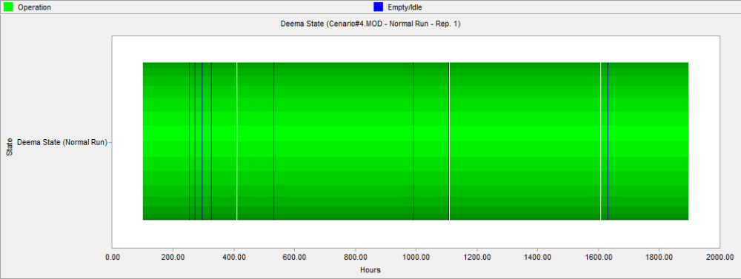

Fi

Fig 6.16.6: Deema state vs. Hours

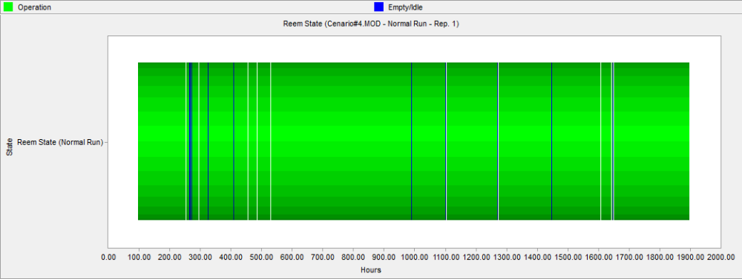

Fig 6.16.7: Reem State vs. Hours

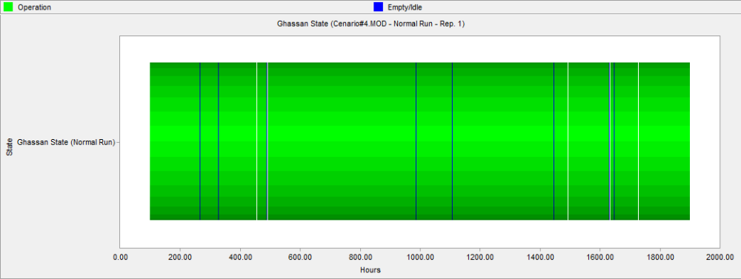

Fig 6.16.8: Ghassan state vs. Hours

Fig 6.16.9: Rasha state vs. Hours

Fig 6.16.10: Wafaa state vs. Hours

Fig.6.16.11: Asmaa state vs. Hours

Fig 6.16.12:Saed State vs. Hours

Fig 6.17:%par Occupied vs. Queuing Line

Results for Scenario Number five:
Achieved results from analyzing the first scenario can be summarized as:
- The average number of customers in the center queues varied between 2 and 143, and the maximum average time required for each entry to be serviced is below 4.86 minutes.
- The maximum number of customer that may be in the center during the simulated period is 394 customers, and it is shown that the maximum number of customers in the queues was in the finished transactions queue which was 235 customers. So, it is clear that there is still a relatively large working load in the finished transactions stations in comparison to other stations.
- All of the finished transactions employees' utilization number is about 100%, and for all of the remaining center employees the utilization number varied between 12% and 90%.
- The average time per customer in the system was 103.4 minutes and this number should be compared with the municipality required policy.

Scenario no. 6

Here we try to mitigate the work pressure due to doubling the arrival rate
Table 6.6: Maximize Frequency (Arrival rate) = 0.596115, and support the finished unit with 2 employee
Scenario No. |  |  |  |  | 6
Scenario Description |  |  |  |  | - Maximize Frequency(Arrival rate) = 0.596115  - Supporting Finished Transactions Unit with two employee  - Supporting communication Unit with an employee
General Information
Simulation Time (hr) |  |  |  |  | 1800
Number of Replications |  |  |  |  | 5
Warm-up Time (hr) |  |  |  |  | 100
Simulation Results
Locations Results
Location |  | Capacity | Total Entries |  |  |  | Avg. time /entry (min) |  | Avg. contents |  | Max. contents |  | Utilization (%)
CSC Arrival Queue |  | INF | 180806 |  |  |  | 0.75 |  | 1.26 |  | 33.6 |  | 0
General Queue |  | INF | 155808.2 |  |  |  | 9.41 |  | 12.58 |  | 223.2 |  | 0
Communication Queue |  | INF | 23550 |  |  |  | 1.80 |  | 0.39 |  | 11.6 |  | 0
Receive Transactions Queue |  | INF | 32708 |  |  |  | 1.84 |  | 0.59 |  | 30.40 |  | 0
Finished Transactions Queue |  | INF | 115885.6 |  |  |  | 2.89 |  | 3.10 |  | 104.4 |  | 0
Bank Queue |  | INF | 23031.4 |  |  |  | 6.14 |  | 1.31 |  | 22.2 |  | 0
Zhoor |  | 1 | 28848.4 |  |  |  | 1.22 |  | 0.33 |  | 1 |  | 32.52
Sameh |  | 1 | 7221.4 |  |  |  | 8.83 |  | 0.59 |  | 1 |  | 59.04
Aisha |  | 1 | 23175 |  |  |  | 2.30 |  | 0.49 |  | 1 |  | 49.29
Sabha |  | 1 | 10929 |  |  |  | 3.51 |  | 0.36 |  | 1 |  | 35.56
Mohammad |  | 1 | 10910.4 |  |  |  | 3.53 |  | 0.36 |  | 1 |  | 35.68
Huda |  | 1 | 10869.6 |  |  |  | 3.54 |  | 0.36 |  | 1 |  | 35.60
Deema |  | 1 | 23190.6 |  |  |  | 2.3 |  | 0.49 |  | 1 |  | 49.45
Reem |  | 1 | 23226 |  |  |  | 2.29 |  | 0.49 |  | 1 |  | 49.21
Ghassan |  | 1 | 23155.6 |  |  |  | 2.30 |  | 0.49 |  | 1 |  | 49.39
Wafaa |  | 1 | 23142 |  |  |  | 2.30 |  | 0.49 |  | 1 |  | 49.34
Rasha |  | 1 | 23031.2 |  |  |  | 1.69 |  | 0.36 |  | 1 |  | 36.09
Asmaa |  | 1 | 23031.4 |  |  |  | 2.63 |  | 0.56 |  | 1 |  | 56.04
Saed |  | 1 | 11793.9 |  |  |  | 4.08 |  | 0.45 |  | 1 |  | 44.51
XYZ |  | 1 | 11757.6 |  |  |  | 4.09 |  | 0.45 |  | 1 |  | 44.56
Queuing Lines Results
Name |  |  |  | Empty (%) |  |  |  |  |  | Partially Occupied (%)
CSC Arrival Queue |  |  |  | 38.89 |  |  |  |  |  | 61.11
General Queue |  |  |  | 8.53 |  |  |  |  |  | 91.46
Communication Queue |  |  |  | 74.59 |  |  |  |  |  | 25.41
Receive Transactions Queue |  |  |  | 81.57 |  |  |  |  |  | 18.43
Finished Transactions Queue |  |  |  | 63.63 |  |  |  |  |  | 36.37
Bank Queue |  |  |  | 55.99 |  |  |  |  |  | 44.01
Processing Locations Results
Name |  |  |  | Operating Time (%) |  |  |  |  |  | Idle Time (%)
Zhoor |  |  |  | 32.52 |  |  |  |  |  | 67.48
Sameh |  |  |  | 59.04 |  |  |  |  |  | 40.96
Aisha |  |  |  | 49.29 |  |  |  |  |  | 50.71
Sabha |  |  |  | 35.56 |  |  |  |  |  | 64.44
Mohammad |  |  |  | 35.68 |  |  |  |  |  | 64.32
Huda |  |  |  | 35.60 |  |  |  |  |  | 64.40
Deema |  |  |  | 49.45 |  |  |  |  |  | 50.55
Reem |  |  |  | 49.21 |  |  |  |  |  | 50.79
Ghassan |  |  |  | 49.39 |  |  |  |  |  | 50.61
Wafaa |  |  |  | 49.34 |  |  |  |  |  | 50.66
Rasha |  |  |  | 36.09 |  |  |  |  |  | 63.91
Asmaa |  |  |  | 43.86 |  |  |  |  |  | 43.96
Saed |  |  |  | 44.51 |  |  |  |  |  | 55.49
XYZ |  |  |  | 44.56 |  |  |  |  |  | 55.44
Entity Results
Total Exits | Avg. Time in Sys. (min) |  |  |  |  | Avg. Time Waiting (min) |  | Avg. Time in Operation (min) |  |  |  | Avg. Time Blocked (min)
180820 | 15.8 |  |  |  |  | 8.95 |  | 6.02 |  |  |  | 0.83

In the following, the most important results for this scenario are graphically [Fig 6.18 - Fig 6.20]

Fig 6.18: Total Entries vs. Locations

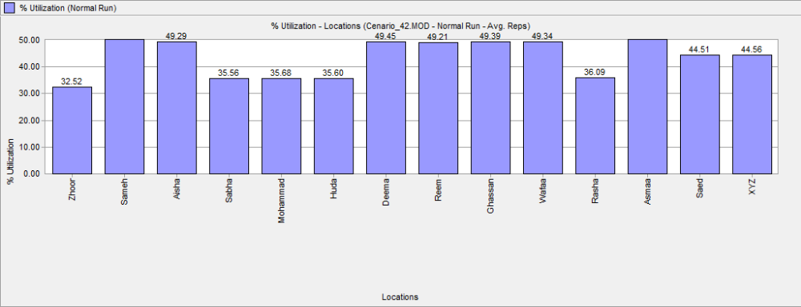

Fig 6.19.3:Sabha state vs.Hours

Fig 6.19: % Utilization vs. Locations

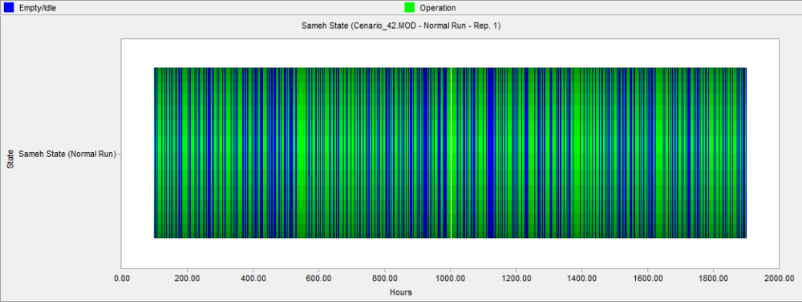

Fig 6.19.1: Sameh state vs. Hours

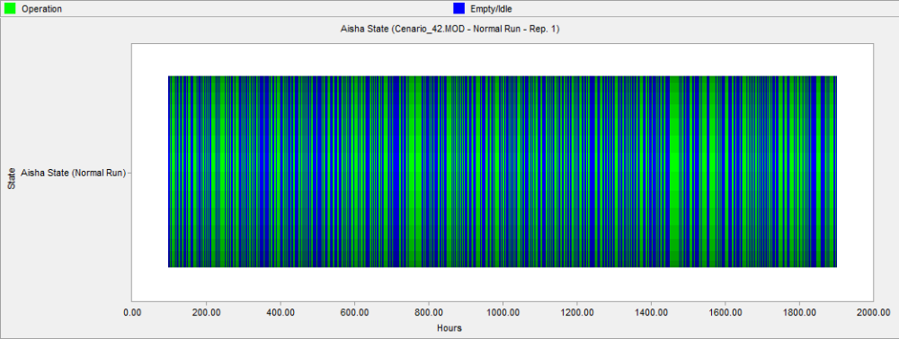

Fig 6.19.2: Aisha state vs. Hours

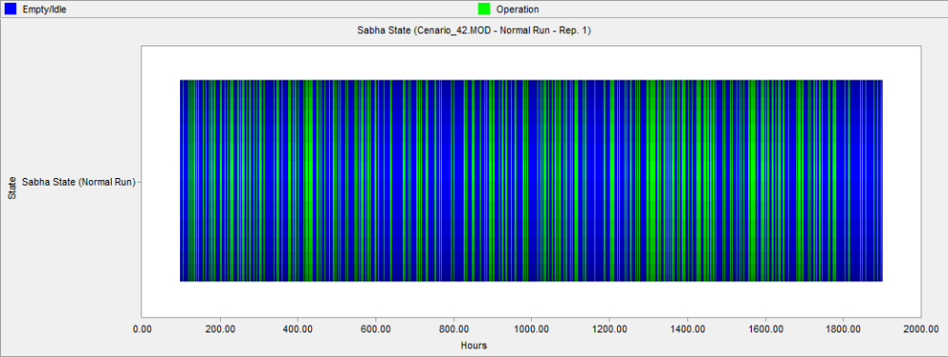

Fig 6.19.3: Sabha state vs. Hours

Fig 6.19.4: Huda state vs. Hours

Fig 6.19.5: Mohammad state vs. Hours

Fig 6.19.6: Deema state vs. Hours

Fig 6.19.7: Reem state vs. Hours

Fig 6.19.8: Ghassan state vs. Hours

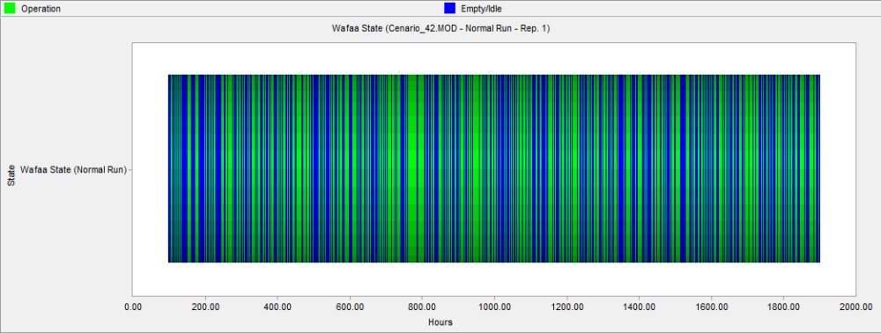

Fig 6.19.9: Wafaa state vs. Hours

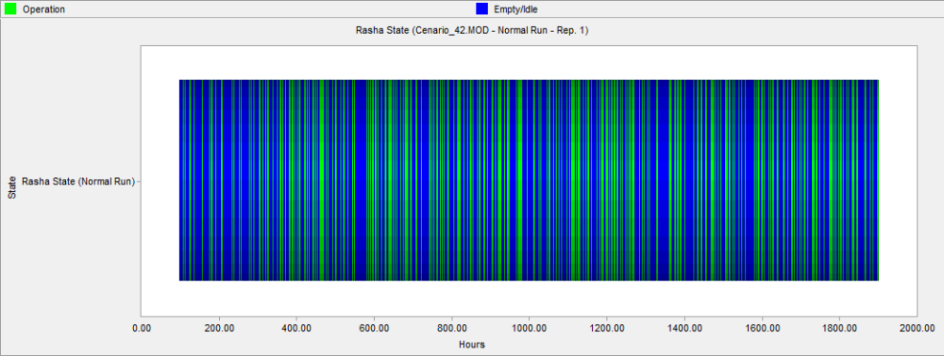

Fig 6.19.10: Rasha state vs. Hours

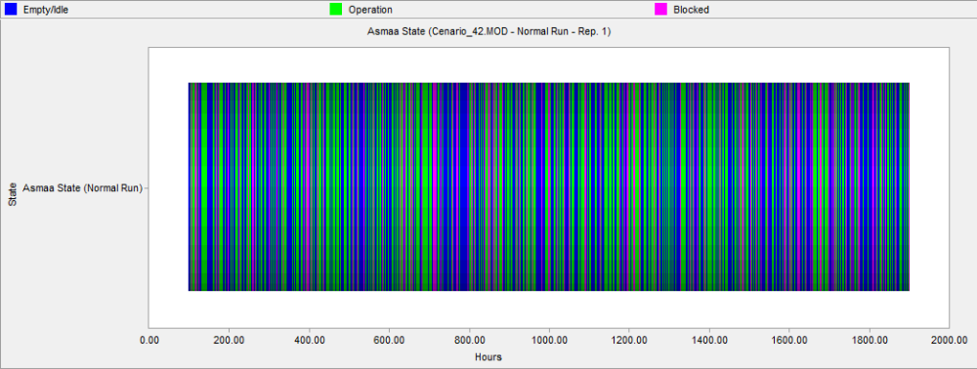

Fig 6.19.11: Asmaa state vs. Hours

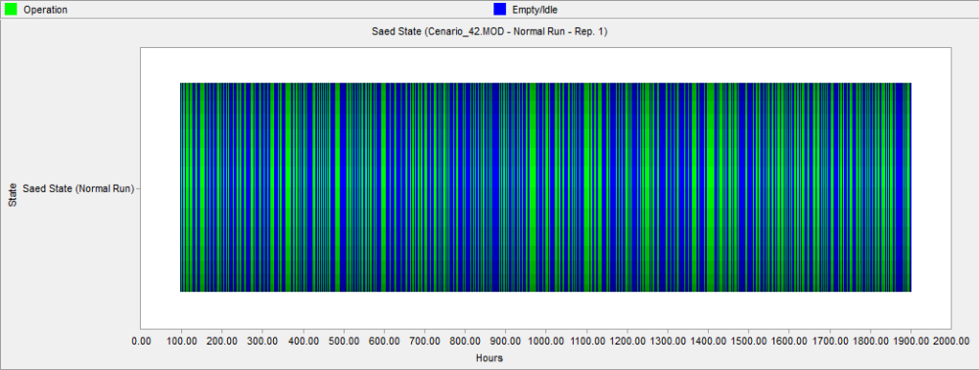

Fig 6.19.12: Saed state vs. Hours

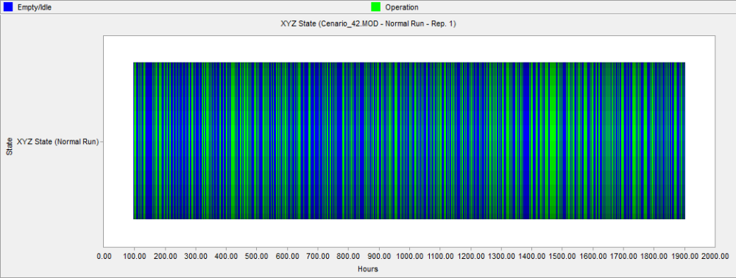

Fig 6.19.13: XYZ state vs. Hours

Fig 6.20: %part occupied vs. Queuing lines

Results for Scenario Number six:

Achieved results from analyzing the first scenario can be summarized as:
- The average number of customers in the center queues varied between 2 and 13, and the maximum average time required for each entry to be serviced is below 4.09 minutes.
- The maximum number of customer that may be in the center during the simulated period is 224 customers, and it is shown that the maximum number of customers in the queues was in the finished transactions queue which was 105 customers. So, it is clear that there is still a relatively large working load in the finished transactions stations in comparison to other stations.
- All of the finished transactions employees' utilization number is about 50%, and for all of the remaining center employees the utilization number varied between 33% and 60%.
- The average time per customer in the system was 15.8 minutes and this number should be compared with the municipality required policy.

6.4 Recommendations

Achieved recommendations from analyzing the scenarios result's can be summarized as:

- Discrete event simulation should be used in the design phase for all municipality new services in order to save money, effort and time.
- Nablus municipality exiting systems should be modeled and simulated in order to choose best developmental alternatives.
- This project should be expanded in future to include different aspects in the municipality.
- It is clear from seeing the first four scenarios results, mainly the utilization, that the center employees work load is relatively low, so that we to improve new municipality services quality by adding it to the center.
- In the current situation scenario, it is clear that the work load in the finished transactions is high in comparison to the work load in the receive transactions stations, so we recommend to choose one of the receive transactions employees, mostly the one who is occupying the station near finished transactions stations and to transform him to a mix employee, which means that if the work load in the receive transactions is high he will work as a receive transaction employee, and if the work load is higher in the finished transaction he can work as a finished transactions employee, in this way we can reduce the utilization and queue length in the finished transactions stations. But of course the recommendation should be controlled by a clear and rational policy, because we don't want him to work all of his day continuously, so he may start supporting the finished transactions employee if the number of customers in their queue exceeded specific number.
- It is clear from the 5th scenario results that there is a problem in the average number of customers in the system and average waiting time in the system in the peak intervals during summer, so we recommend the center to corporate with the municipality information technology department to put creative solutions aiming to reduce the required time for every customer especially in the most frequent services.

References

- Barry Render, Ralph M. Stair, Jr, Quantitative Analysis for Management, sixth edition.
- Charles Harrell, Biman K. Ghosh, Project Leader, Royce O. Boeden, Simulation Using ProModel, second edition, 2004, McGraw-Hill.
- Computer-based Simulation Modeling for Anthropologists. Simulation: Introduction. Available at (http://www.era.anthropology.ac.uk/Simulate/simintro.html), access date: Oct.15, 2010.
- Customer Service Center. Available at (http://www.nablus.org/en/content.php?id_itemcontent=257), access date: April.13, 2010.
- Dan Power, Types of Decision Support System. Available at (http://www.gdrc.org/decision/dss-types.html), access date: Jan.5, 2010.
- Discrete-Event Simulation. Available at (http://www.win.tue.nl/~resing/2S540/week2.pdf), access date: Dec.31, 2009.
- Jay Heizer, Barry Render, OPERATIONS MANAGEMENT, sixth edition, 2001.
- Monte Carlo Simulation. Available at (http://www.vertex42.com/ExcelArticles/mc/MonteCarloSimulation.html), access date: Oct.2, 2009.
- OPERATIONS RESEARCH, THE SIENCE OF BETTER. Available at: (http://www.scienceofbetter.org/what/index.htm), access date: Dec.28, 2009.
- ProModel. ProModel Optimization Software Suit. Available at: (http://www.promodel.com/products/promodel/), access date: Feb.15, 2010.
- Queuing Theory. Limitations. Available at (http://works.bepress.com/cgi/viewcontent.cgi?article=1012&context=vikas_singh), access date: Nov.25, 2009.
- What is Queuing Theory? Available at (http://www.wisegeek.com/what-is-queueing-theory.htm), access date: Nov.25, 2009.
- Wikipedia the free encyclopedia. Discrete Event Simulation. Available at (http://en.wikipedia.org/wiki/Discrete_event_simulation), access date: Dec.31, 2009.
- Wikipedia the free encyclopedia. Queuing Theory. Available at (http://en.wikipedia.org/wiki/Queueing_theory), access date: Nov.25, 2009.

Appendices

Appendix A
Collected Data / Raw Data for Arrival rate

Appendix A Collected Data / Raw Data for Arrival rate

Arrival Rate

Table A.1: Arrival Rate Data (in minutes)

Arrival Rate
00:05 | 09:05 | 00:01 | 10:00 | 00:01 | 00:02 | 00:01 | 00:00 | 00:00 | 00:00 | 00:01 | 00:02 | 00:04
00:03 | 00:01 | 00:00 | 00:00 | 00:01 | 00:01 | 00:00 | 00:04 | 00:01 | 00:00 | 00:02 | 00:00 | 00:00
00:03 | 00:00 | 00:02 | 00:00 | 00:00 | 00:01 | 00:00 | 00:00 | 00:00 | 00:07 | 00:00 | 00:00 | 00:03
00:07 | 00:02 | 00:02 | 00:01 | 00:02 | 00:03 | 00:00 | 00:02 | 00:02 | 00:03 | 00:02 | 00:00 | 00:01
00:04 | 00:00 | 00:01 | 00:02 | 00:01 | 00:05 | 00:00 | 00:01 | 00:04 | 00:01 | 00:01 | 00:04 | 00:01
00:05 | 00:02 | 00:03 | 00:01 | 00:02 | 00:00 | 00:01 | 00:06 | 00:01 | 00:01 | 00:00 | 00:00 | 00:01
00:03 | 00:06 | 00:03 | 00:00 | 00:00 | 00:01 | 00:00 | 00:01 | 00:01 | 00:01 | 00:00 | 00:01 | 00:01
00:04 | 00:01 | 00:00 | 00:00 | 00:00 | 00:00 | 00:00 | 00:02 | 00:03 | 00:01 | 00:01 | 00:00 | 00:03
00:01 | 00:01 | 00:02 | 00:02 | 00:03 | 00:01 | 00:01 | 00:03 | 00:03 | 00:00 | 00:00 | 00:01 | 00:02
00:01 | 00:00 | 00:01 | 00:00 | 00:00 | 00:02 | 00:01 | 00:00 | 00:02 | 00:00 | 00:01 | 00:00 | 00:01
00:07 | 00:00 | 00:00 | 00:02 | 00:01 | 00:01 | 00:01 | 00:01 | 00:01 | 00:01 | 00:00 | 00:03 | 00:00
00:01 | 00:01 | 00:01 | 00:03 | 00:01 | 00:06 | 00:02 | 00:01 | 00:01 | 00:00 | 00:01 | 00:01 | 00:04
00:01 | 00:01 | 00:06 | 00:02 | 00:01 | 00:01 | 00:00 | 00:02 | 00:02 | 00:01 | 00:01 | 00:04 | 00:01
00:01 | 00:00 | 00:00 | 00:01 | 00:00 | 00:00 | 00:01 | 00:00 | 00:01 | 00:03 | 00:00 | 00:00 | 00:03
00:01 | 00:04 | 00:01 | 00:00 | 00:02 | 00:01 | 00:00 | 00:01 | 00:00 | 00:00 | 00:00 | 00:00 | 00:02
00:01 | 00:01 | 00:01 | 00:02 | 00:00 | 00:00 | 00:00 | 00:00 | 00:01 | 00:02 | 00:02 | 00:00 | 00:00
00:05 | 00:01 | 00:00 | 00:01 | 00:01 | 00:00 | 00:01 | 00:00 | 00:00 | 00:01 | 00:01 | 00:02 | 00:02
00:08 | 00:07 | 00:00 | 00:01 | 00:01 | 00:01 | 00:01 | 00:01 | 00:01 | 00:00 | 00:00 | 00:02 | 00:03
00:01 | 00:01 | 00:02 | 00:00 | 00:00 | 00:02 | 00:01 | 00:00 | 00:02 | 00:01 | 00:02 | 00:03 | 00:03
00:02 | 00:00 | 00:02 | 00:01 | 00:01 | 00:01 | 00:00 | 00:00 | 00:01 | 00:01 | 00:00 | 00:02 | 00:04
00:01 | 00:01 | 00:01 | 00:01 | 00:03 | 00:06 | 00:00 | 00:00 | 00:00 | 00:00 | 00:00 | 00:01 | 00:01
00:09 | 00:00 | 00:00 | 00:01 | 00:02 | 00:01 | 00:00 | 00:01 | 00:00 | 00:00 | 00:02 | 00:03 | 00:01
00:03 | 00:02 | 00:01 | 00:01 | 00:01 | 00:00 | 00:03 | 00:00 | 00:01 | 00:01 | 00:00 | 00:02 | 00:04
00:02 | 00:01 | 00:00 | 00:00 | 00:01 | 00:01 | 00:00 | 00:01 | 00:00 | 00:01 | 00:00 | 00:00 | 00:01
00:01 | 00:02 | 00:04 | 00:00 | 00:01 | 00:00 | 00:00 | 00:00 | 00:00 | 00:00 | 00:00 | 00:02 | 00:01
00:03 | 00:00 | 00:01 | 00:03 | 00:01 | 00:02 | 00:00 | 00:00 | 00:02 | 00:01 | 00:02 | 00:03 | 00:04
00:03 | 00:01 | 00:00 | 00:00 | 00:03 | 00:00 | 00:02 | 00:01 | 00:00 | 00:02 | 00:00 | 00:00 | 00:00
00:01 | 00:00 | 00:02 | 00:00 | 00:00 | 00:02 | 00:00 | 00:00 | 00:03 | 00:01 | 00:02 | 00:01 | 00:01
00:01 | 00:04 | 00:01 | 00:03 | 00:01 | 00:04 | 00:05 | 00:00 | 00:01 | 00:00 | 00:01 | 00:00 | 00:03
00:00 | 00:01 | 00:02 | 10:00 | 00:02 | 00:03 | 00:00 | 00:01 | 00:00 | 00:00 | 00:00 | 00:01 | 00:00
00:00 | 00:01 | 00:00 | 00:00 | 00:00 | 00:01 | 00:00 | 00:02 | 00:02 | 00:02 | 00:00 | 00:04 | 00:01
00:00 | 00:02 | 00:00 | 00:01 | 00:00 | 00:00 | 00:01 | 00:01 | 00:01 | 00:01 | 00:04 | 00:02 | 00:00
00:01 | 00:00 | 00:02 | 00:01 | 00:02 | 00:04 | 00:02 | 00:00 | 00:01 | 00:00 | 00:00 | 00:01 | 00:00
00:01 | 00:00 | 00:01 | 00:01 | 00:00 | 00:02 | 00:01 | 00:02 | 00:02 | 00:02 | 00:01 | 00:04 | 00:01
00:01 | 00:03 | 00:00 | 00:00 | 00:00 | 00:01 | 00:01 | 00:00 | 00:00 | 00:02 | 00:02 | 00:02 | 00:02
00:00 | 00:01 | 00:01 | 00:00 | 00:05 | 00:01 | 00:00 | 00:00 | 00:01 | 00:01 | 00:02 | 00:01 | 00:01
00:01 | 00:00 | 00:00 | 00:01 | 00:00 | 00:01 | 00:01 | 00:00 | 00:02 | 00:00 | 00:02 | 00:02 | 00:00
00:01 | 00:04 | 00:00 | 00:00 | 00:01 | 00:00 | 00:00 | 00:03 | 00:03 | 00:01 | 00:00 | 00:01 | 00:02

Arrival Rate
00:01 | 00:01 | 00:00 | 00:00 | 00:00 | 00:01 | 00:01 | 00:01 | 00:02 | 00:01 | 00:05 | 00:01 | 00:00
00:00 | 00:01 | 00:01 | 00:01 | 00:02 | 00:01 | 00:01 | 00:02 | 00:00 | 00:01 | 00:00 | 00:00 | 00:00
00:01 | 09:03 | 00:00 | 00:03 | 00:00 | 00:03 | 00:01 | 00:02 | 00:00 | 00:01 | 00:01 | 00:01 | 00:00
00:04 | 00:00 | 00:01 | 00:00 | 00:00 | 00:00 | 00:01 | 00:00 | 00:01 | 00:00 | 00:00 | 00:01 | 00:03
00:02 | 00:02 | 00:01 | 00:01 | 00:02 | 00:01 | 00:01 | 00:03 | 00:01 | 00:01 | 00:04 | 00:01 | 00:01
00:04 | 00:00 | 00:06 | 00:01 | 00:01 | 00:00 | 00:03 | 00:01 | 00:00 | 00:02 | 00:02 | 00:01 | 00:02
00:03 | 00:01 | 00:00 | 00:02 | 00:00 | 00:00 | 00:00 | 00:00 | 00:00 | 00:01 | 00:02 | 00:02 | 00:02
00:00 | 00:02 | 00:01 | 00:00 | 00:01 | 00:01 | 00:01 | 00:01 | 00:01 | 00:02 | 00:00 | 00:00 | 00:00
00:01 | 00:01 | 00:03 | 00:02 | 00:02 | 00:03 | 00:00 | 00:02 | 00:01 | 00:02 | 00:00 | 00:00 | 00:03
00:05 | 00:00 | 00:00 | 00:00 | 00:00 | 00:00 | 00:01 | 00:00 | 00:00 | 00:06 | 00:00 | 00:00 | 00:01
00:01 | 00:01 | 00:00 | 00:01 | 00:01 | 00:00 | 00:01 | 00:01 | 00:00 | 00:00 | 00:01 | 00:03 | 00:00
00:00 | 00:00 | 00:02 | 00:01 | 00:01 | 00:02 | 00:01 | 00:01 | 00:00 | 00:01 | 00:00 | 00:01 | 00:01
00:01 | 00:01 | 00:00 | 00:00 | 00:00 | 00:01 | 00:01 | 00:01 | 00:02 | 00:02 | 00:01 | 00:00 | 00:02
00:00 | 00:01 | 00:01 | 00:00 | 00:01 | 00:01 | 00:03 | 00:00 | 00:04 | 00:02 | 00:01 | 00:01 | 00:00
00:06 | 00:02 | 00:01 | 00:02 | 00:01 | 00:03 | 00:01 | 00:00 | 00:00 | 00:00 | 00:01 | 00:01 | 00:01
00:02 | 00:00 | 00:03 | 00:03 | 00:04 | 00:00 | 00:00 | 00:00 | 00:00 | 00:01 | 00:00 | 00:01 | 00:01
00:01 | 00:00 | 00:00 | 00:01 | 00:00 | 00:00 | 00:01 | 00:01 | 00:00 | 00:00 | 00:01 | 00:00 | 00:01
00:01 | 00:01 | 00:01 | 00:01 | 00:03 | 00:01 | 00:00 | 00:00 | 00:04 | 00:01 | 00:01 | 00:00 | 00:00
00:02 | 00:00 | 00:00 | 00:01 | 00:00 | 00:03 | 00:00 | 00:00 | 00:01 | 00:01 | 00:01 | 00:02 | 00:00
00:02 | 00:00 | 00:00 | 00:00 | 00:00 | 00:02 | 00:01 | 00:02 | 00:02 | 00:01 | 00:02 | 00:00 | 00:00
00:02 | 00:01 | 00:01 | 10:00 | 00:03 | 00:00 | 00:00 | 00:02 | 00:00 | 00:00 | 00:03 | 00:05 | 00:01
00:01 | 00:02 | 00:02 | 00:00 | 00:00 | 00:03 | 00:00 | 00:01 | 00:02 | 00:02 | 00:02 | 00:00 | 00:00
00:01 | 00:02 | 00:00 | 00:01 | 00:00 | 00:01 | 00:00 | 00:02 | 00:01 | 00:00 | 00:00 | 00:01 | 00:02
00:01 | 00:01 | 00:02 | 00:01 | 00:02 | 00:00 | 00:01 | 00:01 | 00:00 | 00:01 | 00:06 | 00:01 | 00:01
00:01 | 00:00 | 00:00 | 00:01 | 00:00 | 00:00 | 00:02 | 00:00 | 00:03 | 00:01 | 00:00 | 00:01 | 00:00
00:01 | 00:01 | 00:01 | 00:00 | 00:01 | 00:00 | 00:02 | 00:00 | 00:04 | 00:01 | 00:01 | 00:02 | 00:03
00:04 | 00:00 | 00:00 | 00:00 | 00:02 | 00:00 | 00:00 | 00:01 | 00:01 | 00:00 | 00:00 | 00:02 | 00:04
00:03 | 00:01 | 00:01 | 00:01 | 00:01 | 00:01 | 00:00 | 00:00 | 00:01 | 00:00 | 00:01 | 00:00 | 00:01
00:00 | 00:01 | 00:00 | 00:00 | 00:03 | 00:00 | 00:01 | 00:00 | 00:03 | 00:01 | 00:02 | 00:03 | 00:01
00:00 | 00:01 | 00:02 | 00:00 | 00:01 | 00:01 | 00:00 | 00:00 | 00:01 | 00:01 | 00:01 | 00:02 | 00:03
00:14 | 00:02 | 00:02 | 00:01 | 00:00 | 00:01 | 00:01 | 00:00 | 00:03 | 00:00 | 00:02 | 00:01 | 00:01
00:03 | 00:01 | 00:02 | 00:03 | 00:01 | 00:03 | 00:01 | 00:06 | 00:01 | 00:01 | 00:00 | 00:01 | 00:03
00:06 | 00:00 | 00:02 | 00:00 | 00:00 | 00:00 | 00:00 | 00:00 | 00:00 | 00:01 | 00:02 | 00:01 | 00:01
00:01 | 00:00 | 00:01 | 00:01 | 00:00 | 00:01 | 00:02 | 00:00 | 00:02 | 00:01 | 00:01 | 00:00 | 00:00
00:01 | 00:00 | 00:01 | 00:01 | 00:01 | 00:00 | 00:01 | 00:02 | 00:02 | 00:00 | 00:01 | 00:02 | 00:02
00:01 | 00:00 | 00:02 | 00:02 | 00:00 | 00:00 | 00:00 | 00:00 | 00:02 | 00:01 | 00:01 | 00:02 | 00:02
00:03 | 00:02 | 00:01 | 00:00 | 00:02 | 00:01 | 00:01 | 00:01 | 00:00 | 00:00 | 00:01 | 00:00 | 00:02
00:00 | 00:02 | 00:01 | 00:02 | 00:00 | 00:02 | 00:05 | 00:03 | 00:02 | 00:04 | 00:00 | 00:00 | 00:00

Arrival Rate
00:03 | 00:00 | 00:02 | 00:00 | 00:01 | 00:00 | 00:01 | 00:00 | 00:04 | 00:00 | 00:00 | 00:00 | 00:02
00:01 | 00:00 | 00:01 | 00:01 | 00:00 | 00:02 | 00:00 | 00:04 | 00:01 | 00:03 | 00:02 | 00:01 | 00:04
00:02 | 00:01 | 00:02 | 00:01 | 00:00 | 00:00 | 00:06 | 00:01 | 00:01 | 00:01 | 00:00 | 00:00 | 00:01
00:00 | 00:01 | 00:03 | 00:00 | 00:01 | 00:01 | 00:01 | 00:00 | 00:01 | 00:01 | 00:01 | 00:01 | 00:01
00:03 | 00:00 | 00:01 | 00:00 | 00:01 | 00:00 | 00:02 | 00:01 | 00:00 | 00:01 | 00:00 | 00:01 | 00:01
00:04 | 00:02 | 00:00 | 00:02 | 00:01 | 00:01 | 00:01 | 00:00 | 00:01 | 00:01 | 00:01 | 00:01 | 00:00
00:02 | 09:01 | 00:04 | 00:03 | 00:01 | 00:00 | 00:01 | 00:00 | 00:00 | 00:01 | 00:00 | 00:01 | 00:01
00:00 | 00:00 | 00:02 | 00:01 | 00:00 | 00:02 | 00:00 | 00:00 | 00:01 | 00:03 | 00:02 | 00:02 | 00:00
00:03 | 00:02 | 00:01 | 00:01 | 00:01 | 00:00 | 00:00 | 00:02 | 00:01 | 00:00 | 00:02 | 00:00 | 00:01
00:01 | 00:01 | 00:01 | 00:01 | 00:03 | 00:00 | 00:01 | 00:01 | 00:01 | 00:00 | 00:01 | 00:01 | 00:01
00:02 | 00:00 | 00:00 | 00:00 | 00:03 | 00:03 | 00:00 | 00:01 | 00:00 | 00:02 | 00:01 | 00:00 | 00:01
00:00 | 00:01 | 00:00 | 00:02 | 00:05 | 00:01 | 00:01 | 00:01 | 00:01 | 00:01 | 00:01 | 00:02 | 00:00
00:04 | 00:03 | 00:05 | 00:00 | 00:00 | 00:01 | 00:00 | 00:01 | 00:00 | 00:01 | 00:00 | 00:01 | 00:01
00:03 | 00:01 | 00:01 | 00:01 | 00:02 | 00:03 | 00:00 | 00:01 | 00:01 | 00:01 | 00:01 | 00:01 | 00:00
00:04 | 00:03 | 00:00 | 00:01 | 00:00 | 00:00 | 00:01 | 00:00 | 00:01 | 00:01 | 00:00 | 00:02 | 00:01
00:00 | 00:00 | 00:02 | 00:01 | 00:03 | 00:00 | 00:00 | 00:00 | 00:00 | 00:01 | 00:06 | 00:00 | 00:01
00:03 | 00:01 | 00:00 | 00:01 | 00:01 | 00:00 | 00:01 | 00:00 | 00:05 | 00:00 | 00:01 | 00:00 | 00:00
00:03 | 00:01 | 00:00 | 00:00 | 00:00 | 00:04 | 00:01 | 00:01 | 00:01 | 00:02 | 00:00 | 00:02 | 00:05
00:02 | 00:00 | 00:03 | 00:01 | 00:00 | 00:02 | 00:01 | 00:00 | 00:01 | 00:04 | 00:04 | 00:00 | 00:01
00:01 | 00:02 | 00:01 | 00:02 | 00:03 | 00:00 | 00:01 | 00:01 | 00:01 | 00:01 | 00:00 | 00:01 | 00:01
00:02 | 00:00 | 00:00 | 00:00 | 00:00 | 00:03 | 00:00 | 00:01 | 00:01 | 00:01 | 00:00 | 00:00 | 00:01
00:00 | 00:00 | 00:01 | 00:03 | 00:02 | 00:01 | 00:00 | 00:00 | 00:00 | 00:00 | 00:01 | 00:00 | 00:01
00:01 | 00:02 | 00:01 | 00:00 | 00:01 | 00:01 | 00:00 | 00:00 | 00:01 | 00:01 | 00:01 | 00:01 | 00:00
00:01 | 00:06 | 00:03 | 00:01 | 00:05 | 00:00 | 00:02 | 00:01 | 00:01 | 00:00 | 00:00 | 00:00 | 00:01
00:01 | 00:01 | 00:00 | 00:01 | 00:03 | 00:00 | 00:00 | 00:02 | 00:00 | 00:01 | 00:01 | 00:01 | 00:01
00:00 | 00:00 | 00:01 | 00:00 | 00:05 | 00:01 | 00:01 | 00:00 | 00:00 | 00:02 | 00:01 | 00:00 | 00:00
00:01 | 00:01 | 00:01 | 00:00 | 00:02 | 00:01 | 00:00 | 00:01 | 00:00 | 00:00 | 00:00 | 00:02 | 00:00
00:02 | 00:00 | 00:03 | 00:02 | 00:00 | 00:02 | 00:00 | 00:00 | 00:01 | 00:00 | 00:01 | 00:01 | 00:00
00:00 | 00:01 | 00:01 | 00:01 | 00:01 | 00:00 | 00:01 | 00:01 | 00:00 | 00:01 | 00:01 | 00:00 | 00:01
00:01 | 00:00 | 00:00 | 00:02 | 00:00 | 00:00 | 00:00 | 00:00 | 00:02 | 00:01 | 00:00 | 00:09 | 00:00
00:00 | 00:01 | 00:00 | 00:00 | 00:00 | 00:00 | 00:00 | 00:00 | 00:00 | 00:03 | 00:01 | 00:00 | 00:02
00:02 | 00:01 | 00:01 | 00:00 | 00:01 | 00:03 | 00:03 | 00:01 | 00:01 | 00:00 | 00:00 | 00:01 | 00:00
00:00 | 00:01 | 00:01 | 00:04 | 00:00 | 00:01 | 00:00 | 00:00 | 00:00 | 00:00 | 00:00 | 00:00 | 00:01
00:00 | 00:00 | 00:01 | 00:00 | 00:02 | 00:00 | 00:01 | 00:01 | 00:01 | 00:01 | 00:03 | 00:04 | 00:00
00:01 | 00:01 | 00:00 | 00:00 | 00:00 | 00:01 | 00:01 | 00:00 | 00:00 | 00:00 | 00:00 | 00:03 | 00:01
00:01 | 00:00 | 00:02 | 00:01 | 00:00 | 00:01 | 00:05 | 00:00 | 00:00 | 00:01 | 00:08 | 00:00 | 00:00
00:06 | 00:00 | 00:00 | 00:01 | 00:02 | 00:03 | 00:00 | 00:04 | 00:01 | 00:01 | 00:00 | 00:00 | 00:00
00:06 | 00:01 | 00:01 | 00:02 | 00:01 | 00:00 | 00:01 | 00:04 | 00:01 | 00:00 | 00:03 | 00:01 | 00:01

Arrival Rate
00:04 | 00:00 | 00:00 | 00:01 | 00:00 | 00:01 | 00:00 | 00:01 | 00:00 | 00:01 | 00:01 | 00:05 | 00:01
00:01 | 00:01 | 00:01 | 00:02 | 00:00 | 00:00 | 00:00 | 00:03 | 00:01 | 00:01 | 00:01 | 00:03 | 00:00
00:03 | 00:02 | 00:01 | 00:00 | 00:01 | 00:00 | 00:00 | 00:02 | 00:01 | 00:01 | 00:04 | 00:00 | 00:01
00:00 | 00:00 | 00:03 | 00:01 | 00:00 | 00:00 | 00:02 | 00:01 | 00:01 | 00:00 | 00:00 | 00:02 | 00:01
00:01 | 00:01 | 00:02 | 00:01 | 00:01 | 00:05 | 00:01 | 00:01 | 00:01 | 00:00 | 00:01 | 00:01 | 00:01
00:04 | 00:01 | 00:01 | 00:01 | 00:01 | 00:05 | 00:00 | 00:02 | 00:02 | 00:00 | 00:02 | 00:00 | 00:01
00:00 | 00:00 | 00:00 | 00:01 | 00:00 | 00:01 | 00:02 | 00:00 | 00:01 | 00:01 | 00:01 | 00:01 | 00:02
00:00 | 00:01 | 00:04 | 00:00 | 00:01 | 00:01 | 00:00 | 00:00 | 00:02 | 00:03 | 00:03 | 00:00 | 00:01
00:00 | 00:01 | 00:01 | 00:01 | 00:00 | 00:01 | 00:01 | 00:02 | 00:08 | 00:03 | 00:01 | 00:01 | 00:02
00:01 | 00:00 | 00:02 | 00:02 | 00:01 | 00:00 | 00:01 | 00:00 | 00:01 | 00:01 | 00:01 | 00:03 | 00:08
00:03 | 00:00 | 00:00 | 00:00 | 00:00 | 00:00 | 00:01 | 00:01 | 00:02 | 00:01 | 00:00 | 00:01 | 00:01
00:03 | 00:01 | 00:01 | 00:03 | 00:02 | 00:01 | 00:01 | 00:02 | 00:00 | 00:00 | 00:02 | 00:01 | 00:02
00:03 | 00:00 | 00:00 | 00:00 | 00:00 | 00:01 | 00:02 | 00:00 | 00:00 | 00:01 | 00:00 | 00:01 | 00:00
00:02 | 00:01 | 00:01 | 00:01 | 00:00 | 00:00 | 00:00 | 00:02 | 00:02 | 00:01 | 00:00 | 00:01 | 00:00
00:03 | 00:01 | 00:02 | 00:01 | 00:02 | 00:01 | 00:02 | 00:01 | 00:01 | 00:02 | 00:00 | 00:00 | 00:02
00:01 | 00:00 | 00:01 | 00:00 | 00:00 | 00:00 | 00:00 | 00:00 | 00:04 | 00:00 | 00:00 | 00:00 | 00:01
00:03 | 00:00 | 00:00 | 00:00 | 00:01 | 00:00 | 00:02 | 00:00 | 00:01 | 00:03 | 00:00 | 00:01 | 00:04
00:02 | 00:00 | 00:02 | 00:02 | 00:00 | 00:01 | 00:01 | 00:03 | 00:01 | 00:02 | 00:01 | 00:03 | 00:01
00:06 | 00:03 | 00:01 | 00:01 | 00:01 | 00:01 | 00:01 | 00:01 | 00:00 | 00:02 | 00:00 | 00:02 | 00:01
00:02 | 00:00 | 00:02 | 00:02 | 00:00 | 00:01 | 00:00 | 00:00 | 00:01 | 00:00 | 00:00 | 00:00 | 00:00
00:01 | 00:00 | 00:00 | 00:00 | 00:01 | 00:01 | 00:00 | 00:01 | 00:01 | 00:00 | 00:01 | 00:00 | 00:01
00:05 | 00:01 | 00:00 | 00:00 | 00:00 | 00:01 | 00:01 | 00:00 | 00:02 | 00:03 | 00:00 | 00:02 | 00:02
00:01 | 00:00 | 00:00 | 00:04 | 00:01 | 00:01 | 00:00 | 00:00 | 00:00 | 00:00 | 00:02 | 00:01 | 00:00
00:00 | 00:00 | 00:00 | 00:00 | 00:01 | 00:01 | 00:01 | 00:01 | 00:00 | 00:00 | 00:01 | 00:00 | 00:00
00:02 | 00:01 | 00:03 | 00:00 | 00:00 | 00:00 | 00:01 | 00:00 | 00:01 | 00:00 | 00:02 | 00:01 | 00:01
00:04 | 00:00 | 00:00 | 00:01 | 00:01 | 00:01 | 00:00 | 00:01 | 00:02 | 00:01 | 00:00 | 00:01 | 00:02
00:00 | 00:00 | 00:00 | 00:01 | 00:00 | 00:01 | 00:00 | 00:02 | 00:00 | 00:00 | 00:01 | 00:01 | 00:00
00:00 | 00:00 | 00:02 | 00:02 | 00:02 | 00:02 | 00:00 | 00:00 | 00:00 | 00:00 | 00:01 | 00:01 | 00:00
00:02 | 00:00 | 00:00 | 00:01 | 00:00 | 00:00 | 00:01 | 00:00 | 00:01 | 00:01 | 00:02 | 00:02 | 00:01
00:00 | 00:00 | 00:00 | 00:00 | 00:01 | 00:00 | 00:03 | 00:01 | 00:03 | 00:00 | 00:00 | 00:02 | 00:03
00:00 | 00:02 | 00:00 | 00:00 | 00:02 | 00:01 | 00:01 | 00:00 | 00:01 | 00:00 | 00:01 | 00:01 | 00:01
00:02 | 00:00 | 00:02 | 00:00 | 00:01 | 00:00 | 00:00 | 00:03 | 00:03 | 00:01 | 00:00 | 00:00 | 00:03
00:01 | 00:01 | 00:01 | 00:04 | 00:00 | 00:01 | 00:01 | 00:00 | 00:00 | 00:00 | 00:00 | 00:00 | 00:00
00:01 | 00:00 | 00:00 | 00:01 | 00:00 | 00:02 | 00:03 | 00:01 | 00:01 | 00:03 | 00:01 | 00:02 | 00:01
00:01 | 00:00 | 00:00 | 00:05 | 00:00 | 00:02 | 00:03 | 00:01 | 00:01 | 00:01 | 00:00 | 00:01 | 00:01
00:00 | 00:01 | 00:02 | 00:01 | 00:00 | 00:01 | 00:00 | 00:01 | 00:01 | 00:03 | 00:01 | 00:00 | 00:01

Appendix B
Collected Data / Raw Data for processing time

Appendix B Collected Data / Raw Data for processing time

Management
Table B.1: Management Service time (in minutes)

Management
00:11 | 00:02 | 00:26 | 00:04 | 00:37 | 00:10
00:04 | 00:04 | 00:05 | 00:03 | 00:35 | 00:15
00:04 | 00:04 | 00:06 | 00:08 | 00:14 | 00:09
00:01 | 00:17 | 00:01 | 00:00 | 00:13 | 00:04
00:03 | 00:02 | 00:01 | 00:17 | 00:39 | 00:03
00:02 | 00:04 | 00:04 | 00:00 | 00:04 | 00:05
00:12 | 00:03 | 00:02 | 00:48 | 00:01 | 00:05
00:06 | 00:04 | 00:03 | 00:49 | 00:08 | 00:44
00:05 | 00:04 | 00:03 | 00:46 | 00:30 | 00:10
00:05 | 00:30 | 00:09 | 00:37 | 00:03 | 00:03
Receive Transactions Unit

Table B.2: Receive Transactions Unit Service time (in minutes)

Receive Transactions Unit
00:05 | 00:06 | 00:04 | 00:03 | 00:04 | 00:00 | 00:01 | 00:05 | 00:01 | 00:10 | 00:14 | 00:07
00:01 | 00:01 | 00:54 | 00:02 | 00:01 | 00:03 | 00:05 | 00:14 | 00:15 | 00:18 | 00:02 | 00:12
00:12 | 00:01 | 00:02 | 00:14 | 00:09 | 00:00 | 00:00 | 00:02 | 00:02 | 00:02 | 00:03 | 00:06
00:01 | 00:00 | 00:02 | 00:03 | 00:02 | 00:11 | 00:07 | 00:08 | 00:02 | 00:02 | 00:01 | 00:05
00:06 | 00:04 | 00:06 | 00:01 | 00:01 | 00:04 | 00:02 | 00:01 | 00:11 | 00:08 | 00:01 | 00:05
00:06 | 00:01 | 00:02 | 01:00 | 00:20 | 00:02 | 00:12 | 00:01 | 00:10 | 00:02 | 00:07 | 00:02
00:14 | 00:14 | 00:04 | 00:07 | 00:04 | 00:01 | 00:02 | 00:02 | 00:03 | 00:02 | 00:11 | 00:02
00:01 | 00:07 | 00:01 | 00:03 | 00:07 | 00:01 | 00:07 | 00:09 | 00:01 | 00:10 | 00:07 | 00:03
00:08 | 00:01 | 00:06 | 00:06 | 00:17 | 00:06 | 00:01 | 00:01 | 00:01 | 00:04 | 00:01 | 00:05
00:06 | 00:02 | 00:01 | 00:01 | 00:04 | 00:06 | 00:01 | 00:12 | 00:09 | 00:01 | 00:13 | 00:10
00:01 | 00:01 | 00:02 | 00:15 | 00:11 | 00:04 | 00:04 | 00:01 | 00:06 | 00:13 | 00:06 | 00:04
00:01 | 00:03 | 00:01 | 00:04 | 00:02 | 00:01 | 00:04 | 00:07 | 00:06 | 00:13 | 00:01 | 00:09
00:03 | 00:01 | 00:05 | 00:04 | 00:04 | 00:02 | 00:07 | 00:04 | 00:06 | 00:06 | 00:01 | 00:06
00:03 | 00:01 | 00:01 | 00:02 | 00:27 | 00:05 | 00:04 | 00:04 | 00:02 | 00:07 | 00:05 | 00:11
00:06 | 00:01 | 00:05 | 00:01 | 00:12 | 00:01 | 00:05 | 00:04 | 00:04 | 00:08 | 00:06 | 00:04
00:03 | 00:01 | 00:02 | 00:04 | 00:06 | 00:07 | 00:02 | 00:02 | 00:03 | 00:03 | 00:02 | 00:03
00:07 | 00:01 | 00:08 | 00:16 | 00:01 | 00:06 | 00:11 | 00:03 | 00:01 | 00:02 | 00:04 | 00:02
00:01 | 00:01 | 00:02 | 00:01 | 00:01 | 00:09 | 00:04 | 00:02 | 00:02 | 00:16 | 00:04 | 00:07
00:07 | 00:06 | 00:06 | 00:01 | 00:10 | 00:03 | 00:03 | 00:05 | 00:04 | 00:00 | 00:13 | 00:01
00:01 | 00:01 | 00:04 | 00:03 | 00:08 | 00:04 | 00:09 | 00:01 | 00:01 | 00:12 | 00:03 | 00:06
00:01 | 00:03 | 00:01 | 00:04 | 00:02 | 00:03 | 00:01 | 00:11 | 00:04 | 00:06 | 00:03 | 00:01
00:02 | 00:01 | 00:05 | 00:10 | 00:03 | 00:13 | 00:07 | 00:01 | 00:02 | 00:01 | 00:04 | 00:02
00:11 | 00:03 | 00:02 | 00:01 | 00:02 | 00:01 | 00:02 | 00:06 | 00:02 | 00:02 | 00:01 | 00:03
00:04 | 00:04 | 00:08 | 00:05 | 00:05 | 00:01 | 00:02 | 00:28 | 00:09 | 00:05 | 00:06 | 00:05
00:01 | 00:01 | 00:02 | 00:01 | 00:01 | 00:01 | 00:01 | 00:04 | 00:18 | 00:06 | 00:02 | 00:20

Receive Transactions Unit
00:06 | 00:00 | 00:06 | 00:01 | 00:01 | 00:01 | 00:01 | 00:01 | 00:04 | 00:06 | 00:02 | 00:08
00:02 | 00:01 | 00:04 | 00:07 | 00:01 | 00:02 | 00:00 | 00:03 | 00:01 | 00:03 | 00:01 | 00:14
00:02 | 00:01 | 00:01 | 00:07 | 00:17 | 00:09 | 00:03 | 00:04 | 00:01 | 00:03 | 00:01 | 00:05
00:08 | 00:01 | 00:05 | 00:03 | 00:10 | 00:06 | 00:01 | 00:08 | 00:03 | 00:01 | 00:04 | 00:04
00:04 | 00:02 | 00:05 | 00:03 | 00:00 | 00:02 | 00:06 | 00:06 | 00:09 | 00:01 | 00:03 | 00:06
00:01 | 00:07 | 00:02 | 00:01 | 00:06 | 00:12 | 00:06 | 00:04 | 00:06 | 00:01 | 00:03 | 00:01
00:06 | 00:37 | 00:02 | 00:03 | 00:01 | 00:05 | 00:03 | 00:02 | 00:00 | 00:03 | 00:01 | 00:04
00:10 | 00:01 | 00:06 | 00:05 | 00:16 | 00:12 | 00:10 | 00:02 | 00:03 | 00:01 | 00:02 | 00:01
00:07 | 00:01 | 00:19 | 00:03 | 00:12 | 00:03 | 00:04 | 00:09 | 00:05 | 00:01 | 00:10 | 00:10
00:26 | 00:07 | 00:05 | 00:10 | 00:11 | 00:01 | 00:04 | 00:08 | 00:01 | 00:14 | 00:10 | 00:02
00:04 | 00:02 | 00:02 | 00:01 | 00:02 | 00:03 | 00:07 | 00:05 | 00:01 | 00:08 | 00:02 | 00:01
00:05 | 00:02 | 00:02 | 00:08 | 00:11 | 00:02 | 00:09 | 00:15 | 00:02 | 00:11 | 00:05 | 00:06
00:11 | 00:03 | 00:09 | 00:01 | 00:12 | 00:18 | 00:01 | 00:06 | 00:04 | 00:09 | 00:03 | 00:03
00:01 | 00:02 | 00:03 | 00:01 | 00:09 | 00:06 | 00:01 | 00:01 | 00:02 | 00:13 | 00:06 | 00:11
00:01 | 00:01 | 00:01 | 00:12 | 00:04 | 00:01 | 00:01 | 00:03 | 00:08 | 00:14 | 00:04 | 10:03
00:08 | 00:01 | 00:07 | 00:08 | 00:12 | 00:09 | 00:07 | 00:21 | 00:04 | 00:04 | 00:12 | 00:11
00:06 | 00:06 | 00:01 | 00:05 | 00:04 | 00:04 | 00:03 | 00:05 | 00:11 | 00:07 | 00:01 | 00:04
00:16 | 00:01 | 00:03 | 00:06 | 00:04 | 00:07 | 00:01 | 00:08 | 00:10 | 00:05 | 00:22 | 00:03
00:07 | 00:08 | 00:24 | 00:09 | 00:03 | 00:10 | 00:01 | 00:03 | 00:01 | 00:04 | 00:15 | 00:02
00:01 | 00:06 | 00:02 | 00:01 | 00:03 | 00:02 | 00:11 | 01:10 | 00:15 | 00:01 | 00:07 | 00:03
00:08 | 00:02 | 00:01 | 00:02 | 00:01 | 00:01 | 00:04 | 00:21 | 00:03 | 00:05 | 00:07 | 00:01
00:13 | 00:04 | 00:09 | 00:06 | 00:14 | 00:05 | 00:01 | 00:01 | 00:13 | 00:01 | 00:02 | 00:04
00:01 | 00:18 | 00:23 | 00:04 | 00:03 | 00:10 | 00:07 | 00:05 | 00:03 | 00:11 | 00:02 | 00:01
00:09 | 00:09 | 00:09 | 00:09 | 00:02 | 00:06 | 00:05 | 00:07 | 00:02 | 00:03 | 00:08 | 00:02
00:07 | 00:07 | 00:01 | 00:07 | 00:01 | 00:01 | 00:09 | 00:09 | 00:01 | 00:11 | 00:05 | 00:03
Finished Transactions Unit

Table B.3: Finished Transactions Unit Service time (in minutes)

Finished Transactions Unit
0:01 | 0:01 | 0:05 | 0:02 | 0:02 | 0:01 | 0:02 | 0:01 | 0:02 | 0:02 | 0:06 | 0:01 | 0:01 | 0:02 | 0:02
0:01 | 0:04 | 0:01 | 1:01 | 0:06 | 0:02 | 0:01 | 0:02 | 0:06 | 0:01 | 0:01 | 0:02 | 0:02 | 0:04 | 0:04
0:02 | 0:01 | 0:04 | 0:02 | 0:01 | 0:01 | 0:02 | 0:01 | 0:04 | 0:02 | 0:01 | 0:01 | 0:01 | 0:02 | 0:02
0:07 | 0:04 | 0:01 | 0:02 | 0:02 | 0:02 | 0:02 | 0:01 | 0:03 | 0:05 | 0:03 | 0:03 | 0:02 | 0:04 | 0:02
0:01 | 0:03 | 0:01 | 0:02 | 0:03 | 0:09 | 0:03 | 0:02 | 0:02 | 0:02 | 0:05 | 0:02 | 0:01 | 0:04 | 0:09
0:02 | 0:01 | 0:01 | 0:04 | 0:05 | 0:03 | 0:01 | 0:01 | 0:03 | 0:03 | 0:01 | 0:04 | 0:02 | 0:04 | 0:03
0:02 | 0:03 | 0:02 | 0:06 | 0:02 | 0:01 | 0:03 | 0:02 | 0:03 | 0:01 | 0:03 | 0:04 | 0:01 | 0:01 | 0:04
0:01 | 0:02 | 0:12 | 0:04 | 0:02 | 0:04 | 0:02 | 0:22 | 0:01 | 0:02 | 0:01 | 0:02 | 0:03 | 0:02 | 0:02
0:01 | 0:03 | 0:03 | 0:02 | 0:01 | 0:01 | 0:10 | 0:02 | 0:02 | 0:01 | 0:04 | 0:11 | 0:04 | 0:05 | 0:03
0:02 | 0:05 | 0:02 | 0:02 | 0:01 | 0:04 | 0:01 | 0:04 | 0:11 | 0:01 | 0:02 | 0:05 | 0:01 | 0:00 | 0:01
0:02 | 0:03 | 0:09 | 0:17 | 0:04 | 0:08 | 0:04 | 0:01 | 0:00 | 0:04 | 0:04 | 0:03 | 0:01 | 0:01 | 0:02
0:01 | 0:04 | 0:01 | 0:03 | 0:00 | 0:01 | 1:01 | 0:02 | 0:01 | 0:01 | 0:02 | 0:01 | 0:20 | 0:01 | 0:01
0:01 | 0:01 | 0:03 | 0:01 | 0:01 | 0:26 | 0:02 | 0:03 | 0:05 | 0:02 | 0:10 | 0:05 | 0:02 | 0:01 | 0:09
0:02 | 0:03 | 0:05 | 0:02 | 0:02 | 0:01 | 0:02 | 0:01 | 0:01 | 0:01 | 0:06 | 0:04 | 0:02 | 0:01 | 0:03
0:07 | 0:01 | 0:01 | 0:01 | 0:01 | 0:03 | 0:02 | 0:00 | 0:03 | 0:03 | 0:01 | 0:02 | 0:01 | 0:01 | 0:01
0:07 | 0:05 | 0:02 | 0:03 | 0:04 | 0:04 | 0:04 | 0:04 | 0:02 | 0:02 | 0:03 | 0:01 | 0:02 | 0:01 | 0:03
0:02 | 0:02 | 0:01 | 0:02 | 0:04 | 0:04 | 0:06 | 0:02 | 0:01 | 0:08 | 0:01 | 0:01 | 0:02 | 0:01 | 0:01
0:02 | 0:01 | 0:01 | 0:02 | 0:01 | 0:03 | 0:04 | 0:09 | 0:02 | 0:00 | 0:01 | 0:03 | 0:04 | 0:03 | 0:02
0:03 | 0:01 | 0:19 | 0:03 | 0:03 | 0:02 | 0:02 | 0:01 | 0:01 | 0:05 | 0:02 | 0:01 | 0:04 | 0:02 | 0:02
0:01 | 0:01 | 0:01 | 0:03 | 0:02 | 0:01 | 1:02 | 0:02 | 0:02 | 0:02 | 0:07 | 0:01 | 0:02 | 0:01 | 0:02
00:02 | 00:02 | 00:07 | 00:03 | 00:02 | 00:02 | 00:02 | 00:03 | 00:02 | 00:02 | 00:03 | 00:03 | 00:01 | 00:01 | 00:01
00:08 | 00:09 | 00:02 | 00:04 | 00:03 | 00:06 | 00:02 | 00:01 | 00:02 | 00:06 | 00:03 | 00:01 | 00:01 | 00:01 | 00:02
00:08 | 00:02 | 00:04 | 00:03 | 00:01 | 00:02 | 00:03 | 00:02 | 00:02 | 00:02 | 00:02 | 00:01 | 00:02 | 00:01 | 00:02
00:04 | 00:02 | 00:04 | 00:10 | 00:04 | 00:03 | 00:01 | 00:03 | 00:01 | 00:02 | 00:05 | 00:01 | 00:02 | 00:02 | 00:03
00:02 | 00:03 | 00:03 | 00:04 | 00:04 | 00:02 | 00:02 | 00:03 | 00:02 | 00:03 | 00:01 | 00:01 | 00:01 | 00:01 | 00:05

Finished Transactions Unit
00:01 | 00:01 | 00:01 | 00:01 | 00:03 | 00:03 | 00:13 | 00:02 | 00:04 | 00:01 | 00:03 | 00:02 | 00:01 | 00:01 | 00:01
00:01 | 00:01 | 00:06 | 00:01 | 00:06 | 00:06 | 00:01 | 00:03 | 00:01 | 00:02 | 00:04 | 00:02 | 00:03 | 00:11 | 00:09
00:05 | 00:01 | 00:03 | 00:02 | 00:04 | 00:01 | 00:02 | 00:01 | 00:05 | 00:02 | 00:03 | 00:02 | 00:01 | 00:01 | 00:12
00:01 | 00:02 | 00:05 | 00:02 | 00:02 | 00:02 | 00:10 | 00:02 | 00:05 | 00:02 | 00:01 | 00:02 | 00:03 | 00:03 | 00:04
00:03 | 00:08 | 00:01 | 00:02 | 00:03 | 00:01 | 00:09 | 00:03 | 00:05 | 00:01 | 00:01 | 00:02 | 00:21 | 00:01 | 00:05
00:04 | 00:04 | 00:03 | 00:04 | 00:03 | 00:03 | 00:01 | 00:05 | 00:02 | 00:02 | 00:04 | 00:01 | 00:01 | 00:01 | 00:01
00:03 | 00:09 | 00:01 | 00:02 | 00:02 | 00:02 | 00:04 | 00:01 | 00:02 | 00:03 | 00:01 | 00:03 | 00:01 | 00:01 | 00:01
00:01 | 00:02 | 00:01 | 00:02 | 00:02 | 00:02 | 00:06 | 00:03 | 00:07 | 00:03 | 00:03 | 00:02 | 00:03 | 00:03 | 00:02
00:02 | 00:02 | 00:04 | 00:01 | 00:02 | 00:09 | 00:03 | 00:05 | 00:04 | 00:01 | 00:02 | 00:01 | 00:01 | 00:01 | 00:01
00:02 | 00:03 | 00:01 | 00:02 | 00:01 | 00:01 | 00:01 | 00:01 | 00:02 | 00:01 | 00:01 | 00:02 | 00:07 | 00:04 | 00:03
00:01 | 00:02 | 00:03 | 00:02 | 00:05 | 00:01 | 00:05 | 00:12 | 00:04 | 00:02 | 00:02 | 00:01 | 00:01 | 00:02 | 00:05
00:01 | 00:01 | 00:01 | 00:01 | 00:03 | 00:01 | 00:06 | 00:02 | 00:01 | 00:01 | 00:01 | 00:05 | 00:02 | 00:01 | 00:01
00:04 | 00:02 | 00:02 | 00:02 | 00:01 | 00:02 | 00:05 | 00:02 | 00:01 | 00:04 | 00:01 | 00:02 | 00:06 | 00:01 | 00:03
00:01 | 00:02 | 00:05 | 00:01 | 00:01 | 00:03 | 00:03 | 00:02 | 00:01 | 00:02 | 00:02 | 00:12 | 00:06 | 00:01 | 00:05
00:06 | 00:01 | 00:06 | 00:02 | 00:02 | 00:01 | 00:02 | 00:05 | 00:01 | 00:01 | 00:01 | 00:04 | 00:01 | 00:01 | 00:02
00:06 | 00:03 | 00:02 | 00:02 | 00:02 | 00:03 | 00:07 | 00:02 | 00:02 | 00:07 | 00:05 | 00:02 | 00:01 | 00:03 | 00:03
00:01 | 00:01 | 00:01 | 00:01 | 00:02 | 00:01 | 00:04 | 00:03 | 00:01 | 00:02 | 00:03 | 00:03 | 00:01 | 00:01 | 00:02
00:02 | 00:01 | 00:07 | 00:02 | 00:06 | 00:01 | 00:07 | 00:01 | 00:02 | 00:03 | 00:01 | 00:01 | 00:01 | 00:01 | 00:08
00:02 | 00:03 | 00:04 | 00:01 | 00:02 | 00:04 | 00:08 | 00:04 | 00:03 | 00:01 | 00:01 | 00:02 | 00:02 | 00:02 | 00:01
00:02 | 00:05 | 00:01 | 00:01 | 00:03 | 00:03 | 00:01 | 00:01 | 00:01 | 00:01 | 00:02 | 00:05 | 00:02 | 00:08 | 00:09
00:03 | 00:02 | 00:01 | 00:04 | 00:05 | 00:02 | 00:04 | 00:01 | 00:03 | 00:01 | 00:03 | 00:03 | 00:03 | 00:10 | 00:02
00:04 | 00:07 | 00:03 | 00:14 | 00:03 | 00:02 | 00:01 | 00:12 | 00:02 | 00:02 | 00:01 | 00:05 | 00:01 | 00:01 | 00:02
00:01 | 00:02 | 00:02 | 00:07 | 00:01 | 00:04 | 00:03 | 00:03 | 00:01 | 00:04 | 00:03 | 00:06 | 00:01 | 00:01 | 00:01
00:01 | 00:04 | 00:06 | 00:01 | 00:01 | 00:01 | 00:05 | 00:05 | 00:02 | 00:04 | 00:01 | 00:02 | 00:01 | 00:02 | 00:02
00:02 | 00:01 | 00:08 | 00:07 | 00:02 | 00:03 | 00:02 | 00:01 | 00:05 | 00:04 | 00:01 | 00:01 | 00:02 | 00:01 | 01:02

Account Unit

Table B.4: Account Unit service time (in minuets)

Account Unit
00:09 | 00:03 | 00:05 | 00:03 | 00:07 | 00:02 | 00:01 | 00:02 | 00:03 | 00:02 | 00:09 | 00:01 | 00:04 | 00:02 | 00:01
00:06 | 00:02 | 00:01 | 00:01 | 00:02 | 00:04 | 00:04 | 00:01 | 00:01 | 00:01 | 00:06 | 00:02 | 00:04 | 00:01 | 08:53
00:04 | 00:05 | 00:03 | 00:01 | 00:02 | 00:04 | 00:01 | 00:01 | 00:01 | 00:03 | 00:04 | 00:01 | 00:03 | 00:01 | 08:53
00:01 | 00:01 | 00:03 | 00:02 | 00:02 | 00:02 | 00:01 | 00:02 | 00:03 | 00:02 | 00:01 | 00:01 | 00:03 | 00:06 | 00:02
00:03 | 00:04 | 00:01 | 00:01 | 00:03 | 00:02 | 00:01 | 00:03 | 00:03 | 00:01 | 00:03 | 00:08 | 00:05 | 00:01 | 00:02
00:08 | 00:03 | 00:03 | 00:02 | 00:02 | 00:02 | 00:02 | 00:01 | 00:01 | 00:01 | 00:08 | 00:05 | 00:02 | 00:01 | 00:01
00:03 | 00:02 | 00:03 | 00:03 | 00:01 | 00:06 | 00:06 | 00:01 | 00:05 | 00:01 | 00:02 | 00:02 | 00:02 | 00:01 | 00:03
00:01 | 00:02 | 00:03 | 00:05 | 00:02 | 00:04 | 00:01 | 00:03 | 00:08 | 00:01 | 00:02 | 00:09 | 00:02 | 00:01 | 00:22
00:01 | 00:02 | 00:02 | 00:02 | 00:16 | 00:03 | 00:01 | 00:02 | 00:01 | 00:02 | 00:02 | 00:03 | 00:09 | 00:01 | 00:03
00:03 | 00:10 | 00:02 | 00:01 | 00:03 | 00:04 | 00:07 | 00:04 | 00:01 | 00:01 | 00:02 | 00:03 | 00:03 | 00:01 | 00:02
00:04 | 00:02 | 00:06 | 00:02 | 00:02 | 00:02 | 00:01 | 00:01 | 00:06 | 00:01 | 00:01 | 00:02 | 00:02 | 00:01 | 00:03
00:01 | 00:02 | 00:02 | 00:01 | 00:02 | 00:03 | 00:02 | 00:01 | 00:00 | 00:01 | 00:01 | 00:02 | 00:02 | 00:01 | 00:18
00:02 | 00:01 | 00:02 | 00:04 | 00:02 | 00:01 | 00:03 | 00:01 | 00:02 | 00:01 | 00:02 | 00:03 | 00:01 | 00:01 | 00:03
00:01 | 00:03 | 00:02 | 00:02 | 00:01 | 00:02 | 00:02 | 00:01 | 00:01 | 00:02 | 00:01 | 00:03 | 00:01 | 00:02 | 00:03
00:02 | 00:01 | 00:01 | 00:04 | 00:01 | 00:04 | 00:03 | 00:02 | 00:06 | 00:04 | 00:02 | 00:02 | 00:05 | 00:02 | 00:01
00:03 | 00:04 | 00:02 | 00:01 | 00:02 | 00:02 | 00:02 | 00:01 | 00:01 | 00:03 | 00:03 | 00:02 | 00:01 | 00:02 | 00:02
00:01 | 00:03 | 00:02 | 00:02 | 00:01 | 00:06 | 00:01 | 00:03 | 00:02 | 00:01 | 00:04 | 00:01 | 00:01 | 00:04 | 00:02
00:01 | 00:02 | 00:01 | 00:02 | 00:01 | 00:01 | 00:01 | 00:01 | 00:06 | 00:01 | 00:02 | 00:01 | 00:01 | 00:04 | 00:03
00:03 | 00:01 | 00:03 | 00:01 | 00:03 | 00:01 | 00:02 | 00:03 | 00:01 | 00:01 | 00:01 | 00:02 | 00:02 | 00:04 | 00:01
00:02 | 00:02 | 00:01 | 00:06 | 00:01 | 00:02 | 00:01 | 00:02 | 00:02 | 00:02 | 00:03 | 00:02 | 00:01 | 00:04 | 00:05
00:02 | 00:10 | 00:00 | 00:02 | 00:02 | 00:01 | 00:09 | 00:02 | 00:01 | 00:01 | 00:03 | 00:01 | 00:01 | 00:01 | 00:02
00:02 | 00:01 | 00:02 | 00:01 | 00:03 | 00:02 | 00:06 | 00:02 | 00:02 | 00:01 | 00:03 | 00:02 | 00:01 | 00:02 | 00:02
00:02 | 00:02 | 00:03 | 00:02 | 00:02 | 00:02 | 00:04 | 00:02 | 00:02 | 00:02 | 00:05 | 00:01 | 00:04 | 00:02 | 00:02
00:03 | 00:02 | 00:03 | 00:01 | 00:01 | 00:05 | 00:01 | 00:03 | 00:02 | 00:02 | 00:03 | 00:02 | 00:01 | 00:01 | 00:01
00:04 | 00:09 | 00:02 | 00:02 | 00:06 | 00:05 | 00:03 | 00:03 | 00:03 | 00:01 | 00:03 | 00:04 | 00:02 | 00:04 | 00:01
00:03 | 00:06 | 00:01 | 00:03 | 00:03 | 00:02 | 00:08 | 00:04 | 00:03 | 00:03 | 00:05 | 00:04 | 00:01 | 00:01 | 00:01
00:02 | 00:04 | 00:01 | 00:01 | 00:01 | 00:01 | 00:02 | 00:02 | 00:01 | 00:02 | 00:03 | 00:01 | 00:02 | 00:01 | 00:03
00:02 | 00:01 | 00:03 | 00:02 | 00:02 | 00:06 | 00:01 | 00:01 | 00:02 | 00:03 | 00:00 | 00:01 | 00:02 | 00:01 | 00:03
00:01 | 00:03 | 09:01 | 00:02 | 00:01 | 00:01 | 00:01 | 00:01 | 00:01 | 00:04 | 00:02 | 00:04 | 00:02 | 00:01 | 00:03
00:02 | 00:08 | 00:02 | 00:03 | 00:06 | 00:02 | 00:02 | 01:01 | 01:01 | 01:04 | 00:03 | 00:01 | 00:03 | 00:01 | 00:01

Bank Unit

Table B.5: Bank Unit service time (in minutes)

Bank Unit
00:17 | 00:03 | 00:03 | 00:01 | 00:08 | 00:06 | 00:02 | 00:02 | 00:13 | 00:09 | 00:05 | 00:14
00:01 | 00:02 | 00:01 | 00:03 | 00:03 | 00:01 | 00:01 | 00:02 | 00:21 | 00:01 | 00:05 | 00:08
00:01 | 00:01 | 00:07 | 00:03 | 00:06 | 00:02 | 00:01 | 00:01 | 00:07 | 00:02 | 00:03 | 00:01
00:01 | 00:03 | 00:01 | 00:08 | 00:04 | 00:07 | 00:02 | 00:02 | 00:05 | 00:01 | 00:12 | 00:01
00:02 | 00:02 | 00:07 | 00:03 | 00:03 | 00:16 | 00:02 | 00:01 | 00:02 | 00:01 | 00:11 | 00:04
00:02 | 00:07 | 00:04 | 00:01 | 00:12 | 00:09 | 00:02 | 00:02 | 00:03 | 00:02 | 00:06 | 00:05
00:02 | 00:04 | 00:03 | 00:03 | 00:05 | 00:07 | 00:01 | 00:01 | 00:05 | 00:06 | 00:04 | 00:02
00:01 | 00:05 | 00:05 | 00:03 | 00:03 | 00:03 | 00:02 | 00:07 | 00:02 | 00:01 | 00:04 | 00:02
00:07 | 00:01 | 00:02 | 00:04 | 00:06 | 00:02 | 00:01 | 00:03 | 00:39 | 00:13 | 00:01 | 00:01
00:14 | 00:02 | 00:02 | 00:13 | 00:05 | 00:01 | 00:02 | 00:05 | 00:01 | 00:02 | 00:23 | 00:01
00:01 | 00:02 | 00:06 | 00:00 | 00:02 | 00:12 | 00:01 | 00:01 | 02:01 | 00:02 | 00:01 | 00:02
00:01 | 00:01 | 00:01 | 00:02 | 00:03 | 00:04 | 00:02 | 00:15 | 00:01 | 00:02 | 00:02 | 00:03
00:03 | 00:03 | 00:03 | 00:07 | 00:07 | 00:04 | 00:01 | 00:01 | 00:01 | 00:01 | 00:02 | 00:08
00:04 | 00:07 | 00:02 | 00:01 | 00:15 | 00:01 | 00:07 | 00:01 | 00:01 | 00:02 | 00:00 | 00:02
00:01 | 00:19 | 00:01 | 00:07 | 00:04 | 00:02 | 00:03 | 00:06 | 00:03 | 00:02 | 00:12 | 00:02
00:05 | 00:02 | 00:04 | 00:03 | 00:03 | 00:08 | 00:05 | 00:02 | 00:03 | 00:03 | 00:01 | 00:02
00:08 | 00:01 | 00:05 | 00:01 | 00:06 | 00:09 | 00:01 | 00:06 | 00:05 | 00:01 | 00:02 | 00:04
00:07 | 00:01 | 00:07 | 00:00 | 00:01 | 00:05 | 00:15 | 00:04 | 00:03 | 00:04 | 00:05 | 00:02
00:03 | 00:01 | 00:07 | 00:01 | 00:08 | 00:09 | 00:01 | 00:01 | 00:03 | 00:04 | 00:04 | 00:15
00:03 | 00:06 | 00:09 | 00:01 | 00:10 | 00:02 | 00:01 | 00:01 | 00:01 | 00:06 | 00:05 | 00:03
00:06 | 00:09 | 00:09 | 00:01 | 00:07 | 00:07 | 00:06 | 00:02 | 00:07 | 00:04 | 00:01 | 00:07
00:02 | 00:02 | 00:12 | 00:02 | 00:02 | 00:01 | 00:02 | 00:03 | 00:04 | 00:02 | 00:02 | 00:11
00:05 | 00:01 | 00:01 | 00:02 | 00:01 | 00:11 | 00:06 | 00:02 | 00:03 | 00:02 | 00:01 | 00:05
00:02 | 00:02 | 00:01 | 00:02 | 00:02 | 00:07 | 00:04 | 00:01 | 00:20 | 00:03 | 00:01 | 00:02
00:03 | 00:01 | 00:14 | 00:01 | 00:02 | 00:07 | 00:01 | 00:01 | 00:05 | 00:03 | 00:02 | 00:03
00:09 | 00:01 | 00:01 | 00:01 | 00:03 | 00:01 | 00:01 | 00:01 | 00:01 | 00:07 | 00:01 | 00:01
00:03 | 00:01 | 00:02 | 00:03 | 00:04 | 00:02 | 00:02 | 00:02 | 00:01 | 00:04 | 00:08 | 00:05
00:01 | 00:02 | 00:01 | 00:01 | 00:01 | 00:04 | 00:03 | 00:03 | 00:02 | 00:03 | 00:10 | 00:01
01:01 | 00:02 | 00:07 | 00:01 | 00:01 | 00:04 | 00:01 | 00:03 | 00:02 | 00:13 | 00:01 | 00:01

Communication Unit

Table B.6: Communication Unit Service time (In minutes)

Communication Unit
00:17 | 00:03 | 00:08 | 00:09 | 00:02 | 00:09 | 00:14 | 00:01 | 00:03 | 00:02 | 00:13 | 00:05
00:01 | 00:01 | 00:03 | 00:07 | 00:01 | 00:01 | 00:08 | 00:03 | 00:08 | 00:01 | 00:21 | 00:05
00:01 | 00:07 | 00:06 | 00:03 | 00:01 | 00:02 | 00:01 | 00:02 | 00:03 | 00:02 | 00:07 | 00:03
00:01 | 00:01 | 00:04 | 00:02 | 00:06 | 00:01 | 00:01 | 00:07 | 00:01 | 00:01 | 00:05 | 00:12
00:02 | 00:07 | 00:03 | 00:01 | 00:16 | 00:01 | 00:04 | 00:04 | 00:03 | 00:02 | 00:02 | 00:11
00:02 | 00:04 | 00:12 | 00:12 | 00:01 | 00:02 | 00:05 | 00:05 | 00:03 | 00:01 | 00:03 | 00:06
00:02 | 00:03 | 00:05 | 00:04 | 00:01 | 00:06 | 00:02 | 00:01 | 00:04 | 00:07 | 00:05 | 00:04
00:01 | 00:05 | 00:03 | 00:04 | 00:09 | 00:01 | 00:02 | 00:02 | 00:13 | 00:03 | 00:02 | 00:04
00:07 | 00:02 | 00:06 | 00:01 | 00:04 | 00:13 | 00:01 | 00:02 | 00:00 | 00:05 | 00:39 | 00:01
00:14 | 00:02 | 00:05 | 00:02 | 00:02 | 00:02 | 00:01 | 00:01 | 00:02 | 00:01 | 00:01 | 00:23
00:01 | 00:06 | 00:02 | 00:08 | 00:01 | 00:02 | 00:02 | 00:03 | 00:07 | 00:15 | 02:01 | 00:01
00:01 | 00:01 | 00:03 | 00:09 | 00:03 | 00:02 | 00:03 | 00:07 | 00:01 | 00:01 | 00:01 | 00:02
00:03 | 00:03 | 00:07 | 00:05 | 00:16 | 00:01 | 00:08 | 00:19 | 00:07 | 00:01 | 00:01 | 00:02
00:04 | 00:02 | 00:15 | 00:09 | 00:05 | 00:02 | 00:02 | 00:02 | 00:03 | 00:06 | 00:01 | 00:00
00:01 | 00:01 | 00:04 | 00:02 | 00:02 | 00:02 | 00:02 | 00:01 | 00:01 | 00:02 | 00:03 | 00:12
00:05 | 00:04 | 00:03 | 00:07 | 00:05 | 00:03 | 00:02 | 00:01 | 00:00 | 00:06 | 00:03 | 00:01
00:08 | 00:05 | 00:06 | 00:01 | 00:02 | 00:01 | 00:04 | 00:01 | 00:01 | 00:04 | 00:05 | 00:02
00:07 | 00:07 | 00:01 | 00:11 | 00:03 | 00:04 | 00:02 | 00:06 | 00:01 | 00:01 | 00:03 | 00:05
00:03 | 00:07 | 00:08 | 00:07 | 00:06 | 00:04 | 00:15 | 00:09 | 00:01 | 00:01 | 00:03 | 00:04
00:03 | 00:09 | 00:10 | 00:07 | 00:05 | 00:06 | 00:03 | 00:02 | 00:02 | 00:02 | 00:01 | 00:05
00:06 | 00:09 | 00:07 | 00:01 | 00:01 | 00:04 | 00:07 | 00:01 | 00:01 | 00:03 | 00:07 | 00:01
00:02 | 00:12 | 00:02 | 00:02 | 00:02 | 00:02 | 00:11 | 00:02 | 00:01 | 00:02 | 00:13 | 00:02
00:05 | 00:01 | 00:01 | 00:04 | 00:02 | 00:02 | 00:05 | 00:01 | 00:03 | 00:01 | 00:02 | 00:01
00:02 | 00:01 | 00:02 | 00:02 | 00:07 | 00:03 | 00:02 | 00:01 | 00:01 | 00:01 | 00:03 | 00:01
00:03 | 00:14 | 00:02 | 00:01 | 00:05 | 00:03 | 00:03 | 00:01 | 00:06 | 00:02 | 00:01 | 00:02
00:09 | 00:01 | 00:03 | 00:01 | 00:08 | 00:07 | 00:01 | 00:02 | 00:01 | 00:01 | 00:04 | 00:01
00:03 | 00:02 | 00:04 | 00:02 | 00:01 | 00:04 | 00:05 | 00:16 | 00:02 | 00:08 | 00:01 | 00:02
00:01 | 00:01 | 00:01 | 00:02 | 00:04 | 00:03 | 00:01 | 00:01 | 00:07 | 00:10 | 00:01 | 00:07
00:03 | 00:01 | 00:02 | 00:02 | 00:04 | 00:04 | 00:01 | 00:02 | 00:20 | 00:01 | 00:07 | 00:20
00:02 | 00:03 | 00:02 | 00:01 | 00:04 | 00:03 | 00:01 | 00:03 | 00:05 | 00:01 | 00:02 | 00:05

Appendix C
Stat::Fit Method Steps

Appendix C: Stat::Fit Method Steps

Stat::Fit is used to analyze data and fit an appropriate continuous distribution to the data.
Stat::Fit Method (Arrival Rate Data):
1) Input data
2) Choose appropriate options.
3) Set up calculations.
4) Fit (goodness of fit).
5) Graf fit.
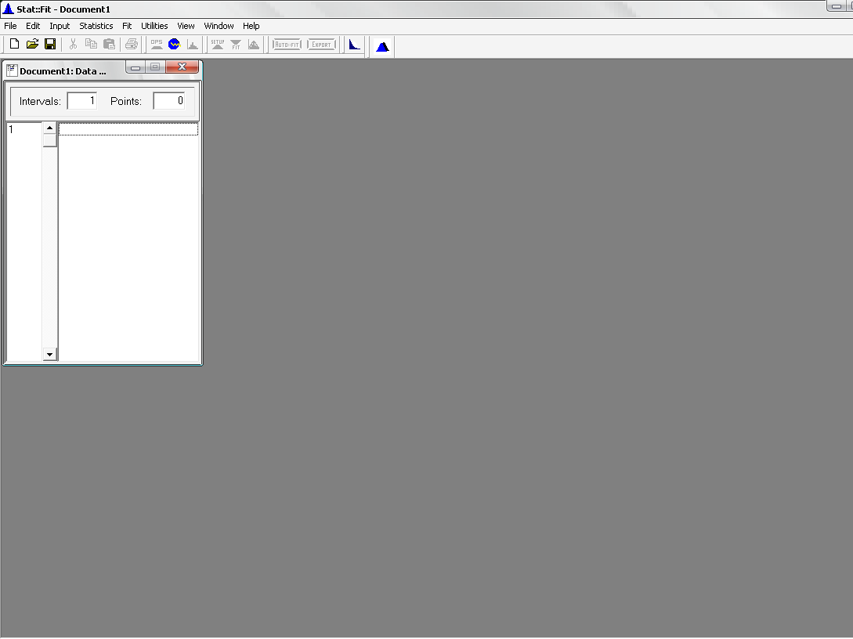

Fig C.1: Stat::Fit Interface

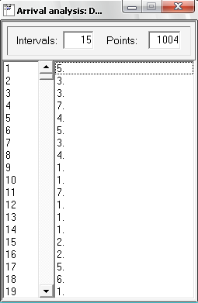
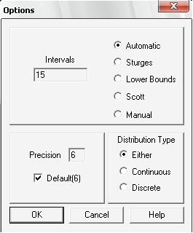
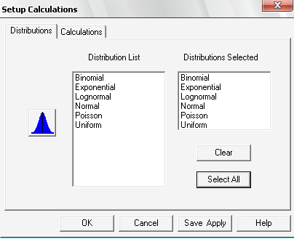
Fig C.2: Input data
Fig C.3: Stat::Fit options
Fig C.4: Setup Calculation
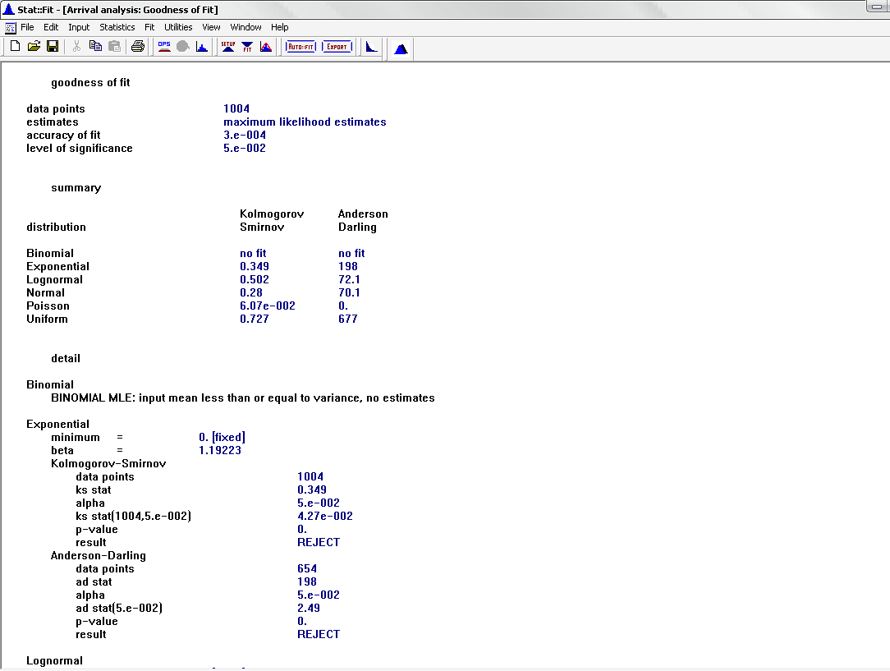

Fig C.5: Goodness of fit

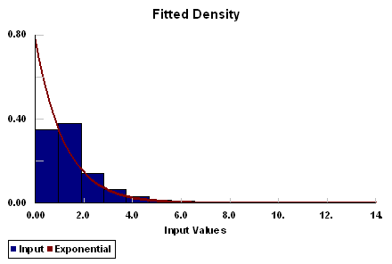

Fig C.6: Fitted Density

Appendix D
Stat::Fit Diagrams

Stat::Fit Diagrams

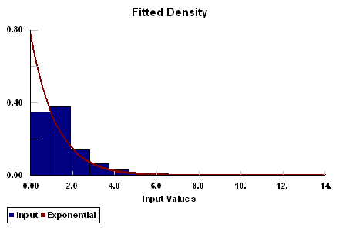

Fig D.1: Arrival Fitted Density

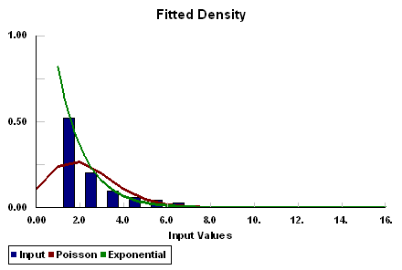

Fig D.2: Zhoor Fitted Density

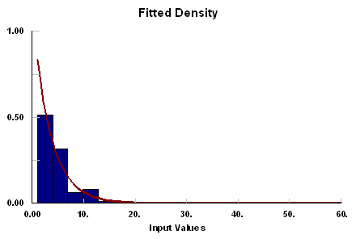

Fig D.3: Aisha Fitted Density

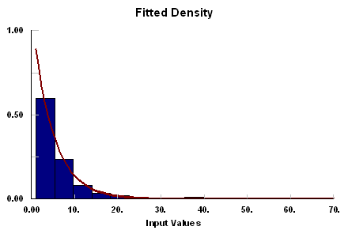

Fig D.4: Sabha Fitted Density

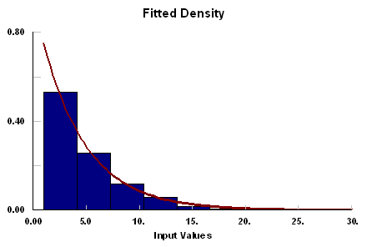

Fig D.5: Mohammad Fitted Density

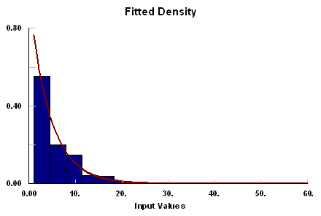

Fig D.6: Huda Fitted Density

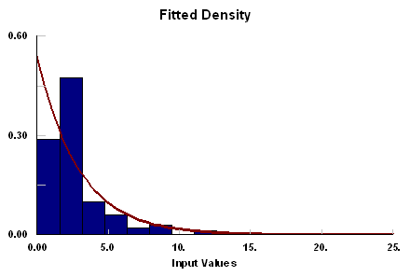

Fig D.7: Deema Fitted Density

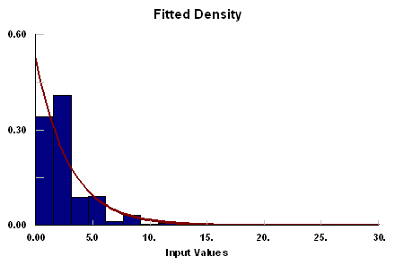

Fig D.8: Reem Fitted Density

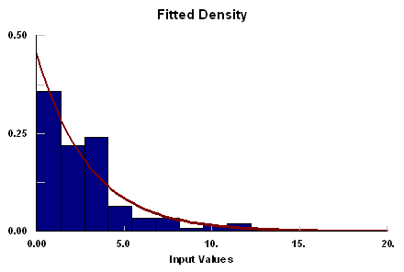

Fig D.9: Ghassan Fitted Density

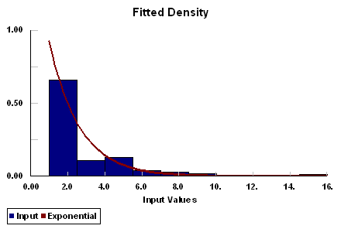

Fig D.10: Wafaa Fitted Density

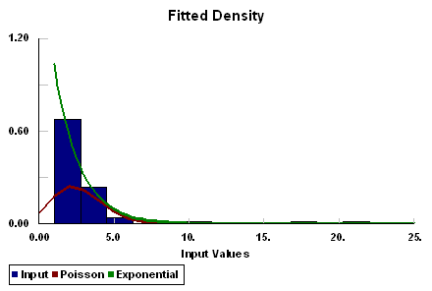

Fig D.11: Rasha Fitted Density

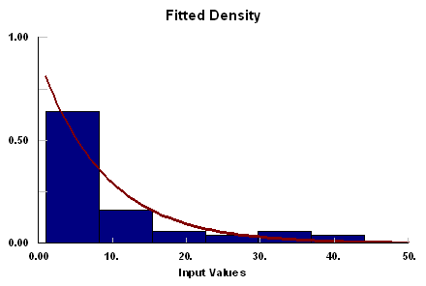

Fig D.12: Sameh Fitted Density

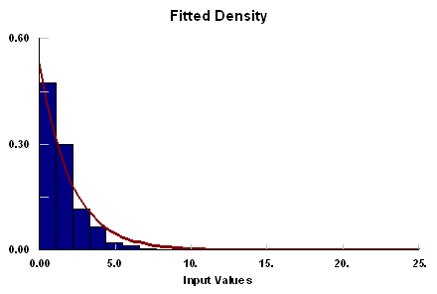

Fig D.13: Asmaa Fitted Density

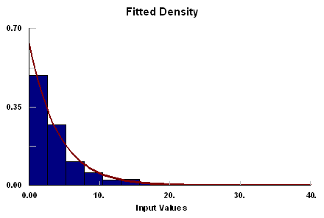

Fig D.14: Saed Fitted Density

Appendix E
Scenarios Diagrams

Scenarios Diagram
Scenario no. 1: CSC current situation

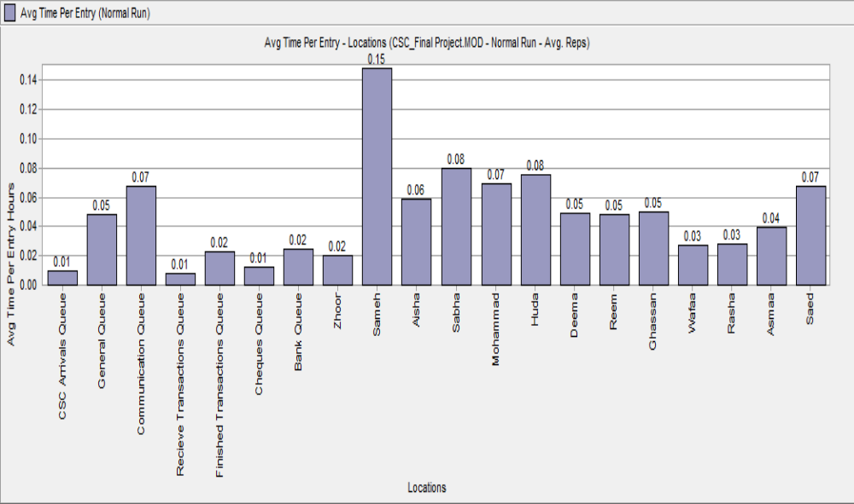

Fig E.1: Avg. Time per Entry vs. Locations (Scenario 1)

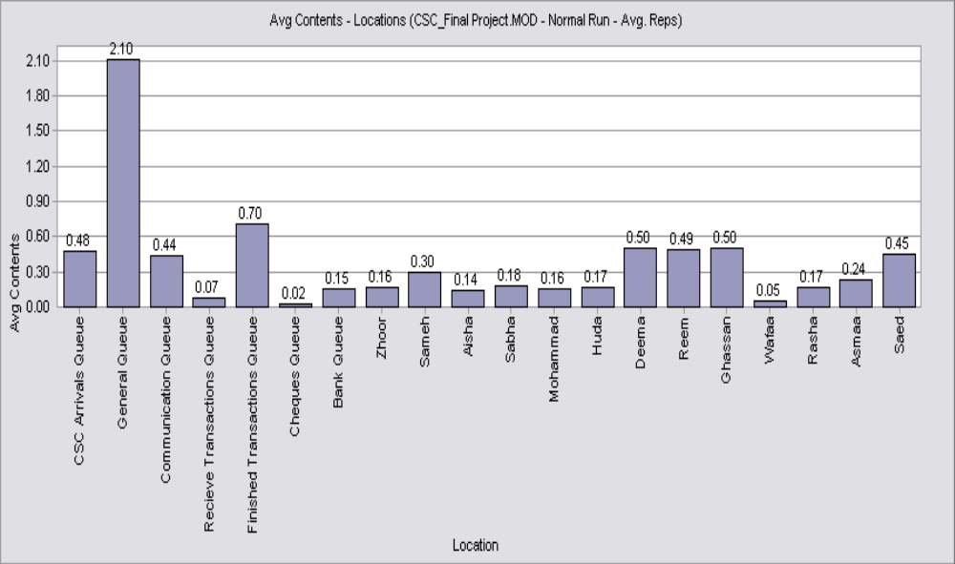

Fig E.2: Avg. Contents vs. Locations (Scenario 1)

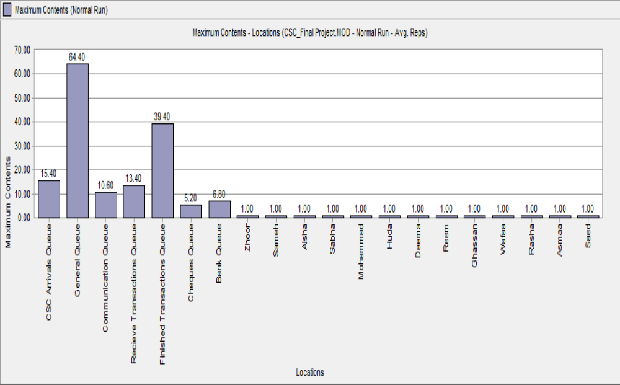

Fig E.3: Maximum Contents vs. Locations (Scenario 1)

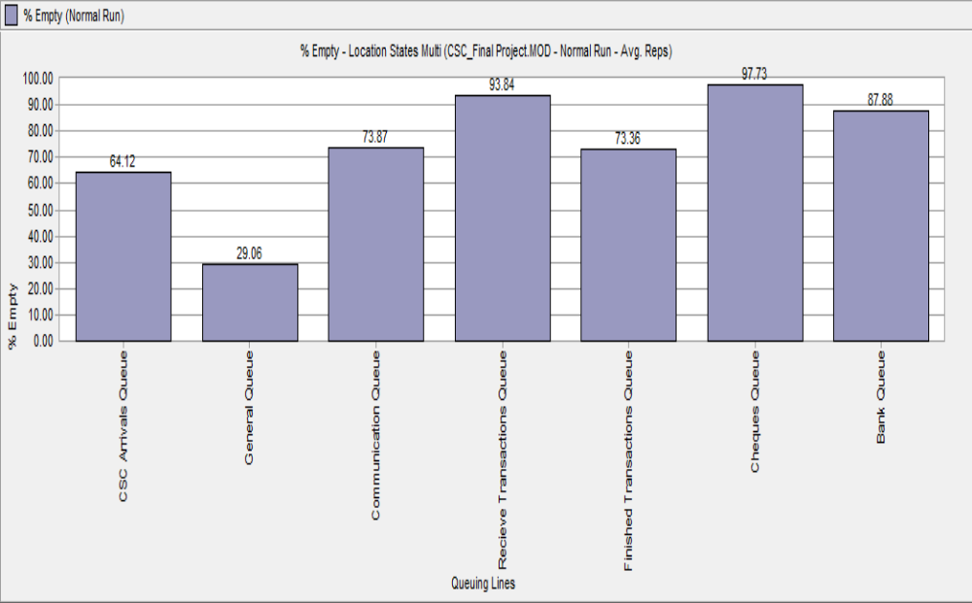

Fig E.4: % Empty vs. Queuing Lines (Scenario 1)

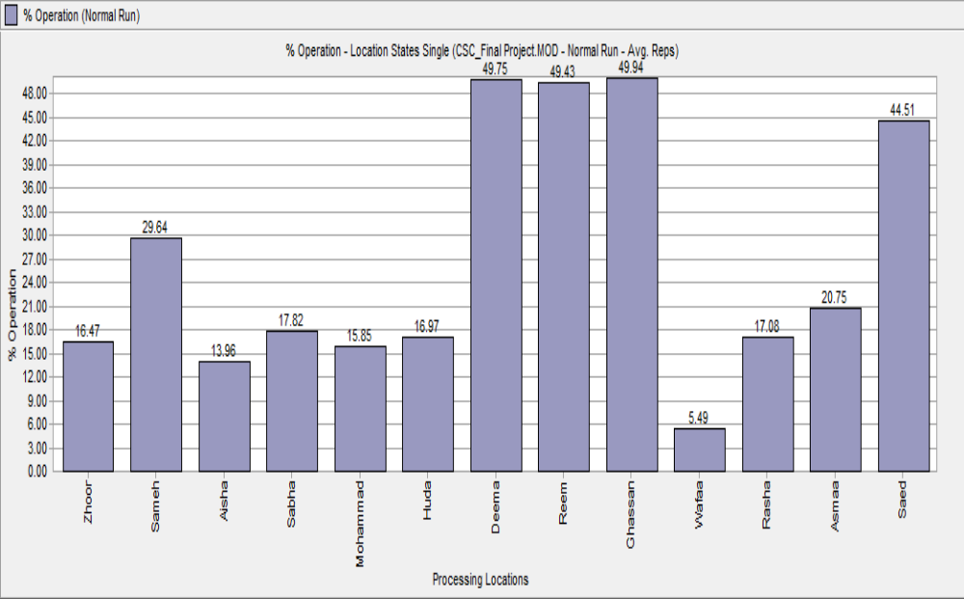

Fig E.5: % Operating vs. Processing Locations (Scenario 1)

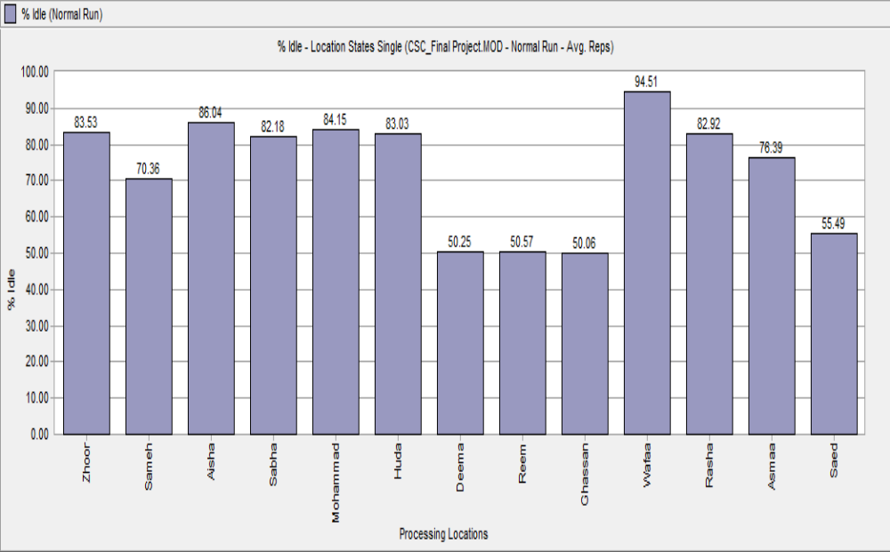

Fig E.6: % Idle vs. Processes Locations (Scenario 1)

Scenario no 2

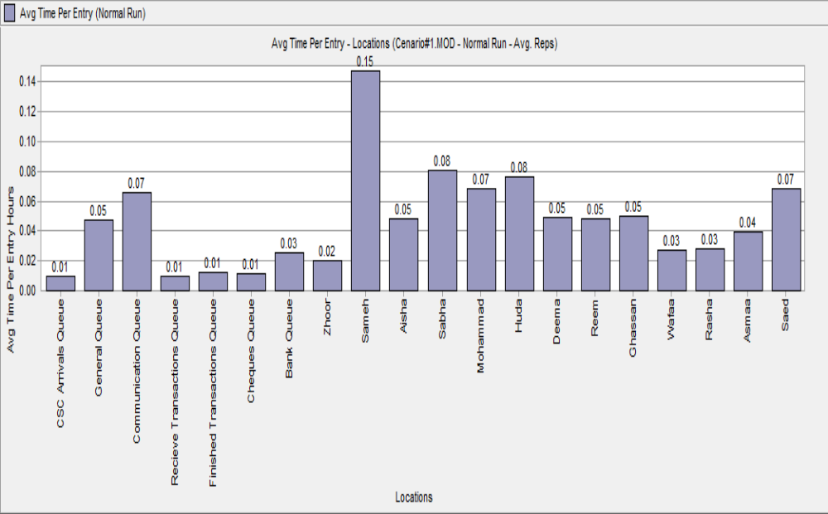

Fig E.7: Avg. Time per Entry vs. Locations (Scenario 2)

Fig E.8: Avg. Contents vs. Locations (Scenario2)

Fig E.9: Maximum Contents vs. Locations (Scenario2)

Fig E.10: % Empty vs. Queuing Lines (Scenario2)

Fig E.11: % Operation vs. Processing Locations (Scenario2)

Fig E.12 % Idle vs. Processing Locations (Scenario2)

Scenario no.3

Fig E.13: Avg. Time per Entry vs. Locations (Scenario 3)

Fig E.14: Avg. Contents vs. Locations (Scenario 3)

Fig E.15: Maximum Contents vs. Locations (Scenario 3)

Fig E.16: % Empty vs. Queuing Lines (Scenario 3)

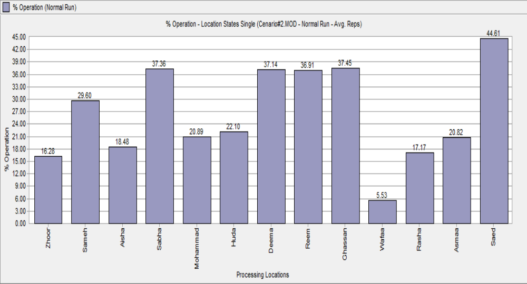

Fig E.17: % Operational vs. Processing Locations (Scenario 3)

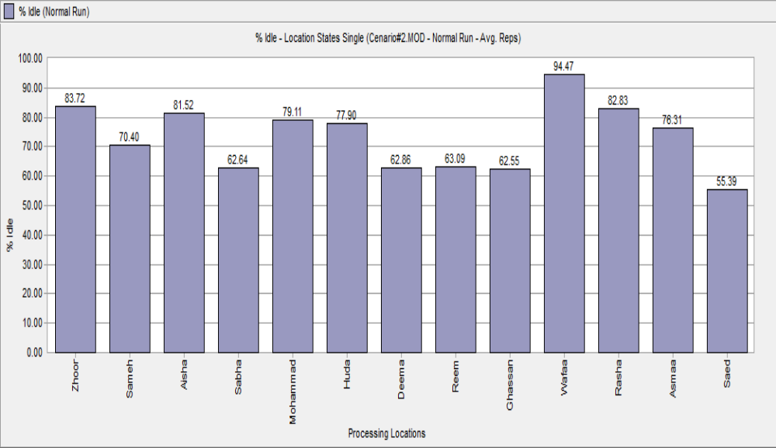

Fig E.18: % Idle vs. Processing Locations

Scenario no.4

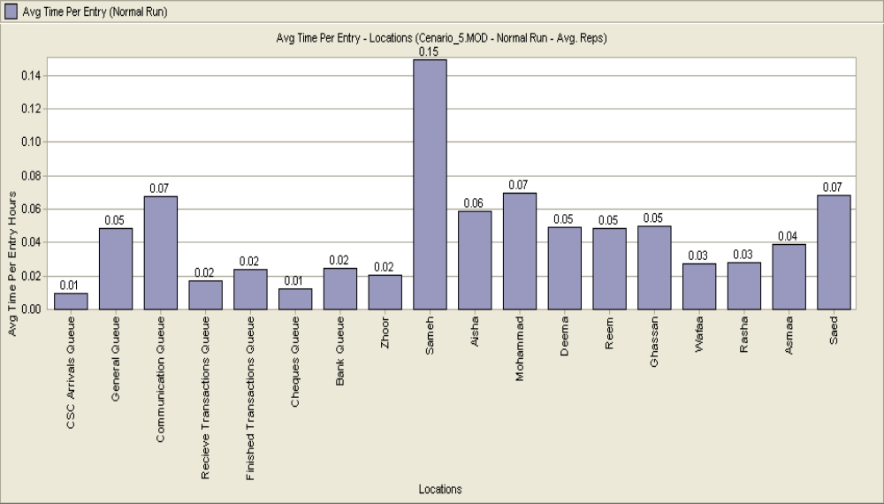

Fig E.19: Avg. Time per Entry vs. Locations (Scenario 4)

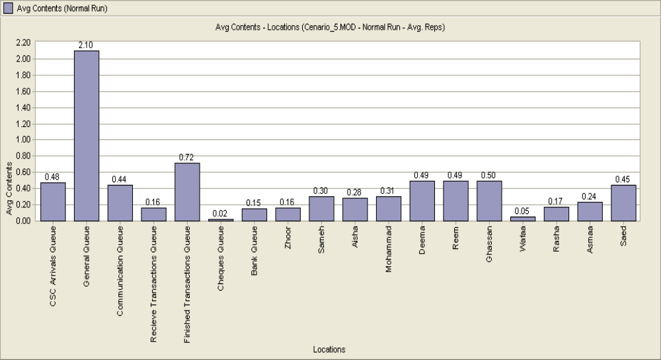

Fig E.20: Avg. Content vs. Locations (Scenario 4)
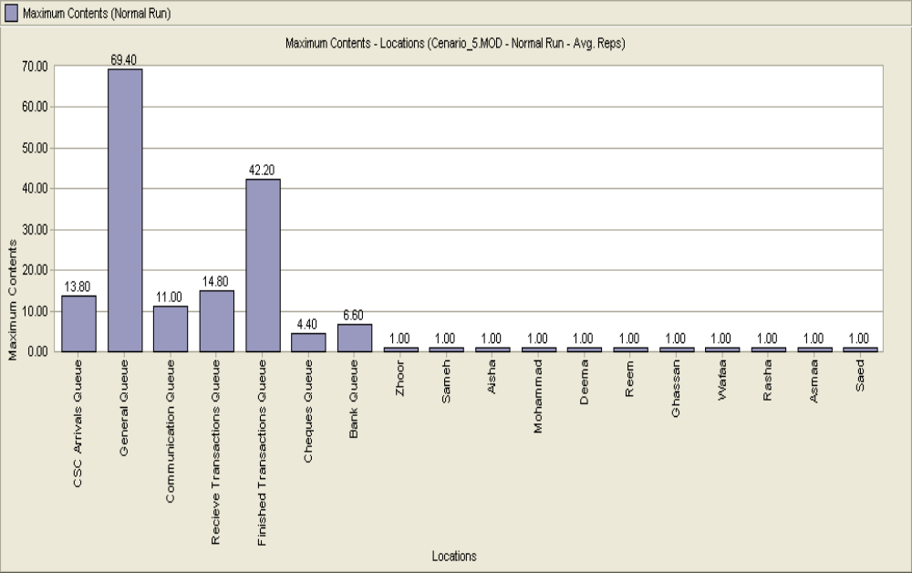

Fig E.21: Maximum Content vs. Locations (Scenario 4)

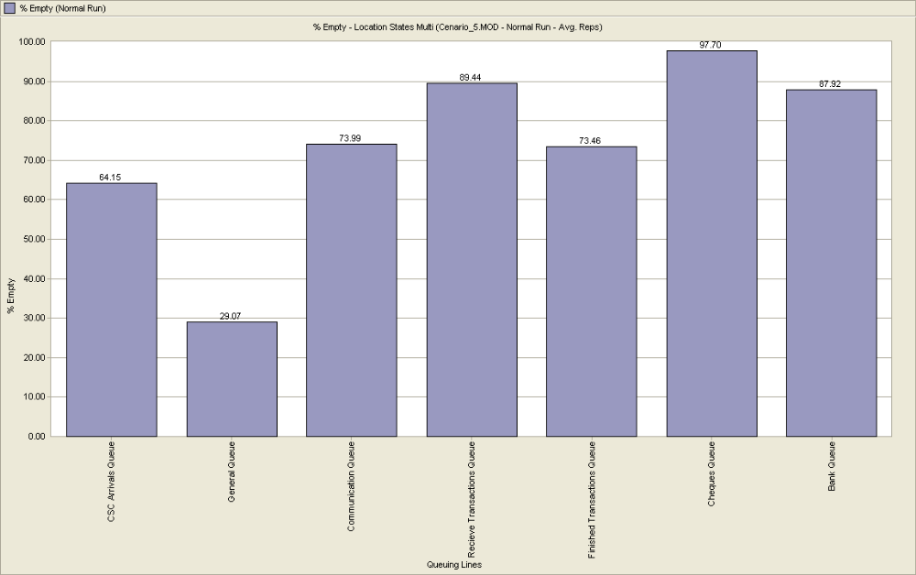

Fig E.22: % Idle vs. Queuing Lines (Scenario 4)
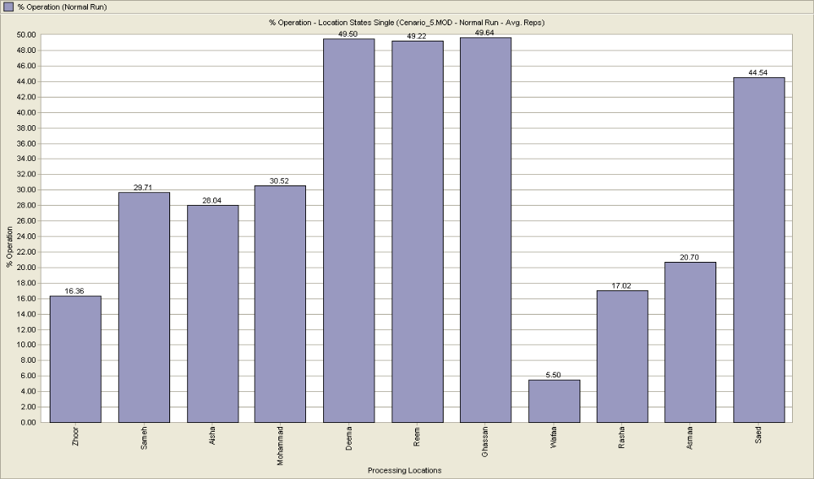

Fig E.23:% Operation vs. Processing Locations (Scenario 4)

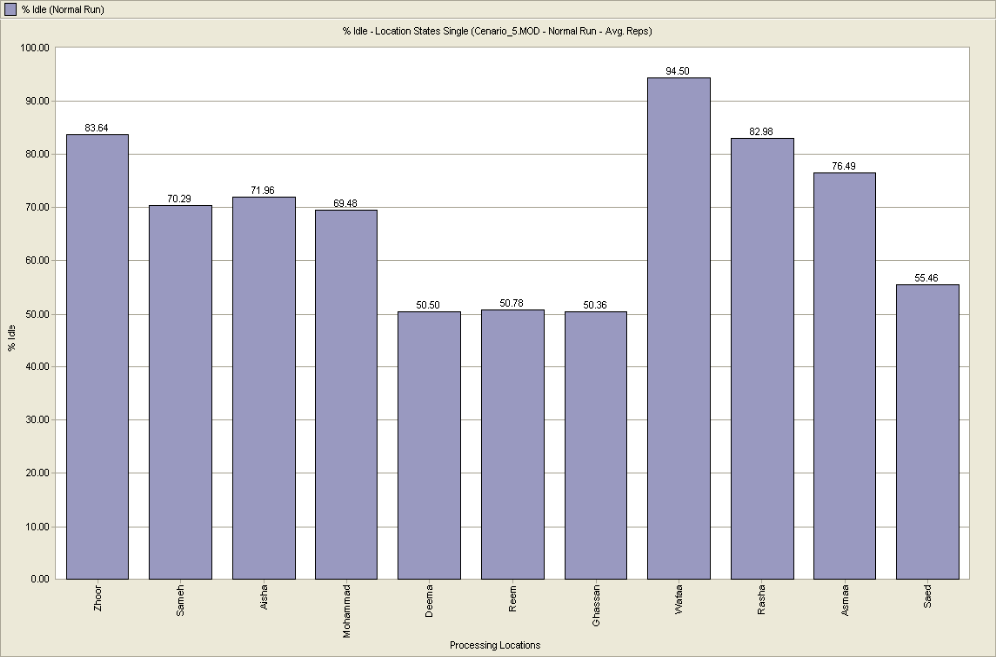

Fig E.24: % Idle vs. Processing Locations (Scenario 4)
Scenario no 5

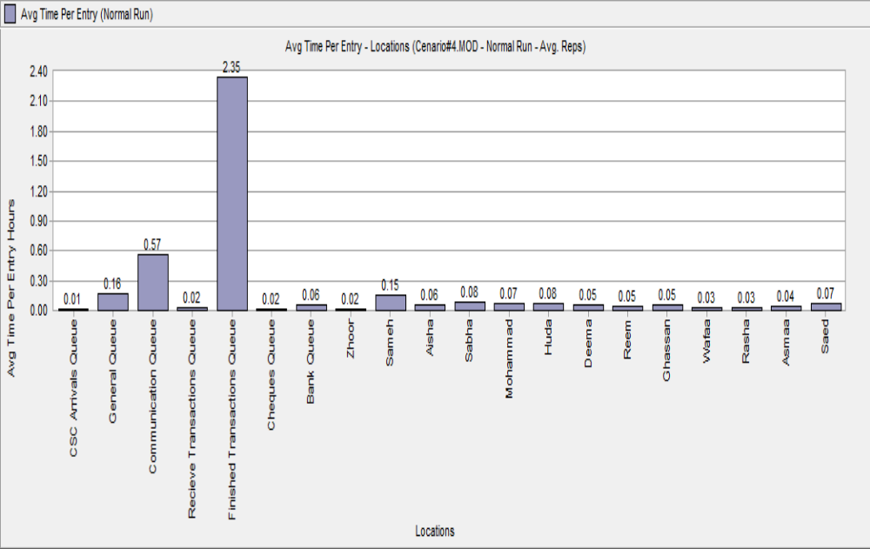

Fig E.25: Avg. Time per Entry vs. Locations (Scenario 5)

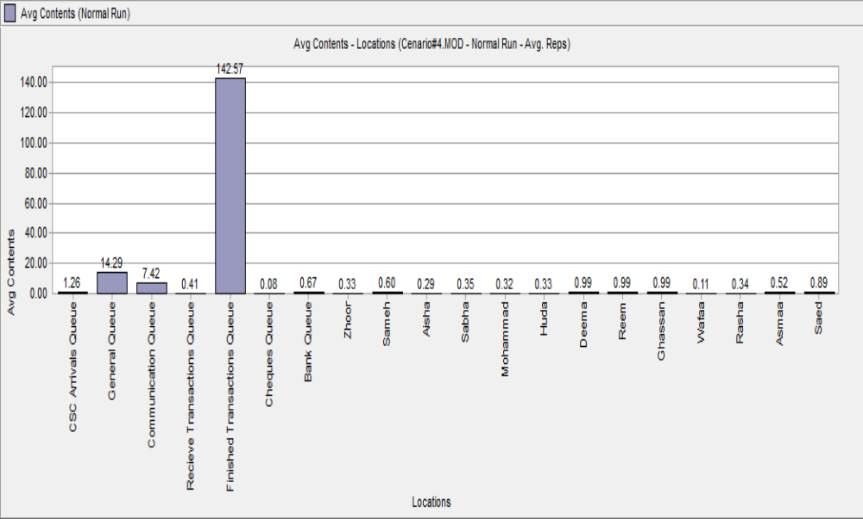

Fig E.26: Avg. Content vs. Locations (Scenario 5)

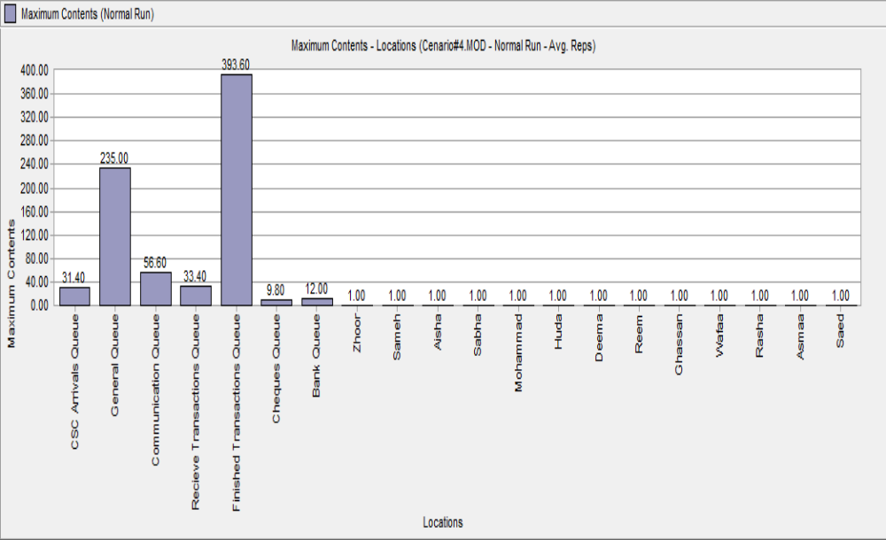

Fig E.27: Maximum Content vs. Locations (Scenario 5)

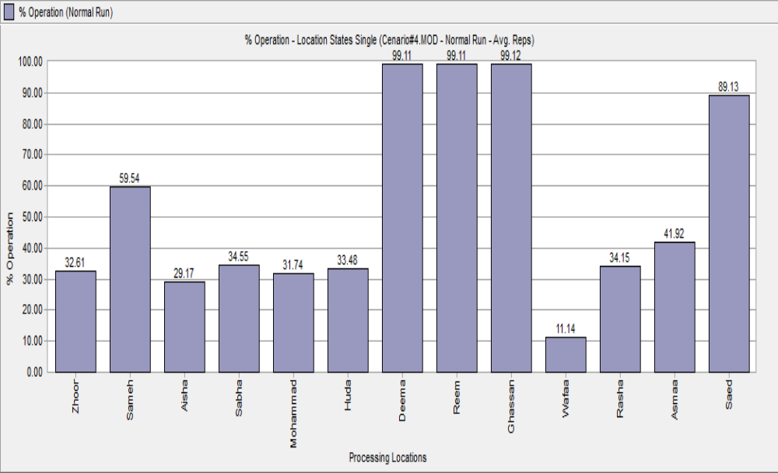

Fig E.28: % Operational vs. Processing Locations (Scenario 5)

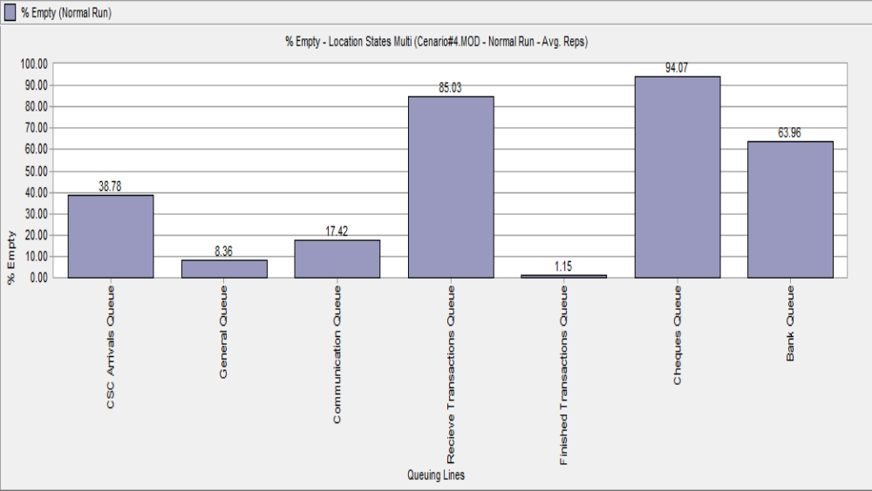

Fig E.29: % Empty vs. Queuing Lines (Scenario 5)

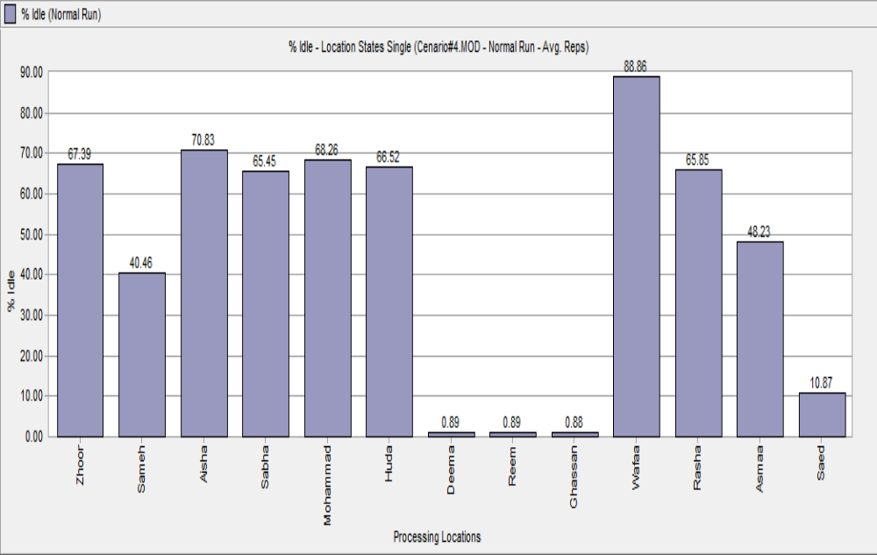

Fig E.30: % Idle vs. Processing Locations (Scenario 5)

Scenario no. 6

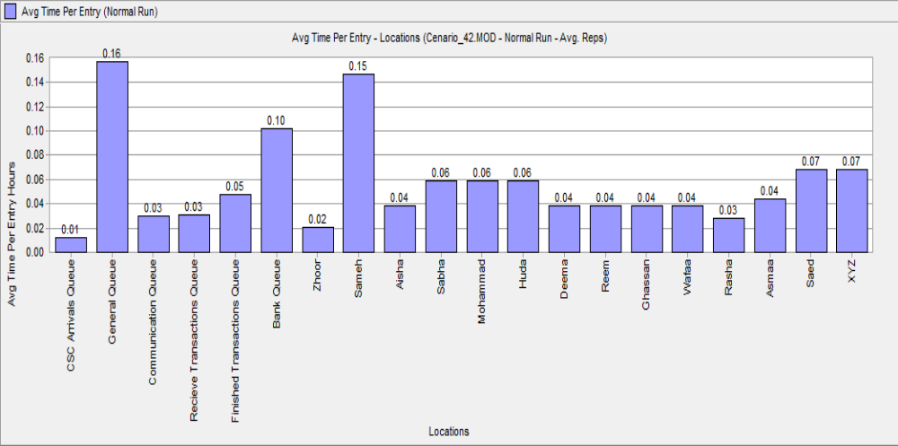

Fig E.31: Avg. Time per Entry vs. Locations (Scenario 6)

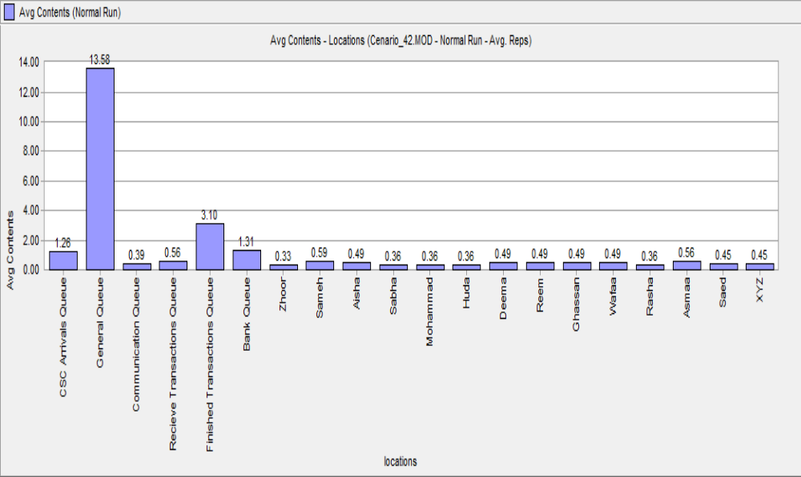

Fig E.32: Avg. Contents vs. Locations (Scenario 6)

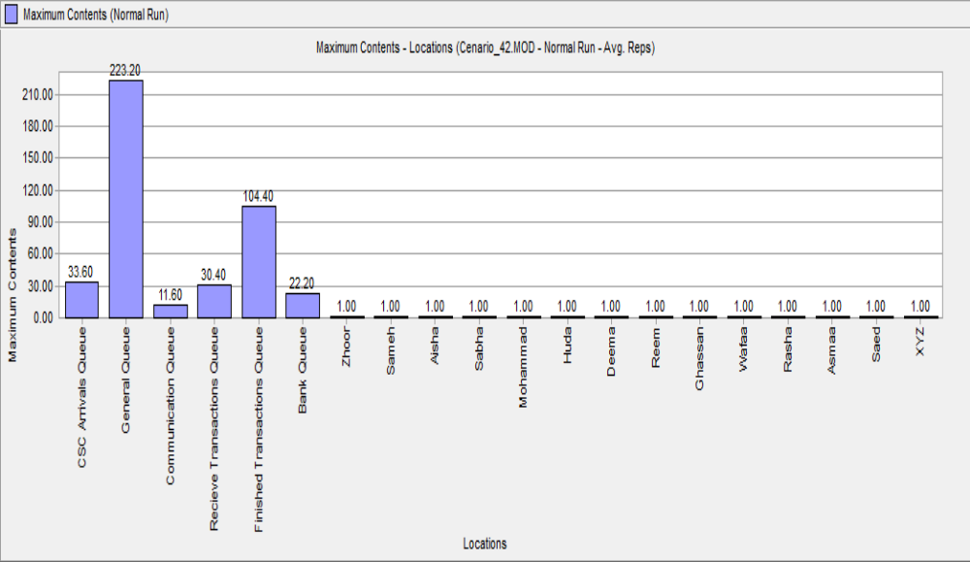

Fig E.33: Maximum Contents vs. Locations (Scenario 6)

Fig E.34: % Empty vs. Queuing Lines (Scenario 6)

Fig E.35: % Operation vs. Processing Locations (Scenario 6)

Fig E.36: % Idle vs. Processing Locations (Scenario 6)

