AN NAJAH NATIONAL UNIVERSITY
FUCULITY OF ENGINEERING
COMPUTER DEPARTMENT

Subject: Graduation Project 1.
HOSPITAL SYSTEM DEVELOPMENT
SUBMETED TO :Computer Department Doctors:-
1:-Lu’ai Malhees.
2:- Raed Al-Qadi.
3:- Anas Tu’mah.
4:- Haya Samaaneh.
STUDENTS NAMES:
HUSSNI MAHER MULHEM.
KHALED WALEED MOHAMMED JOM’A.

In our project we want to develop a web site for a hospital in order to develop the interior and exterior Transactions in order to use fewer amounts of papers in relations, and in more specification we developed a complete storage department system, which controls the storage of the hospital from different ways like sending a requests to the medical companies and receive the requests from other department inside the hospital, and the Possibility to make bills and control the materials mounts, prices, expiration date and other things.
In addition to the above we make some development in other departments of the hospital as:-
- Administrator:-how can make the control of the system, by inserting, updating and deleting the employees and departments.
- Doctors: - were every doctor has an account which may used to send massages to other employees, and the main point that the doctor can see the patents that registered to him, and the patents treated, forwarded and the patents returned from other doctors.
- Counters:-which his main job is to held account form the treated patents.
- Pharmacist:-at this department the employee can request an order from the storage to be distracted by the prescription of the doctors.
- Reception:-were the main job to this department is to register the patents to clinics of doctors in separate departments like burns, Pediatrician (قسم الأطفال) and other more parts.
- Departments part:- where at this part the doctors or the Pharmacists can make a request to the storage department for any type of medicine.

And now we will explain some of the pages of the website. And we will start with the login pages:-
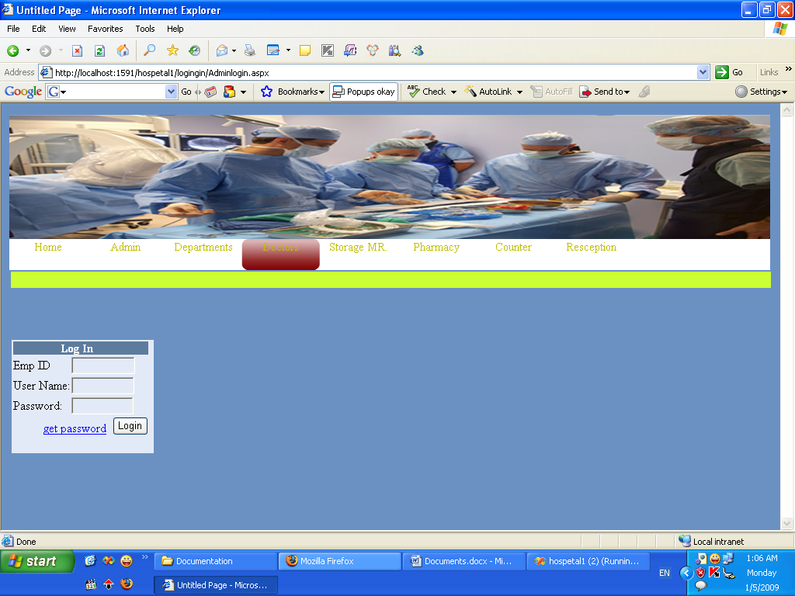

Every part of the hospital has its login page, where the manager cannot use the login page of the doctors, were every login has three fields to enter.
Where the fields are:-
- Employee ID, where everyone has a unique ID.
- User Name, where every user has A User Name.
- Password, which is a Secured Field for password.
And there is A Login Button which is to log in the correct part or department. And a link to return the password.
After that we will explain the storage department and the main work of the storage manager.
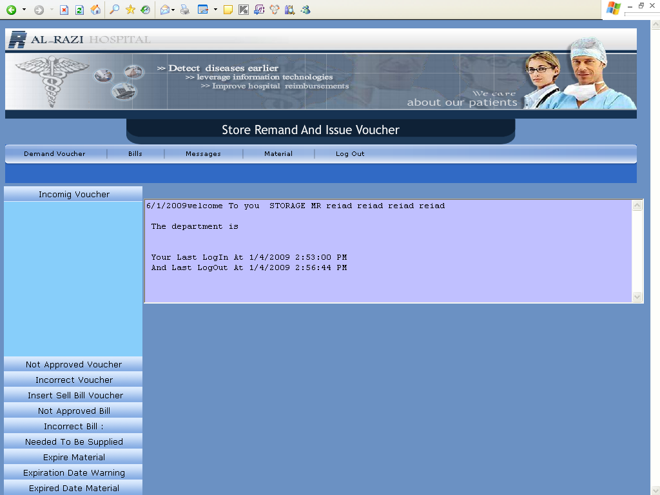
Which is the main page of the storage manager>
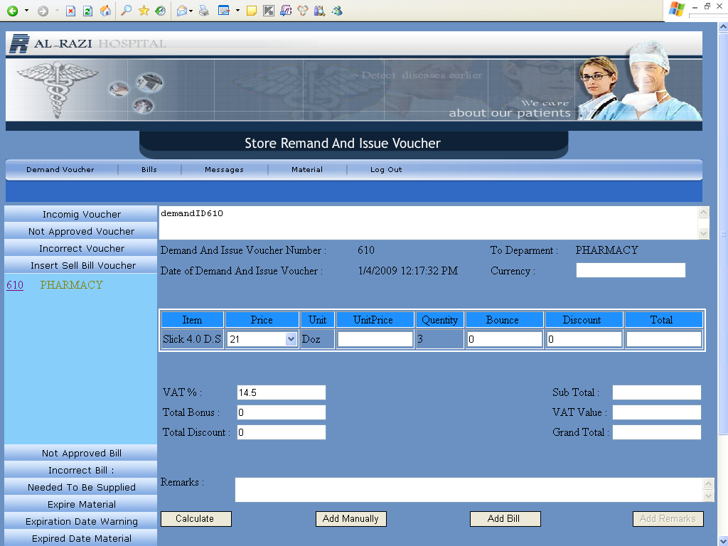
Where at this page the manager can Insert Sell Bill Vouchar for the incoming correct vouchers.
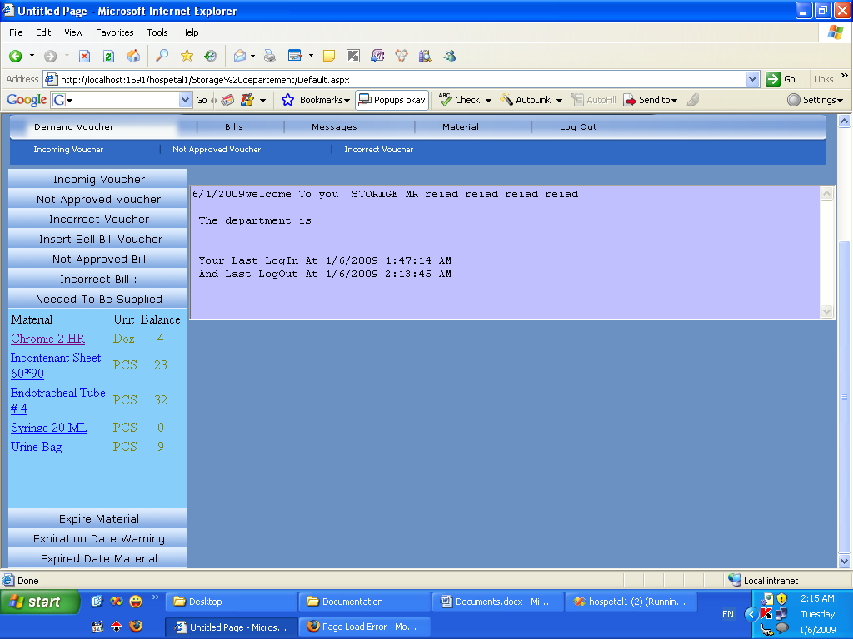
And at this page shows the materials needed to be supplied when it reaches a minimum amount.
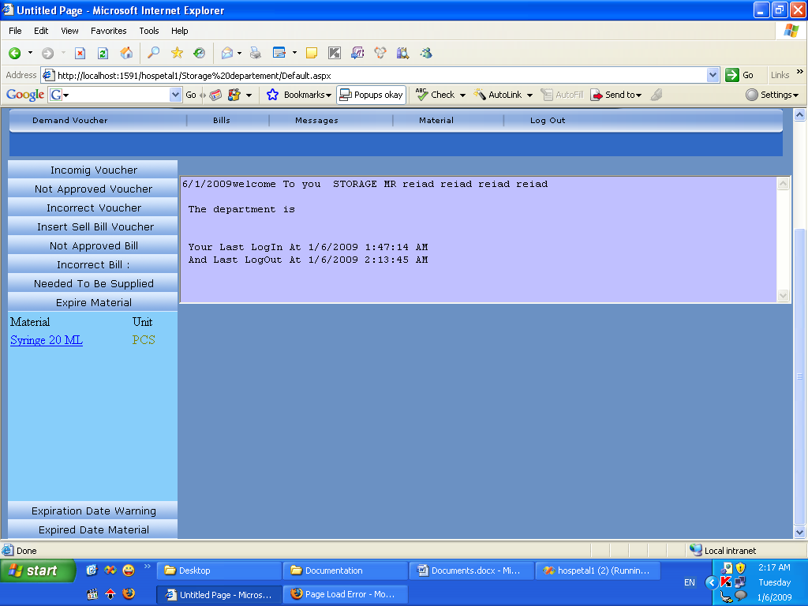
And at this page shows the materials that expiered.

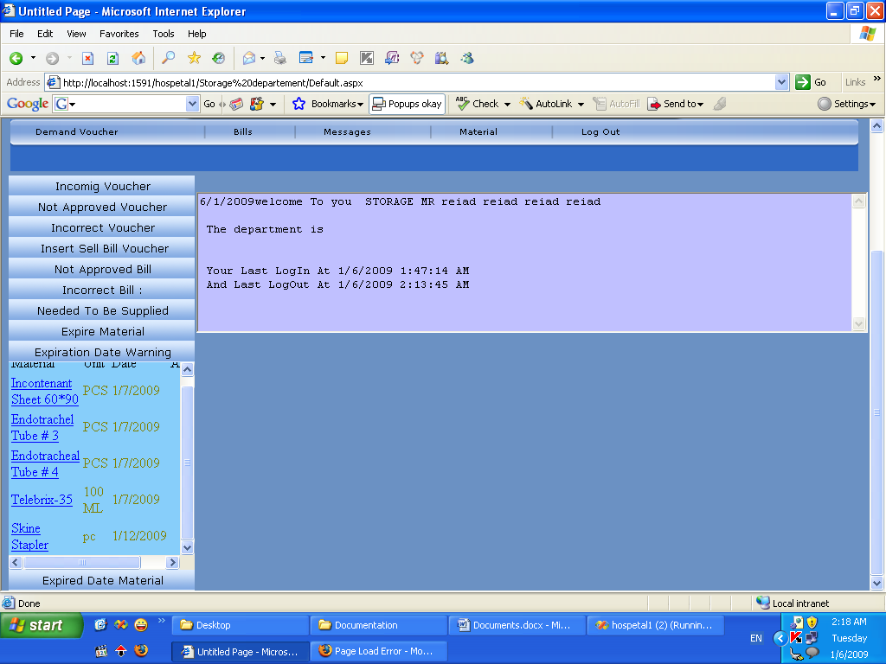
And at this page shows the materials that will be expiered in date in nearly.

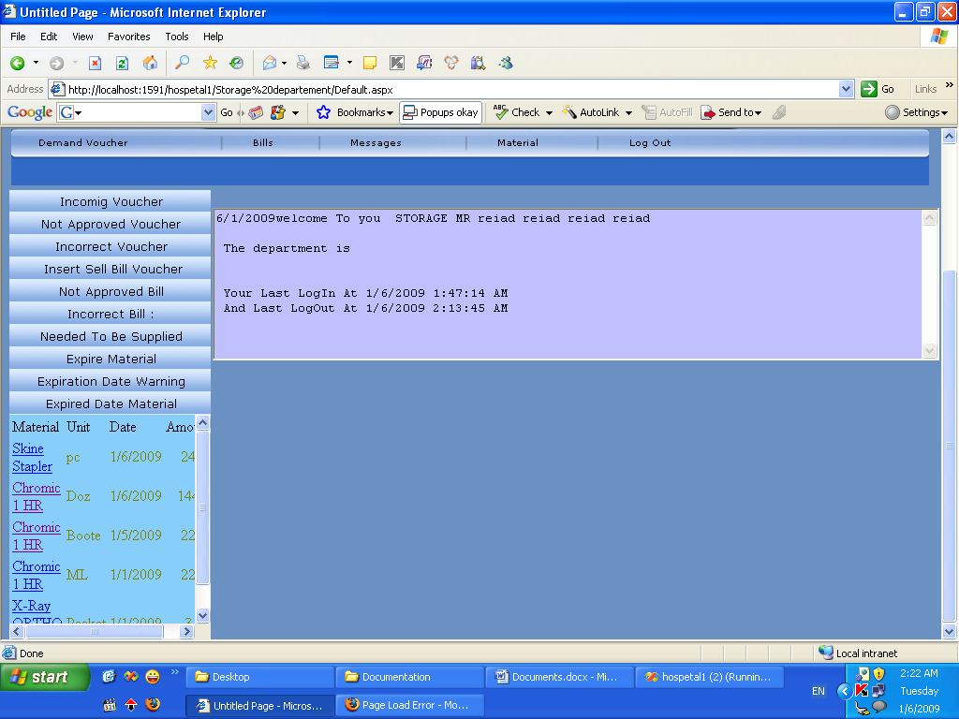
And at this page shows the expired date materials.

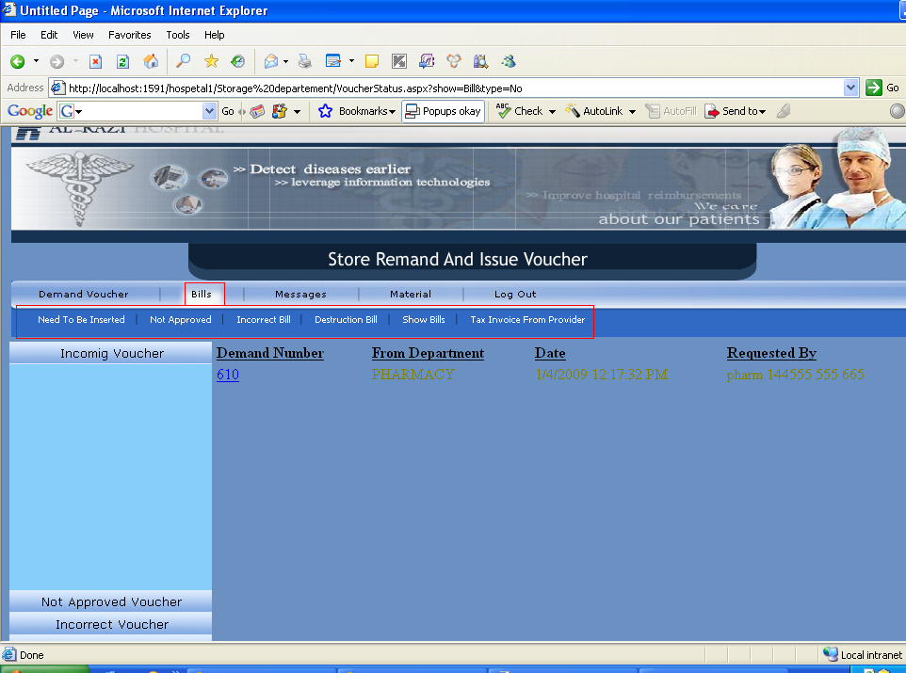
And this page shows the bills and it’s states like need to be inserted, not approved bill, incorrect bill and other types.
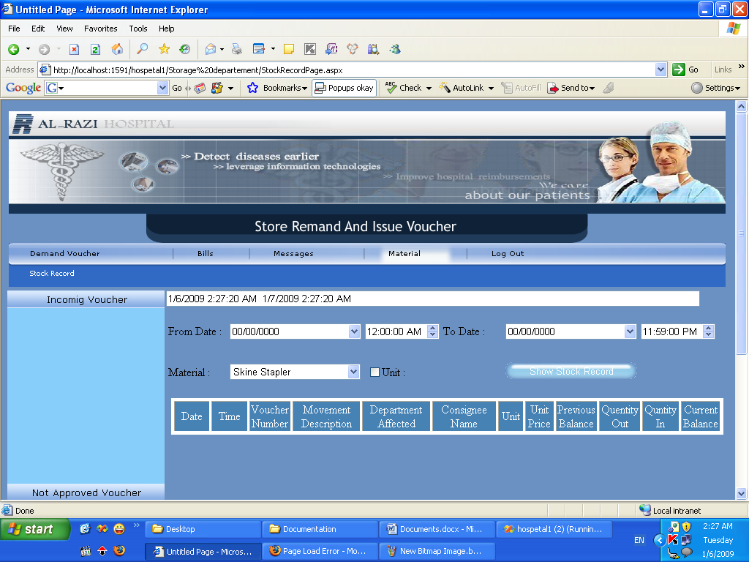

This page shows the stock record of the storage, which explaines a report or a table of the stock records in any period of time, and another page which shows the bills in any period time.
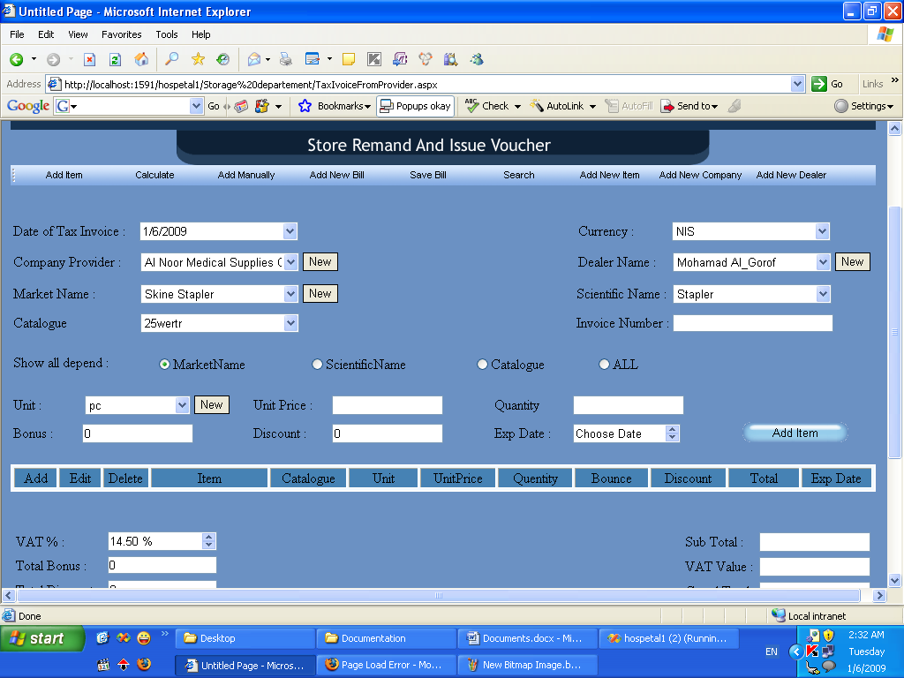
This page shows the tax invoice from provider.

And now let us move to the manager department:-
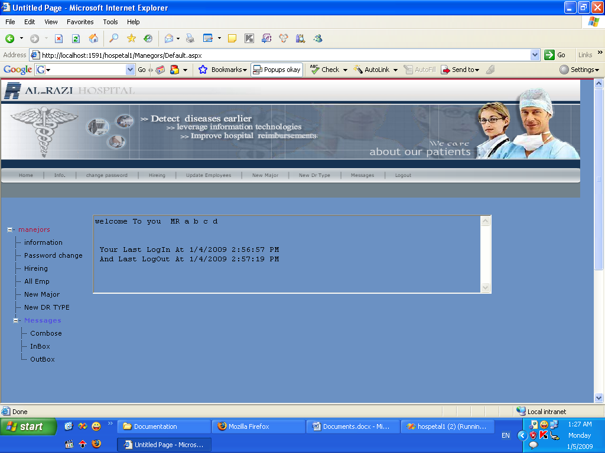
This is the home page for the Manager, which display the name and the last login and logout for the user, and the manager can do many things as shown bellow.
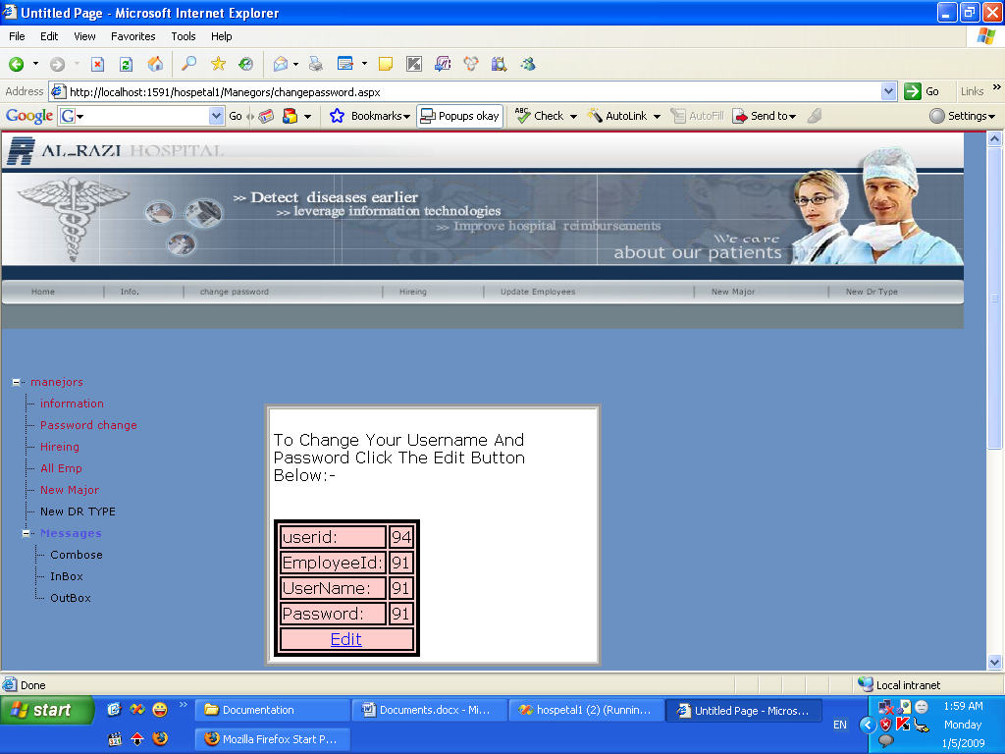
Which at this page the user can change his own username and password.
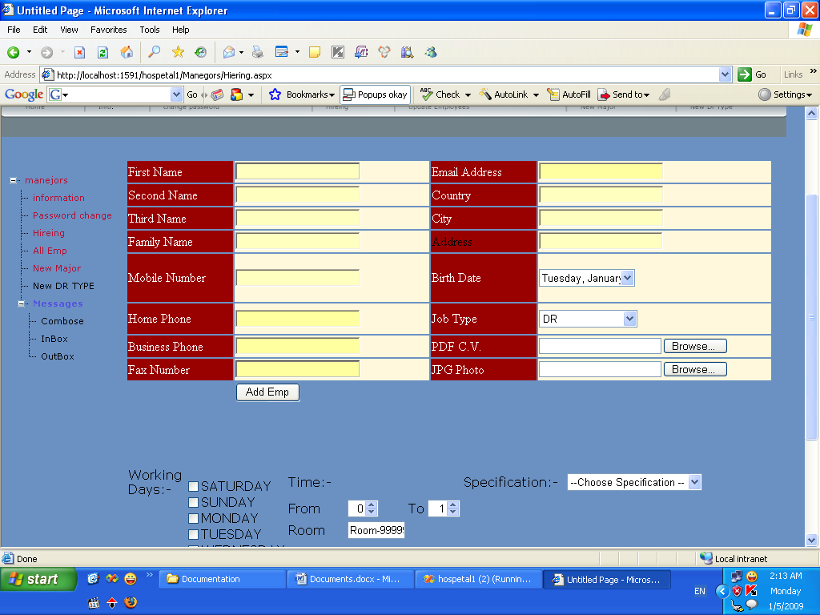
At this page the manager can add any new user.
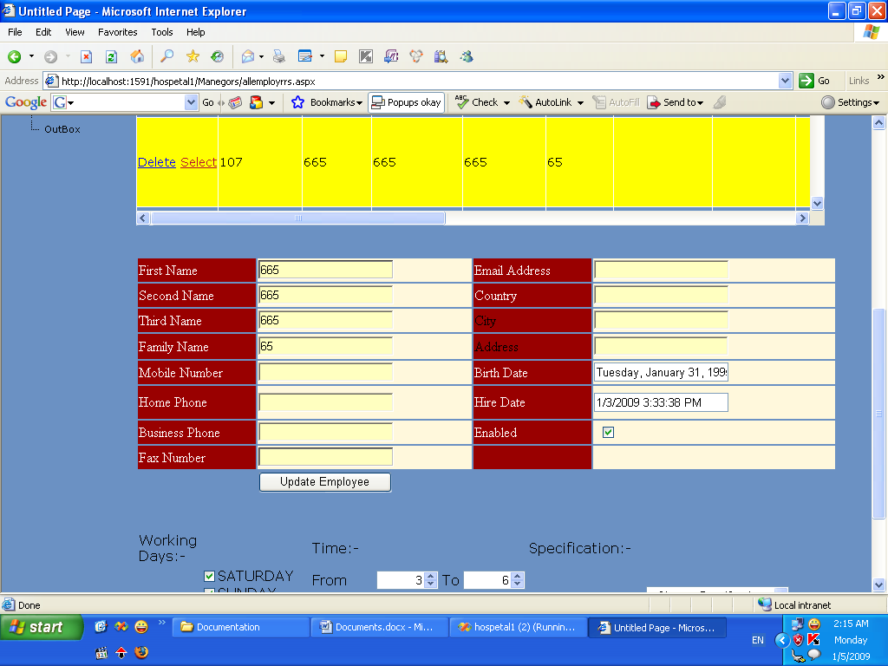
At this page the manager can update any user.
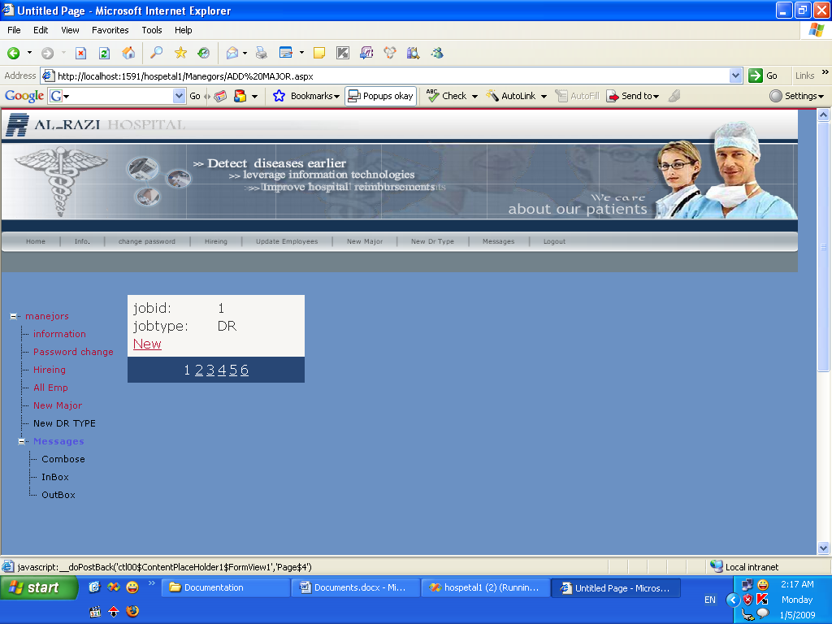
At this page the user can add new job type
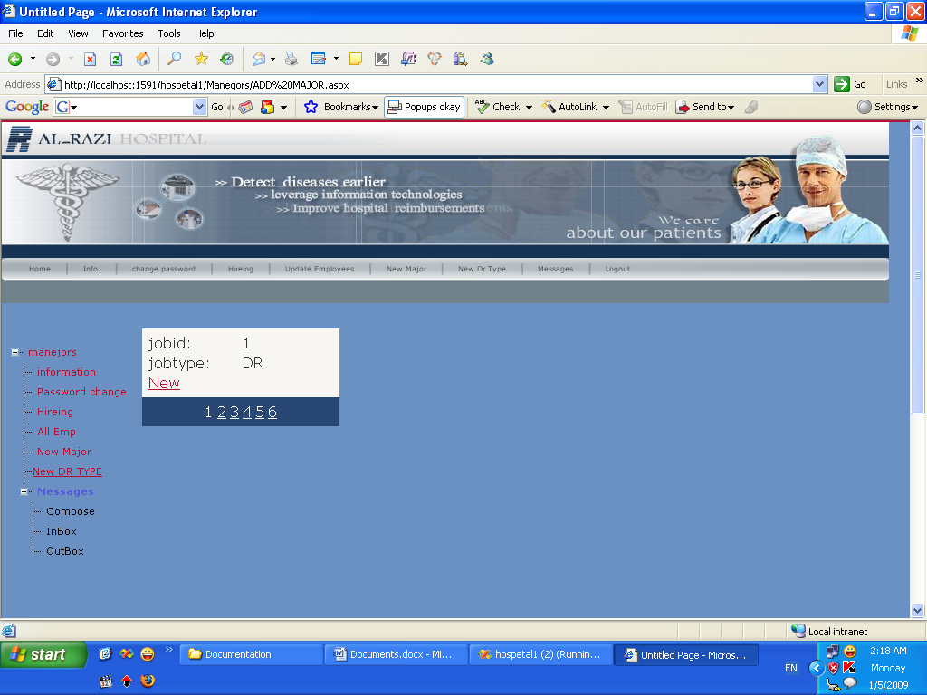
At this page the manager can add new Dr Departments like surgery….
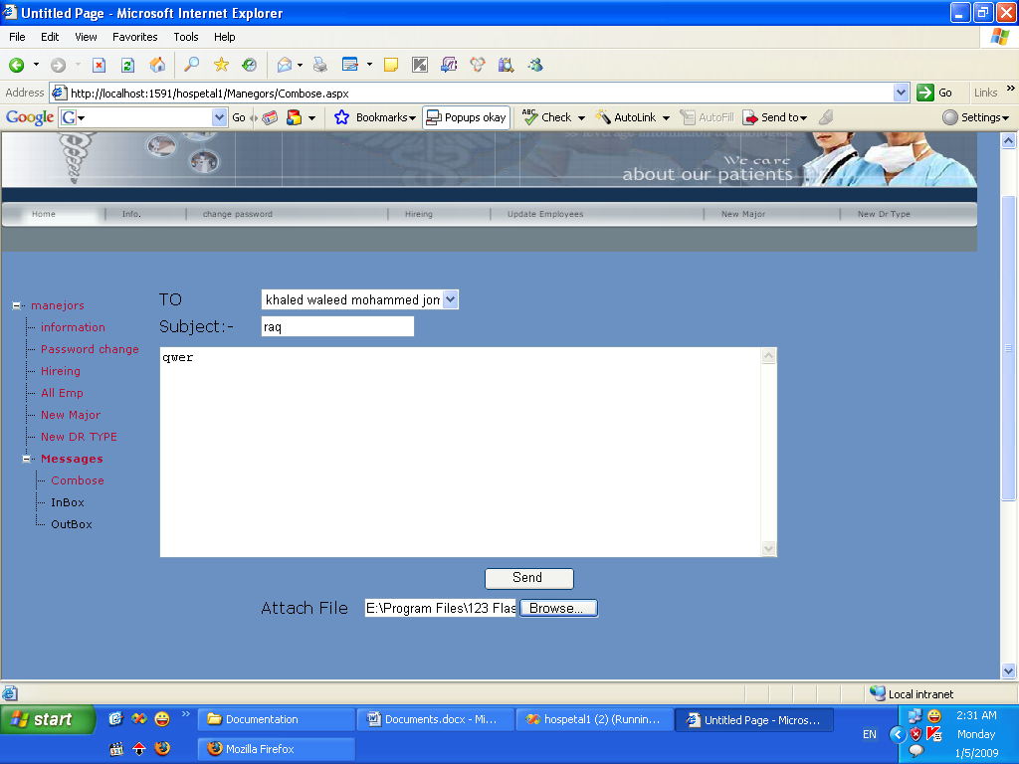At this page the manager can send any message to any employee with an attachment.
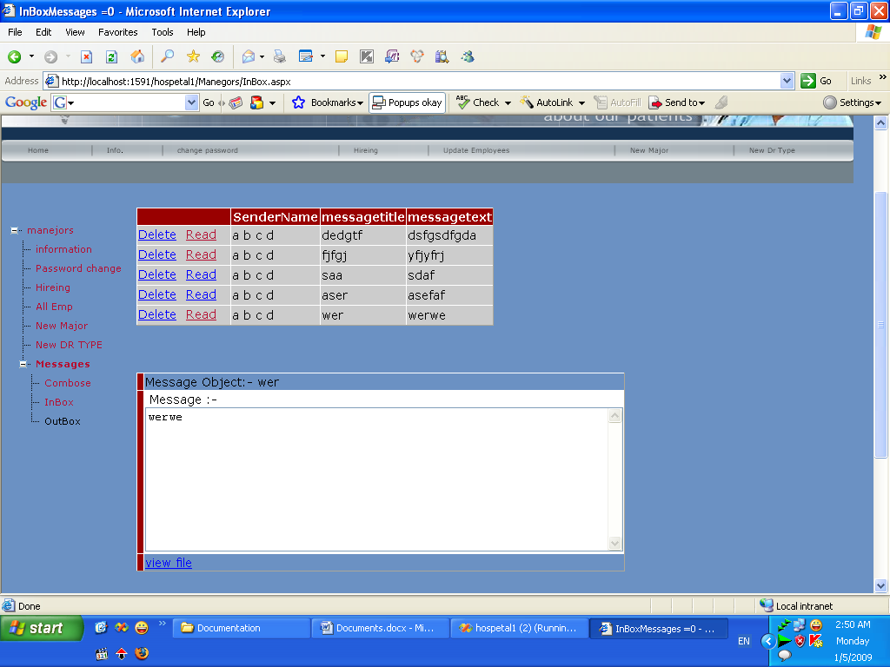
At this page the manager see received message from any employee with an attachment.
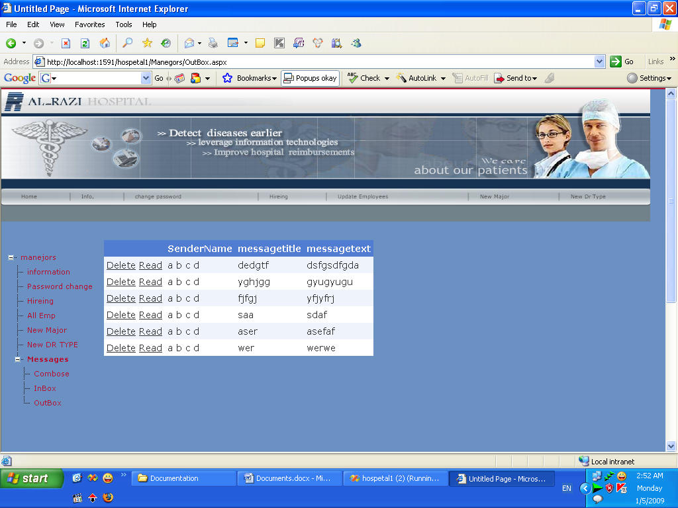
At this page the manager see sent messages from his account.

Now we will explain the doctors department, which has some same pages as manager.
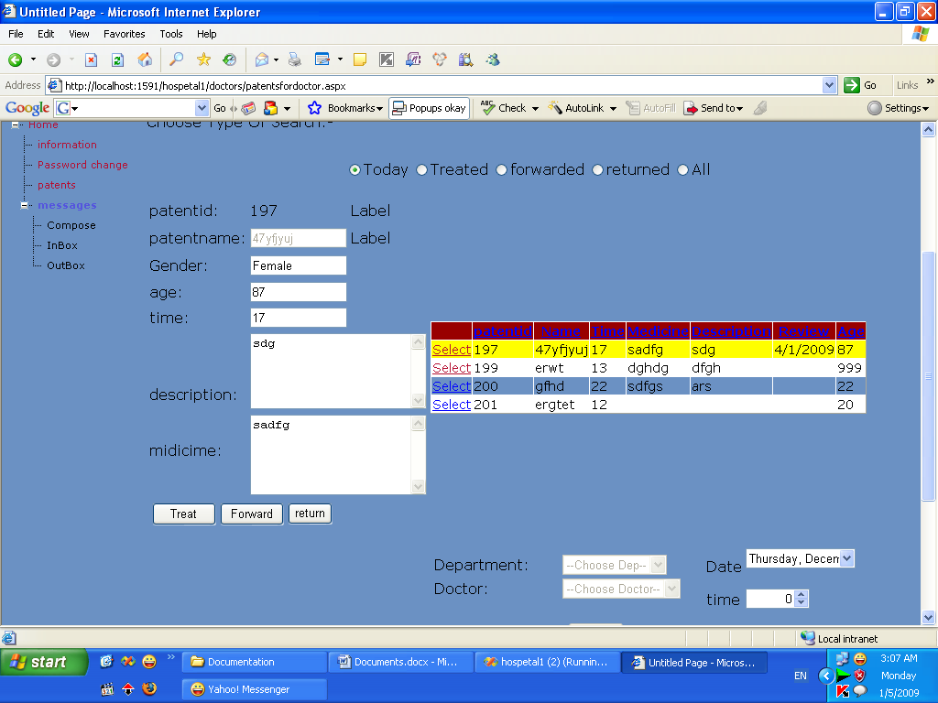
At this page the doctor can see his patents at current day or the forwarded patents , or the treated, returned from other departments.

Now for the pharmacy department,
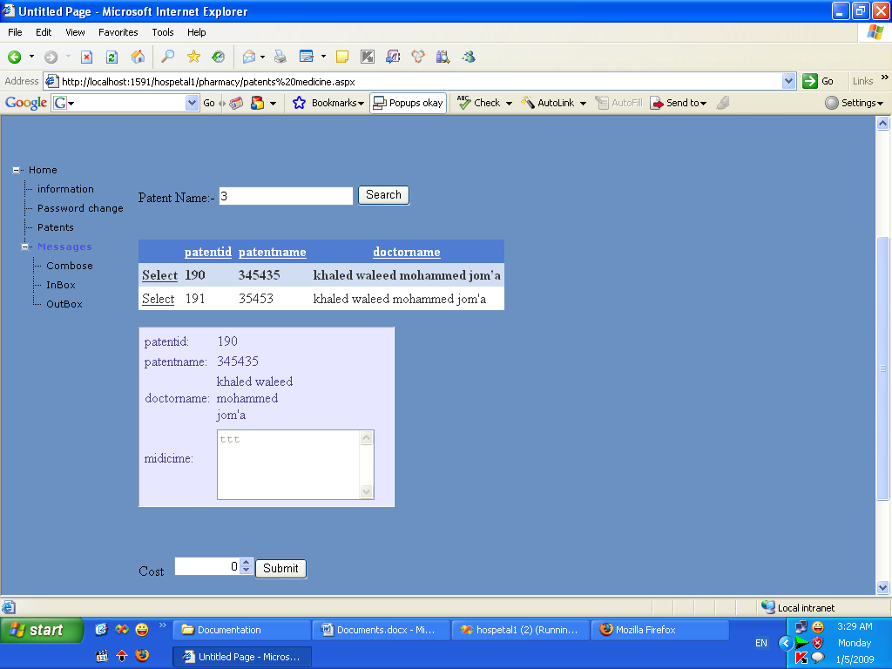
At this page the Pharmacist search the patents using the name of the patent, then he choose the specified patent and give the patent the specified medicine which was written by the doctor and then but the total cost in the Cost box.

Now for the Counter Department:
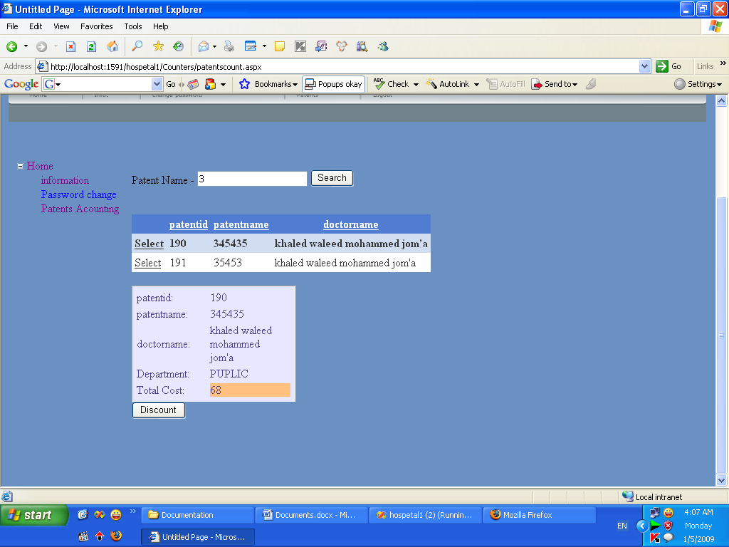
Were at this page the counter selects the patent and took money from him and put his total cost to 0.

Now for the Reception Department:
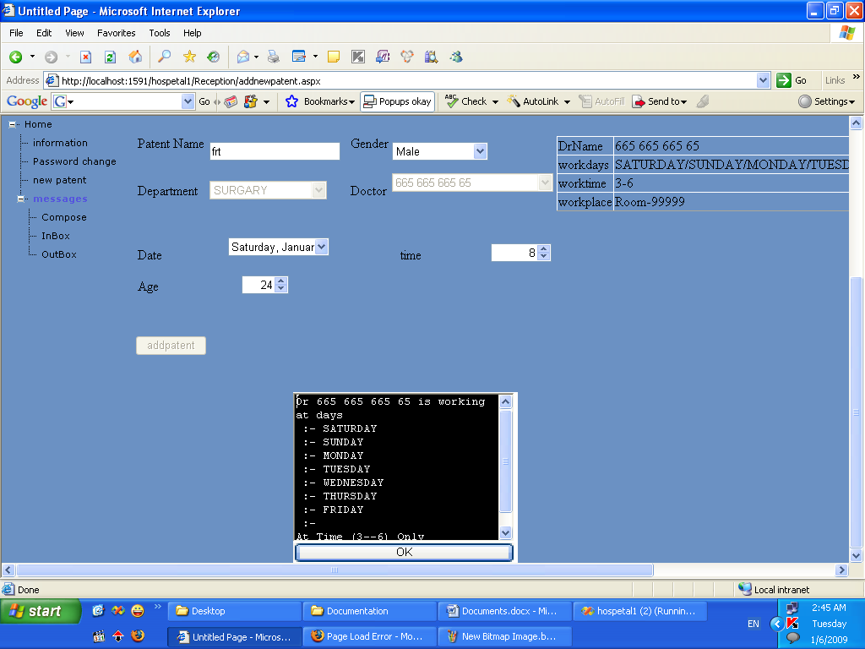
Where this page shows the main work of the reception dapartment which is to add patents to the doctors at specified and correct date and date.

And for the dapartments part, the doctors and the pharmars can mace a request from the storage and to Follow his request as shown bellow:-
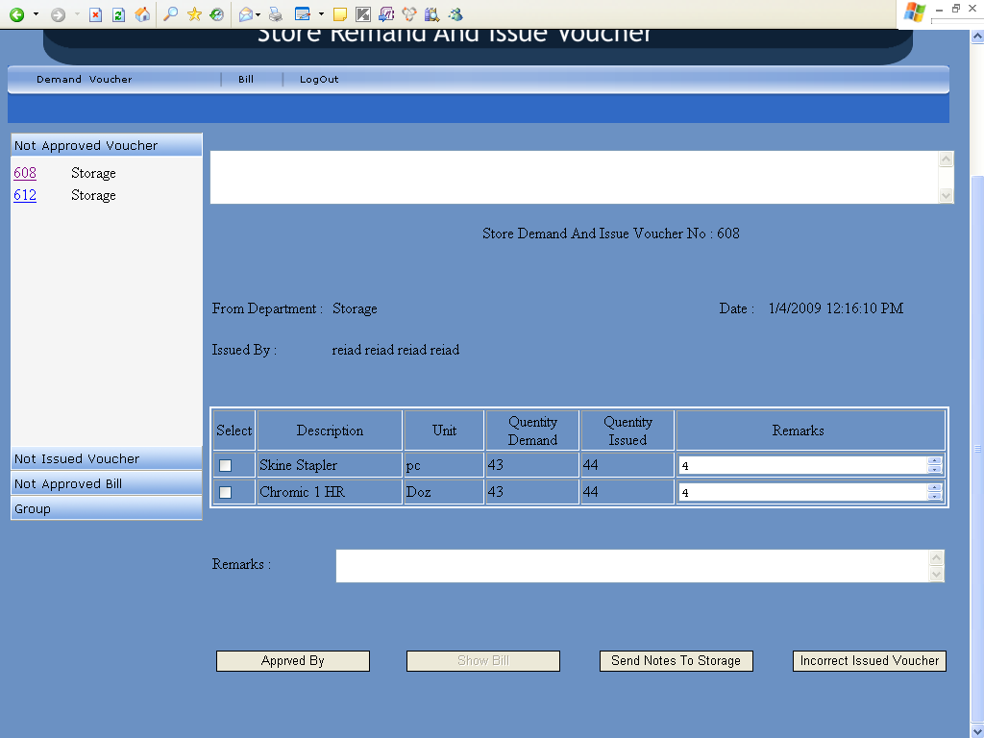

Finally this is an overview of our project and we hope that it will help the people whom they will use it, and the teachers of our department (Department Of Computer Engineering)

THANKS

THE END

