**بسم الله الرحمن الرحيم**



**Faculty of Engineering**

**Computer Engineering Department**

Graduation Project Title

*Prepared By :*

Fadi Nabeel Subhe Omar

Hussein Mustafa Othman Ghanem

*Instructors :*

*Dr.Raed Al Qadi. Dr.Luai Malhees*

*Eng. Haya Samanye*

**2007-2008**

The Contents

|  |  |
| --- | --- |
| **Title** | **Page No.** |
| **Introduction** | **3** |
| **Ministry** | **5** |
| **Directorates** | **7** |
| **Schools** | **8** |
| **Employees** | **10** |
| **Students** | **11** |
| **Crystal Reports** | **11** |
| **The Database** | **14** |
| **Communication in the site** | **23** |
| **Search Engine** | **24** |
| **Programs and Tools Used** | **24** |
| **Security** | **26** |
| **Conclusion** | **27** |
|  |  |

**Zajel of Palestinian Schools**

*Introduction :*

Our Project is a site for schools in Palestine , it concern with all schools in our country , How & Why ?

We decide d to work with this idea because there isn’t any real site up to these days concern with schools in Palestine , other thing we want to make benefit to all people dealing with schools , like students themselves ( and there fathers ) , teachers in the school , directories and ministry of education .

In our country Ministry of Education And Higher Education has what is called directories in all Palestinian cities and each directorate is responsible about schools in its city .

Now there are many schools in a certain directorate , those schools have employees working in and students studying at . So there are many treatments between schools and directorate , between employees and school, and between students and school . Also there are also treatments between directorates and ministry .

This work needs complicated database to make connections between all of this treatments and entities in the project . We will show the database later .

We can show our site in its hierarchal state like this :

**Figure (1):**

**The hierarchal Shape of the site**

*Ministry :*

This is the highest entity in the hierarchal state of our site , the ministry can do all things i.e it has all proprieties in the site .

There are many works the ministry execute , it must for example mange the site codes , mange the classes in the schools , mange subjects to given to each class , deciding the current study year and the last thing doing a backup for the database .

* ***Manage Site Codes :***

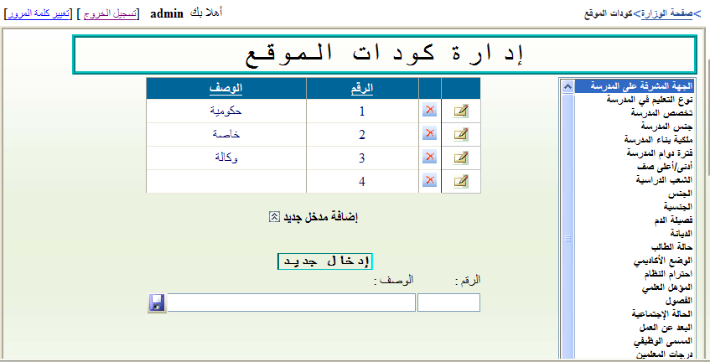When we enter to the site as ministry first of all it mange the site codes , all tables of the combo boxes in the site appear here and we can make changes and updates to them through this page .

*For example* :

Type of education in the school : scientific , literature , industrial , … etc .

Nationality : Palestinian , Jordanian … etc .

Qualifications : illiterate , B.Cs , MCs, PhS … etc .

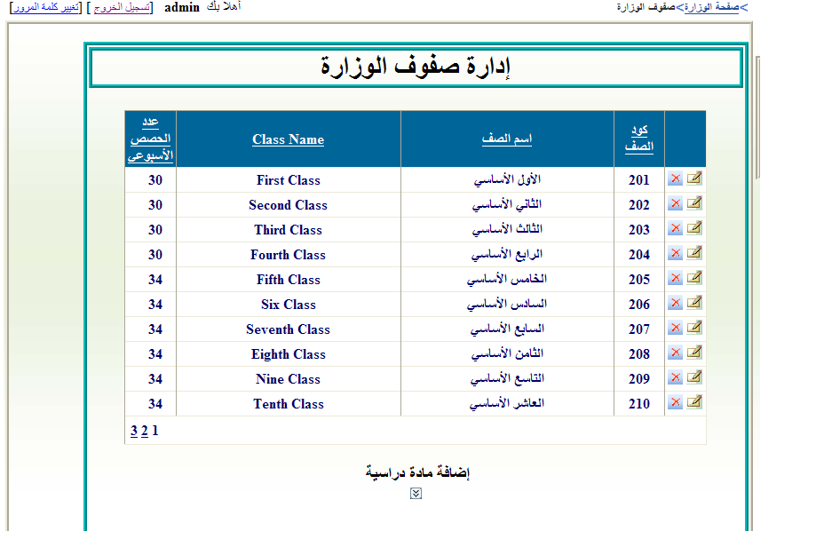 And many other things .

* ***Ministry Class Management :***

The ministry can manage the classes in each school , and distributing number of lectures of each class , in some situations it can add a class or delete it or make any change to that class .

* ***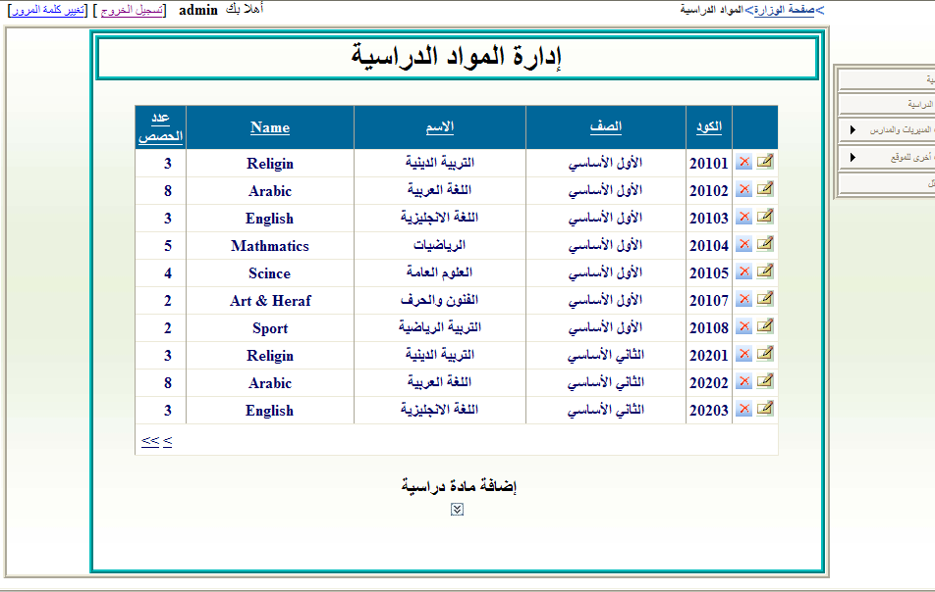Subjects Management :***

This is the most important thing the ministry can decide it , the ministry should distribute the materials to each class and the number of lectures to each material , it can add , delete , update any material to any class .

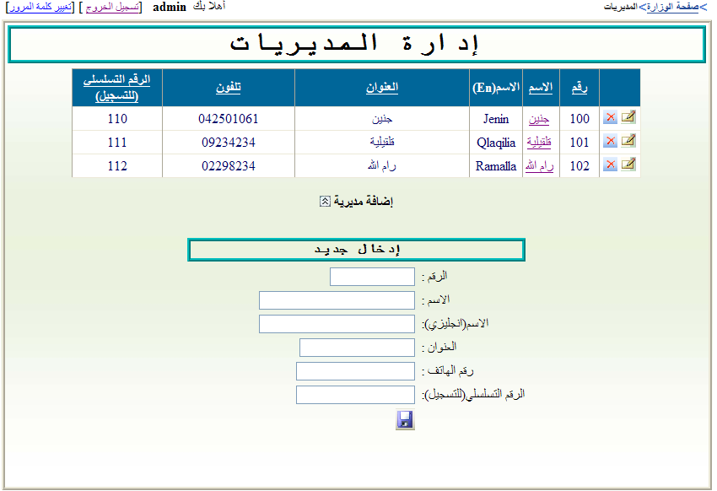

* ***Directories Management :***

Through this page the ministry can add, delete and update any directorate in Palestine . In some situations the ministry need to add a new directorate we enable it to do so easily .

* ***School Management :***

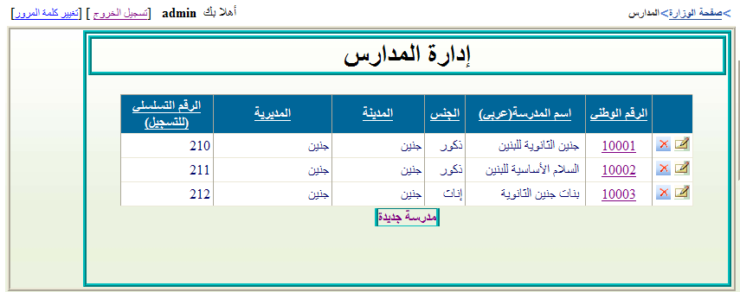Here the ministry add any new school established in the country to any directorate and give it gender ( Boys , Girls ) , through this page it can enter any school in any directorate and make changes in it and also reach to its employees and students , and show all information about them and add some information to employees like degrees and it can do many other things .

* ***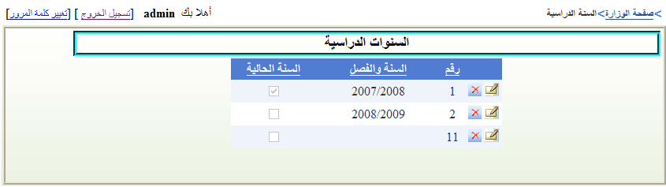Study Year Management & database backup :***

From this point the ministry decide the current year being started the studding year . When the ministry do this change we allow it to make backup to the last database it has .

*Directorates :*

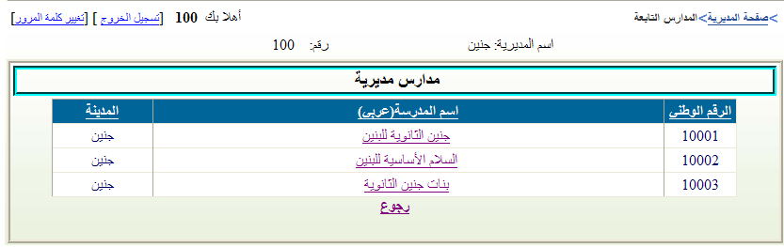 When the user enter to the site as directorate it first face the schools which its responsible about them , after that it can select a school and manage it as needed like displaying its employees and reach to information about them , also it can list the students in that school and reach to information about them , also it can manage the information about the school it self for example add a new school to the directorate or do any updates needed .

The directorate page can only be reached either by the directorate itself or by the ministry only .

*Schools*

The school pages are the most important part of the site those pages can only be entered by ministry , directorate and school itself. But employees and students in that school can’t enter .

School Pages in our site are divided into four categories :

1. *School information :*

This page include information about the school itself education type in this school , when this school was established , its address , the name of its manager … etc .

1. *Employees Management :*

When the user enter to the site as a school and choose employees management , names of all employees in that school are appear in a list , then when the user choose a certain employee , the page of this employee appear .

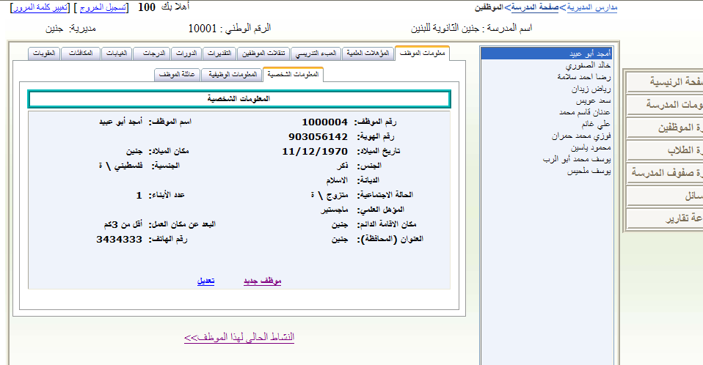 In the employee page the school can change many things like information about employee family and employee teaching ( the load of the teacher at this school ) , and terms the employee had and many other things .

In the other side there is information the school can’t make any change to like employees transferring and the degrees the employee should has , Qualifications , awarding and penalties .

1. *Students Managements :*

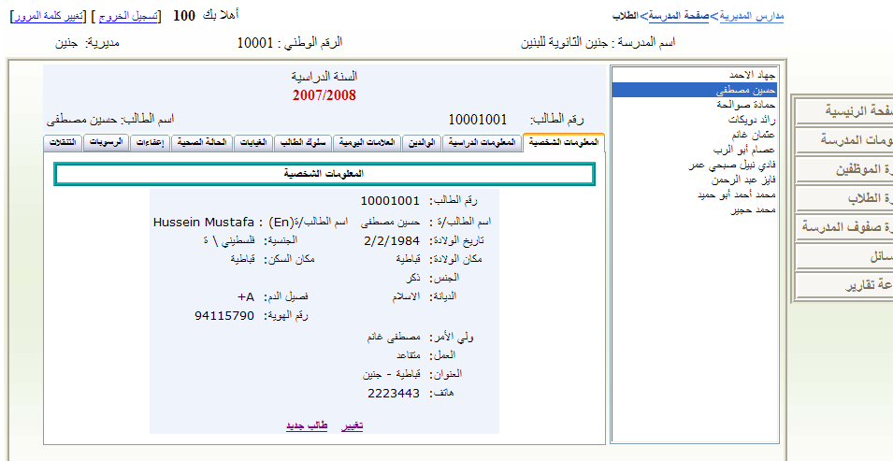 Like employees each school has its students . Through this page the school reach to the information about all students studying at , at the current year .

The information about each student include students personal , education , family and his grades in this year , his behavior and absence , also include his dispensing and transferring and many other things .

The school is allowed to make certificates to all students , first semester certificate , yearly result certificate , rating certificate and many other reports needed to be established we will discuss later .

The school has all proprieties to do any change or addition , deletion to these information .

1. *School Class Management*

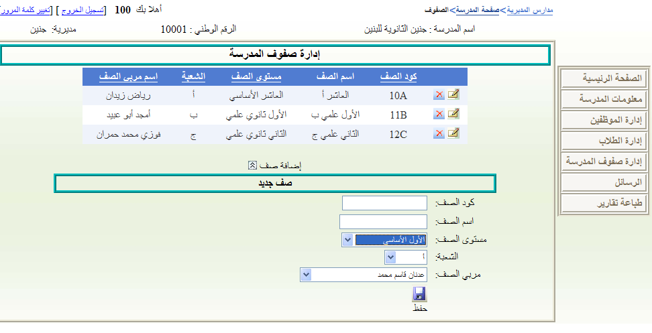Here the school manager decide the classes in the school , the lowest class and the highest one , and distribute the teachers on the classes i.e : each class has a teacher responsible about it called

”Class Educator ” .

Employees

In the employee pages he can enter to see information about him like personal information , job information , his family , his qualifications , ratings , terms , degrees , absence , awarding and penalties .

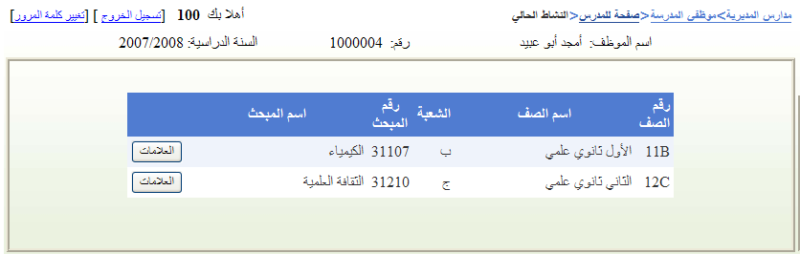 Also through this side the employee can manage his subjects given to the students and the classes he teach .

From here ha can add the grades of the students to a certain subject he gives to a certain class .

If the teacher is responsible about a class i.e if he is a class educator he can change absence of the

students in this class, ratings and his notes about each student .

All higher proprieties than employee can reach to these pages and change on them , ministry , directorate and school but the employee himself can’t change any thing just read only .

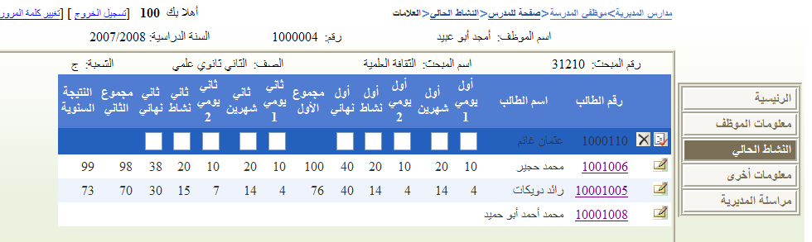

Students

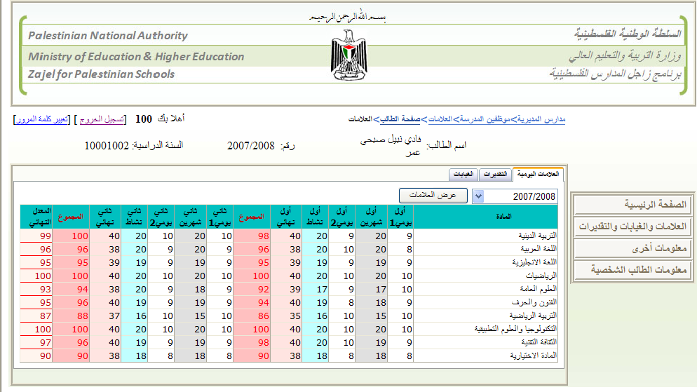 All the users of the site can reach to this point , especially student himself . The student need to know information stored about him , from here he can know every thing about his personal information , education information , family , his dispensing , failing , transferring , absence , also he can reach to the most important thing , his grades from first exam to the final exam . This technique allow the student father to show all his son information in his school .

Crystal Reports :

In our site we used crystal report 10 in visual studio 2005 program . In school there are too much reports needed , like certificates to students and transferring papers and many other reports .

First of all students at the end of each semester need a certificate for his marks from his school , these certificates are in two forms , the first one for the first semester and the second one for the tow semester altogether called “ yearly result ” .

Anther certificates are rating certificates , those given to students having highest grades in the school .

Also when the student want to transfer from one school to anther he need a document which is signatured from the directorate , this form of the document include information about the student who want to transfer and information about both schools .

Lastly , there are some forms with title **“ To whom who concern ”** these include information needed by the student about his state as official paper to be given to official directions , some of these forms are :   
“ students confirming ”, “class finishing” , … and many other reports .

Those reports can be printed by school to either to all students in a certain class it can specify or to one student it choose his name from his class .

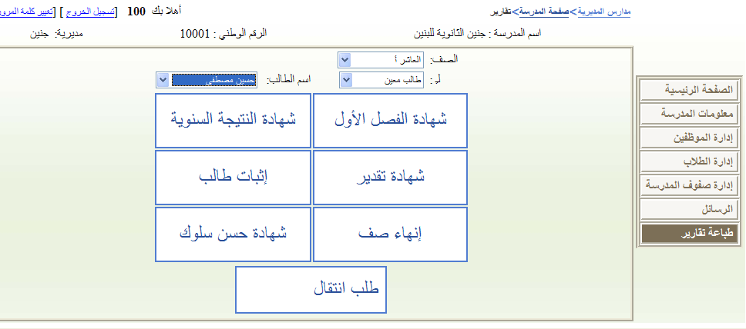

The Database

The database in our site is too large because we want to cover all information needed to deal with students , employees , schools , directorates and ministry .

So first we built the relations and entities as we said we have five main entities are : students , teachers , schools , directorates and ministry .

We work the database on SQL SERVER 2005 . The ministry can make a backup to the data base at the end of each study year by changing the current year here the data base is stored .

In the figure (2) we have the Entity Relation Model (ERM) that show all tables and relations we used , also we have some tables deals with combo boxes in the size like sex , nationality , …etc .

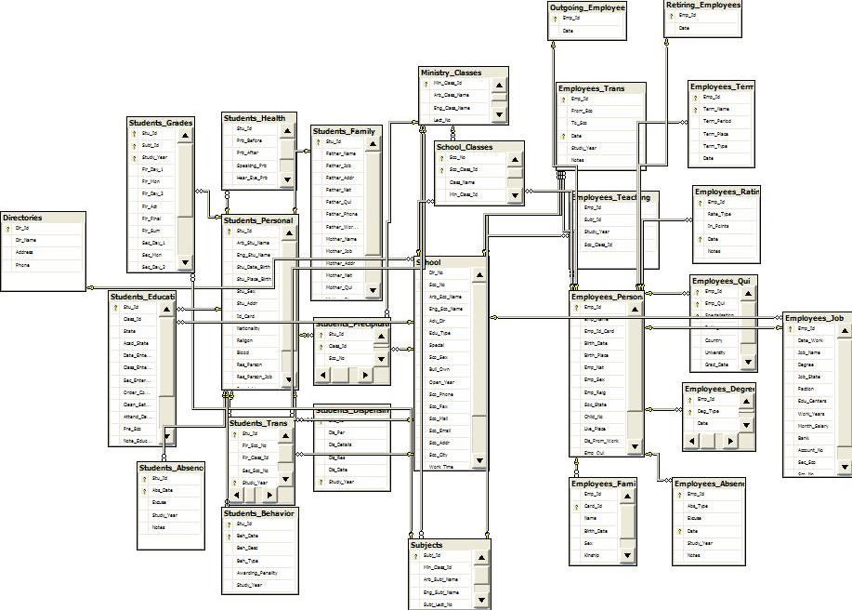

**Figure (2): The Relations Diagram of The Database**

**These are tables we used :**

**Directorates Table : جدول المديريات**

|  |  |  |  |
| --- | --- | --- | --- |
| Dir\_Id | Dir\_Name | Address | Phone |
| int | varchar(50) | varchar(50) | varchar(50) |
|  |  |  |  |

**Ministry Classes Table : جدول صفوف الوزارة**

|  |  |  |  |
| --- | --- | --- | --- |
| Min\_Class\_Id | Arb\_Class\_Name | Eng\_Class\_Name | Lect\_No int |
| int | varchar(50) | varchar(50) | Int |
| كود صف الوزارة | اسم الصف بالعربي | اسم الصف بالانجليزي | عدد الحصص |

**School Classes Table : جدول صفوف المدرسة**

|  |  |  |  |  |  |
| --- | --- | --- | --- | --- | --- |
| Sco\_Class\_Id | Class\_Name | Min\_Class\_Id | Section | Class\_Educ\_Id | Sco\_No |
| varchar(50) | varchar(50) | int | varchar(50) | int | int |
| رقم صف المدرسة | اسم الصف | كود صف الوزارة | الشعبة | رقم مربي الصف | الرقم الوطني للمدرسة |

**Subjects Table : جدول المواد الدراسية**

|  |  |  |  |  |  |
| --- | --- | --- | --- | --- | --- |
| Sco\_Class\_Id | Class\_Name | Min\_Class\_Id | Section | Class\_Educ\_Id | Sco\_No |
| varchar(50) | varchar(50) | int | varchar(50) | int | int |
| رقم صف المدرسة | اسم الصف | كود صف الوزارة | الشعبة | رقم مربي الصف | الرقم الوطني للمدرسة |

***School Table : جدول المدرسة***

|  |  |  |  |  |  |  |  |  |  |
| --- | --- | --- | --- | --- | --- | --- | --- | --- | --- |
| Dir\_No | Sco\_No | Arb\_Sco\_ Name | Eng\_Sco\_ Name | Adv\_Dir | Edu\_Type | Special | Sco\_Sex | Buil\_Own | Open\_Year |
| int | Int | varchar(50) | varchar(50) | varchar(50) | varchar(50) | Varchar (50) | Varchar (50) | varchar(50) | int |
| رقم المديرية | الرقم الوطني | اسم المدرسة بالعربي | اسم المدرسة بالانجليزي | الجهة المشرفة على المدرسة | نوع التعليم | التخصص | جنس المدرسة | ملكية البناء | سنة الافتتاح |
| Sco\_ Phone | Sco\_Fax | Sco\_Mail | Sco\_Email | Sco\_Addr | Sco\_City | Work\_ Time | Sco\_Dir\_Name | Min\_Class | Max\_ Class |
| varchar(50) | Varchar (50) | varchar(50) | varchar(50) | varchar(50) | varchar(50) | Varchar (50) | Varchar (50) | varchar(50) | varchar(50) |
| التلفون | الفاكس | ص.ب | الايميل | العنوان | المحافظة | فترة الدوام | اسم مدير المدرسة | ادنى صف | اعلى صف |

**Students Tables : جداول الطلاب**

**Students\_Personal جدول المعلومات الشخصية للطلاب**

|  |  |  |  |  |  |  |  |  |  |
| --- | --- | --- | --- | --- | --- | --- | --- | --- | --- |
| Stu\_Id | Arb\_Stu\_Name | Eng\_Stu\_ Name | Stu\_Date\_ Birth | Stu\_Place\_Birth | Stu\_Sex | Stu\_ Addr | Id\_Card | Nationality | Religon |
| int | Varchar (MAX) | Varchar (MAX) | Varchar (50) | Varchar (50) | Varchar (50) | Varchar (50) | Varchar (50) | Varchar (50) | varchar(50) |
| رقم الطالب | اسم الطالب بالعربي | اسم الطالب بالانجليزي | تاريخ الميلاد | مكان الولادة | الجنس | العنوان | رقم الهوية | الجنسية | الديانة |
| Blood | Res\_ Person | Res\_Person\_Job | Res\_Addr | Res\_ Phone |  | | | | |
| varchar(50) | Varchar (50) | Varchar (50) | Varchar (50) | Varchar (50) |
| فصيلة الدم | اسم ولي الأمر | وظيفة ولي الأمر | عنوان ولي الأمر | هاتف ولي الأمر |

**Students\_Education جدول المعلومات الدراسية للطلاب**

|  |  |  |  |  |  |  |  |  |  |
| --- | --- | --- | --- | --- | --- | --- | --- | --- | --- |
| Stu\_Id | Class\_Id | State | Acad\_ State | Date\_Enter\_Sco | Class\_Enter\_ Sco | Order\_Consider | Clean\_Setting | Attend\_ Days\_No | Pre\_ Sco |
| int | Varchar (50) | Varchar (50) | Varchar (50) | varchar(50) | varchar(50) | varchar(50) | varchar(50) | int | varchar(50) |
| رقم الطالب | رقم الصف | الحالة | الوضع الأكاديمي | تاريخ دخول المدرسة | الصف الذي دخله | احترام النظام | النظافة والترتيب | عدد ايام حضور الطالب | المدرسة السابقة |
| Note\_Educator | Note\_Mngr | Study\_ Year | Sco\_No |  |  |  |  |  |  |
| Varchar (MAX) | Varchar (MAX) | Varchar (50) | int |  |  |  |  |  |  |
| ملاحظات مربي الصف | ملاحظات مدير المدرسة | العام الدراسي | المدرسة الحالية |  |  |  |  |  |  |

**Students\_Family جدول معلومات والدي الطالب**

|  |  |  |  |  |  |  |  |
| --- | --- | --- | --- | --- | --- | --- | --- |
| Stu\_Id | Father\_ Name | Father\_Job | Father\_Addr | Father\_Nat | Father\_Qui | Father\_Phone | Father\_Work\_Place |
| int | Varchar (50) | Varchar  (50) | Varchar  (50) | Varchar  (50) | Varchar (50) | varchar(50) | varchar (50) |
| رقم الطالب | اسم الأب | وظيفة الأب | عنوان الأب | الجنسية | مؤهلاته العلمية | هاتف الأب | مكان عمل الأب |
| Mother\_Name | Mother\_ Job | Mother\_ Addr | Mother\_Nat | Mother\_ Qui | Mother\_Phone | Mother\_Work\_Place | Notes |
| Varchar (50) | Varchar (50) | Varchar (50) | Varchar (50) | Varchar (50) | Varchar (50) | varchar(50) | Varchar (MAX) |
| اسم الأم | وظيفة الأم | عنوان الأم | الجنسية | مؤهلاتها العلمية | هاتف الأم | مكان عمل الأم | ملاحظات |

**Students\_Grades جدول علامات الطالب**

|  |  |  |  |  |  |  |  |  |  |
| --- | --- | --- | --- | --- | --- | --- | --- | --- | --- |
| Stu\_Id | Subj\_Id | Study\_Year | Fir\_Day\_1 | Fir\_Mon | Fir\_Day\_2 | Fir\_Act | Fir\_Final | Fir\_Sum | **Final**  **Float**  **نتيجة** **سنوية** |
| int | int | varchar(50) | float | float | float | float | float | float |
| رقم الطالب | رقم المبحث | العام الدراسي | أول يومي 1 | أول شهرين | أول يومي 2 | أول نشاط | أول نهائي | أول مجموع |
|  | | | Sec\_Day\_1 | Sec\_Mon | Sec\_Day\_2 | Sec\_Act | Sec\_Final | Sec\_Sum |
| float | float | float | float | float | float |
| ثاني يومي 1 | ثاني شهرين | ثاني يومي 2 | ثاني نشاط | ثاني نهائي | ثاني مجموع |

**Students\_Behavior جدول سلوك الطالب**

|  |  |  |  |  |  |
| --- | --- | --- | --- | --- | --- |
| Stu\_Id | Beh\_Date | Beh\_Desc | Beh\_Type | Awarding\_Penality | Study\_Year |
| int | varchar(50) | Varchar (MAX) | varchar(50) | varchar(50) | Varchar (50) |
| رقم الطالب | تاريخ السلوك | وصف السلوك | نوع السلوك | العقوبة \ المكافئة المترتبة | العام الدراسي |

**Students\_Absence جدول غيابات الطالب**

|  |  |  |  |  |
| --- | --- | --- | --- | --- |
| Stu\_Id | Abs\_Date | Excuse | Notes | Study\_Year |
| int | varchar(50) | varchar(50) | varchar(MAX) | varchar(50) |
| رقم الطالب | تاريخ الغياب | العذر | ملاحظات | العام الدراسي |

**Students\_Health جدول الحالة الصحية للطالب**

|  |  |  |  |  |  |  |
| --- | --- | --- | --- | --- | --- | --- |
| Stu\_Id | Prb\_Before | Prb\_After | Speaking\_Prb | Hear\_Eye\_Prb | Other\_Prb | Notes |
| Int | varchar(MAX) | varchar(MAX) | varchar(MAX) | varchar(MAX) | Varchar  (MAX) | Varchar  (MAX) |
| رقم الطالب | مشاكل سابقة | مشاكل أثناء الدراسة | النطق | السمع | مشاكل أخرى | ملاحظات |

**Students\_Dispensing جدول اعفاءات الطالب**

|  |  |  |  |  |  |
| --- | --- | --- | --- | --- | --- |
| Stu\_Id | Dis\_Per | Dis\_Details | Dis\_Res | Dis\_Date | Study\_Year |
| int | float | varchar(MAX) | varchar(50) | varchar(50) | varchar(50) |
| رقم الطالب | نسبة الاعفاء | تفاصيل الاعفاء | سبب العفاء | تاريخ الاعفاء | العام الدراسي |

**Students\_Precipitate جدول رسوبات الطالب**

|  |  |  |  |
| --- | --- | --- | --- |
| Stu\_Id | Class\_Id | Sco\_No | Study\_Year |
| int | int | int | varchar(50) |
| رقم الطالب | رقم الصف الذي رسب به | رقم المدرسة | العام الدراسي |

**Students\_Transferring جدول تنقلات الطالب**

|  |  |  |  |  |
| --- | --- | --- | --- | --- |
| Stu\_Id | Fir\_Sco\_No | Fir\_Class\_Id | Sec\_Sco\_No | Study\_Year |
| int | int | int | int | varchar(50) |
| رقم الطالب | من مدرسة | من صف | إلى مدرسة | العام الدراسي |

**Employees Tables : جداول الموظفين**

**Employees\_Personal جدول المعلومات الشخصية للموظفين**

|  |  |  |  |  |  |  |  |  |
| --- | --- | --- | --- | --- | --- | --- | --- | --- |
| Emp\_ Id | Emp\_ Name | Emp\_Id\_ Card | Birth\_ Date | Birth\_Place | Emp\_Nat | Emp\_ Sex | Emp\_ Relg | Soc\_State |
| int | Varchar (50) | Varchar (50) | Varchar (50) | Varchar (50) | Varchar (50) | varchar(50) | Varchar (50) | varchar(50) |
| رقم الموظف | اسم الموظف | رقم الهوية | تاريخ الميلاد | مكان الولادة | الجنسية | الجنس | الديانة | الحالة الاجتماعية |
| Live\_ Place | Dis\_From\_Work | Emp\_Qui | Emp\_Addr | Emp\_Phone | Child\_ No |
| Varchar (50) | Varchar (50) | Varchar (50) | Varchar (50) | varchar(50) | int |
| مكان الاقامة | البعد عن مكان العمل | مؤهلات الموظف | العنوان | الهاتف | عدد الأبناء |

**Employees\_Job جدول المعلومات الوظيفية للموظفين**

|  |  |  |  |  |  |  |  |  |
| --- | --- | --- | --- | --- | --- | --- | --- | --- |
| Emp\_ Id | Date\_  Work | Job\_Name | Degree | Job\_State | Faction | Edu\_  Centers | Work\_  Years | Month\_  Salary |
| int | Varchar (50) | Varchar (50) | Varchar (50) | varchar(50) | Varchar (50) | varchar(50) | varchar(50) | Varchar  (50) |
| رقم الموظف | تاريخ التعيين | المسمى الوظيفي | الدرجة | الوضع الوظيفي | الفئة | المراكز التعليمية | سنوات الخدمة | الراتب الشهري |
| Account\_No | Bank | Sec\_Sco | Sco\_No |
| Varchar  (50) | Varchar  (50) | Varchar  (50) | int |
|  | البنك | المدرسة الثانية اذا كان نصف مركز | الرقم الوطني للمدرسة الحالية |

**Employees\_Family جدول عائلة الموظف**

|  |  |  |  |  |  |  |
| --- | --- | --- | --- | --- | --- | --- |
| Emp\_ Id | Card\_Id | Name | Birth\_Date | Sex | Kinship | Job |
| int | varchar(50) | varchar(50) | varchar(50) | varchar(50) | varchar(50) | varchar(50) |
| رقم الموظف | رقم الهوية | الاسم | تاريخ الميلاد | الجنس | صلة القرابة | المهنة |

**Employees\_Quilifications جدول المؤهلات العلمية للموظف**

|  |  |  |  |  |  |  |
| --- | --- | --- | --- | --- | --- | --- |
| Emp\_ Id | Emp\_Qui | Specialisation | Rating | Country | University | Grad\_Date |
| int | varchar(50) | varchar(50) | varchar(50) | varchar(50) | varchar(50) | varchar(50) |
| رقم الموظف | المؤهل العلمي | التخصص | التقدير | الدولة | الجامعة | تاريخ التخرج |

**Employees\_Teaching جدول العبء التدريسي للموظف**

|  |  |  |  |
| --- | --- | --- | --- |
| Emp\_ Id | Subj\_Id | Study\_Year | Sco\_Class\_Id |
| int | int | varchar(50) | varchar(50) |
| رقم الموظف | رقم المبحث | العام الدراسي | رقم صف المدرسة |

**Employees\_Transferring جدول تنقلات الموظف**

|  |  |  |  |  |  |
| --- | --- | --- | --- | --- | --- |
| Emp\_ Id | From\_Sco | To\_Sco | Date | Study\_Year | Notes |
| int | int | int | varchar(50) | varchar(50) | varchar(MAX) |
| رقم الموظف | من مدرسة | إلى مدرسة | التاريخ | العام الدراسي | ملاحظات |

**Employees\_Ratings جدول تقديرات الموظف**

|  |  |  |  |  |
| --- | --- | --- | --- | --- |
| Emp\_ Id | Rate\_Type | In\_Points | Date | Notes |
| int | varchar(50) | int | varchar(50) | varchar(50) |
| رقم الموظف | نوع التقدير | بالنقاط | التاريخ | ملاحظات |

**Employees\_Terms جدول دورات الموظف**

|  |  |  |  |  |
| --- | --- | --- | --- | --- |
| Emp\_ Id | Term\_Name | Term\_Period | Term\_Place | Date |
| int | varchar(50) | varchar(50) | varchar(50) | varchar(50) |
| رقم الموظف | مسمى الدورة | فترة الدورة | مكان انعقادها | التاريخ |

**Employees\_Degrees جدول درجات الموظف**

|  |  |  |  |
| --- | --- | --- | --- |
| Emp\_ Id | Deg\_Type | Date | Notes |
| int | varchar(50) | varchar(50) | varchar(MAX) |
| رقم الموظف | نوع الدرجة | تاريخ الاستحقاق | ملاحظات |

**Employees\_Absence جدول غيابات الموظف**

|  |  |  |  |  |
| --- | --- | --- | --- | --- |
| Emp\_ Id | Excuse | Date | Study\_Year | Notes |
| int | varchar(50) | varchar(50) | varchar(50) | varchar(MAX) |
| رقم الموظف | العذر (ان وجد) | التاريخ | العام الدراسي | ملاحظات |

**Employees\_Awardings جدول مكافئات الموظف**

|  |  |  |  |  |
| --- | --- | --- | --- | --- |
| Emp\_ Id | Awa\_Res | Awa\_Type | Awa\_Date | Study\_Year |
| int | varchar(50) | varchar(50) | varchar(50) | varchar(50) |
| رقم الموظف | سبب المكافئة | نوع المكافئة | التاريخ | العام الدراسي |

**Employees\_Penality جدول عقوبات الموظف**

|  |  |  |  |  |
| --- | --- | --- | --- | --- |
| Emp\_ Id | Pen\_Res | Pen\_Type | Pen\_Date | Study\_Year |
| int | varchar(50) | varchar(50) | varchar(50) | varchar(50) |
| رقم الموظف | سبب العقوبة | نوع العقوبة | التاريخ | العام الدراسي |

And in addition to these tables we add tables used in combo boxes like academic state for the student this table will contain three items , this is the table as an example of what we did :

**Student Acadimic State جدول حالة الطالب الأكاديمية**

|  |  |
| --- | --- |
| Id | Name |
| 1 | ناجح |
| 2 | راسب |
| 3 | مكمل |
|  |  |

And many other tables stored like this .

In the database also we have anther two tables for the communications between entities of the site as we will explain later .

The first table if for the ministry communications :

|  |  |  |  |  |
| --- | --- | --- | --- | --- |
| Ser\_No | Dir\_Sender | Date | Msg | New |
| int | int | smalldatetime | text | bit |
| رقم متسلسل | المديرية المرسلة | التاريخ | نص الرسالة | هل هي جديدة أم لا |

The Second table is for all other communications :

|  |  |  |  |  |  |  |  |
| --- | --- | --- | --- | --- | --- | --- | --- |
| Ser\_No | From\_  Type | Msg\_  From | To\_Type | Msg\_To | Date | Exp\_Date | Msg |
| int | Varchar  (50) | Varchar  (50) | Varchar  (50) | Varchar  (50) | Small  datetime | Varchar  (50) | text |
| رقم متسلسل | نوع المرسل | اسم المرسل | نوع المرسل اليه | اسم المرسل اليه | التاريخ | تاريخ انتهاء الرسالة | نص الرسالة |

Lastly what we want to say about the use of the database is using what is called **stored procedure** this technique allow us to make query in a simple way to use more than one table together .

Communications In the site

As we see in usual sites that there are techniques allow the users to send messages between them , so we used this idea in our site because its one of the most important thing needed in this environment of working .

In the hierarchal we display previous there must be connections between each other i.e ministry with its directorates , directorates with its schools , directorates with its employees , directorates with its students , schools with there directorate , directorate with ministry , …etc .

Figure (3) display the type of connections we allow the users to use in the site .

Ministry

Directorate

School

Teachers

Students



C:\Program Files\Microsoft Office\MEDIA\OFFICE12\AutoShap\BD18215_.wmf

C:\Program Files\Microsoft Office\MEDIA\OFFICE12\AutoShap\BD18215_.wmf

C:\Program Files\Microsoft Office\MEDIA\OFFICE12\AutoShap\BD18215_.wmfC:\Program Files\Microsoft Office\MEDIA\OFFICE12\AutoShap\BD18215_.wmf

**Figure (3): The Communications Between Entities In The Site**

In the main of each entity of the five ; ministry, directorate, school , teachers and students we display a note with the number of messages in box has been received .

In the ministry inbox there are three types : receiving messages , sending messages and new message . In the receiving we put the messages received from directorates , in the sending ones we put the messages to different entities in the site ; to directorate , to school , to teachers and to students . In the new messages the ministry write the message to be send to one or all entities .

In the Directorate ; the receiving messages will be from ministry , anther directorate , schools followed this directorate , teachers in those schools . In sending tab we have the messages send to schools followed to this directorate , or to teachers in those schools , or to students in those school , and lastly we have new messages to be sent .

School messages contain messages from ministry , directorate responsible abut this school and from anther school . Also it can send messages to the higher levels .

Employees messages include messages from ministry , directorate . And finally students messages include messages from ministry or from directorate .

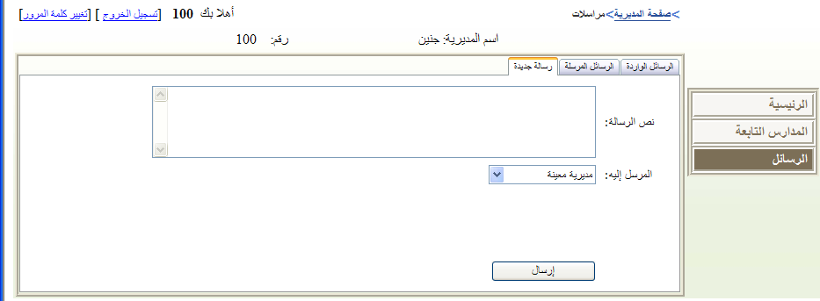

Search Engine:

We add search feature in this site , and this search allow to the ministry , directorates , schools , and teachers to search about a student or to search about the teachers .

For example ; if the directorate want to find a teacher it can search for him also if it want to find a student it can search about him also .

Programs and tools used

In programming and designing our site we used Asp.Net using C# in visual studio 2005 mainly . why ?

Because this languages is so simple to deal with and it provide many tools to be used in the site in the simple way . Anther important reason is the big size of site database that maybe difficult to deal with this data in other languages like PHP , and because the students in normally don’t use this language in our department and they concern in PHP languages we choose to work in this side .

In the database we used SqlServer2005 ; this program is simple to deal with the database stored in , and as we said our site database is too large it exceed 50 tables .

ASP.Net AJAX

Anther tool we have used is Ajax ; this is a very important tool and easy to deal with in designing the site , there are many components we used in our site from ajax tool kit ; as **tabs** this allow us use tab in some forms  , **collapsible panel** ; this is used to auto hide and show a panel when we press on extend button

**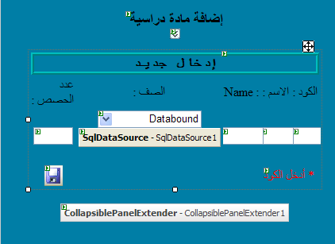**

Extended Button

Collapse Panel

And we used **Confirm button Extender**  this allow us to add a confirmation message when we press on a certain button .

**Filtered Text Box Demonstration**  is anther component provided by ajax which allow us to filter text box on certain type of data for example student\_Id\_Card text box we can write just numbers in it we cant write characters .

**Masked Edit Demonstration** this tool allow us to enter date as 99/99/9999 format and show this --/--/---- when the text box entered .

**Calendar Extender**  which show the calendar on the date text box .

And there are many other tools we had used and we will not talk about them know .

Security

**The most important** thing in our site is **the security** as we said and show in the previous in the ministry of education environment the five entity we have each one has its one site , and he can enter to it with his own username and password , the ministry enter to all sites below i.e directorates , schools , teachers and students . And the directorate can enter to its site and to the school and teachers and students , it can’t enter to the ministry site . The school can enter to its site and to its employees and its students . The employee can enter just to his site and to his students site . And the students only enter to there site .

Also there are many features the user can user like : **logup** for new user may be one of four ; Directorate , School, teacher , student (or his father ) , **Password Recovery** , **Change Password** , ..etc .

Also to provide advanced security we used tow more features :

1. ***Using HTTPS security :*** we used this feature when we want to transfer pages contain passwords , between client and server for example login page . So we used a free trial certificate that allow us to use HTTPS with IIS server and we can run the site by using any server .
2. ***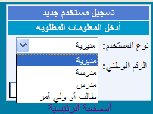 No Concurrent Login :*** No concurrent same user can enter to the site at the same time from different locations . Unfortunately using sql server with asp.net doesn’t call the global function (session\_end) so when we want to check if a user had logged out from his session , the session doesn’t be killed and he remains online so that we use cache with timer feature provided in asp.net .

Conclusion

When we began to choose an idea to work with in our graduation project we decided to choose one that hasn’t been made up to know , and that idea can be applied in the working life and make benefit to all layers of the community especially those dealing with schools employees and students .

For Ministry of Education And Higher Education this site allow them to be connected with all directorates and schools in those directorates and employees and students in those schools , so it make it easy to reach to all information about them and make any change to those information , or to send messages to them . And many other benefits this site apply to the ministry .

Here in Palestine the Ministry of Education doesn’t has any method like this site .

For Directorate this site also make there job easier to deal with its schools and teachers in those schools and also students . In the past if the student want a certificate for a previous class he had finished in the past the method was difficult to the employees in the directorate to give him this certificate , throw this site the employee in the directorate can enter to the study year this student finish his class and print his certificate as report. Also this can be done throw his school .

There are too many benefits our site submit to directorate we can’t say them all , just the most important , it can also make transferring to the employees and students .

To the schools the most important entity in this site because the big one has students and teachers benefit from the site , the school can distribute the load of its teachers i.e what are the subjects the teacher give and the class he teach and how many lectures he give to each class and it can issue the certificates to all students studying in it . And can give student some reports he need as Proof demanded student (اثبات طالب ) .

To teachers ; they can manage there class and students if they are classes educators , they manage there grades and absences and ratings and many other things . the teacher also can show all his stored information about him either the ministry or the directory or the school store them . Also the teacher instead of writing the certificate to his students may be more than 30 certificates , he can print them in one minuet .

To the student ; he can see all his information stored , and he can see his marks daily , monthly and yearly without any effort . And his father can follow his son or daughter without any effort .

So this our work and this what we can do in the limited time we have, a site serve all those people and communities in a simple way . We will be a human being that can’t make things in a complete form . we thanks the god for attention and gave us the capacity to do that .

Lastly we submit our thanks to the teaching stuff of the computer engineering department in An Najah National University , because they gave us all there attention and there knowledge and there encourages ; **Dr.Raed Al Qadi , Dr.Laui Malhees , Eng. Haya Samanee** , and all other employees in this department .