بسم الله الرحمن الرحيم

An Najah National University
Faculty Of Engineering
Computer Engineering Department

Software Graduation Project
Documentation

1st semester
2006-12-21

Network Management System
(NMS)

Contents:

- SNMP overview.
- The project implementation.
- Project's user manual.

Instructor:

- Dr.: Laui Malhees.

Prepared by:

- Fuad Nassar
- Ali Hussien.
Overview:
What is SNMP:

The Simple Network Management Protocol (SNMP) is an application layer protocol that facilitates the exchange of management information between network devices. It is part of the Transmission Control Protocol/Internet Protocol (TCP/IP) protocol suite. SNMP enables network administrators to manage network performance, find and solve network problems, and plan for network growth.

Two versions of SNMP exist: SNMP version 1 (SNMPv1) and SNMP version2 (SNMPv2). Both versions have a number of features in common, but SNMPv2 offers enhancements, such as additional protocol operations.

Basic Components:

An SNMP-managed network consists of three key components: managed devices, agents, and network-management systems (NMSs).

A managed device is a network node that contains an SNMP agent and that resides on a managed network. Managed devices collect and store management information and make this information available to NMSs using SNMP. Managed devices, sometimes called network elements, can be routers
and access servers, switches and bridges, hubs, computer hosts, or printers.
An agent is a network-management software module that resides in a managed device. An agent has local knowledge of management information and translates that information into a form compatible with SNMP.

An NMS executes applications that monitor and control managed devices. NMSs provide the bulk of the processing and memory resources required for network management. One or more NMSs must exist on any managed network.

The following figure will make the image clear about the network management job , and how the administrator can managed and monitoring the network devices , and show the place of the databases and agents.

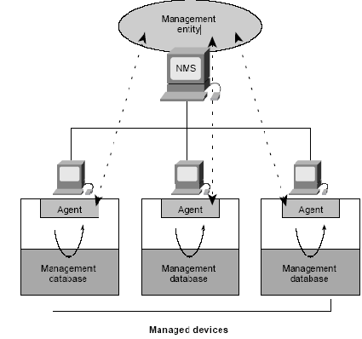
FIG 1: Network Management System.

Basic Commands:

Managed devices are monitored and controlled using four basic SNMP commands: read, write, trap , and traversal operations.
The read command is used by an NMS to monitor managed devices. The NMS examines different variables that are maintained by managed devices.
The write command is used by an NMS to control managed devices. The NMS changes the values of variables stored within managed devices.
The trap command is used by managed devices to asynchronously report events to the NMS. When certain types of events occur, a managed device sends a trap to the NMS.
Traversal operations are used by the NMS to determine which variables a managed device supports and to sequentially gather information in variable tables, such as a routing table.

Management Information Base:

A Management Information Base (MIB) is a collection of information that is organized hierarchically.
MIBs are accessed using a network-management protocol such as SNMP. They are comprised of managed objects and are identified by object identifiers.

A managed object (sometimes called a MIB object, an object, or a MIB) is one of any number of specific characteristics of a managed device.

Managed objects are comprised of one or more object instances ,which are essentially variables.

Two types of managed objects exist: scalar and tabular. Scalar objects define a single object instance.
Tabular objects define multiple related object instances that are grouped in MIB tables.

An example of a managed object is at input , which is a scalar object that contains a single object instance, the integer value that indicates the total number of input AppleTalk packets on a router interface.

An object identifier (or object ID) uniquely identifies a managed object in the MIB hierarchy. The MIB hierarchy can be depicted as a tree with a nameless root, the levels of which are assigned by different organizations.
The top-level MIB object IDs belong to different standards organizations, while lower-level object IDs are allocated by associated organizations.
Vendors can define private branches that include managed objects for their own products. MIBs that have not been standardized typically are positioned in the experimental branch.

The managed object at input can be uniquely identified either by the object
name—iso.identified organization.dod.internet.private.enterprise.cisco.temporary
variables.AppleTalk.at input—or by the equivalent object descriptor, 1.3.6.1.4.1.9.3.3.1.

MIBs’ groups:

- MIB-II system group (1.3.6.1.2.1.1)
- Interfaces group (1.3.6.1.2.1.2)
- Address Translation group (1.3.6.1.2.1.3)
- Internet Protocol group (1.3.6.1.2.1.4)
- Internet Control Message Protocol group (1.3.6.1.2.1.5)
- Transmission Control Protocol group (1.3.6.1.2.1.6)
- User Datagram Protocol group (1.3.6.1.2.1.7)
- Exterior Gateway Protocol group (1.3.6.1.2.1.8)
- SNMP group (1.3.6.1.2.1.11)
- Transmission group (1.3.6.1.2.1.10)

SNMP Version 1:

SNMP version 1 (SNMPv1) is the initial implementation of the SNMP protocol. It is described in Request For Comments (RFC) 1157 and functions within the specifications of the Structure of Management Information (SMI). SNMPv1 operates over protocols such as User Datagram Protocol (UDP), Internet Protocol (IP), OSI Connectionless Network Service (CLNS), AppleTalk Datagram-Delivery Protocol (DDP), and Novell Internet Packet Exchange (IPX). SNMPv1 is widely used and is the de facto network-management protocol in the Internet community.

SNMPv1 and Structure of Management Information:

The Structure of Management Information (SMI) defines the rules for describing management information, using Abstract Syntax Notation One (ASN.1). The SNMPv1 SMI is defined in RFC 1155.
The SMI makes three key specifications: ASN.1 data types, SMI-specific data types, and SNMP MIB tables.

SNMPv1 and ASN.1 Data Types:

The SNMPv1 SMI specifies that all managed objects have a certain subset of Abstract Syntax Notation One (ASN.1) data types associated with them. Three ASN.1 data types are required: name, syntax, and encoding. The name serves as the object identifier (object ID). The syntax defines the data type of the object (for example, integer or string). The SMI uses a subset of the ASN.1 syntax definitions. The encoding data describes how information associated with a managed object is formatted as a series of data items for transmission over the network.

SNMPv1 and SMI-Specific Data Types:

The SNMPv1 SMI specifies the use of a number of SMI-specific data types, which are divided into two categories: simple data types and application-wide data types.

Three simple data types are defined in the SNMPv1 SMI, all of which are unique values: integers, octet strings, and object IDs. The integer data type is a signed integer in the range of –2,147,483,648 to 2,147,483,647. Octet strings are ordered sequences of 0 to 65,535 octets. Object IDs come from the set
of all object identifiers allocated according to the rules specified in ASN.1.
Seven application-wide data types exist in the SNMPv1 SMI: network addresses, counters, gauges, time ticks, opaque, integers, and unsigned integers. Network addresses represent an address from a particular
protocol family. SNMPv1 supports only 32-bit IP addresses. Counters are non-negative integers that increase until they reach a maximum value and then return to zero. In SNMPv1, a 32-bit counter size is specified. Gauges are non-negative integers that can increase or decrease but that retain the maximum
value reached. A time tick represents a hundredth of a second since some event. An opaque represents an arbitrary encoding that is used to pass arbitrary information strings that do not conform to the strict
data typing used by the SMI. An integer represents signed integer-valued information. This data type redefines the integer data type, which has arbitrary precision in ASN.1 but bounded precision in the SMI.
An unsigned integer represents unsigned integer-valued information and is useful when values are always non-negative. This data type redefines the integer data type, which has arbitrary precision in ASN.1 but bounded precision in the SMI.

SNMP MIB Tables:

The SNMPv1 SMI defines highly structured tables that are used to group the instances of a tabular object (that is, an object that contains multiple variables). Tables are composed of zero or more rows, which are indexed in a way that allows SNMP to retrieve or alter an entire row with a single Get, Get Next, or Set command.

SNMPv1 Protocol Operations:

SNMP is a simple request/response protocol. The network-management system issues a request, and managed devices return responses. This behavior is implemented by using one of four protocol operations: Get, Get Next , Set, and Trap. The Get operation is used by the NMS to retrieve the value of
one or more object instances from an agent. If the agent responding to the Get operation cannot provide values for all the object instances in a list, it does not provide any values. The Get Next operation is used by the NMS to retrieve the value of the next object instance in a table or a list within an agent. The Set
operation is used by the NMS to set the values of object instances within an agent. The Trap operation is used by agents to asynchronously inform the NMS of a significant event.

SNMP Version 2:

SNMP version 2 (SNMPv2) is an evolution of the initial version, SNMPv1. Originally, SNMPv2 was published as a set of proposed Internet standards in 1993; currently, it is a draft standard. As with SNMPv1, SNMPv2 functions within the specifications of the Structure of Management Information (SMI). In theory, SNMPv2 offers a number of improvements to SNMPv1, including additional protocol operations.

SNMP Management:

SNMP is a distributed-management protocol. A system can operate exclusively as either an NMS or an agent, or it can perform the functions of both. When a system operates as both an NMS and an agent, another NMS might require that the system query manage devices and provide a summary of the information learned, or that it report locally stored management information.

This is a fast overview about SNMP and the related topics that may help the reader to know the main feature of the SNMP, what we do in our project is an interface that take benefit of these SNMP feature and make it more user friendly to link the network's administrator with the NMS that use SNMP, and enable him to easily apply the SNMP commands on any network component.

Implementation:

As I said this project is just an interface help the administrator to apply the SNMP command using graphical user interface components to make this operations easy and fast.

We implement this interface using visual .NET 2005 framework environment using C# language as a simple strong and comprehensive object oriented language , in visual .NET 2005 all graphical user interface components that the software developer may need such as buttons , textboxes , popup menu , drag and drop controls , list view , tree view , picture boxes , and all well known components.

The fact that the C# is object orient language make it easy to benefit from the different classes that it contain , also this simplify the process of define objects and use the methods of that object in a simple way.

The most part in this language help us is the ability to define property especial in this kind of project that deal with GET and SET operations and the property definition must use those methods on C# make it easier and flexible to access (read or write) the property.

Ex:

public String Oid
{
get { return oid; }
set { oid = value; }
}

In this project we use a very useful and easy and comprehensive package that been built for .NET environment , the implementation of this project classes and objects is depend on this package and also on the visual .NET C# basics parts such that Property and interfaces that C# included, as we said this project is just an interface between the user and the NMS so the use for a ready interface package will make the developing of the project easy and fast and more reliable and easy to repair, this part of the document will include this package main features that been used in this project this package named as:
Advent Net SNMP API .NET:
A comprehensive toolkit for rapid development of SNMP-based management applications that are reliable and scalable. With well-proven APIs enriched with customer experience and an integrated set of easy-to-use tools and features, AdventNet SNMP API caters to the complete development life cycle of network element management.
Network management developers can leverage AdventNet SNMP library to build standalone and Web-based applications. The library provides many of the commonly used functions and components out-of-the-box to make the development simpler.
The core of AdventNet SNMP API .NET Edition is a set of APIs that can be integrated in any application. Built using the best software design patterns and optimized performance, it is a powerful suite to secure APIs to build cross-platform, real-time application for monitoring and tracking the performance of network elements.
Developing Management Applications:
- Using MIBs in Applications.
- Configuring SNMP Agent Parameters.
- Data Retrieval Operations.
- Data Altering Operations.
- Traps and Notifications.
- Deployment Instructions.

Using MIBs in Applications:
Loading MIBs
Applications can load the MIB modules directly from a file. The MibOperations class in the MIB support API provides the methods necessary to load and unload MIB modules in the management applications.
The method loadMibModules(String) of the MibOperations class can be used to load the MIBs. The loadMibModules method loads a set of MIB modules specified by file names separated by space.
The following piece of code illustrates how applications use MibOperations to load MIB files.

MibOperations mibops = new MibOperations();
try {
mibops.loadMibModule("RFC1213-MIB");
}
catch (Exception ex){
System.err.println("Error loading MIBs: " +ex);
}
Factors to Consider While Loading MIB Files:
The imported modules should be present in the current directory or the directory in which the MIB file is present. For example, the dependency file for the IF-MIB should be present in the same directory or in the current directory.
If the imported module is in a different directory, we can set the search path before loading the MIB. The search path can be set by using the method setMibPath(String). The API searches for the module in the path specified. Multiple paths can be given separated by a pipe(|) symbol.
The following code snippet shows how to load a MIB file which has its dependency file in another directory. For example, if the IF-MIB is in mibs directory and if SNMPv2-MIB (dependency file for IF-MIB) is in the patchmibs directory, the following code shows how to load IF-MIB.

MibOperations mibops = new MibOperations();
try {
mibops.setMibPath("C:\AdventNet\SNMPAPI\mibs\ | C:\test\patchmibs\ ");
mibops.loadMibModule("IF-MIB");
}
catch (Exception ex)
{
System.err.println("Error loading MIBs: " +ex);}
The API can load MIB files with the extensions mib, txt, and my. The method setMibFileExtension(String) can be used to set the MIB file extension for the file to be loaded.
Retrieving MIB Information:
Manipulating OIDs:
The MibModule class enables operations on the loaded MIB modules. This class instance for a MIB module is obtained by loading the MIB through the MibOperations object.
The translateToNames(String) method of the MibModule is used for translating numbered OID String to named OID String. The translateToNumbers(String) method is used for translating named OID String to numbered OID String. If the OID does not start with a dot, the standard prefix .1.3.6.1.2.1 is automatically appended and the OID String is returned.
The getInstanceString(SnmpOID) method of MibOperations class gets the instance component of the OID as a String. Instances of scalar objects are identified by the OID value of the object suffixed with ".0". Instances of columnar objects are identified by their OID values suffixed by their index components. The getInstanceString(SnmpOID, MibNode) method of MibOperations class avoids having to search for node if already available. However, it is not ensured that a null is returned for a mismatched node. This returns the sub-string corresponding to the instance. For example, if the MibNode is system and the OID as sysDescr, the return value starts with the sub-id of mib-2. The intersection of the node OID and the given OID are eliminated from the returned OID string.
The getNearestNode() method of MibModule class gets the nearest MIB node corresponding to the int array of the OID. The getNearestNode(SnmpOID) method of MibOperations class searches all MIB modules loaded in this MibOperations instance and returns the OID if found.
The getSubID() of the MibNodeclass gives the sub identifier of this node's object-identifier. The ObjectIdentifier have the 128 sub-identifiers, each sub-identifier can have the value ranges from 0 to 4294967295. The getNumberedOIDString() method of the MibNode class gives the numbered OID string of the node. The getOID() method of the MibNode class gives the numbered OID of the node as an int array. The getOIDString() method of the MibNode class gives the named OID of the node. The getOIDVector() method of the MibNode class gets the named OID of the node as a vector.
Processing MIB Information:
The createVariableBinding(String varName, String[] indexes, String value) method of the MibOperations class creates an SnmpVarBind instance with the supplied parameters.
The method decodeInstanceString(String, Vector) of the LeafSyntax class decodes an instance string based on the instance and index nodes. The encodeInstanceString() method of the MibOperations class encodes an instance string based on the SNMP type of the index node. This encoded instance string should be concatenated to the node OID to get the complete OID. The encodeInstanceString() method of the LeafSyntax class encodes an instance string based on the index vector and index nodes.
The createSnmpVarBind(Vector, SnmpVar, Vector) method of the MibNode class creates an SnmpVarBind instance with the supplied parameters.
The method decodeDefval() of the MibNode class decodes the DEFVAL value that is defined for this node and returns the corresponding SnmpVar object.
Displaying MIB Information:
To print the value in hex string format, you can use the toByteString() method. To print the values in the NVT ASCII format, the setIgnoreSpecificControlCodes(boolean) method of the MibOperations class can be to set true. If the value is between 32 and 127, the ASCII value is printed.
Configuring SNMP Agent Parameters:
AdventNet SNMP API provides methods to configure the common agent parameters. The following table describes the API methods used for configuring the agent parameters:

Agent Parameter | Description | Class/Component Name | API Methods
SNMP Version | Refers to the SNMP version of the agent. If the SNMP version is not explicitly set, the default version is taken as SNMPv1. To set the specific SNMP version, we need to use the following methods. The value 1 is for SNMPv2c. | SnmpSession  SnmpPDU | Version = int value
Host Name | This refers to the network address or the host name of the node in which the agent is installed. Applications use the host name or the IP address of the device to communicate with the agent of the device. | UDPProtocolOptions | RemoteAddress = InetAddress  RemoteHost = String value
Port Number | The management applications communicate with the SNMP agents in the managed node in a particular port number. This remote port number is the UDP port 161. By default, all the SNMP request messages are received in this port. Sometimes, the agent may also be configured to receive messages in ports other than 161. The management applications normally have the provision to send request to the default port and also the option to set different port numbers. | UDPProtocolOptions | RemotePort = int value
Community Name | Community strings are used to authenticate SNMP PDUs. Since SNMP packets are usually sent using UDP packets, there is no connection established as in the case of TCP/IP packets. Therefore, when a UDP packet arrives at the agent, the agent validates the packet. It accepts and sends a response if the community string of the PDU is equal to that set on the agent, else drops the packet. The agent does not change the community name after communicating. Applications typically communicate with the SNMP agents by specifying the community name of the agent. | SnmpSession  SnmpPDU | Community = String value  WriteCommunity = String value
Timeout and Retries | The timeout is the time interval that an application waits for a response message from an agent. Typically these values are given in milliseconds or in seconds. If the value is 5 seconds, the application waits for 5 seconds for the response before timing out. Retries are the number of times a request is sent when a timeout occurs. If the retry value is 0, the request is not re-transmitted during timeout. | SnmpSession  SnmpPDU | Timeout = int value  Retries = int value
Max Repetitions | The Max Repetitions value specifies the number of lexicographic successors to be returned for the remaining variables in the variable-bindings list. The default value is 50. | SnmpSession  SnmpPDU | MaxRepetitions = int value
Non Repeaters | The Non Repeaters value specifies the number of variables in the variable bindings list for which a single lexicographic successor is to be returned. The default value is 0. | SnmpSession  SnmpPDU | NonRepeaters = int)- value

Data Retrieval Operations :
SNMPGet:
Following are the steps involved in performing a simple SNMP GET operation using the API.
- Instantiate the SnmpAPI class.
SnmpAPI api = new SnmpAPI();
- Instantiate and open the SnmpSession class.
SnmpSession session = new SnmpSession(api);
session.Open();
- The default protocol used for SNMP communications is UDP. Every packet that is sent through SnmpSession goes through the UDP implementation of SnmpTransportProvider. Parameters that are required for such operations are given through the UDPProtocolOptions class. After SnmpSession is opened for SNMP communication, the default values such as remoteHost and remotePort can be set using the UDPProtocolOptions object. If the remoteHost and remotePort is not specified in the SnmpPDU object, the API takes it from SnmpSession.
An SnmpPDU instance needs to be created to send any request to an SNMP peer. The SnmpPDU provides most of the communication parameters related methods that are available with SnmpSession and it overrides the value in the session.
Set the SNMP version using the Version() method and use the Command() method to send an SNMP request. The command constants are defined in the SnmpAPI class. The following command sets the constant to GET_REQ_MSG to perform an SNMP GET operation.
//Build GET Request PDU
SnmpPDU pdu = new SnmpPDU();
//get the value from the command line
UDPProtocolOptions option = new UDPProtocolOptions(remoteHost);
pdu.ProtocolOptions=option;
pdu.Command=SnmpAPI.GET_REQ_MSG;
- To make a query for an OID or a list of OIDs, the SnmpOID class is to be instantiated. SnmpOID is the sub class of the SnmpVar class that provides abstract methods to present a uniform interface for applications working with the SNMP variables.
The OID can be given in the form x.x.x... or .x.x.x.... The OID given in the form .x.x.x.x is assumed to be fully qualified, and the OID in the form x.x.x is not fully qualified in which case the value of the SnmpAPI.getOIDPrefix() method is added to the OID as a prefix.
This prefix can be changed by the user but it should be to applied across the entire application. The AddNull method in the SnmpPDU class adds a variable binding with the OID specified and a null variable value. Multiple OIDs can also be given as input.
SnmpOID oid = new SnmpOID("1.1.0"); //Here the OID is .1.3.6.1.2.1.1.0
pdu.AddNull(oid);
- After the SnmpPDU and the OID is setup using the above methods, it should be sent over a session to the peer SNMP entity. The method SyncSend(pdu) is used to send synchronous requests. The PrintVarBinds() methods is used to print the descriptive value of the OID and the variables. An error message is displayed if the request fails.
SnmpPDU result = session.SyncSend(pdu);
System.Console.Out.WriteLine(result.PrintVarBinds());
- Close the session and the API thread.
session.Close();
api.Close();

SNMP GETNEXT:
The SNMP GETNEXT operation is similar to the SNMP GET operation. The GETNEXT operation retrieves the value of the next OID in the tree. The GETNEXT operation is particularly useful for retrieving the table data and also for variables that cannot be specifically named. It is used for traversing the MIB tree.
Unlike SNMP GET, providing the instance value as part of the OID is not mandatory. The SNMP GETNEXT operation always returns the next OID in the MIB tree regardless of whether we specify the particular instance of OID.
This is similar to performing a SNMP GET operation as discussed in SNMP GET topic.
To perform the SNMP GETNEXT operation, we need to use the GETNEXT_REQ_MSG command constant instead of GET_REQ_MSG.
//Build GETNEXT Request PDU
SnmpPDU pdu = new SnmpPDU();
//get the value from the command line
UDPProtocolOptions option = new UDPProtocolOptions(remoteHost);
pdu.ProtocolOptions=option;
pdu.Command=SnmpAPI.GETNEXT_REQ_MSG;
The rest of the steps remain the same as SNMP GET.
SNMP GETBULK:
The GETBULK operation is normally used for retrieving large amount of data, particularly from large tables. A GETBULK request is made by giving an OID list along with a Max-Repetitions value and a Nonrepeaters value.
The GETBULK operation performs a continuous GETNEXT operation based on the Max-Repetitions value. The Nonrepeaters value determines the number of variables in the variable list for which a simple GETNEXT operation has to be done. For the remaining variables, the continuous GETNEXT operation is done based on the Max-Repetitions value.
In other words, the SNMP GETBULK operation does a simple GETNEXT operation for the first N variable bindings in the request and does M GETNEXT operation (continuous) for each of the remaining R variable bindings in the request list where
N is the minimum of
- the value of the Non-Repeaters field in the request
- the number of variable bindings in the request
M is the Max-Repetitions field of the request
R is the maximum of
- the number of variable bindings in the request
- zero
Thus the total number of varbinds in the response message is (N + M x R).
This is similar to performing a SNMP GET operation as discussed in SNMP GET topic. The additional parameters for the SNMP GETBULK operations can be set using the following methods.
- MaxRepetitions()
- NonRepeaters()
To perform an SNMP GETBULK operation, the command constant GETBULK_REQ_MSG defined in the SnmpAPI class is used.

//Build GETNEXT Request PDU
SnmpPDU pdu = new SnmpPDU();
//get the value from the command line
UDPProtocolOptions option = new UDPProtocolOptions(remoteHost);
pdu.ProtocolOptions=option;
pdu.Command=SnmpAPI.GETBULK_REQ_MSG;
pdu.MaxRepetitions=10;
pdu.NonRepeaters=0;
The rest of the steps will remain the same as the SNMP GET operation.
Data Altering Operations:
SNMP SET:
The SNMP SET operation is used by the management applications to modify the value of the managed object. Most of the managed objects have a default value maintained by the agent. Sometimes the applications might want to modify one or more MIB variables by using the SNMP SET operation.
The applications typically perform an SNMP SET operation by providing the host name of the agent, one or more OIDs along with its instance, and the new value. The agent processes the request and assigns the new value to the MIB variable. If an error occurs, the new value is not assigned.
The SnmpAPI, SnmpSession, and SnmpPDU classes are used for most of the management operations.
To use the communication services available with the API, we must instantiate SnmpAPI. The SnmpAPI class is a thread which monitors SNMP sessions and it contains various SNMP parameters.
To communicate with SNMP entities, we need to instantiate the SnmpSession class. The Open() method is to be invoked to get the socket, SnmpTransportProvider, (DatagramSocket in case of UDP) for SNMP communication. Various parameters, such as remote host, remote port, version, community, retries, and timeouts can be set using this class.
Following are the steps involved in performing a simple SNMP SET operation using the API.
Instantiate the SnmpAPI class.
SnmpAPI api = new SnmpAPI();
Instantiate and open the SnmpSession class.
SnmpSession session = new SnmpSession(api);
session.Open();
To perform SNMP SET operations, the command constant SET_REQ_MSG defined in the SnmpAPI class should be used.
// Build set request PDU
SnmpPDU pdu = new SnmpPDU();
pdu.Command=SnmpAPI.SET_REQ_MSG;
To perform SET operations we need to know the OID, its type, and its value. These values are needed to build the varbind and can be received as user input. The variable binding or the varbind is the pairing of the OID and its corresponding value. This varbind should be added to the PDU for performing SET operations.
The type of the variable can be INTEGER, STRING, COUNTER, etc. The SnmpAPI class provides constants for all the SNMP data types. Using this type, the value an instance of SnmpVar is created.
String value = "localhost";
sbyte dataType = SnmpAPI.STRING;
SnmpOID oid = new SnmpOID("1.5.0"); // sysName
SnmpVar var = null;
// create SnmpVar instance for the value and the type
var = SnmpVar.CreateVariable(value_Renamed, dataType);
This SnmpVar object is used to create the varbind.
//create varbind
SnmpVarBind varbind = new SnmpVarBind(oid, var);
The variable binding is then added to the PDU.
//add variable binding
pdu.AddVariableBinding(varbind);
Now the request should be sent over a session to the peer SNMP entity. The method SyncSend(pdu) is used to send synchronous requests. The PrintVarBinds() methods is used to print the descriptive value of the OID and the variables. An error message is displayed if the request fails.
result = session.SyncSend(pdu);
System.Console.Out.WriteLine("Response PDU received from " + result.Address+ ", community: " + result.Community);
System.Console.Out.WriteLine(result.PrintVarBinds());
Close the session and the API thread.
session.Close();
api.Close();

Traps and Notifications:
Trap Parameters:
Management applications can receive trap messages sent by the agent. Following are the trap parameters that are to be set while developing applications
Enterprise OID:
This is the OID of the management enterprise that defines the trap message.
The value is represented as an OBJECT IDENTIFIER and has a variable length. The following table displays the method that can be used for setting the enterprise OID.
Class/Component Name | API Methods
SNMP PDU | EnterpriseOID = SnmpOID
Agent Address
This specifies the source IP address from which the trap was sent. The following table displays the method that can be used for setting the agent address.
Class/Component Name | API Methods
SNMP PDU | AgentAddr=String value
Generic and Specific Type
The SNMP standard defines seven traps that can be generated by SNMPv1 agents. Six of these traps are "generic" traps and the seventh trap is enterprise specific. The enterprise-specific trap is used by the private organizations to define their device-specific traps. The six generic trap types defined for SNMPv1 agents are as follows.
- coldStart trap (0)
- warmStart trap (1)
- linkDown trap(2)
- linkUp trap(3)
- authenticationFailure trap(4)
- egpNeighborLoss trap(5)
The generic traps are fixed and cannot be defined. On the other hand, it is possible to define multiple enterprise-specific traps.
The trap message identity is determined based on the values contained in the Enterprises, Standard Trap Type, and Specific Trap Type fields of the Trap PDU. If the Trap Type value is zero through five, the trap is one of the generic traps and the value of the Specific Trap Type field will be zero. If the Trap type value is six, the trap is enterprise specific and is defined in a private MIB. It can take any integer value between 0 and 2147483647.
The following table lists the methods that can be used for setting the trap type. The following table lists the methods that can be used for setting the generic and specific traps.

Class/Component Name | API Methods | Remarks
SnmpPDU | TrapType = int value  SpecificType = String value | The TrapType method sets the generic type of the trap and the SpecificType sets the specific type of the trap.
Time Stamp
This is the value stored in the MIB-II sysUpTime variable converted into hours, minutes, and seconds. It is a 32-bit unsigned value indicating the number of centiseconds that have elapsed since the start of the SNMP agent and the sending of the trap. The following table displays the method that can be used for setting the time stamp.
Class/Component Name | API Methods
SNMP PDU | UpTime= longvalue
Trap Port
The traps are normally received in the UDP port no 162. However, this port number can be different and the applications should be able to handle this.
The following table lists the methods that can be used for setting the trap port.
Class/Component Name | API Methods
UDPProtocolOptions | LocalPort =int value
An SNMPv2 trap may need to be translated to an SNMPv1 trap. The following table shows the notification parameters that make up an SNMPv1 trap and SNMPv2 traps.
SNMPv1 Trap | SNMPv2 Trap
enterprise value | sysUpTime (first variable -binding)
agent address | snmpTrapOIDvalue(nextvariable bindings)
generic-trap value | snmpTrapEnterprise value (optional)
specific-trap value | additional variable bindings
timestamp
variable-bindings
Deployment Instructions:
The deployed environment should have the following installed:
- The .NET Framework version 1.1 redistributable package to run applications developed using the .NET Framework.

- The Microsoft Visual J# .NET version 1.1 Redistributable Package to run your Visual J# .NET applications on a computer that already has the Microsoft .NET Framework version 1.1 installed.
The application meant for deployment should have the following in the PATH
- mscorlib (part of the .NET Framework version 1.1 redistributable)
- AdventNetSnmp.dll
- <your application libraries>
In addition to the above, if the application has some reference to the MIB, the following needs to be in the PATH
- vjslib (part of the Microsoft® Visual J#™ .NET version 1.1 redistributable)
- AdventNetMibsAPI.dll.

This is the main parts on AdventNet package features that the project has deal with and so the implementation part of the project is complete, this package give the project the following benefits keys:

Flexibility - provides a hierarchy of .net library packages, which allow flexible selection of the level of library support desired. Therefore, you can access the detailed SNMP.
- Multi-lingual support: Complete support for SNMPv1 and SNMPv2c
- Robust SMIv1 and SMIv2 MIB Parser: Seamlessly parses the MIB definitions from any OEM vendor. Offers various flavors of parsing based on the MIB definitions.
- Command line utilities: Perform SNMP operations such as, SNMP GET, SNMP GETNEXT, SNMP SET, SNMP BULK, SNMP WALK, etc. on remote agents.

USER MANUAL:

HOW TO USE THE SOFTWARE:
this part contain the correct way to use this software using figures to each state in the application:
SNMP Main Form:
the following picture show the main form for this SNMP interface , and below it the function of each button in that form:

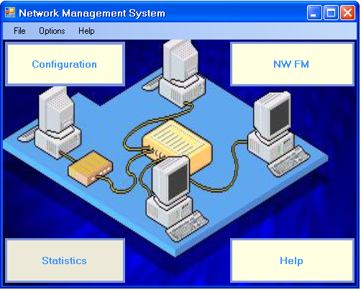
FIG 1: Application main form

the main form contain four button and three menu items each one has a function to open another forms , each button do the following:

- Configuration: open the following configuration form :

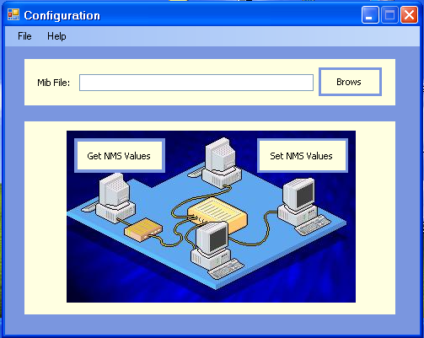
FIG 2 :Configuration Form

the component of this form do the following :
- Brows: enable the user to load the MIB file from any location , this MIB file will contain the standard MIB variables according to the SNMP version this Application can deal with the two version SNMPV1 and SNMPV2 , those variables must be arranged as a MIB tree on the list area under the browse textbox , this will help the user not to memorize all the MIB variables (surely he can't) , so he can take any MIB variable ID from this part.
- Get NMS Values: by it name it will open a form that enable the user to get the wanted variable parameters , the following figure show the opened form :

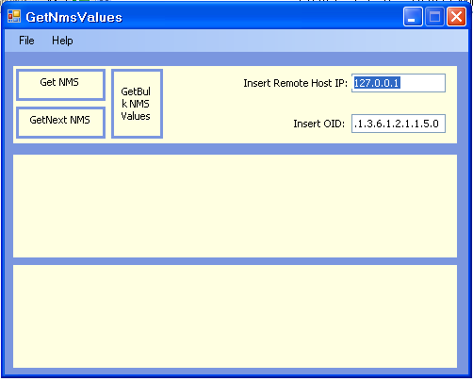
FIG 3: Get NMS Values form

the component of this form do the following :
- Get NMS values: will return the values of this variable in a sorted form using browser list that arrange the values in beautiful way , this need the ID for that variable which can be taken from the configuration form if not been memorized by the user , the other part needed to achieve the GET command is the IP address for the remote managed device , after apply the a correct GET command the following figure appear containing the wanted values:

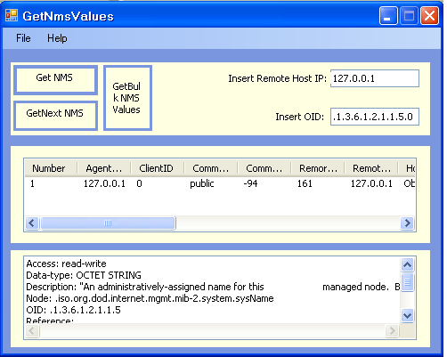
FIG 4 : Correct Get Command

the File menu on each form contain Exit submenu that will close the corresponding form , and the help menu will activate this CHM file help , on this way the GET operation is completed.
- Get Next NMS: represent an event that can retrieve the next variable parameters to that OID on the text box, and update the text box with the new retrieved OID, this enable the user to walk over the MIB and also get the variables parameters also.
- Get Bulk NMS Values: represent an event that can retrieve a set of variables from the given kind of MIB node ID, and arrange them on the list box at the same row.
- Set NMS value: from the configuration form this button from it name used to enable user to open the form that enable him to set the value for a given variable , this button will activate the following form:

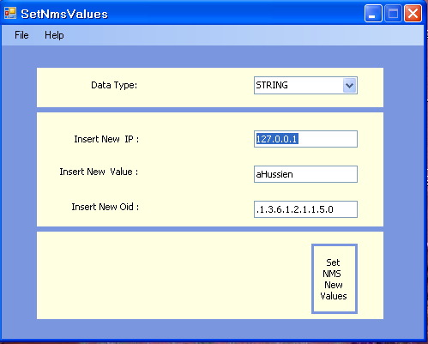
FIG 5: Set NMS Values Form

the only event in this form is:
- Set NMS New Values : button that will set the value of the wanted MIB variables by the inserted value , the event need to choose the type of the remote variable from the combo box that contain all type of the MIB variables , the event also need the IP address for the remote device , and the ID of the MIB variable wanted to reset , after the correct set command apply a list is appear with the new value to be sure that the value is reset as the following :

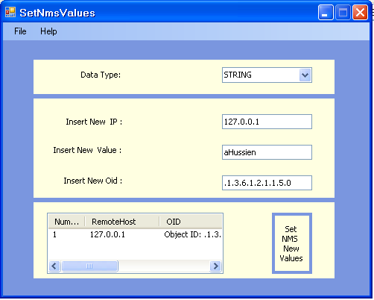
FIG 6: Correct Set Command.

- NW FM : this button from the configuration form is related with the network trap messages that come from the different network devices , the mentioned SNMP trap services on the system is the median between the network nodes and this application you must configure that services to be able to catch the trap messages, this button will open a form that act as a server that listen to any coming trap message and put it format on the form body to enable the administrator to read it and to take a good decision according to that message , the following figure show the NW FM form catching a trap message.

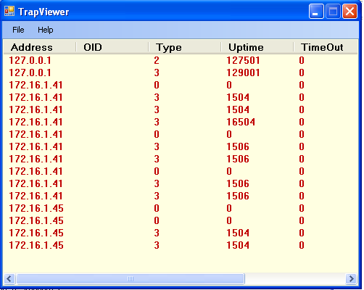
FIG 7: NW FM catching message.
- Statistics: is a button that open the following form that can apply walk command on the MIB or on the Agent, this will return all variable (statistics) on the MIB or on the agent, the MIB group that the user select from the combo box will help in getting the leaves of the same MIB group node forming the mib tree.

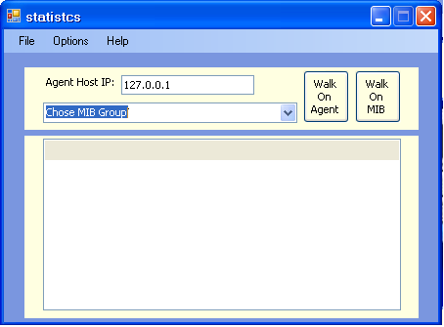
- help: button used to activate this help file.
- the option menu contain three submenus this menu option is can be used to do all the operations mentioned , the submenu are:
- configuration : which contain submenu named (load mib file) work as the configuration button..
- NW FM : work as the NW FM button.
- statistics : Forming the MIB tree from MIB file or Agent.

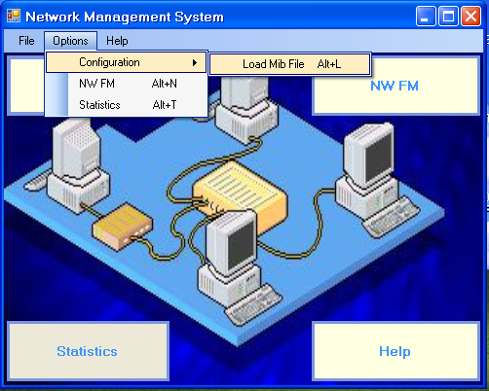
FIG 8: Application Menus

******END******

