An-Najah National University

Faculty of Engineering
Civil Engineering Department
Graduation Project 3D Dynamic Design of Al-Zahra Building with Shear Wall Inclusions Study
Prepared By: Mohammad Bani Jaber Osama Moghrabi Nidal Tabanjeh
Supervisor: Dr.Abdul Razzaq Touqan
2010-2011

الإهداء
نهدي هذا العمل المتواضع إلى نور الحياة ونبع الحنان أمهاتنا الفاضلات
وإلى ذلك الرجل الذي أفنى حياته من أجل تحقيق طموحاتنا في الحياة آبائنا الفاضلين
ونهدي أيضا هذا العمل إلى أساتذتنا الفاضلين في قسم الهندسة المدنية وعلى رأسهم الدكتور عبد الرزاق طوقان الذي أعطانا من وقته وإرشاداته التي كان لها الفضل الكبير في إنجاح هذا المشروع .

والله ولي التوفيق
Dedication

We dedicate this humble work to the light of life and compassion spring our virtuous mothers.
And to the men who dedicated there life to achieve our ambitions in life our virtuous fathers.
And also dedicate this work to the virtuous our professors in the Department of Civil Engineering, headed by
Dr. Abdul Razzaq Touqan who has given us of his time and guidance, which had a great credit to the success of this project.

Contents
chapter one : General Description 6
1.1Abstract 7
1.2Introduction: 8
1.3 Plan View of the Building 10
Chapter Two : Preliminary Design 11
2.1 Selection of the System 12
2.2 One Way Solid Slab 12
2.3 One Way Ribbed Slab 22
Chapter Three : Strucural Analysis laws and verifications 27
3.1 Compatibility 28
3.2 Equilibrium check 28
3.3 Stress-Strain Relationship 29
3.3.1: Beams stress-strain verification 30
3.3.2: Slab stress-strain verification 33
Chapter four : Static Design of the Building 37
4.1 Design of Beams and Girders 38
4.2Shear Design 44
4.3 Torsion Design 55
4.4Design of Slab 67
4.4.1 Bending moment on the slab in Y-direction (M₂₂) 67
4.4.2 Secondary steel in the x direction 69
4.5 Design of columns 70
4.5.1: Design of columns from SAP program 70
4.5.2 Manual Design for an Interior Column 70
4.5.3 Design of columns stirrups 73
Chapter five : Footings 75
5.1 General description 76
5.2 Plan view 77
5.2 service loads on footings 78
5.3 Manual design 79
5.4 SAP Calculations 82
5.5 Design of tie beams 85
chapter six : Dynamic Design of the Building 86
6.1 Introduction to Dynamics of Structures 87
6.2Prevailing codes of seismic design 88
6.2.1 UBC97 versus IBC2006: Zoning and Response Spectrum 88
6.2.2 UBC97 versus IBC2006: Site Classifications 89
6.2.3 UBC97 Response Spectrum: 89
6.2.4 IBC2006 response spectrum: 90
6.2.5 The fundamental or natural period T 90
6.2.6Earthquake Force 91
6.2.7 UBC97 versus IBC2006: seismic use group 92
6.2.8 IBC2006 Seismic-Force-Resisting System 92
6.2.9 IBC2006 seismic design category 92
6.3 Dynamic Design of the structure: 93
6.3.1 Equivalent static method 93
6.3.2Response Spectrum Method 98
6.3.3: Lateral displacements of the Structure 103
6.4 Design of the building 104
6.5 Drawings considerations: 105
chapter SEVEN : Shear Walls Inclusions Study 106
7.1 Abstract 107
7.2 Introduction 107
7.3 Modal analysis: 109
7.4lateral displacements 111
APPENDIX A : Reinforcement Figures and Tables of the Static Design 112
APPENDIX B : Reinforcement Figures and Tables of the Dynamic Design 131
APPENDIX C: Drawings

3D Dynamic Design of Al-Zahra Building
With Shear Wall Inclusions STUDY

chapter one
General description

1.1Abstract:
This project aims to design AL- Zahra multi- story building, which is an office building in Ramallah that consists of ware houses at the ground floor and seven other stories.
The building will be analyzed in 3D model to be as close as possible to the actual model. Both static and dynamic analysis will be performed for a bare frame model and then different types of shear wall inclusions will be studied.
Two methods will be used in the design procedure:
Manual design for 1D model, and 3D design using computer
(SAP 14). 1D design is intended to provide conceptual results to compare with computer output for computer verification.

Since different types of shear wall inclusions will be performed, static and dynamic analysis and design for bare frames and all types of shear wall inclusions will be compared.

1.2Introduction:
This project aims to design AL-ZAHRA building which is a multi story office building that lies in RAMALLAH.
The building consists of seven stories and has a plan area of about1200 m², as shown in Figure1.1.
The first story contains the ware houses in addition to the parking garage for the building.
The floor will be designed to carry a dead load consisting of the own weight of the slab and a super imposed dead load of 300 kg/m² , in addition to a distributed live load of 400 kg/m².
Allowable bearing capacity of 3.5 kg/cm² is going to be used for the soil carrying the building so the single footings system will be recommended.
A height of 4.5m is going to be used for the first story contains the ware houses and 3.75m height for the rest stories.
Reinforced concrete structure is going to be used using concrete of fc`= 250kg/cm² and steel of yield stress = 4200 kg/cm² (grade 60).
Concrete of fc`=400kg/cm²is going to be used for both of columns and the footings.
Hollow blocks of (40*20*25) cm dimensions and 1.2ton/m³density, are going to be used if needed.
Slab- Beam- Girder system is to be used for the floor which contains large spans between columns up to 10.5 m.
Interior beams in the long direction are going to be used to form a one way slab of length to width ratio L/B>2.The slab will be designed as a solid slab in the short direction,(Y direction on SAP).
Using manual and software programs, 1D model for the slab, main beams and girders will be used.
The 3-D model for the whole structure will be conducted by using the structural analysis program SAP version 14.
The structure will be first designed statically for the gravity loads, and then dynamic analysis will be performed for the seismic loads.
Columns dimensions are to be determined using the principle of tributary area carried by the column and minimum steel ratio of 1% is to be used.

1.3 Plan View of the Building

The following figure (1.1) drawn by AutoCAD program represents the plan view for Al-Zahra building:
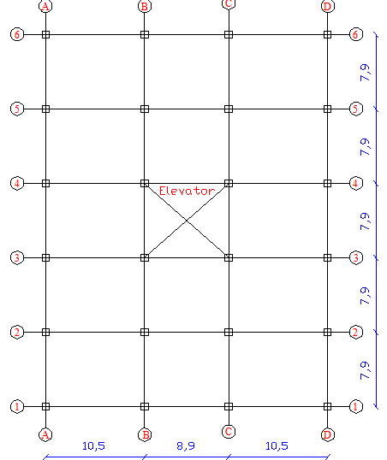
Figure 1.1: plan view of the building

Chapter Two
Preliminary Design

2.1 Selection of the System
The selected structural systems to be used in the project are:
1 – One way solid slab

2 – One way ribbed slab
The main system adopted in this project is the one way solid slab which will be discussed carefully. Basic ideas and preliminary design only is going to be discussed for the one way ribbed slab.

2.2 One Way Solid Slab

2.2.1 Plan View
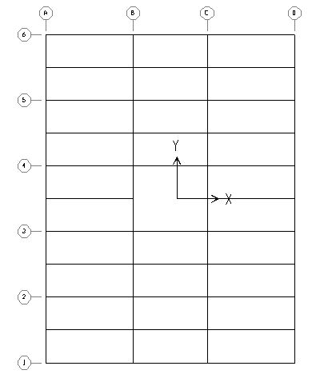

2.2.2 Thickness of the slab

Since we have one end continuous slabs, minimum slab thickness for deflection requirements is:
t = L/24 =3.95/24 =16.45 cm, so take t = 18 cm, and effective depth
d = 16 cm.

2.2.3 Design of columns
Take a typical interior column:
Tributary area = 76.5 m² (9.7m*7.9m).
Ultimate load on column:
Ultimate from slab +ultimate from drop beam +ultimate from column.
Take the preliminary dimensions of the columns to be 0.7*0.7m, and for all drop beams (0.7*0.4) m.
W_{U} on slab= 1.2dead load+1.6 live load
=1.2(0.18*2.5+.3) +1.6(.4) =1.54ton/m².
Ultimate from slab = 1.54t/m² *76.5m² = 118 ton.
Since we have seven stories:
P_{u} from the slabs on the first floor column = 118 *7 = 826 ton.
Ultimate load from drop beams =7*(2*9.7+7.9) (.7*.4)*2.5 *1.2 = 160.5ton.
Ultimate from column = 6* 0.7 ²*3.75*2.5 *1.2+4.5*0.7²*2.5*1.2 = 39.7ton.
Ultimate load on column (P_{u}) =826+160.5+39.7= 1026.2ton.
Since tied columns are going to be used, the capacity reduction factor Φ=0.65.
P_{n} _{req} = P_{u}/Φ =1026.2/.65 =1578.8ton.
P_{n} max = .8 Po, where Po is the nominal strength of the column.
P_{n} max = .8(.85 * fc` (Ag – As) + As Fy)
1578.8 * 1000 kg = 0.8(0.85 *400(Ag – As) + As Fy )
Using concrete of fc`=400 kg/cm² and steel of Fy= 4200 kg/cm²
Using ρ= 0.01
1578.8*1000/.8 = (.85*400(Ag-.01Ag) +.01 Ag *4200)
Ag =5212.6 cm² if a square column of 75*75 cm is used,
→Ag =5625 cm²˃ Ag required, ok.
As = 1% * 5625 = 56.25 cm ² use12 Φ25mm.
2.2.4 Design of the slab
Take a strip of 1 m width spanning on the beams in y – direction and (as defined in SAP) check the applicability of ACI coefficients method, the ACI method is applicable.
Take the width of the supporting beams to be 40 cm, the clear distance of the slab strip equal 3.55 m
Ultimate load per meter run of the slab strip equal 1540 kg /m
Maximum negative moment over the first interior support M_{u}= wu*L_{n}²/10 .
Where L_{n} is the clear distance of the span.
M_{u} = (1540 * 3.55 ²)/ 10 = 1941 kg.m=1.941m.ton.
ρ = $\frac{0.85 fc }{fy}\left[1-\sqrt{1-\frac{2.61 * 10⁵ * Mu}{b * d² * fc }}\right]$
ρ = .002046 compare it with ρ_{min} =ρ _{Shrinkage}= .0018(ρ> ρ_{min}) OK.
As =ρ*b*d = .002046 (100) (16) = 3.27 cm²/m.
Use 3Φ 12 mm /m.
Note: for good practice at least 4 bars/m are used with a spacing of 25cm between them, so use 4 Φ 12 mm /m.
Since largest moment gives almost ρ= ρ_{min}, use minimum area of steel for the positive moment, use 4 Φ12mm/m.
Compare the moments from the ACI coefficients method with the moments from the SAP 1D model shown in figure 2.1a, where only half the model is displayed because of the symmetry. Notice that results are close as the figure shows (units in ton.m).
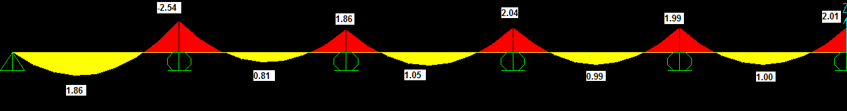
Figure 2.1a moment diagram of half the 1D model slab from SAP
ACI Coefficients method used to find the moment at the face of supports since it take the clear distance between supports and not center to center distance as SAP program does .
From SAP 1D slab model, max. negative moment at the face of the first interior support= 1.87 m.ton (close to 1.94 m.t from ACI method.)
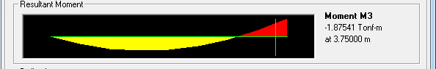Figure 2.1b: maximum negative moment of the slab 1D model at the face of the first interior support
2.2.5 Design of beams carrying the slabs
Taking an interior beam, the interior beam carries a slab width of 3.95 m. For one end continuous beam, min. thickness of the beam according to the deflection requirements = L/ 18.5 = 1050/ 18.5 = 57 cm.
Since beams fail by strength not deflection, use a thickness of 70 cm (d= 64 cm).the width b will be as assumed first =40cm.

Ultimate load per meter of the beam:
Take a typical interior beam, the beam will carry a slab width of 3.95 m in addition to its own weight, and to be more conservative ,all beam weight will be taken and not only the drop part.
Wu = 1540 kg/m²* 3.95 + 1.2 (0.7 * 0.4 * 2500 kg /m³)
= 6923 kg/m.
1-D model:-
Check if the ACI coefficients method is applicable:
A_ more than two spans, ok
B_ gravitational loads only, ok
C_ live load / dead load ˂ 3, ok
The adjacent spans don’t differ by more than 20 %
(10.5 – 8.9)/8.9 *100%= 18 %, ok
ACI coefficients method is applicable.
Max. Negative moment over the first interior support, by taking the average length of the adjacent spans = ((10.5+8.9)/2) -0.4) =9.3m for beams rested on girders and ((10.5+8.9)/2) -0.75) = 8.95m for beams rested on columns.
Maximum negative moment for beams rested on girders:
M_{u} = W_{u} l_{n}²/10 = 6923 ( 9.3²)/10 =59877 kg.m=59.877m.ton.
ρ = $\frac{0.85 fc }{fy}\left[1-\sqrt{1-\frac{2.61 * 10⁵ * Mu}{b * d² * fc }}\right]$
ρ = .01, compare it with ρ_{min}=14/Fy=14/4200=0.0033
ρ > ρ_{min} , ok.
As = ρ *b*d = .01 (40) (64) = 25.6cm² Use 10 Φ 18 mm.
Check if this area of steel gives a tension failure (Φ=0.9):
a=A_{S}Fy/0.85 f'_{c} b
Where, a :( depth of equivalent rectangular stress block).
b: width of the beam.
a=25.6(4200)/0.85(250)(40)=12.65cm.
c=a/β₁, where c: distance from extreme compression fiber to neutral axis, β₁: factor relating depth of equivalent rectangular compressive stress block to neutral axis depth.
c=12.65/0.85=14.88.
Check if (c/d) <0.375?
14.88/64 =0.2325 < 0.375, ok.
Maximum Positive moment for beams rested on girders:
Using the ACI coefficient method, maximum positive moment will be over the exterior span of the beam model and equals:
M_{u}= W_{u}l_{n}²/14 = 6923 (10.1²)/14= 50444 kg.m=50.444m.ton.
ρ = $\frac{0.85 fc }{fy}\left[1-\sqrt{1-\frac{2.61 * 10⁵ * Mu}{b * d² * fc }}\right]$
ρ =.00893, compare it with ρ_{min}=14/Fy=14/4200=0.0033
ρ > ρ_{min} , ok.
As = ρ*b*d =.00893(40) (64) =22.86 cm² Use 9Φ18 mm.
*Positive moment over the middle span:
M_{u}= 6923 (8.5²)/16= 31262kg.m=31.262m.ton.
ρ = $\frac{0.85 fc }{fy}\left[1-\sqrt{1-\frac{2.61 * 10⁵ * Mu}{b * d² * fc }}\right]$
ρ =.00533, compare it with ρ_{min}=14/Fy=14/4200=0.0033
ρ > ρ_{min} , ok.
As = ρ*b*d=.00533(40) (64) =13.65 cm², Use 6Φ18mm.
Maximum negative moment for beams rested on columns:
M_{u} = W_{u} l_{n}²/10 = 6923 ( 8.95²)/10 =55455 kg.m=55.455m.ton.
ρ = $\frac{0.85 fc }{fy}\left[1-\sqrt{1-\frac{2.61 * 10⁵ * Mu}{b * d² * fc }}\right]$
ρ = .0099, compare it with ρ_{min}=14/Fy=14/4200=0.0033
ρ > ρ_{min} , ok.
As = ρ *b*d = .0099 (40) (64) = 25.344cm² Use 10 Φ 18 mm.
Maximum Positive moment for beams rested on columns:
Using the ACI coefficient method, maximum positive moment will be over the exterior span of the beam model and equals:
M_{u}= W_{u}l_{n}²/14 = 6923 (9.75²)/14= 47008 kg.m=47.008m.ton.
ρ = $\frac{0.85 fc }{fy}\left[1-\sqrt{1-\frac{2.61 * 10⁵ * Mu}{b * d² * fc }}\right]$
ρ =.00825, compare it with ρ_{min}=14/Fy=14/4200=0.0033
ρ > ρ_{min} , ok.
As = ρ*b*d =.00825(40) (64) =21.12 cm² Use 9Φ18 mm.
*Positive moment over the middle span:
M_{u}= 6923 (8.15²)/16= 28740kg.m=28.74m.ton.
ρ = $\frac{0.85 fc }{fy}\left[1-\sqrt{1-\frac{2.61 * 10⁵ * Mu}{b * d² * fc }}\right]$
ρ =.00486, compare it with ρ_{min}=14/Fy=14/4200=0.0033
ρ > ρ_{min} , ok.
As = ρ*b*d=0.00486(40) (64) =12.44 cm², Use 5Φ18mm.
Compare the previous computed moments with the 1D SAP model:
To have the max negative moment over the first interior support, live load on the beam must be on the exterior span and the adjacent span only.
Compare between the ACI Coefficients method which considers several cases of loading and the 1D model in the negative moment over an interior support of an interior beam in the value of the max.negative moment resulting from this case of loading.
After doing this case of loading, max negative moment over the first interior support is shown in figure 2.3a for beams rested on girders and in figure 2.3b for beams rested on columns, taken at the face of support as the ACI coefficients method recommends.
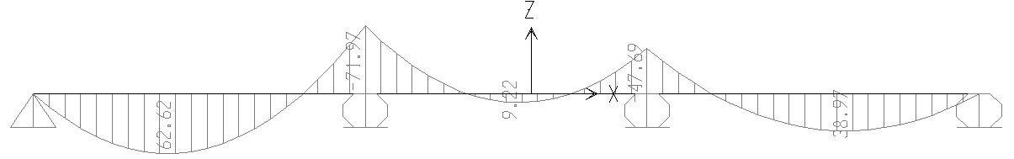Max.negative moment loading case)) Figure 2.2: moment diagram of the 1D beam model from SAP
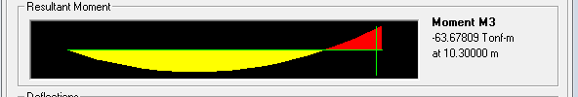
Figure 2.3a: negative moment at the face of the first interior support of beams rested on girders
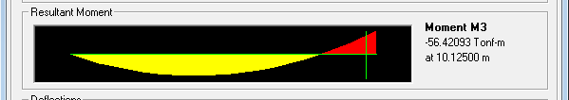
Figure 2.3b: negative moment at the face of the first interior support for beams rested on columns
Compare this values with the values obtained from ACI coefficient method, they are almost the same.
Beams on girders: ACI (59.877m.ton), 1D model (63.37m.ton).
Beams on columns: ACI (55.455m.ton), 1D model (56.42m.ton).
It can be clearly notice that ACI values and 1D model are very close.
To compare the positive moment over the interior span obtained from the ACI coefficients method with the SAP 1D model, another case of loading must be considered, where the live load will be over the interior span only.

2.2.6 Design of Girders
Depth of girder according to deflection=L/18.5=790/18.5=43cm.
But since the girders carry a heavy load and since beams fail due to strength not deflection ,girders depth will be take =70cm.
Girders width will be taken as 40 cm.
The girders will be loaded by the reactions from beams in addition to their own weight.
Take an interior girder, Reactions will be as a point load on the joints where beams meet the girders.
Load on the interior joint of the girder:
= length of beam carried by the girder*load per meter of the beam
=9.7* (6923kg/m) = 67153 kg=67.153ton.
Load on the exterior joints = .5 load on the interior joints
=.5 *67153=33576 kg=33.576 ton.
Or take the loads from the reactions of the 1D model of the beams as figure 2.4 shows:
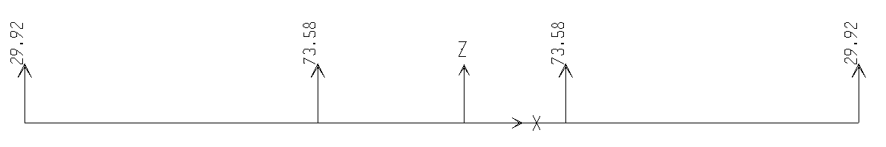
Figure 2.4: 1D beam model reactions (girder loads)
Notice that the computed loads and SAP reactions are close, so use SAP values for girder loading.
After doing 1D model for an interior girder on SAP, the resulting moment will be as shown in figure 2.5 in the next page.

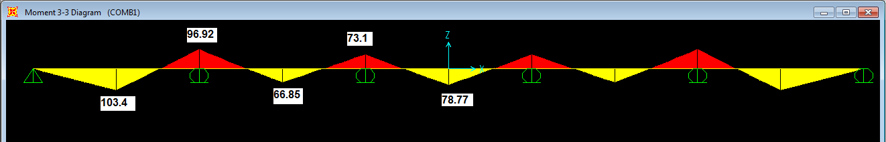
Figure 2.5: SAP 1D bending moment (m.ton) for an interior girder (B-B/C-C)
Max negative moment over the first interior support M_{u}=96.93m.ton.
ρ = $\frac{0.85 fc }{fy}\left[1-\sqrt{1-\frac{2.61 * 10⁵ * Mu}{b * d² * fc }}\right]$
ρ =.019, compare it with ρ_{min}=14/Fy=14/4200=0.0033
ρ > ρ_{min} , ok.
As = ρ*b*d=0.019 (40) (64) =48.64 cm², Use 10Φ25mm.
Maximum positive moment over the exterior span, M_{u}=103.4m.ton.
ρ = $\frac{0.85 fc }{fy}\left[1-\sqrt{1-\frac{2.61 * 10⁵ * Mu}{b * d² * fc }}\right]$
ρ =0.021, compare it with ρ_{min}=14/Fy=14/4200=0.0033
ρ > ρ_{min} , ok.
As = ρ*b*d=0.0.021(40) (64) =53.76 cm², Use 11Φ25mm.

2.3 One Way Ribbed Slab

2.3.1 Plan View

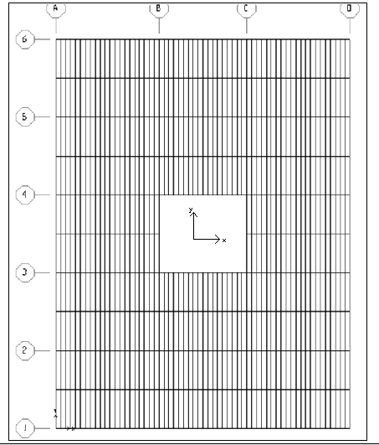

2.3.2 Thickness of Slab
Since the slab consists of several panels of one end continuous or both ends continuous panel types, the one end continuous slab will control the total slab thickness, the minimum slab thickness (t) as the ACI code recommends will be as follows:
t = L/18.5 =3.95/18.5=21.35 cm take t = 25cm, d =22 cm.
2.3.3 Design of Columns
Slab –beam – girder system is assumed for this building, so take preliminary dimensions for all drop beams to be (40*70) cm, and for all columns to be (70*70) cm.
Take a typical interior column:
Tributary area = 76.5 m²
Ultimate load on column:
Ultimate from slab +ultimate from drop beam +ultimate from column W_{u} on slab = 1.2 dead load +1.6 live load
W_{D} = {(0.1*0.17+0.08*.5)*2.5}*2+{.4*0.17*1.2ton/m³}*2+0.3ton/m²
= 0.7482 ton
W_{u} =1.2*0.7482+1.6*0.4=1.54 ton.
Ultimate from slab = 1.54 t/m² *76.5m² = 118 ton.
Since we have seven stories:
Ultimate load on the first floor column from the slabs = 118 *7 = 826t.
Ultimate load from drop beams =7*(2*9.7+7.9) (.7*.4)*2.5 *1.2 = 160.5ton.
Ultimate from column = 6* .7 ²*3.75*2.5 *1.2+1.2*4.5*0.7^{2*}2.5 = 39.7 ton. Ultimate load on column (P_{u}) = 1026.2ton.
Pn _{req} = Pu/Φ =968.7/.65 =1578.8ton.
Pn max =0.8 P_{o}
1578.8*1000 kg = 0.8(0.85 *400(Ag – As) + As F_{y})
Using concrete of fc`=400 kg/cm² and steel of F_{y}= 4200 kg/ cm²
Using ρ= .01
1578.8*1000/0.8 = (0.85*400(Ag-0.01Ag)+0.01 Ag *4200)
Ag =5212.6cm², if a square column of 75*75 cm is used, Ag = 5625cm². Ag_{provided} > Ag_{required} → ok.
As = 1% * 5625 = 5625 cm ², use 12 Φ25 mm.
2.2.4 Design of the slab
Slab is going to be designed for stresses (moments), resulting from the distributed dead and live loads on the whole floors.
To make it simple, 1Dmodel is assumed to represent the slab by talking a slab strip of 1m width ,and treat it as a rectangle beam to find the reinforcement per meter of the slab in the direction of loading which consider the short direction between beams ,forming a slab spans of 3.95m center to center of supports (beams).
Take a strip of 1 m width spanning on the beams in y - direction (as defined in SAP), and check the applicability of ACI coefficients method, the ACI method is applicable.
Take the width of the supporting beams to be 40 cm, the clear distance of the slab strip equal 3.55 m.
Load per meter on the rib=.5(1540 kg/m²)
w= 770 kg/m
max. Negative moment
Mu= Wu Ln²/10
Mu =770(3.55)²/10= 970.4 kg.m= .97 m.ton
ρ = $\frac{0.85 fc }{fy}\left[1-\sqrt{1-\frac{2.61 * 10⁵ * Mu}{b * d² * fc }}\right]$
Where: b is the width of the web of the tee section =10cm.
d is the effective depth of the tee beam =22cm.
→ρ=.0055> ρ_{min}=0.0033,ok.
As= 1.12cm², use 2 Ø 12 mm/rib for good practice.
Maximum positive moment:
M_{u} =w_{u} L_{n}²/14= 693.14 kg.m=0.693m.ton.
ρ = $\frac{0.85 fc }{fy}\left[1-\sqrt{1-\frac{2.61 * 10⁵ * Mu}{b * d² * fc }}\right]$
ρ= .004, compare it with ρ_{min}=14/Fy=14/4200=0.0033
ρ > ρ_{min} , ok.
As = ρ*b*d=0.004(10) (22) =0.88 cm².
(Recommended to use at least 2 Ø 12 mm for good practice)
2.2.5 Design of beams
Consider an interior beam:
Beams will transmit the slab loads to the columns, all beams considered drops with a depth of 70cm and a width of 40 cm spanning in the x- directions .Each beam will carry a slab width of 3.95m in addition to its own weight of the full beam width to be more conservative. The edge beams will carry half the interior beams load.
Wu= 3.95(1540 kg/m²) + 1.2 (.7) (.4) (2500)
= 6923 kg/m.
Negative moment:
max. Negative moment M_{u}= w_{u} L_{n}²/10
M_{u} =6923(9.3)²/10=59877kg.m=59.877m.ton.
ρ = $\frac{0.85 fc }{fy}\left[1-\sqrt{1-\frac{2.61 * 10⁵ * Mu}{b * d² * fc }}\right]$
ρ=.01, compare it with ρ_{min}=14/Fy=14/4200=0.0033
ρ > ρ_{min} , ok.
As= ρ*b*d=0.01*40*64=25.6 cm².
Use 10 Φ 18 mm.

Positive moment:
Maximum positive moment over the exterior span M_{u}= w_{u} L_{n}²/14
M_{u} =6923(10.1²)/14=50444 kg.m=50.444m.ton
ρ = $\frac{0.85 fc }{fy}\left[1-\sqrt{1-\frac{2.61 * 10⁵ * Mu}{b * d² * fc }}\right]$
ρ= .00893, compare it with ρ_{min}=14/Fy=14/4200=0.0033
ρ > ρ_{min} , ok.
As= ρ*b*d=0.00893*40*64=22.86 cm².
Use 9 Φ18mm.

Chapter Three
Structural Analysis
Laws & verifications
OF THE SOLID SLAB

3.1 Compatibility
To achieve the condition of compatibility all the elements of the structure must act like a single unite. This condition is clearly satisfied from SAP program. Figure (3.1) shows the compatibility of the structure.
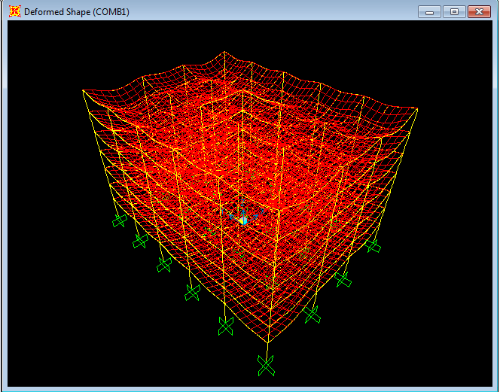
Figure (3.1) the structure after pressing the start animation button

3.2 Equilibrium check
Hand calculations: -
Dead load: - Load from own weight of the slabs, the super imposed dead load, from the drop beams and the columns.
Plan area of the building = (39.5*29.9)-(7.9*8.9) =1110.74m²/floor.
*Slab own weight =1110.74*0.18*2.5=499.833ton/floor.
*Super imposed dead load=1110.74*0.3=333.222ton/floor.

Beams and girders own weight:
Beams and girders have the same cross section (70*40cm) and a total length of 478m/floor.

*Beams and girders weight =478*0.4*0.7*2.5=3346 ton/floor.
*Total dead load from the columns in the building:
=24*4.5*0.75²*2.5+6*24*3.75*0.75²*2.5=911.25ton.
Total dead load =911.25+7(499.833+333.222+3346) =9084.835ton.
Total live load= 7*1110.74*.4=3110.072ton.
SAP results: Total dead load=9084.835ton.
Total live load =3110.072ton.
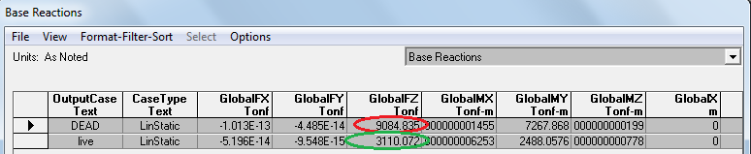
Table (3.1) Base reactions from SAP program
% of error in dead load = (9084.835 -9084.835)/ 9084.835=0%
% of error in live load= (3110.072 - 3110.072)/ (3110.072) =0%
Notice that there is no difference between the SAP results and the computed live and dead loads, so the equilibrium condition is clearly verified.

3.3 Stress-Strain Relationship
To ensure reliability of the 3D model, stress- strain relationship must be verified between the 3D model and the 1D model by comparing the internal moments in both sides.

3.3.1: Beams stress-strain verification:
Comparison must be in an interior beams (spans), since the exterior beams give non accurate values because of the torsion influence.
Maximum permissible difference between the 3Dmodel and the1D model will be considered as 10%.
Take the middle beam of the interior frame in the x-z direction 2-2/5-5, and check the value of the total moment over the middle span (8.9m length) in both of 3D and 1D models, using the same load combination(1.2D+1.6L) as following:
Moment diagram from the 1D model of a typical interior beam, using the load combination will be as shown in figure3.2

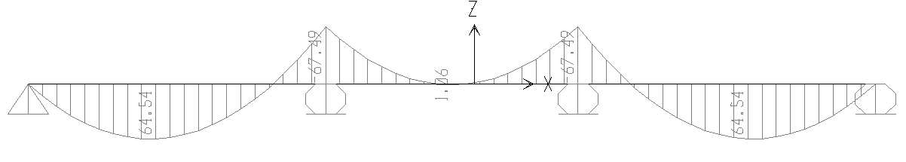
Figure 3.2: moment diagram of an interior beam from1Dmodel
Total moment over the middle span=
Positive moment+ 0.5(∑negative moments at the ends).
=1.06+0.5(67.49+67.49) =68.55 m.ton.
For the 3-D SAP model the bending moment diagram of the interior x-z frame 2-2/5-5 is shown in figure3.3 in the next page, and maximum negative and positive moments of the middle beam for the different stories are tabulated next in table 3.1.
Max positive moment(m.ton) | Max negative moment(m.ton) | Storey
22.419 | 44.8 | First storey
22.457 | 44.06 | Second storey
22.386 | 44.14 | Third storey
22.425 | 44 | Fourth storey
22.372 | 44.073 | Fifth storey
22.59 | 43.58 | Sixth storey
21.45 | 46.14 | Seventh storey

Table3.1: Max positive & negative moments of the middle beam in frame2-2/5-5
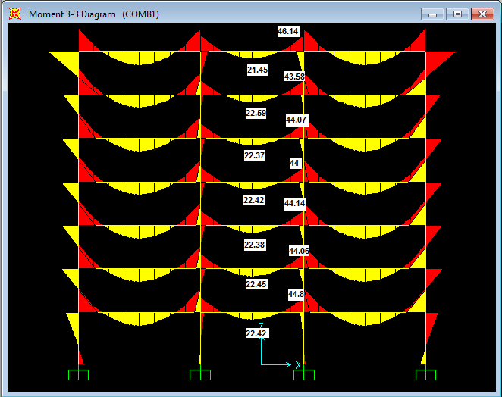
Figure3.3: Moment diagram of frame 2-2/5-5(Ton.m)
It can be noticed from the previous table that the maximum positive moments as well as the maximum negative moments for the middle span are almost the same for the first six stories with a slight difference in the seventh storey, so values of the first storey will be taken for the comparison with the 1D model.
Total moment over the middle span=
Positive moment+ .5(∑negative moments at the ends)
=22.42+0.5(44.8+44.8)
=67.219 m.ton.
So difference between the 3Dmodel and the1Dmodel in the internal forces=68.55-67.219/68.55=0.019= 1.9 %( less than 10%).
From the previous result, notice that the 1D and the 3D results are very close and our assumption in beams resting on columns is right as 1D.
For beams resting on girders in the 3D model, the internal force are expected to be different from the 1D model since the 1D assume that the supports (girder in our case) will not deflect, is not right because the girders stiffness is smaller than the columns stiffness, so we expect a considerable difference between the 1D results and the 3D results in the moments values over the beams resting on girders not columns.
Take an interior beam resting on girder and check the total moment over the middle span (8.9m) in both of 1Dand3D.
From the 1D, as the previous results shown, total positive moment over the middle span =68.55 m.ton.
For the 3D model positive and negative moments over the middle span of an interior beams resting on a girders between frame 2-2&3-3 is shown in figures 3.4
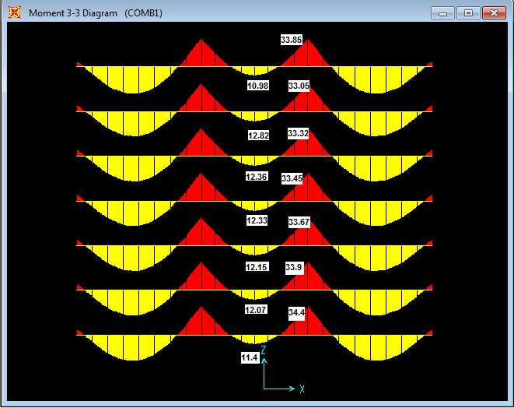
Figure3.4: Bending moment of the beams resting on girders between frame2-2&3-3(ton.m)

From the previous figure, it can be noticed that the maximum positive moments as well as the maximum negative moments for the middle span are almost the same for all stories between the first and the last one. The values for the first and the last storey are also close and differ a little bit from the other stories, so values of the fourth storey will be taken as a reference for the comparison with the 1D model.
Max +ve moment over the middle span in the 4th storey=12.33m.ton
Max -ve moment at the ends of the middle span in the 4th storey =33.45m.ton.
Total moment =Positive moment+ .5(∑negative moments at the ends)
=12.33+0.5(33.45 +33.45) =45.78t.m
Difference between 1D and 3D results:
68.55-45.78/68.55=0.33=33%
The previous difference indicates that the 1D representation for the beams resting on girders is not accurate because of the wrong assumptions, so the 3D representation gives us more realistic representation and results as expected ,so SAP 3D model results are going to be adopted.

3.3.2: Slab stress-strain verification
Taking the slab 1D SAP model, moment diagram of the load combination on the slab is shown in figure 3.5(half the model is displayed because of the symmetry):
Figure 3.5: moment diagram of half 1D slab model from SAP(m.ton)
Maximum positive moment over the first span and equals (1.86m.ton).
Maximum negative moment over the first interior support, and equals (2.54m.ton).
Taking the slab 3D SAP model, and display the shell stresses of the different stories in the direction of loading (M₂₂) using the load combination case as shown in figure 3.6, they are almost the same in the 2nd ,3rd ,4th ,5th and 6th stories with a slight difference in the first and seventh stories, so slab stresses of the first story will be displayed .
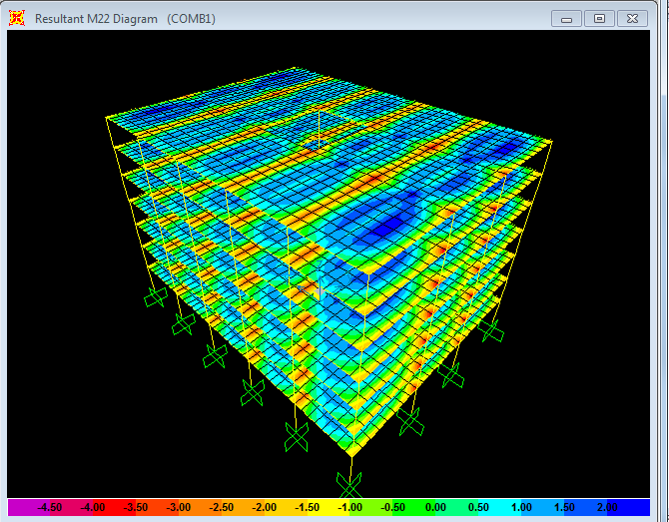
Figure 3.6: M22 stresses diagram in the y-direction for the structure slabs
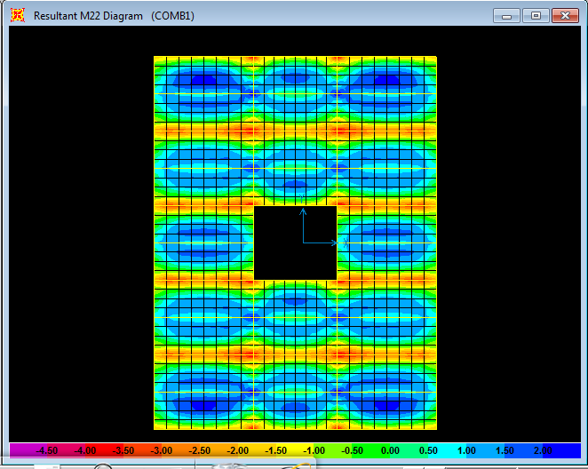
Figure 3.7: M22 stresses diagram in the y-direction for the 1st storey slab
As the color bar at the bottom indicates, colors from green to red represent the negative moments(stresses) which increase as we move from green to red ,where the max negative moment =3.5ton.m represented by the red color near the beams resting on columns.
Positive moments are represented by the colors from sky blue to dark blue where the max positive moment =2.m.ton.
If we take a section cut in the moment diagram M₂₂ , positive and negative moments will appear like figure 3.8
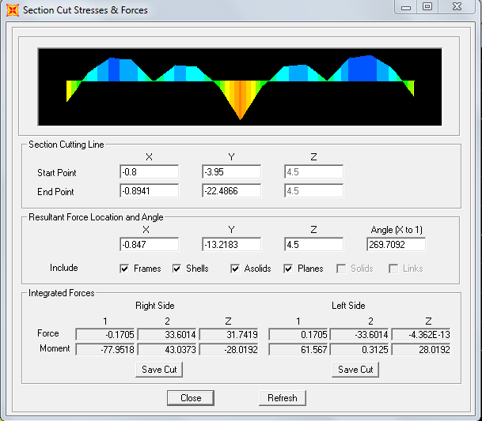
Figure 3.8:M₂₂ section cut diagram between B-B&C-C grid lines in the 1st storey
This diagram shows that slab moments change from positive to negative only over the beams (supports) resting on column and stay positive over the internal beams carrying the slab, which resting on girder .

The slab1D model assumes a rigid supports for all beams carrying the slab, and as a result, it assumes a moment change from positive to negative over these supports (beams) which is clearly untrue as the 3D model section cut shows where the moment only changes from positive to negative over the beams resting on stiff columns and stay positive over the beams resting on girders which have a less stiffness compared with columns and as a result they will deflect more.
the conclusions taken from the previous comparison that the representation of the slab as 1D is not true here because of the different supports stiffness and deflection values which affect the moment diagram direction and value ,so again the 3D model is more realistic and gives results close to our expectations, so it deserves to be adopted.
From the previous results, the stress –strain condition is clearly satisfied for the 3D SAP model.
Since all conditions (compatibility, equilibrium, & stress-strain relationship) are satisfied, the 3Dmodel is verified and its results can be adopted.
After model verification, structure is designed using the SAP program v.14, considering the ACI code recommendations and assuming a sway ordinary building.
All areas of steel reinforcement for beams, girders and columns will be taken directly from the program design.
Since SAP program doesn't give the reinforcement of the slabs (shells), stresses will be taken from the program, and hand calculation for the reinforcement will be done.

Chapter four

Static design of the building

4.1 Design of Beams and Girders
Beams in this project are a structural system that transmits loads from the slab directly to the columns or indirectly to the girders which transmit the load to the columns. Beams must be designed to resist the bending moment, shear and the torsion stresses.
Girders are beams used here to support beams carrying the slab and carry their reactions (girders load) to the column and finally to the footings to provide a safe bath for all slab loads.

Design of X-Z direction beams using SAP program (3D Model):
- Flexure steel :
Flexure area of steel needed for the frames in the X-Z direction (beams and columns) is shown in the following figures:
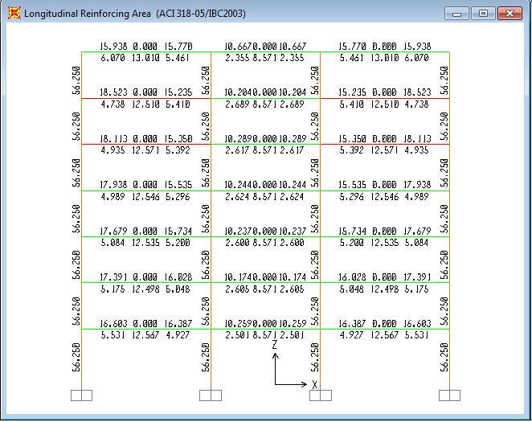
Figure (4.1) flexure reinforcement of x-z frames (1-1) and (6-6)
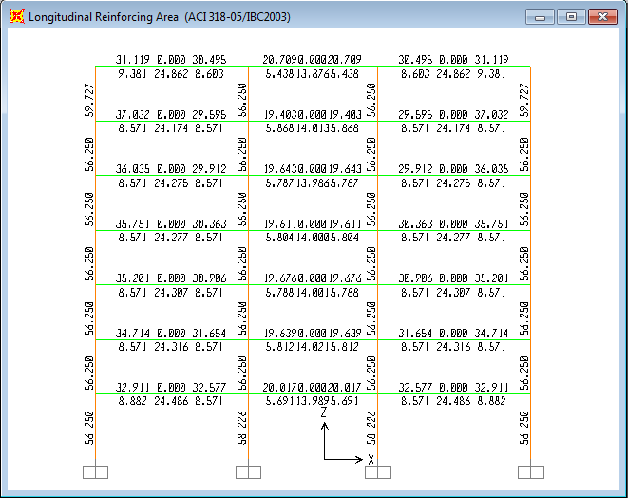
Figure (4.2) flexure reinforcement of x-z frames (2-2) and (5-5)
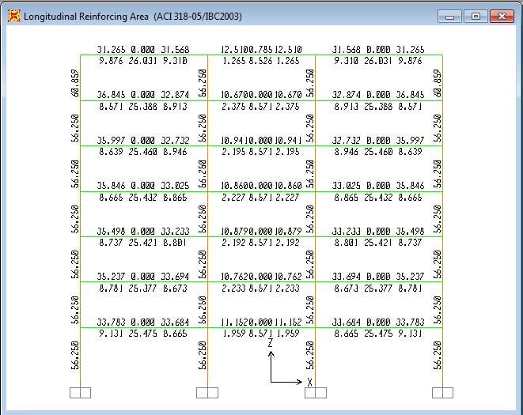
Figure (4.3) flexure reinforcement of x-z frames (3-3) and (4-4)
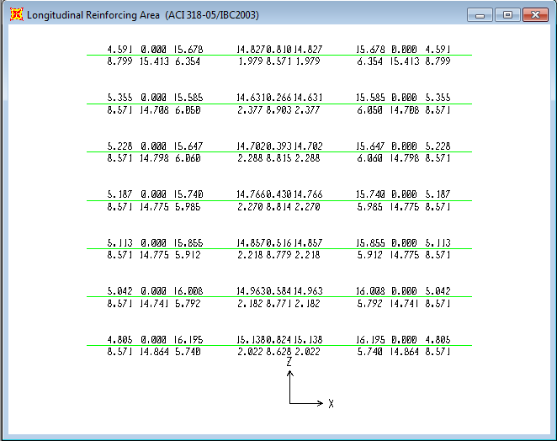
Figure (4.4) flexure reinforcement of x-z beams between frames (1-1) and (2-2)
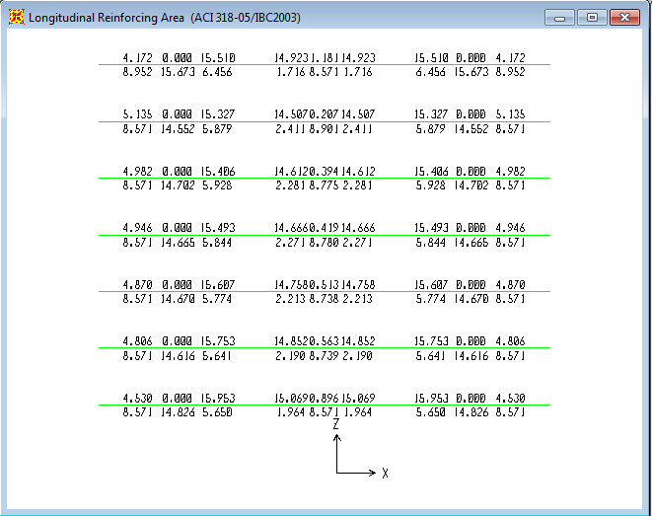
Figure (4.5) flexure reinforcement of x-z beams between frames (2-2) and (5-5)
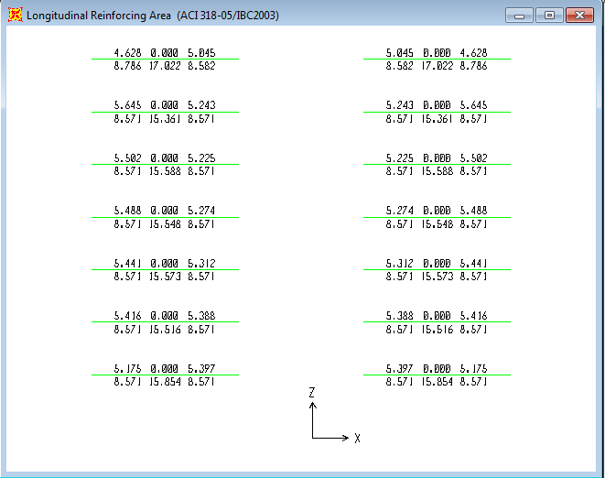
Figure (4.6) flexure reinforcement of x-z beams between frames (2-2) and (5-5)

Design of Y-Z direction girders using SAP program (3D Model):
Y-Z frames are the frames formed by the girders which have an equal span length of 7.9 meter center to center of each column in each frame.
- Flexure steel
The flexural area of steel needed for the frames in the y-z direction is shown in the next page where only two of the four frames in the Y-Z direction are going to be displayed because of the symmetry and
Only one half of each frame of the two frames will be displayed because of the symmetry as well.

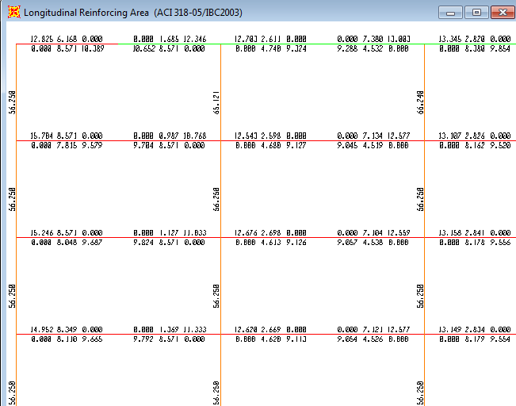
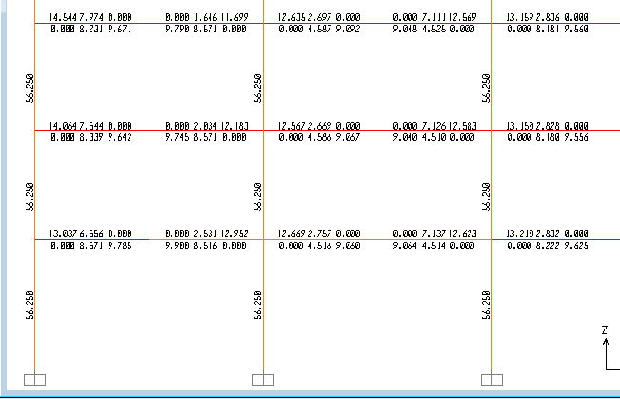
Figure 4.7: Flexure steel of the exterior y-z frames A-A/D-D

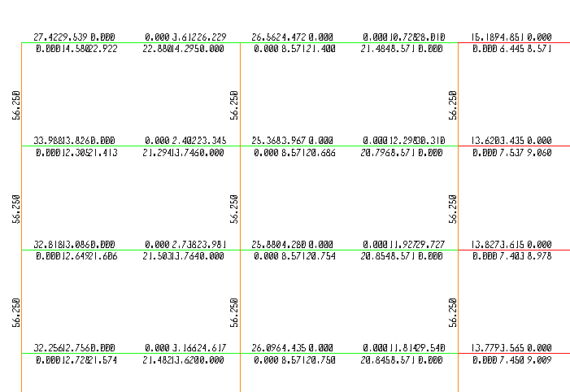
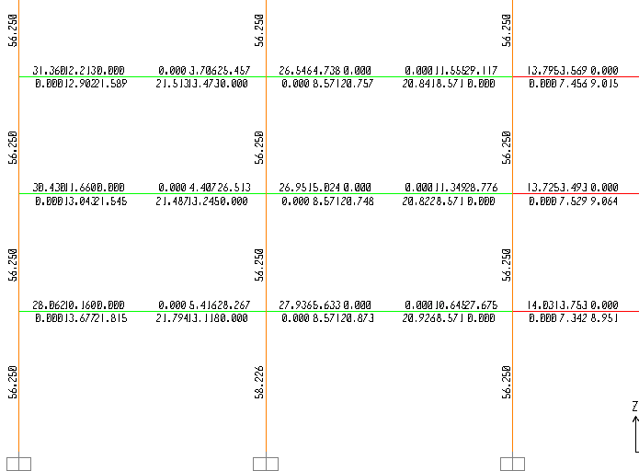
Figure4.8: Flexure steel of the exterior y-z frames B-B/C-C

The previous figures of the flexural steel show that some of the beams in the exterior x-z frames and almost all the beams in the exterior y-z frames,in addition to the beams around the elevator opening in the y-z direction faild as a result of the excessive torsion and shear stresses together .These beames which appeared in the red color in the figures cant be fixed by adding shear and torsion reinforcement because shear and torsion stresses exceeded the maximum permissible stresses can be taken by this cross section dimension ,so its obligatory to increase the dimensions of these beams to increase their shear and torsion capacity.
Large torsion stresses in the previous mentiod beams is expected since the main beams in x-z direction which support the slab cause a torsional moment on the girders (y-z) appears clearly in the exterior girders where the compatability torsion has nothing to counter act its effect.
Since girders have much load than the beams in the x-z direction and to solve the excessive torsion and shear stresses ,all girders (y-z direction) will be increased in width by 10 cm to be 50*70cm instead of 40*70cm.
The effect of changing the dimensions of the girders will be discussed in the shear and torsion design sections.

4.2Shear Design
Shear is the forces applied in a parallel way to the element cross section ,in this project beams and footings exposed to shear forces come from the gravity loads carried by the beams and transmitted finally to the footings .
For beams, the shear forces will be represented by the reactions at the beam support. The max design shear force located at a distance (d) from the face of the beam support, where the distance (d) is considered as the effective depth of the beam.
Beams shear strength is based on an average shear stress on the full effective cross section b_{w}d. In a member without shear reinforcement, shear is assumed to be carried by the concrete web. In a member with shear reinforcement, a portion of the shear strength is assumed to be provided by the concrete and the reminder by the shear reinforcement.
The shear strength provided by concrete Vc is assumed to be the same for beams with and without shear reinforcement and is taken as the shear causing significant inclined cracking.
Design of cross sections subject to shear shall be based on:
φVn ≥ Vu
Where Vu is the factored shear force at the section considered and Vn is nominal shear strength computed by:
Vn = Vc + Vs
Where Vc is nominal shear strength provided by concrete and Vs is nominal shear strength provided by shear reinforcement.
Vc=$0.53\sqrt{f_{c}^{´}}b_{w}d$ (metric units)
$vc=\frac{\sqrt{f_{c}^{´}} b_{w}d }{3}$ (SI units)
Vs=$\frac{AvFy}{S}$
Where: A_{v} is the shear reinforcement steel cross sectional area.
S: spacing between shear stirrups.
— Computation of maximum Vu at supports shall be permitted if all conditions (a), (b), and (c) are satisfied:
(a)- Support reaction, in direction of applied shear, introduces compression into the end regions of member;
(b) Loads are applied at or near the top of the member;
(c) No concentrated load occurs between face of support and location of critical section defined earlier.
footings shear forces must be handled by the concrete strength and the footing dimensions represented by the footing thickness which is the most critical element in resisting the shear forces and it must be enough to take the shear force, because no steel reinforcement is used in the case of footings.
Shear strength provided by shear reinforcement
Types of shear reinforcement:
Shear reinforcement consisting of the following shall be permitted:
(a) Stirrups perpendicular to axis of member;
(b) Welded wire reinforcement with wires located perpendicular to axis of member;
(c) Spirals, circular ties, or hoops.
For nonprestressed members, shear reinforcement shall be permitted to also consist of:
(a) Stirrups making an angle of 45 deg or more with longitudinal tension reinforcement;
(b) Longitudinal reinforcement with bent portion making an angle of 30 deg or more with the longitudinal tension reinforcement;
(c) Combinations of stirrups and bent longitudinal
In this project, steel stirrups of 10mm diameter are going to be used, set perpendicularly with the beams axes.
The spacing between shear stirrups should be as the ACI code recommends in the following provisions taken from the code:
11.5.5 — Spacing limits for shear reinforcement:
11.5.5.1 — Spacing of shear reinforcement placed perpendicular to axis of member shall not exceed d/2 in nonprestressed members or 0.75h in prestressed members, nor 600 mm.
11.5.5.2 — inclined stirrups and bent longitudinal reinforcement shall be so spaced that every 45 degree line, extending toward the reaction from mid-depth of member d/2 to longitudinal tension reinforcement, shall be crossed by at least one line of shear reinforcement.
11.5.5.3 — Where Vs exceeds 0.33√ f_{c}′b_{w}d, maximum spacing given in 11.5.5.1 and 11.5.5.2 shall be reduced by one-half.
11.5.6 — Minimum shear reinforcement
11.5.6.1 — A minimum area of shear reinforcement Av_{min} , shall be provided in all reinforced concrete flexural members, where Vu exceeds 0.5φVc, except:
(a) Slabs and footings;
(b) Concrete joist construction;
(c) Beams with h not greater than the largest of250 mm, 2.5 times thickness of flange, or 0.5 the width of web.
Shear reinforcement restrains the growth of inclined cracking. Ductility is increased and a warning of failure is provided. In an unreinforced web, the sudden formation of inclined cracking might lead directly to failure without warning. Such reinforcement is of great value if a member is subjected to an unexpected tensile force or an overload. Accordingly, a minimum area of shear reinforcement not less than that given by Eq.below is required wherever Vu is greater than 0.5 φVc. Slabs, footings and joists are excluded from the minimum shear reinforcement requirement because there is a possibility of load sharing between weak and strong areas.
$$\frac{{Av}_{min}}{S}≥\frac{0.35b_{w}}{F_{Y}}$$
SAP program design gives ratios of the areas of stirrups resisting the Shear forces to the spacing between them, and consistently, stirrups spacing can be determined after choosing the appropriate stirrup diameter, using the hand calculations and the ACI cod recommendations.
If 2 stirrups of 10mm diameter is used (Av=3.14cm²for 4 legs).
Take the spacing as the minimum of d/2 or 60cm.
$$\frac{0.35b_{w}}{F_{Y}}≤\frac{A_{Vmin}}{S}$$
If a spacing of d/2=32cm (substitute S=30cm) is used: →Av_{min}/S=0.1046. A_{V}/S>0.35b_{w}/F_{Y} =0.0033
Where, S is the spacing between the shear stirrups.

The figures bellow show the ratios between the area of stirrups and the spacing between them (A_{V}/S) for all building frames, taken from SAP14 program design for the complete 3Dmodel after increase the width of the exterior y-z frames as discussed earlier.
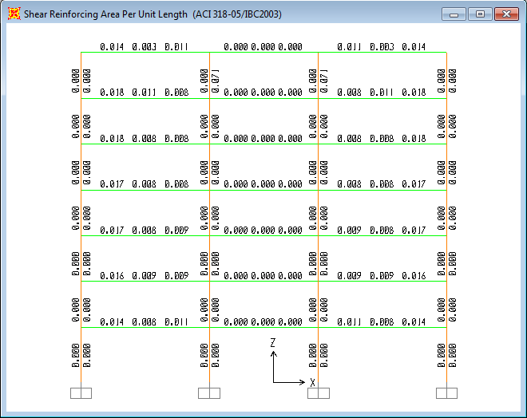
Figure 4.9: A_{V}/S of the exterior x-z frames 1-1/6-6

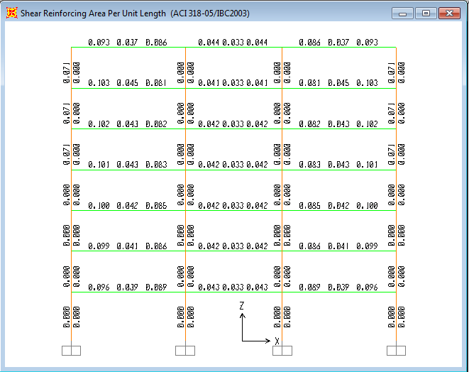
Figure 4.10: A_{V}/S of the x-z frames 2-2/5-5
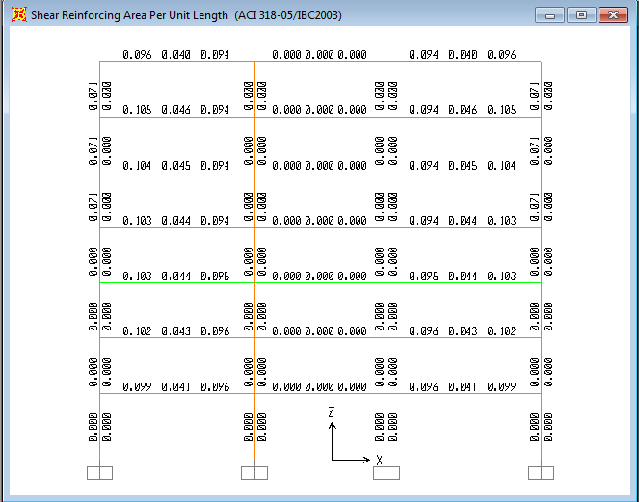
Figure4.11: A_{V}/S of x-z frames 3-3/4-4
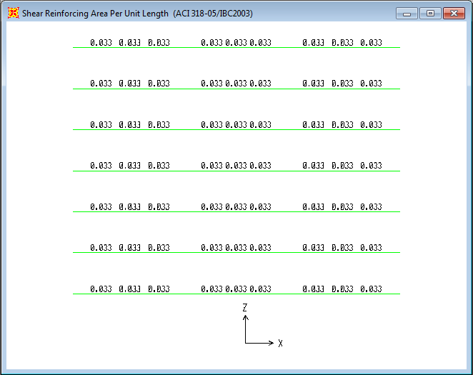
Figure4.12: A_{V}/S for beams between 1-1&2-2, 2-2&-33,4-4&5-5,5-5&6-6
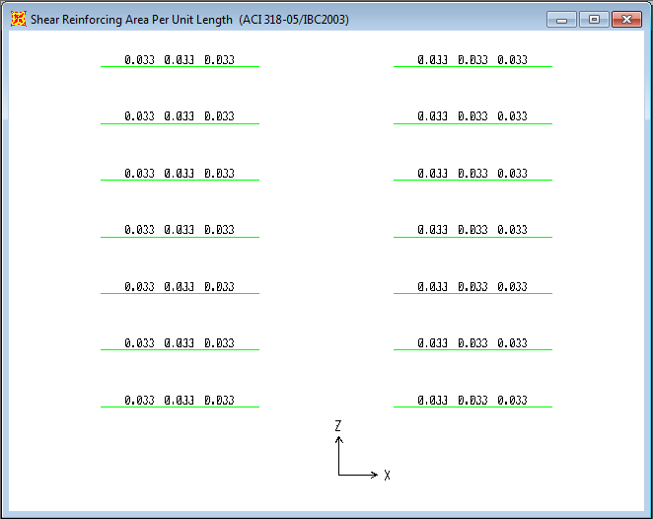
Figure4.13: A_{V}/S for Beams between 3-3&4-4
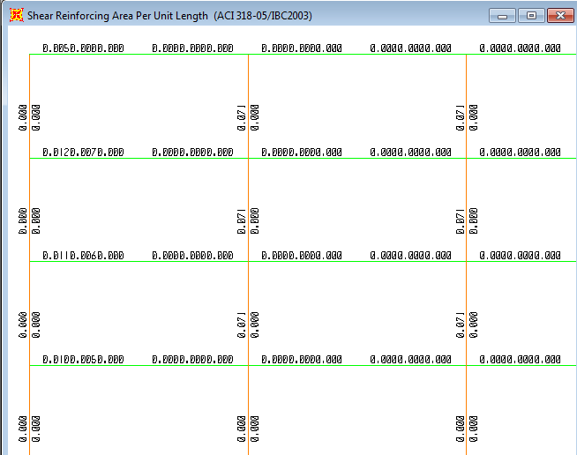
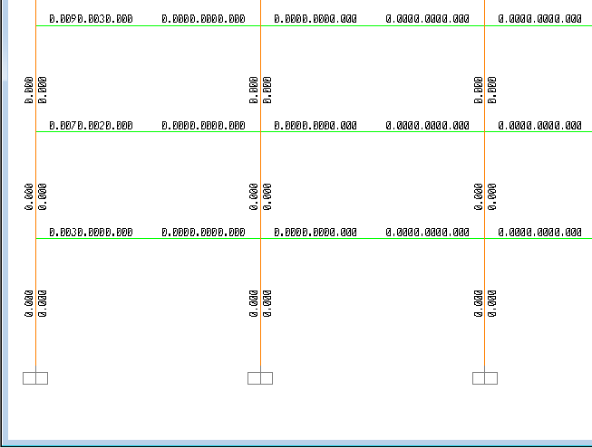
Figure 4.14: A_{V}/S for half the exterior y-z frames A-A/D-D
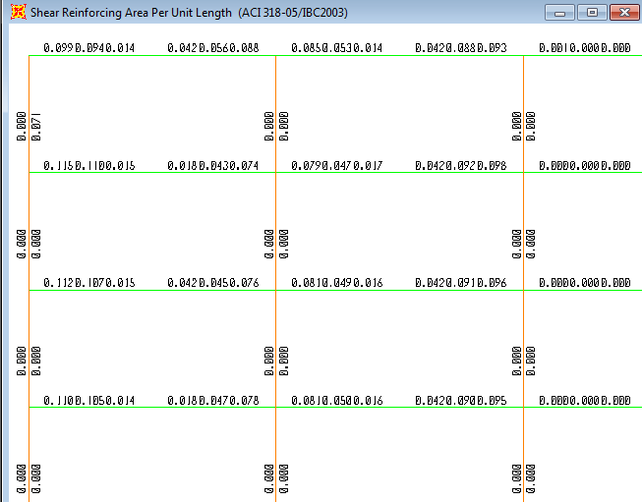
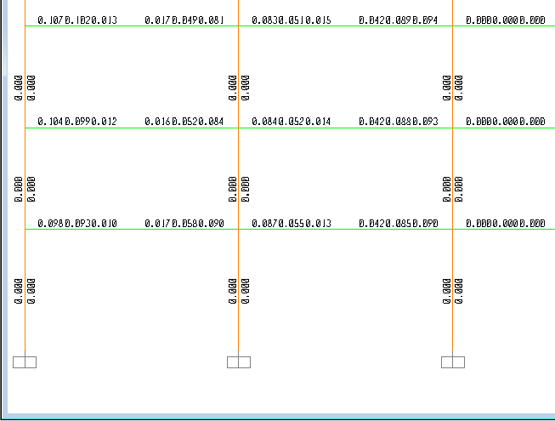
Figure 4.15: A_{V}/S of half the y-z frames B-B/C-C
It can be noticed from the previous figures that A_{V}/S values near the supports where the maximum shear force is expected to be (at distance d from the face ) is larger than the values of the middle part of the beams where the shear force is smaller.
For beams with A_{V}/S=0,which means that no need for shear reinforcement since the concrete can take all shear force ,the lateral reinforcement (stirrups)will be provided to gather and hold the longitudinal steel bars with a practical spacing of d/2 between them, so
2stirrups of 10mm diameter/30cm will be provided wherever A_{V}/S=0.

All A_{V}/S values of the X-Z Beams are less than (0.1046) which means than we can use 2stirrups of 10mm diameter /30cm everywhere in the x-z direction beams.
According to this figures 10mm stirrups with 30cm spacing are going to be used where ever A_{V}/S ≤0.1046 (use2ϕ10mm/30cm).
For the y-z girders, the maximum A_{V}/S value is located near the exterior supports of an interior y-z frame and equals=0.115, where all the other values are less than (0.1046).
For the exterior y-z frames, it can be noticed that a small A_{V}/S values near the exterior supports and all the remaining values are zeros.
As a result , all girders in the exterior y-z frames in addition to all interior girders in the interior y-z frames will have 2 stirrups of 10 mm diameter/30 cm.Exterior girders in the interior y-z frames will have 2 stirrups of 10mm diameter /20cm as a shear reinforcement.
A_{V}/S= 3.14/20=0.157 > 0.115 (largest value).

The final spacing and stirrups diameter of the lateral reeinforcement will be considered after the torsion design to provide appropriate spacing for both torsion and shear forces together .

Shear sample Calculations:
Shear strength (ACI 318 sec 11.1)
Ø V_{n} ≥ Vu , capacity ≥ demand
V_{U} = factored shear force at section.
V_{n}= Nominal shear strength
Ø= 0.75 (shear) - strength reduction factor
V_{n} = V_{C} + V_{S}
V_{C} = 0.53√f_{c} b_{w} d = Nominal shear resistance provided by concrete.
V_{s} = Nominal shear resistance provided by the shear reinforcement.
Since the width of the beams is 40 cm and the effective depth is 64 cm.
Take the middle beam in frame 2-2 of the first story, the resultant ultimate shear force is shown in figure (4.16):

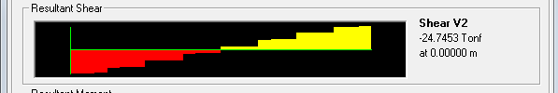
Figure (4.16): shear force diagram for the middle beam in frame 2-2 of 1st storey

V_{u} = 24.74ton From SAP program.
Ф$Vc=0.75*0.53*\sqrt{250}*0.4*0.64=1.6*10=16.09 ton$
Vu ≥ ФVc (shear reinforcement must be provided).
Vs = Vu – ФVc = 24.74– 16 = 8.74ton
Vs = $\frac{Av*Fy*d}{S}$
8.74*1000kg = 3.14* 4200 * 64 / S
S= 96.5cm.
Comparing this value with the ACI code requirement:
* S ≤ d/2 S= 64/2= 32cm
*S=60cm
S=94.2cm *$\frac{0.35b_{w}}{F_{Y}}≤\frac{A_{Vmin}}{S}$
Take the minimum spacing according to the ACI code S =32 cm, Use 2 stirrups of Ø10mm/30cm.

4.3 Torsion Design
Torsion is usually not taking into consideration during the design because of the complexity assigned with this subject. The average designer does not worry about torsion although most structures are subjected to torsional stresses .However, reducing the factor of safety over the past years resulted in increasing situations where torsional failure occurs with the result that torsion is a more common problem.
Torsion stresses lead to additional cracking especially around the exterior beams where the moment causing the torsion in the exterior beams has no opposite moment to equalize it and prevent excessive torsion and as a result, diagonal tension stresses created by shear stresses arise due to torsion.
Torsion stresses will lead to sever cracking which can develop well beyond the allowable serviceability limits unless special torsional reinforcement is provided .the addition of steel reinforcement reduces cracks width ,raises the torsional strength ,and gives ductility .
Torsion may arise as a result of primary or secondary actions. The case of primary torsion occurs when the external load has no alternative to being resisted but torsion. Examples of this case are curved girders or girders in which the resultant of the applied loads acts with a large eccentricity from the centroid of the cross section.
However, in statically indeterminate structures, torsion can also arise as a secondary action from the requirement of continuity .neglecting this torsion will not cause problems because :(1) the shear and moment capabilities of the beam are not reduced by small amounts of torque, and (2) the stressing of the adjacent members as the beam twists permit a redistribution of forces to these members and reduces the torque that must supported by the beam.
For a tabular section, and considering a thin wall tube subjected to a torsion T, the product of the shear stress resulting from the torsion and the thickness of the tube t, is called the shear flow q and equals (vt).
q = v t (Eq 4.3.1)
As a result, the torque equals:
T=2qA_{ₒ}→v=q/t=T/2 A_{ₒ}t (Eq 4.3.2)
Where A_{ₒ} is the area enclosed by the middle of the wall of the tube. For the rectangular hollow box beam, the previous equations are not applicable as long as the wall thickness is less than x/10.since the shear stresses are low near the center of the cross section, a hollow box beam with a small opining at its center has about the same torsional strength as a solid beam with the same outside dimensions. Therefore the ACI code is based on the thin –walled tube space truss analogy. Such analogy has the advantage of being applicable to both the elastic and fully plastic state of stress.
knowing that the principle tensile stress equal to the shear stress for element subjected to pure shear , thus the concrete will crack when the shear stress equal to the tensile capacity of cross section . If we use conservatively 0.37√f´c instead of 0.7√f´c for modulus of rupture, and remembering that A_{ₒ} must be some fraction of the area enclosed by the outside perimeter of the full concrete cross section A_{cp}. Also the value of( t) can, in general, be approximated as a fraction of the ratio A_{cp}/p_{cp} where p_{cp}is the perimeter of the cross section. Then for solid members with rectangular cross section ,t is typically 1/6 to1/4 of the minimum width .using a value of1/4 for a member with a width-to- depth ratio of 0.5 yields a value of A_{ₒ} approximately equal to 2 A_{cp}/3.for the same member t=2 A_{cp}/4p_{cp} ,using this values in equation 4.3.2 yields:
T_{cr}=$1.06\sqrt{fc}\frac{A_{cp}^{2}}{p_{cp}}$ kg.cm (Eq.4.3.3)
Space truss Analogy theory:
Similar to plane truss analogy for shear behavior, space truss analogy theory is used for torsion behavior. Reinforced concrete beams subjected to torsion will have a decrease in torsional strength after concrete cracks to about half of that of the uncracked member, the reminder being now resisted by the reinforcement .as the section approaches the ultimate load, the concrete outside the stirrups cracks and begins to spall off. Thus the area enclosed by the dimensions x_{ₒ} and y_{ₒ} is now the one that resist torsion. The x_{ₒ} and y_{ₒ} dimensions are measured to the centerline of the outermost closed transverse reinforcement and hence the gross area A_{ₒh}= x_{ₒ} y_{ₒ} and the shear perimeter P_{h}=2(x_{ₒ} + y_{ₒ}).with shear reinforcement, the beam is said to behave much as a space truss consisting of spiral concrete diagonals that are able to take load parallel but not perpendicular to the torsional cracks, instead the load is carried by transverse tension tie members that are provided by closed stirrups ,and tension chords that are provided by longitudinal reinforcement.(Figures R11.6.3.6(a)and R11.6.3.6(b) taken from the ACI code show the space truss analogy diagram and the A_{ₒh} definition for different types of beams).
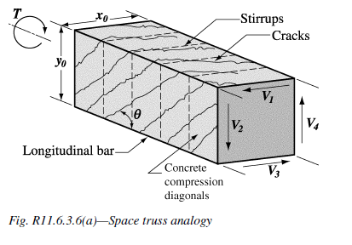
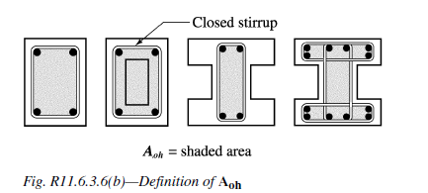
Basis for torsional design:(a)vertical tension in stirrups ,(b)diagonal compression in vertical wall of beam;(c)equilibrium diagram of forces due to shear in vertical wall.
T_{n}=$\frac{2Atf_{yv} xₒyₒ }{S}cosө$ (Eq 4.3.4)
Were A_{t}=area of one stirrup leg of closed stirrup.
f _{yv}=yield strength of the transverse reinforcement.
S=stirrup spacing.
$ө$ =Torsional crack angle.
It has been founded experimentally that, after cracking, the effective area enclosed by the shear flow path is somewhat less than the value of x_{ₒ} y_{ₒ} =A_{ₒh} , instead ACI recommends using 0.85 A_{ₒh} with A_{ₒ} substituted for A_{ₒh}.
Design procedure for torsional reinforcement:
To design for torsion we need to equate ultimate torsion to design torsion as follows (ACI11.6.3.5)
T _{u} ≤ ΦT _{n} (Eq 4.3.5)
Where Φ_{t} =0.75 .T_{n} is based on Eq.4.3.4 with A_{ₒ} substituted for A_{ₒh}.
T _{n} =$\frac{T_{u}}{Φ_{t}}=$ $\frac{2{ A_{ₒ}A}_{t} f_{yv} }{S}cosө$ (Eq 4.3.6)
Minimal Torsion:
According to ACI 11.6.1 no need to design for torsion if:
$T_{u }≤φ\left(0.265\right)\sqrt{f_{c}}\frac{A_{cp}^{2}}{P_{cp}}→kg.cm$ (Eq 4.3.7)
This lower limit (T_{cr}/4) is placed for conservative purposes to deal with equilibrium torsion. The use of T_{cr} is permitted according to ACI 11.6.2.2 for compatibility torsion.
Reinforcement for combined torsion, shear and bending:
The shear reinforcement can be calculated as the sum of that needed for shear and that needed for torsion .Based on the typical two-leg stirrup:
$\frac{A_{v+t}}{S}$= $\frac{A_{v}}{S}$+2$\frac{A_{t}}{S}$ (Eq4.3.8)
Were:
$\frac{A_{v}}{S}=\frac{V_{s}}{f_{y}d}$ (Eq.4.3.9)
And from Eq4.6.6
$\frac{A_{t}}{S}=\frac{T_{n}}{2A_{°} f_{yv} cosθ}$ (Eq.4.3.10)
The transverse stirrup used for torsional reinforcement must be of a closed form .However, for practical reasons, if a two pieces stirrup is used instead of a closed one, and then the transverse torsional reinforcement must be anchored within the concrete core.
To control spiral cracking, the maximum spacing of torsional stirrups shouldn’t exceed P_{h}/8 or 30 cm, whichever is smaller
(Or d/2 or d/4 as required by shear design).Also the minimum area of closed stirrups according to ACI 11.6.5 is:
A_{V} +2A_{t} ≥ 3.5 b_{w}S/f_{yv} (kg.cm) (Eq.4.3.11)
The area of longitudinal bar reinforcement A_{t} required to resist torsion is given as:
Where At/s is taken from Eq.4.3.10.
Based on evaluation of the performance of reinforced concrete beam torsional test specimens, ACI 11.6.5 requires:
$A_{t min}=\frac{1.32{\sqrt{f}}_{c}A_{cp}}{f_{y}}$ –$\frac{A_{t}}{S}$ $P_{h}\frac{f_{yv}}{f_{y}}$ (kg.cm) (Eq.4.3.12)

Where:
Kg.cm $\frac{A_{t}}{S}≥\frac{{1.75b}_{w}}{f_{yv}}$
The spacing of longitudinal bars should not exceed 30cm, and they should be distributed around the perimeter of cross section to control cracking. The diameter of longitudinal bar may not be less than S/16 or 10mm according to ACI 11.6.6.2. At least one longitudinal bar must be placed at each corner of the stirrup.
in this project the exterior beams in the complete model of the building in addition to the beams around the elevator opining were failed (over stressed) as a result of the excessive shear and torsion stresses resulted from the compatibility torsion as shown earlier and this problem solved by changing the dimension of all girders (50*70cm) where the beams failed before changing the dimensions are not overstressed any more(not appeared in the red color) as clearly shown in the shear section discussed earlier.
Torsion reinforcement for all beams taken from SAP is shown next:
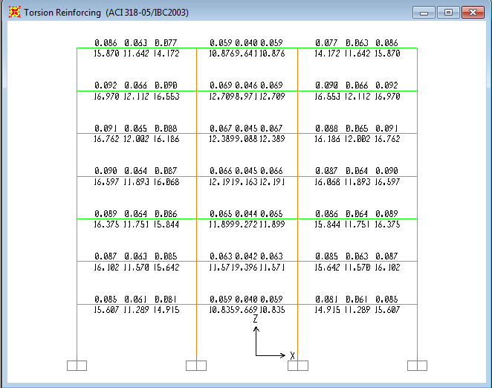 figure4.17: Torsion reinforcement of the exterior x-z frames 1-1/6-6
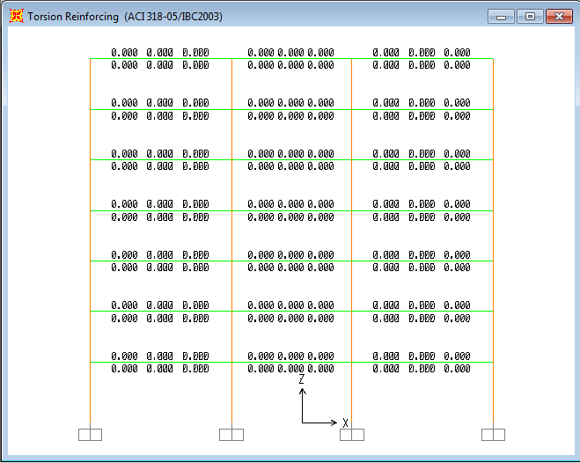
Figure4.18: torsion reinforcement of x-z frame 2-2/5-5
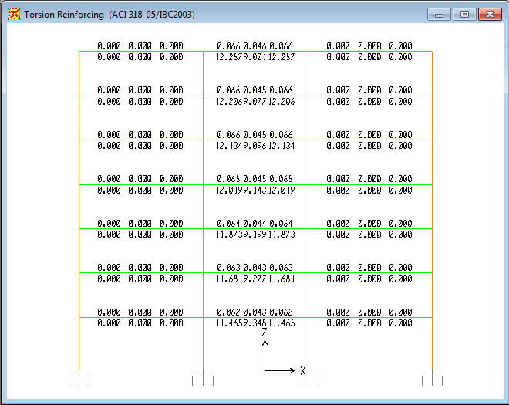
Figure4.19: torsion reinforcement of x-z frame 3-3/4-4
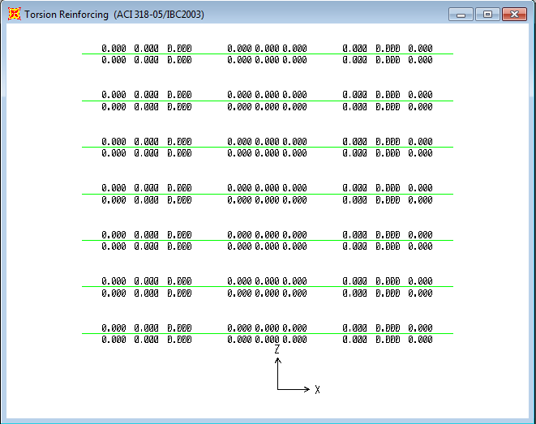
Figure4.20: Torsion reinforcing of beams between 1-1&2-2/2-2&3-3/4-4&5-5/5-5&6-6 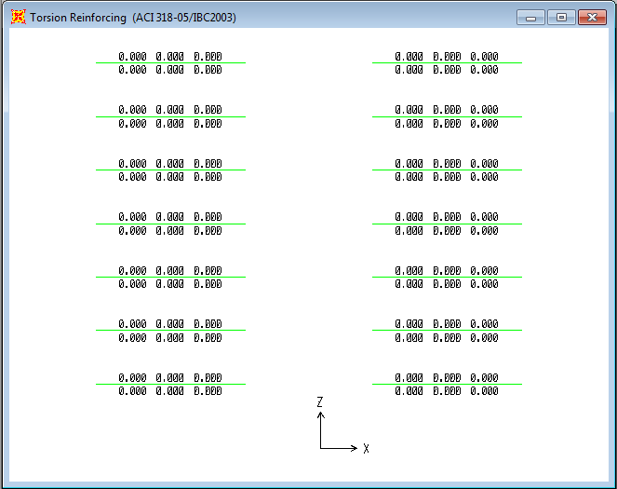
Figure4.21: Torsion reinforcing of beams between 3-3&4-4
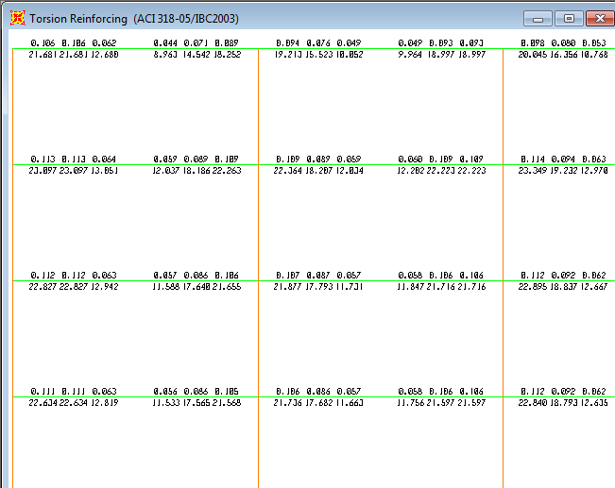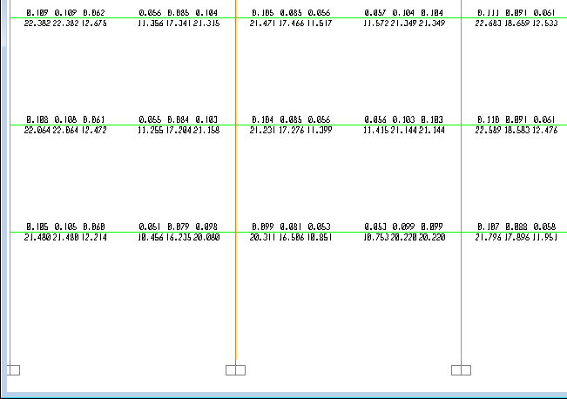
Figure4.22: Torsion reinforcing of half the exterior y-z frames A-A/D-D
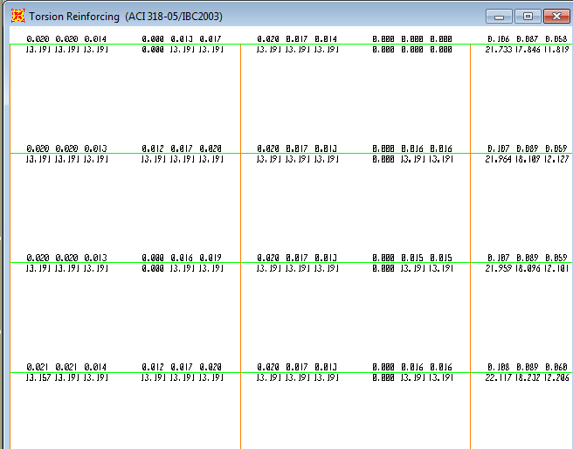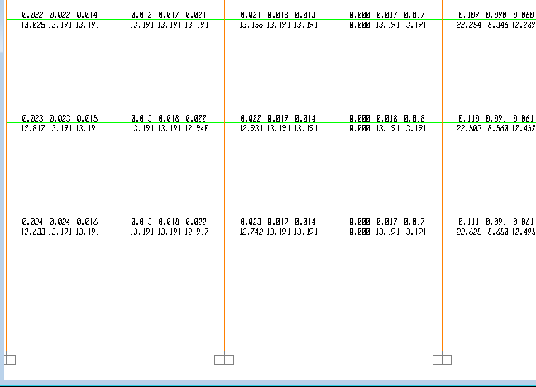
Figure4.23: Torsion reinforcing of half the interior y-z frames B-B/D-D

It’s clearly appeared from the previous figures that x-z direction beams have no torsional reinforcement except the exterior ones where the torsion is expected to be existed at the exterior beams.
moment on the x-z beams came from the slab loads will cause a considerable torsion stresses on the girders laid at the other direction (y-z) which is clearly appeared in the previous figures where a considerable lateral and longitudinal amount of steel is needed to overcome the torsional stresses in the exterior girders(frame A-A/D-D).
Transverse Reinforcement for Torsion:
Take a look at the torsion reinforcement design from SAP program in figure4.22, it can be noticed that all torsion reinforcement ratios (A_{t}/S) of the girders near the supports (in the exterior y-z frames) are almost the same, at the other hand, for the middle section of every girder in the exterior frames y-z, (A_{t}/S) are almost the same as well.
For transverse reinforcement, 2 stirrups of 10mm diameter are going to be used (A_{t}=0.785cm²). Every girder is going to be divided into three sections, the edge sections (near the supports) will have the same stirrups spacing because they have the same reinforcement ratio (A_{t}/S), but the middle section will have a different stirrups spacing.
As shown in figure 4.22, the maximum (A_{t}/S) ratio near the supports (edge sections of the girders) is 0.113 and its going to be used for all edge sections for the girders in the exterior y-z frames. For the middle section of the girders in the same frames, the maximum (A_{t}/S) ratio is 0.065 and it's going to be used for all middle sections of the beams in the exterior y-z frame.
For rear sections of the girders:
A_{t}/S=0.114→0.785/S=0.113
S=7cm.
Compared this value with the spacing value from the next equation as the ACI recommends:
$$\frac{A_{t}}{S}≥\frac{{1.75b}_{w}}{f_{yv}}$$
0.785/7 ≥ 1.75*50/4200→0.112>0.02 ok.
For middle third (section) of the girders:
A_{t}/S=0.0.065→0.785/S=0.065
S=12cm.
Compared with the ACI equation:
$$\frac{A_{t}}{S}≥\frac{{1.75b}_{w}}{f_{yv}}$$
0.785/12 ≥ 1.75*50/4200→0.065> 0.02 ok.
Use ϕ10mm stirrup/12cm in the middle third of the girders.
Longitudinal Reinforcement for Torsion:
Longitudinal reinforcement is used in the torsion as well as transverse reinforcement represented by the ties.
Take a look at the torsion reinforcement diagrams of the exterior y-z frames from SAP program design, it can be noticed that the area of longitudinal steel and its distribution in the girders is almost the same for all girders. It can be also noticed that at each girder, the biggest area of steel is concentrated near the supports (rear ends of each girder) and decreases at the middle.
Taking the maximum area of steel as shown in figure 4.22to be 23cm², which going to be generalized for all girders in the exterior y-z frame. (Use 9ϕ18mm).
The torsion longitudinal bars are going to be distributed as three thirds, the first one third at the top of the beam, the second one third at the middle and the last one third at the bottom with the positive bending steel.
So use 3ϕ18mm at the top and 3ϕ18mm at the middle and3 ϕ18mm at the bottom

4.4Design of Slab
Slab is a structural system that carries and transmits live and dead loads in a safe ways to the beams. The type of slab used in this building is the one way solid slab , where the dead load comes from the own weight of the slab which has a thickness of 18cm , in addition of a super imposed dead load of 0.3t/m²comes from the partition ,tiles, plastering,…etc. In addition to that a live load of 0.4t/m²is used comes from the occupancy of the building as an office building.
After doing the static analysis of the 3Dmodel, using SAP program, and assuming that slab loads are going to be carried in the Y-direction (short direction between beams), and since slabs stresses under the gravity loading is almost the same for all floors, shells moments of the first story will be taken as shown in figure4.24

4.4.1 Bending moment on the slab in Y-direction (M₂₂)
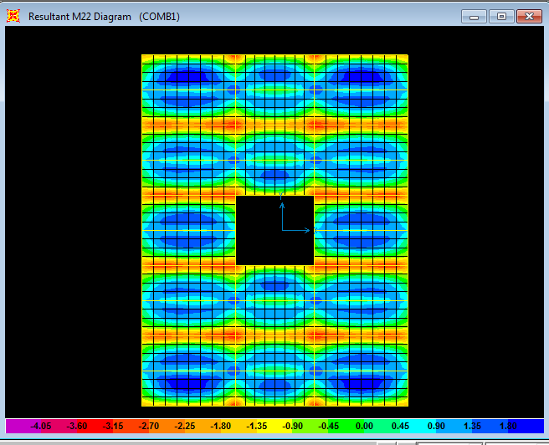
Figure (4.24): Shell stresses (M₂₂ bending moment)
Maximum positive moment on the slab
As the color bar in figure 4.24 shows, max positive moment is represented by the blue color and equals 1.8m.ton/m, and to be more conservative, it's going to be generalized and used for all positive moments on the slab.
Mu=1.8m.ton/m.
Using the steel ratio formula to calculate the area of steel needed to resist the positive moment of the slab.
ρ = $\frac{0.85 fc }{fy}\left[1-\sqrt{1-\frac{2.61 * 10⁵ * Mu}{b * d² * fc }}\right]$
ρ = 0.001892> ρ_{min} = ρ _{shrinkage}=0.0018
A_{s} = ρ* b*d = 0.001892*100*16 = 3.027cm²/m →As _{needed}=3Ø12mm/m.
But, for good practice use 4Ø12mm/m with a spacing of 25cm between the bars.
The code recommends to extend at least one third of the positive steel between the supports (main beams) but since we have the almost the minimum area of steel, if we extend one third the bars and make a cut off for the rest, that will affect the spacing between bars and make it exceed the maximum permissible spacing, so all positive steel bars will be extended between the slab supports (beams).

Maximum negative moment on the slab
As the color bar in the slab moment diagram shown in figure 4.24 indicates , max negative moment on the slab (near the beams supported on the columns)=3.15m.ton/m, and to be more conservative this moment is going to be generalized for all slab negative moments over the beams carrying the slab and supported on the columns.
Mu=3.15m.ton/m.
ρ = $\frac{0.85 fc }{fy}\left[1-\sqrt{1-\frac{2.61 * 10⁵ * Mu}{b * d² * fc }}\right]$
ρ = 0.003361
A_{s} = ρ * b * d = 0.003361 * 100 * 16 = 5.38cm²/m greater than A_{s min}
A_{s min} = 0.0018 * b* t = 3.6 cm²/m.→ Use 5Ø 12 mm /m.
Negative moment bars will be extended above the supports to one third the clear distance slab span from each side of the support.
Since we have slab spans of 3.95 m between supports (main beams)
1/3*(3.95) =1.3 m
So slab negative steel bars will be extended to a distance of 1.3 m from each side of the support. (Bar length =3m)

4.4.2 Secondary steel in the x direction
It’s clearly that we need secondary steel in the other direction(x direction) to take the small moments resulting from the part of loads that go in the other direction because loads will not completely go in the direction we assumed (y direction: shorter length between supports) since load will be distributed at an angle of 45⁰ ,which means that as the ratio between the length to the width of the slab increases ,slab can be considered more as one way slab starting from the condition of L/B>2.
The secondary steel will be also used to tie and support the main positive steel and to take the shrinkage stresses as well.
Secondary steel will be taken as:
A_{S} =0.0018*100*18=3.24cm²(use 4 ϕ10mm /m).

4.5 Design of columns

4.5.1: Design of columns from SAP program
All columns are 75*75 cm and have the same reinforcement except some columns in the last floor where they are exposed to large moment in addition to their axial loads, so additional area of steel should be provided to handle the large moment which cannot be neglected. Back to designed area of steel in the appendix (A) it can be noticed that the exterior columns in the interior x-z frames of the seventh storey have a different area of steel than the rest of structure column so the maximum column area of steel in the seventh storey which equal 63.77cm²is going to be used for all seventh stories columns which will be named as C7.
Column | As (cm²) | Distribution of steel
C | 56.25 | 12 Ø25
C7 | 63.77 | 14 Ø25

4.5.2 Manual Design for an Interior Column
Introduction
Columns are divided into two types according to their dimensions:
-short columns.
-long columns.
-Column type can be determined by using the following equations:
K L_{u}/r ≤ 34 – 12M_{1b /} M_{2b} (The column is short column)
K L_{u}/r > 34 – 12M_{1b /} M_{2b} (The column is long column)
Where:
L_{u} = un-braced length of column.
k = effective length of the column.
0.5 ≤ K ≤1, for braced columns.
K ≥ 1, for un-braced columns.
r = radius of gyration=$\sqrt{(\frac{I}{A})}$
Where:
I: moment of inertia of the column cross section.
A: column cross section area.
r = (0.3h) for rectangular sections = (0.25 D) for circular sections.
h= Least column dimension.
D= circular column diameter.
Since columns are braced, a value of K can be taken between the 0.5 and 1
Take K to be 0.7
r= 0.3 * 0.75 = 0.225
L_{u} = 4.3 m for the first floor columns.
From SAP program and taking the 3D model of the building, the base reaction of a typical interior column (maximum tributary area 76.63 m²) from the load combination equals 1051.43 ton as shown in figure 4.25, notice that the same value can be taken from the axial forces figure from SAP as shown in figure 4.26.
Figure 4.27 show the ultimate moments M₁&M₂ at the top and at the bottom of the mentioned column.
The minimum eccentricity to consider the load as concentric =1.5cm+0.03h (where h is the width of the column). e_{min}=1.5+0.03*75=3.75cm
M_{min}=P_{U}* e_{min}=1051.43*0.0375=39.42ton.m.
Any moment less than M_{min} can be neglected, since M1&M2 at the top and at the bottom of the selected column are less than M_{min}, they can be neglected.
K L_{u}/r =0.7*4.3/0.225 =13.377≤ 34→short column. Figure 4.27shows that moments at the top and the bottom of the mentioned column are small and can be neglected, so only axial force will be taken in the following design.
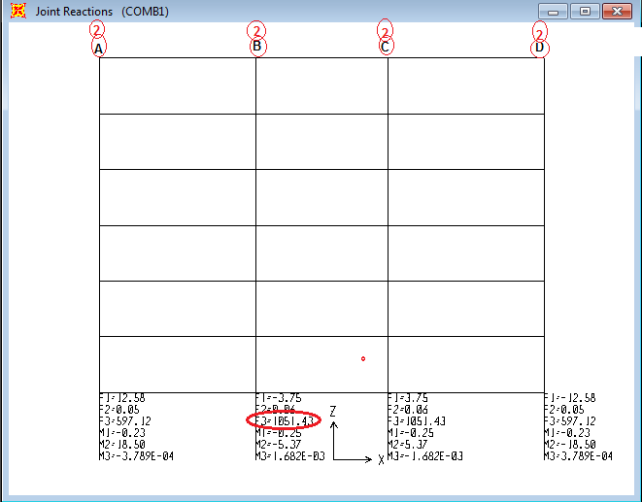
Figure 4.25: joint reactions of the interior x-z frames 2-2/5-5
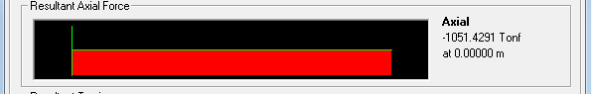
Figure 4.26: axial force of the interior first floor columns in frame 2-2/5-5
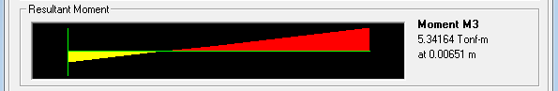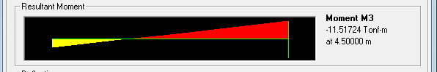
Figure 4.27:M₁&M₂ of the interior first floor columns in frame 2-2/5-5

P_{u} = 1051.43ton.
P_{U}= Ø λ [o.85 f/_{c} (A_{g}- A_{s}) + F_{y} A_{s}]
Where:
Ø: strength reduction factor. (Ø =0.65 in case of tie columns.)
λ: reduction factor due to minimum eccentricity. (λ=0.8)
A_{g}= (75*75= 5625 cm²), f/_{c}=400kg/cm², F_{y}=4200kg/cm².
1051.43* 10³ = 0.65 *0.8 *(0.85* 400 (5625 – A_{s})) + 4200 * A_{s}
A_{s}= 14.15cm²
Steel ratio for column= A_{s}/ A_{g} = 14.15/5625 =0.0025
But the ACI code recommends at least 1% steel ratio
From SAP, As=56.25cm²

4.5.3 Design of columns stirrups
Stirrups in columns used to gather and tie the longitudinal bars and it also give small additional strength to the column.
Use 10 mm diameter for the stirrups,

The ACI code recommends that the spacing (S) between stirrups shouldn’t exceed the minimum of the following:
S ≤ 12 d_{b}
S ≤ 48 d_{t}
S ≤ least lateral dimension of column
Where:
d_{b} : longitudinal bars diameter
d_{t} : tie bar diameter
S ≤ 12 d_{b}
S=12*2.5 = 30cm
S ≤ 48 d_{t} s= 48*1= 48 cm
Least lateral dimension of column= 75 cm
So, Spacing S= 30 cm.
Every corner and alternate longitudinal bar shall have lateral support provided by the corner of a tie with an inclined angle not more than 135^{ₒ}, and no bar shall be more than 15cm clear on either side from "support "bar.
Since a column of 75*75cm is used (cover =4cm).
12 Ø25mm for each column (4 at each side).
Spacing between bars (75-2*4)/ (4-1) =22cm>15(code recommended).
Lateral support for each bar must be provided.
Use three Ø10mm stirrups/30cm.
One stirrup around the whole cross section, the other two stirrups support the two middle bars in each side of the column cross section.

Chapter five
Footings

5.1 General description
The main principle of the structural design is to provide a safe path for the loads to the soil, because the structure will not fail as long as there is a safe path. Loads are transmitted from the slab to the beams carrying the slab then to the columns which transmit the loads to the foundation and finally to the soil.
There are several types of footings such as single footings, combined footings, wall footings, mat or raft footings and piles footings.
The type of footings used in any structure depends mainly on the soil characteristics (bearing capacity of the soil), in addition to the type and value of the service loads.
In this project the single footing foundation system is going to be used because to the following reasons:

* Single footing system is considered the least cost foundation system (cheapest) compared with the other foundations systems.
* The bearing capacity of the soil in this project is 3.5 kg/cm² which considered a good soil strength and suitable for isolated footings.
* The length of the spans between columns is long enough to permit the design of single footings without any overlapping.
since the building is symmetric, there are only five different column tributary areas resulting of five different design values of the service loads applied to the corresponding single footings F1,F2,F3,F4 and F5.
The five nominated single footings are shown in figure 5.1 on the structure plan view in the next page.
Load on these footing will be taken from SAP program as the columns reactions resulting from the own weight of the slabs, beams, columns, and the super imposed dead in addition to the service distributed slabs live load resulting from the occupancy of the building. This section will consider only the design of footings for the axial columns load where the moments (if any) will be taken by the tie beams.

5.2 Plan view

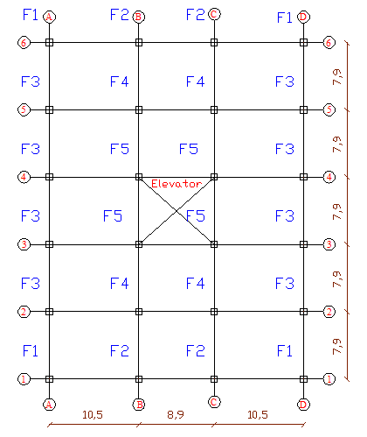
figure5.1: suggested footings distribution according to the tributary areas

5.2 service loads on footings
In the footing design, service and not ultimate loads must be taken, because the factor of safety is already taken in the design bearing capacity value which is in fact less than the actual bearing capacity of the soil. The following table shows the dead and live loads on every single footing of the project taken from SAP program:
Total(ton) | live load(ton) | Dead load(ton) | Footing no.
262.4 | 56.4 | 206 | 1
450.04 | 109.8 | 340.24 | 2
460.11 | 112.7 | 347.41 | 3
805.62 | 217.72 | 587.9 | 4
654.31 | 168.02 | 486.29 | 5

Since the values of total service load for F2 and F3 are close they are going to be designed using the larger total service load which is equal 460.11ton. (Footings will be named as F2).
The final distribution and label names of the footings according to the designed loads are shown in figure 5.2.
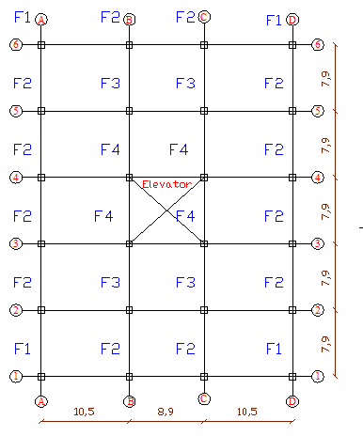
figure5.2: selected names& distribution of footings
5.3 Manual design
The design loads corresponding to the final distribution are shown in table5.1:
Total service load(ton) | Live load | Dead load | Footing no.
262.4 | 56.4 | 206 | 1
460.11 | 112.7 | 347.41 | 2
805.62 | 217.72 | 587.9 | 3
654.31 | 168.02 | 486.29 | 4
Table5.1: service loads on the selected footings
Taking footing number four (F3):
Service dead load = 587.9ton, service live load= 217.72 ton
Total service load = 805.62ton.
Area of footing= total service load / bearing capacity of the soil
A_{f} Required = 805.62/ 35 = 23.02 m²
Use a square footing of 4.8* 4.8 m
A_{F} design = 4.8*4.8= 23.04 m²
A_{f} design > A_{f} required Ok
Thickness of footing:
To determine the thickness of footing which depends on the shear resistance requirements, the ultimate pressure (q_{u}) under the footing must be calculate first.
Ultimate pressure under footing = factored load / design footing area
Factored load = 1.2 Dead load + 1.6 live load
P_{u}= 1.2* 587.9 + 1.6 *217.72 = 1053.83ton.
q_{u} = P_{u} / A_{FD} = 1053.83/ 23.04= 45.74ton/m² .

Check the wide beam shear:
Assume depth of the footing to be t= 1m, effective depth (d) = 0.93m.
V_{u} = q_{u} *B * {(L – c)/2}
Where,
V_{u} = ultimate shear force on the footing from the ultimate load.
B= the width of the footing
L= the length of the footing
c= column width
V_{U} = 45.74 * 4.8 * (4.8-0.75)/2
V_{U} = 444.6ton
Compare the ultimate shear force with the nominal shear strength provided from the concrete (V_{n}):
$$Vn = 0.53 \sqrt{fc} B d$$
$Vn = 0.53 \sqrt{400} * 490 * 93$= 483 ton > V_{U} → Ok

Check the punching shear:
$$Vu = qu \left( B *L -{\left(c+d\right)}^{2} \right)$$
$$Vu = 45.74 \left(4.8 * 4.8 – {\left(.75+.93\right)}^{2} \right)$$
V_{u} = 924.75 ton
Compare the ultimate punching shear force with the nominal shear strength provided from the concrete (V_{n}):
$$Vn = 1.06 \sqrt{fc} {b }_{o} d$$
Where:
b_{o} = the parameter exposed to the punching force at distance (d) from the column face.
V_{n} = 1.06 * √400 * 4 * (75+93) * (93)
V_{n} = 1324.9 ton
V_{n} > V_{u} Ok
So use a square foundation F3 {4.8*4.8* 1} m

Footing design for flexure:
In the footing design for flexure, the footing will be treated as a cantilever beam fixed at the column .the design will be per meter width of the footing, and the cantilever will be loaded by the ultimate pressure under the footing which will be considered uniformly distributed under the footing for model simplification.
Ultimate moment on the footing$\left(M_{U}\right)=qu*\frac{L_{n}^{2}}{2}$
Where: L_{n}: the clear distance from the face of the support (fixation) to the end of cantilever (footing end).
M_{u}=45.74*((4.8-0.75)/2)²/2=93.78m.ton
M_{n} required= M_{u}/ϕ
Where ϕ: capacity reduction factor=0.9
M_{n}=93.78/0.9=104.2m.ton
Approximately:
M_{n}=T (0.9d)
Where T: tention force in the footing.
M_{n}=A_{s}F_{Y} (0.9d)
A_{S}=104.2*10⁵/4200(0.9*93)
A_{s}=29.64cm²/m
Use 12ϕ18mm/m.
As_{min}=ρ_{min}*b*t
As_{min}=0.0018*100*100=18cm²less than the required area of steel, so use the calculated area of steel.
Since it is a square footing, the moment will be the same in the both directions, and as a result the reinforcement will be also the same.
So use 12ϕ18mm/m in both directions,
For the rest foundation the excel sheet will be used to find the appropriate dimensions of the footings depending on the ultimate pressure under footing and the shear criteria as done above .
Footing dimensions and flexure reinforcement will be next tabulated for all footings in table 5.2.
Shrinkage steel/m | Steel in y direction/m | Steel in x direction/m | Depth (t)m | Width  (B)m | Length  (L)m | Total service load | Footing #
5ϕ18mm | 7ϕ18mm | 7ϕ18mm | 0.5 | 2.8 | 2.8 | 262.4 | 1
6ϕ18mm | 8ϕ18mm | 8ϕ18mm | 0.7 | 3.7 | 3.7 | 460.11 | 2
7ϕ18mm | 12ϕ18mm | 12ϕ18mm | 1 | 4.8 | 4.8 | 805.62 | 3
7ϕ18mm | 10ϕ18mm | 10ϕ18mm | 0.8 | 4.4 | 4.4 | 654.31 | 4

Table 5.2: reinforcement of the selected footings

5.4 SAP Calculations
By using SAP program to design footing F3 the stress (S₁₁) diagram is shown in the figure (5.3)
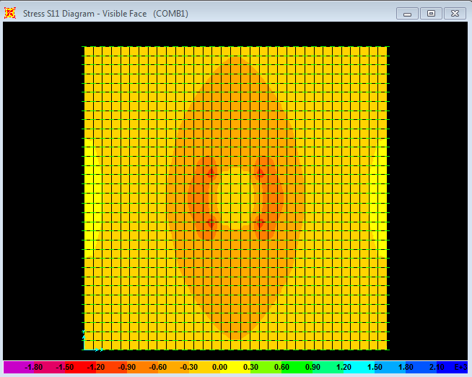
Figure (5.3): stress diagram (s₁₁=s₂₂) in F3
Taking section cut near the face of the support (column), the moment diagram is shown in figure (5.4) in the next page.
From figure (5.4), maximum bending moment equal 429.5.ton
Divide the total moment by the length of the section cut 429.5/4.8 equal 89.48m.tom/m.
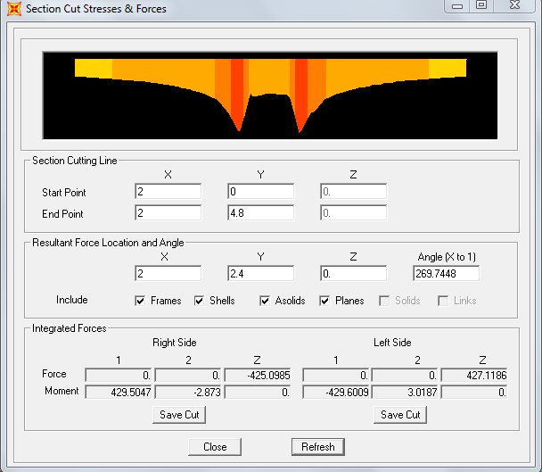
Figure (5.4) F4 Maximum bending moment near the face of support
Error = (93.78 – 89.48)/93.78
Error = 4.5%
figure 5.5 shows the reinforcement intensity Ast₁, which is the same as the intensity in the other direction Ast₂ ,because the footing is a square one and the moments are the same in both direction .the selected area in the middle of the figure is the column (support) where the moment is expecting to be the maximum at the face of the support and as a result the reinforcement intensity as well ,which is clearly obvious in figure 5.6 where the maximum reinforcement intensity at the face of support =0.003347
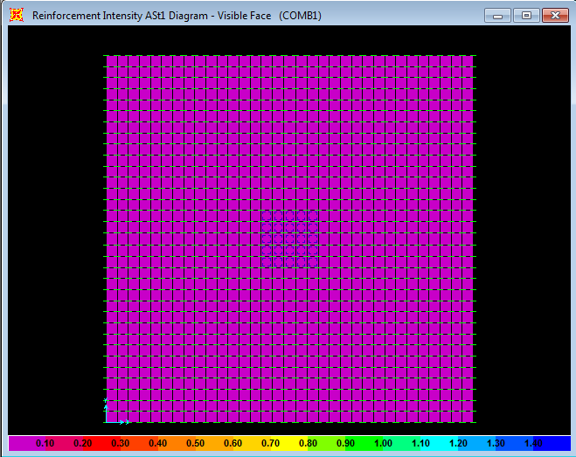
figure5.5: reinforcement intensity Ast₁ of footing F3
Figure (5.6): The maximum reinforced intensity at the face of support of F3
Area of steel = ρ * b*d
A_{s =}0.003347 * 100* 93=31cm².
5.5 Design of tie beams
Tie beams are used to tie the columns and connect them to make the structure act as one unit by reducing the differential settlement, they also used to take the footings moments resulting from the eccentric axial loads, where it’s not recommended to make the footing take moment because footings rest on soil which is poor in resisting moments, so tie beams will be designed to take the footings moments which are expected to be small, because the axial footings loads have a small eccentricity less than e_{min}.
Tie beams are also used to carry the outside facades or cladding walls, which is beyond the scope of this project, so tie beam will be designed to take the small moments on footings.
Since the SAP gives the same analysis for frames with fixed foundation or frames with pinned foundation with tie beams , all reinforcement figures in the appendix considered the building with fixed supports on SAP and the tie beams will be designed separately.
Take the depth of all tie beams to be 60 cm (d=54) and the width to be 30 cm.
Since all positive and negative moments on the tie beams are small and less than 10 ton.m the steel ratio will be less than the minimum steel ratio =14/F_{Y}
ρ _{min}=14/4200=0.0033
A_{S}=0.0033*30*54=5.4 cm².
Use 3ϕ16 mm at the top and at the bottom of all tie beams, and, let the tie beam steel to extend from the middle to the middle of columns.
For tie beams stirrups and since we have small shear forces on the tie beams, use one stirrup of 10 mm diameter every d/2 spacing to gather and tie longitudinal steel and to take the small shear stresses .
Use ϕ10mm stirrup/25cm.

chapter six
dynamic design

6.1 Introduction to Dynamics of Structures
It also called the theory of vibration of structures, the study of the vibration of structures, methods of designing structures subjected to dynamic loads, and means of reducing vibration; a branch of structural mechanics. Dynamic loads on a structure are characterized by such rapid change with time in their size, direction, or point of application that they cause vibrations of the structure, which must be considered during its design. Loads occurring during the operation of machines with unbalanced moving masses, upon impacts of massive bodies, and during earthquakes and explosions are examples of such loads. Not only the movements of structural points but also internal stresses and strains in structural elements may be of a vibrational nature.

Theoretical dynamics of structures, based on the research results of experimental dynamics of structures, develops analytical and numerical methods of determining the amplitude of forced vibrations (the fundamental problem of dynamics of structures), as well as the frequency and shape of free (or intrinsic) vibrations of structures. Methods of solving the basic problems depend on the type of dynamic load and the design scheme of the structure. Dynamic loads are divided into determined loads, which change with time according to a definite law, and random loads, which change irregularly with time and are characterized by statistical values. Depending on the type of design scheme of the structure (beam, truss, frame, arch, plate, dome, or casing), the corresponding method is used to determine the amplitude of vibrations as a function of the coordinates of points of the structure. Methods for determining the frequency and shape of vibrations depend only on the design scheme of the structure. Knowledge of the frequency and shape of the intrinsic vibrations of a structure makes possible, before designing for dynamic load, the prediction of the qualitative pattern of the forced vibrations, the maximum reduction of the estimation, and the revelation of disadvantageous frequency levels for periodic loads and durations for short-term loads.
Structural dynamics design is to design a structure subject to the dynamic characteristics requirement, i.e., determine physical and geometrical parameters such that the structure has the given frequencies and (or) mode shapes. This problem often arises in engineering connected with vibration.

6.2Prevailing codes of seismic design
The source of most codes in the US is the provisions of the National Earthquake Hazard Program, NEHRP, as administrated by the Federal Emergency Management Agency, FEMA. Thus the main issues covered by IBC-code will follow the same trend as in the UBC-code with some changes force calculations and seismic maps.
Both UBC1997 (for its familiarity) and IBC2006 will be presented (reference to IBC2006 will be ASCE Standard 7-05).
There are three methods to perform the 3D dynamic analysis and design for the structures:
1-Static Equivalent Method.
2-Time History.
3- Response Spectrum.

In this project manual calculation will be made using the concepts of the static equivalent method and results will be compared with the results taken from the response spectrum method performed by SAP program, using the IBC2006 code recommendations.

6.2.1 UBC97 versus IBC2006: Zoning and Response Spectrum
UBC97: assigns ground acceleration in each zone based on 90% probability that it will not be exceed in 50 years. The design response spectrum is determined according to soil type by assigning two coefficients: one for acceleration C_{a}, and the other for velocity C_{v}.
IBC2006: assigns two spectral accelerations for a Maximum Considered Earthquake (MCE). One for short period (0.2 sec) S_{s} (analogous to C_{a}), and one at 1-sec period S₁ (analogous to C_{v}). These values are measured at bedrock then modified for site effects using factors F_{a} and F_{v} (refer to Tables 2a and 2b), and further modified to design response spectrum as:
S_{Ds} = 2\3 (F_{a} S_{s}), S_{D1} = 2\3 (F_{V} S₁)

6.2.2 UBC97 versus IBC2006: Site Classifications
Both adopt the same classification which identifies site into six categories:
1-Soil Type SA: Hard rock
2-Soil Type SB: Rock
3-Soil Type SC: Very dense soil and soft rock
4-Soil Type SD: Stiff soil profile
5-Soil Type SE: Soft soil profile
6-Soil Type SF: Needs special evaluation
*20.1: a. When the soil properties are not known in sufficient detail to determine the soil profile type, Type SD shall be used.
b. Site classes A and B shall not be assigned to a site if there is more than 3m of soil between the rock surface and the bottom of the spread footing or mat foundation.

6.2.3 UBC97 Response Spectrum:
For equivalent static force, the value 2.5 C_{a} extends to zero period.
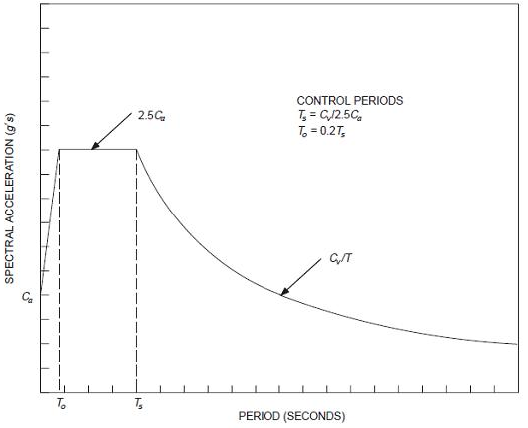
Where:
T_{s} = C_{v}\2.5 C_{a}
T₀= 0.2 T_{s}
C_{a}: Coefficient of velocity
C_{v}: Coefficient of velocity

6.2.4 IBC2006 response spectrum:
For equivalent static force, the value S_{ds} extends to zero
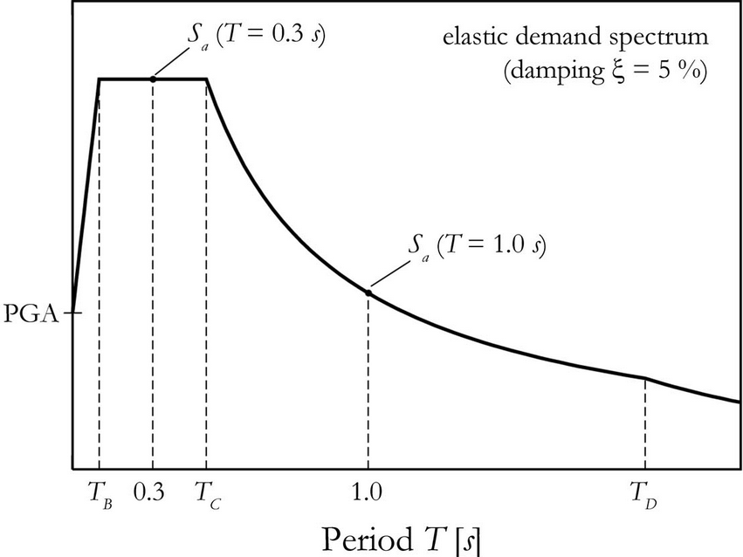

Where:
S_{ds:} spectral design acceleration at short period.
S_{d1:} spectral design acceleration at one period.
T_{s}= S_{d1}\ S_{ds}
T_{O}= 0.2 T_{S}

6.2.5 The fundamental or natural period T
The fundamental period of the structure T is calculated using the following formula:
T=2π/ω, ω=$\sqrt{\frac{K}{M}}$
Where: k is the summation of the stiffnesses in the target direction. M is the total mass of the structure.
The previous equation is simple to use when we have one story structure and it getting a little complicated when two stories are used .for more than two stories computer analysis needed to compute the value of ω from the mass-stiffness matrices.
Codes provide empirical formulas to calculate the fundamental period of the structures with respect to their heights.
For concrete framed structures:
_ T= 0.073 (H_{N}) ^{3\4} IBC2003
_ T= 0.04 (H_{N}) ^{0.9} IBC2006
T= period in seconds
H_{N} = Height of building in meters.
*For all other structures:
T= 0.049 (H_{N}) ^{3\4} IBC2003, IBC2006

6.2.6Earthquake Force
*Response spectrum values are normalized with respect to ground accelerations, thus:
F_{s}= M S_{a} = (W\g) S_{a} = (S_{a} \g) W
The weight of the structure to represent the mass of the structure is given as:
a. Total dead load.
b. 25% of live load in storage areas and warehouses.
c. partition weight or minimum 0.5 KN\m² whichever is greater.
d. permanent equipment.

6.2.7 UBC97 versus IBC2006: seismic use group
Buildings are classified in both codes into seismic use groups according to their occupancy and functionality and use an importance factor I_{E}.
IBC2006 Identifies four groups, group three uses I_{E}=1.25 for hazardous facilities whose failure may result in large number of casualties, and I_{E}=1.5 for essential facilities that are expected to remain functional during and after the earthquake.
For all other types of buildings, the importance factor I_{E} will be taken =1.

6.2.8 IBC2006 Seismic-Force-Resisting System
According to IBC2006, there are five basic seismic-force-resisting systems including the bearing wall system, building frame system, moment resistant frames, dual system with special moment frame and dual system with intermediate moment frames.
Every system of the mentioned systems has different cases of reinforcement (special, ordinary, detailed, intermediate)
which imply the way of sway or the ductility of the system and represented by the response modification factor R as shown in table 4 taken from the IBC2006 code.

6.2.9 IBC2006 seismic design category
Buildings are classified into three seismic design categories according to their seismic hazard:

1-Category A (regions of negligible seismicity: S_{S} < 0.15 and S₁ < 0.04): no spectral values are required. Use a minimum lateral force 1% of the dead load.
2- Categories B and C (low to moderate seismicity): use S_{s} and S₁ map values.
3- Categories D, E and F (high seismicity): S_{s} and S₁ should not be less than 1.5g and 0.6g respectively.

6.3 Dynamic Design of the structure:
As it mentioned earlier, there are three methods to design the structure for the seismic load.
The first method is the equivalent method where the base shear resulting from the seismic load is found at the base of the building depending mainly on the weight of the building W multiply by a specific factor C_{s} taking into consideration the importance of the building I_{E} ,the type of the seismic load resisting system R, the response spectrum at short period and at one second and the fundamental period of the building.
Every storey of the building will take a share from the base shear according to a specific factor depends on the storey weight and height.
The second design method is the response spectrum method which is going to be adopted for the seismic design in this project, where a dynamic analysis is done using SAP program by using the spectrum values of the acceleration S_{S} and S₁ depending on the area classification of the seismic activity, the ground acceleration will be towards the design direction (weak direction) and many cases of loading can be taken to take the critical combination used in the design.
The final method is the time history method, where the structure is being exposed to a specific real happened earthquake from the database of the SAP in a specific direction, and the analysis results will depend on this quake only.

6.3.1 Equivalent static method
According to IBC2006 and UBC97, the soil where the building is existed is classified as soil B. Building follows category 1 in the IBC2006 code classification for occupancy importance factor, so I_{E}=1.and since the seismic-force- resisting system used in this project is the ordinary reinforced concrete moment resistant frames, the response modification factor R will equal 3 as the code recommends.
First of all, the fundamental period of the building (T) must be calculated using the code formula.

T=0.047H_{N}^{0.9} IBC2006
Total height of the building H_{N}=27m.
T=0.047(27)^{0.9}=0.912sec.
From SAP program the fundamental period of the building in X direction equal (1.44sec.) and in Y direction equal (1.267 sec.) as shown in figure 6.3
Since the code equation used to compute the fundamental period is an empirical formula considering the structure height as the only variable and made under specific condition of fixed foundation and light super imposed load in addition to a special material properties limits , the difference between the code formula and the SAP results in computing the fundamental period is expected and as a result, SAP fundamental period will be adopted.
To make sure that the values of the fundamental period of the structure taken from SAP is accurate, checks will be made by computing the fundamental period of the first story manually and compare it with the fundamental period taken from SAP program.
SAP fundamental period for the one storey model:
As figure 6.1&6.2 show, the first mode in the x direction with a T= 0.2214sec, and the second one is in the y direction with T= 0.21sec.
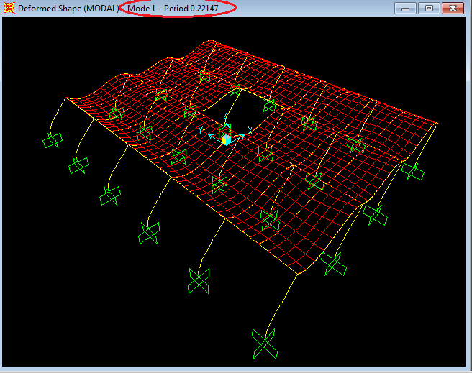
Figure6.1: First mode of the one storey model (u_{x})
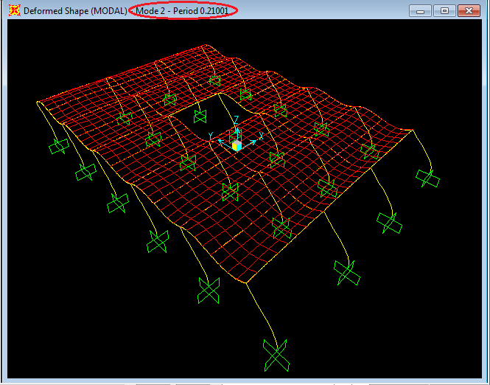
Figure6.2: second mode of the one storey model (u_{y})

Analogical computation of T_{X} andT_{Y} for one storey:
The stiffness (K) in x and y directions are equal because the columns are square columns.
K_{X} = K_{y} = 12 E I / L³
Where:
E= Modulus of elasticity of concrete=$15100\sqrt{f_{c}^{´}}$
I= Moment of inertia of the column cross section.
L= column height.
E=$15100\sqrt{400}$ =302000kg/cm²=30.2*10⁶KN/m².
K_{x} = K_{Y} = 24*12*(30.2*10⁶)* (0.75) ⁴/ 12*(4.5) ³
= 2516666.67 KN/m.

Mass calculations of the first floor:
Plan area of the building = (39.5*29.9)-(7.9*8.9) =1110.74m².
*Slab mass=1110.74*0.18*2.5=499.833ton.
*Super imposed mass=1110.74*0.3=333.222ton.
Beam mass:
Beams 70*40 have a total length of 320m.
M_{70*40}=320*0.4*0.7*2.5=224ton.
Beams 70*50 have a total length of 158m.
M_{70*50}= 158*0.5*0.7*2.5=138.25ton.
*Beam mass=224+138.25=362.25ton.
* Mass of the columns = =24*(4.5/2)*0.75²*2.5 =75.94ton.
So the total mass = 499.833 +333.222+362.25+75.94
= 1271.25ton.
But time period (T) =$2π\sqrt{\frac{M}{K}}$
T_{X} = T_{Y} =$2π\sqrt{\frac{1271.25}{2516666.67}}$ =0.141 second.
It can be noticed that there is a difference between the analogical solution of the SDOF and the SAP results of the fundamental period computation, because in the manual solution we assumed total fixation with rigid diaphragm and as a result K=12EI/L³was used ,but the model we have is a flexible diaphragm since a slab of 18 cm thickness is used with large rigid columns so K must be between 3EI/L³and 12EI/L³which means $\sqrt{\frac{\frac{12EI}{L^{3}}}{\frac{3EI}{L^{3}}}}$ =2,so the period T must lie between 0.141and (2*0.141=0.282) which is clearly achieved in SAP results (T_{X}=0.22,T_{Y}=0.21).
For the target area (Ramallah), the peak ground acceleration PGA taken from Palestine seismological Hazard map (attached in the appendix) equals 0.2g.
For soil type B (rock), site coefficients: Fa=F_{V}=1
PGA=0.2g.
$$0.4S_{DS}=\frac{2PGA F_{a}}{3g}$$

$$0.4S_{DS}=\frac{2\left(0.2g\right)*1}{3g}$$
S_{DS}=0.3333
S_{DS}=S_{s} F_{a}(2/3)→S_{s}=0.5
S₁=0.2, estimated
S_{D1}=S₁F_{v} (2/3) =0.13333
From tables 3a and 3b, the seismic design category for seismic use group 1 and 2 and for S_{DS}=0.3333 and S_{D1} =0.1333 is: B (Low to moderate seismicity).
Thus use S_{S} and S₁ map values.
V=C_{s} W
Where: V =Total shear force at the base of the building due to seismic load.
C_{S}: coefficient depends on the response spectrums and building characteristics.
W: total weight of the building.
$$C_{S}=\frac{S_{D1}}{\left(\frac{R}{I}\right)T}≤\frac{S_{DS}}{\left(\frac{R}{I}\right)}$$
$$C_{S} in x direction=\frac{0.1333}{\left(\frac{3}{1}\right)1.44}=0.031≤\frac{0.333}{\left(\frac{3}{1}\right)}=0.111$$
So use C_{S}=$0.031$
Building mass calculations:
Plan area of the building = (39.5*29.9)-(7.9*8.9) =1110.74m²/floor.
*Slab mass=1110.74*0.18*2.5=499.833ton/floor.
*Super imposed mass=1110.74*0.3=333.222ton/floor.

Beams mass:
Beams 70*40 have a total length of 320m.
M_{70*40}=320*0.4*0.7*2.5=224ton.
Beams 70*50 have a total length of 158m.
M_{70*50}= 158*0.5*0.7*2.5=138.25ton.
*Beam mass=224+138.25=362.25ton/floor.
*Total mass of column in the building:
=24*4.5*0.75²*2.5+6*24*3.75*0.75²*2.5=911.25ton.
- Structure mass: M=911.25+7(499.833+333.222+362.25) =9278.4ton.
Base shear force:
V_{X} =C_{s} W
V_{X} =0.031*9278.4*9.81=2821.6 KN.
$$C_{S} in y direction=\frac{0.1333}{\left(\frac{3}{1}\right)1.267}=0.034≤\frac{0.333}{\left(\frac{3}{1}\right)}=0.111$$
V_{Y} =C_{s} W
V_{Y =}0.035*9278.4*9.81=3185.7 KN.

6.3.2Response Spectrum Method
This method requires computer software to do the analysis, where the SAP program using the IBC2003 code recommendations is going to be used for this purpose.
The response spectrum values calculated in the previous method are going to be used here also:
S_{S}=0.5&S₁=0.2
Soil type B →F_{a}=F_{V}=1
Response modification factor R=3, (sway ordinary MRF).
Building importance factor I_{E}=1
Dynamic analysis will be performed using the following:
Scale factor =g/(R/I_{E}) =9.8/ (3*1) =3.266
After performing the SAP model, the following results were obtained:

* Modal Analysis:
The first five modal shape of the structure degrees of freedom are shown in figures (from6.2 to 6.6).figure 6.1 shows the values of the fundamental period, the companying degree of freedom, and the modal mass participation ratios for the different modes.

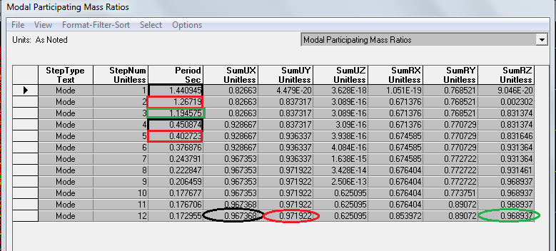
figure6.3: Fundamental periods and MMPR
Where: U_{X} = The X-direction.
U_{y} = The Y-direction.
U_{z} = The Z-direction.
R_{x} = The rotation in X-direction.
R_{Y}= The rotation in Y-direction.
R_{Z}= The rotation in Z-direction.

From the previous figure it can be clearly noticed that the first and the forth modes (marked with the black color) represent the building trend to sway laterally in the x direction (u_{x}) which is the weakest direction and has a modal contribution of about 96.7%.
The second critical mode is the y direction mode (u_{y}), marked with the red color (2nd and 5th modes) with a MMPR of 97% in the y direction.
The third mode represents a rotation around the z axis with MMPR of 96.89 %.( marked with green).
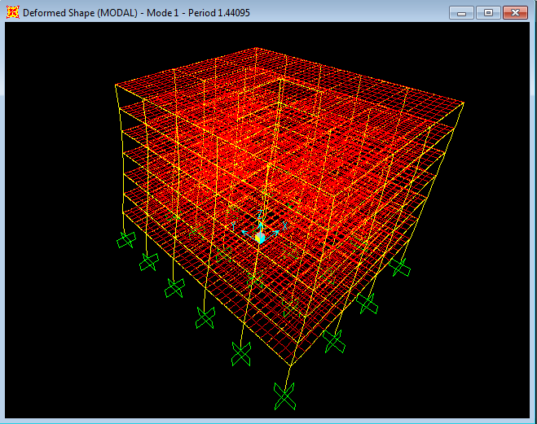
Figure6.4: Modal shape First mode (translation in x direction)

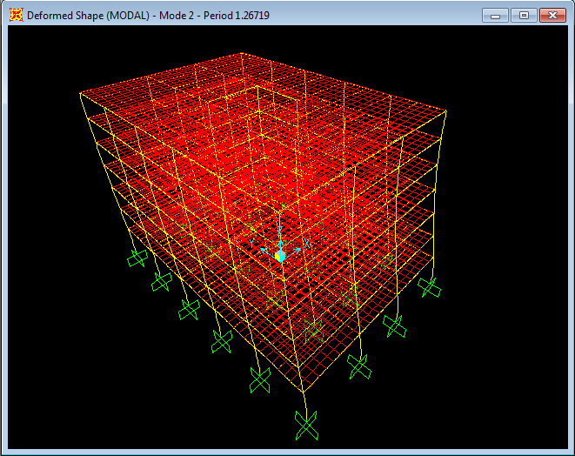
Figure6.5: Modal shape, second mode (translation in y direction)
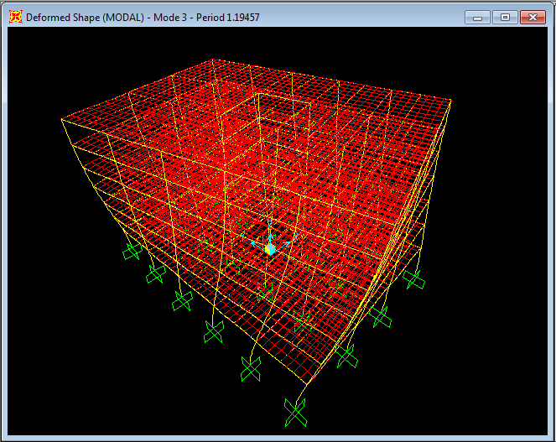
Figure6.6: Modal shape: third mode (rotation around Z axis)

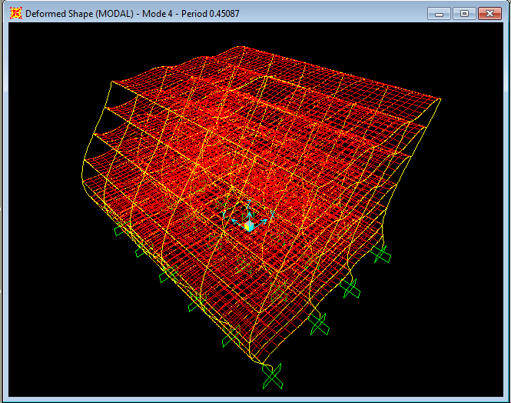
Figure6.7: Modal shape: fourth mode (second translation in x direction)

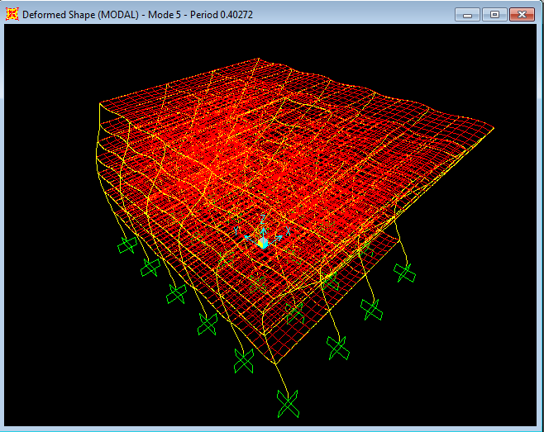
Figure6.8: Modal shape: fifth mode (second translation in y direction)

As a result the dynamic design will be conducted by exposing the directions (DOFS) which achieved a summation of modal mass participation ratio equal or greater than 90%(90% of the structure contributes in this DOF)to a response spectrum as discussed before .in our case X and Y direction will be considered in the response spectrum design.

Base Reactions:
The base reactions in the x &y direction resulting from the response spectrum analysis by SAP program is shown in table6.1 (units in KN).
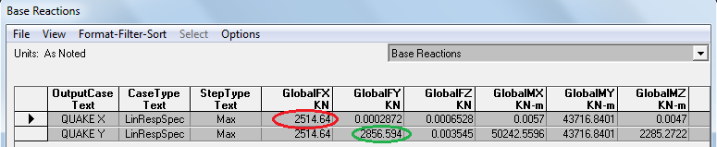
Table (6.1): base shear forces in the building in X and Y directions (KN).
Comparing these values with the base shear values obtained from the equivalent static method:
Equivalent method: V_{X}=2821.6 KN.
V_{Y}=3185.7KN.
The values of the two methods are close because SAP fundamental period was used in both methods to compute the base shear, but the equivalent method still gives more conservative values.
6.3.3: Lateral displacements of the Structure
Structure will have a displacement in the X and Y directions due to the designed quake responses. The displacements will be increased gradually from the first floor to the last one as a result of the height increase and fixity deduction which are proportional to the increase in the lateral displacement , where the last floor is expected to have the maximum displacement in the X&Y direction.
Lateral displacement of the seven stories taken from SAP will be as shown in table 6.2:
Displacement in Y(cm) | Displacement in X (cm) | Floor
0.3 | 0.32 | First
0.67 | 0.73 | Second
1 | 1.12 | Third
1.27 | 1.45 | Fourth
1.53 | 1.73 | Fifth
1.7 | 1.93 | Sixth
1.8 | 2.06 | Seventh

Table6.2: structure displacement in x &y direction
It can be noticed that the lateral displacement in x and y direction due to the dynamic force is small, where the total draft of the building is 2.06 cm in the x direction and 1.8 cm in the y direction .
The permissible displacement lies between H/500 and H/200, where H is the total height of the building.
Total height of the building =2700cm.
∆=2700/500=5.4cm →x &y lateral displacement less than ∆, ok.

6.4 Design of the building
After exposing the SAP model to the response spectrum and let the program to design the building for all cases of loading and take the critical combination of these case of loading to be used in design ,the flexure, shear and torsion reinforcement will be as shown in appendix B .
-static design results depending on reinforcement figures of the different frames are tabulated in appendix A.
-Final design results (Results after dynamic design) will be tabulated for both transverse and longitudinal steel in appendix B.
-For transverse stirrups, 2 closed stirrups of 12 mm diameter is going to be used ,where the calculation in the spacing table based on one leg area {(A_{v}/S)/4+(A_{t}/S)}.
-Each beam and girder is divided into three parts, two edge parts with the same stirrups spacing and a middle part with different spacing.
To understand the results and the values in the tables of appendix A and B, the following notes must be considered.

- For the longitudinal steel, largest area of steel in each frame for the left, middle and right side of the frame beams is determined and circled to be considered for the seven stories (typical floor detailing for the seven stories considering the maximum values in all stories).
- Torsion steel will be divided into three thirds; the first part will be added to the bottom steel, the second third to the top steel and the third on at the middle of the beam.
- Two longitudinal bars diameters are going to be used, 25 mm diameter and 20mm diameter to reduce the difference between the area of the selected number of bars and the design area of steel resulting from the round up process.
- Because of the symmetry, one frame of each symmetric frames will be displayed /half frame for y-z direction.

6.5 Drawings considerations:
- All drawings attached with the project report are based on the dynamic design results shown in the reinforcement tables in appendix B.
- One typical storey detailing and drawings will be made to represent the seven stories.
- Steel diameters used in the drawings are :
-ϕ18mm for all footings steel.
- ϕ25mm for columns longitudinal steel and ϕ 10mm for ties.
- ϕ 25mm & ϕ20mm for all beams and girders longitudinal steel.
- ϕ12mm for all beams and girders stirrups.
- ϕ12mm for slab main steel (y direction) and ϕ10mm for x direction steel.
- All Negative steel for beams, girders, and slabs will be extended over their supports from each side to a distance of one third the maximum clear distance of the supports adjacent spans.
- All Positive steel for beams, girders& slabs will be extended between their supports to the middle of these supports.
- Torsion longitudinal steel for beams and girders will be extended between their supports.
- For beams supported on girders which have no top torsion steel (which also used to tie and support the lateral reinforcement), two bars of ϕ12mm will be used for that purpose.
- Three sections cut will be taken for each beam and girder to show the reinforcement detailing at the edges and the middle.

chapter SEVEN

The Effect of Shear Walls Distribution on the Dynamics of Reinforced Concrete Structure

7.1 Abstract. The inclusion of a soft story in multistory concrete building is a feature gaining popularity in urban areas where the land is of exorbitant cost .In earthquake prone zones; this feature has been observed in post earthquake investigations. Although engineers are prepared to accept the notions that a soft story poses a weak link in seismic design, yet the idea demands better understanding. The following study illustrates the importance of the judicious distribution of shear walls. The selected building (Al-Zahra office building) is analyzed through two numerical models which address a part of the framed structure behavior. The parameters discussed include the modal shapes, the fundamental period of vibration, lateral displacement.
7.2 Introduction:
In metropolitan areas ,planners have a tendency to allocate the firs level or first levels of high rise buildings for functional or vernacular requirements such as parking facilities or public service areas .this features is particularly true in urban areas in many geographical locations worldwide especially in locations where land is scarce commodity .Such a task is normally accomplished by removing the walls surrounding the building ,thus reducing the stiffness of that particular floor and producing a soft storey. However since Palestine lies in a seismically active zone, it becomes an indispensable task to thoroughly evaluate the behavior of such structures. Furthermore, since it is customary for facades of building to be covered either by infill masonry walls with no reinforcement or by reinforced concrete shear walls with natural stone cladding , the seismic evaluation task becomes even more pressing. According to the ASCE 7-05{1} buildings are classified as having a "soft story" if that level is less than 70% as stiff as the floor immediately above it, or less than 80% as stiff as the average stiffness of the three floors above it.
In this study three different models of shear wall inclusions were adopted to represent the common shear wall structures.
The first model will contain a shear walls all around the building from the first storey to the last one as shown in figure 7.1(Model A)
The second model will contain shear walls all around the stories from the second storey to the last one as shown in figure7.2 (Model b)
The third model will have shear walls around the elevator opening only, starting from the base, as shown in figure7.3 (Model c).
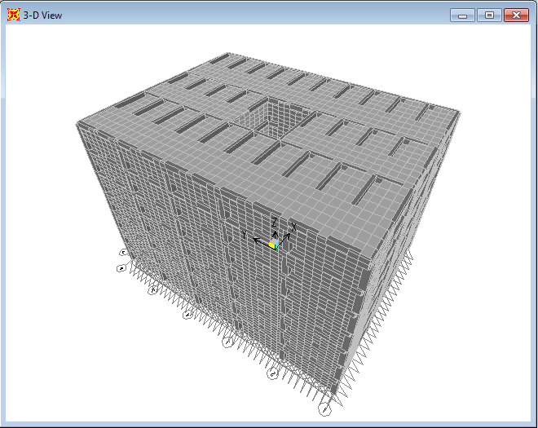
Figure 7.1 Model A: shear walls inclusions from the first storey (from base)
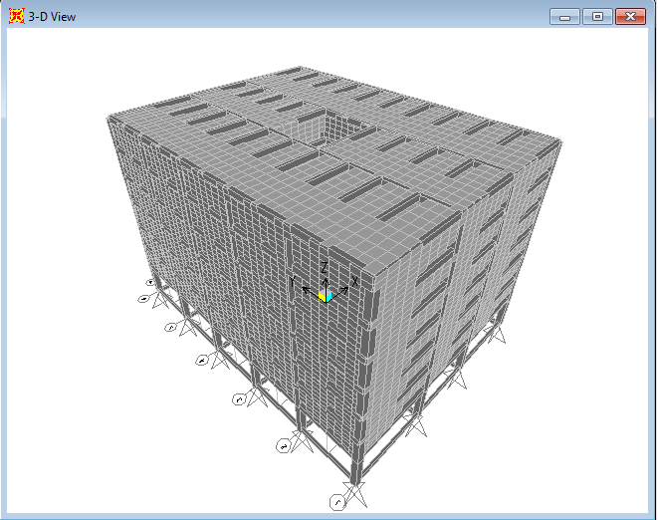
Figure 7.2 Model b: shear walls inclusions from the second storey
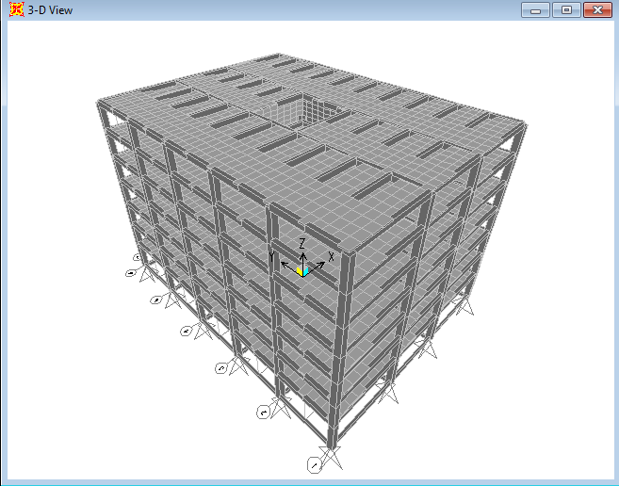
Figure 7.3Model c: shear walls inclusions around the elevator opening only
After performing the three models, the following results were obtained:

7.3 Modal analysis:
In the modal analysis, comparison will be made on the base of the modal variables which are the degrees of freedom of the structure DOF, the natural period T and the modal mass participation ratio (MMPR).The first fife modes of each model will be considered in the comparison between the three different cases of the shear walls inclusions.
DOF, MMPR and T of model A,B&C taken from SAP Program, are shown in table 7.1
modal variables | Degrees of freedom DOF  (mode of failure) |  |  | Fundamental period T(sec) |  |  | Modal mass participation ratio MMPR
Mode Model | a | b | c | a | b | c | a | b | c
1st | U_{X} | R_{Z} | R_{Z} | 0.212 | 0.51 | 0.71 | 0.78 | 0.996 | 0.88
2nd | U_{Y} | U_{X} | U_{Y} | 0.180 | 0.34 | 0.54 | 0.79 | 0.92 | 0.76
3rd | U_{Z} | U_{Y} | U_{X} | 0.149 | 0.32 | 0.51 | 0.39 | 0.95 | 0.75
4th | U_{Y} | U_{Z} | R_{Z} | 0.148 | 0.152 | 0.24 | 0.01& | 0.52 | 0.08
5th | U_{X} | R_{X} | U_{Y} | 0.145 | 0.151 | 0.17 | 0.006 | 0.136 | 0.01
Table 7.1: DOF, MMPR and T of A, B &C models

-The previous tables shows that the model A where we included the shear walls from the base of the building ,has the first fife weakest degrees of freedom as translations in x ,y and z which is expected because the increase in the rotational stiffness resulting from establishing the shear walls from the base of the structure met by the increase of the moment of inertial so no change will affect the period and no chance to have a torsional mode as the first mode .so the first mode stayed as translation as our dynamic model which have no shear walls.
since we already designed the building for gravity and dynamic loads in x and y directions there will be no problem in the inclusion of the shear wall since they increase the stiffness of the building and no torsion mode of failure arises because of the equally distribution of the shear walls in the building which gives the same stiffness of the stories without any soft stories formation, so model A is recommended but has one disadvantage which is uneconomically to put the shear walls all around the building ,so if we put shear walls at the corners of the building (2-3 m from each corner side for example ) that will give almost the same results.
-Model B and C have the first mode of failure (weakest direction) to be torsional which is expected because the huge increase in moment of inertia due to add the shear walls from the second story met by a small increase caused by adding the shear wall around the elevator from the base of the building ,and since the period T is proportional to the square root of the moment of inertia divided by the rotational stiffness so the rotational period will increase and the rotation bode will be the first mode and since torsion will cause unequal distribution of the lateral dynamic load on the column so that will cause a potential failure for the soft storey model (B) and as a conclusion ,model B is not recommended .
-Model C has the first mode to be torsional so it’s not recommended as well.
-the previous table also shows that the inclusion of the shear walls will decrease the fundamental period T of the structure as a result of the increasing the lateral stiffness of the structure due to the shear walls where the mass of structure M will increase, but not as the increment of the lateral stiffness resulting from the considerable increasing in the moment of inertia, where the lateral stiffness =12EI/L³ for rigid diaphragm and 412EI/L³ for flexible diaphragm and the fundamental period T=2π$\sqrt{\frac{M}{K}}$ .

7.4lateral displacements
Lateral displacement s of A, B &C models in the x and y direction are shown in table 7.2.
Floor model | A |  | B |  | C
 | ∆x cm | ∆y cm | ∆x cm | ∆y cm | ∆x cm | ∆y cm
1st | 0.026 | 0.021 | 0.237 | 0.217 | 0.093 | 0.103
2nd | 0.05 | 0.04 | 0.26 | 0.236 | 0.2 | 0.213
3rd | 0.07 | 0.058 | 0.29 | 0.257 | 0.32 | 0.34
4th | 0.097 | 0.075 | 0.32 | 0.28 | 0.457 | 0.478
5th | 0.118 | 0.09 | 0.347 | 0.3 | 0.59 | 0.61
6th | 0.135 | 0.1 | 0.37 | 0.317 | 0.72 | 0.748
7th | 0.148 | 0.11 | 0.39 | 0.33 | 0.83 | 0.86
Table 7.2: lateral displacement of the stories in model A, B&C
It can be noticed that model A has the smallest lateral displacement as the result of having the shear walls from the base which increase the fixity of the building and decease the lateral displacement.
Model B has the largest displacements as a result of having a soft storey at the base where a considerable mass above that storey with relatively small lateral stiffness compared with model A, so the P∆ effect is considerable and cannot be neglected and a second order analysis has to be made (moments resulting from the considerable deflection with applying large loads).
So again model B is not recommended because of the large deflections with additional stresses due to the second order moment analysis (P∆).
Model c has small lateral displacement compared with model B and also compared with the frames model (the project model).

APPENDIX A
Static Design Results
Figures and Tables of frames longitudinal and transverse steel

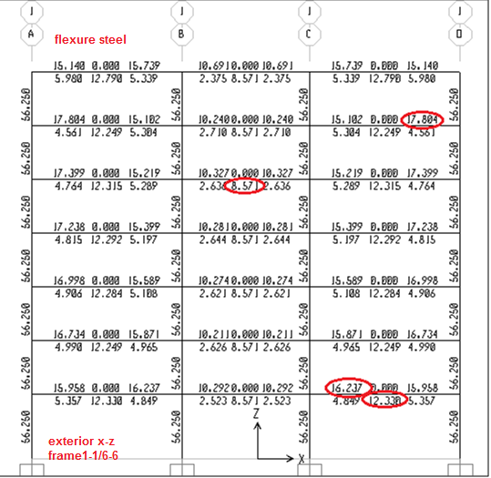
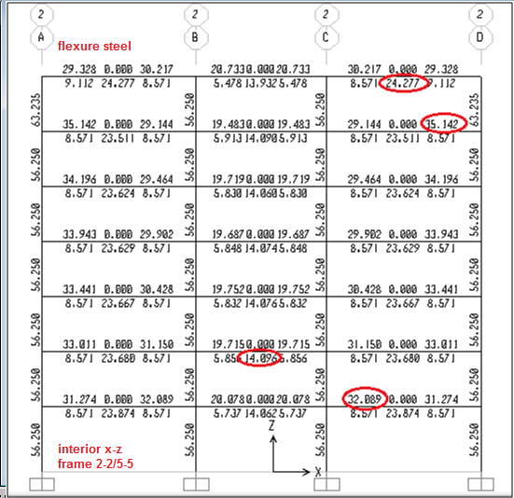
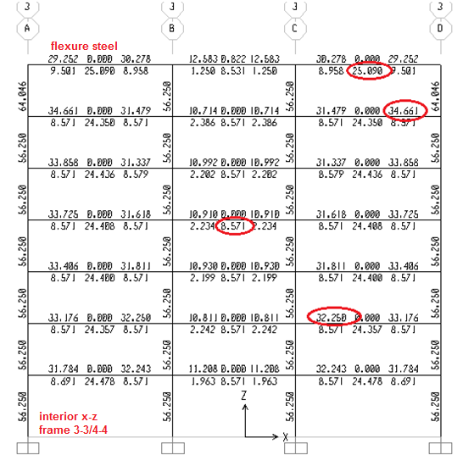
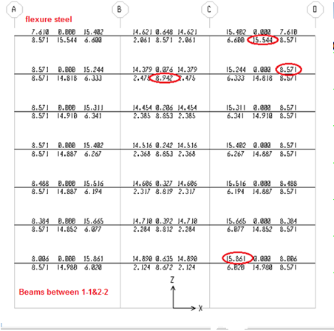
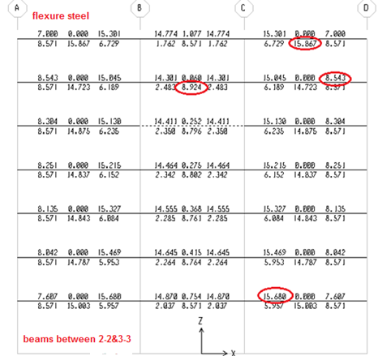
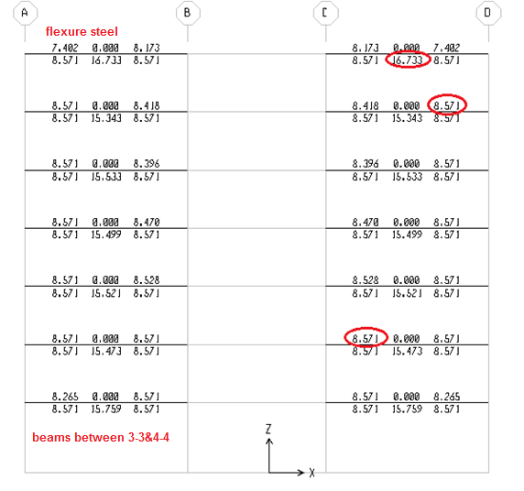

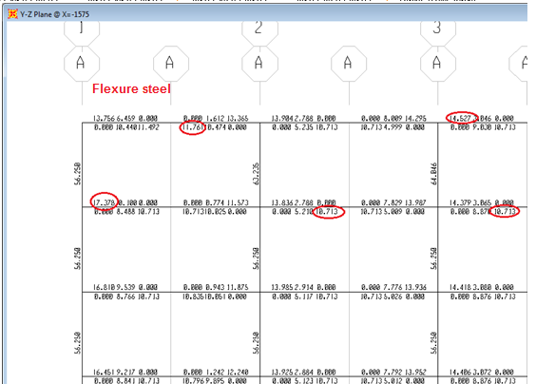

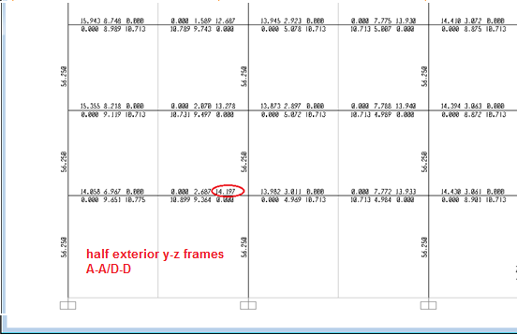

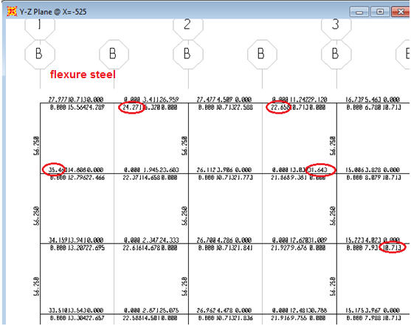
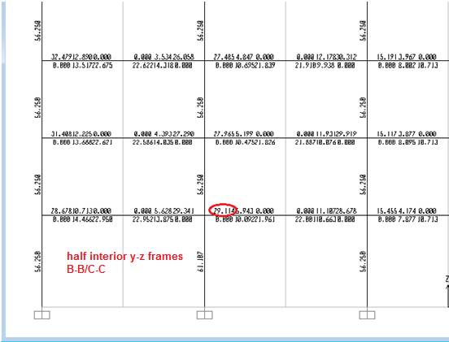

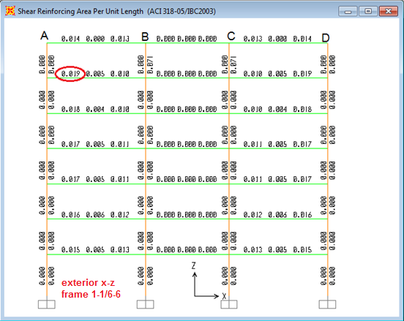
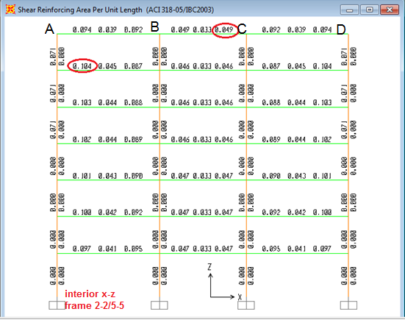
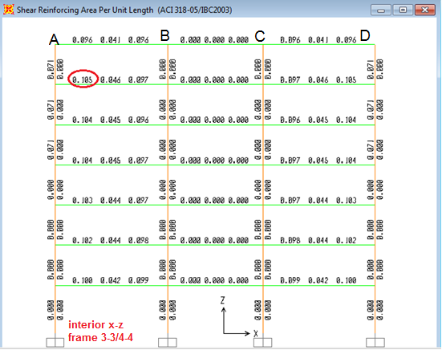
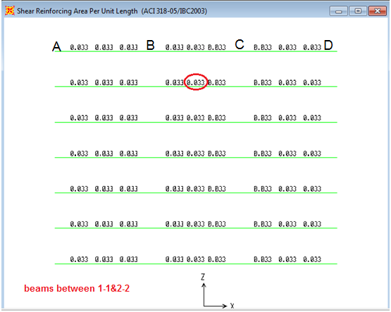
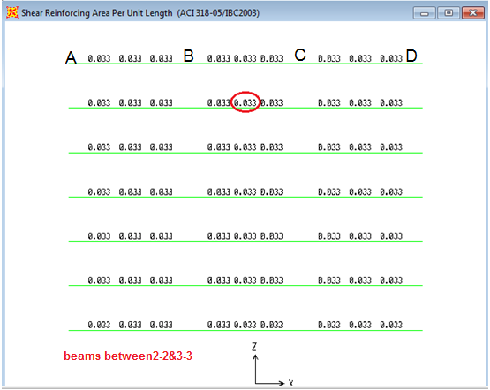

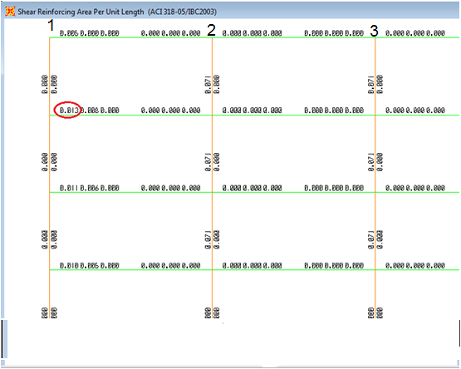
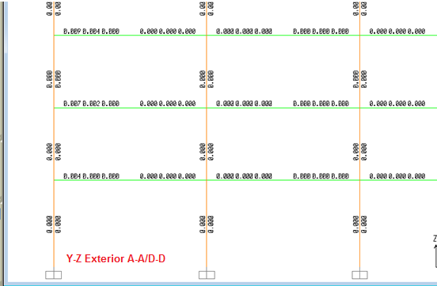

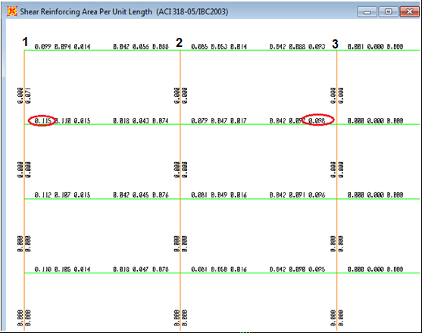
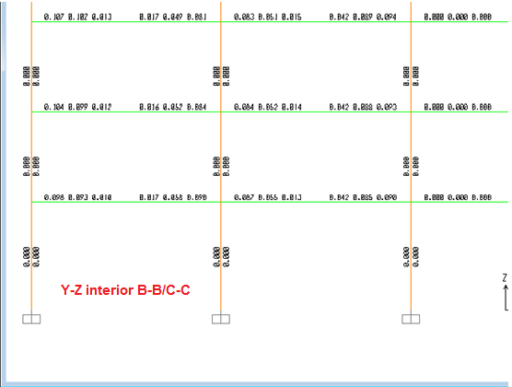
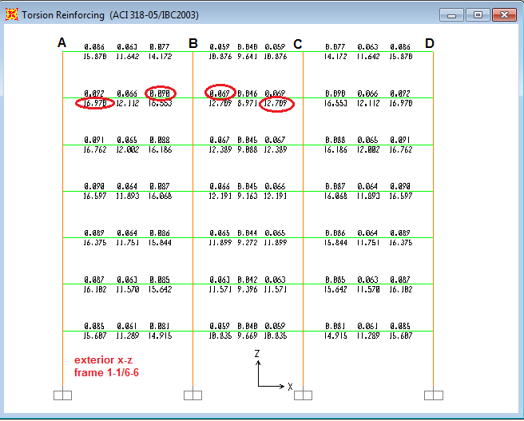
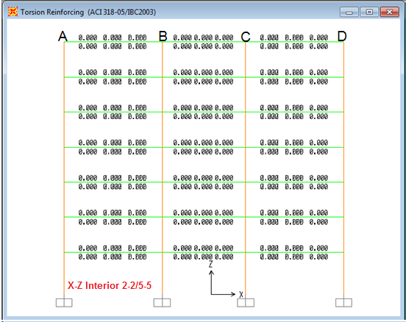
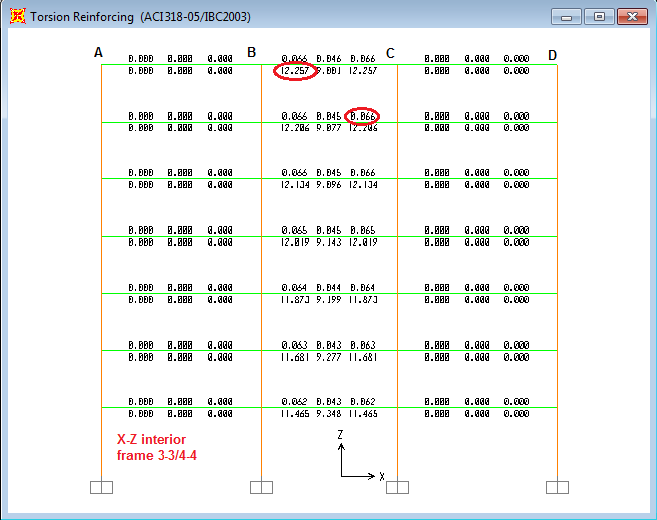
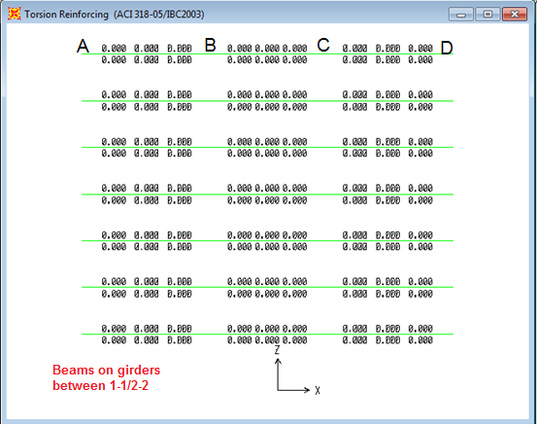
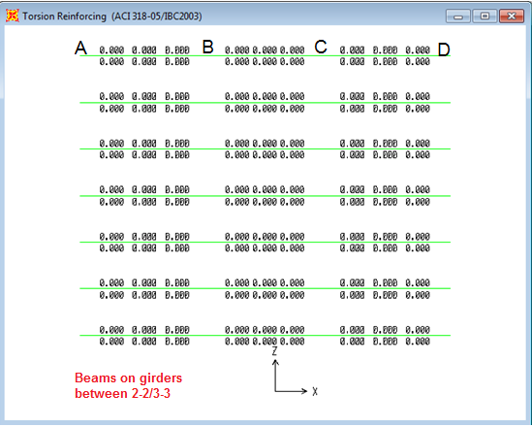
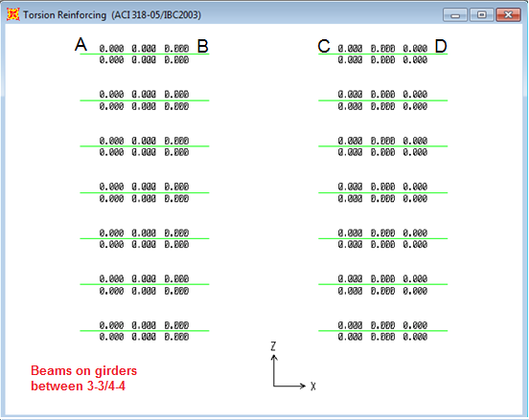
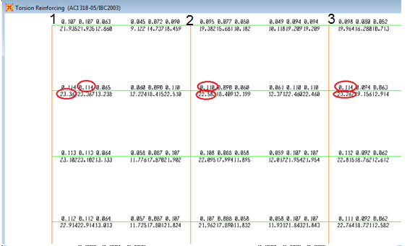
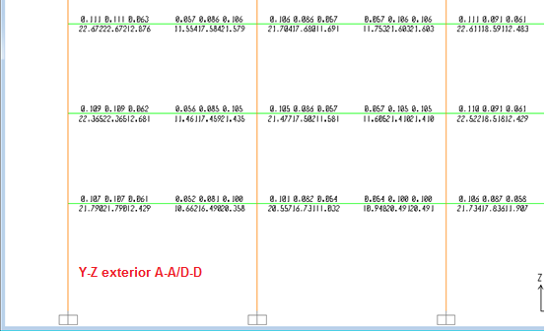

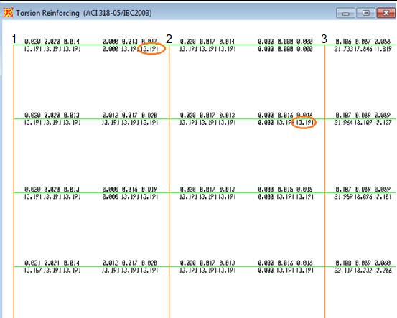
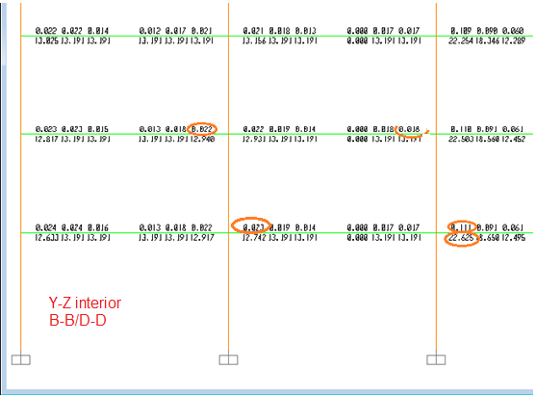

Selected S  cm |  | Computed S  Cm |  | Max A(v+t)/S  For one leg |  | Max At/S |  | Max Av/S |  | part | Frame
Middle | EDGE | Middle | EDGE | Middle | EDGES | Middle | EDGE | middle | EDGE
15 | 12 | 16.74 | 11.93 | 0.0675 | 0.09475 | 0.066 | 0.09 | 0.006 | 0.019 | AB | 1-1&6-6
20 | 15 | 24.57 | 16.38 | 0.046 | 0.069 | 0.046 | 0.069 | 0 | 0 | BC
15 | 12 | 16.74 | 11.93 | 0.0675 | 0.09475 | 0.066 | 0.09 | 0.006 | 0.019 | CD
30 | 30 | 100.44 | 43.46 | 0.01125 | 0.026 | 0 | 0 | 0.045 | 0.104 | AB | 2-2&5-5
30 | 30 | 136.97 | 92.24 | 0.00825 | 0.01225 | 0 | 0 | 0.033 | 0.049 | BC
30 | 30 | 100.44 | 43.46 | 0.01125 | 0.026 | 0 | 0 | 0.045 | 0.104 | CD
30 | 30 | 100.44 | 43.05 | 0.01125 | 0.02625 | 0 | 0 | 0.045 | 0.105 | AB | 3-3&4-4
20 | 15 | 24.57 | 17.12 | 0.046 | 0.066 | 0.046 | 0.066 | 0 | 0 | BC
30 | 30 | 100.44 | 43.05 | 0.01125 | 0.02625 | 0 | 0 | 0.045 | 0.105 | CD
12 | 10 | 17.38 | 9.91 | 0.065 | 0.114 | 0.065 | 0.114 | 0 | 0 | 1_2 | A-A/D-D
12 | 10 | 18.83 | 10.27 | 0.06 | 0.11 | 0.06 | 0.11 | 0 | 0 | 2_3
12 | 10 | 17.94 | 9.91 | 0.063 | 0.114 | 0.063 | 0.114 | 0 | 0 | 3_4
12 | 10 | 18.83 | 10.27 | 0.06 | 0.11 | 0.06 | 0.11 | 0 | 0 | 4_5
12 | 10 | 17.38 | 9.91 | 0.065 | 0.114 | 0.065 | 0.114 | 0 | 0 | 5_6
20 | 20 | 42.64 | 22.27 | 0.0265 | 0.05075 | 0.016 | 0.022 | 0.042 | 0.115 | 1_2 | B-B/C-C
20 | 20 | 46.12 | 23.79 | 0.0245 | 0.0475 | 0.014 | 0.023 | 0.042 | 0.098 | 2_3
12 | 10 | 18.52 | 10.27 | 0.061 | 0.11 | 0.061 | 0.11 | 0 | 0 | 3_4
20 | 20 | 46.12 | 23.79 | 0.0245 | 0.0475 | 0.014 | 0.023 | 0.042 | 0.098 | 4_5
20 | 20 | 42.64 | 22.27 | 0.0265 | 0.05075 | 0.016 | 0.022 | 0.042 | 0.115 | 5_6
30 | 30 | 136.97 | 136.97 | 0.00825 | 0.00825 | 0 | 0 | 0.033 | 0.033 | AB | between1&2
30 | 30 | 136.97 | 136.97 | 0.00825 | 0.00825 | 0 | 0 | 0.033 | 0.033 | BC
30 | 30 | 136.97 | 136.97 | 0.00825 | 0.00825 | 0 | 0 | 0.033 | 0.033 | CD
30 | 30 | 136.97 | 136.97 | 0.00825 | 0.00825 | 0 | 0 | 0.033 | 0.033 | AB | between2&3
30 | 30 | 136.97 | 136.97 | 0.00825 | 0.00825 | 0 | 0 | 0.033 | 0.033 | BC
30 | 30 | 136.97 | 136.97 | 0.00825 | 0.00825 | 0 | 0 | 0.033 | 0.033 | CD
30 | 30 | 136.97 | 136.97 | 0.00825 | 0.00825 | 0 | 0 | 0.033 | 0.033 | AB | between 3&4
30 | 30 | 136.97 | 136.97 | 0.00825 | 0.00825 | 0 | 0 | 0.033 | 0.033 | CD

Table 1: Stirrups spacing based on 12mm diameter 2 stirrups

total longitudinal steel (cm²) |  |  |  |  | selected flexure steel (cm²) |  |  | Part | Frame
As middle | As top right | As top left | As Bottom | torsion steel | As -ve right | As -ve left | AS+ve
5.66 | 21.89 | 23.46 | 17.99 | 16.97 | 16.237 | 17.804 | 12.33 | A-B | 1-1 / 6-6
4.23 | 20.47 | 20.47 | 12.80 | 12.7 | 16.237 | 16.237 | 8.571 | B-C
5.66 | 23.46 | 21.89 | 17.99 | 16.97 | 17.804 | 16.237 | 12.33 | C-D
0 | 32.08 | 35.14 | 24.28 | 0 | 32.08 | 35.142 | 24.277 | A-B | 2-2 /5-5
0 | 32.08 | 32.08 | 14.10 | 0 | 32.08 | 32.08 | 14.096 | B-C
0 | 35.14 | 32.08 | 24.28 | 0 | 35.142 | 32.08 | 24.277 | C-D
0 | 32.25 | 34.61 | 25.09 | 0 | 32.25 | 34.611 | 25.09 | A-B | 3-3/4-4
4.09 | 36.34 | 36.34 | 12.66 | 12.257 | 32.25 | 32.25 | 8.571 | B-C
0 | 34.61 | 32.25 | 25.09 | 0 | 34.611 | 32.25 | 25.09 | C-D
7.79 | 22.31 | 25.16 | 19.55 | 23.36 | 14.527 | 17.378 | 11.761 | 1_2 | A-A/D-D
7.53 | 22.05 | 22.05 | 18.24 | 22.58 | 14.527 | 14.527 | 10.713 | 2_3
7.76 | 22.28 | 22.28 | 18.47 | 23.267 | 14.527 | 14.527 | 10.713 | 3_4
7.53 | 22.05 | 22.05 | 18.24 | 22.58 | 14.527 | 14.527 | 10.713 | 4_5
7.79 | 25.16 | 22.31 | 19.55 | 23.36 | 17.378 | 14.527 | 11.761 | 5_6
4.40 | 33.84 | 39.85 | 28.67 | 13.19 | 29.44 | 35.45 | 24.271 | 1_2 | B-B/C-C
4.40 | 36.04 | 33.84 | 26.96 | 13.19 | 31.64 | 29.44 | 22.568 | 2_3
7.54 | 39.18 | 39.18 | 18.25 | 22.62 | 31.64 | 31.64 | 10.713 | 3_4
4.40 | 33.84 | 36.04 | 26.96 | 13.19 | 29.44 | 31.64 | 22.568 | 4_5
4.40 | 39.85 | 33.84 | 28.67 | 13.19 | 35.45 | 29.44 | 24.271 | 5_6
0 | 15.86 | 8.57 | 15.46 | 0 | 15.861 | 8.571 | 15.455 | A-B | between1&2
0 | 15.86 | 15.86 | 8.94 | 0 | 15.861 | 15.861 | 8.942 | B-C
0 | 8.57 | 15.86 | 15.46 | 0 | 8.571 | 15.861 | 15.455 | C-D
0 | 15.68 | 8.54 | 15.87 | 0 | 15.68 | 8.543 | 15.867 | A-B | between2&3
0 | 15.68 | 15.68 | 8.92 | 0 | 15.68 | 15.68 | 8.924 | B-C
0 | 8.54 | 15.68 | 15.87 | 0 | 8.543 | 15.68 | 15.867 | C-D
0 | 8.57 | 8.57 | 16.73 | 0 | 8.571 | 8.571 | 16.733 | A-B | between 3&4
0 | 8.57 | 8.57 | 16.73 | 0 | 8.571 | 8.571 | 16.733 | C-D

Table 2: Total longitudinal steel for structure frames and beams

total longitudinal steel |  |  |  | total longitudinal steel (cm²) |  |  |  | Part | Frame
As middle | As top  right | As top  left | As  Bottom | As middle | As top right | As top left | As Bottom
2ϕ25mm | 4ϕ25+1ϕ20 | 5ϕ25mm | 4ϕ25mm | 5.66 | 21.89 | 23.46 | 17.99 | A-B | 1-1 / 6-6
2ϕ25mm | 4ϕ25+1ϕ20 | 4ϕ25+1ϕ20 | 3ϕ25mm | 4.23 | 20.47 | 20.47 | 12.80 | B-C
2ϕ25mm | 5ϕ25mm | 4ϕ25+1ϕ20 | 4ϕ25mm | 5.66 | 23.46 | 21.89 | 17.99 | C-D
0 | 6ϕ25+1ϕ20 | 7ϕ25mm | 5ϕ25mm | 0 | 32.08 | 35.14 | 24.28 | A-B | 2-2 /5-5
0 | 6ϕ25+1ϕ20 | 6ϕ25+1ϕ20 | 3ϕ25mm | 0 | 32.08 | 32.08 | 14.10 | B-C
0 | 7ϕ25mm | 6ϕ25+1ϕ20 | 5ϕ25mm | 0 | 35.14 | 32.08 | 24.28 | C-D
0 | 6ϕ25+1ϕ20 | 7ϕ25mm | 5ϕ25+1ϕ20 | 0 | 32.25 | 34.61 | 25.09 | A-B | 3-3/4-4
2ϕ25mm | 7ϕ25+1ϕ20 | 7ϕ25+1ϕ20 | 3ϕ25mm | 4.09 | 36.34 | 36.34 | 12.66 | B-C
0 | 7ϕ25mm | 7ϕ25mm | 5ϕ25+1ϕ20 | 0 | 34.61 | 32.25 | 25.09 | C-D
2ϕ25mm | 4ϕ25+1ϕ20 | 5ϕ25+1ϕ20 | 4ϕ25mm | 7.79 | 22.31 | 25.16 | 19.55 | 1_2 | A-A/D-D
2ϕ25mm | 4ϕ25+1ϕ20 | 4ϕ25+1ϕ20 | 4ϕ25mm | 7.53 | 22.05 | 22.05 | 18.24 | 2_3
2ϕ25mm | 4ϕ25+1ϕ20 | 4ϕ25+1ϕ20 | 4ϕ25mm | 7.76 | 22.28 | 22.28 | 18.47 | 3_4
2ϕ25mm | 4ϕ25+1ϕ20 | 4ϕ25+1ϕ20 | 4ϕ25mm | 7.53 | 22.05 | 22.05 | 18.24 | 4_5
2ϕ25mm | 5ϕ25+1ϕ20 | 4ϕ25+1ϕ20 | 4ϕ25mm | 7.79 | 25.16 | 22.31 | 19.55 | 5_6
2ϕ25mm | 7ϕ25mm | 8ϕ25+1ϕ20 | 6ϕ25mm | 4.40 | 33.84 | 39.85 | 28.67 | 1_2 | B-B/C-C
2ϕ25mm | 8ϕ25mm | 7ϕ25mm | 5ϕ25+1ϕ20 | 4.40 | 36.04 | 33.84 | 26.96 | 2_3
2ϕ25mm | 8ϕ25mm | 8ϕ25mm | 4ϕ25mm | 7.54 | 39.18 | 39.18 | 18.25 | 3_4
2ϕ25mm | 7ϕ25mm | 8ϕ25mm | 5ϕ25+1ϕ20 | 4.40 | 33.84 | 36.04 | 26.96 | 4_5
2ϕ25mm | 8ϕ25+1ϕ20 | 7ϕ25mm | 6ϕ25mm | 4.40 | 39.85 | 33.84 | 28.67 | 5_6
0 | 3ϕ25+1ϕ20 | 2ϕ25mm | 3ϕ25+1ϕ20 | 0 | 15.86 | 8.57 | 15.46 | A-B | between1&2
0 | 3ϕ25+1ϕ20 | 3ϕ25+1ϕ20 | 2ϕ25mm | 0 | 15.86 | 15.86 | 8.94 | B-C
0 | 2ϕ25mm | 3ϕ25+1ϕ20 | 3ϕ25+1ϕ20 | 0 | 8.57 | 15.86 | 15.46 | C-D
0 | 3ϕ25+1ϕ20 | 2ϕ25mm | 3ϕ25+1ϕ20 | 0 | 15.68 | 8.54 | 15.87 | A-B | between2&3
0 | 3ϕ25+1ϕ20 | 3ϕ25+1ϕ20 | 2ϕ25mm | 0 | 15.68 | 15.68 | 8.92 | B-C
0 | 2ϕ25mm | 3ϕ25+1ϕ20 | 3ϕ25+1ϕ20 | 0 | 8.54 | 15.68 | 15.87 | C-D
0 | 2ϕ25mm | 2ϕ25mm | 3ϕ25+1ϕ20 | 0 | 8.57 | 8.57 | 16.73 | A-B | between 3&4
0 | 2ϕ25mm | 2ϕ25mm | 3ϕ25+1ϕ20 | 0 | 8.57 | 8.57 | 16.73 | C-D

Table 3: bars distribution of total longitudinal steel for structure frames and beams

APPENDIX B
Final Design Results (Static and Dynamic Design)
Figures and Tables of frames longitudinal and transverse steel

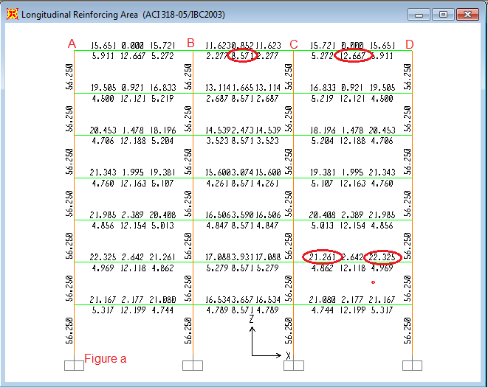
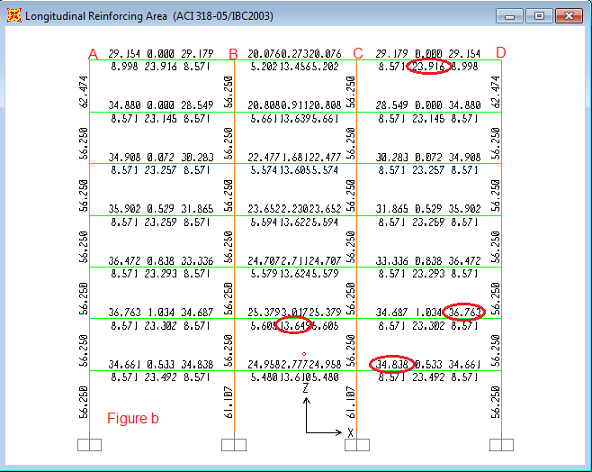
Figure a: flexure steel of the exterior x-z frames 1-1/6-6
Figure b: flexure steel of the interior x-z frames 2-2/5-5
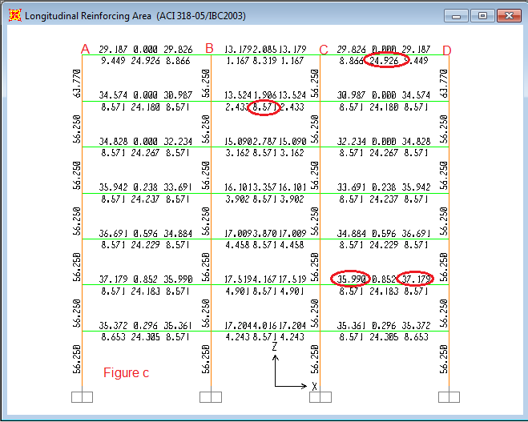
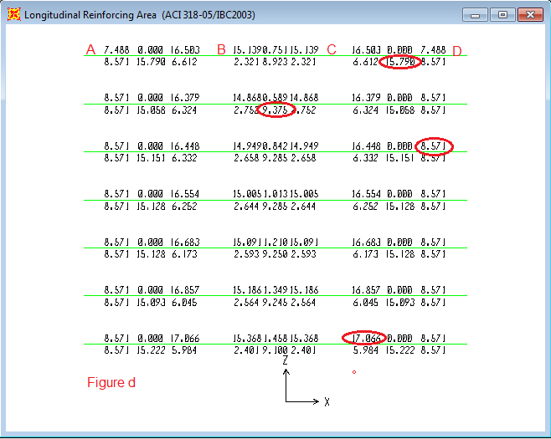
Figure c: flexure steel of the interior x-z frames 3-3/4-4
Figure d: flexure steel of the beams resting on girders between 1-1&2-2
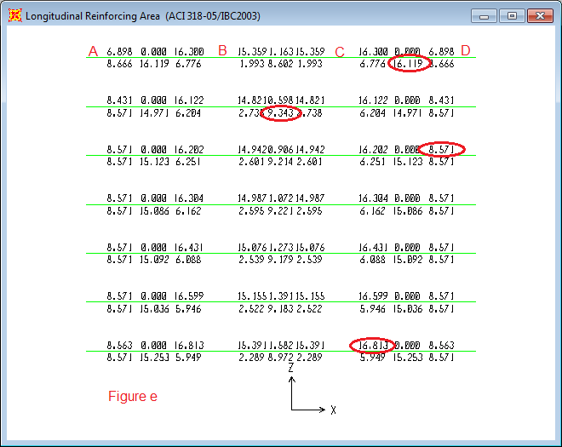
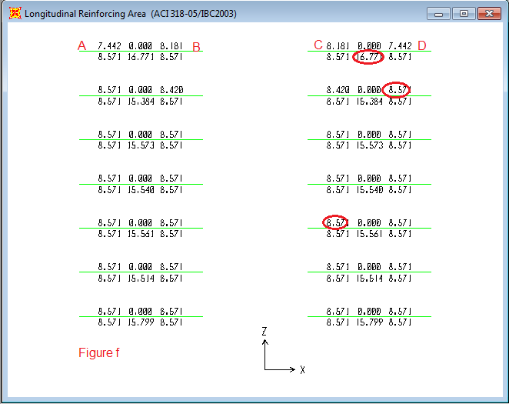
Figure e: flexure steel of the beams resting on girders between 2-2 &3-3
Figure f: flexure steel of the beams resting on girders between 3-3 & 4-4
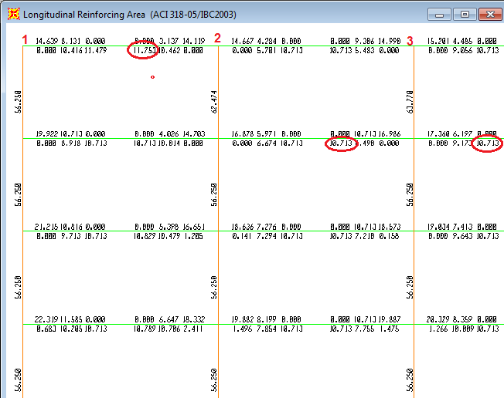
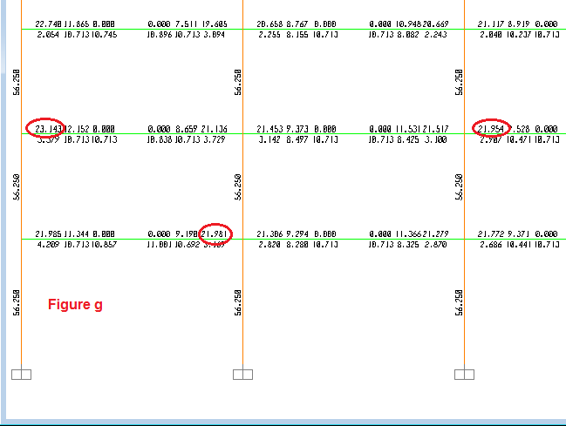
Figure g: Flexure steel of half the exterior y-z girder frames A-A/D-D
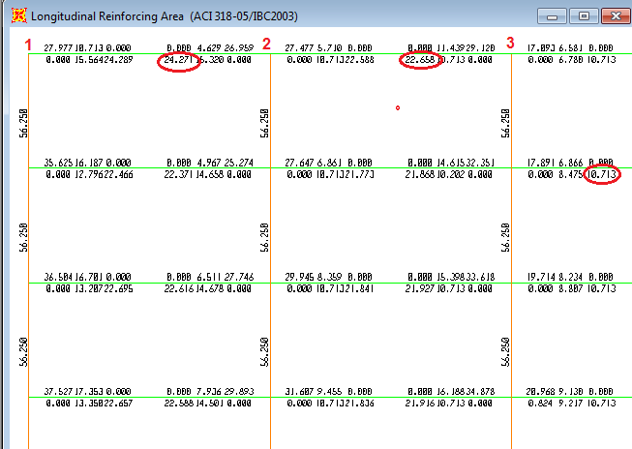
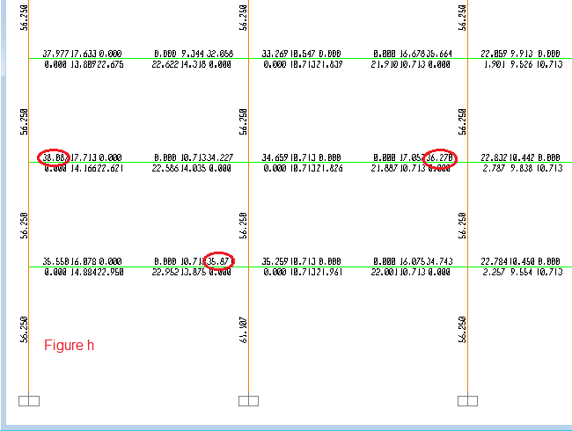
Figure h: Flexure steel of half the interior y-z girder frames B-B/C-C
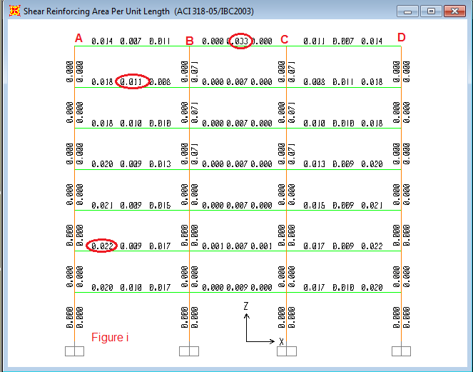
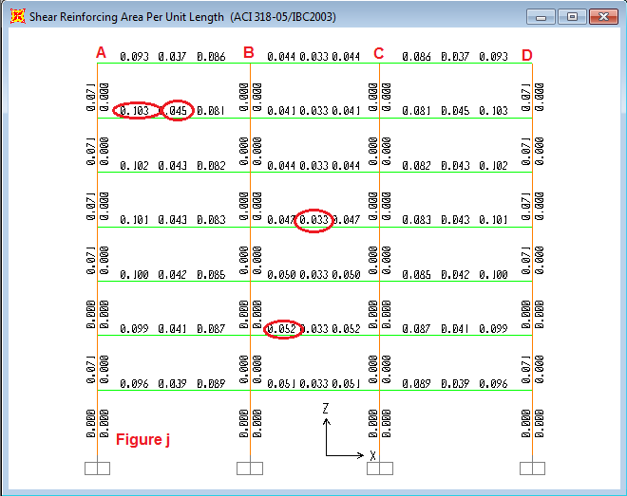
Figure i: shear reinforcing (A_{V}/S) of the exterior x-z frames 1-1/6-6
Figure j: shear reinforcing (A_{V}/S) of the interior x-z frames 2-2/5-5
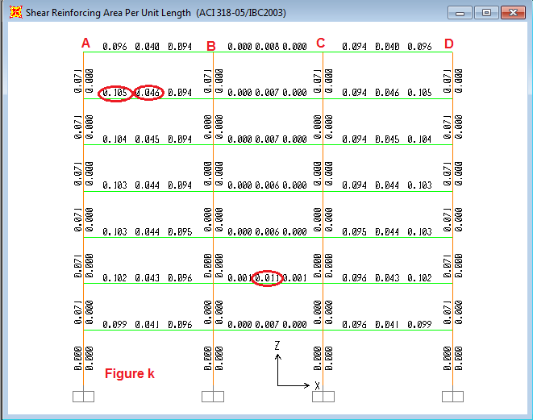
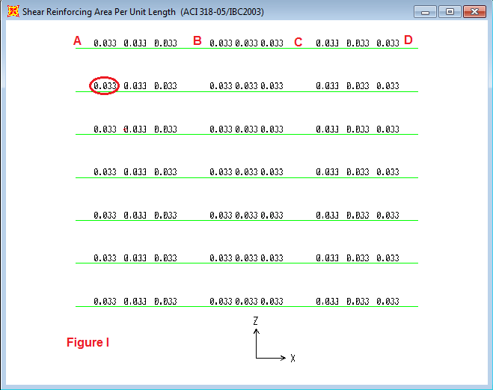
Figure k: shear reinforcing (A_{V}/S) of the interior x-z frames 3-3/-4-4
Figure l: shear reinforcing (A_{V}/S) of the beams resting on girders between 1-1&2-2/5-5&6-6
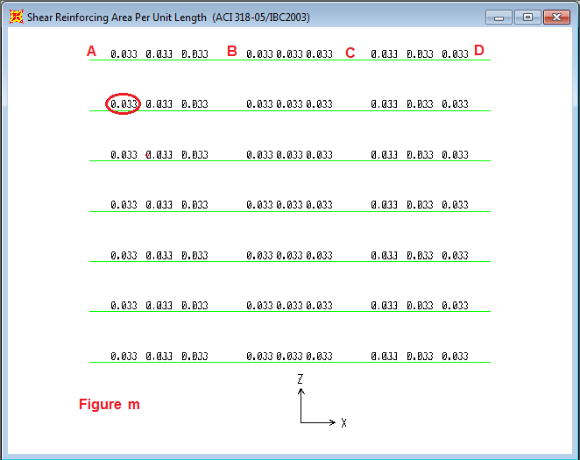
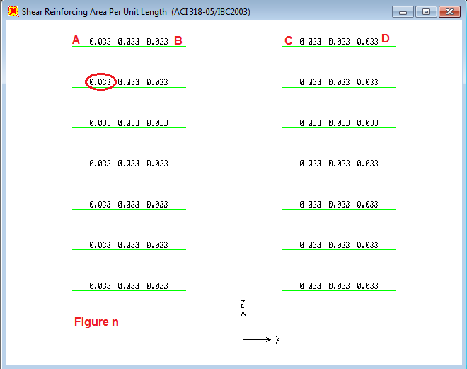
Figure m: shear reinforcing (A_{V}/S) of the beams resting on girders between 2-2 &3-3/4-4&5-5
Figure n: shear reinforcing (A_{V}/S) of the beams resting on girders between 3-3 & 4-4
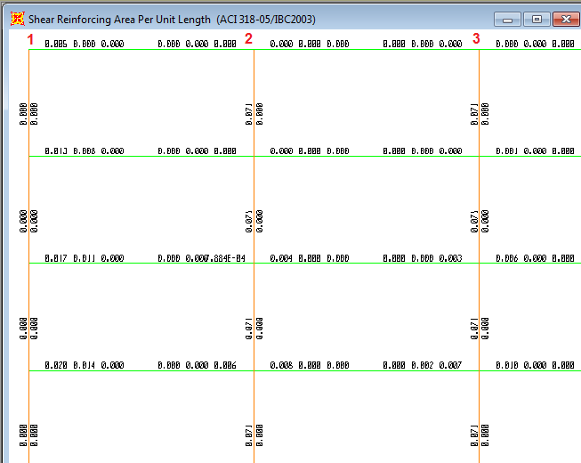
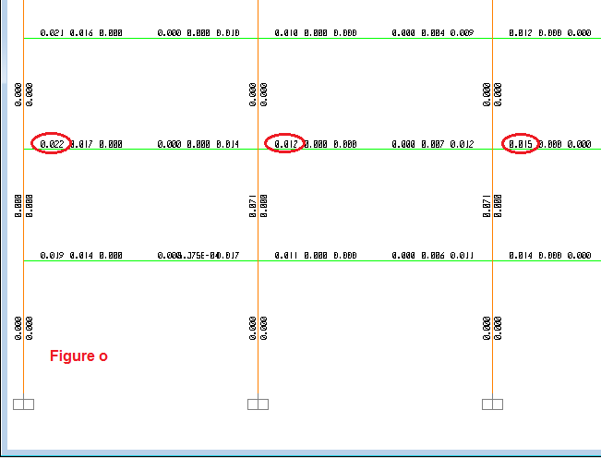
Figure o: shear reinforcing (A_{V}/S) of half the exterior y-z girder frames A-A/D-D
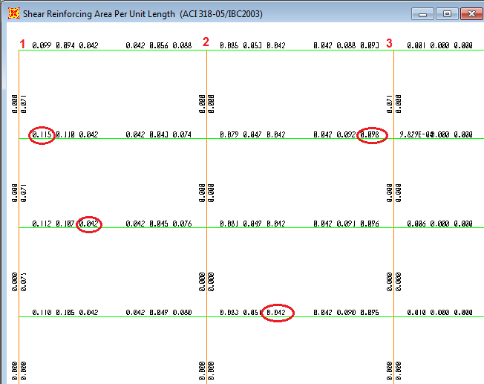
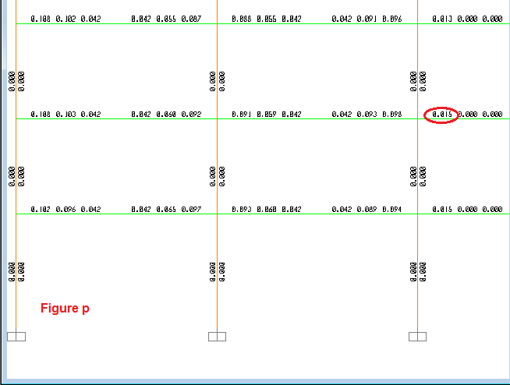
Figure P: shear reinforcing (A_{v}/S) of half the interior y-z girder frames B-B/C-C
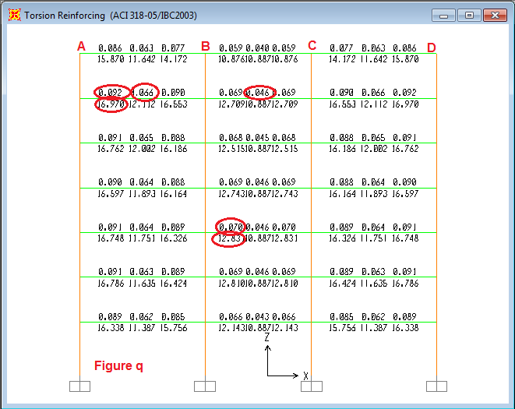
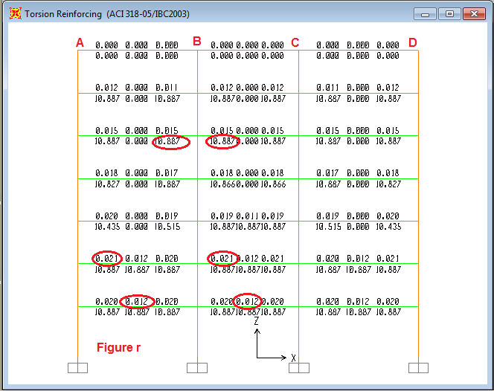
Figure q: Torsion reinforcing of the exterior x-z frames 1-1/6-6
Figure r: Torsion reinforcing of the interior x-z frames 2-2/5-5
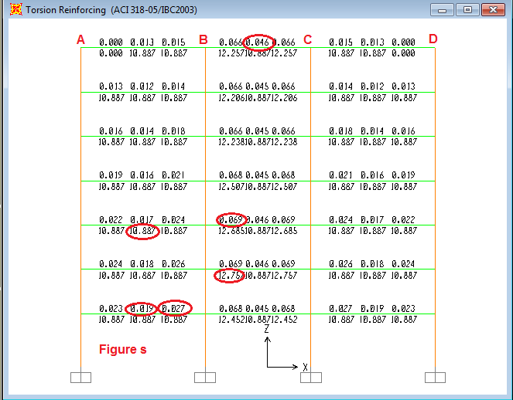
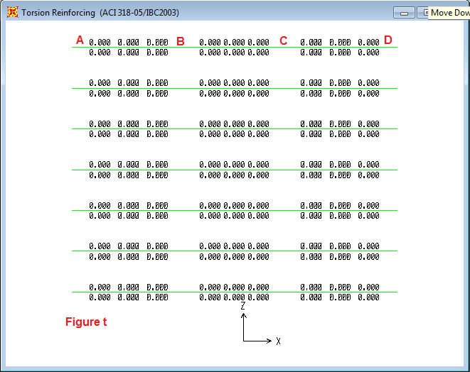
Figure s: torsion reinforcing of the interior x-z frames 3-3/4-4
Figure t: torsion reinforcing of the beams resting on girders between 1-1&2-2/5-5&6-6
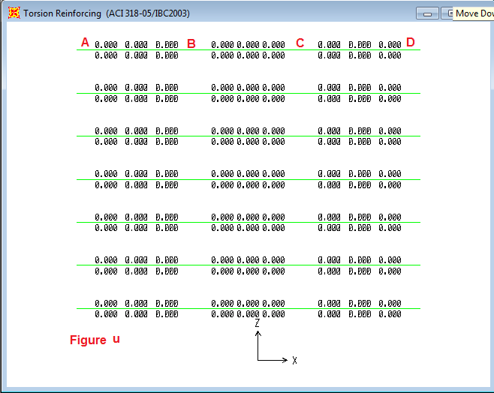
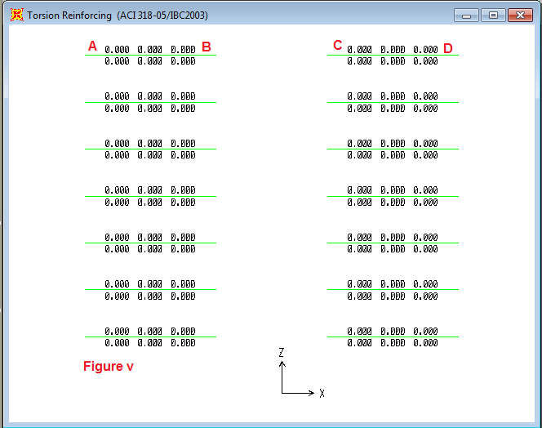
Figure u: torsion reinforcing of the beams resting on girders between 2-2 &3-3/4-4&5-5
Figure v: torsion reinforcing of the beams resting on girders between 3-3 & 4-4
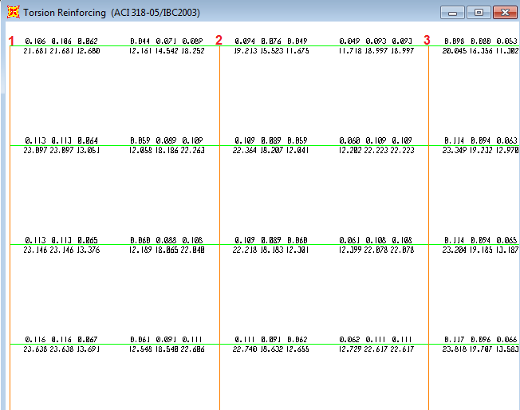
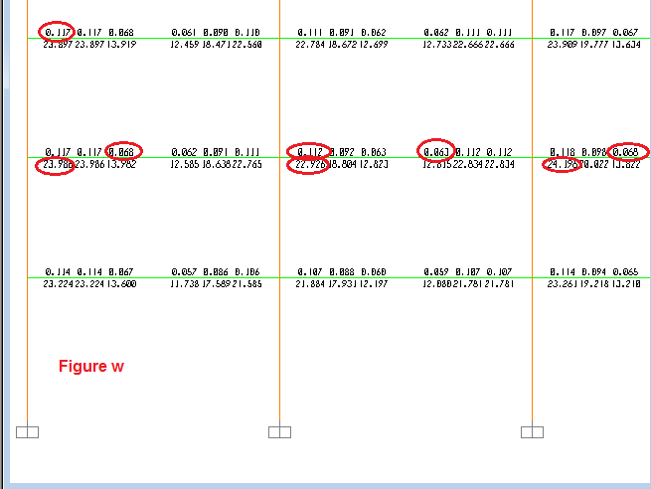
Figure w: torsion reinforcing of half the exterior y-z girder frames A-A/D-D
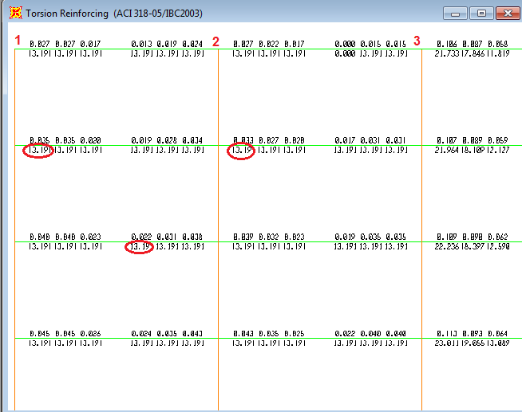
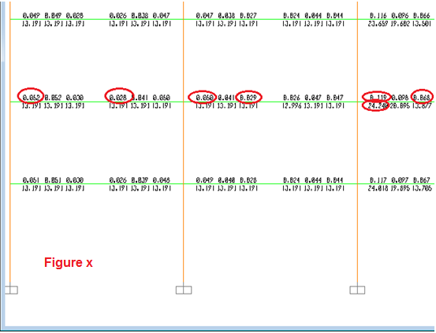
Figure x: torsion reinforcing of half the interior y-z girder frames B-B/C-C
Selected S |  |  | Computed S |  |  | Max A(v+t)/S for one stirrup leg |  |  | Max At/S |  |  | Max Av/S |  |  | part |  | Frame
 | middle | EDGE |  | middle | EDGE |  | Middle | EDGES |  | Middle | EDGE |  | middle | EDGE
 | 15 | 12 |  | 16.44 | 11.59 |  | 0.06875 | 0.0975 |  | 0.066 | 0.092 |  | 0.011 | 0.022 |  | AB |  | 1-1&6-6
 | 20 | 15 |  | 20.83 | 16.14 |  | 0.05425 | 0.07 |  | 0.046 | 0.07 |  | 0.033 | 0 |  | BC
 | 15 | 12 |  | 16.44 | 11.59 |  | 0.06875 | 0.0975 |  | 0.066 | 0.092 |  | 0.011 | 0.022 |  | CD
 | 30 | 20 |  | 48.60 | 24.17 |  | 0.02325 | 0.04675 |  | 0.012 | 0.021 |  | 0.045 | 0.103 |  | AB |  | 2-2&5-5
 | 30 | 30 |  | 55.80 | 33.24 |  | 0.02025 | 0.034 |  | 0.012 | 0.021 |  | 0.033 | 0.052 |  | BC
 | 30 | 20 |  | 48.60 | 24.17 |  | 0.02325 | 0.04675 |  | 0.012 | 0.021 |  | 0.045 | 0.103 |  | CD
 | 30 | 20 |  | 37.05 | 21.22 |  | 0.0305 | 0.05325 |  | 0.019 | 0.027 |  | 0.046 | 0.105 |  | AB |  | 3-3&4-4
 | 20 | 15 |  | 23.18 | 16.38 |  | 0.04875 | 0.069 |  | 0.046 | 0.069 |  | 0.011 | 0 |  | BC
 | 30 | 20 |  | 37.05 | 21.22 |  | 0.0305 | 0.05325 |  | 0.019 | 0.027 |  | 0.046 | 0.105 |  | CD
 | 15 | 8 |  | 16.62 | 9.22 |  | 0.068 | 0.1225 |  | 0.068 | 0.117 |  | 0 | 0.022 |  | 1_2 |  | A-A/D-D
 | 15 | 8 |  | 17.66 | 9.83 |  | 0.064 | 0.115 |  | 0.064 | 0.112 |  | 0 | 0.012 |  | 2_3
 | 15 | 8 |  | 16.38 | 9.28 |  | 0.069 | 0.12175 |  | 0.069 | 0.118 |  | 0 | 0.015 |  | 3_4
 | 15 | 8 |  | 17.66 | 9.83 |  | 0.064 | 0.115 |  | 0.064 | 0.112 |  | 0 | 0.012 |  | 4_5
 | 15 | 8 |  | 16.62 | 9.22 |  | 0.068 | 0.1225 |  | 0.068 | 0.117 |  | 0 | 0.022 |  | 5_6
 | 25 | 12.5 |  | 29.35 | 13.99 |  | 0.0385 | 0.08075 |  | 0.028 | 0.052 |  | 0.042 | 0.115 |  | 1_2 |  | B-B/C-C
 | 25 | 12.5 |  | 28.61 | 15.17 |  | 0.0395 | 0.0745 |  | 0.029 | 0.05 |  | 0.042 | 0.098 |  | 2_3
 | 15 | 8 |  | 16.62 | 9.21 |  | 0.068 | 0.12275 |  | 0.068 | 0.119 |  | 0 | 0.015 |  | 3_4
 | 25 | 12.5 |  | 28.61 | 15.17 |  | 0.0395 | 0.0745 |  | 0.029 | 0.05 |  | 0.042 | 0.098 |  | 4_5
 | 25 | 12.5 |  | 29.35 | 13.99 |  | 0.0385 | 0.08075 |  | 0.028 | 0.052 |  | 0.042 | 0.115 |  | 5_6
 | 30 | 30 |  | 136.97 | 136.97 |  | 0.00825 | 0.00825 |  | 0 | 0 |  | 0.033 | 0.033 |  | AB |  | between1&2
 | 30 | 30 |  | 136.97 | 136.97 |  | 0.00825 | 0.00825 |  | 0 | 0 |  | 0.033 | 0.033 |  | BC
 | 30 | 30 |  | 136.97 | 136.97 |  | 0.00825 | 0.00825 |  | 0 | 0 |  | 0.033 | 0.033 |  | CD
 | 30 | 30 |  | 136.97 | 136.97 |  | 0.00825 | 0.00825 |  | 0 | 0 |  | 0.033 | 0.033 |  | AB |  | between2&3
 | 30 | 30 |  | 136.97 | 136.97 |  | 0.00825 | 0.00825 |  | 0 | 0 |  | 0.033 | 0.033 |  | BC
 | 30 | 30 |  | 136.97 | 136.97 |  | 0.00825 | 0.00825 |  | 0 | 0 |  | 0.033 | 0.033 |  | CD
 | 30 | 30 |  | 136.97 | 136.97 |  | 0.00825 | 0.00825 |  | 0 | 0 |  | 0.033 | 0.033 |  | AB |  | between 3&4
 | 30 | 30 |  | 136.97 | 136.97 |  | 0.00825 | 0.00825 |  | 0 | 0 |  | 0.033 | 0.033 |  | CD

Table 1: spacing between the transverse reinforcement for the structure frames (beams &girders)

total longitudinal steel (cm²) |  |  |  | torsion steel  (cm²) | selected flexure steel (cm²) |  |  | Part | Frame
As middle | As top  right | As top left | As Bottom |  | As -ve right | As -ve left | A_{S} +ve
5.66 | 26.92 | 27.98 | 18.32 | 16.97 | 21.261 | 22.325 | 12.667 | A-B | 1-1 / 6-6
4.28 | 25.54 | 25.54 | 12.85 | 12.83 | 21.261 | 21.261 | 8.571 | B-C
5.66 | 27.98 | 26.92 | 18.45 | 16.97 | 22.325 | 21.261 | 12.79 | C-D
3.629 | 38.467 | 40.39 | 27.55 | 10.887 | 34.838 | 36.763 | 23.916 | A-B | 2-2 /5-5
3.629 | 38.467 | 38.467 | 17.27 | 10.887 | 34.838 | 34.838 | 13.645 | B-C
3.629 | 40.39 | 38.467 | 27.55 | 10.887 | 36.763 | 34.838 | 23.916 | C-D
3.629 | 39.619 | 40.81 | 28.555 | 10.887 | 35.99 | 37.179 | 24.926 | A-B | 3-3/4-4
4.25 | 40.24 | 40.24 | 12.82 | 12.75 | 35.99 | 35.99 | 8.571 | B-C
3.629 | 40.81 | 39.619 | 28.555 | 10.887 | 37.179 | 35.99 | 24.926 | C-D
8.02 | 30.08 | 31.17 | 19.77 | 24.054 | 22.065 | 23.15 | 11.753 | 1_2 | A-A/D-D
7.73 | 29.99 | 29.80 | 18.45 | 23.2 | 22.261 | 22.065 | 10.713 | 2_3
8.17 | 30.43 | 30.43 | 18.89 | 24.52 | 22.261 | 22.261 | 10.713 | 3_4
7.73 | 29.80 | 29.99 | 18.45 | 23.2 | 22.065 | 22.261 | 10.713 | 4_5
8.02 | 31.17 | 30.08 | 19.77 | 24.054 | 23.15 | 22.065 | 11.753 | 5_6
4.40 | 40.27 | 42.48 | 28.67 | 13.19 | 35.87 | 38.08 | 24.271 | 1_2 | B-B/C-C
4.40 | 40.67 | 40.27 | 27.05 | 13.19 | 36.27 | 35.87 | 22.658 | 2_3
8.08 | 44.35 | 44.35 | 18.79 | 24.24 | 36.27 | 36.27 | 10.713 | 3_4
4.40 | 40.27 | 40.67 | 27.05 | 13.19 | 35.87 | 36.27 | 22.658 | 4_5
4.40 | 42.48 | 40.27 | 28.67 | 13.19 | 38.08 | 35.87 | 24.271 | 5_6
0 | 17.07 | 8.57 | 15.79 | 0 | 17.066 | 8.571 | 15.79 | A-B | between1&2
0 | 17.07 | 17.07 | 9.38 | 0 | 17.066 | 17.066 | 9.375 | B-C
0 | 8.57 | 17.07 | 15.79 | 0 | 8.571 | 17.066 | 15.79 | C-D
0 | 16.81 | 8.57 | 16.12 | 0 | 16.813 | 8.571 | 16.119 | A-B | between2&3
0 | 16.81 | 16.81 | 9.34 | 0 | 16.813 | 16.813 | 9.343 | B-C
0 | 8.57 | 16.81 | 16.12 | 0 | 8.571 | 16.813 | 16.119 | C-D
0 | 8.57 | 8.57 | 16.77 | 0 | 8.571 | 8.571 | 16.77 | A-B | between 3&4
0 | 8.57 | 8.57 | 16.77 | 0 | 8.571 | 8.571 | 16.77 | C-D

Table 2: Total longitudinal area of steel for the structure frames (beams &girders)

total longitudinal steel |  |  |  | total longitudinal steel (cm²) |  |  |  | Part | Frame
As middle | As top right | As top left | As Bottom | As middle | As top right | As top left | As Bottom
2ϕ25mm | 5ϕ25+1ϕ20 | 6ϕ25mm | 4ϕ25mm | 5.66 | 26.92 | 27.98 | 18.32 | A-B | 1-1 / 6-6
2ϕ25mm | 6ϕ25mm | 5ϕ25+1ϕ20 | 2ϕ25+1ϕ20 | 4.28 | 25.54 | 25.54 | 12.85 | B-C
2ϕ25mm | 6ϕ25mm | 6ϕ25mm | 4ϕ25mm | 5.66 | 27.98 | 26.92 | 18.45 | C-D
0 | 0 | 0 | 0
2ϕ25mm | 8ϕ25mm | 8ϕ25+1ϕ20 | 5ϕ25+1ϕ20 | 3.629 | 38.467 | 40.39 | 27.55 | A-B | 2-2 /5-5
2ϕ25mm | 8ϕ25mm | 8ϕ25mm | 3ϕ25+1ϕ20 | 3.629 | 38.467 | 38.467 | 17.27 | B-C
2ϕ25mm | 8ϕ25+1ϕ20 | 8ϕ25mm | 5ϕ25+1ϕ20 | 3.629 | 40.39 | 38.467 | 27.55 | C-D
0 | 0 | 0 | 0
2ϕ25mm | 8ϕ25+1ϕ20 | 8ϕ25+1ϕ20 | 6ϕ25mm | 3.629 | 39.619 | 40.81 | 28.555 | A-B | 3-3/4-4
2ϕ25mm | 8ϕ25+1ϕ20 | 8ϕ25+1ϕ20 | 2ϕ25+1ϕ20 | 4.25 | 40.24 | 40.24 | 12.82 | B-C
2ϕ25mm | 8ϕ25+1ϕ20 | 8ϕ25+1ϕ20 | 6ϕ25mm | 3.629 | 40.81 | 39.619 | 28.555 | C-D
0 | 0 | 0 | 0
2ϕ25mm | 6ϕ25+1ϕ20 | 6ϕ25+1ϕ20 | 4ϕ25mm | 8.02 | 30.08 | 31.17 | 19.77 | 1_2 | A-A/D-D
2ϕ25mm | 6ϕ25+1ϕ20 | 6ϕ25+1ϕ20 | 4ϕ25mm | 7.73 | 29.99 | 29.80 | 18.45 | 2_3
2ϕ25mm | 6ϕ25+1ϕ20 | 6ϕ25+1ϕ20 | 4ϕ25mm | 8.17 | 30.43 | 30.43 | 18.89 | 3_4
2ϕ25mm | 6ϕ25+1ϕ20 | 6ϕ25+1ϕ20 | 4ϕ25mm | 7.73 | 29.80 | 29.99 | 18.45 | 4_5
2ϕ25mm | 6ϕ25+1ϕ20 | 6ϕ25+1ϕ20 | 4ϕ25mm | 8.02 | 31.17 | 30.08 | 19.77 | 5_6
0 | 0 | 0 | 0
2ϕ25mm | 8ϕ25+1ϕ20 | 9ϕ25mm | 6ϕ25mm | 4.40 | 40.27 | 42.48 | 28.67 | 1_2 | B-B/C-C
2ϕ25mm | 9ϕ25mm | 8ϕ25+1ϕ20 | 5ϕ25+1ϕ20 | 4.40 | 40.67 | 40.27 | 27.05 | 2_3
2ϕ25mm | 9ϕ25mm | 9ϕ25mm | 4ϕ25mm | 8.08 | 44.35 | 44.35 | 18.79 | 3_4
2ϕ25mm | 8ϕ25+1ϕ20 | 9ϕ25mm | 5ϕ25+1ϕ20 | 4.40 | 40.27 | 40.67 | 27.05 | 4_5
2ϕ25mm | 9ϕ25mm | 8ϕ25+1ϕ20 | 6ϕ25mm | 4.40 | 42.48 | 40.27 | 28.67 | 5_6
0 | 0 | 0 | 0
0 | 3ϕ25+1ϕ20 | 2ϕ25mm | 3ϕ25+1ϕ20 | 0 | 17.07 | 8.57 | 15.79 | A-B | between1&2
0 | 3ϕ25+1ϕ20 | 3ϕ25+1ϕ20 | 2ϕ25mm | 0 | 17.07 | 17.07 | 9.38 | B-C
0 | 2ϕ25mm | 3ϕ25+1ϕ20 | 3ϕ25+1ϕ20 | 0 | 8.57 | 17.07 | 15.79 | C-D
0 | 0 | 0 | 0
0 | 3ϕ25+1ϕ20 | 2ϕ25mm | 3ϕ25+1ϕ20 | 0 | 16.81 | 8.57 | 16.12 | A-B | between2&3
0 | 3ϕ25+1ϕ20 | 3ϕ25+1ϕ20 | 2ϕ25mm | 0 | 16.81 | 16.81 | 9.34 | B-C
0 | 2ϕ25mm | 3ϕ25+1ϕ20 | 3ϕ25+1ϕ20 | 0 | 8.57 | 16.81 | 16.12 | C-D
0 | 0 | 0 | 0
0 | 2ϕ25mm | 2ϕ25mm | 3ϕ25+1ϕ20 | 0 | 8.57 | 8.57 | 16.77 | A-B | between 3&4
0 | 2ϕ25mm | 2ϕ25mm | 3ϕ25+1ϕ20 | 0 | 8.57 | 8.57 | 16.77 | C-D

Table3: number of used longitudinal steel bars for structure frames (beams and girders)

