CHAPTER 1

Introduction

1.1 General Introduction
Year after year, traffic volumes in Palestine increase because of the increase in population, and due to the development of industry and commerce. That means more need for transportation, which produces more and more traffic.
Nablus city is a major city in Palestine. It lies in the north of the West Bank as shown in Figure (1.1). It is considered one of commercial centers in the West Bank, but it suffers from high congestion because of its mountainous nature, high population, and high numbers of people coming into and leaving the city everyday. Therefore its road network needs development and upgrading.
The city connects the northern districts such as: Jenin, Tulkarm, and Qalqilya, etc. With the southern districts such as: Ramallah, Jerusalem, and Hebron, etc. This project deals with the geometric design of Nablus-Deir Sharaf road (the western entrance of Nablus city) which carries a considerable volume of traffic from and to the northern districts.
Geometric design deals with geometry of the road such as the vertical and horizontal curves, width and number of lanes, right of way, superelevation, etc. That means the transportation design includes all the specifications of all features of the road to make it functions smoothly and effectively.
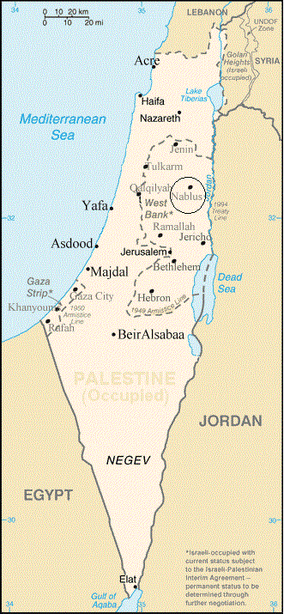
Figure (1.1) the location of Nablus in Palestine.
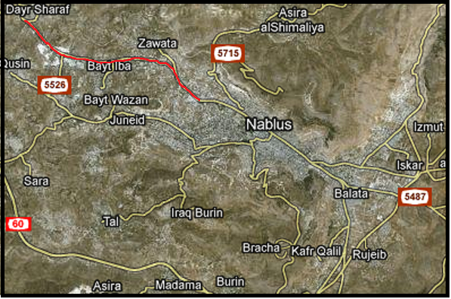
Figure(1.2) A satellite image showing the location of the road in Nablus.

1.2 Defining The Project
This project is concerned with designing the road which connects Nablus city and Deir-Sharaf village as shown in Figure (1.2). It lies in a rolling terrain. This is not a marginal road only connects a city with village, but it conveys the traffic from all the northern districts of West Bank to Nablus. It is the western entrance of the city that will be designed taking into consideration mobility, safety, smooth curves, and aesthetics.
The existing road is an old and narrow one; that means it is insufficient to convey the existing traffic at an acceptable level of service. The road has two lanes without a median, and limited shoulder widths, but the right of way is 30m, which means that the road can be widened, increasing the number of lanes if needed, and widening shoulders or installing sidewalks to reduce the number of crashes which occur on this road, because they are considered relatively high.

1.3 Methodology
The methodology for the design of Nablus Deir-Sharaf road, which is as considered the western entrance of Nablus city, carrying traffic from and to the northern districts of the West Bank is presented here. The following steps are to be followed to complete the project.
- Performing site visit.
- Collecting data and maps.
Information will be collected from the following institutions:
- Nablus Municipality.
- Nablus traffic police department.
- The Universal Group (MAALEM).
- The local councils of Beit Eba, Beit Wazan, and Deir Sharaf.
- Traffic study.
Traffic study is about the traffic count, analyzing the traffic at a certain site, the annual traffic growth rate, and the Design Hourly Volume(DHV).
- Setting design criteria.
- Functional classification.
- Design speed which affects on other criteria such as: grades and curve radii.
- Design vehicle.
- Level of service.
- Geometric design.
- Cross section.
- Horizontal alignment.
- Vertical alignment.
- Intersections design.
- Traffic control devices.
- The bill of quantities evaluation.
- Final evaluation.

1.4 Report Outline
This project is about the design of Nablus Deir-Sharaf road. It consists of six chapters. The first chapter is an introduction that illustrates the project. The second chapter is about the collected information and the institutions which visited to get these information. The third chapter is the geometric design of the road, including the cross section, horizontal alignment, and vertical alignment. The fourth chapter is about intersection design. The fifth chapter is the design of intersections specially the three main intersections Tunis intersection, Qusin intersection, and Deir Sharaf intersection. The sixth chapter is contains the traffic control devices in the road. The seventh chapter is about the cost and the bill of quantity of the road. The eighth chapter is the final conclusion about the project. The ninth chapter is appendix.

CHAPTER2

Data Collected

2.1 Site visit
Firstly, site visits should be performed to have an idea and a good impression about the project, starting from wadi At-Tuffah intersecting Beit Eba where the Israeli check point was located, ending at Deir Sharaf. Some notes were observed such as the restricted sight distance especially at curves, the limited width of the travel way, and old and deteriorated pavement, Figures (2.1), (2.2), and (2.3) show that.
2.2 Collecting Information and Maps
It is an essential step to know more on the project, identify the problems, discuss options for solving the existing problems, interviews were made with the following institutions for the essential information
- Nablus Municipality.
- The road doesn’t has median between the two directions which makes safety problems.
- Problems in the intersections because the insufficient lane width and turning radius.
- The road needs parking lane in commercial and residential area.
- Restricted sight distance specially at the entrance of Zawata .
- The limited budget.

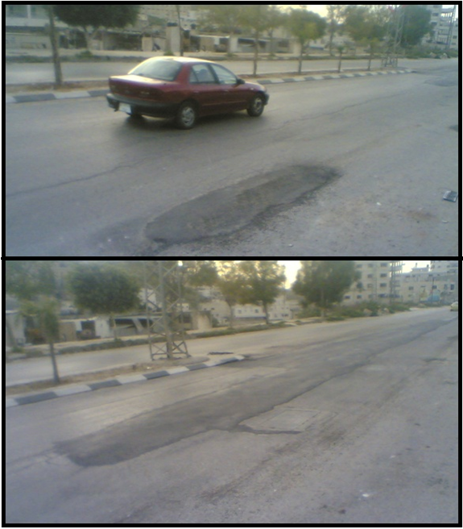
Figure (2.1) the old and deteriorated pavement of the road.
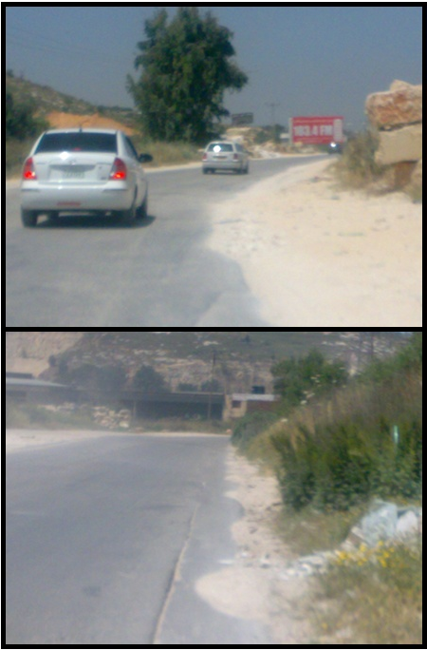
Figure (2.2) the restricted sight distance.

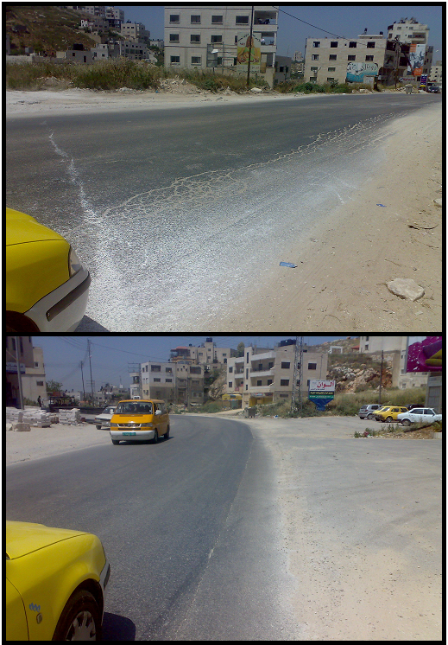
Figure (2.3) the limited width of pavement.

- Nablus Traffic Police Department.
The rate of crashes is high ,at least three crashes per week , according to the police department. Their causes are as follows:
- The large distance between the electric poles, which causes glare vision.
- Changes in the travel way width along the road which make confusion for the driver.
- No barriers on the edge of roadway in rural areas.
- No traffic signs to warn the driver for danger attend.
- The is no regulation of the width of shoulders.
- The restricted sight distance.
- The deteriorated pavement.
- The incorrect position of trees on the sides of the road.
- The difference between the friction coefficient pavement and shoulders.

- Village Councils.
The councils of Deir Sharaf, Beit Eba, and Beit Wazn where visited and the following information were collected.
- Problems in drainage of rain water and waste water .
- Beit eba divided into two parts, south and north the highway and there is a school in one side, so pedestrian crossing must be established.
- The sharp curves with limited radii which make insufficient sight distance for stop or passing.
- The Universal Group (MAALEM).
An interview with the universal group and the following was obtained.
●The surveying map of the road.
● the growth rate
2.3 Traffic Counting
Traffic counting is very important to design the road. It supplies the designer with essential information in designing like average daily traffic (ADT), peak hour volume (PHV), peak hour factor (PHF), the percentage of every vehicle type, etc.
12-hour counting from 6:30am to 6:30pm was performed on Monday 22-2-2010 in Wadi At-Tuffah (the beginning of the road) as shown in Tables A1, A2, and A3 in Appendix A. The percentage of each type of vehicles is shown in Figure (2.4). Figure (2.4) The percentage of every type of vehicles which the traffic flow consists of.

From the 12-hr counting from Tables A1, A2, A3 in Appendix A the following data are determined:
●12-hr traffic is 11492 veh.
● The peak hour (7:15am-8:15am).
●The peak hour volume (PHV):
Peak hour volume is 1288 veh. However, as Jenin Nablus road is closed because of reconstruction works, assuming the percent of Jenin traffic is 30%, the peak hour volume will be as follows:
→PHV=1288/0.7=1840 veh.
→ Design Peak Hour Volume.
In designing highways the designer should have a look to future, forecast the road needs, and the traffic volume after specific number of years using a growth rate. In designing the structure of the road it should be designed for 20 years, taking into consideration a growth rate of 3% as mentioned in the previous section.
So the Hourly Design Traffic volume after 20 year =1840(1+0.03)²⁰= 3323 veh/hr.
→Average Daily Traffic (ADT).
According to previous study performed by the Universal Group (1999) on Deir Sharaf intersection, and previous graduation project for Nesreen Abu Yaseen (2000), the percent of traffic is 25.8% during night and 74.2% during day time, so ADT is estimated to be:
24-hr traffic = veh/day.
With the addition of Jenin traffic, ADT becomes = veh/day
●The percent of trucks including the two axle heavy truck and the heavier trucks is 4.5%. the percent of trucks and busses is 5.4%.
CHAPTER 3

Design Control & Criteria

The first step in the design process is to define the functional classification of the road, the design speed, the horizontal and vertical alignment elements.
The elements of highway design are influenced by a wide variety of design controls and criteria, such factor include:
- Traffic volume and composition of traffic.
- Design vehicle.
- Level of service.
- Design speed.
- Cross section elements.
There are other factors which have influence on the design process as like:
- Topography.
- Cost and available funds.
- Social and environmental concerns.
- Safety conditions.
To determine design criteria the data should be collected from counting and classification for the vehicle on the needed road.
The data collected on counting is shown in tables A1, A2, A3 in Appendix A.
3.1 Functional Classification
Roads are divided into 3 categories due to the traffic volume as shown below:
- Arterial, it has a high mobility for vehicles, but its accessibility is too low.
- Collector, its mobility is lower than the arterial, the accessibility is higher than the arterial.
- Local road, it has the lowest mobility and the highest accessibility.
Figure (3.1) shows the relationship between the functional classification, and the mobility and land access.
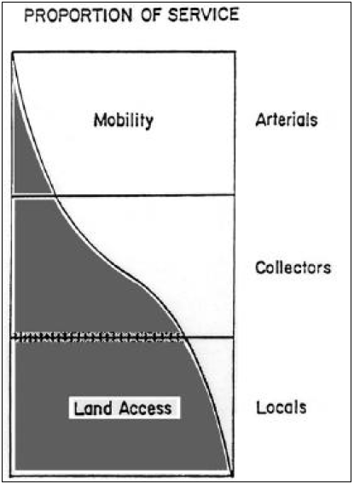
Figure (3.1) Relationship functionally classified systems in serving traffic mobility and land access. (AASHTO, 2001).
Classification should also be made according to the type of area:
- Urban area.
- Rural area.
This road serves national movement of traffic has a high volume(22000 veh./day) because it is the entrance of the city, so it is considered an arterial. It lies in two regions, firstly the urban area from Wadi At-Tuffah to Qusin intersection, and a rural area starts from Qusin intersection to Deir-sharaf village.
So the functional classification of the road is urban arterial for the first part, and rural arterial for the second part. The road could be considered as a suburban arterial.

3.2 Design Speed
Design speed is a selected speed that can be maintained over a specific section of highway when conditions are favorable that the design features of highway govern.
Design speed depends mainly on the functional classification of the road and the topography of the area. On the other hand there are several criteria depending on design speed such as minimum radius and maximum grade.
This road is an arterial, so the design speed is between 50 and 100km/hr, but the urban area has sharp curves, restricted sight distance, and the route of the road can’t be changed and governs the new design, so the design speed is chosen to be be conservative and is considered to be 60 km/hr.

3.3 Design Vehicle
Design vehicle is the vehicle that will represent all vehicles expected to use the road.
Any design vehicle has static, operation, and turning characteristics the road will be designed due to them, therefore a representative vehicle should be chosen to be the design vehicle. The road the percentage of trucks on the road is 4.5%, so the chosen vehicle is (WB-15) the characteristics of the vehicle according to AASHTO are as follows:
→ Width 2.6 m
→ Length 16.77 m
→Minimum turning radius 13.72 m
→ minimum inner radius 5.18 m
Figure(3.2) shows all other details
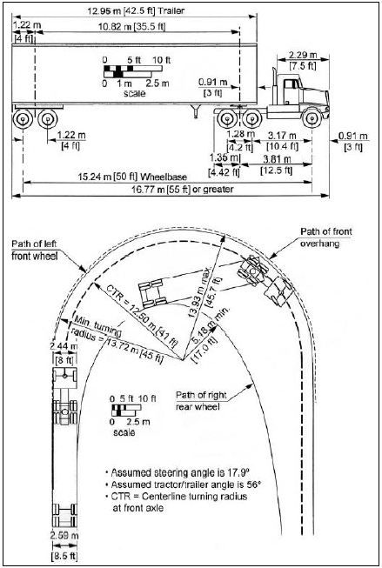
Figure(3.2) minimum turning radius for intermediate semitrailer (WB-15) design vehicle(AASHTO,2001).

3.4 Capacity & Level Of Service Analysis
Level of service (LOS) is the measure of quality of flow, it ranges from A to F; A is the highest level of service and F is the worst. In this project the road functional classification is suburban arterial, so the required design level of service is C according to AASHTO as shown in Table(3.1).
Table (3.1) guidelines for selection of design levels of service
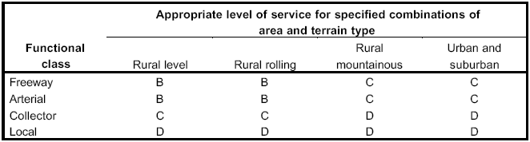
Source: A Policy On Geometric Design Of Highways And Streets, (AASHTO,2001).

Firstly, the level of service will be checked to examine where two lanes will be sufficient. If the level service is worse than C, it will be checked for four lanes. Level of service is checked based on the Highway Capacity Manual (HCM).

Two lanes analysis:-
Assume the percent of Jenin traffic is 30%, so peak hour volume is
Design Hourly Volume is 1840(1+.03)²⁰=3323veh/hr
PTSF= BPTSF+ f_{d/np}………………eq (3.1)
where,
PTSF: percent time spent following.
F_{d/np} : adjustment in PTSF to account for the combined effect of (1) percent of directional distribution of traffic and (2) percent of no passing zones.
referring to HCM →f_{d/np}=0.95 by interpolation
BPTSF: the base percent time spent following for both direction
…………………………….eq (3.2)

where,
v_{p}: passenger car equivalent flow rate for the 15-min period.
……………………………….eq (3.3)
where,
v_{p}: passenger car equivalent flow rate for the 15-min period.
PHF: peak hour factor
f_{G} : grade adjustment factor for level or rolling terrain.
f_{G}= 1 from HCM
f_{HV} : adjustment factor to account for heavy vehicles in the traffic stream.
……………………………eq (3.4)
P_{T} and P_{R} : the decimal portion of trucks (and buses) and recreational vehicles in the traffic stream.
E_{T} and E_{R} : the passenger car equivalent for trucks and recreational vehicles respectively.
E_{T}= 1 refering to HCM
BPTSF=96.83
PTSF= 96.73+.95=97.68
according to HCM LOS is E
→ two lanes are not sufficient to serve the flow.

Four Lanes analysis:-
V(in one direction)=694 veh/hr
Where, V: peak our volume (veh/h) in one direction.
With Jenin traffic, V=694/.7=991 veh/hr
After 20 years of 3% growth rate, V will be
991(1+0.03)²⁰=1790 v/hr/ln
E_{T}= 2.5
………………..eq (3.5)
where, N is number of travel lanes in one direction.
N=2
PHF=0.854
f_{b}= 1
density=volume/speed.
density= 1123/40= 28 pc/mi/lane
according to AASHTO LOS is C.
Therefore, the recommendation is to consider the number of lanes to be four. Two lanes in each direction.

CHAPTER 4

Highway Geometric and Pavement Design

Geometric design deals with the elements of the highway such as vertical and horizontal curves, cross sections, truck climbing lane, etc. Generally it follows the existing topography for economical purposes.

4.1 Cross Section Design
Cross section includes the main elements of the road such as travel lanes, median, cross slope, etc. There are two typical cross sections in this project. The first is for urban area which begins at Wadi At-Tuffah in Nablus to Qusin intersection, while the second is for rural area from Qusin intersection to Deir-Sharaf. Every element of the two section will be detailed in this section.
4.1.1 Travel Lanes
Lane width effects on safety and comfort of driver and passengers, it varies from 3m to 3.6m. Because of high traffic volume and the percent of trucks is 4.5% of traffic the lane width is 3.6m.
The number of lanes is determined to achieve the required level of service (LOS C), so the number of lanes is 4 as mentioned before, two lanes in each direction.
4.1.2 Shoulders
Shoulders are provided in rural area, and they are used for several purposes, the main use is to support the pavement structure of the road and there are many functions such as:
- Place to stop in emergency.
- Facilitate drainage.
- Provides lateral clearance for signs and guard rails.
- Provides space for maneuver to avoid crashes.
The width of shoulder ranges from 1.2m (0.6 m in special cases) to 3 or 3.6 in case of heavy traffic and high speed. For this road it is determined to be 2.5m.
The recommended slope of the shoulder ranges from 2% to 6% as the type of shoulder pavement, in this project the shoulder slope is 4% because it’s surface is basecourse.

4.1.3 Cross slopes
Cross slope should be adequate to provide proper drainage ranges from 1.5 to 2 percent for high type pavement. High type pavement are those that retain smooth riding qualities and good non-skid properties in all weather under heavy traffic volumes and loading with little maintenance required.Low-type pavements are those with treated earth surfaces and those with loose aggregate surface. A cross slope of 3% to 7% for low-type pavement. In this project a high-type pavement will be used, so the cross slope is 2%.

4.1.4 Median
Median is the part of highway that separates opposing directions of the travel way, medians are highly desirable for multilane highways. Generally median width ranges from 1.2 to 24m, economical factors often limit the median width, because of the cost of construction and maintenance, sometimes the restricted right of way limits the median width.
Medians are used for many purposes such as:
- The principal function is to separate the opposing traffic.
- Provide a recovery area for out of control vehicles.
- Storage of U-turning and left-turning vehicles.
- Provide width for future lanes.
- Provide refuge area for pedestrians crossing the street
- Control the location of intersection traffic conflicts, for maximum efficiency.
Types of medians:
- Depressed Median: it is preferred on freeways for more efficient drainage and snow removal.
- Raised Median: it is preferred to be used on arterial streets where it is desirable to regulate left turn movement, and where the width is relatively narrow.
- Flushed Median: it is commonly used on urban arterials, but a median barrier may be needed.
For Nablus Deir-Sharaf road a raised median with 4m width will be used, because it is an arterial with restricted right of way and to regulate left turn movement.

4.1.5 SideWalks
Sidewalk is used in urban areas only because there is no need for them in rural areas, the minimum width of sidewalk is 1.2m. In this project the sidewalk width will be 3.4m in urban area.

4.1.6 parking lane
The area of Zawata is full with commercial shops that means a parking lane is needed. The parking lane width is 2.4m.

4.1.7 Side Slope
The maximum side slope should depend on the stability of soil as determined by soil investigation and local experience, slopes should be as flat as practical, flat side slope improves safety by providing a maneuvering area in emergencies work.
Drivers who leave the traveled way can often recover control of their vehicles if the side slope is 1V:4H or flatter, cut section should be designed with adequate ditches, the side slope should not be steeper than 1V:2H, and where practical, should be 1V:4H or flatter. Figures (4.1) and (4.2) show the urban and rural cross section elements.

4.2 Horizontal Alignment
The horizontal alignment consists of straight sections of the road, known as tangent, connected by horizontal curves. The curves are usually segments of circle, which have radii that provide for smooth flow of traffic along the curve. A number of general controls are important for efficient and smooth flowing highways, minimum radius, sight distance and other factors.

4.2.1 Maximum Superelevation
The maximum super elevation used on highways is controlled by many factors, as climate conditions, terrain conditions(level, rolling or mountainous), type of facility (rural or urban).
Tests and experiences show that the maximum superelevation rate of 8% is preferable. Where snow and ice are founded to minimize slipping across highway. For highway design in urban areas a maximum rate of 4% to 6% is applicable. In special cases a maximum super elevation of 10% can be used.
This project lies in urban area, that means the maximum superelevation is 6% .
4.2.2 Minimum Radius
The minimum radius as a limiting value of curvature for a given design speed and is determined from the maximum super elevation and the maximum side friction factor selected for design.
The minimum radius (R_{min}) can be calculated directly from the simplified curve formula:
R_{min}=$\frac{V2}{127(emax+f)}$
where :
R_{min}=minimum radius of curvature (m).
V=design speed (Km).
e_{max}=maximum super elevation rate.
f=side friction coefficient factor.
The minimum radius can be also found by tables from AASHTO as shown in Table (4.1).

Table (4.1) minimum radius for design of rural highways and high speed 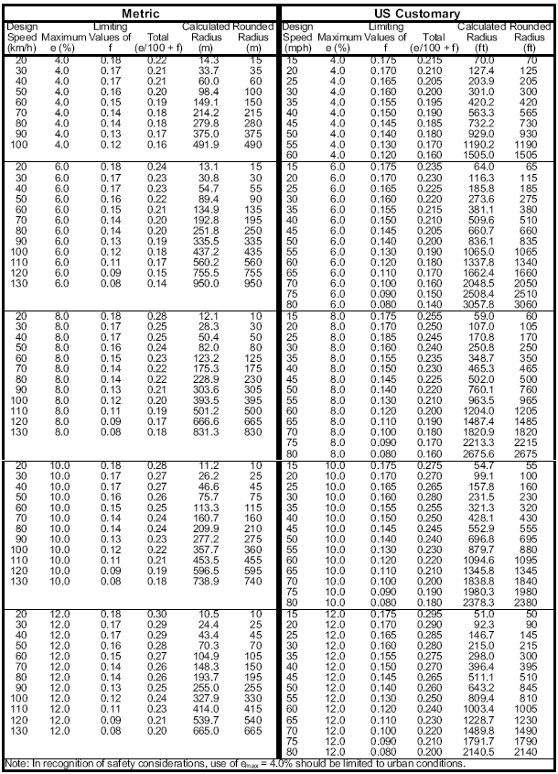
urban streets using limiting values of e and f (AASHTO, 2001).
For 60 Km/h design speed and 6% superelevation the minimum radius is 135 m.

4.2.4 Types Of Horizontal Curves
Horizontal alignment consists of straight segments of the roads known as a tangents; these tangents are connected by different types of curves. There are four types of curves: simple, compound, reversed and spiral.

- Simple Curves
The curve is a segment of a circle with radius R. As shown in figure (4.4), the point at which the curve begins is known as the point of curve (PC), and the point at which it end is known as the point of tangent (PT). The point at which the two tangents intersect in known as the point of intersection (PI). The simple circular curve is described either by its radius or by the degree of the curve.
Referring to Figure (4.3) and using the properties of a circle , the two tangent length are equal and designated as T. the angle ∆ formed by the two tangents is known as intersection angle. We can therefore obtain the tangent length as:
T=R(tan ∆/2)
where,
T: tangent length
∆: intersection angle
The length C of the chord,which is known as the long chord is given as;
C=2R(sin ∆/2)
The external distance E is the distance from the point of intersection to the curve on a radial line is given as;
E= R sec (∆/2)- R
The middle ordinate M is the distance between the midpoint of the long chord and the midpoint of the curve and is given as;
M=R-R cos (∆/2)
The length of the curve is given as;
L=(R∆π/180)
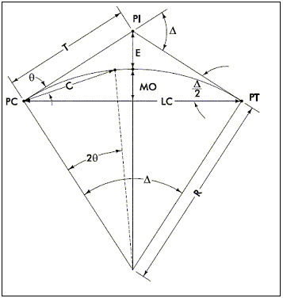
Figure (4.3) simple curve.

- Compound Curves
Compound curves consist of two or more curves in succession, turning in the same direction, with any two successive curves having a common tangent point. Figure (4.4) shows a typical layout of a compound curve consisting of two simple curves. These curves are used mainly in obtaining desirable shapes of the horizontal alignment, particularly at at-grade intersection, ramps of interchanges, and highway sections in difficult topographic conditions. To avoid abrupt changes in the alignment, the radii of any two consecutive simple curves that the ratio of the flatter radius to the sharper radius in open highways should not be greater than 2:1, where drivers can adjust to sudden change in curvature and speed. The maximum desirable ratio recommended by AASHTO is 1.75:1. In cases where ratio higher than 2:1 are to be used, a spiral curve should be placed between the simple curves.
To provide smooth transition from a flat curve to a sharp curve, and to facilitate a reasonable deceleration rate on a series of curves of decreasing radii, the length of each curve should not be too short.
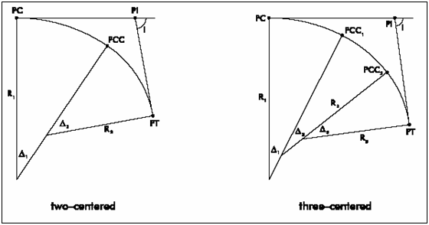Figure (4.4) compound curves.

- Reverse Curves
Reverse curves usually consist of two simple curves with equal radii turning in opposite directions with a common tangent. They are generally used to change the alignment of the highway. Figure (4.5) shows a reverse curve with parallel tangent.
Reverse curves are seldom recommended because sudden changes to the alignment may result in drivers finding it difficult to keep in their lanes. When it is necessary to reverse the alignment, a preferable design consists of two simple horizontal curves, separated by a sufficient length of a tangent between them; to achieve full super elevation. Alternatively, the simple curves may be separated by an equivalent length of spiral
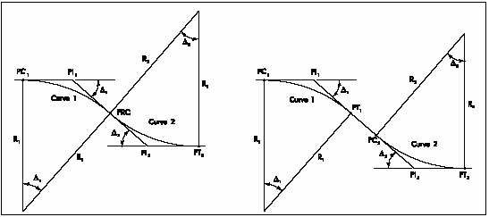Figure (4.5) reverse curves.

4.2.5 Horizontal Alignment design
As mentioned before, the horizontal alignment consists of horizontal curves connected dimensions with straight lines called tangents. In this project there are 21 curves with minimum radius of 135m and minimum length of three times of the design speed (180 m) shown in Figure (4.6) and detailed in Tables A4, A5, A6, in Appendix A. It is noticed that the curves radii satisfies the minimum acceptable value (135m), but some of curves their lengths are shorter than 180 m because of the restricted right of way, and the existing houses in the urban area.

4.3 Vertical Alignment
Vertical alignment of the highway consists of straight segments are Known as grades or tangents connected by vertical parabolic curves. The design of vertical curves involves the suitable grades for the tangents and the suitable length of the curves.

4.3.1 Terrain
The terrain has an influence on the vertical alignment and its elements, and there final design. Terrain is generally separated into three classification: level, rolling, and mountainous. In this project the terrain is rolling.

4.3.2 Grades
The grades of the vertical alignment are very important, because they affect on the vehicle performance, so maximum grade should be designed carefully. This road is urban arterial in a rolling terrain and the design speed is 60 K/hr, so the maximum grade is 8% as shown in Table (4.2). The grade has also a minimum limit for drainage facility, According to (AASHTO 2001) the minimum grade is 0.5%, but grades of 0.3% may be used where there is a high-type pavement accurately sloped and supported on firm subgrade.
Table(4.2) Max. grades in urban arterial
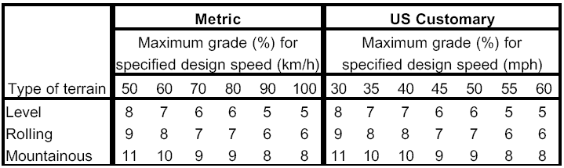
Source: A Policy On Geometric Design Of Highways And Streets, (AASHTO,2001).

4.3.3 Vertical Curves
Vertical curves provide gradual changes between tangent grades may be one of the crest or sag types shown in Figure(4.10).
- Crest vertical curves.
Minimum length of crest vertical curves based on sight distance criteria. There are two cases to determine the minimum length of the curve. The first is when the sight distance is less than the length of the curve, the second is when the sight distance is more than the length of the curve. The length in each case can be determined by equations (4.8)in the first case, and by equation (4.9) for the second case.
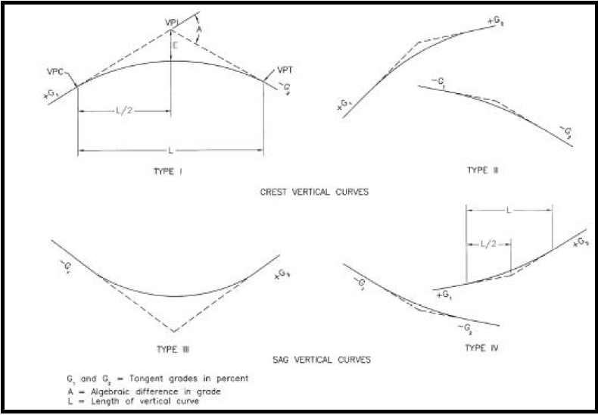
Figure(4.7) Types of vertical curves.

Where,
L: length of vertical curve (m).
S: sight distance (m).
A: algebraic difference in grade.
The length of the curve can be also determined by the rate of vertical curvature(K), depending on the design speed as shown in Table(4.3)and Figure(4.9), where L=KA.

Table(4.3) Design Controls for Crest Vertical Curves
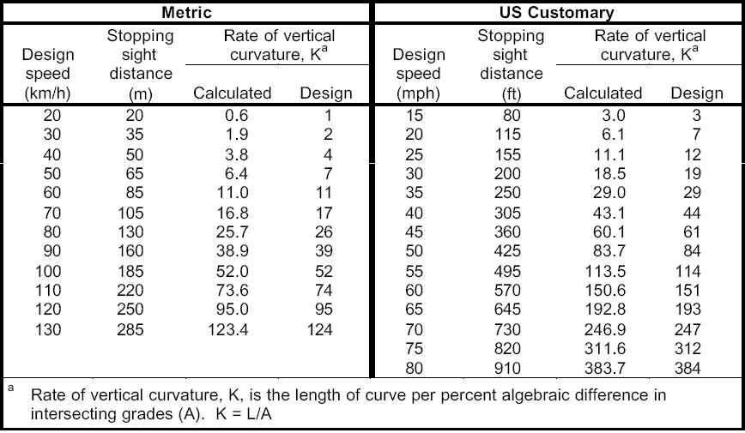
Source: A Policy On Geometric Design Of Highways And Streets, AASHTO 2001
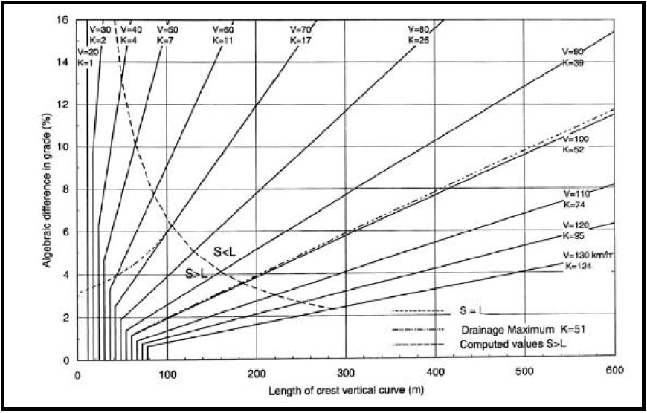Figure(4.8) Design Controls for Crest Vertical Curves (AASHTO, 2001).
Source: A Policy On Geometric Design Of Highways And Streets, AASHTO 2001

- Sag vertical curves.
At least four different criteria for establishing lengths of sag vertical curves are recognized to some extent. These are:
- Headlight sight distance.
- Passenger comfort.
- Drainage control.
- General appearance.
Headlight sight distance in sag vertical curves should be long enough that the light beam distance is nearly the same as the stopping sight distance. Length of the curve can be determined by the following two equation.
Headlight sight distance can be also determined by the rate of vertical curvature (K) from Table(4.4) and Figure(4.10).
Table (4.4) Design Controls for sag Vertical Curves (AASHTO 2001).
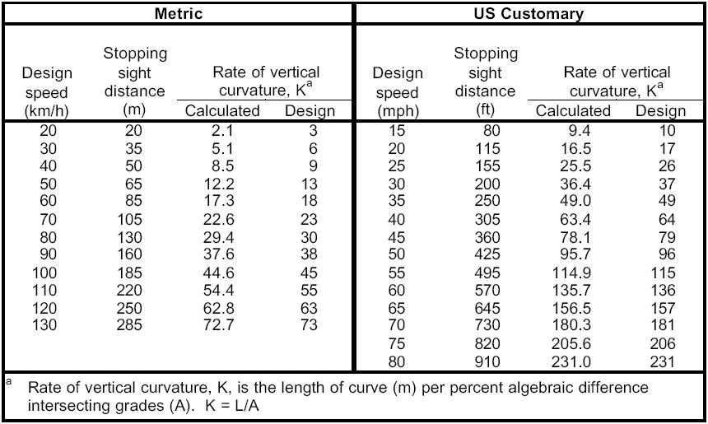
Source: A Policy On Geometric Design Of Highways And Streets, AASHTO 2001

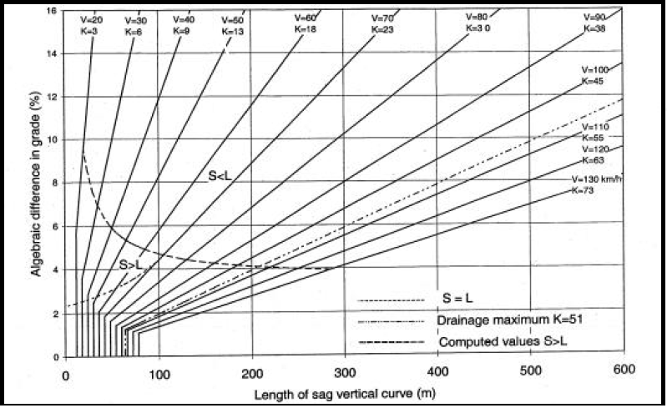Figure(4.9) Design Controls for sag Vertical Curves .
Source: A Policy On Geometric Design Of Highways And Streets, AASHTO 2001

The effect of passenger comfort of the change in vertical directions greater in sag than on crest vertical curves, because gravitational and centripetal forces are in the same direction. When the centripetal acceleration does not exceed 0.3m/s² the minimum length of vertical curve is given by equation (4.12).
Drainage affects design of vertical curves where curbed sections are used. This criterion corresponds to K of 51m per percent change in grade as in Figure (4.12). The drainage criterion differs from other criteria in that the length of sag vertical curve determined for it is a maximum, when the design speed more than 100 km/hr.
For general appearance of sag vertical curves, some use was formerly made of a rule of thumb for minimum curve length of 30A, or use K=30 in Figure (4.9).

4.3.4 design of vertical alignment:
In the application of the design of the vertical alignment the maximum grade is 4.42% and the minimum was 0.5%, the minimum K value is 19.7 and the minimum vertical curve length is 50 m. AS shown in Table A7 in Apendix A.

4.4 Design Of Flexible Pavement
Highway pavements are divided into two main categories flexible and rigid. The wearing surface of a rigid pavement usually is constructed of Portland cement concrete such that it acts like a beam over any irregularities in the under lying supporting material. The wearing surface of flexible pavement, on the other hand, usually is constructed of bituminous materials such that they remain in contact with the underlying material even when minor irregularities occur. Flexible pavements usually consist of bituminous surface under laid with a layer of granular material and layer of suitable mixture of coarse and fine material. traffic loads are transferred by the wearing surface to the underlying supporting material through the interlocking of aggregates, the fractional effect of granular materials, and cohesion of fine materials.
Flexible pavements are further divided into three subgroups: high type, intermediate type and low type. High type pavement have wearing surfaces that adequately support the expected traffic load without visible distress due to fatigue, and are not susceptible to weather conditions. Intermediate type pavements have wearing surfaces that range from surface treated to those with qualities just below that of high type pavements. low type pavements are used mainly for low cost roads and have wearing surfaces that range from untreated to loose natural materials to surface treated earth.
4.4.1 Structural Components Of Flexible Pavement
The component s of flexible pavements are the subgrade, the subbase, the base, and the wearing surface. The performance of the pavement depends on the satisfactory performance of each component, which requires proper evaluation of the properties of each component separately .
- Subgrade (prepared road bed):
The subgrade is usually the natural material located along the horizontal alignment of the pavement and serves as the foundation of the pavement structure. It also may consist of a layer of selected borrow materials.
- Subbase Course:
Located immediately above the subgrade, the subbase component consists of material of a superior quality to that which is generally used for subgrade construction. The requirement for subbase materials usually given in terms of the gradation, plastic characteristics, and strength.
- Base course:
The base course lies immediately above the subbase. It is placed above the subgrade if subbase is not used. This course is usually consists of granular materials such as crushed stone, crushed slag and sand. The specifications of base coarse materials usually include more restrict requirements than those of subbase materials, particularly with respect to their plasticity, gradation and strength.
- Surface course:
The surface course is the upper course of the road pavement and is constructed immediately above the base course .The surface course in flexible pavements usually consists of mineral aggregates and asphalt. It should be capable of withstanding high tire pressure, resisting abrasive forces due to traffic, providing a skid-resistant driving surface, and preventing the penetration of surface water into the underlying layers. The thickness is vary from 3 in to more than 6 in, depending on the expected traffic on the pavement.

4.4.2 Determination of the thicknesses of Haifa Street
In order to find the depths of each layer, there is many terms must be determined; so these terms must be determined as follows:
SN=a₁ D₁+a₂D₂m₂+a₃D₃m₃
where,
SN: structural number
m_{i}: Drainage coefficient
a₁,a₂,a₃: layer coefficients representative of surface, base and subbase course respectively.
D₁,D₂,D₃: Actual thicknesses in of surface, base and subbase course, respectively.
The coefficients a1, a2, and a3 and the other input parameters are to be founded.
- The layer coefficient as follow,
a₁ (for asphalt) with Mr = 450000 a₁ = 0.4
a₂ (for base course) with CBR = 100 a₂ = 0.14
a₃ (for subbase) with CBR = 50 a₃ = 0.135
from AASHTO
- The level of reliability = 90%
- Standard deviation = 0.45
- The drainage coefficient
m₁, m₂ =0.9
- Resilient coefficient (Mr)
It depends on the CBR value, in this project the results of CPR testing to divide the highway was divided into three groups.
- Mr for subbase:
Table (4.5) shows CBR values for sub-grade which obtained from the universal group (MAALEM).

Table (4.5) CBR Values
Sample no. | Station | CBR | Soil classification
1 | 1000 - 1500 | 14 | A-6
2 | 1500 - 2000 | 6 | A-4
3 | 2000 - 2500 | 3 | A-7-6
4 | 2500 - 3000 | 9 | A-6
5 | 3000 - 3500 | 70 | A-4
6 | 3500 - 4000 | 11 | A-6
7 | 4000 - 4500 | 74 | A-2-4
8 | 4500 - 5000 | 23 | A-2-4
9 | 5000 - 5500 | 16 | A-4
10 | 5500 - 6000 | 13 | A-4

- First group with minimum CBR = 3
So, Mr₁=(3)(1500) = 4500
- Second group with minimum CBR = 13
Mr₂ =11000
- Third group with minimum CBR = 11
Mr₃=10500
- Mr for base course:
with CBR = 100, Mr = 30000
- Mr for asphalt = 450000
- Equivalent single axle load (ESAL)
ESAL=∑ ESAL_{i}
ESAL_{i}=f_{d} X G_{rn} X AADT_{i} X 365 XN_{i} X F_{Ei}
Where,
ESAL_{i} =equivelant accumulated 18,000 lb (80KN) single axle load for the axle category i.
f_{d} = design lane factor (0.45) .
G_{rn} =growth factor (27).
AADT_{i} =first year annual average daily traffic for axle category.
N= mumber of axles.
F_{Ei} =load equivalency factor
By substitution the upper values the following results are obtained in Table (4.6).

Table(4.6) ESAL for the different types of vehicles
 | type of vehicle |  | %vehicle | % | AADTi | factor | ESALi
 | p.c |  | 48.2 | 0.482 | 10663.77 | 0.0004 | 18916.46
 | Taxi |  | 23.3 | 0.233 | 5154.892 | 0.0004 | 9144.263
 | taxi van |  | 14.3 | 0.143 | 3163.732 | 0.02 | 280607.2
 | pick up |  | 3.1 | 0.031 | 685.844 | 0.02 | 60830.93
 | Bus |  | 0.97 | 0.0097 | 214.6028 | 0.21 | 199859.1
 | L.Truk |  | 5.3 | 0.053 | 1172.572 | 0.02 | 104001.3
 | H.Truck |  | 2.54 | 0.0254 | 561.9496 | 0.21 | 523342.3
 | S.Truck |  | 0.37 | 0.0037 | 81.8588 | 0.73 | 265007
 | Trailer/truk |  | 0.78 | 0.0078 | 172.5672 | 0.98 | 749986.5
 | Articulated |  | 0.75 | 0.0075 | 165.93 | 0.98 | 721140.9
 | other |  | 0.04 | 0.0004 | 8.8496 | 0.02 | 784.9153
 | Tractor |  | 0.23 | 0.0023 | 50.8852 | 0.02 | 4513.263
 |  |  |  |  |  | total = | 2938134
SN for the different CBR for subbase is as follow
SN at (CBR =3) is 4.5
SN at (CBR =13) is 3.3
SN at (CBR =11) is 3.3
So, thicknesses of sub-basecoures are:
Depth (at CBR =3) equal 28cm, D3 use 30cm
Depth (at CBR =13) equal 6.5 cm, D3 use 20 cm
Depth (at CBR =11) equal 8cm. D3 use 20 cm
Depth of the base course (D2) is 30 cm
Depth of the pavement (D1) is 12 cm. As shown in Figures (4.10), (4.11), and (4.12).

CHARTER 5

INTRSECTION DESIGN

5.1 INTRODUCTION:
An intersection is an area shared by two or more roads, whose main function is to provide for the change of route direction. Intersection vary in complexity from a simple intersection, which has only two roads crossing at a right angle to each other, to more simple intersection, at which three or more roads cross with, in the same area. Drivers therefore have to make a decision at an intersection concerning which of the alternative routes they wish to take. this effort, which is not required at non-intersection areas of the highway, is part of the reason why intersections tend to have a high potential for crashes. The overall traffic flow on any highway depends to a great extent on the performance of the intersections, since intersections usually operate at a lower capacity than through sections of the road.

5.2 Types of Intersections:
Intersections are classified into three general categories:
1-Grade-separated without ramps.
2-Grade-seperated with ramps.
3-At grade intersection, which has many types that are:
- Three leg intersection. These intersections can range from simple to a channelized with a divisional islands and turning roadways.
- Four leg intersections. These are the most common type of intersection and these intersections can be channelized or not.
- Multi-leg intersection. This type of intersection has five or more approaches, this type of intersection should be avoided.

5.3 Design Principles for at Grade Intersections:
The Fundamental objective in the design of at-grade intersections is to minimize the severity of potential conflicts among different streams of traffic and between pedestrian and turning vehicles. At the same time, it is necessary to provide for smooth flow of traffic across the intersection. The design should therefore incorporate the operating characteristics of both the vehicles and pedestrians using the intersection. The design should ensure adequate pavement widths of turning roads and approach sight distances. This suggests that at-grade intersection should not be located at or just beyond sharp crest vertical curves or at sharp horizontal curves.
The design of an at-grade intersection involves the design of the alignment, the design of a suitable channeling system for the traffic pattern. The determination of the minimum required widths of the turning roadways, when traffic is expected to make turns at speed higher than 24 Km /hr, and assurance that the sight are adequate for the type of control at the intersection.

5.4 Geometric Design:
The proper geometric design of an intersection improves traffic safety, increase capacity and accommodate vehicle movement such as large size vehicles. To achieve this, turning radius which is the turning radius at curbs and for turning into another lane, should be enough to accommodate the largest size vehicle using this intersection the design of the curb line at intersection depends on the composition of the traffic, the angle of intersection, the right of way available, the width and the number of lanes on the intersecting streets and the need of pedestrian. Figure (5.1) shows WB-15 design vehicle path in turning highway.
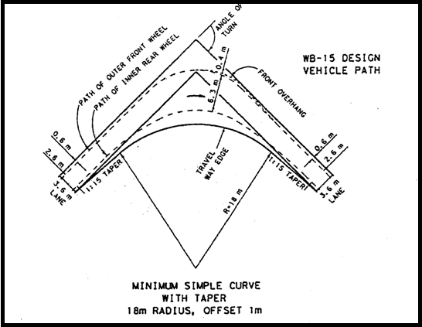
Figure (5.1) WB-15 design vehicle path in turning highway
Source: A Policy On Geometric Design Of Highways And Streets, (AASHTO,2001).

5.5 Channelization of at grade intersections:
Channelization is defined as separation of conflicting traffic movement into definite path of travel by traffic island or pavement marking to facilitate the safe and orderly movements of both vehicles and pedestrians. A traffic island is a defined area between traffic lanes that it used to regulate the movement of vehicles or to serve as a pedestrian refuge. A properly channelized intersection will result in increased capacity, enhanced safety and increased driver confidence. On other hand, an intersection that is not properly channelized may have the opposite effect.
The design of channelized intersection should also always be governed by the following principles:
- Motorists should not be required to make more than one decision at a time.
- Sharpe reverse curves and turning paths greater than 90 degree should be avoided.
- Merging and weaving areas should be as long as possible, but other areas of conflict between vehicles should be reduced to minimum.
- Crossing traffic streams that do not weave or merge should intersect at 90 degree, although a range of 60-120 degree is acceptable.
- The intersecting angle of merging streams should be such that an adequate sight distance is provided.
- Prohibited turns should be blocked wherever possible.

5.6 Function Of Traffic Islands
Traffic islands can be classified into three categories based on their functions:
- Directional Islands:
The objective of channelized islands is to eliminate confusion to motorists at intersections with different traffic movements by guiding them into the correct lane for their intended movement.
- Divisional islands:
These are frequently used at intersections of undivided high-ways to alert drivers that they are approaching an intersection and to control traffic at the intersection. They also can be used effectively to control left turns at skewed intersection.
- Refuge Island:
Refuge islands, sometimes referred to as pedestrian islands, are used mainly at urban intersections to serve as refuge areas for wheelchairs and pedestrians crossing wide intersections. They also may be used for loading and unloading transit passengers. Perform two or more of these functions rather than a single function, although each island may have a primary function.

5.7 Project Intersections Design:
There are many intersections in this road. The three main intersections Tunis intersection, Qusin intersection, and Deir Sharaf intersection will be designed in details in this section.

- Tunis Intersection:
This intersection is important because it connects two main streets which have relatively high volume.
This intersection which has 3 legs, (T-intersection), should be designed as shown in drawing IS-1 in Appendix B, which has a corner islands for right turn from and to Tunis street, and an auxiliary lane that include deceleration length, storage length and taper. Acceleration length for the auxiliary lane with taper 1:10 is 30 m for safe turning and to be sufficient to store vehicles with width of 3m.

- Qusin Intersection
This intersection is an important three leg intersection. It was connect Nablus – Qaqilya road and the main road. But now it is an entrance to Nablus city. It has an elongated island to divide the traffic and corners for left turn, the taper details Tunis intersection. As detailed in drawing IS-2 in Appendix B.

- Deir sharaf intersection
This intersection is a three leg intersection. the first approach from Nablus city. The second approach from Tulkarem. The third approach is from Jenin. It has an elongated island to divide the traffic and corners for left turn, the taper details Tunis intersection and Qusin intersection. As shown in drawing IS-3 in Appendix B

CHAPTER 6

TRAFFIC CONTROL DEVICES

Traffic control devices are the media traffic engineers use to communicate with drivers. Virtually every traffic flow, regulation, or operating restriction must be communicated through the use of devices that fall into three broad categories:
- Traffic marking.
- Traffic signs.
- Traffic signals.
And to be effective, the traffic control devices should be:
- Fulfill a need.
- Command attention .
- Convey a clear, simple meaning.
- Command the respect of road users.
- Give adequate time of proper response.
6.1 Traffic Marking:
Traffic marking are the most frequently used traffic control devices, and fall into three broad categories:
- Longitudinal markings.
- Transverse markings.
- Object marking.
Longitudinal and transverse markings are applied to the roadway surface using a variety of materials that satisfy the purpose of marking installation. Object markers and delineator are small object mounted reflector.
- Longitudinal Markings
Longitudinal Markings are those placed on the longitudinal pavement such as the centre line of highway.
- Transverse Markings
Transverse Markings are those placed across travel lanes, there are primary types of transverse of marking: stop lines, crosswalks, and parking lanes.
Crosswalks are of particular importance as pedestrians are attempt cross the street in a vertical path, which would place them in conflict with moving traffic lane and can be marked in three different ways:
- Crosswalks is marked by paint line and leave the other.
- Marked as zebra shape.
- Marked the boundary of crosswalk only.
Note: only the white color is used in crosswalk marking.
Stop lines which are used in urban area are to emphasize where vehicles should stop, and the relationship between where vehicles stop, and the pedestrian path .
Solid white lines are 0.3 meter width, extend across all approach lanes.

- Word and symbol markings
The word which used in marking should be short and simple, and where word marking used, they elongated to appear in proportion to the driver of moving vehicle.

6.2 Traffic signs:
Traffic signs fall into three categories:
- Regulatory signs.
- Warning sign.
- Guidance signs.

1-Regulatory signs:
Regulatory signs all convey information about a specific traffic regulation will which drives comply such as the speed limit, stop signs and yield signs.
- Stop signs
Stop sign is used where an approaching vehicle is required to stop before interring the intersection. stop sign should not be used at signalized intersection or on through roadways of express ways.
Stop signs may be used on a minor road when it intersects a major road, and where a combination of high speed, restricted view, and serious crashes indicates the necessity for such a control.
- Yield signs
All drivers on approaches with yield signs are required to slow down and yield the right of way to all conflicting vehicles at the intersection. Stopping at yield signs is not mandatory, except when it is necessary to avoid accident. Yield signs are placed at minor road approach, when it is necessary to yield the right of way to the major road traffic.
This sign is warranted at intersections where there is a separate or channelized right-turn lane without an adequate acceleration lane.
- Speed limit signs
Road speed limits are used in most countries to regulate the speed of road vehicles. Speed limits may define maximum (which may be variable), minimum or no speed limit and are normally indicated using a traffic sign. Speed limits are used to reduce the differences in vehicle speeds by drivers using the same road at the same time which increases safety. In situations where the natural road speed is considered too high, notably on urban areas where speed limits below 50 km/h are used then traffic calming is often also used. For some classes of vehicle speed limiters may be mandated to enforce compliance.
2-warning signs
Warning signs provide drivers with information impending on conditions that are or may be hazardous warning signs are not placed where conditions are apparent and easily discerned by the driver.
Warning signs are primarily for drivers who is unfamiliar with the roadway. Thus, signs must be placed sufficiently in advance of the hazard conditions to allow the driver to see the sign, and go to through the full perception reaction sequence before reaching it.
Some conditions for warning signs may generally be placed:
- Changes in horizontal alignment.
- Intersection.
- Converging traffic lanes.
- Narrow roadways.
- Changes in highway design.
- Grades.
- Roadway surface conditions.
- Railroad crossing.
3-Guidance signs
Guide signs provide information to assist drivers in selecting appropriate routes to their desired destinations. guidance signing is somewhat different from other types; it is used in generally not in the concern such that the name of the road and the number if existed.

6.3 Application Of Traffic Control Devices
All the traffic control devices witch mentioned before will be applied practically this section, and it will be shown where and how every device should be used.
6.3.1 longitudinal marking:
Center line in marked by broken white lines, because the road is divided by a median, which means that the passing is permitted all over the road. AS shown in drawing drawings TR-1, TR-2, and TR-3 in Appendix B.
6.3.2 Transverse Marking:
- Stop lines indicates the driver must stop to response the stop sign. As shown in drawing drawings TR-1, TR-2, and TR-3 in Appendix B.
- Crosswalks were set to indicate were the pedestrians should cross the road. As shown in drawing drawings TR-1, TR-2, and TR-3 in Appendix B.

6.3.3 Traffic signs:
Too many signs are used in traffic control process. Every sign has a certain meaning and place as detailed in drawing drawings TR-1, TR-2, and TR-3 in Appendix B.

CHAPTER 7

BILL OF QUANTITIES

This project is about the construction of Nablus - Deir Sharaf road. Its length is 6.5km. This includes earth works, where there is excavations and fill embankment constructions the amounts of cut and fill are taken from the software “Auto Cad Civil 3D 2011” there is 115000 m³ of cut and 12500 m³ of fill.
There is 30cm subbase course from station 0+000 to station 3+000 about 17280m³, and 20cm of subbase course from station 3+000 to station 6+000. There is two layers of basecourse, each one is 15cm thick, with CBR equals 100. furnishing of 12cm thick (after compaction) asphaltic two layers, the first is 7cm thick and the second is 5cm thick. This road has a median of 4m width. Two tiled sidewalks of 3.4m width for each one in the urban area. Applying traffic control devices to control the traffic on the road and for more safety. The estimated cost of the project is 6718000 $ is detailed in a priced bill of quantities in Table (7.1).
The unit cost for each item is taken from the Universal Group (MAALEM).
The cost of retaining walls and the drainage facilities are not estimated because they are not within the scope of the project.

Table (7.1) Bill of Quantities
Item | Unit | Quantity | Unit price ($) | Total price($)
Earth Works
excavation | m³ | 115000 | 4 | 460000
embankment construction | m³ | 12500 | 10 | 112500
earth works coast |  |  |  | 572500
Sub-Base And Base course
sub-base course | m³ | 37280 | 20 | 745600
base-course | m² | 35000 | 28 | 980000
sub-base and base course coast |  |  |  | 1725600
Bituminous Construction
prime coat | m² | 117600 | 0.9 | 105840
tack coat | m² | 117600 | 1 | 117600
5 cm thickness asphalt | m² | 117600 | 10 | 1176000
7 cm thickness asphalt | m² | 117600 | 12 | 1411200
bituminous construction coast |  |  |  | 2810640
Miscellaneous Works
traffic signs | No. | 132 | 100 | 13200
curbstones for sidewalks | m | 10000 | 28 | 280000
curbstones for islands | m | 10310 | 25 | 257750
sidewalk tile | m² | 34000 | 30 | 1020000
longitudinal traffic marking | m | 32500 | 1 | 32500
object marking | m² | 850 | 7 | 5950
miscellaneous works coast |  |  |  | 1609400
Total Coast |  |  | 6718140

Chapter 8

Conclusions
and
Recommendations

There are some conclusions about the road are to be mentioned such as the deteriorated pavement, and the limited width of pavement, which has only two lanes. This means that the road capacity is low, so it will not be sufficient to carry the volume of traffic in the future.
The existing radii of the horizontal curves are small and their lengths are too short which means low safety and no comfort in riding. There is no marking and few traffic signs to regulate, guide, and warn the drivers for more safety. The existing intersections has no or not sufficient channelization, not enough turning radii, and limited widths to achieve safety and smoothness in riding.
It is recommended to apply this design of Nablus-Deir Sharaf road because the existing road is not sufficient to serve the area properly. In the suggested design the full 30m right of way is used to improve the intersections, and to facilitate the mobility on the road. Four travel lanes are suggested in addition to parking lane on each direction. The road is divided by a 4m median to separate the traffic for safety and to regulate the traffic. There is a 3.4 sidewalk on each side to provide safety for the pedestrians. The horizontal curves are designed with a minimum radius of 135m for 60 km/h design speed. The vertical alignment is designed as a rolling terrain, the maximum slope is 8% according to AASHTO, and the maximum applied slope is 4.42%. the minimum k value for stopping sight distance is 11 for crest curves, and 18 for headlight sight distance.
Some legs are connected with the main road in acute angle, they need realignment for more safety. The road needs continuous operating maintenance because of the heavy volume of traffic presented on it.

REFERENCES:
- American Association of state Highway and Transportation, (AASHTO,2001), A Policy On Geometric Design Of Highways And Streets, Washington, DC.
- Garber. N, Hoel. L, Traffic and highway Engineering, 4th Edition, 2008.
- Aaraj. H, Shaheen. Q, O’deh M, B.Sc. Graduation Project, Design of the Western Part of Nablus Ring Road, 2009, An-Najah National University.
- Abu Yaseen. N, B.Sc. Design of Nablus Tulkarem Road, 2000, Graduation Project, An-Najah National University.
- Highway Capacity Manual (HCM) 2004.

APPENDIX
(A)

Output Design:
Table A4: Horizontal Curves:
Tangent Data
Length: | 10.264 | Course: | N 80° 04' 23.7983" W
Circular Curve #01
Delta: | 33° 11' 49.3527" | Type: | RIGHT
Radius: | 250.000
Length: | 144.849 | Tangent: | 74.521
Mid-Ord: | 10.418 | External: | 10.870
Chord: | 142.832 | Course: | N 63° 28' 29.1220" W
Tangent Data
Length: | 308.570 | Course: | N 46° 52' 34.4457" W
Circular Curve #02
Delta: | 16° 16' 13.8742" | Type: | LEFT
Radius: | 320.000
Length: | 90.872 | Tangent: | 45.744
Mid-Ord: | 3.220 | External: | 3.253
Chord: | 90.567 | Course: | N 55° 00' 41.3828" W
Circular Curve #03
Delta: | 25° 26' 58.2110" | Type: | RIGHT
Radius: | 300.000
Length: | 133.253 | Tangent: | 67.744
Mid-Ord: | 7.368 | External: | 7.554
Chord: | 132.161 | Course: | N 50° 25' 19.2144" W
Tangent Data
Length: | 182.990 | Course: | N 37° 41' 50.1088" W
Circular Curve #04
Delta: | 20° 55' 35.0834" | Type: | RIGHT
Radius: | 400.000
Length: | 146.094 | Tangent: | 73.870
Mid-Ord: | 6.651 | External: | 6.764
Chord: | 145.283 | Course: | N 27° 14' 02.5672" W
Tangent Data
Length: | 51.124 | Course: | N 16° 46' 15.0255" W
Circular Curve #05
Delta: | 24° 01' 46.5227" | Type: | LEFT
Radius: | 300.000
Length: | 125.819 | Tangent: | 63.848
Mid-Ord: | 6.572 | External: | 6.719
Chord: | 124.899 | Course: | N 28° 47' 08.2868" W
Tangent Data
Length: | 130.447 | Course: | N 40° 48' 01.5482" W
Circular Curve #06
Delta: | 15° 51' 11.1874" | Type: | LEFT
Radius: | 438.436
Length: | 121.311 | Tangent: | 61.045
Mid-Ord: | 4.189 | External: | 4.229
Chord: | 120.924 | Course: | N 48° 12' 56.2458" W
Circular Curve #07
Delta: | 36° 41' 44.6339" | Type: | LEFT
Radius: | 210.674
Length: | 134.928 | Tangent: | 69.869
Mid-Ord: | 10.710 | External: | 11.284
Chord: | 132.634 | Course: | N 71° 04' 53.2086" W
Tangent Data
Length: | 55.431 | Course: | N 89° 03' 12.0142" W
Circular Curve #08
Delta: | 41° 26' 31.3884" | Type: | RIGHT
Radius: | 180.000
Length: | 130.194 | Tangent: | 68.092
Mid-Ord: | 11.643 | External: | 12.449
Chord: | 127.375 | Course: | N 68° 19' 56.3200" W
Circular Curve #09
Delta: | 36° 09' 16.7593" | Type: | LEFT
Radius: | 230.000
Length: | 145.134 | Tangent: | 75.075
Mid-Ord: | 11.353 | External: | 11.943
Chord: | 142.738 | Course: | N 65° 41' 19.0054" W
Tangent Data
Length: | 127.973 | Course: | N 83° 45' 57.3851" W
Circular Curve #10
Delta: | 04° 34' 41.1223" | Type: | LEFT
Radius: | 3000.000
Length: | 239.708 | Tangent: | 119.918
Mid-Ord: | 2.394 | External: | 2.396
Chord: | 239.644 | Course: | N 86° 03' 17.9462" W
Tangent Data
Length: | 324.236 | Course: | N 88° 20' 38.5074" W
Circular Curve #11
Delta: | 13° 51' 26.0113" | Type: | LEFT
Radius: | 700.000
Length: | 169.298 | Tangent: | 85.064
Mid-Ord: | 5.112 | External: | 5.150
Chord: | 168.886 | Course: | S 84° 43' 38.4870" W
Tangent Data
Length: | 236.301 | Course: | S 77° 47' 55.4814" W
Circular Curve #12
Delta: | 09° 26' 27.7594" | Type: | RIGHT
Radius: | 900.000
Length: | 148.300 | Tangent: | 74.318
Mid-Ord: | 3.053 | External: | 3.063
Chord: | 148.132 | Course: | S 82° 31' 09.3611" W
Tangent Data
Length: | 338.938 | Course: | S 87° 14' 23.2408" W
Circular Curve #13
Delta: | 23° 46' 57.3643" | Type: | RIGHT
Radius: | 350.000
Length: | 145.280 | Tangent: | 73.701
Mid-Ord: | 7.511 | External: | 7.676
Chord: | 144.239 | Course: | N 80° 52' 08.0771" W
Tangent Data
Length: | 130.972 | Course: | N 68° 58' 39.3949" W
Circular Curve #14
Delta: | 19° 53' 32.1380" | Type: | LEFT
Radius: | 400.000
Length: | 138.874 | Tangent: | 70.143
Mid-Ord: | 6.012 | External: | 6.103
Chord: | 138.178 | Course: | N 78° 55' 25.4639" W
Tangent Data
Length: | 117.632 | Course: | N 88° 52' 11.5329" W
Circular Curve #15
Delta: | 15° 45' 51.5121" | Type: | RIGHT
Radius: | 500.000
Length: | 137.570 | Tangent: | 69.222
Mid-Ord: | 4.724 | External: | 4.769
Chord: | 137.136 | Course: | N 80° 59' 15.7768" W
Tangent Data
Length: | 250.183 | Course: | N 73° 06' 20.0208" W
Circular Curve #16
Delta: | 06° 54' 07.1118" | Type: | RIGHT
Radius: | 1500.000
Length: | 180.693 | Tangent: | 90.456
Mid-Ord: | 2.720 | External: | 2.725
Chord: | 180.584 | Course: | N 69° 39' 16.4649" W
Tangent Data
Length: | 135.850 | Course: | N 66° 12' 12.9090" W
Circular Curve #17
Delta: | 22° 11' 52.5683" | Type: | RIGHT
Radius: | 500.000
Length: | 193.714 | Tangent: | 98.087
Mid-Ord: | 9.352 | External: | 9.530
Chord: | 192.504 | Course: | N 55° 06' 16.6249" W
Tangent Data
Length: | 114.382 | Course: | N 44° 00' 20.3408" W
Circular Curve #18
Delta: | 03° 46' 09.5395" | Type: | RIGHT
Radius: | 3000.000
Length: | 197.361 | Tangent: | 98.716
Mid-Ord: | 1.623 | External: | 1.624
Chord: | 197.325 | Course: | N 42° 07' 15.5710" W
Tangent Data
Length: | 502.176 | Course: | N 40° 14' 10.8012" W
Circular Curve #19
Delta: | 18° 31' 18.1409" | Type: | LEFT
Radius: | 400.000
Length: | 129.306 | Tangent: | 65.222
Mid-Ord: | 5.214 | External: | 5.282
Chord: | 128.744 | Course: | N 49° 29' 49.8717" W
Tangent Data
Length: | 161.319 | Course: | N 58° 45' 28.9422" W
Circular Curve #20
Delta: | 69° 05' 28.5009" | Type: | RIGHT
Radius: | 160.000
Length: | 192.939 | Tangent: | 110.153
Mid-Ord: | 28.212 | External: | 34.251
Chord: | 181.460 | Course: | N 24° 12' 44.6917" W
Circular Curve #21
Delta: | 67° 51' 32.4202" | Type: | LEFT
Radius: | 180.000
Length: | 213.185 | Tangent: | 121.090
Mid-Ord: | 30.650 | External: | 36.939
Chord: | 200.942 | Course: | N 23° 35' 46.6513" W
Tangent Data
Length: | 77.062 | Course: | N 57° 31' 32.8615" W

Table A5: Reverse Curves:
 | PC | PRC | PT | R1 | R2
C#02&C#03 | 0+463.68 | 0+554.56 | 0+687.81 | 300m | 320m
C#08&C#09 | 1+635.95 | 1+766.15 | 1+911.29 | 180m | 230m
C#20&C#21 | 6+031.35 | 6+224.29 | 6+437.47 | 160m | 180m

Table A6: Compound curves:
 | PC | PCC | PT | R1 | R2
C06&C07 | 1+324.28 | 1+445.59 | 1+580.52 | 440 | 210

Simple Curves:
The rest of curves are simple curves.

Table A7: Vertical Alignment:
Station Range: Start: 0+000.02, End: 6+514.64
Vertical Curve Information:(sag curve)
PVC Station: | 0+078.72 | Elevation: | 428.323m
PVI Station: | 0+103.72 | Elevation: | 427.421m
PVT Station: | 0+128.72 | Elevation: | 427.021m
Low Point: | 0+128.72 | Elevation: | 427.021m
Grade in(%): | -3.61% | Grade out(%): | -1.60%
Change(%): | 2.00% | K: | 24.943m
Curve Length: | 50.000m | Curve Radius | 2,494.316m

Vertical Curve Information:(sag curve)
PVC Station: | 0+206.87 | Elevation: | 425.768m
PVI Station: | 0+231.87 | Elevation: | 425.368m
PVT Station: | 0+256.87 | Elevation: | 425.110m
Low Point: | 0+256.87 | Elevation: | 425.110m
Grade in(%): | -1.60% | Grade out(%): | -1.03%
Change(%): | 0.57% | K: | 87.277m
Curve Length: | 50.000m | Curve Radius | 8,727.683m

Vertical Curve Information:(crest curve)
PVC Station: | 0+351.00 | Elevation: | 424.141m
PVI Station: | 0+411.00 | Elevation: | 423.524m
PVT Station: | 0+471.00 | Elevation: | 421.137m
High Point: | 0+351.00 | Elevation: | 424.141m
Grade in(%): | -1.03% | Grade out(%): | -3.98%
Change(%): | 2.95% | K: | 40.700m
Curve Length: | 120.000m | Curve Radius | 4,070.037m

Vertical Curve Information:(sag curve)
PVC Station: | 0+530.78 | Elevation: | 418.760m
PVI Station: | 0+555.78 | Elevation: | 417.765m
PVT Station: | 0+580.78 | Elevation: | 417.339m
Low Point: | 0+580.78 | Elevation: | 417.339m
Grade in(%): | -3.98% | Grade out(%): | -1.71%
Change(%): | 2.27% | K: | 22.001m
Curve Length: | 50.000m | Curve Radius | 2,200.116m

Vertical Curve Information:(crest curve)
PVC Station: | 0+613.20 | Elevation: | 416.786m
PVI Station: | 0+653.20 | Elevation: | 416.104m
PVT Station: | 0+693.20 | Elevation: | 414.334m
High Point: | 0+613.20 | Elevation: | 416.786m
Grade in(%): | -1.71% | Grade out(%): | -4.42%
Change(%): | 2.72% | K: | 29.418m
Curve Length: | 80.000m | Curve Radius | 2,941.827m

Vertical Curve Information:(sag curve)
PVC Station: | 0+990.00 | Elevation: | 401.202m
PVI Station: | 1+100.00 | Elevation: | 396.335m
PVT Station: | 1+210.00 | Elevation: | 393.569m
Low Point: | 1+210.00 | Elevation: | 393.569m
Grade in(%): | -4.42% | Grade out(%): | -2.51%
Change(%): | 1.91% | K: | 115.172m
Curve Length: | 220.000m | Curve Radius | 11,517.190m

Vertical Curve Information:(crest curve)
PVC Station: | 1+489.98 | Elevation: | 386.530m
PVI Station: | 1+524.98 | Elevation: | 385.650m
PVT Station: | 1+559.98 | Elevation: | 384.696m
High Point: | 1+489.98 | Elevation: | 386.530m
Grade in(%): | -2.51% | Grade out(%): | -2.73%
Change(%): | 0.21% | K: | 331.930m
Curve Length: | 70.000m | Curve Radius | 33,192.970m

Vertical Curve Information:(sag curve)
PVC Station: | 1+718.35 | Elevation: | 380.380m
PVI Station: | 1+743.35 | Elevation: | 379.699m
PVT Station: | 1+768.35 | Elevation: | 379.217m
Low Point: | 1+768.35 | Elevation: | 379.217m
Grade in(%): | -2.73% | Grade out(%): | -1.93%
Change(%): | 0.80% | K: | 62.725m
Curve Length: | 50.000m | Curve Radius | 6,272.516m

Vertical Curve Information:(crest curve)
PVC Station: | 1+848.88 | Elevation: | 377.664m
PVI Station: | 1+958.88 | Elevation: | 375.543m
PVT Station: | 2+068.88 | Elevation: | 372.227m
High Point: | 1+848.88 | Elevation: | 377.664m
Grade in(%): | -1.93% | Grade out(%): | -3.01%
Change(%): | 1.09% | K: | 202.506m
Curve Length: | 220.000m | Curve Radius | 20,250.560m

Vertical Curve Information:(sag curve)
PVC Station: | 2+190.15 | Elevation: | 368.571m
PVI Station: | 2+230.15 | Elevation: | 367.366m
PVT Station: | 2+270.15 | Elevation: | 366.719m
Low Point: | 2+270.15 | Elevation: | 366.719m
Grade in(%): | -3.01% | Grade out(%): | -1.62%
Change(%): | 1.40% | K: | 57.264m
Curve Length: | 80.000m | Curve Radius | 5,726.414m

Vertical Curve Information:(crest curve)
PVC Station: | 2+391.91 | Elevation: | 364.749m
PVI Station: | 2+417.91 | Elevation: | 364.329m
PVT Station: | 2+443.91 | Elevation: | 363.634m
High Point: | 2+391.91 | Elevation: | 364.749m
Grade in(%): | -1.62% | Grade out(%): | -2.67%
Change(%): | 1.06% | K: | 49.241m
Curve Length: | 52.000m | Curve Radius | 4,924.099m

Vertical Curve Information:(sag curve)
PVC Station: | 2+600.00 | Elevation: | 359.461m
PVI Station: | 2+625.00 | Elevation: | 358.792m
PVT Station: | 2+650.00 | Elevation: | 358.602m
Low Point: | 2+650.00 | Elevation: | 358.602m
Grade in(%): | -2.67% | Grade out(%): | -0.76%
Change(%): | 1.91% | K: | 26.135m
Curve Length: | 50.000m | Curve Radius | 2,613.484m

Vertical Curve Information:(crest curve)
PVC Station: | 3+009.97 | Elevation: | 355.865m
PVI Station: | 3+054.97 | Elevation: | 355.523m
PVT Station: | 3+099.97 | Elevation: | 354.067m
High Point: | 3+009.97 | Elevation: | 355.865m
Grade in(%): | -0.76% | Grade out(%): | -3.24%
Change(%): | 2.48% | K: | 36.359m
Curve Length: | 90.000m | Curve Radius | 3,635.861m

Vertical Curve Information:(sag curve)
PVC Station: | 3+232.17 | Elevation: | 349.790m
PVI Station: | 3+272.17 | Elevation: | 348.495m
PVT Station: | 3+312.17 | Elevation: | 347.573m
Low Point: | 3+312.17 | Elevation: | 347.573m
Grade in(%): | -3.24% | Grade out(%): | -2.31%
Change(%): | 0.93% | K: | 86.109m
Curve Length: | 80.000m | Curve Radius | 8,610.901m

Vertical Curve Information:(sag curve)
PVC Station: | 3+536.28 | Elevation: | 342.403m
PVI Station: | 3+621.28 | Elevation: | 340.443m
PVT Station: | 3+706.28 | Elevation: | 339.364m
Low Point: | 3+706.28 | Elevation: | 339.364m
Grade in(%): | -2.31% | Grade out(%): | -1.27%
Change(%): | 1.04% | K: | 163.858m
Curve Length: | 170.000m | Curve Radius | 16,385.768m

Vertical Curve Information:(crest curve)
PVC Station: | 3+764.14 | Elevation: | 338.630m
PVI Station: | 3+839.14 | Elevation: | 337.678m
PVT Station: | 3+914.14 | Elevation: | 336.172m
High Point: | 3+764.14 | Elevation: | 338.630m
Grade in(%): | -1.27% | Grade out(%): | -2.01%
Change(%): | 0.74% | K: | 202.965m
Curve Length: | 150.000m | Curve Radius | 20,296.460m

Vertical Curve Information:(sag curve)
PVC Station: | 4+730.08 | Elevation: | 319.786m
PVI Station: | 4+825.08 | Elevation: | 317.878m
PVT Station: | 4+920.08 | Elevation: | 316.287m
Low Point: | 4+920.08 | Elevation: | 316.287m
Grade in(%): | -2.01% | Grade out(%): | -1.67%
Change(%): | 0.33% | K: | 570.062m
Curve Length: | 190.000m | Curve Radius | 57,006.229m

Vertical Curve Information:(crest curve)
PVC Station: | 5+042.28 | Elevation: | 314.241m
PVI Station: | 5+117.28 | Elevation: | 312.985m
PVT Station: | 5+192.28 | Elevation: | 311.563m
High Point: | 5+042.28 | Elevation: | 314.241m
Grade in(%): | -1.67% | Grade out(%): | -1.90%
Change(%): | 0.22% | K: | 679.353m
Curve Length: | 150.000m | Curve Radius | 67,935.251m

Vertical Curve Information:(sag curve)
PVC Station: | 5+361.07 | Elevation: | 308.363m
PVI Station: | 5+436.07 | Elevation: | 306.941m
PVT Station: | 5+511.07 | Elevation: | 305.772m
Low Point: | 5+511.07 | Elevation: | 305.772m
Grade in(%): | -1.90% | Grade out(%): | -1.56%
Change(%): | 0.34% | K: | 445.368m
Curve Length: | 150.000m | Curve Radius | 44,536.793m

Vertical Curve Information:(crest curve)
PVC Station: | 6+018.33 | Elevation: | 297.865m
PVI Station: | 6+053.33 | Elevation: | 297.319m
PVT Station: | 6+088.33 | Elevation: | 295.968m
High Point: | 6+018.33 | Elevation: | 297.865m
Grade in(%): | -1.56% | Grade out(%): | -3.86%
Change(%): | 2.30% | K: | 30.402m
Curve Length: | 70.000m | Curve Radius | 3,040.230m

Vertical Curve Information:(sag curve)
PVC Station: | 6+115.58 | Elevation: | 294.915m
PVI Station: | 6+150.58 | Elevation: | 293.564m
PVT Station: | 6+185.58 | Elevation: | 293.453m
Low Point: | 6+185.58 | Elevation: | 293.453m
Grade in(%): | -3.86% | Grade out(%): | -0.32%
Change(%): | 3.55% | K: | 19.744m
Curve Length: | 70.000m | Curve Radius | 1,974.381m

Vertical Curve Information:(crest curve)
PVC Station: | 6+290.82 | Elevation: | 293.121m
PVI Station: | 6+325.82 | Elevation: | 293.010m
PVT Station: | 6+360.82 | Elevation: | 292.074m
High Point: | 6+290.82 | Elevation: | 293.121m
Grade in(%): | -0.32% | Grade out(%): | -2.67%
Change(%): | 2.36% | K: | 29.686m
Curve Length: | 70.000m | Curve Radius | 2,968.588m

Table A8: Cut and fill Data
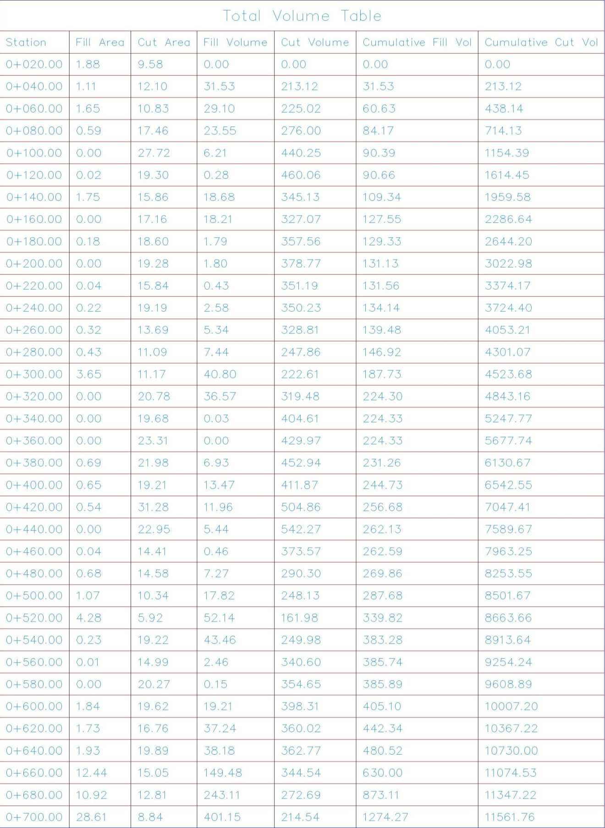
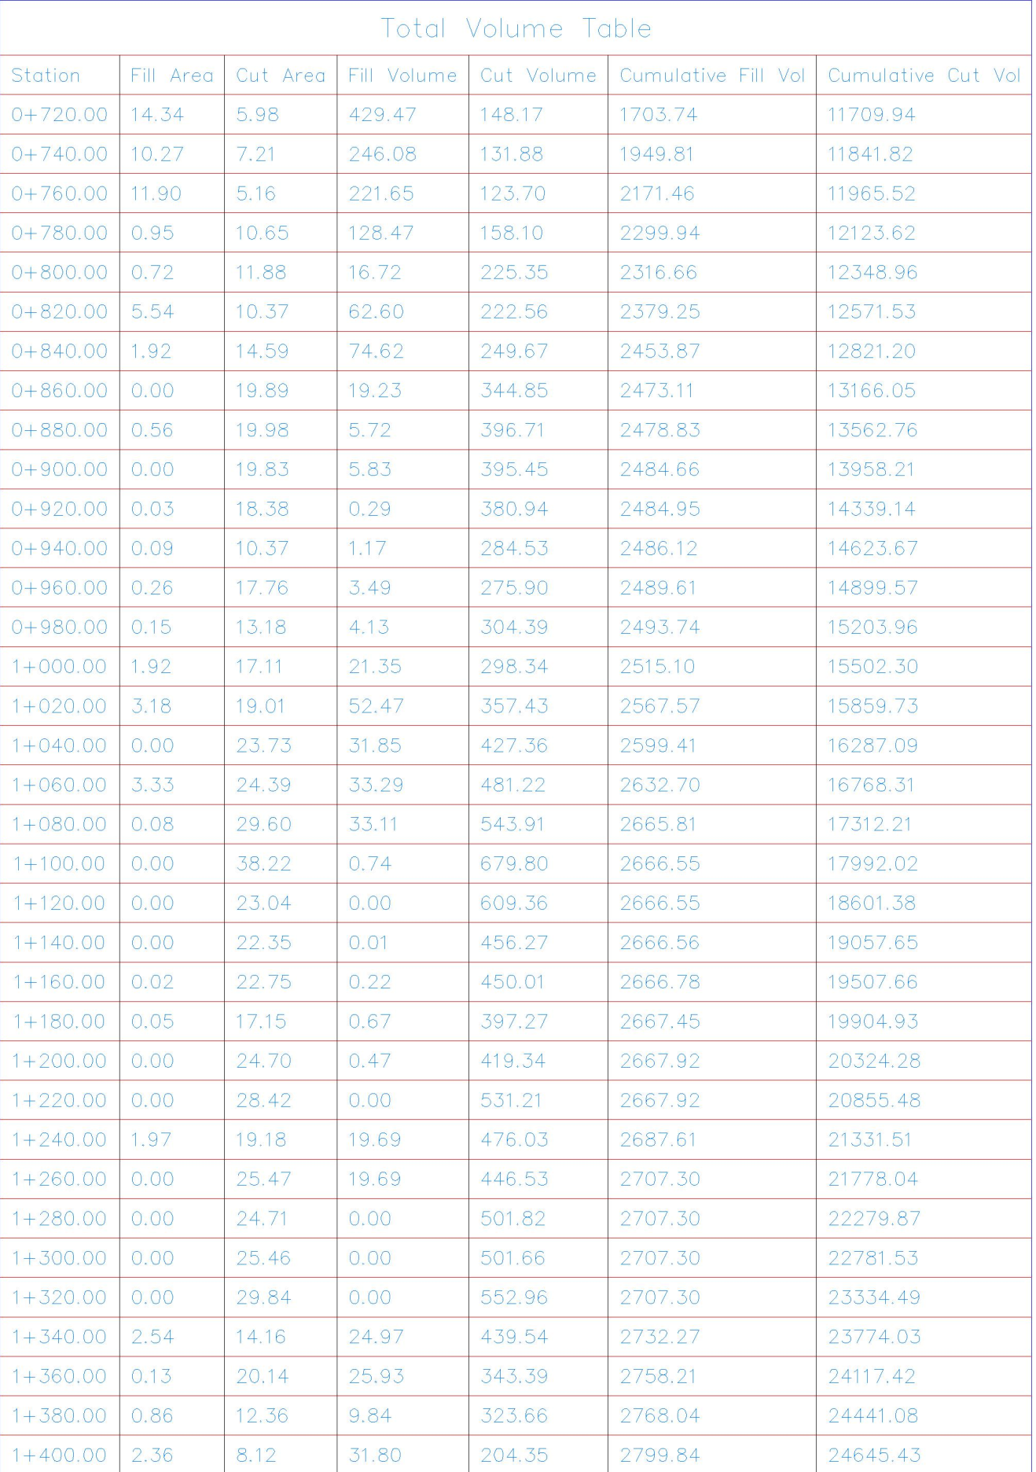
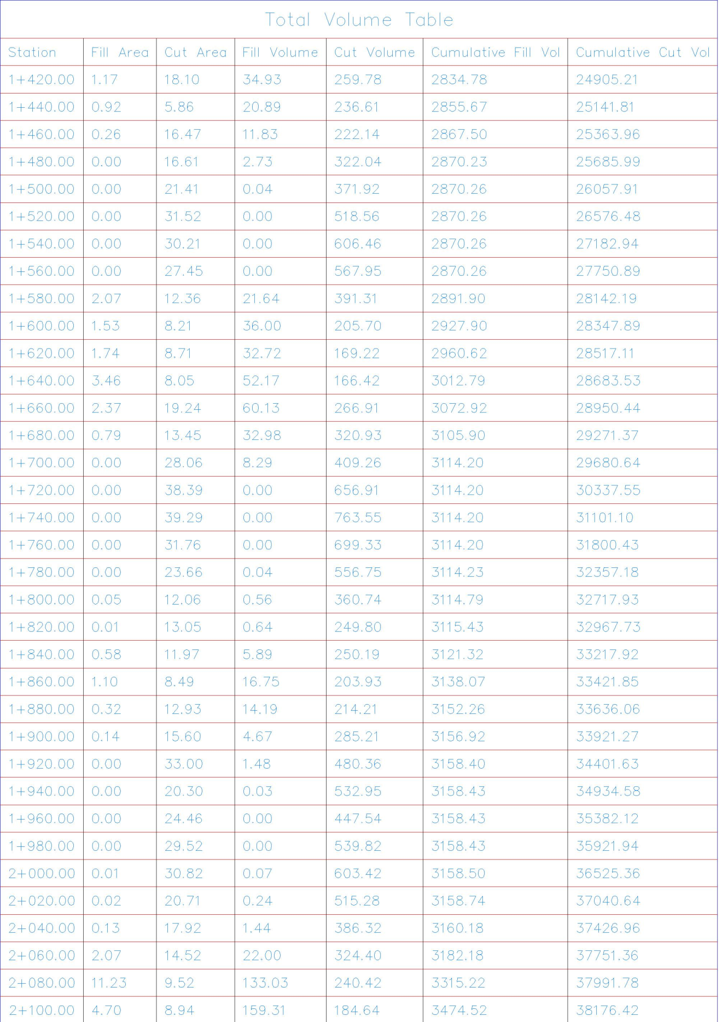
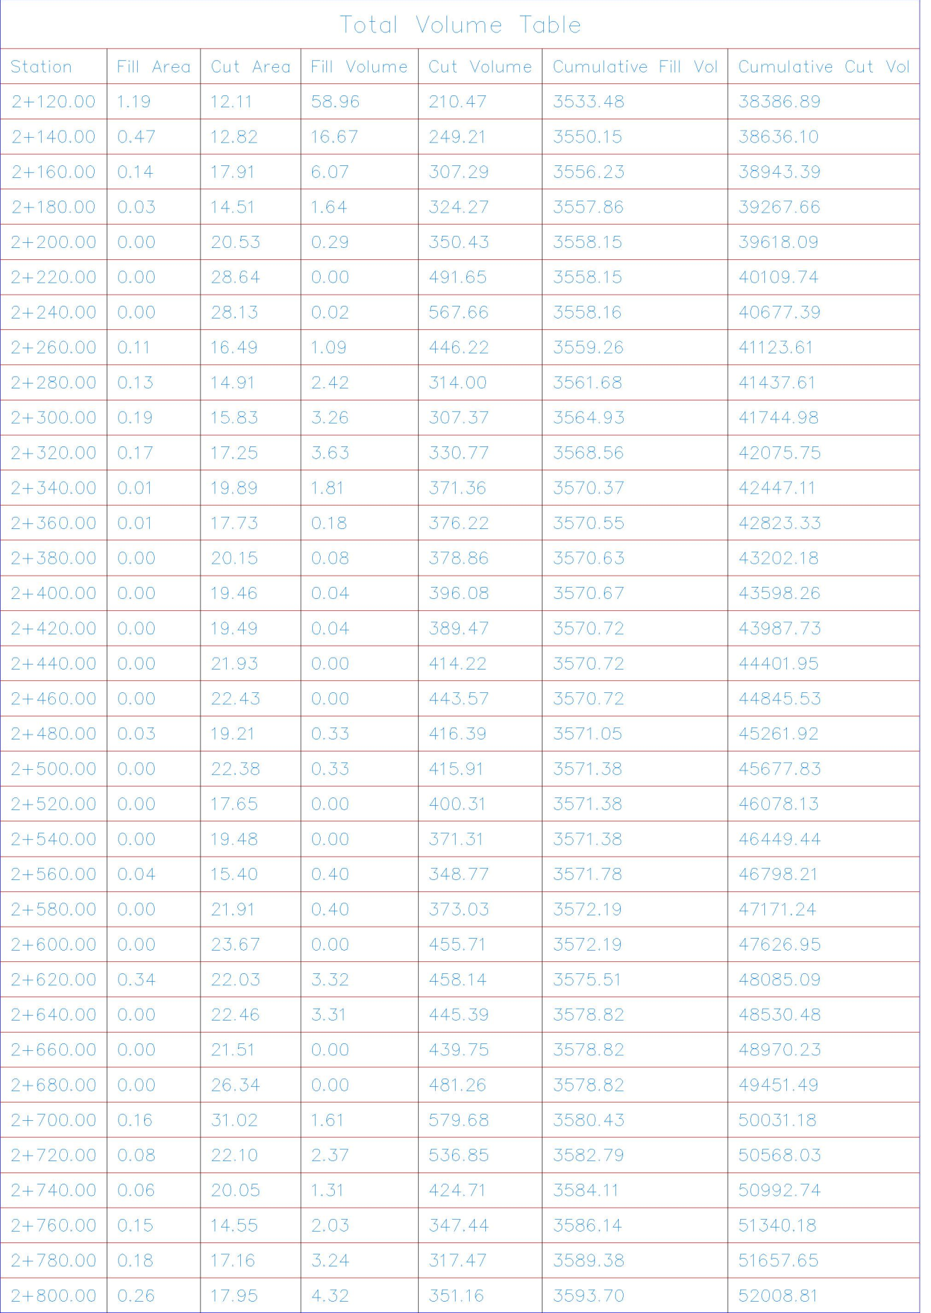

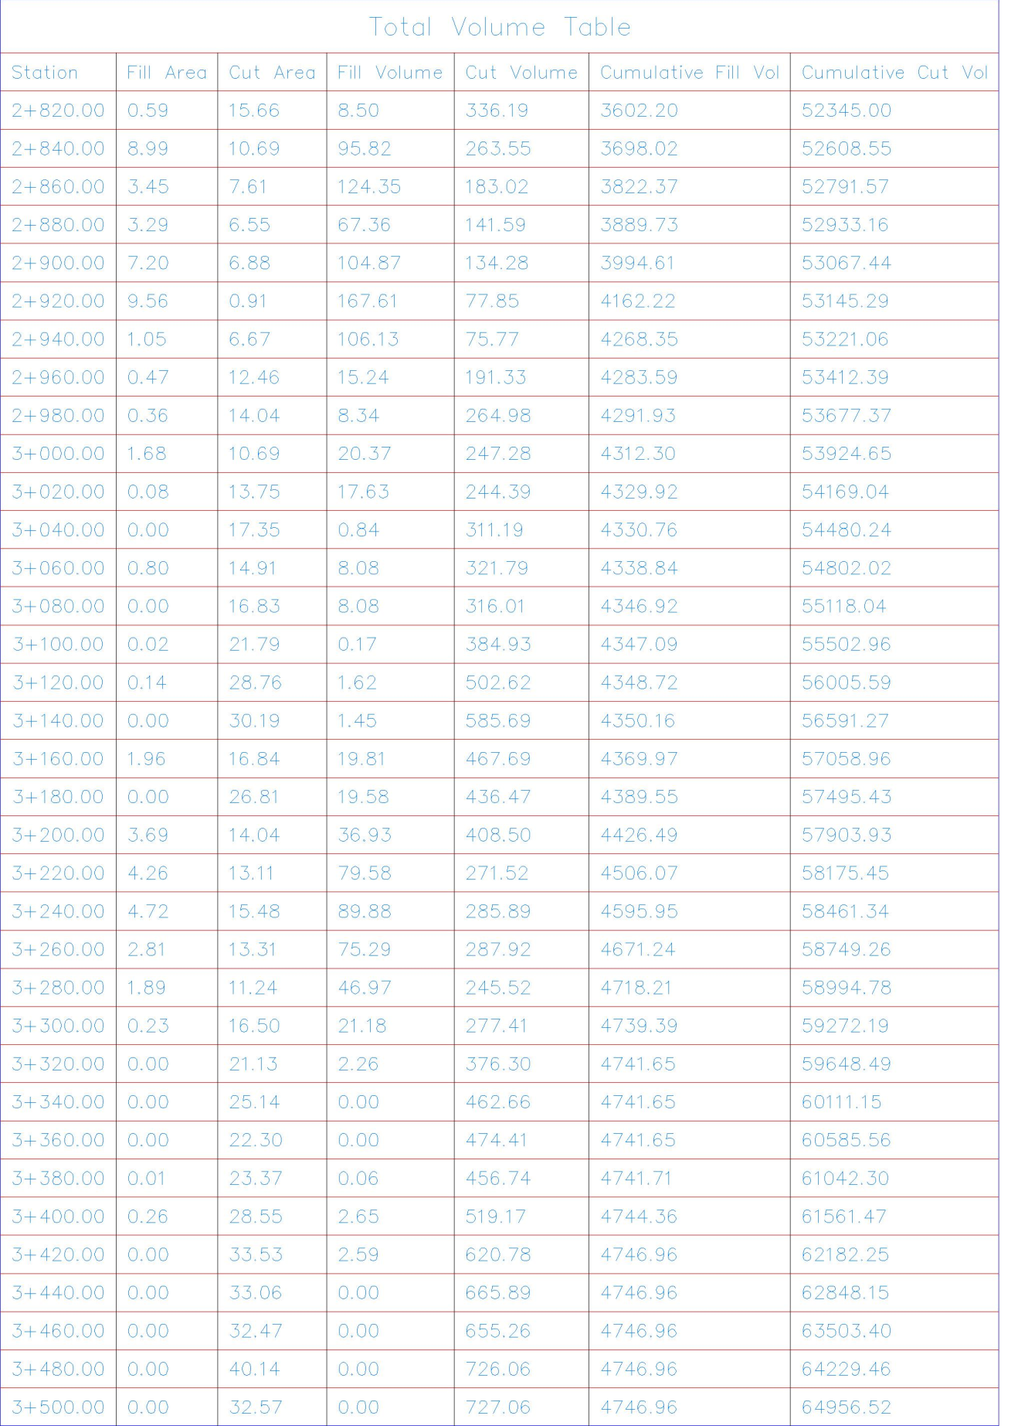

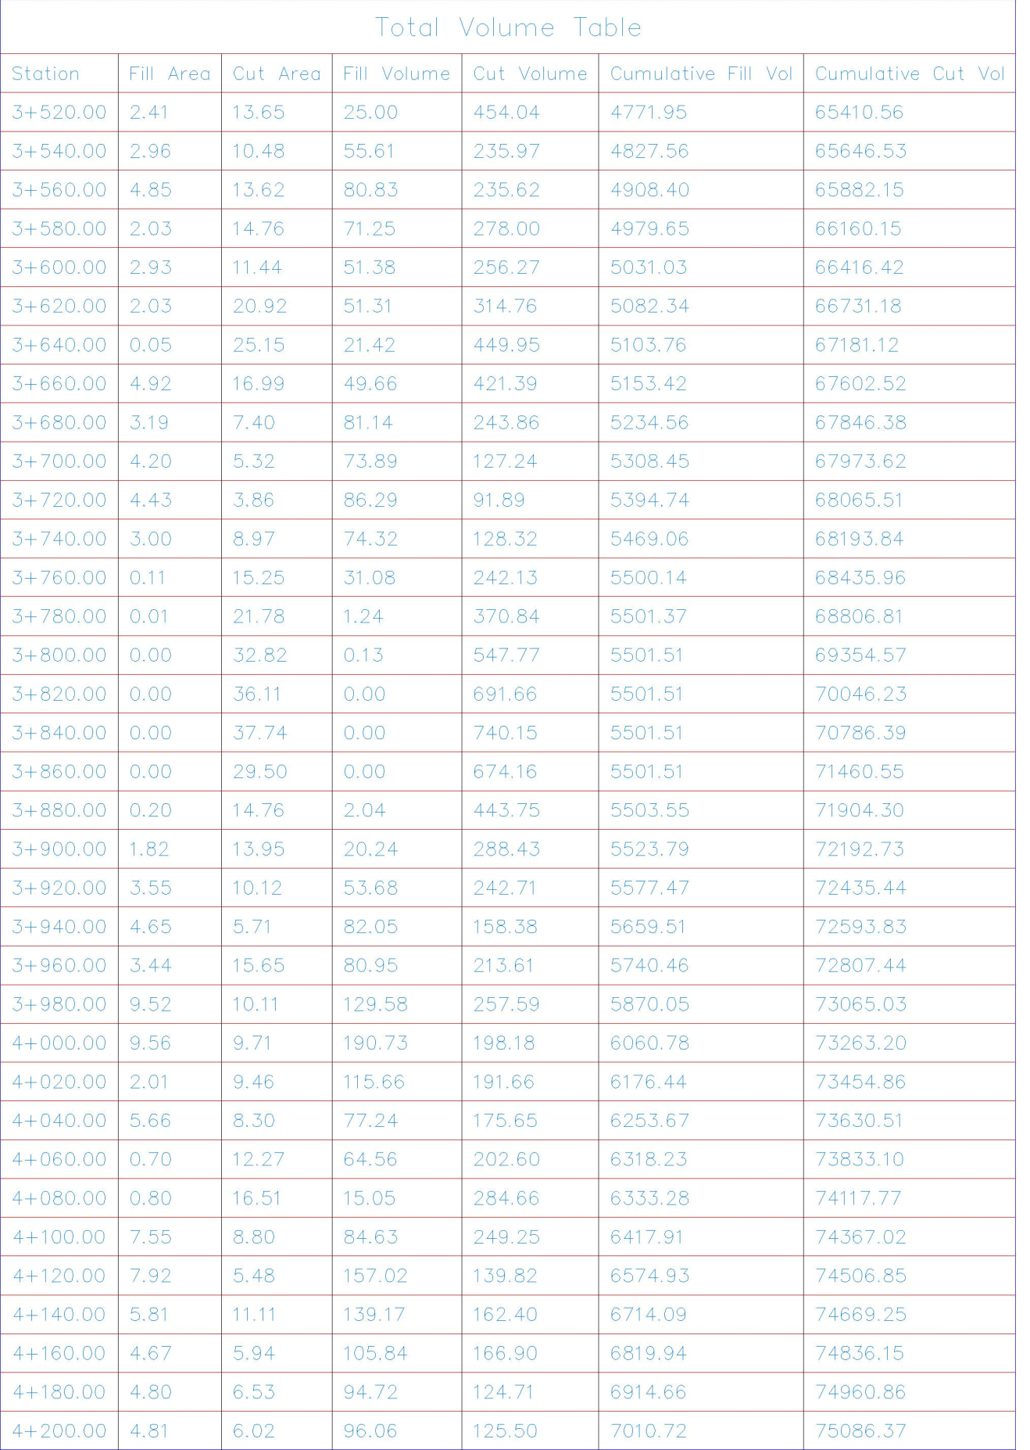

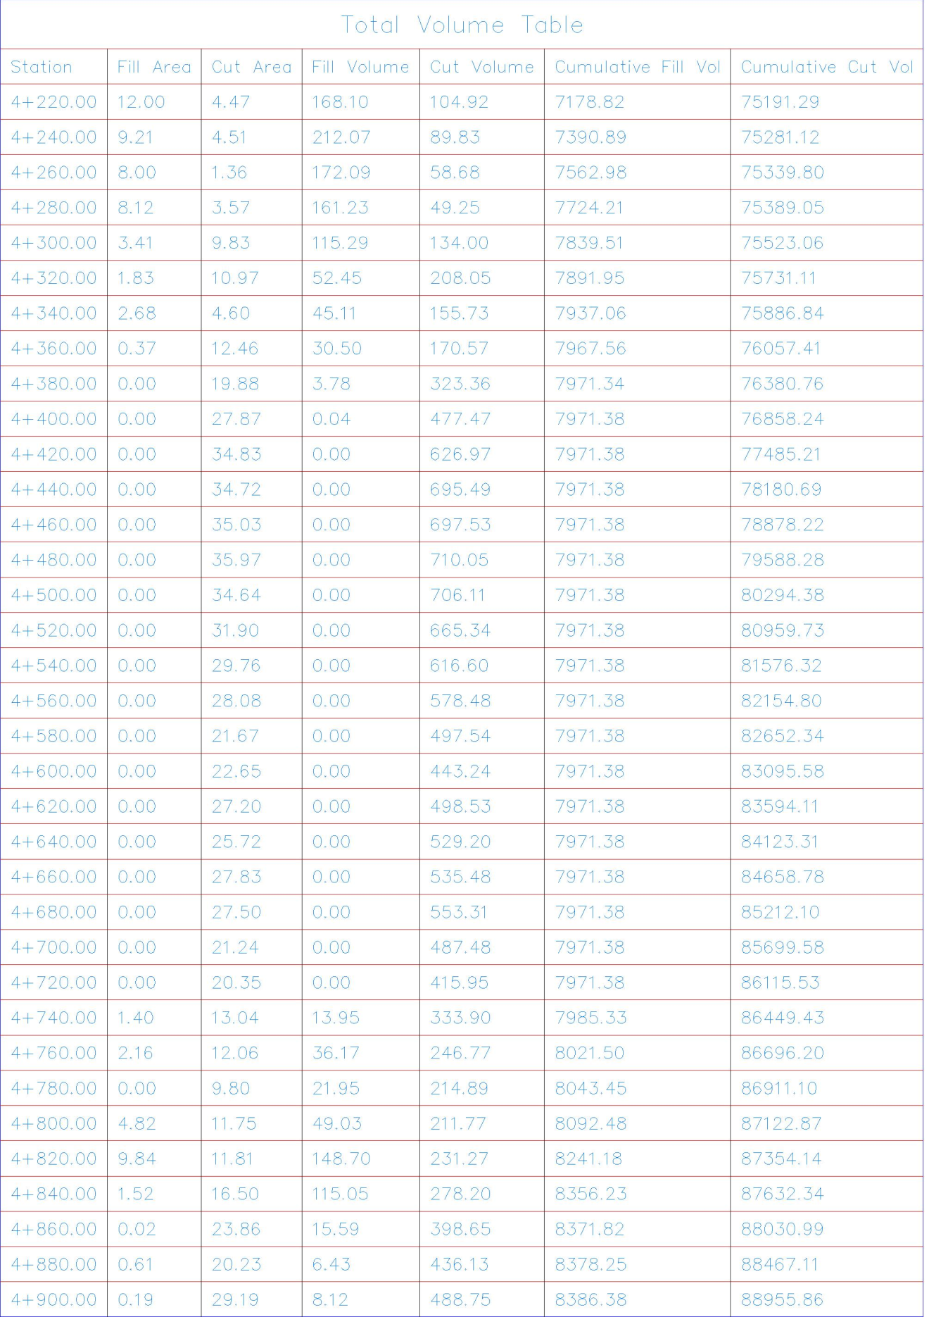
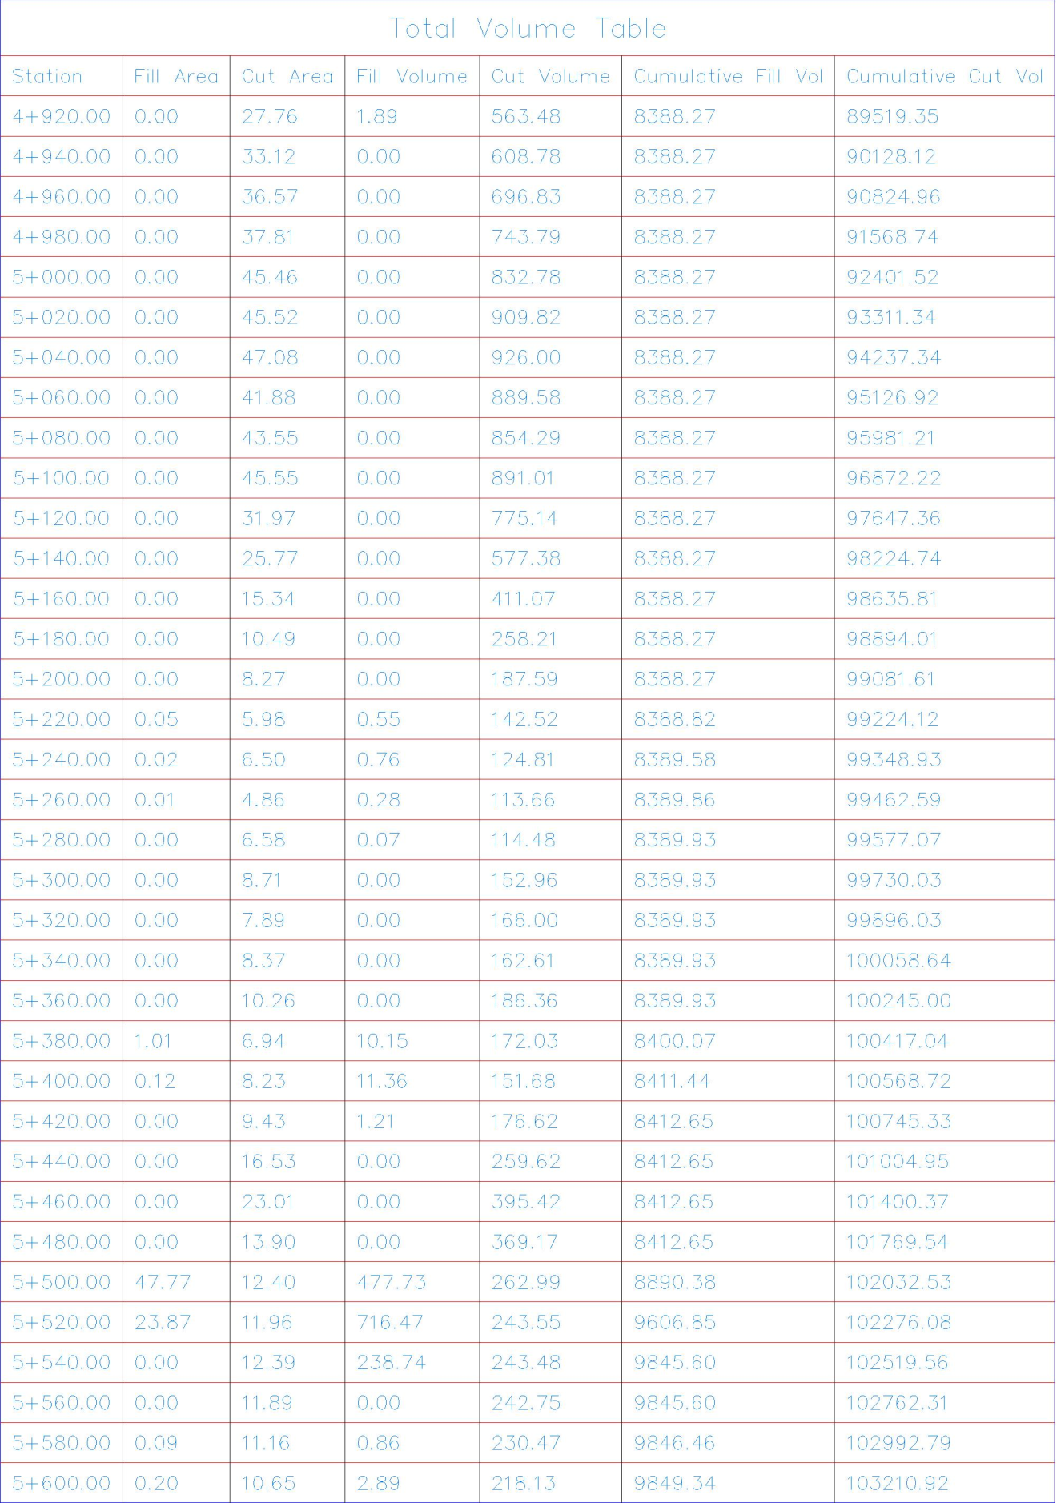
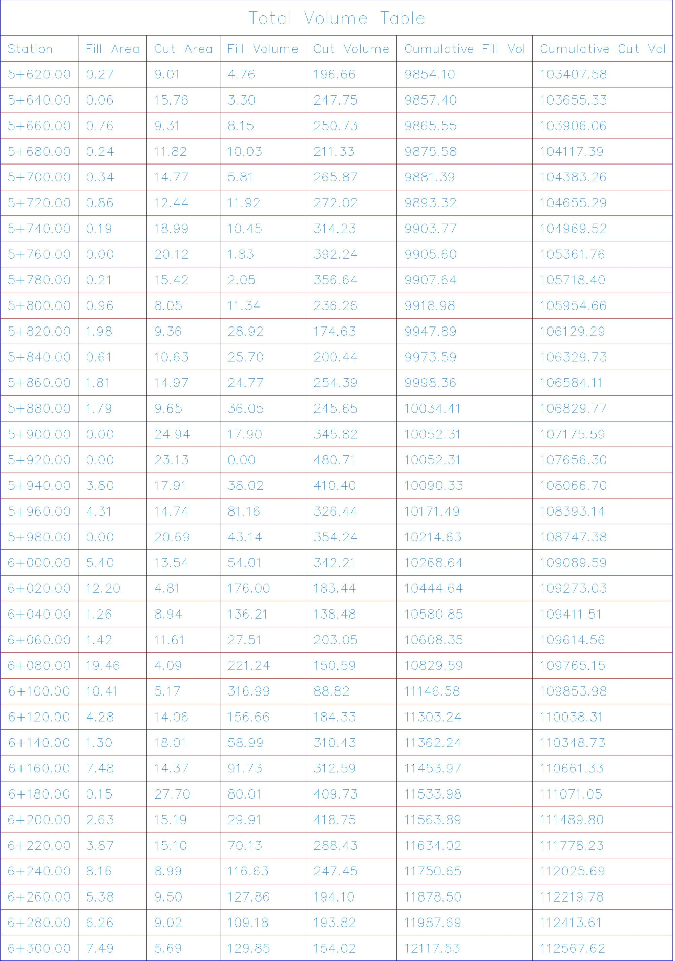
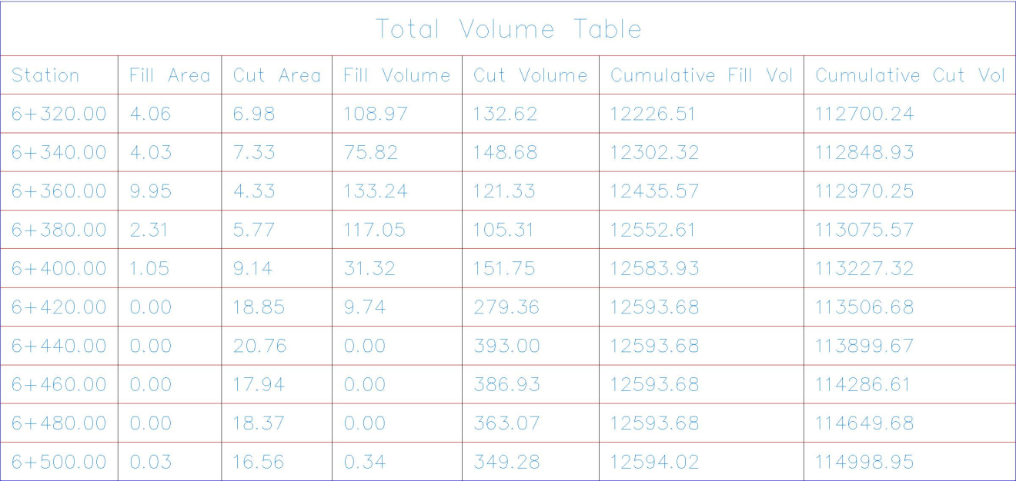

Appendix
(B)
Attached

