An-Najah National University

Faculty of Engineering

Industrial Engineering Department

Project Title:

**Investigating the Implementation of Quality Function Deployment in Cartoon Industry**

**Prepared by:**

Mohammed Tanbour

Moath Sholi

Taha Beshtawi

**Supervised by:**

Eng. Mohammad Sayed

Eng. Tamer Haddad

SUBMITTED IN PARTIAL FULFILLMENT OF THE REQUIREMENT OF THE DEGREE OF BSC. INDUSTRIAL ENGINEERING AT An-NAJAH NATIONAL UNIVERSITY NABLUS, PALESTINE

May, 2010

بسم الله الرحمن الرحيم

قُلْ إِنَّ صَلاَتِي وَنُسُكِي وَمَحْيَايَ وَمَمَاتِي لِلّهِ رَبِّ الْعَالَمِينَ * لاَ شَرِيكَ لَهُ وَبِذَلِكَ أُمِرْتُ وَأَنَاْ أَوَّلُ الْمُسْلِمِينَ

صدق الله العظيم

إهداء

إلى معلم البشرية محمد (عليه الصلاة والسلام)

إلى أرواح شهداء فلسطين

وأسرانا البواسل

إلى..... عوائلنا

إلى من ساعدنا في إنجاح هذا المشروع

أ.م. تامر حداد

أ.م. محمد السيد

إلى الضمائر المخلصة ... الهيئة التدريسية في قسم الهندسة الصناعية

إليكم جميعا نهدي عملنا هذا

Table of Contents

**Abstract** 9

1 Introduction: 10

1.1 Problem Definition: 11

1.2 Project Objectives: 11

1.3 Arrangements of chapters 12

2 The National Carton Industry Company Ltd. 14

3 Quality Function Deployment “QFD”: 17

3.1 History of QFD 17

3.2 QFD Definition: 19

3.3 QFD Importance: 22

3.4 Objectives of QFD: 23

3.5 Inputs and Outputs of QFD: 25

3.6 Success of QFD project: 25

3.6.1 Success of the QFD project: 26

3.6.2 Improvement of product quality: 27

3.6.3 Reduction in costs for R&D: 27

3.6.4 Shorter R&D time: 28

3.6.5 Comprehensive technical support for the QFD project: 28

3.6.6 Strict organization of the QFD project: 29

3.6.7 Motivated employees in the QFD project team: 31

3.7 QFD phases: 32

3.7.1 Product Planning (House of Quality): 32

3.7.2 Product Design: 33

3.7.3 Process Planning: 33

3.7.4 Production Planning (Process Control): 33

3.8 QFD Applications: 34

3.8.1 Transportation and communication: 34

3.8.2 Electronics and electrical utilities: 35

3.8.3 Software systems: 35

3.8.4 Manufacturing: 36

3.8.5 Services: 36

3.8.6 Education and research: 37

3.8.7 Other industries: 37

3.9 Benefits of Using QFD: 38

3.10 QFD in relation with Total Quality Management “TQM”: 39

3.11 Advantages and Disadvantages of QFD: 42

4 HOQ Building and Analysis Steps: 43

**Planning Matrix** 45

This figure (4-2) shows the steps of QFD, step-by-step, and then its details 47

4.1 Need analysis and identification of customer requirements: 48

4.2 Importance of customer requirements. 49

4.3 Identification of design dependent parameters (DDPs). 49

4.4 Correlation of customer requirements and design dependent parameters. 50

4.5 Check correlation matrix. 50

4.6 Benchmarking customer requirements. 51

4.7 Technical assessment of design dependent parameters (DDPs). 51

4.8 QFD matrix inconsistency analysis. 52

4.9 Definition of design dependent parameter target values. 52

4.10 Delineation of design dependent parameter relative importance. 52

5 Field Work: 53

5.1 Working Methodology: 53

6 Results and Data Collection: 55

6.1 Customers Segmentation and Needs (Voice of Customers/What): 55

6.2 VOC Importance and Prioritizations 56

6.3 Voice of Company / How: 60

6.4 The Relationship Matrix: 61

6.5 The Correlation Matrix: 62

6.6 The Planning Matrix: 65

6.7 The Final Scores of technical points 67

6.8 67

6.9 Technical Evaluation: 68

6.10 Final Model of HOQ 69

7 Recommendations 70

7.1 Technical Recommendations: 70

7.1.1 Use high quality Glue 70

A. Due to dispersion agents, extra coverage over others 71

B. Extremely good bond strength without any bleeding, wrinkling 71

C. Due to proper stabilizers used, more shelf life 71

D. Water is the thinner as well as cleaner for roller and appliances used 71

E. Non toxic and non-inflammable 71

F. Quick dry in a few seconds almost 71

7.1.2 Renewal the cutting and marking knifes continuously 72

7.1.3 Coordination with procurement dept. 72

7.1.4 Set a weekly Production schedule 72

7.2 Manegarial recommendations 73

8 APPENDICES 74

8.1 Factory Checklist 74

8.2 General Questioner 75

8.3 Survey 76

**Factory’s name: ………………………………….** 76

8.4 Production Line description 77

9 References 78

**List of tables:**

Table ‎1: Correlation between customer requirements and parameters. 50

Table ‎2: Voice of Customer 56

Table ‎3: Results for the customer requirements 57

Table 4: Voice of Company …..60

**List of Figures**

Figure ‎2‑1: Carton rolls production line 15

Figure ‎3‑1: QFD Outcome 20

Figure ‎3‑2: Success of QFD project 26

Figure ‎3‑3: Phases of QFD 32

Figure ‎3‑4: Deming Quality Chain 41

Figure ‎4‑1: HOQ Components 46

Figure ‎4‑2: The Quality Function Deployment (QFD) process. 47

Figure ‎6‑3: Comparisons Curves 58

Figure ‎6‑4: comparisons and prioritizations data 59

Figure ‎6‑6: The Relationship Matrix 61

Figure ‎6‑7: The Correlation Matrix 63

Figure ‎6‑8: Benchmarking & Planning Matrix 66

Figure ‎6‑9: Technical Actions Priorities: 67

Figure ‎6‑10: engineering opinions about the technical objectives 68

**Abstract**

The aim of this project is to build a structured approach to product development through the House of Quality (HOQ) with application to carton products in the National Cartoon Industry Company Ltd. (NCI). The project procedure and Quality Function Deployment (QFD) implementation process was started by identifying customer’s requirements and expectations from NCI cartoon products and their importance. Various relationships between these expectations and the corresponding technical requirements to satisfy them were determined in addition to the correlation between technical requirements themselves. To recognize the real differences between NCI products and the Israeli competitor’s products, a planning matrix was designed. This matrix shows in what aspects the NCI products quality is exceeded by the Israeli products in addition to the proposed level of customer’s satisfaction NCI hypothesize to reach. Depending on the importance and relationships between customer’s needs and technical specifications and between technical specifications themselves, the whole HOQ matrix was build. The output of this matrix is a set of scores suggesting the most important technical that should be controlled in order to satisfy the customer’s requirements. After performing HOQ matrix quantitative analysis, it is clear that the quality of glue used and the cutting blades renewal are the most important technical specification that should be controlled and monitored to ensure cartoon products quality toward continuous quality improvements as a part of TQM.

# Introduction:

Improving the quality of an organization’s products and services is fundamental to business success. Managers on world-class companies realize that customer wants and desires changing, that customers’ expectations must be clearly understood, and that their firm must conform to customer wishes.

Quality Function Deployment (QFD) is a very is useful tool for translating customer voice into product development in quality engineering. The primary function of QFD have been expanded from product development, quality management, to wider fields such as product design and costing, especially, decision-making, included performance measurement, evaluating company’s current status. In fact, QFD is a methodology for measuring and analyzing evaluation indicators by their relationship matrix.

In this Project, we have aimed to apply QFD in Al-Wataniya Carton Factory which is one of few cartoon factories here in Palestine and has a fine market share between the others in the same industry, although the political issues and enclosures which leads to difficulties in maintaining a stable level of performance. For example, it is difficult to import some types of raw materials and maintenance equipments which will negatively affect the quality of products.

QFD was used as a nontraditional tool or method to recognize customers’ requirements of customer and a set of powerful product development tools that to transfer the concepts of quality control from the manufacturing process into the new product development process. The main features of QFD are a focus on meeting market needs by using actual customer statements (referred to as the "Voice of the Customer"), its effective application of multidisciplinary teamwork and the use of a comprehensive matrix (called the "House of Quality") for documenting information, perceptions and decisions.

## Problem Definition:

QFD implementation can be achieved in both service and manufacturing organizations effectively to achieve its main goal in improving products quality level.

This project is mainly focus on creating a scientific comparison between Al-Wataniya Cartoon Factory (which is considered as a manufacturing organization) and the Israeli competitor in terms of products quality which is based on building the house of quality (HOQ) matrix to highlight the main strength and weakness points at the national factory in addition to showing up the available aspects of improvement opportunities that should be taken into consideration by the firm’s top management.

## Project Objectives:

Although this project is mainly considering investigating the implementation of QFD in a local firm in Palestine which is Al-Wataniya Carton Industry, it has other important objectives that summarized as follows:

1. Developing the ability to work in one group as a team work.
2. Identifying the products’ quality elements from customers’ point view.
3. Obtaining a quantitative assessment about the firm ability to meet required quality elements in comparison with competitors.
4. Identifying the potential improvements opportunities and their effects in meeting customers’ expectations.
5. Performing quantitative analyses to show how customers’ quality requirements can be achieved through performing suggested improvements activities.
6. Specifying data based improvement suggestions for increasing quality level from customers’’ point views.
7. Discussing the role of QFD in achieving TQM targets toward business excellence.

## Arrangements of chapters

Chapter 1, which has ''Introduction'' title, reviews a brief introduction about the role of Quality Function Deployment (QFD) and its general objectives and benefits, problem definition, and project objectives.

Chapter 2 gives detailed information about the national cartoon industry company (NCI) which represents the case study in which this project was implemented, considering their work flow, production lines and produced cartoon products.

Chapter 3 represents the literature review of QFD, its definitions, concepts, benefits, applications and its link with Total Quality Control (TQM). It also shows the meaning of the House of Quality and how to build it.

Chapter 4 discusses the sequence of steps followed in order to build a practical HOQ matrix and how to analyze the relationships between customer’s requirements and the technical aspects to ensure them.

Chapter 5 clarifies the working methodology followed in this project to implement QFD successfully, in addition to the analysis of results and data collected in details and step by step.

Chapter 6 shows the results of the project with its details and sample of calculations

Finally, Chapter 7 which is entitled ''Conclusions and recommendations'' summarizes the project outputs, what was concluded from this work, and suggests some recommendations for future work.

# The National Carton Industry Company Ltd.

NCI was founded in 1989 as a private company with a starting capital of 600,000 JD. In 1993, the company raised new capital after becoming a public shareholding company, which positively impacted the performance and growth of the company, and its current capital is over five million JDs.

NCI has two main production lines. The first is the production of corrugated cardboard in DD, CF, BF, and EF types in addition to special paper roles for packaging furniture products. The second line of production is the transformation of these boards into their desired shapes and colors.

NCI endeavors to meet the needs of a variety of sectors such as food and pharmaceuticals. As recently as January 2009, NCI added a new production line of the ‘Flatbed Die-cutter’ type open-cardboard boxes to fulfill the needs of a growing agricultural sector. The high-tech quality of the device, which produces over 7-10 million units a year, insures the high quality of the cardboard which is especially treated to package fruits and vegetables.

With its new production line, NCI has now grown to make up more than 20% of the Palestinian market. NCI is looking forward to increase its stake to more than 50% in 2010 with a view to expand on a regional and then global scale.

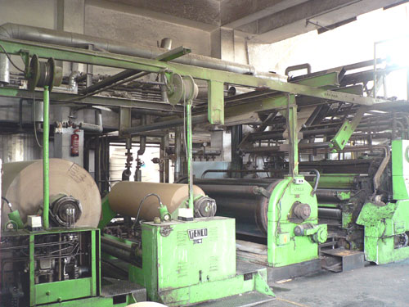

Figure ‎2‑1: Carton rolls production line

NCI’s produce has improved significantly, especially after establishing a Research and Development department which is striving to attain the Palestinian standards institution certificate and the ISO9001 in the first half of 2009.

NCI currently serves over 300 businesses in a wide array of sectors; industrial, sanitary, food and many others.

There are 44 employees in the factory, 15 Administrative Officers, 7 Technicians and 3 Engineers, Two of them are Industrial Engineers and the last one is Elec. Engineer.

This factory runs over than 100 customer needs from carton and most of them is the head in it's industry such like Anabtawi group , Al Junaidy, coca kola and marawi factory for fruit drinks, so it’s very important and vital for the factory to keep up with customer needs and specification in order to maintain a good position and relation with customer and so to stay in the market, recently and as a result of decreasing quality in the factory some of consumers became more tending to have orders for an Israeli suppliers which means hard competition environment , the Israeli's supplier can easily fill the whole local market with high quality products and from this point it takes serious dimension about thinking really what does our customer wants from us and found it with the competitor.

There are many local competitors with little market share, but the biggest competitor of the plant is the Israeli factories, which enjoy freedom of import and export, with the support of the occupation government, all of this in addition to some administrative and strategy problems in the top management of the factory make the quality of Israeli products is much better than the quality of local product , hence it was necessary to make a study about the most important technical problems which face local product, through the study that may contribute to raising the quality of local products and solving a part of the problem .

# Quality Function Deployment “QFD”:

## History of QFD

QFD was developed in Japan in the late 1960s by Professors Shigeru Mizuno and Yoji Akao. At the time, statistical quality control, which was introduced after World War II, had taken roots in the Japanese manufacturing industry, and the quality activities were being integrated with the teachings of such notable scholars as Dr. Juran, Dr. Kaoru Ishikawa, and Dr. Feigenbaum that emphasized the importance of making quality control a part of business management, which eventually became known as TQC and TQM.

The purpose of Professors Mizuno and Akao was to develop a quality assurance method that would design customer satisfaction into a product before it was manufactured. Prior quality control methods were primarily aimed at fixing a problem during or after manufacturing.

The first large scale application was presented in 1966 by Kiyotaka Oshiumi of Bridgestone Tire in Japan, which used a process assurance items fishbone diagram to identify each customer requirement (effect) and to identify the design substitute quality characteristics and process factors (causes) needed to control and measure it.

At the same time, Katsuyoshi Ishihara introduced the Value Engineering principles used to describe how a product and its components work. He expanded this to describe business functions necessary to assure quality of the design process itself.

Merged with these new ideas, QFD eventually became the comprehensive quality design system for both product and business process.

Japan has continued to push the envelope of QFD applications through an on-going QFD Research Sub-Committee at the [Union of Japanese Scientists and Engineers (JUSE)](http://www.juse.or.jp) and their annual QFD Symposium established in 1993. They hosted the first International Symposium on QFD and are a charter member of the International Council for QFD.

The introduction of QFD to America and Europe began in 1983 when the American Society for Quality Control published Akao's work in Quality Progress and Cambridge Research invited Akao to give a QFD seminar in Chicago.

[The Customer-Driven Approach to Quality Planning and Deployment](http://www.qfdi.org/books/published_books.htm#customerdrivenapproachtoqualityplanning) and [QFD: Integrating Customer Requirements into Product Design](http://www.qfdi.org/books/published_books.htm#integratingcustomerrequirementstoproductdesign), QFD caught on across a wide variety of industries in the U.S. and Western Europe. In the U.S., in particular, because of its flexibility and comprehensiveness, the methodology was eagerly embraced by the businesses that were facing the Japanese competition. There, new and innovative applications of QFD were experimented by industries and businesses that were not reached before.

Today, QFD continues to inspire strong interest around the world, generating ever new applications, practitioners and researchers each year. Countries that have held national and international QFD Symposium to this day include the U.S., Japan, Sweden, Germany, Australia, Brazil, and Turkey.

## QFD Definition:

The name “Quality Function Deployment” gives little hint as to what the tool actually is or what purpose it serves. So why is its name so perplexing? The answer lies in two main issues:

1. “Quality Function Deployment” was originally created by two Japanese professors back in the 1960’s. Thus, the process was originally given a Japanese name, which was later translated into English. The original Japanese name, “Hin-shitsu Ki-no Ten-kai”, was translated quite literally into the name “Quality Function Deployment”. Although the name supposedly carries with it a more intuitive meaning in Japanese, it doesn’t seem to have the same readily apparent meaning in English.
2. The term “QFD” is used by many people today to refer to a series of “House of Quality” matrices strung together to define customer requirements and translate them into specific product features to meet those needs. However, these prioritization matrices were only a small part of the system that Drs. Akao and Mizuno originally created. (See “[What is the House of Quality? Why it isn’t a QFD?](http://www.qfdi.org/what_is_qfd/faqs_about_qfd.htm#What%20is%20the%20House%20of%20Quality%20Why%20it%20isnt%20a%20QFD)” at qfdi.org for more information on this topic.) Thus, the application of the term “QFD” has changed over the course of the past 30+ years as well. Even though much was lost in translation from its Japanese name, “Quality Function Deployment” was a much more apropos name for the system of processes originally created by Akao and Mizumo than it is for the derivative tool that it has come to refer to today.



Figure ‎3‑1: QFD Outcome

Quality Function Deployment (QFD) was developed to bring this personal interface to modern manufacturing and business. In today's industrial society, where the growing distance between producers and users is a concern, QFD links the needs of the customer (end user) with design, development, engineering, manufacturing, and service functions. Aligning the entire company toward achieving a common goal.

As a quality system that implements elements of Systems Thinking with elements of Psychology and Epistemology (knowledge), QFD provides a system of comprehensive development process for:

* Understanding 'true' customer needs from the customer's perspective.
* What 'value' means to the customer, from the customer's perspective.
* Understanding how customers or end users become interested, choose, and are satisfied.
* Analyzing how do we know the needs of the customer.
* Deciding what features to include.
* Determining what level of performance to deliver.
* Intelligently linking the needs of the customer with design, development, engineering, manufacturing, and service functions.
* Intelligently linking Design for Six Sigma (DFSS) with the front end Voice of Customer analysis and the entire design system.

It does so by seeking both spoken and unspoken needs, identifying positive quality and business opportunities, and translating these into actions and designs by using transparent analytic and prioritization methods, empowering organizations to exceed normal expectations and provide a level of unanticipated excitement that generates value.

The QFD methodology can be used for both tangible products and non-tangible services, including manufactured goods, service industry, software products, IT projects, business process development, government, healthcare, environmental initiatives, and many other applications.

QFD can be described as an approach to product quality design, which attempts to translate the voice of the customer into the language of the engineer and subsequently into design characteristics. The design features are transformed into part features during a parts development process. In the work preparation phase crucial operating procedures are defined on the basis of the specified part features. The crucial operating procedures in turn serve to determine the production requirements in great detail. The core principle of this concept is a systematic transformation of customer requirements and expectations into measurable product and process parameters.

It adherents of this concept claim that managers can implement QFD in any organization – manufacturing, service, nonprofit or government – and that it generates improved products and services, reduced costs, more satisfied customers and employees, and improved bottom line financial performance. The latter claim is controversial. Although many adherents openly praise QFD, others have identified significant costs and implementation obstacles. Critics have suggested, for example, that QFD entails excessive retraining costs, consumes unrealistic employee commitment levels, emphasizes process over results, and fails to address the need of small firms, service firms or nonprofits. Therefore, QFD’s impact on firm performance remains unclear and under-examined, and the existing empirical studies of QFD performance – intended to help managers implement QFD more effectively – lack rigor and theoretical support.

This paragraph specifically is to address the following four questions: What are the variables which affect QFD? What are the outcomes from using QFD? What relationships exist between QFD variables and outcomes? What guidelines may be offered for managers of QFD?

## QFD Importance:

It is very powerful as it incorporates the voice of the customer in the designs - hence it is likely that the final product will be better designed to satisfy the customer's needs. Moreover, it provides an insight into the whole design and manufacturing operation (from concept to manufacture) and it can dramatically improve the efficiency as production problems are resolved early in the design phase. QFD is applied in the early stages of the design phase so that the customer wants are incorporated into the final product. Furthermore it can be used as a planning tool as it identifies the most important areas in which the effort should focus in relation to our technical capabilities.

Ask yourself these questions:

1. Why do QFD in this case?
2. What will the QFD be made of?
3. Is it the right tool at this time?
4. Is this the right place for implementation?
5. What is the goal and what is success?
6. Who all should we involve?

## Objectives of QFD:

In general, QFD as a quality improvement tool has many objectives that are summarized in the following points:

* + To define product characteristics that meet effective customer requirements.
  + To assign, on specially structured forms, all the information deemed necessary for the development of a new product or service.
  + To effect a comparative analysis of our product performances against those of competitors.
  + To guarantee coherence between manifest customer needs and measurable product characteristics without neglecting any point of view.
  + To ensure that all those in charge of each process step are constantly kept informed about the relationship between the output quality of that step and the quality of the final product.
  + To reduce the necessity of applying modifications and corrections during advanced stages of development, because, right from the start, everyone is conscious of all the factors that can influence project evolution.
  + To minimize time allotted to customer interaction.
  + To guarantee full coherence between product planning and planning of the relative production processes (by facilitating the integration between the various product functions and by emphasizing interactions and mutual conditionings).
  + To increase the capability of a company to react. So that any errors that could stem from a faulty interpretation of priorities and objectives are kept to minimum.
  + To have self-explanatory documentation on the project as it evolves.
  + To agree on specific reference documents, useful for the customer as well as for those involved in drawing them up, which limit to a minimum the formulation of ideas and requests that cannot be coded and, most importantly, may not find general consensus.

## Inputs and Outputs of QFD:

Each QFD project should have inputs and expected outputs whatever the case study is (manufacturing or service) as inputs are as follows:

* + Customer requirements.
  + Technical requirements.
  + Customer priorities.
  + Market reality/competitive analysis.
  + Organization’s strength and weaknesses.

Where outputs are:

* + Prioritized technical requirements.
  + Measurable, testable goals.

## Success of QFD project:

To have successes in any QFD project, many other interrelated success factors should be achieved to have an overall QFD project success. The following figure () shows these success factors and their relationships among each others.



Figure ‎3‑2: Success of QFD project

### Success of the QFD project:

* + **Proof of the success of the project:** the project under consideration has been proved to be successful: when repeated, it does not require any fundamental improvement.
  + **Investments and expenditure have been worthwhile:** Investment and expenditure for the QFD project in terms of finance and personnel have paid off.
  + **Increase in profit and/or profitability:** Profit and/or return on capital has improved because of the QFD project.

### Improvement of product quality:

* + **Increase in customer satisfaction:** the introduction of the QFD concept has resulted in a sustained improvement in customer satisfaction.
  + **Improvement in product quality:** Numerous difficulties in the quality of goods and services have been resolved on a long-term basis.
  + **Reduction in the frequency of complaints:** The number of negative comments and complaints about the company’s performance has been reduced as a result of the QFD approach.
  + **Increase in customer loyalty:** It has been possible to ascertain an increase in customer loyalty since the QFD concept was introduced.
  + **Reduction in expenditure for reworking:** Since the QFD approach was introduced, there has been a reduction in expenditure for reworking arising as a result of quality defects.

### Reduction in costs for R&D:

* + **Financial requirement of other projects:** By introducing the QFD concept, more financial resources are available for other projects.
  + **Reduction in costs for research and development project:** The costs for research and development were reduced considerably by applying the QFD concept.
  + **Reduction in need for consultants:** The QFD approach contributed to a sustained reduction in the need for external or in-company consultants as part of research and development projects.
  + **Better project coordination:** The outlay for planning, coordinating, implementing and controlling research and development activities could be reduced considerably.

### Shorter R&D time:

* + **Time saving:** A reduction in the time to market has been achieved through systematic implementation of the QFD approach.
  + **More time for other projects:** Since the company has implemented the QFD project, more time has been available for other projects than was the case before the QFD concept was introduced.
  + **Better coordination of projects:** The QFD approach makes it easier to coordinate research and development activities.
  + **More time for conceptual work:** The QFD concept makes an important contribution to ensuring that more time is available for conceptual work.

### Comprehensive technical support for the QFD project:

* + **Measurement of what the customer wants:** What an individual wants and desires is the starting point of product design. In this respect, it is absolutely essential to make a comprehensive survey of consumer needs.
  + **Recording the activities of competitors:** The activities of competitors determine the success of a new product on the market. Consequently, systematic collection of information about competitors and their activities in respect of marketing policy is required.
  + **Identification of the actual weighting factors:** Part of the specification of the House of Quality requires the interdisciplinary team to make a large number of decisions in respect of various weighting factors. If product development is to be successful, it is absolutely essential for the determination of such coefficients to be as close to reality as possible.
  + **Mastering the complexity of House of Quality:** Even a small number of perceived product attributes and physical- chemical-technical quality characteristics result in a very complex House of Quality. Therefore, before this method is applied, it must be ensured that the members of staff involved have mastered its complexity.
  + **Knowledge of QFD techniques:** Both Akao and King give a stern warning against using the QFD method without specific experience and particular knowledge. The danger is too great that the team members may use this instrument like a cook book and come to incorrect conclusions.

### Strict organization of the QFD project:

* + **Intensity of interaction with the management:** The progress of the project is facilitated by close contact between the members of the project team and the responsible line managers. This includes regular meetings at which the project manager passes on information on the status of the project to those who actually carry out the work within the company.
  + **Support from top management:** When a QFD project is introduced, it must be supported by top management. Only if this is the case can one be sure that the recommended action identified as a result of the project will be systematically implemented.
  + **Clear structure of the project team:** QFD projects in many companies have shown that the ideal team is only made up of those employees who are absolutely essential. The success of the project is put at risk if there are tortuous and lengthy coordination processes, the lines of responsibilities are unclear and if many entirely different interests have to be taken into account.
  + **Interdisciplinary composition of teams:** When the teams are being established, it is essential that all relevant functions within the company (such as marketing, production and research and development) are represented. Thus it appears that the interests of different functions, which frequently diverge widely, can be taken into account. Innovative nature of the QFD project. Many authors argue that the prospect of a QFD project being brought to a successful conclusion is particularly high if this project refers to already established products. However, if it involves new products, new technologies and new consumers, many problems occur which have a detrimental effecon the QFD project.
  + **Transparency in the project process:** Being absolutely open about the targets, measures and techniques facilitates project progress and increases acceptance of the project among employees and managers. The team leader should therefore at each stage of the project ensure that transparency exists concerning the stages of the work already completed and the forthcoming project phases.
  + **Keeping to the time schedule:** It would appear that keeping to the time schedule is an important prerequisite as a measure of whether the QFD project is brought to a successful conclusion and that the findings of the project are actually implemented. Differentiated network diagrams, which show even slight deviations from the time schedule, are used for this purpose.

### Motivated employees in the QFD project team:

* + **Commitment of team members:** The success of the QFD project is greatly dependent on the commitment of the members of the project team. Parallel to this, they also act as a role model for other employees and line managers who are taking part in the project.
  + **Project experience of those involved:** Project-related experience of the employees and their knowledge of the necessary techniques assist with the smooth running of the project. Here it is also necessary to broaden the specialist knowledge of those involved through targeted training measures.
  + **Availability of project members:** It is of key importance for the implementation of the QFD project that the employees who are assigned to the work are given relief from their normal workload. It appears that only if this procedure is adopted is it possible for those concerned to give their undivided attention to completing the tasks they are assigned as part of the project.
  + **Utilization of authority:** All authority entrusted to the team members needs to be utilized to implement the project. In this way it will be ensured that the findings obtained from the QFD project will also be applied.

## QFD phases:

According to the figure below, Comprehensive QFD may involve four phases:



Figure ‎3‑3: Phases of QFD

### Product Planning (House of Quality):

* + Define and prioritize customer needs.
  + Analyze competitive opportunities.
  + Plan a product to respond to needs and opportunities.
  + Establish critical characteristics target values.

### Product Design:

* + Identify critical parts and assemblies.
  + Flow down critical product characteristics.
  + Translate into critical partlassy characteristics and target values.

### Process Planning:

* + Determine critical processes and process flow.
  + Develop production equipment requirements.
  + Establish critical process parameters.

### Production Planning (Process Control):

* + Determine critical part and process characteristics.
  + Establish process control methods and parameters.
  + Establish inspection and test methods and parameters.

Linking these phases provides a mechanism to deploy the customer voice through to control of process operations. By following these steps:

1. Learn what each element represents.
2. Form a multidisciplinary team. Obtain voice of the customer from market surveys, focus groups, observations, interviews. Identify customer requirements and ask customer to rate importance.
3. The development of the first issue of the charts is the most time consuming part. Conduct competitive analysis by customer requirement Establish a quality plan based on competitive analysis you would like to have for your future product.

Once this is completed regular reviews and updates require minimum time. Remember that the benefits from an appropriately developed QFD chart are very big compared with the effort - put focus on the issues that are important to the customer.

## QFD Applications:

The first two reported applications of QFD were in the shipbuilding and electronics industries. QFD’s early applications focused on such industries as automobiles, electronics, and software. The fast development of QFD has resulted in its applications to many manufacturing industries. Eventually, QFD has also been introduced to the service sector such as government, banking and accounting, health care, education and research. Now it is hardly to find an industry to which QFD has not yet been applied.

### Transportation and communication:

Shipbuilding is one of the two earliest QFD application sectors, and Lyu and Gunasekaran (1993) report another such QFD application. Automobile is an earlier and important industry to which many authors report their QFD applications. QFD applications can also be found in aircraft, airlines, automotive parts, car audio, commercial vehicles, container port, motors, railways, pedestrian crossings, satellite, telecommunications, transportation, transportation equipment, and voice mail systems.

### Electronics and electrical utilities:

Akao applies QFD to electrostatic copying machines and thus makes electronics another earliest QFD application sector. QFD has been applied to such electronics-related companies as AT&T, DEC, Hewlett-Packard, IBM, Intel, Motorola, and Philips, and to electronics-related products/parts such as automated teller machines, blend door actuators , chip, climatic control systems, computers, hard disk drives, integrated circuit, robotic work cell, and sensor, QFD has also been applied to electrical utilities such as battery, Florida Power and Light, gas burners, Pacific Gas and Electric, power systems, and wind turbines.

### Software systems:

Another early popular sector of QFD applications is software systems. Especially, there are many reported QFD applications in software, such as Anonymous, Basili and Musa, Brown, Chang…Other related QFD application areas include decision support systems, expert systems, human machine interface, information systems, integrated systems, management information systems, profiling systems, and Web pages.

### Manufacturing:

Manufacturing is also an earlier area of QFD applications, which can be found, e.g., in the earlier papers of Sullivan and Swackhamer. Along with its fast development, there have been more and more QFD applications in manufacturing.QFD has also been applied to diversified manufacturing areas, such as assembly lines/plants/stations bearing, braking systems, capital goods, chocolate, composite material, computer-integrated manufacturing, cork removers, engine filters, equipment, food, furniture, helmet-mounted displays, hybrid bicycles, instrumentation (Rice, 1989), meat, medical devices, metals, metrology probes, pencils, plastic components, power protection equipment, printing, pultruders, quick release top nozzles, safety shoes, tea, and tractors.

### Services:

QFD is a customer-oriented quality management and product development technique originally used for hard products, but its ideas are by no means inapplicable to soft services. Indeed, it was gradually introduced into the service sector to design and develop quality services.The wide acceptability of the QFD technique can be shown from its reported applications in various service areas such as accounting, administration, banking, etc.

### Education and research:

Among the broad service areas, academic organization is a special one that has witnessed a number of QFD applications to conduct quality education and research based on QFD’s customer driven planning principles. In the educational area, QFD’s applications include colleges/universities, distance education, educational institutes, kindergartens, public schools, training, vocational secondary schools and, interestingly, business schools. QFD has also been applied to R&D and research program design.

### Other industries:

QFD’s principles set no prerequisites about the types of the products/services and the producing/ serving organizations. Indeed, the applications of QFD are industry free and, beyond the above six general industries, QFD has also attracted the attention from many other industries such as aerospace, agriculture, beautiful enterprises, construction, disaster prevention, environment protection, indoor air quality, management culture, military, national security, packaging, peacekeeping forces, police stations, political elections, socio-economic development, technologies, and textile.

## Benefits of Using QFD:

QFD is considered as a tool that enhance the actual Quality to gain to perceived Quality level so it's used to fix, improve, redesign the product or the service in order to catch and maintain customer satisfaction toward the company, so it's very vital to utilize this the effects of QFD in the life Cycle of the product, benefits of using QFD:

* + Customer driven:  The focus is on customers’ wants, not what the company thinks the customer wants.  The "Voice of the Customer" drives the development process.
  + Competitive analysis:  Other products in the marketplace are examined, and the company product is rated against the competition.
  + Reduced development time:  The likelihood of design changes is reduced as the QFD process focuses on improvements to be made to satisfy key customer requirements.  Careful attention to customer requirements reduces the risk that changes will be required late in the project life cycle.  Time is not spent developing insignificant functions and features.
  + Reduced development costs:  The identification of required changes occurs early in the project life cycle.  Minimizing changes following production reduces warranty costs and product support costs.
  + Documentation:  A knowledge base is built as the QFD process is implemented.  A historical record of the decision-making process is developed.
  + Improved communication and sharing of information within a cross-functional team charged with developing a new product. This team will typically include people from a variety of functional groups, such as marketing, sales, service, distribution, product engineering, process engineering, procurement, and production.

## QFD in relation with Total Quality Management “TQM”:

In today's business environment, any organization that wishes to exceed customer expectations and stay competitive needs a long-range strategic plan. This plan must be forward-looking, visionary and achievable, while at the same time striving toward continuous improvement of the organization's key business processes. The organization must, in effect, keep "both hands on the wheel" to move forward successfully

At its core, Total Quality Management (TQM) is a management approach to long-term success through customer satisfaction. In a TQM effort, all members of an organization participate in improving processes, products, services and the culture in which they work. The methods for implementing this approach come from the teachings of such quality leaders as Philip B. Crosby, W. Edwards Deming, Armand V. Feigenbaum, Kaoru Ishikawa and Joseph M. Juran.

The aim of QFD is to satisfy **customers**, *not* employees. The input to QFD comes from customers, not employees. Perhaps you are confusing Quality Function Deployment with Policy Deployment or TQM (Total Quality Management), Policy Deployment uses the same tool set as QFD and does incorporate input from all areas in an organization in order to plan the accomplishment of the organizational strategy. Even then, and also in TQM, the essential part of strategy or improvement is often to satisfy those customers whom the organization exists to serve (thus the role for QFD in TQM). QFD aims to benefit customers directly, not employees. We apply QFD in order to benefit the customer, and to do so better than any competitor. Thus we assure the jobs of everyone in our organization.

A key to improving quality through TQM is linking the design of products or services to the processes that produce them. Quality Function Deployment (QFD) is a means of translating customer requirements into appropriate technical requirements for each stage of product or service development and production. Bridgestone Tire and Mitsubishi Heavy Industries originated QFD in late 1960s and early 1970s when they used quality charts that take customer requirements into account in the product design process.

**The House of Quality:**

House of Quality or QFD is Known as an effective tools from TQM stuff tools it helps very good in achieving total quality purposes , for example the Deming chain reaction declared that explicitly ,

Improve Quality

Cost decrease

Productivity Improves

Increase Market share with better quality and lower prices.

Stay in business

Provide jobs and more jobs

Figure ‎3‑4: Deming Quality Chain

And also by logic there is many types of quality some of it (Quality Expected, Quality Actually ,Quality perceived), by focusing on the actual and the expected quality the customer expecting specific features of quality From the producer ,else it would be dissatisfied case so here if you thinking like a producer you have to increase the actual quality until it reaches the expected quality or even get over it , here begins the rule of QFD in order to integrate with total quality principle and so it’s essential to have QFD practice in the strategic planning to Quality.

## Advantages and Disadvantages of QFD:

QFD is mainly a tool to help companies focus on what customers perceive as important and certify that these desired abilities exist in the final product or service. The work is usually documented in a series of matrices. Its primary benefits are reduced design costs and development time. Other benefits include improved communication and cohesion within a product development or improvement team and solidifying design decisions early in the development cycle. These are the main advantages and disadvantages of QFD:

* **Advantages:**
  + Generates specific technical requirements.
  + Requirements are traceable.
  + Follows a repeatable, quantitative process.
  + Records rational for each technical requirements.
  + Effectively translates VOC.
* **Disadvantages:**
  + Time-consuming process for >10requirements.
  + Data storage, manipulation and maintenance costs.
  + Very dependent on customer requirements.
  + Inflexible to changing requirements, must recalculate.

# HOQ Building and Analysis Steps:

The QFD program introduces a chart, commonly called the House of Quality. In very simple terms, the house of quality can be thought of as a matrix of **what** and **how**:

1. **What** do customers want and need from your product or service? (Customer requirements).
2. **How** will your company achieve the what? (Technical requirements).

The matrix shows where relationships exist between what and how, and the strength of those relationships. Figure 13.1.3 is a simplified example for large rolls of paper stock used in commercial printing. Following is a brief summary of the completed chart:

**Customer requirements:** Customers’ wants and needs, expressed in their own words. As a first step, the functional need is analyzed and translated into more specific customer requirements to better understand the perceived deficiency. In essence, the purpose of this step is to capture the “Voice of the Customer”. Reference to the “customer” includes not only the end-users, but also the applicable regulations and standards, the intermediate distributors, installers, retailers, and the maintainers. As such, this is the first significant opportunity to integrate logistics requirements and issues into the mainstream design and development process.

**Importance to customer:** Indicates which requirements are most important to customers. On a scale from 1 - 5, customers then rate the importance of each requirement. This number will be used later in the relationship matrix.

**Competitive evaluation:** Understanding how customers rate the competition can be a tremendous competitive advantage. In this step of the QFD process, it is also a good idea to ask customers how your product or service rates in relation to the competition. There is remodeling that can take place in this part of the House of Quality. Additional rooms that identify sales opportunities, goals for continuous improvement, customer complaints, etc., can be added.

**Technical requirements:** The technical descriptors are attributes about the product or service that can be measured and benchmarked against the competition. Technical descriptors may exist that your organization is already using to determine product specification, however new measurements can be created to ensure that your product is meeting customer needs.

**Relationship matrix:** The relationship matrix is where the team determines the relationship between customer needs and the company's ability to meet those needs. The team asks the question, "what is the strength of the relationship between the technical descriptors and the customer’s needs?" Relationships can either be weak, moderate, or strong and carry a numeric value of 1, 3 or 9.

**Technical evaluation:** To better understand the competition, engineering then conducts a comparison of competitor technical descriptors. This process involves reverse engineering competitor products to determine specific values for competitor technical descriptors.

**Target values:** At this stage in the process, the QFD team begins to establish target values for each technical descriptor. Target values represent "how much" for the technical descriptors, and can then act as a base-line to compare against.

**Importance weighting:** Finally, the team calculates the absolute importance for each technical descriptor. This numerical calculation is the product of the cell value and the customer importance rating. Numbers are then added up in their respective columns to determine the importance for each technical descriptor. Now you know which technical aspects of your product matters the most to your customer!

**Correlation matrix:** This room in the matrix is where the term House of Quality comes from because it makes the matrix look like a house with a roof. The correlation matrix is probably the least used room in the House of Quality; however, this room is a big help to the design engineers in the next phase of a comprehensive QFD project. Team members must examine how each of the technical descriptors impact each other. The team should document strong negative relationships between technical descriptors and work to eliminate physical contradictions.

For each combination of customer and technical requirement, the level of interrelationship is recorded. Use a relative scale of high, medium, low, and none. Each ranking is assigned a numeric value such as high – 9, medium – 3, low – 1, none – 0.

**Planning Matrix**

1. Quantifies the customer’s requirements priorities.
2. Quantifies perceptions of the performance of existing products.
3. Allows priorities to be adjusted based on the issues that concern the design team.

Measures used are gathered from customer’s using a questionnaire and shown in a column alongside the customer requirement description. One of the better methods for prioritizing is the Analytical Hierarchy Process where requirements are paired and the customer picks the most important of the pair.

INTERRELATIONSHIP BETWEEN TECHNICAL DESCRIPTORS

RELATIONSHIP BETWEEN

REQUIREMENTS &

DESCRIPTORS

TECHNICAL DESCRIPTORS

(VOICE OF THE COMPANY)

PRIORITIZED TECHNICAL DESCRIPTORS

CUSTOMER REQUIREMENTS

(VOICE OF THE CUSTOMER)

PRIORITIZED CUSTOMER REQUIREMENTS

IMPORTANCE

+

COMPETITIVE ANALYSIS

+

MARKET

POTENTIAL

Figure ‎4‑1: HOQ Components

To sustain continuous improvement, one of the most important tools in the Quality applications is the Quality Function Deployment (QFD). Our needs to improve the quality of the products cannot be achieved unless we follow some specific steps to build the House Of Quality (HOQ), in order to determine and achieve a real progress, these steps that we'll explain with details.

This figure (4-2) shows the steps of QFD, step-by-step, and then its details

**Identify and Classify**

**Customer Requirements**

**Analyze Correlation Grid**

**for Inconsistencies**

**Identify Importance of**

**Customer Requirements**

**Identify Design Dependent**

**Parameters**

**Delineate Design**

**Dependent Parameter**

**Target Values and**

**Relative Priorities**

**Benchmark Design**

**Dependent Parameters**

**Correlate Requirements**

**and Parameters**

**Benchmark Customer**

**Perceptions**

**Check Correlation Grid**

Figure ‎4‑2: The Quality Function Deployment (QFD) process.

## Need analysis and identification of customer requirements:

The functional need is analyzed and translated into more specific customer requirements to better understand the perceived deficiency. In essence, the purpose of this step is to capture the “Voice of the Customer”. Reference to the “customer” includes not only the end-users, but also the applicable regulations and standards, the intermediate distributors, installers, retailers, and the maintainers. As such, this is the first significant opportunity to integrate logistics requirements and issues into the mainstream design and development process. Properly developed checklists and taxonomies can help ensure a comprehensive and complete identification of customer requirements. Further, consistent and concise translation of the need into customer requirements ensures uniformity of effort, and better understanding and communication between members of a design team. The customer’s language is often qualitative and subjective which imparts vagueness and imprecision to this phase of system design. Often the customer requirements are generated through a brainstorming exercise by members of the design team. This approach suffers from a number of crucial drawbacks. More likely than not, this process “captures” the “Voice of the Company” or “The Voice of the Team Leader” rather than the all-important “Voice of the Customer”. Such practices can lead to poor reception of the ultimate product in the market place. Once identified, similar customer requirements are classified into groups and sub-groups. This develops into a hierarchy of customer requirements, from the most abstract to the most specific. The number of classification levels depends upon system complexity or the extent of detail being represented.

## Importance of customer requirements.

Selected requirements often impact each other adversely. For instance, a customer may desire ease while opening and closing a car door, but at the same time want power windows. Power windows increase the weight of the door and this correlates negatively with the ease of closing or opening it. To overcome such conflicts, requirements areas signed priorities. It is essential that priorities reflect preferences of the customers. There are several approaches to prioritizing customer requirements. These approaches range from direct indication by the customer to usage of the analytical hierarchy process and cost and technical factors.

## Identification of design dependent parameters (DDPs).

Design dependent parameters or technical performance measures are engineering characteristics under a designer’s control. These parameters are manipulated to directly or indirectly influence customer requirements. In this context, customer requirements are often referred to as the set of “WHATs”, while design set of “WHATs”, while design dependent parameters represent the set of “HOWs”. The DDPs should be tangible, describe the product in measurable terms, and directly affect customer perceptions . DDPs guide the analysis and evaluation of design concepts, configurations, and artifacts during the conceptual, preliminary, and detailed system design phases. As such, it is essential that all relevant DDPs be identified. Once again, development of focused checklists and taxonomies facilitates this objective. A complete and comprehensive set of DDPs includes not only performance related parameters, but also parameters which impact system supportability and cost.

## Correlation of customer requirements and design dependent parameters.

This step of theQFD process involves populating the correlation matrix within the “house of quality”. Each DDP is analyzed in terms of the extent of its influence on customer requirements. Varying levels of this correlation are represented in the correlation matrix. Depending upon the extent of resolutionnecessary, three or five levels of correlation are used. Further, correlation between DDPs and customer requirements may be represented through the use of symbols as shown in table 1.

|  |  |
| --- | --- |
| Correlation  Label | Corresponding  Icon |
| Low |  |
| Medium |  |
| High |  |

Table 1: Correlation between customer requirements and parameters.

## Check correlation matrix.

It is necessary at this stage to conduct an examination of the correlation grid before proceeding further. This examination involves checking for:

• *Empty rows in the correlation matrix*. Empty rows in the correlation grid signify unaddressed customer requirements. In response, the set of design dependent parameters needs to be revisited and, if necessary, additional DDPs identified.

• *Empty columns in the correlation matrix*. Empty columns in the correlation grid imply redundant or unnecessary system-level design requirements. The design team may have included design requirements which cannot be traced back to any customer requirement and could potentially be dropped from further consideration. The above two possibilities, and other inconsistencies pertaining to customer requirements, their importance and correlation with design dependent parameters, must be identified and discussed in terms of their implication on system design and development.

## Benchmarking customer requirements.

A key activity involves identification of available systems/products capable of responding to the functional need (to whatever extent). Customer perceptions are then benchmarked relative to how well these capabilities satisfy the initially specified set of requirements. The objective is to assess the state-of-the-art from a customer perspective. It is important that members of the design and development team not influence this activity. Benchmarking of customer perceptions is facilitated through tools such as customer surveys, customer interviews, demonstrations, media information, and feedback from the marketing, sales and service organizations. The purpose of this effort is to “highlight the absolute strengths and weaknesses of the products in the marketplace and those areas of your products that require improvement”. This activity provides invaluable insight into avenues where competitive gains can be made most effectively.

## Technical assessment of design dependent parameters (DDPs).

This activity involvesassessment of the competition from a technical perspective. Designers and engineers activelyparticipate during this step in the QFD process. Technical assessments are expressed inquantitative and objective terms, and often convey a need for research and technology development if the current state of the art fails to satisfy important customer requirements.

## QFD matrix inconsistency analysis.

The source, nature, and implication of various inconsistencies in the QFD matrix must be addressed prior to the definition of design requirements. For instance, if results from the technical assessment activity seem contradictory to results pertaining to customer benchmarking, it may signal faulty measures or misinterpretation of customer perception.

## Definition of design dependent parameter target values.

This is a critical system design activitysince the DDP target values specify the feasibledesign space and impact subsequent designdecisions. Pertinent and strategic opportunitiesmust be identified and exploited. Experience andfamiliarity with similar systems is invaluable foreffectiveness during this activity. Once again, forcompleteness, logistics-related requirements mustbe integrated into this step. Comprehensivedefinition of design requirements facilitatessubsequent supportability-related analyses such asdefinition of the maintenance concept, level ofrepair analysis, failure mode, effects, and criticalityanalysis, maintenance task analysis, and so on.

## Delineation of design dependent parameter relative importance.

To facilitate design analysisand evaluation activities, DDP relative prioritiesmust be delineated. Further, in order to maintaintraceability, relative priorities of design dependentparameters are computed from the importancelevels assigned to customer requirements and theextent of their correlation with DDPs.Along with the activities identified anddiscussed thus far, a “roof” is often developed overthe QFD matrix. This mechanism allowsdelineation of positive and/or negative correlationsbetween design dependent parameters, which in turn facilitates informed trade-offs.

# Field Work:

## Working Methodology:

This project was accomplished completely according the following methodology:

1. Performing a scientific study to have an excellent theoretical background about QFD, its definition, elements, benefits, advantages, disadvantages, … etc.
2. Choosing The National Carton Industry Company Ltd, as a case study to investigate the implementation of QFD due to its large production size, market share.
3. Gathering complete information about the factory, its working status, production lines, market share, and competitors.
4. Segmenting the factory’s customers as: Gold, silver and Bronze (due to their cartoon products demand) in order to identify their requirements and priorities
5. Identifying customers’ needs and requirements through taking a sample of customers (most of it from Gold customers) as an input for building HOQ. This sample covers approximately half of the total number of firm’s customers.
6. Determining Voice of customers or Customer requirement through distributing a questionnaire among them to distinguish what they expect from the factory and what are the current quality problems it suffers from.
7. Determining Voice of Company (How) through meetings with the factory Engineers.
8. Building the HOQ, and showing all relationships between voice of customers and voice of company in addition to any comparisons between the factory and the competitor.
9. Analyzing quantitatively the whole HOQ and suggesting some improvement activities that will lead to improve quality elements.
10. Evaluating QFD implementation difficulties and build further recommendations for future work.
    * Customers’ difficulties, as fear from giving their objections and problems, don’t giving a specific answer sometimes and talk about all problem in one package and they lost hope of developing that factory.
    * Difficulties to conduct the ideas with further customers by telephone and fax.
    * Difficulties in giving exact numbers by customers; because most of customers’ requirements were critical, so tradeoffs needed.

# Results and Data Collection:

Building the whole House of Quality Matrix requires a complete data collection methodology starting from determining customers’ requirements and needs and ending by self evaluation in comparison with Israeli competitor for further improvement activities to take place which will lead to increase the quality level and the market share among Palestinian society.

## Customers Segmentation and Needs (Voice of Customers/What):

NCI’s customers were distributed into three main categories: Gold, Silver and Bronze according to their cartoon product demands, half of the total customers was taken as a sample (majority of gold customers) to be the source of information about customers’ requirements and needs.

This sample was examined in a market survey shown in appendix (). The survey was established through a set of questions to four key categories: customer’s degree of satisfaction, most important and required cartoon products specifications, main quality problems in the current NCI’s products and if the customers deal with any other cartoon firms either local or Israeli.

These surveys were gathered and analyzed to generate the main customers’ needs and requirements shown in Table () below

|  |  |
| --- | --- |
| **Voice Of Customers "VOC"/What?** | |
| **1** | Good adhesion between the layers |
| **2** | Dimensions and measurement accuracy |
| **3** | Clarity of print |
| **4** | Durability during loading and storage |
| **5** | Harmless sides |
| **6** | Stability of quality in the same order |
| **7** | Delivery time |
| **8** | Appropriateness of the work circumstances |
| **9** | The absence of twisting in the carton |
| **10** | Quality of the tongue Adhesion |
| **11** | Quality of the raw materials |

Table 2: Voice of Customer

## VOC Importance and Prioritizations

Although all customers’ needs should be taken into account by the manufacturer, they have different importance due to their effects on the required final cartoon product and its quality level. To recognize these importance, a prioritization survey shown in Table () was designed and distributed to NCI’s customers. This survey was designed and established so that customers’ will evaluate or give importance or priority to their main requirements in addition to comparing NIC’s and Israeli products (Benchmarking) in terms of each requirement gathered in the previous section. Rating and prioritization activities were based on 1 to 10 scale.

|  |  |  |  |
| --- | --- | --- | --- |
| **Items** | **Evaluation** | **average** | **Importance** |
| **Good Adhesive between layers** | **Rank(10)** | | 9.3 |
| **company rank(10)** | 9.53 |
| **Competitor rank(10)** | 8.56 |
| **Dimensions and  Measurement Accuracy** | **Rank(10)** | | 9.53 |
| **company rank(10)** | 7.43 |
| **Competitor rank(10)** | 9.26 |
| **clarity of print** | **Rank(10)** | | 9.83 |
| **company rank(10)** | 8.93 |
| **Competitor rank(10)** | 9.3 |
| **Durability during  loading and storage** | **Rank(10)** | | 8.7 |
| **company rank(10)** | 8.4 |
| **Competitor rank(10)** | 9.3 |
| **harmless sides** | **Rank(10)** | | 9.53 |
| **company rank(10)** | 8.56 |
| **Competitor rank(10)** | 9.53 |
| **stability of quality in  the same order** | **Rank(10)** | | 7.43 |
| **company rank(10)** | 9.26 |
| **Competitor rank(10)** | 9.83 |
| **punctuality timeliness** | **Rank(10)** | | 8.93 |
| **company rank(10)** | 9.3 |
| **Competitor rank(10)** | 8.7 |
| **Appropriateness of the  work circumstances** | **Rank(10)** | | 8.4 |
| **company rank(10)** | 9.3 |
| **Competitor rank(10)** | 9.53 |
| **the absence of twisting  in the carton** | **Rank(10)** | | 8.56 |
| **company rank(10)** | 9.53 |
| **Competitor rank(10)** | 7.43 |
| **Quality of the tongue  adhesive** | **Rank(10)** | | 9.26 |
| **company rank(10)** | 9.83 |
| **Competitor rank(10)** | 8.93 |
| **Quality of the  raw material** | **Rank(10)** | | 9.3 |
| **company rank(10)** | **8.4** |
| **Competitor rank(10)** | **9.2** |

Table 3: Results for the customer requirements

Some of these surveys were filled by the intended customers themselves and others by interviews and meetings.

All surveys were gathered and the average priority and rate for both NCI and the Israeli competitor were calculated for direct comparison to judge the aspects of strength and weakness for both factories and in what requirements the competitor has the superiority over NCI. These averages are shown in table (3). For easier and more clear comparison, two charts are plotted, one for NCI rating and the other for the competitor rating as shown in figure below.

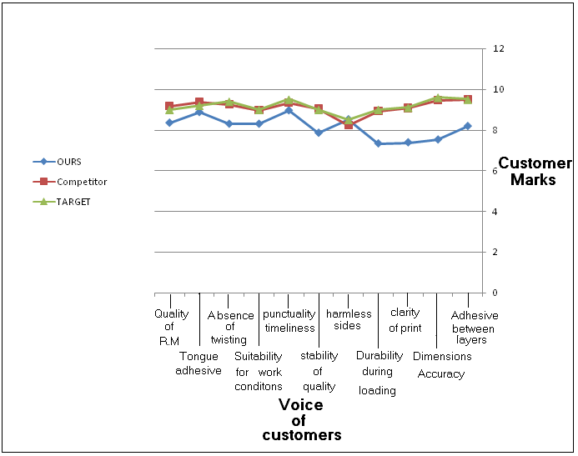

Figure ‎6‑1: Comparisons Curves

Unfortunately, it is clear that the competitor has the superiority over NCI in all customers’ quality requirements except in Harmless Sides need. This gap between the two ratings was taken into account for further analysis to conclude what NCI can do to reduce it and increase its level in competition.

These comparisons and prioritizations data are very important and was put in the overall NCI’s HOQ as shown in figure (10).

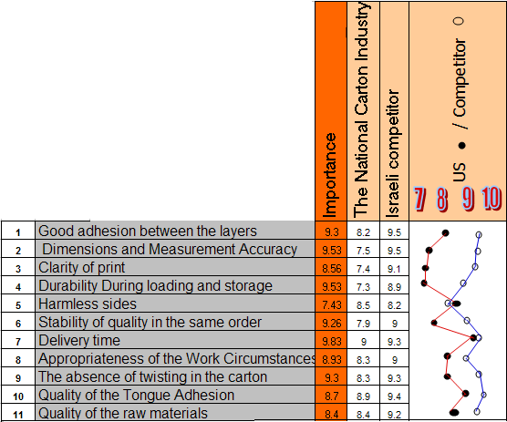

Figure ‎6‑2: comparisons and prioritizations data

The comparison charts were drawn in the range of 7 to 10 rating scale because each customer requirements was given a rate of 7 at least for both NCI and the competitor’s cartoon products.

## Voice of Company / How:

To improve NCI’s level of quality, all customers’ need was linked to technical specifications or design qualities supplied by NCI’s production engineers do to their high experience in cartoon industries.

These technical specifications that are related and have effects of products quality aspects are called voice of company. NCI technical specifications are summarized in table (). As we can see, the number of customers’ needs is more that the number of technical specifications which indicates that each one affects more than one quality aspect and here comes the importance of the interrelationship between the voice of customer and the voice of company.

|  |  |
| --- | --- |
| **Voice of Company/How?** | |
| 1 | Control the double Becker machine |
| 2 | Renewal the cutting knifes continuously |
| 3 | Use Ink dryer |
| 4 | Buy a raw material with stable quality |
| 5 | Implement a new Production plan (scheduling) |
| 6 | Use high quality Glue |

Table 4: Voice of Company

Due to the high importance of technical specification in improving cartoon products quality, the relationship matrix between them was build for easier and further understanding by NCI’s managers and it can be considered as a starting point for improvements activities.

## The Relationship Matrix:

The aim of this matrix is to convert customer requirements into design characteristics, through to a part level, and then into a manufacturing processes and controls.

The mechanism to achieve and display the results is the common matrix diagram that presents one set of ideas or data type against those of another, thereby providing a means to evaluate their relationships.

This matrix shown in figure below was filled with the help of NCI’s engineers due to their high practical experience

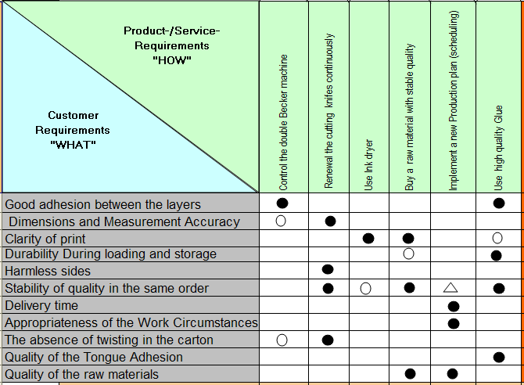

Figure ‎6‑3: The Relationship Matrix

Strong relationships were represented by black circles, white circles for medium and white triangles for weak relations.

## The Correlation Matrix:

For further analysis, the relationships between technical specifications themselves were determined through what is called correlation matrix. It is also called roof matrix because it lies over voice of company row. It was designed to determine the effect of one technical feature on the others. High correlation indicates product features that must be given consistent attention. This matrix is shown in figure () with the same relationships symbols used in the relationship matrix between voice of customer and voice of company.

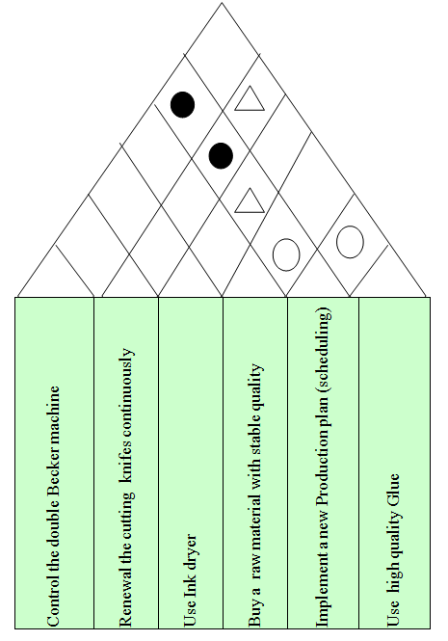

Figure ‎6‑4: The Correlation Matrix

Six technical relationships were investigated as follows:

**1-** There is a strong relation between {*Implement a new Production plan (scheduling) & Control the double Becker machine*}; because if we make a control system to the double Becker machine it will increase the productivity, reduce the time needed and reduce the expected & unexpected failures, so there is a big impact on one of them if we improve the other one, so improving one requirement of them may enough for the other one.

**2-** There is a strong relation between {Implement a new Production plan (scheduling) & Renewal the cutting knifes continuously}; because when we renewed the cutting knifes continuously as a preventive action it will avoid failures and increase the reliability of machines, so automatically increasing the productivity.

**3-** There is a weak relation between {Implement a new Production plan (scheduling) & use ink dryer}; because of the little impact of using ink dryer on productivity, because the mean time between failure decreasing.

**4-** There is a medium relation between {Implement a new Production plan (scheduling) & Buy a raw material with stable quality}; because when the procurement dept. takes the production dept. notes about the quality stability of the raw material quantities, they will determine the best supplier to deal with, and requesting good R.M, this may improve the production rate by decreasing the variation of the input's of the production processes.

**5-** There is a medium relation between {Use high quality Glue & Implement a new Production plan (scheduling)}.

**6-** There is a weak relation between {Use high quality Glue & Renewal the cutting knifes continuously }; because of its little impact of the glue type on the knifes work, and on its edges.

## The Planning Matrix:

This matrix constitute the right portion of the whole HOQ, it was designed to show the objective measures which are a comparison customers’ requirements degree of satisfaction against the proposed degree required by the NCI managers.

The first column of this matrix represents the target value which represents the proposed value of customers’ ratings which exceeds that of the competitor. It was calculated by determining the maximum rating for each customer’s need between NCI and the Israeli competitor, taking in to account its importance from customer’s point view. For example, clarity of prints requirement, NCI’s rating is 7.4 whereas it is 9.1 for the competitor, so that the NCI’s target value can be 9.1 which is the maximum rating between 7.4 and 9.1, and the same for other requirements.

But for dimensions and measurements accuracy and durability requirements, the target value was chosen to be more that the rating of both NCI and the competitor due to their high importance and priority according to customers’ opinions, for dimensions accuracy the target is 9.6 and for durability it is 9.

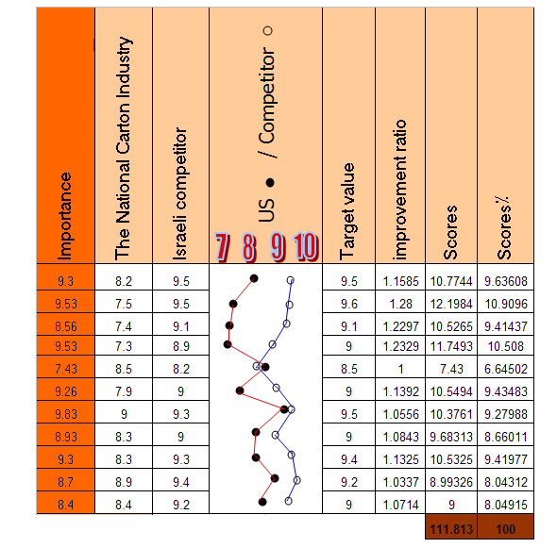

Figure ‎6‑5: Benchmarking & Planning Matrix

Improvement ratios were also calculated to show how much NCI customer’s requirements rating shall be improved to increase customer satisfaction. It was calculated by dividing the proposed target value over the current rate, in other words (Us in the future / us today). For example, the first point has an improvement ratio 1.1585 calculated by (9.5 / 8.2) = 1.1585 .

Scores were calculated by multiplying the importance of each customer need with its improvement ratio. For example, the good adhesion point score equals to 10.7744 calculated by (1.158*9.3) = 10.7744.

To get the percentage scores, each score was divided by the total score for each customer requirement multiplied by 100%. For example, delivery time score is 10.3761, so that its percentage score = (10.3761/111.813)*100% = 9.28%

## The Final Scores of technical points

## 

|  |  |  |  |  |  |
| --- | --- | --- | --- | --- | --- |
| **Control the double Becker machine** | **Renewal the cutting knifes continuously** | **Use Ink dryer** | **Buy a raw material with stable quality** | **Implement a new Production plan (scheduling)** | **Use high quality Glue** |
|  |  |  |  |  |  |
|  |  |  |  |  |  |
|  |  |  |  |  |  |
|  |  |  |  |  |  |
|  |  |  |  |  |  |
|  |  |  |  |  |  |
|  |  |  |  |  |  |
|  |  |  |  |  |  |
|  |  |  |  |  |  |
|  |  |  |  |  |  |
|  |  |  |  |  |  |
| **147.71298** | **327.683** | **113.034** | **273.609** | **243.3372** | **366.8415** |
| **10.03336** | **22.258** | **7.6778** | **18.585** | **16.5286** | **24.9176** |

2

3

4

1

Figure ‎6‑6: Technical Actions Priorities:

As we have done with customer’s requirements, it is possible to give a score for each technical actions or specifications that will directly affect the products quality level. Technical scores depends on the relationship matrix between voice of customers and voice of quality, each relationship symbol discussed previously has a value, strong relationship with a black circle was given a score of 9, 3 for medium (white circle) and 1 for weak relations (white triangle).

The score of each technical aspect was calculated by summing the multiplications of each relationship value by its associated customer need. For example, for the first column this represents “Control the double Becker machine”,

The final score = (9*9.63608)+(3*10.9096)+(3*9.41977) = 147.71298 .

The percentage score was calculated by dividing scores by the total scores multiplied by 100% which represents the percentage score of each technical specifications ‘voice of customer’.

## Technical Evaluation:

We asked the production engineer in the carton factory about his opinion from technical point view, he assessed the technical objectives for the carton factory and the competitor by giving marks from (1 - 5). The figure # (6-10), shows the two curves of the engineering opinion for the two factories.

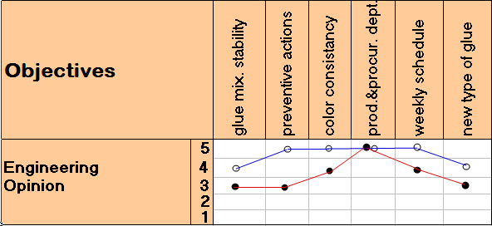



Figure ‎6‑7: engineering opinions about the technical objectives

## Final Model of HOQ

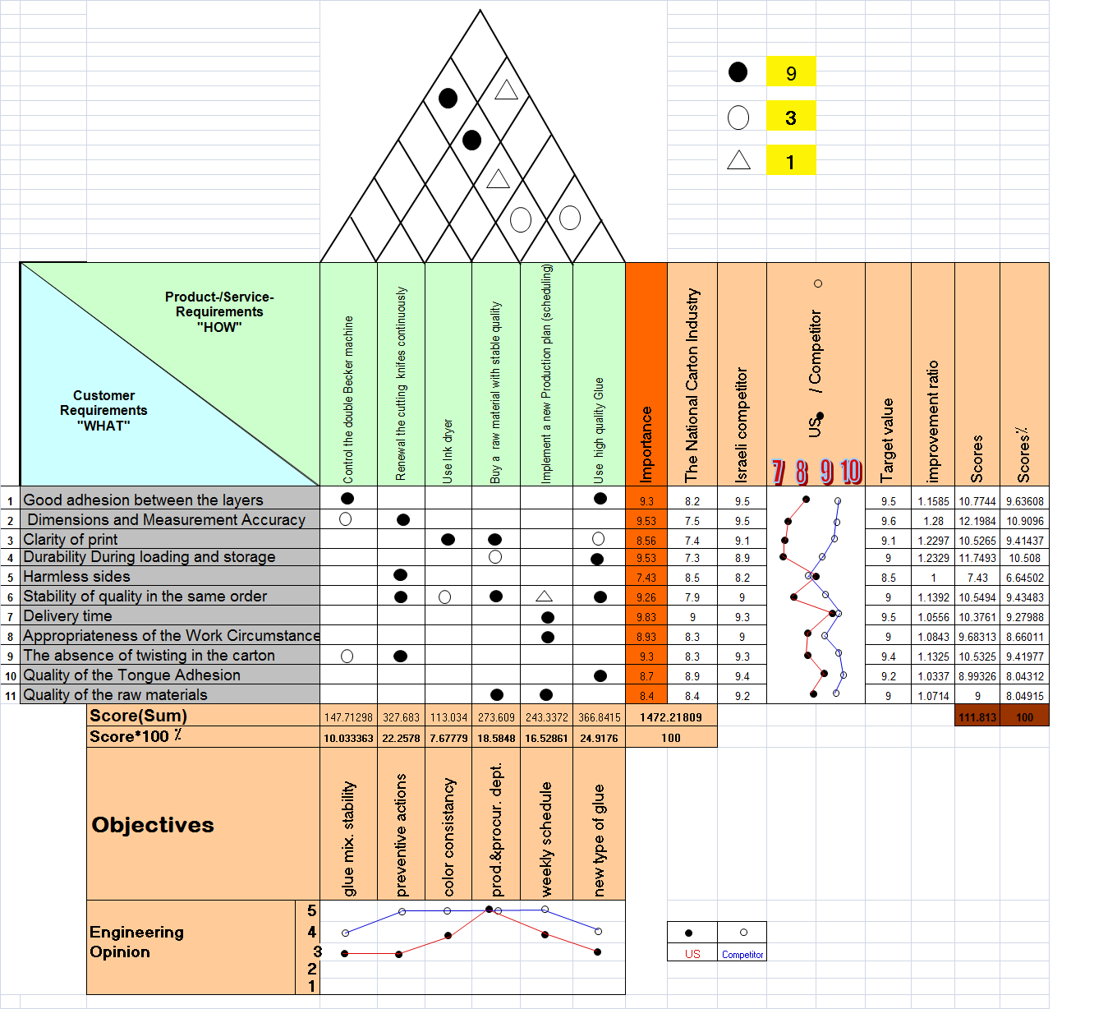

# Recommendations

According to the results raised through the project , the recommendations can be divided into two main categories ,Technical aspects and Managerial recommendations as follows:

## Technical Recommendations:

### Use high quality Glue

Contains a suitable amount of dryer to enhance drying process in 12 seconds at most; there are a lot of Glue types , there are a many choices to make when choosing glue. Here are some of the most common:

#### White glue

Is the most popular choice for general purpose adhering. It's non-toxic, odorless, and nonflammable and dries clear in under an hour. One drawback of white glue is that is has a low resistance to water, so it should not be used for outdoor projects.

#### Yellow carpenter's glue

Sets quicker and is more resistant to water than white glue. It won't be affected by solvents used in woodworking such as varnish, lacquer, or paint. Yellow glue dries to a translucent finish but can be sanded.

#### Hot-melt glue

Applied with a glue gun. It sets almost instantly on wood, metal, cloth, and ceramics. There are several formulas available for you to match to your project. Hot-melt glues, however, do not adhere well to cold surfaces, so make sure that your work pieces are not cold.

#### Instant bonding glue

Is incredibly strong and sets almost instantly. It is ideal for non-porous surfaces such as glass, certain plastics, ceramics, and metal but can also be used to bond wood and paper as well. After studying the most common types of Glue. We found that the best type to use in carton industry was:

#### {LM-50/SP-50 (MLV)}

It is a milky white copolymer & an excellent Adhesive For manufacturing different types of adhesive tapes and in Carton Industry.

***ADVANTAGES OF {LM-50/SP-50 (MLV)}:-***

A. Due to dispersion agents, extra coverage over others

B. Extremely good bond strength without any bleeding, wrinkling

C. Due to proper stabilizers used, more shelf life

D. Water is the thinner as well as cleaner for roller and appliances used

E. Non toxic and non-inflammable

F. Quick dry in a few seconds almost

G. Compatibility: LM-50/ SP-50 (MLV) has very good compatibility with surface active agents both ionic and non-ionic. In small % solvents like ethyl cellulose acetate, MEG, PEG, Toluene etc. added in small % under proper stirring to modify drying or film formation temperature. It has good compatibility with cellulose derivative and polyvinyl alcohol solutions added in requisite quantity

### Renewal the cutting and marking knifes continuously

Renewal the cutting and marking knifes continuously and set a specific period to change these knifes, as we know knife's edge eroded down by the ongoing work and the circumstances surrounding the work place. So it is important to put a preventive actions plan to avoid knife's fracture at a critical time of production.

### Coordination with procurement dept.

In order to buy a raw material with stable quality and colors, the cross functional teams help the procurement dept. to take a good decision about the best supplier and the proper raw material. This action considered as involving a lot of employee in D.M.P, and meeting the TQM principles.

### Set a weekly Production schedule

To determine the orders time sequence to produce it regularly according to its sequence, in other words(implement a new Production plan), this will help the company being able to meet customers’ expectations, because it is very important for customer to receive good products in the suitable time when they need it .

But the last two points didn't score an important mark in the HOQ , So it isn't necessary to work on their improvement :

**7.1.5**  Control the double Becker machine and watch the stickiness of the glue (stability of glue mixture).

**7.1.6** Use Ink dryer to prevent color volatility and hand dirtiness.

## Managerial recommendations

QFD Method is an effective tool to gain with every need to improve, it’s wildly spread in the west industries and it’s an important key in quality success by achieving competitive advantage, thought it’s not well known in our industries at all, we recommend to the responsible heads in the Palestinian industries union and the industrial engineering dept.

That:

1. Implementing a strategic vision to aware and declare the rule of QFD in the success of industries as a growing one in Palestine.
2. Establishing a national award to encourage the companies that follows continuous improves, and adopts a sponsorship for applying QFD.

# APPENDICES

## Factory Checklist

|  |  |
| --- | --- |
| **Description** | **Item** |
| The National Carton Industry Company Ltd | Factory Name |
| The industrial region_ Nablus | Factory location |
| 1989 | Establish year |
| Public contribution | Factory’s ownership (Private / Public contribution) |
| Producing Carton cans and Pieces | General work scope |
| 5 millions JD | Capital of the factory |
| 25% of the West Bank | Market share and Target markets |
| 3 lines | The number of Production lines |
| 245 Tons monthly | The total number of products |
| 44 employees | The total number of employees |
| 15 employees | The total number of administrative employees |
| 7 technicians, 2 industrial engineers, 1 elec. engineer | The number of Engineers and production audits |
| ______ | The number of workers and staff of public services |
| The West Bank | Marketing Regions |

## General Questioner

Factory’s Name: ………………………………………….

What is the extent of customer satisfaction for the quality of cardboard? .........................................................................................................................................................................................................................................................................................................................................................................................................................................................................................................

What are the main standards you need in the carton products?

1-……………………………………………………………………………..

2-……………………………………………………………………………..

3-……………………………………………………………………………..

4-……………………………………………………………………………..

5-……………………………………………………………………………..

What were the main problems you faced in using the carton products?

1-……………………………………………………………………………..

2-……………………………………………………………………………..

3-……………………………………………………………………………..

4-……………………………………………………………………………..

5-……………………………………………………………………………..

6-……………………………………………………………………………..

7-……………………………………………………………………………..

8-……………………………………………………………………………..

Other factories you had buy carton from , in the past:

1-……………………………………………………………………………..

2-……………………………………………………………………………..

3-………………………………………………………………................

## Survey

**Factory’s name: ………………………………….**

|  |  |  |  |
| --- | --- | --- | --- |
| **Items** | **Evaluation** | **Average** | **Importance** |
| **Good Adhesive between layers** | **Rank(10)** | |  |
| company rank(10) |  |
| Competitor rank(10) |  |
| **Dimensions and  Measurement Accuracy** | **Rank(10)** | |  |
| company rank(10) |  |
| Competitor rank(10) |  |
| **clarity of print** | **Rank(10)** | |  |
| company rank(10) |  |
| Competitor rank(10) |  |
| **Durability during  loading and storage** | **Rank(10)** | |  |
| company rank(10) |  |
| Competitor rank(10) |  |
| **harmless sides** | **Rank(10)** | |  |
| company rank(10) |  |
| Competitor rank(10) |  |
| **stability of quality in  the same order** | **Rank(10)** | |  |
| company rank(10) |  |
| Competitor rank(10) |  |
| **punctuality timeliness** | **Rank(10)** | |  |
| company rank(10) |  |
| Competitor rank(10) |  |
| **Appropriateness of the  work circumstances** | **Rank(10)** | |  |
| company rank(10) |  |
| Competitor rank(10) |  |
| **the absence of twisting  in the carton** | **Rank(10)** | |  |
| company rank(10) |  |
| Competitor rank(10) |  |
| **Quality of the tongue  adhesive** | **Rank(10)** | |  |
| company rank(10) |  |
| Competitor rank(10) |  |
| **Quality of the  raw material** | **Rank(10)** | |  |
| company rank(10) |  |
| Competitor rank(10) |  |

## Production Line description

|  |  |  |  |  |  |  |  |  |
| --- | --- | --- | --- | --- | --- | --- | --- | --- |
| *# of products* | *Product description* | *# of employees* | *Current production capacity* | *Maximum production capacity* | *The case of it when they buy* | *Buy year* | *General description of production line* | *#* |
| 1 | plates | 9 | 4 tons/ hr | 12 tons/ hr | Old | 1989 | Plate's production line | 1 |
| 2 | Printed plate | 5 | 6000cans /hr 35000/ 8hr | 6000cans /hr 42000/ 8hr | New | 1994 | Print’s production line | 2 |
| 1 | Open cans | 4 | 4000 units/hr 32000 / hr | 4000 units/hr 32000 / hr | new | 2009 | Open cans production line | 3 |

# References

1. Operations Management, Jay Hazier & Barry Render, 9th edition.
2. Advanced Quality Function Deployment, Fiorenzo Franceschini, Department of Manufacturing Systems and Economics, Turin Polytechnic, Turin, Italy.
3. Quality Function Deployment, A Practitioner's Approach, James L. Bossert, 1991 by ASQC.
4. International Journal of ''Quality & Reliability Management'' Best practice quality function deployment (QFD) Part II: Strategy and regional QFD, Guest Editors: Robert A. Hunt and Catherine P. Killen.
5. Analyzing a Quality Function Deployment (QFD) Matrix: An Expert System Based Approach to Identify Inconsistencies and Opportunities, Dinesh Verma, Ph.D. & Rajesh Chilakapati & Wolter J. Fabrycky, Ph.D., ISE, Virginia Tech.
6. Quality Function Deployment (QFD) :Integration of Logistics requirements into mainstream system design, Systems Engineering Design Laboratory (SEDL), Industrial and Systems Engineering, Virginia Tech .
7. Quality Function Deployment in Business Case Studies, Kanishka Bedi & J. K. Sharma, Graduate School for Global leaders, Nov 2006 .
8. QFD Institute, <http://www.qfdi.org/>.
9. <http://www.npd-solutions.com/whyqfd.html>.
10. <http://www.qfdonline.com/templates/>.
11. <http://www.qfdcapture.com/products.asp>.
12. <http://www.mazur.net/publishe.htm>.
13. <http://thequalityportal.com/q_know01.htm> .