
An-Najah National university
Collage of Engineering
Civil Engineering Department

First project

Student names:
Shadi Basher Al-zawyani
Zeina Emad Sinan
10-5-2010
بسم الله الرحمن الرحيم
قال تعالى:"يرفع الله الذين امنوامنكم و الذين اوتو العلم درجات" صدق الله العظيم
الحمد لله الذي وفقنا و امدنا بنوره لنتم ما ابتدء به معلم البشريه النبي الكريم.
في البدايه نبلرق اهداء اليك يا من استمددنا نور ليالينا اليك يا رسولنا الكريم
الى الشمعة التي تفانت لتنير لنا الدرب الى من سهرت طول الليالي لنغط في السبات العميق اليك يا ارق من الحرير اليك يا امي الحنون

الى من اغبرت يداه الى من تعب الكثير لنرتاح الكثير و ليقدم لنا الافضل اليك يا ابي
اليكم احبتي اساتذتي يا من تفانيتم لبناء جيل من العلم و المعرفه و نخص بالذكر استاذنا براق جمعه

الى جميع اصدقائي ,اليكم يا شهدائنا الكرام يا من رويتم بدمائكم تراب فلسطين الحبيبه
الى كل من ساهم و ساعد لايصالنا هذا الموصل

نهدي عملنا المتواضع

Content of the project
part one
Number of chapter | Title | Page
Chapter one | project management | 5
Chapter two | Project scope management | 35
Chapter three | Project time management | 49
Chapter four | Project cost management | 85
Chapter five | Project resource management | 104
Chapter six | Project risk management | 114
Chapter seven | Project quality management | 135
Chapter eight | Project communication management | 152
Chapter nine | Constructs & procurement | 160
Chapter ten | Project integration management | 165

part two
Number of chapter | Title | Page
Chapter one | Project overview | 173
Chapter two | Objective and method of construction | 176
Chapter three | Work breakdown structure | 178
Chapter four | Activity list | 181
Chapter five | Sample of calculation | 185
Chapter six | Resource and network preparation | 189
Chapter seven | Results | 191
Chapter eight | Conclusion and recommendation | 193
Chapter nine | Check for design | 195
Appendix A | Calculation of quantity | 198
Appendix B | Primavera | 206

Chapter one

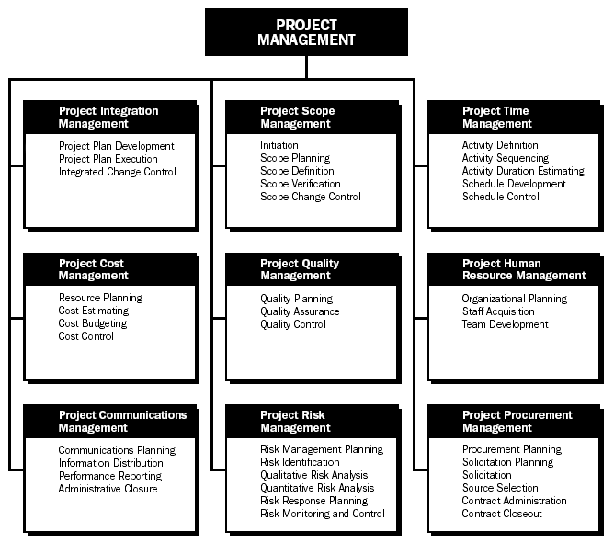

Here is a brief indication of chapter content:
1_ This is a familiar introductory chapter. It presents back ground information applicable to construction management. It considers some topics which will be explained later in the following chapters.

2_ This chapter discusses the project scope management and talk about the importance of planning as the main function of management.

3_ Define the project activities ,determine the relationship between activities,and estimating the activity duration by CPM method is introduce in this chapter .also ,work break down structure will be explain.

4_ This chapter deals with the project cost management, and estimate the cost for each activities including all resources (material, equipment ,labor and overhead costs and profit).

5_ This chapter talks about resources management. Where resource management is concerned ,there are two broad scenarios . one method, termed here as resource allocation while the other method, resource leveling and we will talk expand about each method.

1. What is a project?
Looking for the word “project “in the dictionary we will find the following description:
Project is a temporary endeavor undertaking to create a unique product or service.
Also,
- A project is complex.
- A project is homogeneous.
- A project is non_repetitive.
- There is an end.
- The duration is finite.
- Characteristics are progressively elaborated.

1.1 An example of projects:
- Construction a building or facility.
- design a new transportation vehicles
- Automating an assembly line.
- Installing a computer network in a building.
- Building a bridge.

1.2 Project constraints:
Most of the projects are operated under the triple constraints of Time , Cost , Quality.
When the scope increases the schedule increases along with cost. Hence there is always a tradeoff between these constraints. Other examples of constraints can be; legal policies of the land in which the project is executed, geographical conditions, cultural issues…

2. Project life cycles:
The project life cycle refers to a logical sequence of activities to accomplish the project`s goals or objectives. Regardless of the scope or complexity , any project goes through a series of stages during its life.
There is first an initiation or birth(definition) phase, in which the outputs and critical success factors are defined, followed by a planning phase, characterized by breaking down the project into smaller parts / task. An execution phase, in which the project plan is executed. And lastly a closure or exist (delivery) phase, that marks the completion of the project.
Project activities must be groubed into phases because by doing so, the project manager and the core team can efficientlyplan and organize resources for each activity , and also objectively measure achievement of goals and justify their decisions to move ahead , correct , or terminate.
It is of great importance to organize project phases into industry_specific project cycles. Why? Not only because each industry sector involves specific requirements , tasks , and procedures when it comes to project, but also because different industry sectors have different needs for life cycle management methodology . And paying close attention to such details is the difference between doing things well and excelling as project managers.
The construction of a project has become a process with definite and discrete stages. Let`s take a closer look at what`s important in each one of these stages:

- Initiation stage
Initiation stage is the first stage in the project life cycles, involves starting up the project. The scope of the project is defined along with the approach to be taken to deliver the desired outputs. The project manager is appointed and in turn , he selects the team members based on their skills , and experience. The level of effort in this stage is low.
The most common tools or methodologies used in the initiation stage are:
- Project charter
A formal document issued by senior management which explains the purpose of the project including the business needs the project and the resulting product. It provides the project manager with the authority to apply organizational resources to project activities.
- Business plan.
- Project framework (or overview).
- Business case justification.
- Milestones review.

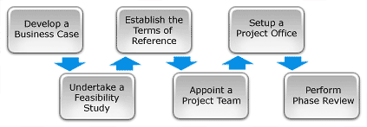

- Planning stage
The second stage in project life cycles, it should include a detailed identification and assignment of each task until the end of the project.
It should also inslude a risk analysis and a definition of a criteria for the successful completion of each deliverable.
Also, planning involves setting out the roadmap for the project by creating the followings plans:
- Project plan.
- Resource plan.
- Financial plan.
- Quality plan.
- Acceptable plan.
- Communication plan.
The most common tools or methodologies used in the planning stage are:
- Business plan.
- Milestones review
The level of effort in this stage increases.
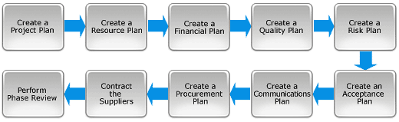

- Execution stage
With a clear definition of the project and a suite of detailed project plans, you are now ready to enter the Execution phase of the project.
This is the phase in which the deliverables are physically built and presented to the customer for acceptance.While each deliverable is being constructed, a suite of management process are undertaken to monitor and control the deliverables being output by the project.
These processes include managing time, cost, quality, change, risks, issues, suppliers, customers and communication.
Once all the deliverables have been produced and the customer has accepted the final solution, the project is ready for closure.
The most important issue in this stage is to ensure that project activities are properly executed and controlled. During the execution phase, the planned solution is implemented to solve the problem specified in the project`s requirement. In product and development , a design resulting in a spesific set of product requirement is created. This convergence is measured by prototypes , testing, a nd reviews.
As the execution phase progresses, groups across the organization become more deeply involved in planning for the final testing , production , and support.
The most common tools and methodologies used in execution phase are:
- Update of risk analysis.
- Score cards.
- Business plan.
- Milestones review.

The level of effort in this stage is the highest.

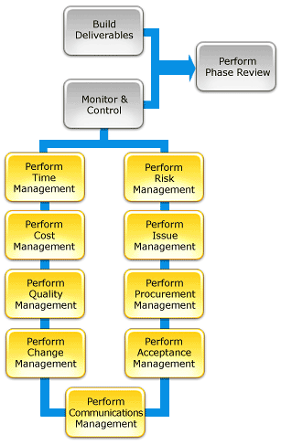

- Closure stage
In this last stage, the project manager must entire that the project is brought to its proper completion. The closure phase is characterized by a written formal review report containing the following components:
- A formal acceptance of the final product by the client.
- Weighted critical measurement (mathing the initial requirementswpecified by the client with the final delivered product).
- Rewarding the team.
- A list of lessons learned.
- Releasing project resources.
And a formal project closure notification to higher management.
No special tool or methodology is needed during the closure phase.
The level of effort in this stage is low.
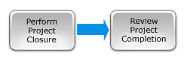

2.1 Summery
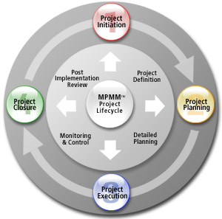
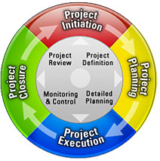
3 Project Plan
The project plan is used to:
- Guide project execution.
- Document assumptions and decisions.
- Facilitate communication, define reviews.
- Provide baseline for progress measurement and project control.

3.1 Elements of a project plan:
- Project Charter.
- Management approach / strategy.
- Scope statement including deliverables and objectives.
- WBS.
- Performance measurement baselines.
- Major milestones and target dates.
- Key or required staff.
- Key risks, constraints, assumptions .
- Open issues and pending decisions.
The project plan is a working document. It should be updated as needed.And it may be summary or detail.

3.2 What is the size of the project?
Large enterprise projects generally require large number of project teams to work on clearly defined deliverables. The scale of the deliverables is proportional to the size of the project team assigned to do it. Thus, larger project teams are assigned larger set of deliverables which need to be clearly defined. With this kind of scenario, long iterations or waterfall would be more ideal.
4. Top 10 Reasons Projects Fail
I think that any project can fail because of:
- Inadequately trained and /or inexperienced project managers.
- Failure to set and manage expectations.
- Poor leadership at any and all levels.
- Failure to adequately identify , document and track requirements.
- Poor plans and planning processes.
- Poor effort estimation.
- Cultural and ethical misalignment.
- Misalignment between the project team and the business or other organizations it serves.
- Inadequate or misused methods.
- Inadequate communication , including progress tracking and reporting.

5. Project vs. Operation vs. Program
- A project is a temporary endeavor undertaken to create a unique product or service. It has a definite starting and ending point.

- An operation has similar characteristics to a project: it is performed by people; constrained by limited resources; planned, executed, and controlled. The major difference is that an operation is on-going and repetitive.

- A program is a group of related projects managed in a coordinated way and is on-going.

6. What is management?
The functions of planning ,organizing , directing ,and controlling are essential to every business regardless of the type and the purpose of performing. This four functions above means Management.

6.1 Summary on construction & management:

Function | Definition | Techniques & scope
Planning | Is the process to answer what is to be done, when and How. | - Scheduling.  - Procedures /guidelines  - Resource allocation.  - Method statements.
Organization | Is a process of creating a skeleton for allocating responsibilities, channels of communications and patterns of relations. | - Organization charts.  - Traditional  - Matrix  - Job description.  - Level of authorities procedures.
Directing | Is the proper implementation of plans by people. | - Supervising/guiding.  - Leading.  - Coordination.  - Motivating.
Controlling | Is a process of comparing the planned with actual to detect deficiencies & correct them. | - Budgeting.  - Cost codes.  - Cost control system.  - S-curve.  - Reporting system.

6.2 What is project management?
In construction, if we want to define “project management “we can say it is the process of using management (planning, organizing, directing and controlling) , to meet the client`s expectation from start to finish within the planned period , budget and quality.
Project management is the principle of planning different projects and keeping them on track within time, cost and resources constraints.
Indeed, project management is the science and art of enhancing the probability of success by inspired leadership using structural techniques for planning that integrate technical performance, scheduling and budgeting.

6.2.1 The purpose of project management
The purpose of project management is to predict as many of the dangers and problems as possible and to : plan, organize, coordinate and control.
The objective of a project management is to deliver a product that meets the requirements of the project`s objectives and the contract delivery schedule.

6.2.2 Project management requires:
- Set project objectives or goals in terms of :
- time
- cost
- logic
- Produce alternative schedules, and associated time and cost.
- Select the best schedule.
- Optimize resource allocation for the schedule.
- Implement the project plan.
- Monitor progress (plan, compare, modify).

6.2.3 Decision making
Decision is a choice made from two or more alternatives. It is a part of all four management functions.
Decision are made on the basic of :
- Rationality .
- Bounded Rationality.
- Intuition.

6.2.4 Project manager`s authority
- Technical decisions
- Directing the deign approach.
- Selecting subsystems or components.
- Identifying type and scope of tests.

- Commercial decision
Make or buy.
Selecting and recommending subcontractors or vendors.

- Administrative decision
- Selecting and assigning personnel.
- Scheduling personnel , resources and equipment.

- Monetary decision
- Determining the expenditure of funds.

6.2.5 Role of Project Manager
- Produce end item with available resources, within time, cost and performance constraints.
- Make all required decisions regarding the project.
- Act as interface with customer and top functional managers.
- Negotiate with functional managers to accomplish necessary work within time, cost, and quality goals.
- Resolve conflicts.

6.2.6 Functions Performed by Project Manager
- Planning and scheduling.
- Performance analysis, progress reporting.
- Client / consultant relations.
- Project and cost trend analysis.
- Logistics management, cost control.
- Organization and manpower planning.
- Contract and materials administration and estimating.
- 7. Project management body of knowledge
The project management institute has identified nine topic areas to define the scope of the project management knowledge as follows:

- Project scope management:
The project scope management plan refers specailly to the input / output mechanism that consists of a formalized document that is used for the purposes of detailing exactly how the project scope will be defined , what means will be undertaken to develop the project scope , how the project scope will ultimately be varified , and exactly how any and all the components of the work breakdown structure will be ultimately created and defined.
The project scope management plan also will provide information and assistance in determining exactly how the actual scope of the project will ultimately be controlled in the management process by the project management team and / or the project management team leader.
The actual project scope management plan , as with most project management components , can be vary formally written document , or it can also be a much more informally written document. The detail level can vary widly as well , depending on exactly what needs of the project.

- Project time management:
This Project Time Management Process describes how to monitor and control time spent within a project. It describes each of the Time Management procedures step-by-step, explaining how to use Timesheets and Time Management Logs to record time spent.
By using this Time Process, you can control the amount of time that it takes staff to build deliverables within a project, increasing your chances of delivering "on time" and to schedule.
This project management process will help you:
- Put in place a process for recording time within project.
- Use Timesheets to monitor the time spent by staff.
- Identify and resolve time management process.
- Keep your project plan up-to-date at all times.
This project management process is unique as it:
- Lists the key steps taken to manage time within a project.
- Includes a process diagram , showing when those steps are taken.
- Describes each of the roles and responsibilities involved.
- Is pre-completed and ready to use on projects now.
If you are looking for a Project Time Management process that can be used immediately, with little customization, then this time process will meet your need. It describes how to manage time and deliver projects on schedule.
I think that you can Save time by using this Project Time Management process.

- When do I use a Time Management Process?
The best way to see if your project is on track is to record time actually spent vs. time planned to be spent. This is what we called " Project Time Management" , and it is by far the most effective way to monitor project progress. The time process allows you to see for every task, whether is has been completed on time. This time process also allows you to control time spent by implementing a timesheet approval process.

- Project communication management
The communication management plan is the written document that outlines, highlights, and detail the communications need and expectations for the entire project. This can include specific communications technologies that are requiredsuch as the need for dedictated phones, so that the project team members can keep in touch, as well as specific update formats, such as the need for a weekly email update, or perhaps the need for a weekly conference call.
The communication management plan also includes mention of the specific party or parties who are to be responsible for each format of communication. Communication management plans come in a wide variety of shapes and sizes, I will mention them later.
Project communication management plays a key role in keeping all members of the project management team on the same page. Without communications among all team members and project stakeholders there can be a breakdown in processes which could have a negative impact on the final product. The project manager must know the communication processes involved in effective project management . First of all, there should be planning to determine what information needs to be communicated to all stakeholders in the project. Next, that information must be made readily available to the stakeholders and generated in a timely fashion. Performance must also be accounted for by reporting the project status, measuring progress and forecasting. Finally, communication with project stakeholders must be managed so that all requirements are met and issues are promptly resolved.
Interactions and overlap among the communication processes are inevitable and expected throughout all phases of project management.
Project communications management can be broken down into essential knowledge and skills as follows:

- Managing a meeting by having an agenda as well as resolving conflicts.
- Writing style to be used.
- Methods of communication;written or oral,informal memo or formal report,face_to_face or email, all of which are dependent on the situation at hand.
- Techniques for presentation including whether to use visual aids and effective use of body language.
- Possible barriers or feedback loops that infleunce communication.
Communication is an essential process in the world of project management.it is difficult to master but essential to make a good effort in achieving. Communication is essentially the effective and complete exchange of information from one person or persons on a project team to other person or persons.
Communication on an effective team starts from day one, from the moment a project is assigned and continues on a daily basis, if not hourly basis, throughout the life cycle of a project. Effective communication means that each and every project team member should be fully apprised of the project status at all the time. Some detailed information may not be shared with all team members if they are very individual specific,but the big ticket items should always be shared among the entire team.

- Project procurement management
Project procurement management is part of the project management process in which products or services are aquired or purchased from outside the existing employee base (which would work on the project) in order to complete the task or project.
There are essentially two different types of procurement , one in which the company is responsible for the particular product or service under a legal contract, this PPM includes contract management responsibilities that issue specific tasks to various team members. Both of these project mangement processes are impertive to a company`s success.
Project procurement management can also include responsibility of the contracts in which the buyer that hired for this particular project is performing the task for a certain seller, this contract is placed between the one providing a service and the particular team that was responsible for completion of this project.
PPM includes a variety of tasks including the planning process where one decides what to acquire or purchase and how they will do so. Next, they plan the contract which provides a legal document of the exchange. After the legal documents are drafted, the seller can respond with variety inquiries such as a bid or proposal. After these answers are feeded back to them, they will review the various offers and choose whom will be awarded the project. The most important process of project procurement management includes project management relations between both buyer and seller via the contract.

- Project quality management
Quality can be defined as meeting the customer's expectations or exceeding the customer expectations achieved by way of deliverables and/or activities performed to produce those deliverables.
Project Quality Plan can be defined as a set of activities planned at the beginning of the project that helps achieve Quality in the Project being executed. The Purpose of the Project Quality Plan is to define these activities ( tasks ) that intends to deliver products while focusing on achieving customer's quality expectations. These activities / tasks are defined on the basis of the quality standards set by the organization delivering the product.
Project Quality Plan identifies which Quality Standards are relevant to the project and determines how they can be satisfied. It includes the implementation of Quality Events (peer reviews, checklist execution) by using various Quality Materials (templates, standards, checklists) available within the organization .The holding of the Quality Event is termed as Quality Control. As an output of the various activities, Quality Metrics or Measurements are captured which assist in continuous improvement of Quality thus adding to the inventory of Lessons Learned. Quality Assurance deals in preparation of the Quality Plan and formation of organization wide standards.

- Evaluating your Project Quality Plan
For quality assurance to be effective, two things must be ensured:
First, the Project Quality plan must be sufficient to achieve the required quality standards expected of the organization. In this regard the plan must not only be specific and detailed listing all quality requirements and standards, but also include all the steps taken to ensure that those requirements and standards are met.
Secondly, quality assurance (i.e. final product testing) should be independent of the project itself (as well as the project manager). This comes down from the project management guidelines for effective quality assurance, and builds on a broad-based, organizational approach to standards-based product testing.
The development of a Project Quality Plan is a team process that depends as much on communicating information as it does on planning. The key objective is to create a cohesive dialog and subsequently develop awareness of potential quality issues assurance. Based on this awareness, project managers can prepare plans and actions to counter any weaknesses or deficiencies in the project execution, thus ensuring that all quality standards are met effectively.

- Project integration management
What is integration management? Collection of processes required to ensure that the various elements of the projects are properly coordinated. It involves making tradeoffs among competing objectives and alternatives to meet or exceed stakeholder needs and expectations.
The processes and activities needed to identify, define, combine, unify, and coordinate process and project management activities within the project management group are included in the project integration management knowledge area. Characteristics of unification, consolidation, articulation, and integrative actions crucial to project completion fall within the context of integration.
Decisions related to choices such as, concentration of resources, coordination of work efforts, and anticipating potential problems are addressed under integration. Other considerations including the balancing of competing objectives and exploration of alternative actions are also within the domain of integration. Real world applications involving coordinated efforts of project integration management components are seldom clearly defined by boundaries. A certain amount of overlap is to be expected. The interaction of these individual processes requires effective integration in project management.
There is no single way to manage a project. Experienced project management practitioners apply their knowledge, skills, and processes uniquely to each situation, depending on its circumstances, variables, and objectives. The mere fact that a particular process or technique was not utilized in a project does not mean that it was not considered. On the contrary, project integration management and team management are charged with assessing the applicability of all processes and the level of implementation of those deemed appropriate to the success of the project when formulating the overall project integration management plan.

What Processes are Involved in Project Integration Management?
Integration mangement involves seven processes here there are: The first of these processes is the development of the project charter. The project charter initiates the project. This document authorizes the project to get underway. Project charters state the project objectives and name the project manager. It is usually no more than one page long.
The second process is the development of the preliminary scope statement.The scope statement defines what is and what is not a part of the project. Well-defined scope statements will list all and only the work involved with a specific project.
The third process in integration management is the development of the project plan. The project plan includes the project charter, the definition of the project, project objectives, the project budget, the project schedule, the resources required for the project, the approach, management plans, and the initial risk assessment.
The next process involved is the directing and monitoring of project execution. This is when the project really gets underway. Items produced during this phase include the final deliverable product.
Fifth, project work must be monitored and controlled. One important aspect of this process is change management. Requests for project change may be made during the project lifecycle. If these requests are not monitored and controlled, then the quality of the project may be compromised. A team must be formed in order to oversee requests for change and implementation of change. This process is closely related to the sixth: the control of integrated change.
Finally, the project must be closed when it has been completed. Closing the project involves reviewing the processes, successes and deficits that were encountered during the project lifecycle. During this phase, a lessons learned document is produced by the project management team.

- Project risk management
Since all projects involve some degree of risk, a project risk management plan is necessary to define and document those procedures that will be used to manage risk throughout the life of the project. Risk can be understood as any factor that may potentially interfere with successful completion of the project. Therefore, it follows that by recognizing potential problems the project manager and core team members can avoid most, if not all, of these problems through proper actions.
The procedure used to manage risks is defined in the planning stage, documented in the project risk management plan, and then executed through the life of the project. Indeed, Risk Management is the process of thinking systematically about all potential undesirable outcomes before they happen and determining procedures that will avoid them, minimize their impact, or cope with their impact.
There are four stages to risk management planning:
- Risk Identification;
- Risk Quantification;
- Risk Response;
- Risk Monitoring and Control Assessment.

A project risk management plan should also specify who is responsible for managing the different areas of risk, how risks will be tracked through the project life cycle, how contingency plans will be implemented, and how project reserves will be allocated in order to handle risks.
Project size has an effect on the project risk management plan. Large projects normally require more detailed risk planning than smaller projects due to the bigger number and complexity of potential risks. Quite often, this requires developing and analyzing alternative strategies and strategy evaluation criteria.
As a final note, a project risk management plan helps you increase your chances of success as project manager by assessing risk occurrence and defining clear strategies, techniques, and control mechanisms to deal with risk.

- Project cost management
Cost estimation and control is vital to a project`s success. For this reason a major part of any project is the cost management plan. It can be found within, inside, or be presented as part of a project management plan.
A cost management plan is a document which will outline the criteria and activities which must be carried out as part of project management. A cost management plan provides both input cost estimates, the amount of money being spent, and cost output estimates, which is the amount of money estimated to be received. It will provide the planning and structure necessary to control the costs of the project, keeping them within the limits of your budget.
The exact nature of a cost management plan may very greatly. They can be formal and precisely worded or written very casually. Some can be highly detailed while others take on a broader aspect that looks more at the big picture. More experienced project management will have less need for a clearly defined cost management plan, though will still be required to review it and follow it to the letter.
So it is clear that, the exact nature of the cost management plan is dependent on the interests and needs of the project stakeholders. And no project can survive for long without the application of funds to pay for the material , machinery and the labor. This need demands a budget and requires the determination of feasible cash flow.

- Project human resource management

Definition
The Human resource management includes the processes required to coordinate the human resources on a project. Such processes include those needed to plan, obtain, orient, assign, and release staff over the life of the project.

Functions
- Development of Human resource plan
- Acquiring staff
- Measuring the Performance of staff
- Release of staff at the end

Introduction
As we know that people are an important part of a project’s success. The projects are resource constrained. The management of the human resources on a project has a major impact on the project’s success or failure. Of course, this article has taken a general view, human resource processes are strongly influenced by the human resource policies and procedures of the delivery organization. Much has been written about dealing with people in the operations of anongoing enterprise; leading, communicating, delegating, motivating, team building, recruiting, appraising, etc. Much of that knowledge is directly applicable to leading and managing people in a project environment and the project manager should be familiar with it.

However, the project manager must also be sensitive to the unique needs of the project environment and as to how this general knowledge is applied in a different way than in the operational environment of the ongoing enterprise.
- The temporary nature of projects means that personal and organizational relationships generally will also be temporary and, quite often, new. Staff-related project management processes must address these transient relationships.
- Both the nature and number of people involved in a project change as the project moves through its life cycle. For example initially there will be limited number of staff in the project and as we move along we induct more staff into the project. Staff management processes must recognize and address these changing needs.
- Human resource management activities are often split between project management and other managers within the performing organization. The scope of responsibility of the project manager may lie somewhere between:
- An extended responsibility, including the selection of sourcing organizations, obtaining staff and performance assessment.
- A limited responsibility focused on coordination with the permanent roles outside
the project such as the functional manager, the resource deployment manager and/or the people development manager .

All the parties must understand and carefully adhere to the division of responsibilities that is in force. All the processes here must be carefully interpreted based on the actual distribution of responsibilities between the project manager and the other roles. In some companies there may be a two managers for a team member – one the project manager who takes care of the day-to-day work of the team member and provides feedback to others, second a people manager who takes care of the people development aspects of the team member like promotion, salary hike, career needs/interest. Ideally to my view a team member should have only one Manager who should take care of everything (Project management and people management) and should have no more than 14 people directly reporting to him. Again it depends on many factors – company policies, location, style of functioning and project needs.

Indeed, Project human resource management involves organization and managing a project team. The team is usually made up of people with specific skill and responsibilities. The project team also known as a project staff, should be involved in plans and decision making from the beginning of the project. Team members should feel invested in the outcome of the project. This will increase layalty and communication to project goals and objectives. The number of team member and their responsibilities can change as the project develops.
The project management plan team, also called the core, executive, or leadership team, is responsible for project planning, controlling, and closing and tasks directives from project team. Smaller project responsibilities can be shared by the team or designated by the project manager. The project management team and the project sponsor work together to secure funding, simplify scope questions, and influencing team mambers.
Project human resources management processes include human resource planning, acquiring the project team, developing the project team and managing the team. Processes are used multiple times, usually occuring at least once in a project or several times in different phases if the project is made up of many phases. Project human resource management planning may be required if more experienced mambers are added to the team. The project management team should also prepare for risk management and changes to project duration.

Chapter two
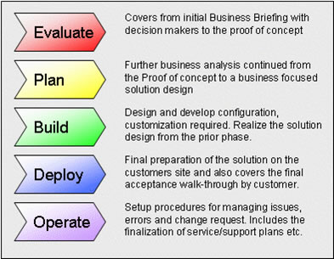

Project scope management
Definition
The project scope management plan is the document that details how the project scope will be defined, developed, and verified while provisioning how scope will be managed and controlled by the project management team. The Project Scope Management Plan also defines how the work break down structure (WBS) will be created and detailed.
Purpose
The scope management plan establishes how scope management will be carried out in the project. It serves as guidance for scope process and formats and defines the roles and responsibilities for stakeholders in those processes. It is not the detailed requirements information, but instead explains how that information will be captured, expressed, and modified (if or when necessary).

T he following items are the five inputs used to create a Project Scope Management Plan:
- Enterprise environmental factors – Enterprise environmental factors can influence how the project scope is defined, controlled, verified, and managed.

- Organizational process assets _Organizational process assets provide information about existing policies, procedures as well as historical records and lessons learned from previous projects. They provide information that is used to help the project manager take measures to control scope in the Project Scope Management Plan.

- Project Charter – The project charter is a document issued by the project initiator or sponsor that formally authorizes the existence of a project and provides the project manager with the authority to apply organizational resources to project activities. This objective forms the basis of scope planning.
- Preliminary Project Scope Statement – The Preliminary Scope Statement begins to define the project and what needs to be accomplished. It includes the product requirements, project boundaries and methods of acceptance. The deliverables are used in scope planning as the basis for the WBS.

- Project Management Plan – The Project Management Plan is a formal, approved document that provides the structure and outline for the Project Scope Management Plan. It describes which project scope management processes will be performed and at what level they'll be implemented.

Application

- The scope management plan is used by project managers and the project office to define how management practice will be conducted. In some organizations, it may be a standardized document, applied across multiple projects and modified only slightly to reflect the individual resource and delivery requirements of the project. It is used to prevent project managers from reinventing the process every time they face a new project.

In order create the Project Scope Management Plan, project manager often rely on the following tools and techniques:
- Expert judgment - Expert judgment is based on expertise in a particular discipline, industry, application area, or knowledge area. Such expertise may be provided by a individual or a group with specialized education, skills, or training, and it is available from such sources as consultants or stakeholders.

- Templates, forms, and standards - Templates, forms, and standards are commonly used tools for creating the Project Scope Management Plan. Examples include Project Scope Management Plan templates and project scope change control forms.

Content
The scope management plan includes descriptions of required documents (e.g., functional requirements, technical requirements, change control forms), as well as some insight on how those documents may be developed.
The necessary components of the Project Scope Management Plan are:
- Scope Planning, including information about scope stability – Scope planning contains a description of the preparation of a detailed Project Scope Statement.

- Scope Definition – Scope Definition contains a description of the preparation of a detailed Project Scope Statement.

- Work breakdown structure – The Work Breakdown Structure contains a description of the creation of the WBS from the detailed Project Scope Statement.

- Scope Control – Scope Control contains a description of the process for handling changes to the detailed Project Scope Statement.

- Scope verification – Scope Verification contains a description of the process for verification or acceptance of the completed project deliverables and the WBS.
Scope Process
Scope process will include definitions on how the scope for the project will be documented. It will address the nature of functional and technical requirements and the areas/individuals responsible for developing those requirements. It will also include detail on how and when the scope may be modified both before and after the project baseline is established. The process includes information on when the scope should be baselined and when certain types of documents (e.g., change control logs, functional and technical requirements documentation) should be updated.

Scope Responsibilities
The responsibilities should reflect who will be accountable for scope definitions (functional and technical), updates, and real-time information capture on project and task performance. This may also include who is in charge of the scope documentation and who is conducting data entry.

- Scope planning
Scope planning refers to a project management process that defines boundaries and deliverables. Also, scope planning is an important component of the project management. The basic matrix of a scope planning analysis consists of three main categories:
- Initiation.
- Planning.
- definition.
With two control categories interspersed between the three main categories:
- Verification
- and change control.
Initiation inputs contain program deliverable description, strategic planning, program selection criteria, and historical information.Tools and techniques include program selection methods and expert judgment. The output of the initiation phase will include a program charter, the identification and assignment of a program director, and the identification of known constraints and assumptions.
The planning category covers descriptions on deliverables, the program charter, constraints, and assumptions. Tools and techniques involved in this category include deliverable analysis, a benefit/cost analysis, the identification of alternatives.
The final main category includes a statement of scope, a definition of assumptions and constraints, and other planning outputs and historical information. Tools and techniques involved include work breakdown structure templates and decomposition. The output of definition is work breakdown structure, and the defined scope section of the project management plan.

Two control devises, verification and change control are interspersed between the main categories of scope planning. Verification’s inputs are work results, and deliverable documentation. Inspection is its sole tools and technique. Formal acceptance is verification’s output, and is necessary to advance the project management plan to the next level.
Change control is situated between planning and definition. Its inputs are comprised of work breakdown structure, performance reports, change requests, and the scope management plan. Tools and techniques include the scope change control system, performance measurements and additional planning when indicated. The outputs of change control are changes in scope, corrective actions, and lessons learned entered in the knowledge base for other project management considerations.

Here are the importance of scope planning:
- Develop a Scope management plan to state how the scope will be managed and any proposed changes to scope should be handled. The process of managing project scope needs to be defined and agreed in the planning stage. The PM has responsibility to ensure the process is both defined and adhered to.

- To control the scope change the business objectives must be fully supported by the senior management, the original scope clear and fully approved and agreement reached on scope freeze prior to development.

- Include in the process a Scope Change Request Form, a Scope Change Log, analysis and options evaluation for each scope change request, and a formal approval process for each scope request.

- Agree tolerances between the Project Board and the Project Manager with reference to the Schedule and Cost and if a Change Request can be completed within these tolerances the Project Manager can make the decision to accept a change or not.

- Configuration Management should be established to identify, track and protect the project’s products as they are developed. Configuration management is a control technique for formal review and approval of configuration changes.

- Implement a scope change control system.
- Identify changes from original scope.
- Forecast scope change.
- Subject them to managerial analysis and decision.
- Record actual figures on them.
- Highlight them to senior management.
- Set up a system to resolve disputes.
- See that changes are implemented.

- Scope definition
One of the first and most important steps in project management is to flesh out a statement or scope definition which identifies and describes all work necessary to produce the final product. The statement establishes the tone for the remainder of the planning efforts and therefore should be sufficiently detailed. Keep in mind however that being too detailed can be as bothersome as not providing enough detail.
During the planning phase the project management team should identify and describe all work that is necessary to bring the project to fruition. The scope definition is meant to ensure that everyone on the team understands what is expected of them during the project. In addition all project work that can be reasonably predicted must be ascertained and reported. The scope definition should also allow for appropriate administrative control during the project management process.
Suitable scope definition is essential to the success of the project and should be given ample consideration and thought. If this step is skipped or inadequately developed it will most likely mean that additional project planning will suffer as a result.
Scope definition document provides the detailed information for the Scope Plan. It provides the basis for estimating cost, time and resources, performance measurement and responsibilities.
Generally the Scope Definition document is presented in list format but development of the document requires some brainstorming activities that are best done with the key stakeholders and the project team involved using some simple tools like "sticky" notes on the wall.

Inputs to project scope definition:
- Project defintion document.
- Facilitative planning process outputs.
- Generic process inputs.

Mechanisim for project scope definition:
- Work breakdown structure templates. Although each project is unique, many projects will resemble another project to some extent. For example, most projects within a given organization will have the same or simillar project lifecycles and will thus have the same or simillar deliverables required from each phase. These common elements can be put into a template that serves as the starting point for development of a WBS.

- Decomposition Decomposition involves subdividing the major project deliverables into smaller, more manageable elements until the deliverables are defined in sufficient detail to support future project activities.

- Generic process mechanism.

Outputs from project scope definition:
- Work breakdown structure WBS is a deliverable_oriented grouping of project elements that organizes and defines the total scope of the project. As with the project definition document, the WBS is often used to develop or confirm a common understanding of project scope.
scope verification

Process definition
Scope verification is the process of formalizing acceptance of the project scope by the stakeholders. It requires reviewing work products and results to ensure that all were completed correctly and satisfactorily. Scope verification occurs at the end of each project phase, and as part of the project closeout process. Also, Scope verification is concerned with stakeholder acceptance of the work. Work is sometime denied and must be Re-Worked.
As we said, Scope verification happens at the end of each project phase-or as major deliverables are created. Scope verification is ensuring that the deliverables the project creates are in alignment with the project scope.
Scope verification and quality control happen in tandem as the quality of the work contributes to scope verification. Poor quality will typically result in scope verification failure.
Should a project get cancelled before it has completed the scope, scope verification is measured against the deliverables to the point of the project cancellation. In other words, scope verification measures the accuracy of the work up to the cancellation, not the work that was to be completed after project termination.

Mechanism for scope verification
With project management, once the scope of the project has been defined, it is important to get the approval of stakeholders before proceeding further. If the project is small it might only require a single signature from the main sponsor or client for scope verification, however with larger projects there may be a number of stakeholders involved.
With key stakeholders it is crucial to get explicit scope verification which could be a formal signature on paper or via email that specifically states project approval. Whichever the method, a record of scope verification should be retained. Of cource, the stakeholders should already have been exposed to draft copies of the proposal making the verification process a mere formality.
With other, less involved, stakeholders it is acceptable to get implicit approval or scope verification. In other words the project manager presents the project plan to them for inspection with an ending date for voicing any questions or concerns. After that date if the project management team has not heard from the stakeholder, it is assumed that approval has been granted.
With other interested parties the project manager need only deliver to them a copy of the project plan letting them know the document is for informational purposes only. These parties are not in a position to request changes and by this piont the project has probanly already been approved by the sponsor or main client. The project management team should however so available to answer questions or clarify the parameters of the project.
Conclusion
Scope Verification is the process by which the project manager gets the formalized acceptance of the completed project deliverables. The scope of the project in its inherent sense is the work, that must be done to met the required targets. But whether the work has sucessfully been done or not can only be measured by comparing the generated targets of the project with the required targets. Nevertheless, scope verification is obtaining the stakeholders formal acceptance by commonly reviewing the deliverables to ensure that each is completed satisfactorily.

The following lists potential outputs from Scope verification:
- Accepted Deliverables: The Scope Verification process documents those completed deliverables that have been accepted. Those completed deliverables that have not been accepted are documented, along with the reasons for non-acceptance. Scope verification includes supporting documentation received from the customer or sponsor and acknowledging stakeholder acceptance of the project’s deliverables.
- Requested Changes; Requested changes may be generated from the Scope Verification process, and are processed for review and disposition through the Integrated Change Control processes.

- Recommended Corrective Actions.

- Scope change control
Introduction
For a successful project, the Project Manager is in charge of scope control. Scope control is concerned with influencing the factors that create project scope changes and controlling the impact of those changes. Scope control assures all requested changes and recommended corrective actions are processed through the project Integrated Change Control process. Project scope control is also used to manage the actual changes when they occur and is integrated with the other control processes. Uncontrolled changes are often referred to as project scope creep. Change is inevitable, thereby mandating some type of change control process. The biggest thing to remember is to communicate to all team members and stake holders during this process. It is wise to institute a formal change control system.
A project scope change control system, documented in the project scope management plan, defines the procedures by which the project scope and product scope can be changed. The system includes the documentation, tracking systems, and approval levels necessary for authorizing changes. The scope change control system is integrated with any overall project management information system to control project scope. When the project is managed under a contract, the change control system also complies with all relevant contractual provisions.
Project performance measurements are used to assess the magnitude of variation. Important aspects of project scope control include determining the cause of variance relative to the scope baseline and deciding whether corrective action is required. Earned value management is very helpful here. Approved change requests affecting the project scope can require modifications to the WBS and WBS dictionary, the project scope statement, and the project scope management plan. These approved change requests can cause updates to components of the project management plan.
A formal configuration management system provides procedures for the status of the deliverables, and assures that requested changes to the project scope and product scope are thoroughly considered and documented before being processed through the Integrated Change Control process.

In the other word, Change management is an important part of a successful project. A change management process defines the steps used to identify and make changes to a project including its scope. The elements included in a change management process include the purpose of the change management plan,change control procedures, roles and responsibilities for managing change, a change request form, and a change request log. This tool includes a sample preliminary Project Scope & Change Management plan.

Purpose

The purpose of the Scope Change Management Plan is to:

1. Manage and control scope change during the Implementation Project.

2. Ensure that the project is implemented on time and within the approved budget and scope.

3. Evaluate and prioritize all changes to the project implementation plan at the institutional level.

4. Provide a process for implementing change required by the system.

Goals

The goals of the Scope Change Management Plan are to:

1. Manage the handling of gaps between institution processes and procedures and the baseline system being implemented.

2. Align efforts and institution resources to meet institutional needs.

3. Help limit modifications to the baseline system.

4. Allocate spending on 3rd party auxiliary systems.

5. Encourage process and policy change before system modifications.

6. Adhere to contractual obligations for change orders with vendor.

7. Encourage communication of project changes as appropriate.

Chapter three

Time management
Introduction
You can't add any more hours to your day! so learning to manage your time more effectively will help you plan your work more efficiently and ensure deadlines are met. Managing time effectively is a particularly crucial ingredient in successful projects. Managing your own time will not only benefit you but those around you as well.
Many people see schedules as an inflexible method of organizing time. An inflexible schedule, however, is both useless and destructive. Instead, create a schedule to suit your individual needs and personality, one which will help you study at the best possible time. If used correctly, schedules will give you more freedom.
A schedule is a tool that helps you plan your time and work. Think of it as a time map with every task spread out in plain sight. You are in control. You can move the tasks around and change the amount of time you wish to allot. When the schedule is finally set up, it will work well since everything is planned and accounted for the way you want it to be.
Since it is your schedule, you can decide how flexible or rigid the schedule needs to be to get tasks done. An effective schedule reflects your personality. Match your personality - rigid, flexible, or a combination of both - with your schedule.
Decide how effective you want to be in scheduling your tasks. You may wish to jot a few things down, now and then, and live with it. Or you may decide to get actively involved in your life and meet the three requirements for good time management:

- Be aware and sensitive to your unique life's rhythm.
- Be aware of how you value your time by knowing how and on what you spend it
- Match the appropriate task with the appropriate energy level time, keeping in mind that subdividing tasks will help all energy times to be used more effectively
1. Project planning

The key to a successful project is in the planning. Creating a project plan is the first thing you should do when undertaking any kind of project. Often project planning is ignored in favour of getting on with the work. However, many people fail to realise the value of a project plan in saving time, money and many problems.
This article looks at a simple practical approach to project planning. On completion of this guide, you should have a sound project planning approach that you can use for future projects.

1.2 Project planning in theory
Project planning is where we fully detail every step and process we will follow in the project. This project planning effort utilizes 90% of the project sponsor's time that is devoted to the project and as much as half of the project manager's time that is devoted to the project. The intent of this intense project planning process is to make all of the decisions before we start work. That approach of making the plan and then executing it is much more efficient than a "plan as you go" process for projects. It is also difficult or impossible in many organizations.
For this approach to work, the organization, its executives and the project managers must all do things correctly. That is, the executives must specify exactly what they want the project to deliver. They cannot make the project assignment in vague generalities where the only thing that is specific is the due date. The organization must have processes for evaluating and prioritizing projects and giving them access to resources based on those priorities. Last, the project managers must know how to do top-down project planning where they are able to take the clear acceptance criteria, specified by the executive, and decompose it down to the level of specific assignments for each team member. Most organizations fail to meet one or more of these criteria which is why the project planning ideal is so rarely achieved.

1.3 Create a project plan in 6 easy steps

Have you ever created an early Project plan — maybe to get approval for the project — only to find it unworkable when you started tracking progress? (tracking: Viewing and updating of the actual progress of tasks so that you can see progress across time, evaluate slippage of tasks, compare scheduled or baseline data to actual data, and check the completion percentage of tasks and your project.)
With the right start, you can ensure that the plan you create at the beginning of your project is an effective management tool throughout the project.
Now I will list a 6 useful steps, that we will follow to ensure that we don`t go down the wrong path.

Step one:
- Project goals
A project is successful when the needs of the stakeholders have been met. (A stakeholder is anybody directly or indirectly impacted by the project).
As a first step it is important to identify the stakeholders in your project. It is not always easy to identify the stakeholders of a project, particularly those impacted indirectly. Examples of stakeholders are:
- The project sponsor .
- The customer who receives the deliverables.
- The users of the project outputs.
- The project manager and project team.
Once you understand who the stakeholders are, the next step is to establish their needs. The best way to do this is by conducting stakeholder interviews. Take time during the interviews to draw out the true needs that create real benefits. Often stakeholders will talk about needs that aren't relevant and don't deliver benefits. These can be recorded and set as a low priority.
The next step once you have conducted all the interviews and have a comprehensive list of needs is to prioritise them. From the prioritised list create a set of goals that can be easily measured. A technique for doing this is to review them against the smart principle. This way it will be easy to know when a goal has been achieved.
Once you have established a clear set of goals they should be recorded in the project plan. It can be useful to also include the needs and expectations of your stakeholders.
This is the most difficult part of the planning process completed. And now It's time to move on and look at the project deliverables.

- Project deliverables
Using the goals you have defined in project goals , create a list of things the project needs to deliver in order to meet those goals. Specify when and how each item must be delivered.
Add the deliverables to the project plan with an estimated delivery date. More accurate delivery dates will be established during the scheduling phase that will be explain later.
Step two
Work breakdown structure
1. Introduction
In planning a project, it is normal to find oneself momentarily overwhelmed and confused, when one begins to grasp the details and scope of even a modest size project. This results from one person trying to understand the details of work that will be performed by a number of people over a period of time. The way to get beyond being overwhelmed and confused is to break the project into pieces, organize the pieces in a logical way using a WBS, and then get help from the rest of your project team.
The psychologists say our brains can normally comprehend around 7-9 items simultaneously. A project with thousands or even dozens of tasks goes way over our ability to grasp all at once. The solution is to divide and conquer. The WBS helps break thousands of tasks into chunks that we can understand and assimilate. Preparing and understanding a WBS for your project is a big step towards managing and mastering its inherent complexity.
The WBS is commonly used at the beginning of a project for defining project scope, organizing Gantt schedules and estimating costs. It lives on, throughout the project, in the project schedule and often is the main path for reporting project costs. On larger projects, the WBS may be used throughout the project to identify and track work packages, to organize data for Earned Value Management (EVM) reporting, for tracking deliverables, etc.

2. work breakdown structure definition
work break down structure is A hierarchical structure that is used to organize tasks for reporting schedules and tracking costs. With Project, you can represent the work breakdown structure by using task IDs or by assigning your own WBS code to each task.
The WBS is the hierarchical list of the project's phases (phase: A group of related tasks that completes a major step in a project.), tasks (task: An activity that has a beginning and an end. Project plans are made up of tasks.), and milestones (milestone: A reference point marking a major event in a project and used to monitor the project's progress. Any task with zero duration is automatically displayed as a milestone; you can also mark any other task of any duration as a milestone.).
It's the core of the project schedule. The WBS is critical because it drives the scope (scope: The combination of all project goals and tasks, and the work required to accomplish them.) of the project. The scope translates into the timeline and budget (budget: The estimated cost of a project that you establish in Project with your baseline plan.). Taking the time to map out the WBS will save you significant time later by helping you to avoid rework and false starts.
Indeed, failing to understand the importance of the work break down structure is one of the biggest mistakes that planners make.
3. The importance of work breakdown structure
Work break down structure is very important items and it is just one of many project management forms. We also can say that Company owners and project managers use the Work Breakdown Structure (WBS) to make complex projects more manageable. The WBS is designed to help break down a project into manageable chunks ( work packages) that can be effectively estimated and supervised.
Some widely used reasons for creating a WBS include:
- Assists with accurate project organization .
- Helps with assigning responsibilities .
- Shows the control points and project milestones .
- Allows for more accurate estimation of cost, risk and time .
- Helps explain the project scope to stakeholders .

4. the main purpose for using the WBS?
WBS is used to break down the project from one main and relatively big entity into smaller, defined, manageable and controllable units, usually called work groups or tasks (work packages) , or, at the finest level of detail (which is undesirable) activities.

5. who develops the work breakdown structure?
A work break down structure is developed by the A/E at the end of the design phase and /or by the bidders during the proposal (procurement phase).

6. Construction a breakdown structure
To build your WBS, start by listing the major pieces (summary tasks) of your project, and then map out the minor pieces (tasks) within each major piece. Continue to break down each piece until you have sufficient level of detail to support your plan. What's sufficient detail? Consider these factors:

- What level of task do you want to track and report status on?
Team members will need to give you status on tasks, and you'll need to report status on them. If you break down work (work: For tasks, the total labor required to complete a task. For assignments, the amount of work to which a resource is assigned. For resources, the total amount of work to which a resource is assigned for all tasks. Work is different from task duration.) to one-day tasks and your project is months long, you and your team will be spending a lot of time entering and tracking status.

- What level of detail gives you early warning about risk?
( risk : an event or situation that may negatively affect the project scope, schedule, budget, or quality)
You want to break down your tasks so that you can identify problems early enough to do something about them.

- Can you effectively identify dependencies between tasks?
If work on one thing can't start until work on another is finished, you need each work item to be a separate task so that you can indicate that dependency.
We will talk about dependencies between tasks (activities) briefly later.

7. Work breakdown structure numbering
WBS elements are usually numbered, and the numbering system may be arranged any way you choose.
- The deeper you go into the lower levels of the WBS , the more detailed knowledge you`ll need to know.
- A good rule of thumb is the rule of 1-5-5-5 , which entails that each level be broken down into a maximum of five lower levels.

8. what is a work breakdown structure diagram?
A WBS diagram expresses the project scope in simple graphic terms. The diagram starts with a single box or other graphic at the top to represent the entire project. The project is then divided into main, or disparate, components, with related activities ( or elements) listed under them. Generally, the upper components are the deliverables and the lower level elements are the activities that create the deliverables.
Here is an example of the WBS:

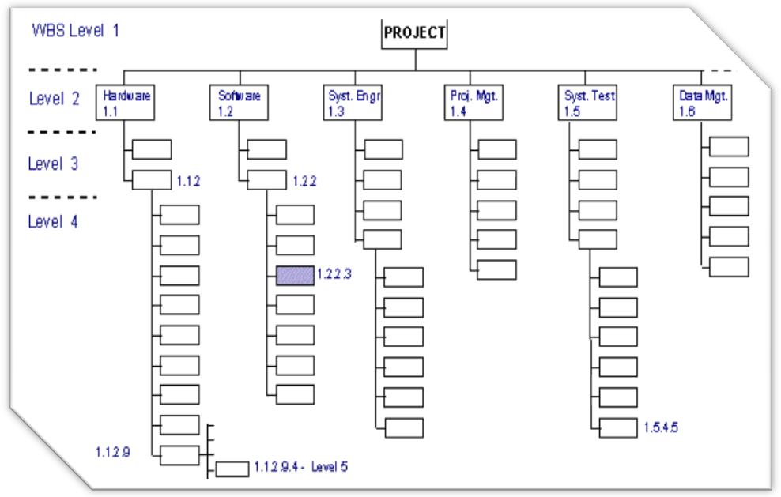

Step three
Organization breakdown structure
- Term definition
- Organization Breakdown Structure (OBS) is an intermediate level of the Work Breakdown Structure (WBS) in which organizational relationships are identified and used as the framework for assigning work responsibilities.
Work Breakdown Structure (WBS) captures all the elements of a project in an organized fashion. Breaking down large, complex projects into smaller project pieces provides a better framework for organizing and managing the project. WBS can facilitate resource allocation, task assignment, responsibilities, measurement and control of the project. The WBS is utilized at the beginning of the project to define the scope, estimate costs and organize Gantt schedules. Once the WBS is developed, resources and responsibilities must be assigned. The OBS groups together similar project activities or “work packages” and relates them to the organization structure. OBS is then used to define the responsibilities for project management, costing, budgeting and project control.
The OBS provides an organizational rather than a task-based perspective of the project. The hierarchical structure of the OBS allows the aggregation of project information to higher levels. When project responsibilities are defined, the OBS and WBS are merged. In using WBS and OBS, it is assured that all elements (scope) of a project will be assigned to a responsible organization.
- We can also say in other words that An Organizational Breakdown Structure is an intermediate level of a different chart that many of you are already familiar with: The Work Breakdown Structure. The OBS displays organizational relationships and then uses them for assigning work to resources in a project.
Like its originator, the OBS allows complex projects to be broken down, providing a more organized representation of the work to be completed. While the WBS is used to define the project during early stages of its cycle, the OBS provides an organizational structure for the project as it moves to completion. The hierarchical nature of the Organizational Breakdown Structure allows for the appropriate resources and responsibilities to be assigned.

- When is an organizational breakdown structure used?
An Organizational Breakdown Structure is used in complex projects and in conjunction with the Work Breakdown Structure. It is used whenever a WBS would be helpful. It allows an at-a-glance look at the organizational resources structured in a hierarchical manner.
- An OBS is helpful in:
- Project Management.
- Workforce Management.
- Work Breakdown Structures.
- Having a visual reference of the resources for any project.
- Viewing costs by resource.

Creation an Organizational Breakdown Structure.

An OBS is created much in the same manner as a Work Breakdown Structure .
Here are the steps that are used to create the OBS:
- Identify the organizational structure for the resources involved in the project, and draw this out.

- Once the structure has been filled out, identify all team members. Assign each team member a position in the structure.

- If there are extra positions that have not been filled, fill them now. If there are additional resources, assign those resources so that all resources and positions are accounted for.

- Be sure that the OBS is structured from the most responsible department and then by the performing departments at the lower levels. These lower levels are where the project responsibilities are matched up with the resource needed.

Once both a Work Breakdown Structure and an Organizational Breakdown Structures have been created, a Responsibility Assignment Matrix can be created, giving a full accounting of tasks and responsible parties.
- Conclusion
The project management term organizational breakdown structure (also referred to by the 3 letter anagram OBS) refers specifically to a tool that can be utilized by the project management team and or project management team leader in a hierarchal manner for the purposes of conducting and creating a thorough and clearly delineated depiction of the project organization for the purposes of creating an arrangement for the purposes of establishing a relationship between and among the various project related work packages as well as between those work packages and the project’s pre-defined performing organizational units. It is important to keep in mind that organizational breakdown structure is also written and recorded as organization breakdown structure with the same definition applied and typically using the same three letter anagram of OBS. The organizational breakdown structure should be established at the onset of the activity to help in the purposes of organization; however, it is possible to conduct this in an ongoing basis.
Step four
- Project activities (tasks)
  - Activity definition
An activity is a unique unit of the project which can be described within prescribed limits of time.
In other words, it is any task, function, or decision that consumes time. it does not need to cost any thing nor does it need any resource other than time.

  - Types of activities
One must recognize the different types of activities that can come into play in a construction project.
- Production activities:
Production activities are those that can be taken directly from the plans and specifications. They involve the application of resources ( materials, labor, or equipment). Such activities are the most obvious and consume the greatest amount of time for completion of the project, and these activities relate directly to the physical effort of creating the project. Some examples are: excavating forming, setting reinforcing steel, placing concrete, building the west wall, and so on…
Production activities must be completely shown on any construction project network. The omission of a production activity from the activity list and out of the network might result in failure to fulfill the contract.

- Procurement activities:
These activities include arranging for the acquisition of material, money, equipment, and manpower. These may include a number of activities that influence the timing of production activities.
Readily available items generally do not require separately defined procurement activities. Special-order, long, or uncertain lead-time items should always have procurement activities incorporated into the network. This permits appropriate analysis to be performed if changes or delays occur. The inclusion of long lead-time items will also function as a reminder to take appropriate procurement actions on selected items before they begin to delay the project.
- Management decision activities:
Support or administrative tasks often directly impact the project schedule. The scheduler should always be aware of those required "extra" or management activities that are not included in the above two categories.
Activities such as preparing inspection reports, processing shop drawing approvals, tracking submittal approvals, developing as built drawing, providing certifications on factory tests performed, and variety of similar tasks may need to be included.

  - Activity sequencing
- Activity sequencing process:
The term activity sequencing refers within the context of project management to a dual process. Initially, activity sequencing involves a specific process of the identification of dependencies among a series of schedule activities.
The next step of activity sequencing involves the documentation of the said series of dependencies among those schedule activities. More specifically, activity sequencing involves the chronicling the dependencies among these schedule activities and putting them into a logical order. Activity sequencing also involves a careful examination of the relationships between schedule activities and their precedence relationships, which is also provides a tangible benefit to the development of an accurate schedule. Some techniques of activity sequencing that are particularly effective include precedence diagramming method, arrow diagramming method, schedule network templates, dependency determination, and the application of leads and lags.
Some outputs from activity sequencing include project network schedule diagrams, activity list updates, activity attributes updates, and requested changes.

    - Dependencies
One of the most critical steps in scheduling is to create task dependency, or links. Determining the dependency among activities is a step of the planning phase and this step makes the difference between a plan that can be used as an effective management tool and a plan that can only be used as a presentation tool.
Linking: in a project, establishing the dependency between tasks (start and finish dates.

Also, this step demands the understanding of the whole project and the knowledge of the applied technologies.
A dependency occurs when the start or finish of one task depends upon the start or finish of another. Most tasks are dependent upon other tasks.

After the dependencies are set, you can easily identify the critical path, and understanding the driving factors for the project end date. You can also easily make changes to one task and immediately see the ripple effect it will have on the rest of the plan. This is where project shows its power as a tool for managing projects.
Critical path : is the longest path on the network. The series of tasks that must be completed on schedule for a project to finish on schedule. Each task on the critical path is a critical task

The challenge planners have is to ensure that all tasks are in the dependency chain. Here is a good rule of thumb:
( every task should have a predecessor unless it is driven by the start date of the project. Every task should have a successor unless it is the last task or milestone in the project.)
Predecessor : a task that must start or finish before another task can be start or finish.
Successor : a task that cannot start or finish until another task starts or finishes

When liking tasks, you can specify different types of dependencies. The most common dependency is Finish-To-Start (FS), which means that the predecessor task must finish before the successor task can start.

      - Activities relationships
In the past, relationships between activities were defined as being finish-to-start (FS), whereby the preceding activity must be finished before the succeeding activity can start. This assumption makes it much easier and simpler to develop schedules by manual means. Since most scheduling is now done with the aid of computers, this limitation no longer poses a constraint or concern.
Other types of relationships are also encountered, namely:
- Start-to-start (SS).
- Finish-to-finish (FF).
- Start-to-finish (SF).
- And finish-to-start (SF).
Here is the explanation of each type:
- Finish-to-start relationship:
We talk about this relationship above , but in addition I will give here a briefly explanation because of it`s importance.
In this relationship the start of each activity depends on the completion of its preceding activity. That is if an activity depends on other, it will not be able to start until the preceding activity has been completed. For example, a door jamb must be installed before the door can be hung, similarly, footing excavation must be completed prior to placing concrete for the footing.
For many activity relationships, this assumption is accurate and adequate. Also for manual computations on networks, this assumption is essentially necessary.

- Finish-to-finish relationship:
In which two activities are related by the fact that they must both be completed at the same time. Also, it can be used where activities can overlap to a certain limit.
For example, assume a simple task of setting a flagpole. The task will consist of digging a hole for the pole, setting the pole in the hole, positioning the pole in the hole, and backfilling the hole with the excavated materials. Note that the pole must be held in position until the backfilling is completed. Thus, the backfilling task and the positioning the pole will be finished at the same time

- Start-to-start relationship:
- Start-to-finish relationship:
This type of relationship might appear to be illogical or even irrational however there are numerous situations for which the start-to-finish (typically with a delay or lag) relationship is appropriate to illustrate the relationships between different activities.

Ordering activities:
The order of the activities is based on the timing of some activities relative to the occurrence of the other activities. For each identified activity, the following must be determined:
Which activities must precede it?
Which activities must follow it?
Which activities can be concurrent with it?

Actually, all these questions can be addressed by simply identifying, for each activity, all of the immediately preceding activities (IPAs). Once the IPAs list is completed, the network can be created.
Ordering activities is not necessarily as straight forward as it may seen on the surface. The reason why two activities must be done in a particular order can be termed a constraint. Without constraints on a project all activities can theoretically begin on the first day of construction.
But constraint do exist in the real world and they must be considered in order for a network to be useful.

Constraints are of a variety of types:

Physical constraints:
Physical constraints exist due to the physical process of construction, such as the need to erect forms before concrete can be placed. These are logic constraints that include those defined by "how" the project is to be carried out.

Resource constraints:
These constraints are conditions of limited availability that dictate that certain activities cannot be performed simultaneously because insufficient resources are available. For example, having only one crane available that must be used on two otherwise independent activities might require that the activities be scheduled so that they do not occur at the same time.

Safety constraints:
Safety constraints imposed by safety requirements through performing the work. Sometimes imposes that two activities could not be performed at the same time due to non-safe work conditions. For example, overhead and ground level work at the same area.
And sometimes imposes specific sequence of the work. For example, erecting of scaffolding before external paints can start.
Also , sometimes imposes non-working days due to external hot or cold days.

Financial constraints:
In financial constraints, high cost activities could be delayed due to non-availability of cash requirement during construction. The amount of cost a company can pay within a specific period of time usually limited. So, try to avoid overlap between high cost activities.

Environmental constraints:
Environmental constraints include restrictions to the work to avoid environmental violations. For example, not working in certain area during specific times to avoid affecting proliferation of eagles, fish run.

Management constraints:
Management constraints reflect decision of management that result in a reasonable benefit of the company. For example, the management decided to borrow from your project resources to be utilized in another project.
Another example, the management decided to extend the new year holiday another 2 days.

Contractual constraints:
The owner may impose constraints on the construction process. For example, the owner may require a particular phase of the project to be fully completed and occupied before start construction of next phase. And he may require to minimize the noise and dust because that portion is occupied and in operation.

Regulatory constraints:
These types of constraints related to the regulations of the area of construction. Imposed by municipality, government, etc.
For example, if the construction site in the downtown, heavy vehicles like concrete mixers prohibited to access the site in a specific times of the day. So, you can just cast concrete at night.

Impacts of constraints on the network:
In the initial definition of the network, it is desirable to minimize the number of constraints, because excessive constraints have the following impact of the project:
Lengthen project duration.
Generally increase project costs.
Confuse basic scheduling logic.
Reduce scheduling flexibility.

The imposition of constraints in the network results in linear ordering of activities. Which is not desired. Because the linear order of activities prolong the project duration and set most of the activities as critical.
Only physical constraints should be considered I n the early preparation of the network. Other constraints can be deferred until actual schedule of activities. Where it can be determined that:

The constraints are not met by the schedule.

It can be addressed by shifting of activities within their available float time.

Step five
Activity duration estimation

1.Introduction
Activity duration estimating represents the act of quantifying the amount of time that it is anticipated the activity will take to complete. This phase of the project, that which consists of the estimating of the amount of time needed to complete all individual schedule activities, typically and traditionally takes place before a project is kicked off, during the conception phase, however, it is possible for the actual activity duration estimating period to take place later, perhaps close to or even slightly after the project has officially kicked off, however, even in those cases a draft or preliminary estimation has typically been made. Estimations can be made in any calendar unit that seems appropriate, such as months, weeks, days, etc., the entirety of the activity duration estimate can be further broken down into subparts or milestones at which certain elements, or deliverables, of the activity are to have been completed in final or draft form.
Also we can say that the activity duration estimating is the process of making a realistic quantitative assessment of the likely number of work periods that will be required to complete an activity.

The estimation is often progressively elaborated and more accurate. To ensure that the estimates at this stage are realistic, those of the project team who are more familiar with the nature of the specific activity and those who have the necessary technical knowledge or experience (by participating or managing similar activities/ projects in the past) should be consulted.
In the real life specially in project management, to determine the cost of the project, construction estimates are prepared before a project is constructed. Thus, an estimate is, at best, a close approximation of the actual cost. There are many variations in the cost of materials, equipments, and labor from one locality to another and from one point in time to another. Therefore, the cost estimate of the project, even when compared to other similar projects, is unique to that project. To determine the cost accurately, the estimator should have an accurate estimate of the quantities of material, equipment hours, and labor hours required to complete a given project. The estimator then applies the proper unit costs to these items.

The soundness of the completed estimate depends on the following two factors:
1. The accuracy of the quantity take-off.
2. The judicious selection of the unit costs and the production rates to be used.

The inputs for activity duration estimating are:
- The Activity List: The Activity list identifies work tasks that will be included on the Project Schedule. Remember only activities that are within the scope appear on this list. The Activity List contains all of the tasks for which a duration needs to be projected.

- Activity attributes :Activity attributes list the assumptions or constraints about timing and location of activities and who will be responsible for them.
- Project Scope Statement : The Project Scope Statement is a broad view of the project helps project managers estimate the duration of project activities. Project managers use the Project Scope Statement as an input because it includes deliverables, constraints, and assumptions that apply to the overall project. Specific milestones or limitations imposed by the project's customer, including project deadlines and reporting requirements, are described in the Project Scope Statement.

- Risk Register : The Risk Register describes the effect and probability of events that may delay or disrupt the project. The likelihood of negative events need to be include in the estimate.

- Activity cost estimates : Activity cost estimates provide approximate quantities of resources allocated to specific activities. If the budgeted cost for an activity limits how many people or how much equipment can be used for a specific activity, this needs to be accounted for in the duration estimate. Also keep in mind the law of diminishing returns. There is a point in time where resource additions, just won’t help to speed up the project.

- Activity resource requirements : Activity resource requirement detail the number of hours of effort or equipment time needed to complete an activity. The type and quantity of resources needed are part of the calculation of activity duration.

- The resource calendar : A resource calendar provides availability for people, equipment, and materials needed to do the work activities.

- Enterprise environmental factors : Enterprise environmental factors capture the external environment in which a project organization operates. Information about the effect of environmental factors may be gathered from commercially available estimating databases or from the organization's own records.
- Organizational process assets : Organizational Process Assets should have historical information about previous project and standard operating time to complete a request.

As more information is gathered about the activities included in a project, the duration estimates can be refined.

There are common tools and techniques to estimate how long an activity will take. These are:
- Expert judgment - Experienced coworkers or outside advisers can provide expert judgment. They can recommend shortcuts and identify risks that might be overlooked otherwise.

- Analogous estimating - Companies perform the same activities in one project after another. Analogous estimating bases estimates on the actual duration of earlier activities.

- Parametric estimating - Project managers estimate the duration of an activity by calculating how long it will take to complete a required quantity of work at a standard rate for one employee or one piece of equipment. For example, if we know that it takes 4 hours to setup a single server. We could expect it will take 2 days to setup 4 servers.

- Reserve analysis : Reserve analysis creates a buffer in the schedule. Reserve time is added to the estimated duration of an activity in which delays are very likely. Project managers frequently add reserve time by increasing their initial duration estimates by a fixed percentage. For example, it may be well know that any purchase will take 6 weeks to go through the authorization process.
As a result, activity duration can be calculated as follows:

Quantity of the work /( qty /crew hour ) = crew hours

Where, qty/crew hour is the productivity.

The process of estimating the duration of project activities creates two resulting outputs which are used as the foundation in developing the Project Schedule.
- Activity duration estimates - The first of the outputs is activity duration estimates. The estimated durations show how much time is required for each activity that will appear on the Project Schedule.

- Activity attributes – Activity attributes are updated with the assumptions and constraints that are a part of the estimate.

The Activity Duration Estimating process yields an estimate of how long each activity in a project will take to complete
Some factors that affects duration:
Weather
Availability, quality , and training of operatives.
Quality of workmanship specified.
Quality of management /supervision.
Size and completion date of project.
Length and incidence of holidays
Familiarity with the work
Repetitiveness of the work
Physical constraints of the site. Such as access, size, storage space and etc.

2. Schedule development
2.1 Definition:
First of all schedule means (noun) : 1.written document. 2.Written or printed list, catalog, or inventory, also timetable.
As a verb: 1.to appoint, assign, or designate for a fixed time.

2.2 Introduction
Everyone makes a schedule to organize his or her own everyday life. We register the date of meetings, business lunches, when to go shopping, etc. As we, ourselves are the only human resource for such a plan, it has to reflect that we cannot be at two or more places at the same time. A failure of this kind of planning will result in a lot of confusion, last-minute rush in our work or in our life.
Making a schedule for a construction or any kinds of project means the same: a plan with a sequence of operations and the list of resources, for example: materials, machines, work force.
So that the schedule is an important tools we can use in projects. No matter the size or scope of your project, the schedule is a key part of project management. The schedule tells you when each activity should be done, what has already been completed, and the sequence in which things need to be finished.

2.3 The importance of scheduling
We can say that schedule will help us to do the following:
- They provide a basis for you to monitor and control project activities.
- They help you determine how best to allocate resources so you can achieve the project goal.
- They help you assess how time delays will impact the project.
- You can figure out where excess resources are available to allocate to other projects.
- They provide a basis to help you track project progress.

  - Schedule inputs
- Project Scope Statement : The project scope statement is the description of the project scope, major deliverables, project objectives, project assumptions, project constraints, and a statement of work.

- Risk Register : The Risk Register is used to have a well thought through and accepted evaluation of risk that may delay or halt the project. The PM should consider these events and make adjustments for them.

- Network diagram :The network diagram is used to obtain the sequencing information of activities.

- Activity attributes : Activity attributes describe the who, what, where, why, and how of the project activities to be completed. This information is just to group and categorize activities on the schedule.

- Activity duration estimates :Activity duration estimates determine the length of time (duration) is needed to perform each individual activity.

- Activity resource requirements : Activity resource requirements detail what type of resource is needed and how many are necessary before the law of diminishing returns hits. This is also necessary for physical resources. For example it is very useful to know what type of platform will be needed and used for testing.

- Activity list : The Activity List is the listing of all of the work activities that must be performed to complete the project. All activities must be included in the project schedule and have resources available to do the work.

- Resource calendars : Resource calendars identify the time periods when specific project team members or pieces of equipment are available. Resource calendars show when team members are committed to other projects, are on vacation, or otherwise unavailable to a project.
- Organizational process assets : The organization's own internal policies may limit the times when work activities can be performed. The organization's policies for employee available hours, overtime, and holidays determine which days—and hours—are work time and non-work time. These are organizational process assets that affect the development of a project schedule.

  - Schedule outputs
The outputs from the Schedule Development process yield a completed project schedule among other items. The outputs of schedule development are:
- The Project Schedule – The project schedule includes start and finish dates for project activities, assignments and timing for specific leaders, workers, or other project resources.

- Schedule Model Data - Schedule Model data is supporting information to the Project Schedule. Schedule Model data includes resource requirements by time period, imposed dates, constraints, and schedule alternatives.

- The Schedule Baseline – The Schedule Baseline is the bought into, accepted, reviewed, and formalize version of the schedule. When schedule changes are approved, the altered schedule becomes the new Schedule Baseline and the previous baseline becomes obsolete.

- Requested Changes – Obviously developing the schedule may reveal the need for changes in other parts of the project plan. The analysis of activities during schedule development may show a need to change deadlines, milestones, or resource allocations.
In addition to these outputs, the Schedule Development process updates information created in other project management processes. The following items may be updated as a result of developing a schedule:
- Resource requirements : The Schedule Development process may produce updates to a project manager's estimate of the resource requirements for a project. Many schedule development techniques adjust the quantity or type of resources, or the timing of when they will be used. For example, crashing a schedule may double the resources on some activities.

- Activity attributes: As Project managers develop schedules, they may realize that changes are needed in where, when, or how some activities are performed. These changes to activity attributes must be recorded and communicated to the project teams responsible for performing the activities.

- Project calendar : Project calendars show the days and shifts during which project activities can be performed. When project managers develop the project schedule, they may find it necessary to add days or shifts to the calendar.

- Project Management Plan : The Schedule Development process produces updates to the Schedule Management Plan, which is part of the Project Management Plan. The completion of the schedule may require new strategies to cope with variances between the schedule and actual activity durations.

Chapter four


Project cost management

1. Introduction
project cost management steps:
In general, the steps of project cost management can consider as:

_Resource Planning.
_Cost Estimating.
_Budgeting
_Cost Control.

And we will explain each step in this chapter.

1.1 Resource Planning

_ What is resource plan?
A Resource Plan summarizes the level of resources needed to complete a project. A properly documented Resource Plan will specify the exact quantities of labor, equipment and materials needed to complete your project. This Resource Planning template also helps you gain approval from your Sponsor, ensuring their buy-in.

_ How can we plan our Resources?

There are several questions you need to consider concerning the resources for your project. As we have pointed out, adding resources doesn’t necessarily mean that you will shorten the time needed for various activities. Adding too many people can actually add time to the project. Another factor to consider deals with the skill level of the resources.
Let’s say that you are going to have a team of developers work on the application. When you are planning resources, you have to know the skill level of the potential resources. You may have to trade money for time. That means you may be able to get a lower cost by using a junior developer, but it’s likely that you will also find the process takes longer. Knowing the skill sets of the available people and taking that into account when doing scheduling is a major part of resource planning.
Another issue to consider is that of using part-time people. At first glance, using part-time people looks like a good idea. It appears you can make good decisions concerning their schedules and that you are getting extremely efficient use of their time. However, this isn’t reality, particularly if the part-time people are coders. Development is a mental task; you’re working with knowledge workers. You can’t turn on and off a mental process at will.
Similarly, scheduling people on two projects the same day won’t be efficient use of resources. It takes some time for the developer to get up to writing speed. So when you’re scheduling, don’t think you can schedule different projects for the same knowledge worker on the same day. That kind of schedule may look good on paper, but it doesn’t work. Give your resources a chance to get into the flow of work, and you’ll be much more successful.

-Time using a Resource Plan
A Resource Plan is created during the Resource Planning phase of the project. Anyone responsible for Project Resource Management will need to create a comprehensive Resource Plan, to ensure that all of the resources needed to complete the project are identified. By implementing proper Resource Planning practices, it also helps you with budgeting and forecasting project expenditure
As a result we can say that, this Project Resource Management Plan helps you to identify all of the resources required to complete your project successfully.
Using this Resource Plan, you will be able to identify the quantity of labor, equipment and materials needed to deliver your project.
You will then create a resource schedule, which enables you to plan the consumption of each type of resource, so that you know that you will have enough resources to complete the project.

This Resource Planning template will help you identify the:
Types of labor required for the project
Roles and key responsibilities for each labor type
Number of people required to fill each role
Items of equipment to be used and their purposes
Types and quantities of equipment needed
Total amount of materials needed
1.2 Cost Estimating
when we have an estimates for activity duration and resource requirements, we have the data we need to establish the cost of the project. This is our first look at the dollars involved in doing the project. We know the resources that will be required and the number of hours or volume of resources needed. Unit cost data can be applied to the amount of resource required to estimate cost.

When doing an estimate, you need to consider a few concepts. The first is that no matter how well you estimate cost, it is always an estimate. One of the reasons that so many projects come in over budget is that people actually believe that they have done perfect estimating and that their baseline estimate is set in stone. Remember that it is always an estimate. Anytime you are forecasting the future, as you are when you plan a project, you are dealing with some amount of uncertainty. Because projects are unique by definition, you are doing an estimate. Projects are so often over budget because the budget is an estimate, not an exact mathematical calculation. Even experienced cost estimators miss the mark. The caveat that you must keep in mind is that each project is unique, and it is that uniqueness that means you will have a slightly different budget for your estimate than the one from the previous project. Don’t use the exact same figures when you estimate; it will come back to haunt you sometime in the project.

- Estimating can be done several ways:
- Analogous Estimating.
- Bottom-up Estimating.
- Parametric Estimating.
- computerized tools.

- Also we must put in mind that construction cost includes:
- materials costs.
- labor costs.
- plant and equipment costs.
- overhead costs and profits.

- Materials costs: the costs of materials incorporated in a construction project, together with the labor and equipment costs, constitute the bulk of the costs of construction.
Materials are typically ordered from suppliers through purchase orders or purchase agreements. It is common for materials to be delivered to the construction site before the contractor has any obligation to pay for them. Shortly after the materials are delivered to the site, however, the contractor is generally expected to pay for them. The actual payment arrangements vary between suppliers and these differences should be clearly understood.
Construction planning and scheduling (Jimmie W. Hinze)

- Labor costs: the cost of labor on a project can be substantial. A rough estimate puts labor at approximately one-third of the total cost of a construction project. However, this is largely dependent on the type of project and the amount of work subcontracted. The timing of the disbursement of funds for labor is largely dictated by law. Hourly wages are paid weekly. The primary difference between companies might be simply the day of the week on which the wages are actually paid; otherwise there are few differences. The wage rates and any overtime pay should be included in the estimate, as this information must be known prior to submitting the bid. The timing of the payment of these wages is of particular concern in the cash flow analysis.
Construction planning and scheduling (Jimmie W. Hinze)

- Equipment costs: equipment used on a project will fall into one of the two categories: equipment owned by the company versus equipment leased or rented by the company.
Construction planning and scheduling (Jimmie W. Hinze)

- Operating overhead costs (company overhead):
These costs cover the company-specific costs of running the business, such as those for corporate office costs (office services, supplies, personnel, communications and etc. These costs continue as long as the company exists even one project is running. Construction planning and scheduling (Jimmie W. Hinze)
- Profit:
Profit is company-specific and represents the excess monies earned by a firm over its total costs. As it provides investors with a return on their investment in the company, it is necessary to consider profit as a cost of the project. Construction planning and scheduling (Jimmie W. Hinze)

_ For the following discussions it is important to remember :

* Direct Costs: These are the costs readily identified as being related to putting the facility components in place. They represent the costs of the resources used by activities, such as the materials installed, workers and equipment used, and subcontractors. The cost of materials and the costs of the subcontracted work tend to be relatively fixed or not subject to considerable variance. The biggest variable concerns the costs associated with labor and equipment. If the productivity estimates are overestimated, these costs will overrun. Overestimates on the productivity will result in a longer duration to complete the project. If the productivity is underestimated, the costs will be below budget for that work items and the time to complete the activity will also be reduced. Construction planning and scheduling (Jimmie W. Hinze)

* Indirect Cost ( job overhead ): indirect costs are those that not specifically identified as being associated with a particular work item. These costs are generally incurred whether or not productive work is actually accomplished. Every project requires certain costs to be incurred as long as the project is underway. These are specifically related to one job, such as a site superintendent, job shack, or security fencing. They are generally not related to any particular activity in the project. Also longer project duration will result in higher indirect costs. Construction planning and scheduling (Jimmie W. Hinze)

1.3 cost budgeting
Once you’ve done an estimate, you want to go into the cost budgeting phase. This phase is the time when you assign costs to tasks on the WBS. Cost budgeting is actually very formulaic. You take the needed resources and multiply the costs times the number of hours they are to be used.
Cost budgeting gives the sponsor a final check on the costs of the project. The underlying assumption is that you’ve got all the numbers right. Usually you’ll have the cost of a resource right, but often it’s tough to be exact on the total number of hours the resource is to be used. Remember that no matter what, you are still doing an estimate. Cost budgeting is different than estimating in that it is more detailed. However, the final output is still a best effort at expressing the cost of the project.

- Budgeting Responsibility
The budgeting process creates a great deal of pressure, not only for project managers, but for departments, divisions, and subsidiaries. There is an implied test of fiscal success built into the budgeting process: If you
meet or come in under the budget, you’re assumed to be doing a good job; if you exceed the budget, you’re not.

You should always develop your own project budget, for several reasons:

- You will be responsible for explaining future project expense and cost variances. That’s not possible if you’re working with an imposed budget.

- As project manager, you are in the best position to know what the project should cost. The budget you develop is a financially stated goal, and it should serve a purpose on two levels:

- To give you a means for measuring success during the project
- To serve as a way to measure your performance as a project manager.

- You will also be able to develop the assumptions that go into the budgeted numbers. This is essential if any future variance explanations are to make sense. The assumption is compared to actual, and precise differences are isolated. Only when you can compare on this level will the budgeting process work as intended.

  - Cost control
Cost control is the final step of the cost management process but it continues through the end of the project. And it is the major element of project success.

Introduction

Cost control is equally important to all companies, regardless of size. Small companies generally have tighter monetary controls, mainly because of the risk with the failure of as little as one project, but with less sophisticated control techniques. Large companies may have the luxury to spread project losses over several projects, whereas the small company may have few projects.

Cost control is not only "monitoring" of costs and recording perhaps massive quantities of data, but also analyzing of the data in order to take corrective action before it is too late. Cost control should be performed by all personnel who incur costs, not merely the project office.

- Cost control implies good cost management, which must include:
- Cost estimating
- Cost accounting
- Project cash flow
- Company cash flow
- Direct labor costing
- Overhead rate costing
- Others, such as incentives, penalties, and profit-sharing

- Definition

Application of: (1) investigative procedures to detect variance of actual costs from budgeted costs. (2) Diagnostic procedures to ascertain the cause(s) of variance. (3) Corrective procedures to effect realignment between actual and budgeted costs.

- The following activities make up the cost control process:
- Monitor project spending to ensure it stays within the baseline plan for spending rates and totals.
- When spending varies from the plan determine the cause of variance, and we must keep in mind that maybe this variance is a result of incorrect assumption made when the original cost estimate was developed.
- Change the execution of the project to bring the spending back in line within acceptable limits.
- Prevent unapproved changes to the project and the cost baseline.

- The cost control process maybe include other activities, when it is not possible to maintain the current cost baseline:
- In order to change the baseline, we must manage the process and this is done to allow for the new realities of the project.
- The cost baseline must include an accurately record.
- Inform stakeholders of changes.

- Finally, we should mention the output of cost control:
- Products which are ongoing throughout the life of the project.
- Revised cost estimates.
- Budget updates.
- Corrective actions.
- Expect what will be the total cost of the project.
And we must know that the final product is very important, since it is a compilation of lessons learned during the execution of the project.

Contract cash flow
Definition
We can define cash flow as a measure of a company's financial health. Equals cash receipts minus cash payments over a given period of time; or equivalently, net profit plus amounts charged off for depreciation, depletion, and amortization.
So in other words we can say, Cash flow is essentially the movement of money into and out of your business; it's the cycle of cash inflows and cash outflows that determine your business' solvency.
Cash flow called 'positive' if the closing balance is higher than the opening balance, otherwise called 'negative.'

Cash flow is increased by:
- Selling more goods or services,
- Selling an asset,
- Reducing costs,
- Increasing the selling price,
- collecting faster,
- Paying slower,
- Bringing in more equity,
- Taking a loan.

Cash flow analysis is the study of the cycle of your business' cash inflows and outflows, with the purpose of maintaining an adequate cash flow for your business, and to provide the basis for cash flow management.
Cash flow analysis involves examining the components of your business that affect cash flow, such as accounts receivable, inventory, accounts payable, and credit terms. By performing a cash flow analysis on these separate components, you'll be able to more easily identify cash flow problems and find ways to improve your cash flow.
A quick and easy way to perform a cash flow analysis is to compare the total unpaid purchases to the total sales due at the end of each month. If the total unpaid purchases are greater than the total sales due, you'll need to spend more cash than you receive in the next month, indicating a potential cash flow problem.
- The S-curve
The S Curve is a well known project management tool and it consists in "a display of cumulative costs, labor hours or other quantities plotted against time". The name derives from the S-like shape of the curve, flatter at the beginning and end and steeper in the middle, because this is the way most of the projects look like.
The S curve can be considered as an indicator and it's used for many applications related to project management such as: target, baseline, cost, time etc. That's why there is a variety of S Curves such as:
* Cost versus Time S Curve; (appropriate for projects that contain labor and non-labor tasks).
* Target S Curve;(This S Curve reflects the ideal progress of the project if all tasks are completed as currently scheduled)
* Value and Percentage S Curves;(Percentage S Curves are useful for calculating the project's actual percentage complete)
* Actual S Curve;(This S Curve reflects the actual progress of the project to date)
In order to be able to generate a S Curve, A Baseline and Production Schedule are necessary because they contain important information for each task: -the Baseline - contains information about Actual Start date and finish date. And it can also contain information about Man Hours and costs. On the other hand, the Production Schedule contains information about the actual percentage complete.
There is some software scheduling packages that generate automatically S Curves. For example MS Project does not have this possibility so a third party software application is needed to process the Baseline and Production Schedule data and generate the needed S Curve.( for example S Curve Generator that integrates with MS Excel to generate S Curves).

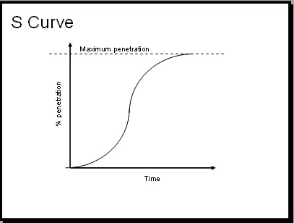
The S-curve

- Project income (cash-in)
Project income is income received or earned by the project as a direct result of the grant activity during the funding period. Examples of project income are such things as
* Reimbursements for services.
* Sales of goods produced with project funds.
* Client fees.
* Registration.

* Earned value management
1. Introduction
1.2 Project Control Using Earned Value Analysis
The goal of exercising control is to achieve project objectives; there are cost, time, performance, and scope targets that are always important. As we have noted, we exercise control to bring performance back on target by comparing performance to plan and taking corrective actions when deviations or variances occur.

One of the hardest things to do in managing projects is to actually measure progress. I mean, in well-defined jobs, such as some construction projects, it is generally fairly easy to tell where you are. That is, you can tell where you are when a part of the work is actually finished. When work is poorly defined and is only partially complete, however, you have to estimate where you are. Naturally, if you can’t tell where you are, you can’t exercise control.

Just you must keep in mind, The fact that planning and monitoring progress may not always be accurate does not justify the conclusion that they shouldn’t be done. Remember, if you have no plan, you have no control, and if you don’t try to monitor and follow the plan, you definitely don’t have control. And if you have no control, there is no semblance of managing. You’re just flailing around.
Fundamental of project management

- Earned Value Analysis

It is one thing to meet a project deadline at any cost. It is another to do it for a reasonable cost. Project cost control is concerned with ensuring that projects stay within their budgets, while getting the work done on time and with the correct degree of quality. One system for measuring these factors is called earned value analysis (also known as variance analysis), that use to allow the government to decide if a contractor should receive a progress payment for work done. Variance analysis allows the project manager to determine “trouble spots” in the project and to take corrective action.
So as a conclusion we can say that earned value is a means for integrating costs and schedule.

- Terms Used in Earned Value Analysis

- Cost Variance: Measures the gap between the budgeted cost and the actual cost of performed work.

- Schedule Variance: Compares planned versus actual work completed.

- Budgeted Cost of Work Scheduled (BCWS): The budgeted cost of work scheduled to be done in a given time period, or the level of effort supposed to be expended during that period.

- Budgeted Cost of Work Performed (BCWP): The budgeted cost of work actually performed in a given period, or the budgeted level of effort actually expended. BCWP, also called earned value, is a measure of the dollar value of the work actually accomplished in the period being monitored.

- Actual Cost of Work Performed (ACWP): The amount of money (or effort) actually spent in completing work in a given period.

- Variance thresholds can be established to define the level at which reports must be sent to various levels of management within an organization.

- By combining cost and schedule variances, an integrated cost/schedule reporting system can be developed.

Two formulas are of use in performing earned value analysis using these concepts:
- Cost variance = BCWP - ACWP
- Schedule variance = BCWP – BCWS
Fundamental of project management & Construction planning and scheduling (Hinze)

Chapter five
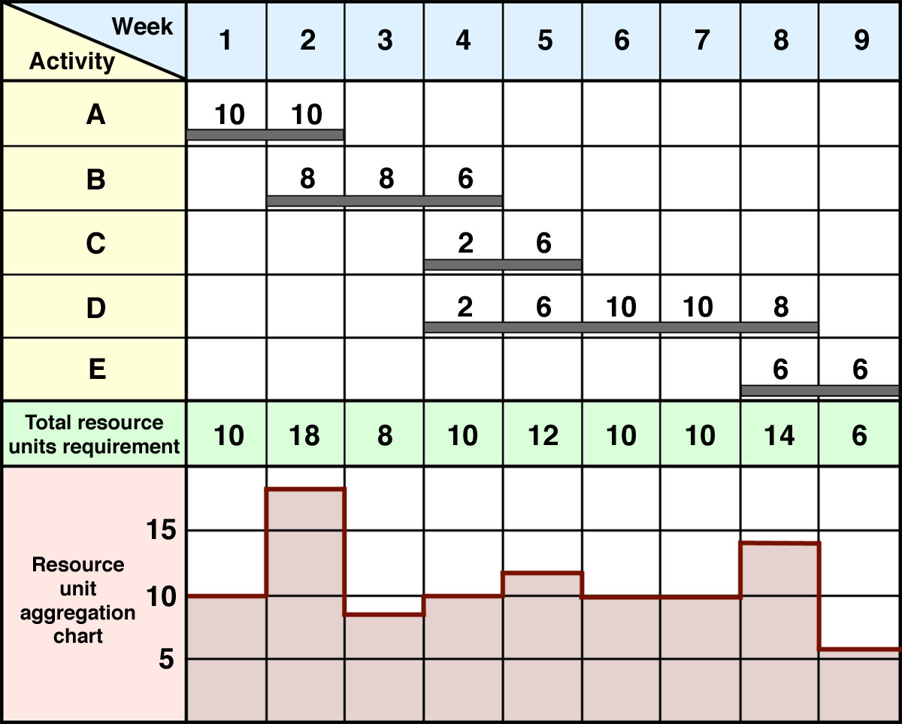

1. Resource Definition
In general, we can define resource as:
- Something that can be used for support or help.
- An available supply that can be drawn on when needed.
But in business dictionary we can say that resources are:
Money, people, time, and equipment necessary for any organization. Resource allocation is one of the most critical of the manager's decisional roles and we will discuss this subject later.

- Resource Management

In the previous chapters we talked about management and it`s stages. so that after each stage, it is necessary to ask the question , " Are all the resources available? " If so, the plan –we put- can be used; however in most real- life projects, resources are limited and hence impose constraints on the scheduling of activities.
Construction performance control by networks (H. N. Ahuja)

During the time analysis we obtained the early and late start and finish times of the activities. During these procedures no resources were assigned to the activities. However, in the practice the completion of individual tasks requires different resources, e.g. , manpower, machines and materials. The limitations of these resources can influence the start and the finish of activities and sometimes the project duration . On the other hand, even if the resource requirements for a projects are far below the limitations, a good arrangement of the activities can cut the peak resource requirement and can make the project more efficient. No doubt, systematic and optimal planning of resource demand can cut the project cost, therefore it has growing importance.
Network scheduling techniques for construction project management (Miklos hajdu)

As the result, these limited resources must be managed. The types of resources that are subject to consideration are those that impose the greatest limitations in the schedule. These limitations arise because the resources may be limited in availability. Construction planning and scheduling (Jimmie W. Hinze)

Other resource that is commonly managed is personnel assigned to a project. The productivity of crews on a project will generally be highest if a constant crew size is maintained for the project duration. Additional crews hired for a short duration require additional orientation and their productivity will not be high. So that, we need to maintain the lowest possible number of employees to perform the work. Construction planning and scheduling (Jimmie W. Hinze)

All of the equipment owned by large companies could not be operated on the a full-time basis. Thus, it was imperative for some firms to carefully manage their equipment operations.
Also, materials is another resource that must be managed. Construction planning and scheduling (Jimmie W. Hinze)

Where resource management is concerned, there are two broad scenarios. One method, when the assumption of the limited resources is being used. This means that the schedule has to be such that the limitations in resources have to be satisfied. Procedures that arrange activities in this way can lengthen the project duration that has been gained from the ordinary time analysis. These kinds of procedures are called resource allocation procedures.
Procedures of the second group cannot change the project duration. In these cases a more efficient resource utilization is the main goal. These methods are known as resource leveling methods.
These two methods will be discuss in the following subjects.
Network scheduling techniques for construction project management (Miklos hajdu)

3. Resource Allocation
3.1 Resource Allocation Definition:

Resource allocation is used to assign the available resources in an economic way. It is also a part of resource management as we said before. In project management, resource allocation is the scheduling of activities and the resources required by those activities while taking into consideration both the resource availability and the project time.

From Wikipedia, the free encyclopedia

3.2 The Series and Parallel Methods:
There are two methods of resource allocation:
*The series method.
*The parallel method.

The basic allocation procedures is a method of scheduling work by balancing need with availability of resources at a given time. the series method accomplishes this by allocating resources to activities in series, i.e. the series method relies on the assumption that once an activity has been started, it cannot interrupted.
The parallel method allocates resources to activities one day at a time. an activity may be allocated resources one day but delayed the next day while another activity using these resources is executed. So that the parallel method is similar to the series method with one basic difference : the parallel method permits activities to be interrupted.

As a conclusion, it can be seen that resource allocation is an essential part of planning. Anyone can make a plan, but it will be useful only if it can be translated into actual work. It can be put into action only if the resources required are available.
Construction performance control by networks (H. N. AHUJA)

3.3 Scheduling Limited Resources
The rules for scheduling activities with limited resources might be summarized as follows:
_ Schedule activities to start as soon as their predecessors have been completed.
_ if more than one activity using a specific limited resource can be schedule , priority is given to the activity with the earliest late start.
_ if the activities are tied for the early late start date, give priority to the activity with least total float.
_ if the activities are tied for total float, give priority to the activity with the largest number of resources.
_ if the activities are tied in the number of resources, give priority to the activity that has already started (top priority in the series method).
_ if no activity has been selected with the above rules, simply start the activity that occurs first in the input order.
Construction planning and scheduling (Jimmie W. Hinze)

4. Resource Aggregation
4.1 Resource Aggregation Definition:

Resource aggregation - or resource loading- is simply the summation, on a period-by-period basis, of the resources required to complete all activities based on the resource allocation carried out in the previous stage. The results are usually shown graphically as a histogram.
Such aggregation may be done on an hourly, daily, or weekly basis, depending on the time unit used to allocate resources. When a bar chart is used as the planning tool, the resource aggregation is fairly simple and straightforward. For a given bar chart, there is a unique resource unit aggregation chart which can be drawn underneath the bar chart. However, a separate graph will be required for each resource unit.

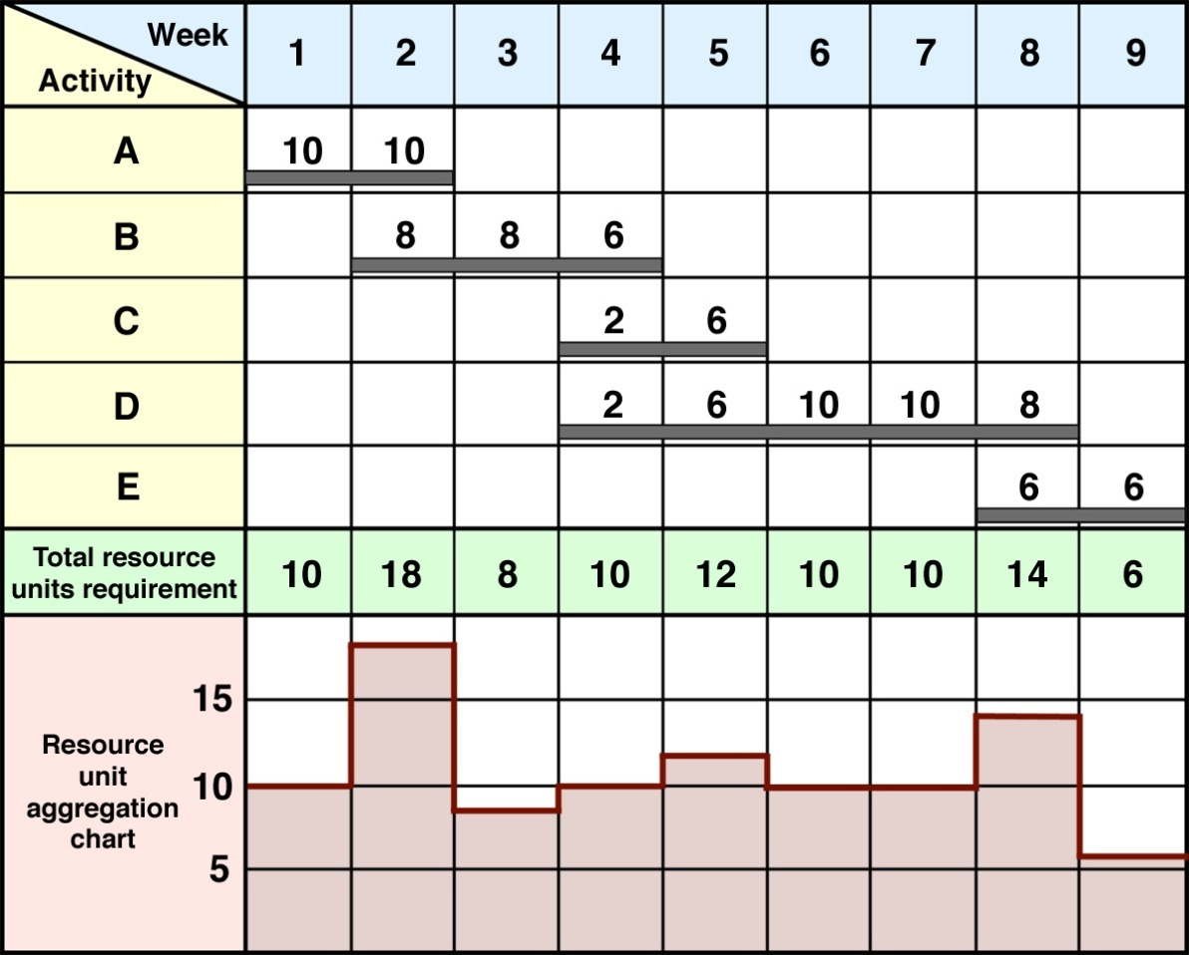
Resource Unit Aggregation Chart Derived from a Bar
5. Resource Leveling
Resource leveling also known as leveling within the float or smoothing is used when resource limits are far beyond the requirements, therefore they do not have any influences on project duration. Network scheduling techniques for construction project management (Miklos hajdu)

In addition, resource leveling, while not constrained by limited resources, tends to reduce the maximum demands for a given resource on any given time. this is desirable, particularly where personnel are concerned, because it helps avoid or minimize the need for hiring short-term workers. In addition, the day-to-day fluctuation of resource will be reduced
On some projects and in some locations, it may be difficult to locate skilled workers. New workers must be given an orientation session and some may require additional training. Newly hired workers are also less efficient in performing the work. These shortcomings can be reduced with resource leveling.
Construction planning and scheduling (Jimmie W. Hinze)

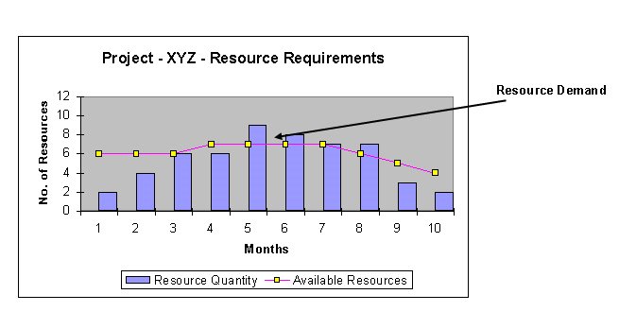
Here is an example about resource leveling
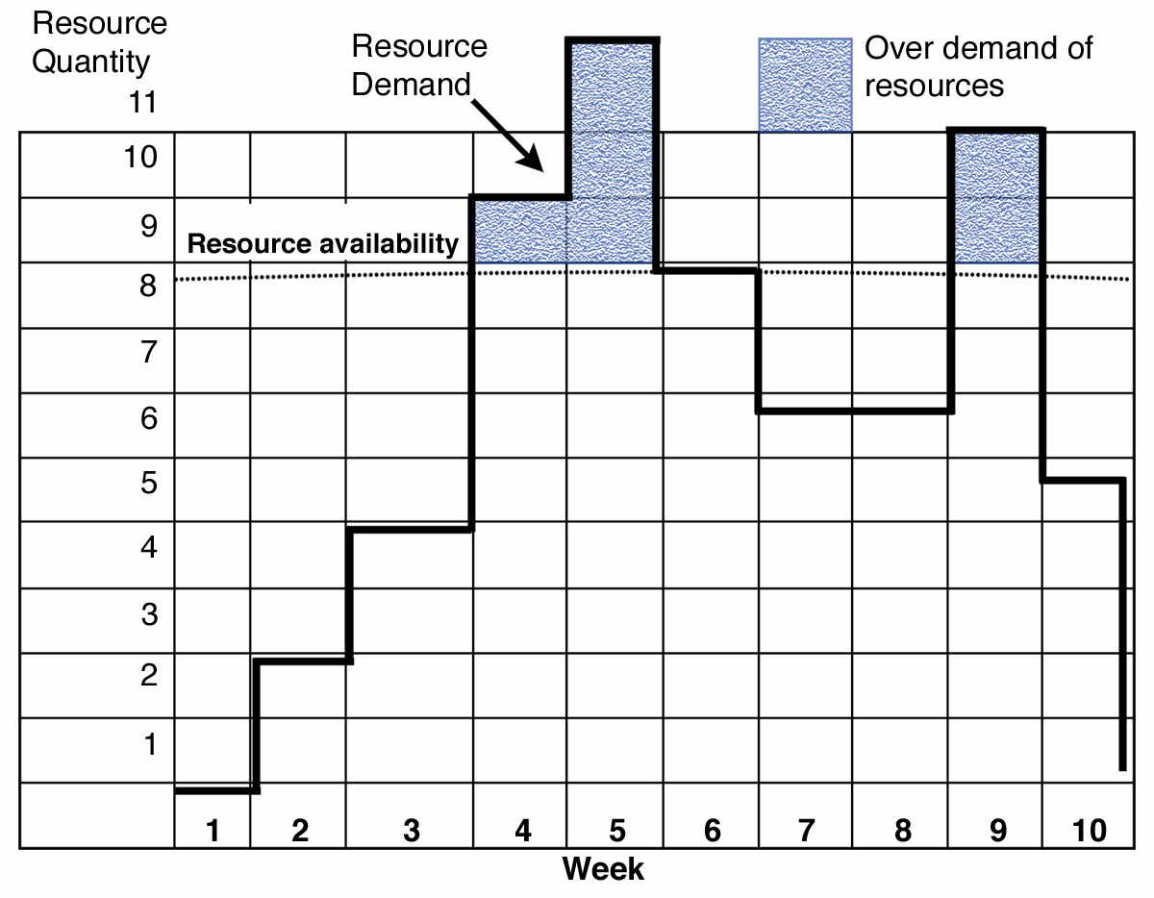
Another example about resource leveling

6. Analyze Resources

"if I had more resources" is the traditional cry of the frustrated project manager. Although, with additional resources, the resources problem itself remains. So we can say that adding more resources rarely improves project performance.
So project managers need to analyze their resource requirements. The purpose of the analyze resources step is to provide project managers with better information about the real resource situation, thereby enabling more effective decision making about the three parameters.

Typical project decisions involve tradeoffs between three parameters:
1. the scope of the project.
2. the schedule of the project.
3. the resources available to do the project.
Effective resources management, based on a good analysis of the resources, is a key element of the project success.
Harvard business school – project management manual

Chapter six


Definition of Risk
In general "risks" are simply the future issues which can be avoided or mitigated, rather than present problems that must be immediately addressed. We can say also that risk is:
- the possibility of suffering harm or loss; danger.
- Exposure to possible economic loss or gain arising from involvement in construction process.
- A variable in the process of constructing a project whose results in uncertainty in the final cost to the owner

In construction management, Risk is a measure of the probability and consequence of not achieving a defined project goal. Most people agree that risk involves the notion of uncertainty. However, when risk is considered, the consequences or damage associated with occurrence must also be considered.
In real life, Risk is not always easy to assess, since the probability of occurrence and the consequence of occurrence are usually not directly measurable parameters and must be estimated by statistical or other procedures.

Risk has two primary components for a given event:
- A probability of occurrence of that event.
- Impact of the event occurring (amount at stake).

Conceptually, risk for each event can be defined as a function of likelihood and impact . and it is important to know that both the likelihood and impact must be considered in risk management.
Risk constitutes a lack of knowledge of future events. Typically, future events (or outcomes) that are favorable are called opportunities, whereas unfavorable events are called risks.
Another element of risk is the cause of risk. Something, or the lack of something, can induce a risky situation. We denote this source of danger as the hazard. Certain hazards can be overcome to a great extent by knowing them and taking action to overcome them. After this we can say that Risk increases with hazard but decreases with safeguard. So, good project management should be structured to identify hazards and to allow safeguards to be developed to overcome them. If enough safeguards are available, then the risk can be reduced to an acceptable level.

- Risk classification

- Known : range of potential outcomes inherent in the activity

- Known-Unknown : Acknowledged situation that could affect the activity by its potential for occurrence; is not immediate nor would normally be expected in the cause of the activity.

- Unknown-Unknown - unknown and unexpected occurrence, have no idea about them .

- Risk classification

- Socioeconomic

1. Environmental protection

2. Public safety regulations

3. Economic instability
- Organizational relationships

1. Unclear, deceitful contractual relationships

2. Attitude of participants

3. Communication
- Technological problems

1. Design assumptions

2. Site conditions

3. Construction methods and techniques

4. Occupational safety

- What is risk management?
Risk management is the act or practice of dealing with risk. In other words, risk management is a systematic approach to minimizing an organization's exposure to risk. A risk management system includes various policies, procedures and practices that work in unison for:
- planning for risk.
- assessing (identifying and analyzing) risk issues.
- developing risk handling options.
- and monitoring risks to determine how risks have changed.

Examples of risk management practices include:
1. purchasing insurance.
2. installing security systems
3. maintaining cash reserves and diversification.

Risk management is not a separate project office activity assigned to a risk management department, but rather is one aspect of sound project management. Risk management should be closely coupled with key project processes, including but not limited to: overall project management, systems engineering, cost, scope, quality, and schedule.

Traditional risk management works to reduce vulnerabilities that are associated with accidents, deaths and lawsuits, among others. While Financial risk management focuses on minimizing risks through the use of financial tools and instruments including various trading techniques and financial analysis. Many large corporations employ teams of risk management personnel.
Risk management can be justified on almost all projects. The level of implementation can vary from project to project, depending on such factors as size, type of project, who the customer is, relationship to the corporate strategic plan, and corporate culture. Risk management is particularly
important when the overall stakes are high and a great deal of uncertainty exists. Today, risk management is a key part of overall project management. It forces us to focus on the future where uncertainty exists and develop suitable plans of action to prevent potential issues from adversely impacting the project.

- Why manage your risk?
An organization should have a risk management strategy because:
- People are now more likely to sue. Taking the steps to reduce injuries could help in defending against a claim.
- Courts are often sympathetic to injured claimants and give them the benefit of the doubt.
- Organizations and individuals are held to very high standards of care.
- People are more aware of the level of service to expect, and the recourse they can take if they have been wronged.
- Organizations are being held liable for the actions of their employees/volunteers.
- Organizations are perceived as having a lot of assets and/or high insurance policy limits.

- Benefits to managing risk
Risk management provides a clear and structured approach to identifying risks. Having a clear understanding of all risks allows an organization to measure and prioritize them and take the appropriate actions to reduce losses. Risk management has other benefits for an organization, including:
- Saving resources: Time, assets, income, property and people are all valuable resources that can be saved if fewer claims occur.
- Protecting the reputation and public image of the organization.
- Preventing or reducing legal liability and increasing the stability of operations.
- Protecting people from harm.
- Protecting the environment.
- Enhancing the ability to prepare for various circumstances.
- Reducing liabilities.
- Assisting in clearly defining insurance needs.
An effective risk management practice does not eliminate risks. However, having an effective and operational risk management practice shows an insurer that your organization is committed to loss reduction or prevention. It makes your organization a better risk to insure.

- Project Risks

Project plans are "living documents" and are therefore subject to change. Changes are needed in order to prevent or rectify unfortunate situations. These unfortunate situations can be called project risks.
Risk refers to those dangerous activities or factors that, if they occur, will increase the probability that the project's goals of time, cost, and performance will not be met. Many risks can be anticipated and controlled. Furthermore, risk management must be an integral part of project management throughout the entire life cycle of the project.

Some common risks include:
  - Poorly defined requirements
  - Lack of qualified resources
  - Lack of management support
  - Poor estimating

- Certainty, Risk, and Uncertainty

Decision-making falls into three categories: certainty, risk, and uncertainty. Decision-making under certainty is the easiest case to work with. With certainty, we assume that all of the necessary information is available to assist us in making the right decision, and we can predict the outcome with a high level of confidence.

- Decision-Making under Certainty

Decision-making under certainty implies that we know with 100 percent accuracy what the states of
nature will be and what the expected payoffs will be for each state of nature.

- Decision-Making under Risk

In most cases, there usually does not exist one dominant strategy for all states of nature. In a realistic
situation, higher profits are usually accompanied by higher risks and therefore higher probable
losses. When there does not exist a dominant strategy, a probability must be assigned to the occurrence of each state of nature.

- Decision-making under Uncertainty

The difference between risk and uncertainty is that under risk there are assigned probabilities, and under uncertainty meaningful assignments of probabilities are not possible. As with decision-making under risk, uncertainty also implies that there may exist no single dominant strategy.

- Stages of risk management program
- Risk identification.
- Risk measurement or evaluation.
- Risk control.

Each of these stages will be explain.

- Risk identification

risk identification includes Classification and cataloging of risk, Check list based on previous experience.
Team approach must ensure that all risks are identified, and when we say all risks we mean:

- Known risks
- Ranges of possible outcomes that are inherent in the activity must be explicitly or implicitly accounted for in the estimate.
- High frequency but low severity.
- Contract document is good source for identifying risks (administrative requirements, time requirement, payment provisions, quality requirements, material requirements).
- Check that contract terms are fair, clear and equitable that vital causes are present.
- The ideal contract is the one that will be most cost effective through assigning each risk to the party that is best equipped to manage or minimize that risk recognizing the unique circumstances of the project

- Example: Pre-construction planning
a) Congested site
b) Limited site access
c) Competing projects may limit labor availability

- Known-Unknown Risks
- Neither explicit nor normally expected, but foreseeable and possible
- Discrete events
- Low frequency
- High sensitivity
- Can be identified from
a) Checklist developed from experience
b) Reviewing of historical reports on similar past projects

- Example:
(1) Extreme bad weather(e.g., tornado, hurricane, flood)
(2) Unusual difficulty with client
(3) Extreme adverse labor activity

- Unknown-Unknown risks
- Unknown - you have to acknowledge their potential
- Very severe
- Low probability of occurrence
- Catastrophic effect
- Experience might help

- Risk measurement and evaluation
In this stage we will Associate potential losses with each risk element, and it is difficult to quantify known-unknown and unknown-unknown risks.
Usually people underestimate uncertainty and overestimate the precision of their own knowledge and judgment but I think that this is wrong, and they must depend on a proper method to evaluate these risks.

And now we will take the method that use to achieve this:

1. Traditional: the use of allowances based on past experience.
a) An allowance of 5% may be included for bulk material quantity growth.
b) A percentage for possible wage increases.
c) An across-the-board markup given to the entire estimated cost of the project to account for all variables.
d) judgment based on previous experience w co the comparable work.

- Simulation:
which use the power of the computer to predict the possible range outcomes for the project.
a) Known as Monte Carlo methods.
b) Most common measurement technique after traditional method.

- Analytic :
the use of mathematics of probability to assess and combine the effects of the individual risk events into an overall measure of risk.

- Discrete event :
appropriate for analysis of known-unknown risks.
a) Decision analysis : is a structured approach to formalizing a problem and defining optimal choices
b) Decision Tree - a conceptual device for enumerating each of the possible decisions that can be made and each of the possible outcomes that may occur, according to each of the events or states of nature that may develop in the pattern.
c) Influence diagram : a graphical representations of a decision problem consisting of simple geometric shapes (circles and squares) connected by arrows such that there are no paths following the arrows.

d) Utility theory (multi-attribute) : permits a decision maker to quantitatively represent his/her preferences via utility functions, evaluate qualitative data typically submitted by contractors, and account for risk and uncertainty in a contractor’ performance.

3.Risk Control

- Advanced planning action:
during the pre-bid phase, the contractor seeks to identify all potential cost items in the contract so that the contract can be realistically priced; for work items, the contractor will envision all potential methods for accomplishing the work with a view to finding the most cost-effective approach; a number of actions are possible in advance of bid submission

1.Risk avoidance
an option always available to the contractor is to avoid all risks by dropping out of competition for the project
a) Wise choice when loss potential clearly outweighs the profit potential
b) If major risks are the type which can truly be controlled through prudent management, contractor should proceed
c) If major risks are the type beyond the contractor’s control(such as unforeseen subsurface conditions), the contractor should not proceed

2. Risk sharing
a) A joint venture arrangement is a classic way to share risk
- Examples
(1) Partnering
(2) Target cost/work-hour contract, where risk is usually shared though a formula that splits over runs and under runs between owner and contractor

3.Risk reduction :
through study of articularly risky elements, it may be possible to find an alternative which carries with it less loss potential.

4.Risk transfer :
transfer of risk to another party
a) Subcontractor is best suited to handle certain risky elements
b) Contractor can reject some owner-assigned risk

5.Insurance :
potential losses associated with many risks will be insured through Worker’s compensation, Bodily Injury, Property Damage Liability, Builder’s Risk, and other policies.

6.Risk acceptance with contingency :
contingency is a reserve account expressed in dollars and/or time to cover losses that do occur
a) Contingency amount selected keeps the probability of not overrunning the target with the desirable limits
b) Sum of planned profit and contingency represents the total ability of the contractor to absorb losses without experiencing a net loss on the project

7. Risk acceptance without contingency :
if competitive condition preclude inclusion of a large contingency, then some risks must be accepted without contingency

- Risk containment actions
Recognizing that the losses assumed are not inevitable and could be either greater or smaller, management wants to contain risk; effective risk containment may convert some or all of the contingency set-aside to additional profit.

1.Contingency planning :
by planning for both normal and contingency events, response to adverse situations can be speeded up and their effects minimized

2.Qualified personnel :
use of known, experience personnel extremely selective recruiting and presence of personnel qualified to deal with any situation

3.Qualified specialty contractors :
use of prequalified specialty contractors will assure that work will meet quality and time requirements and not adversely affect other activities

4.Safety/Loss control program :
will minimize human and material losses on a project plus contribute to lower Workers’ compensation costs on a project plus contribute to lower Workers’ compensation costs on future projects

5.Responsibility allocation :
responsibility for control of risk should be assigned to the individuals or organizations with the greatest capability to control that risk along with a requirement for regular status reporting

6.Strong project controls :
this operation can provide timely and accurate reporting and analysis services for the staff; enables identification of actual and potential problem areas in time for positive corrective action

7.Constructability analysis :
reduction of accident exposure should be made a key element in selecting work methods

8. Pareto’s Law Control :
the attention of management should be focused on key risk items with lesser surveillance of the remainder

9. Critical items reporting :
a system should be established for special reporting of any situation that has affected or has the potential of significantly affection cost or schedule so that these items can receive special attention.

10. Contingency account management :
contingency should be allocated to the various risk accounts and controlled account by account; these accounts are not necessarily the same control accounts used for cost and schedule control purposes

11. Substance abuse program :
a well-planned and administrated program can help assure that all personnel are fit for duty, eliminate the distractions and delays associated with substance abuse problem on the job site, and reduce the potential for accidents

12. Training programs :
special training programs designed for the project can develop needed personnel skill quickly, contribute to team building and otherwise contribute to efficiency and successful interaction of project team members

13. Rehearsals :
for critical operations, rehearsals will reduce the potential for errors during the real operation

14. Project labor agreement :
on union projects, such agreements can eliminate unfavorable work practices and contribute to efficiency of labor and the maintenance of a favorable labor-management atmosphere

15. Risk re-evaluation :
throughout the life of the project, risk exposures should be re-evaluated so that timely control action can be taken and management attention can be refocused as necessary

- Risk Management Process

It is important that a risk management strategy is established early in a project and that risk is continually addressed throughout the project life cycle. Risk management includes several related actions involving risk:

- Planning.
- Assessment (identification and analysis).
- Handling.
- Monitoring.

- Risk planning: This is the process of developing and documenting an organized, comprehensive, and interactive strategy and methods for identifying and tracking risk issues, developing risk handling plans, performing continuous risk assessments to determine how risks have changed, and assigning adequate resources.

- Risk assessment: This process involves identifying and analyzing program areas and critical technical process risks to increase the likelihood of meeting cost, performance, and schedule objectives. Risk identification is the process of examining the program areas and each critical technical process to identify and document the associated risk. Risk analysis is the process of examining each identified risk issue or process to refine the description of the risk, isolate the cause, and determine the effects.

- Risk handling: This is the process that identifies, evaluates, selects, and implements options in order to set risk at acceptable levels given program constraints and objectives. This includes the specifics on what should be done, when it should be accomplished, who is responsible, and associated cost and schedule. Risk handling options include assumption, avoidance, control (also known as mitigation), and transfer. The most desirable handling option is selected, and a specific approach is then developed for this option.

- Risk monitoring: This is the process that systematically tracks and evaluates the performance of risk handling actions against established metrics throughout the acquisition process and provides inputs to updating risk handling strategies, as appropriate.

- Allocation of Risk

- Types
1. Contractual - found in contract
2. Construction - inherent in the process

- Groups of risk resources
1. Resources and project prerequisites
2. Performance - related
3. Outside influences

- Generally accepted principles of risk allocation:
1. Risk belongs with those parties who are best able to evaluate, control, bear the cost, and benefit from the assumption of risks
2. Many risks and liabilities are best shared
3. Every risk has an associated and unavoidable cost which must be assumed somewhere in the process

4. The ideal contract is the one that will be most cost effective through assigning each risk to the party that is best equipped to manage or minimize that risk recognizing the unique circumstances of the project

- The benefit of Allocation Risk
1. Reduced cost of delays and disputes
2. Enhanced awareness of rights and responsibilities during construction
3. Reduces language of questionable enforceability

- Options
1. Transfer all risk of loss to other parties (costly and dispute prone )
2. Allocate and manage risks in accordance with the established principles (reduced cost and not dispute prone)

- Suggestions
1. Review general conditions
2. Obtain/provide geotechnical information
3. Review construction documents
4. Use “real time” dispute resolution
5. Establish realistic contract performance times
6. Establish budget contingency
7. Plan for communication
8. Preplan permits/utilities/zoning
9. Use differing site conditions clause
10. Recognizing small % of design cost relative to total project cost
11. Delegate decision-making authority to Owner’s site representative; include predefined adjustment equations and procedures

- Steps in risk allocation
1. Establish objectives maintain status quo or develop and implement philosophies, attitudes, and procedures
2. Commitment - schedule, budget, philosophy, staffing - this is not just “slow period” work
3. Scoping and objectives conference - identify specific objectives and define specific tasks
4. Review existing documents/procedures in a risk allocation context
5. Preparation and submission of draft(s)
6. Revision conference(s) - discuss in detail every comment and potential recommendations
7. Deliverables - owner should request deliverables such as a markup of contract documents a final report of proposed practice guidelines
8. Implementation - includes contract administration training and contractor and consultant familiarization training

Chapter seven
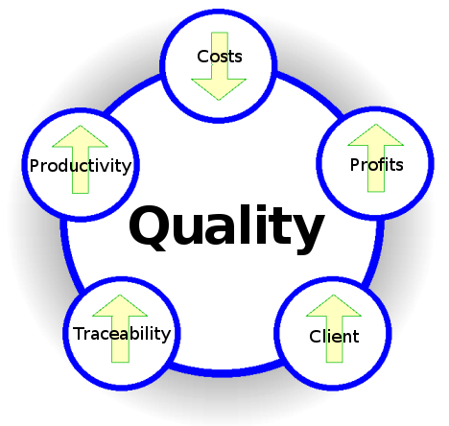
Quality Management

Introduction
During the past twenty years, there has been a revolution toward improved quality. The Improvements have occurred not only in product quality, but also in quality leadership and quality project management. It takes an economic disaster or a recession to get management to recognize the need for improved quality. High-tech engineering companies never fully recognized the need for shortening product development time and the relationship between project management, total quality management, and concurrent engineering.
The push for higher levels of quality appears to be customer driven. Customers are now demanding:
• Higher performance requirements
• Faster product development
• Higher technology levels
• Materials and processes pushed to the limit.
And now one of the major things that customer looking for in the project is the best quality and the fewer prices to pay.

Definition of Quality
Mature organizations today readily admit that they cannot accurately define quality. The reason for this is because quality is defined by the customer. The Kodak definition of quality is those products and services that are perceived to meet or exceed the needs and expectations of the customer at a cost that represents outstanding value. The ISO 9000 definition is "the totality of feature and characteristics of a product or service that bears on its ability to satisfy stated or implied needs."Terms such as fitness for use, customer satisfaction, and zero defects are goals rather than definitions.
Most organizations today view quality more as a process than a product. To be more specific, it is a continuously improving process where lessons learned are used to enhance future products and services in order to
• Retain existing customers
• Win back lost customers
• Win new customers
Therefore, companies today are developing quality improvement processes.

The Quality Movement
During the past 100 years, the views of quality have changed dramatically. Prior to World War I, Quality was viewed predominantly as inspection, sorting out the good items from the bad. Emphasis was on problem identification. Following World War I and up to the early 1950s, emphasis was still on sorting good items from bad.
However, quality control principles were now emerging in the form of:
• Statistical and mathematical techniques
• Sampling tables
• Process control charts
From the early 1950s to the late 1960s, quality control evolved into quality assurance, with its Emphasis on problem avoidance rather than problem detection. Additional quality assurance Principles emerged, such as:
• The cost of quality
• Zero-defect programs
• Reliability engineering
• Total quality control
Today, emphasis is being placed on strategic quality management, including such topics as:
• Quality is defined by the customer.
• Quality is linked with profitability on both the market and cost sides.
• Quality has become a competitive weapon.
• Quality is now an integral part of the strategic planning process.
• Quality requires an organization-wide commitment.

Quality. Furthermore, the ultimate goals should be a continuous refinement of the processes rather than quotas. Statistical process control charts (SPCs) allowed for the identification of common cause and special .
Common cause variations are inherent in any process. They include poor lots of raw material, poor product design, work conditions being unsuitable, and equipment that cannot meet the design tolerances. These common causes are beyond the control of the workers on the floor and therefore, for improvement to occur, actions by management are necessary.
Special or assignable causes include lack of knowledge by workers, worker mistakes, or workers not paying attention during production. Special causes can be identified by workers on the shop floor and corrected. However, workers can eliminate only special cause variability. Management's decision to change the manufacturing process is still needed to reduce common cause variability.
Deming contended that workers simply cannot do their best. They had to be shown what constitutes acceptable quality and that continuous improvement is not only possible, but necessary. For this to be accomplished, workers had to be trained in the use of statistical process control charts. Realizing that even training required management's approval, Deming's lectures became more and more focused toward management and what they must do.

Quality Management Concepts
The project manager has the ultimate responsibility for quality management on the project. Quality management has equal priority with cost and schedule management. However, the direct
Measurement of quality may be the responsibility of the quality assurance department or the
Assistant project manager for quality. For a labor-intensive project, management support (i.e., the project office) is typically 12–15 percent of the total labor dollars of the project. Approximately 3–5 percent can be attributed to quality management.
Therefore, as much as 20-30 percent of all the labor in the project office could easily be attributed to quality management.

From a project manager's perspective, there are six quality management concepts that should exist to support each and every project. They include:
• Quality policy
• Quality objectives
• Quality assurance
• Quality control
• Quality audit
• Quality program plan
Ideally, these six concepts should be embedded within the corporate culture.

- Quality Policy
The quality policy is a document that is typically created by quality experts and fully supported by top management. The policy should state the quality objectives, the level of quality acceptable to the organization, and the responsibility of the organization's members for executing the policy and ensuring quality. A quality policy would also include statements by top management pledging its support to the policy. The quality policy is instrumental in creating the organization's reputation and quality image.
Many organizations successfully complete a good quality policy but immediately submarine the
Good intentions of the policy by delegating the implementation of the policy to lower-level
Managers. The implementation of the quality policy is the responsibility of top management. Employees will soon see through the ruse of a quality policy that is delegated to middle managers while top executives move onto "more crucial matters that really impact the bottom line."
A good quality policy will:
• Be a statement of principles stating what, not how.
• Promote consistency throughout the organization and across projects.
• Provide an explanation to outsiders of how the organization views quality.
• Provide specific guidelines for important quality matters.
• Provide provisions for changing/updating the policy.
- Quality Objectives
Quality objectives are a part of an organization's quality policy and consist of specific objectives and the time frame for completion of the stated objectives. The quality objectives must be selected carefully. Selecting objectives that are not naturally possible can cause frustration and
Disillusionment. Examples of acceptable quality objectives might be: to train all members of the
Organization on the quality policy and objectives before the end of the current fiscal year, to set up baseline measurements of specific processes by the end of the current quarter, to define the
Responsibility and authority for meeting the organization's quality objectives down to each member of the organization by the end of the current fiscal year, etc.
Good quality objectives should:
• Be obtainable.
• Define specific goals.
• Be understandable.
• State specific deadlines.

- Quality Assurance
Quality assurance is the collective term for the formal activities and managerial processes that are planned and undertaken in an attempt to ensure that products and services that are delivered are at the required quality level. Quality assurance also includes efforts external to these processes that provide information for improving the internal processes. It is the quality assurance function that attempts to ensure that the project scope, cost, and time functions are fully integrated.
The Project Management Institute Guide to the Body of Knowledge (PMBOK)® refers to quality assurance as the management section of quality management. This is the area where the project manager can have the greatest impact on the quality of his project. The project manager needs to establish the administrative processes and procedures necessary to ensure and, often, prove that the scope statement conforms to the actual requirements of the customer. The project manager must work with his team to determine which processes they will use to ensure that all stakeholders have confidence that the quality activities will be properly performed. All relevant legal and regulatory requirements must also be met.
A good quality assurance system will:
• Identify objectives and standards.
• Be multifunctional and prevention oriented.
• Plan for collection and use of data in a cycle of continuous improvement.
• Plan for the establishment and maintenance of performance measures.
• Include quality audits.

- Quality Control
Quality control is a collective term for activities and techniques, within the process, that are intended to create specific quality characteristics. Such activities include continually monitoring processes, identifying and eliminating problem causes, use of statistical process control to reduce the variability and to increase the efficiency of processes. Quality control certifies that the organization's quality objectives are being met.
The PMBOK® refers to quality control as the technical aspect of quality management. Project team members who have specific technical expertise on the various aspects of the project play an active role in quality control. They set up the technical processes and procedures that ensure that each step of the project provides a quality output from design and development through implementation and maintenance. Each step's output must conform to the overall quality standards and quality plans,
thus ensuring that quality is achieved.
A good quality control system will:
• Select what to control.
• Set standards that provide the basis for decisions regarding possible corrective action.
• Establish the measurement methods used.
• Compare the actual results to the quality standards.
• Act to bring nonconforming processes and material back to the standard based on the information collected.
• Monitor and calibrate measuring devices.
• Include detailed documentation for all processes.

- Quality Audit
A quality audit is an independent evaluation performed by qualified personnel that ensures that the project is conforming to the project's quality requirements and is following the established quality procedures and policies.
A good quality audit will ensure that:
• The planned quality for the project will be met.
• The products are safe and fit for use.
• All pertinent laws and regulations are followed.
• Data collection and distribution systems are accurate and adequate.
• Proper corrective action is taken when required.
• Improvement opportunities are identified.

- Quality Plan
The quality plan is created by the project manager and project team members. The project quality
Plan is created by breaking down the project objectives into a work breakdown structure. Using a
Treelike diagramming technique, the project activities are broken down into lower-level activities until specific quality actions can be identified. The project manager then ensures that these actions are documented and implemented in the sequence that will meet the customer's requirements and expectations. This enables the project manager to assure the customer that he has a road map to delivering a quality product or service and therefore will satisfy the customer's needs.
A good quality plan will:
• Identify all of the organizations external and internal Customers.
• Cause the design of a process that produces the features desired by the customer.
• Bring in suppliers early in the process.
• Cause the organization to be responsive to changing customer needs.
• Prove that the process is working and that quality goals are being met.

- The Cost of Quality
To verify that a product or service meets the customer's requirements requires the measurement of the cost of quality. For simplicity's sake, the costs can be classified as "the cost of conformance" and "the cost of nonconformance." Conformance costs include items such as training, indoctrination, verification, validation, testing, maintenance, calibration, and audits. Nonconforming costs include items such as scrap, rework, warranty repairs, product recalls, and complaint handling.
Trying to save a few project dollars by reducing conformance costs could prove disastrous. For
example, an American company won a contract as a supplier of Japanese parts. The initial contract called for the delivery of 10,000 parts. During inspection and testing at the customer's (i.e., Japanese) facility, two rejects were discovered. The Japanese returned all 10,000 components to the American supplier stating that this batch was not acceptable. In this example, the nonconformance cost could easily be an order of magnitude greater than the conformance cost. The moral is clear:
Build it right the first time.
Another common method to classify costs includes the following:
• Prevention costs are the up-front costs oriented toward the satisfaction of customer's requirements with the first and all succeeding units of product produced without defects. Included in this are typically such costs as design review, training, quality planning, surveys of vendors, suppliers, and subcontractors, process studies, and related preventive activities.
• Appraisal costs are costs associated with evaluation of product or process to ascertain how well all of the requirements of the customer have been met. Included in this are typically such costs as
Inspection of product, lab test, vendor control, in-process testing, and internal–external design
reviews.
• Internal failure costs are those costs associated with the failure of the processes to make products acceptable to the customer, before leaving the control of the organization. Included in this area are scrap, rework, repair, downtime, defect evaluation, evaluation of scrap, and corrective actions for these internal failures.
• External failure costs are those costs associated with the determination by the customer that his
requirements have not been satisfied. Included are customer returns and allowances, evaluation of customer complaints, inspection at the customer, and customer visits to resolve quality complaints and necessary corrective action.

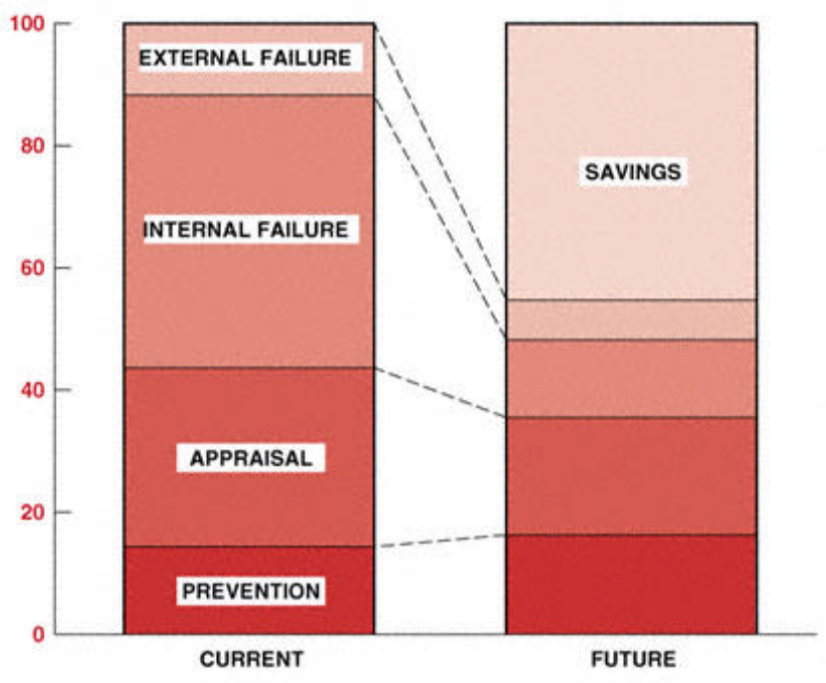
Total quality cost.
Figure shows the expected results of the total quality management system on quality costs.
Prevention costs are expected to actually rise as more time is spent in prevention activities throughout the organization. As processes improve over the long run, appraisal costs will go down as the need to inspect in quality decreases. The biggest savings will come from the internal failure areas of rework, scrap, reengineering, redo, etc. The additional time spent in up-front design and development will really pay off here. And, finally, the external costs will also come down as processes yield first-time quality on a regular basis. The improvements will continue to affect the company on a long-term basis in both improved quality and lower costs. Also, as project management begins to mature, there should be further decreases in the cost of both maintaining quality and developing products.

Figure shows that prevention costs can increase. This is not always the case. Prevention costs actually decrease without sacrificing the purpose of prevention if we can identify and eliminate the costs associated with waste, such as waste due to
• Rejects of completed work
• Design flaws
• Work in progress
• Improperly instructed manpower
• Excess or noncontributing management (who still charge time to the project)
• Improperly assigned manpower
• Improper utilization of facilities
• Excessive expenses that do not necessarily contribute to the project (i.e., unnecessary meetings, travel, lodgings, etc.)
If the ultimate goal of a quality program is to continuously improve quality, then from a financial standpoint, quality improvement may not be advisable if the positive economic return becomes negative.
The Seven Quality Control Tools
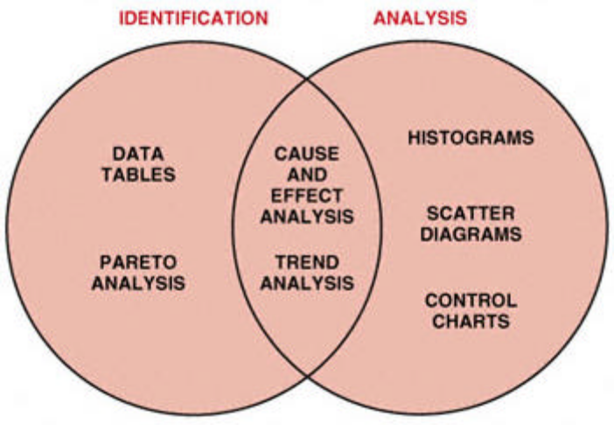
The seven quality control tools.
Over the years, statistical methods have become prevalent throughout business, industry, and
science. With the availability of advanced, automated systems that collect, tabulate, and analyze
data, the practical application of these quantitative methods continues to grow. Statistics today plays a major role in all phases of modern business.More important than the quantitative methods themselves is their impact on the basic philosophy of business. The statistical point of view takes decision making out of the subjective autocratic decision-making arena by providing the basis for objective decisions based on quantifiable facts.

This section is taken from H. K. Jackson and N. L. Frigon, ''Achieving the Competition Edge" (New York:
John Wiley & Sons, Inc., 1996), Chapters 6 and 7.

This change provides some very specific benefits:
• Improved process information.
• Better communication.
• Discussion based on facts.
• Consensus for action.
• Information for process changes.
Statistical process control (SPC) takes advantage of the natural characteristics of any process. All
business activities can be described as specific processes with known tolerances and measurable
variances. The measurement of these variances and the resulting information provide the basis for continuous process improvement. The tools presented here provide both a graphical and measured representation of process data. The systematic application of these tools empowers business people to control products and processes to become world-class competitors.
The basic tools of statistical process control are data figures, Pareto analysis, and cause-and-effect analysis, trend analysis, histograms, scatter diagrams, and process control charts. These basic tools provide for the efficient collection of data, identification of patterns in the data, and measurement of variability. Figure 23–10 shows the relationships among these seven tools and their use for the identification and analysis of improvement opportunities. We will review these tools and discuss their implementation and applications.

Data Tables
Data tables or data arrays provide a systematic method for collecting and displaying data. In most cases, data tables are forms designed for the purpose of collecting specific data. These tables are used most frequently where data is available from automated media. They provide a consistent, effective, and economical approach to gathering data, organizing them for analysis, and displaying them for preliminary review. Data tables sometimes take the form of manual check sheets where automated data are not necessary or available. Data figures and check sheets should be designed to minimize the need for complicated entries. Simple-to-understand, straightforward tables are a key to successful data gathering.
In the Figure is an example of an attribute (pass/fail) data figure for the correctness of invoices.
From this simple check sheet several data points become apparent. The total number of defects is
34.
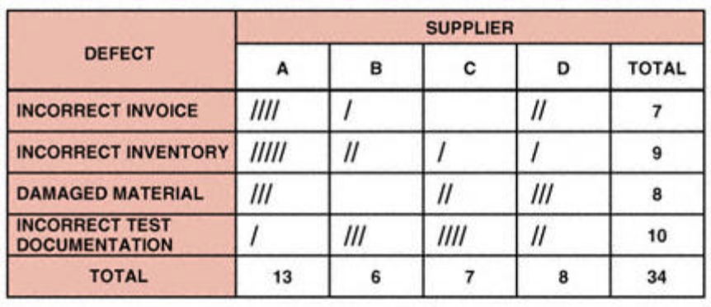
Check sheet for material receipt and inspection.

The highest number of defects is from supplier A, and the most frequent defect is incorrect test
documentation. We can subject this data to further analysis by using Pareto analysis, control charts, and other statistical tools.
In this check sheet, the categories represent defects found during the material receipt and inspection function. The following defect categories provide an explanation of the check sheet:
• Incorrect invoices: The invoice does not match the purchase order.
• Incorrect inventory: The inventory of the material does not match the invoice.
• Damaged material: The material received was damaged and rejected.
• Incorrect test documentation: The required supplier test certificate was not received and the material was rejected.
Cause-and-Effect Analysis
After identifying a problem, it is necessary to determine its cause. The cause-and-effect relationship is at times obscure. A considerable amount of analysis often is required to determine the specific cause or causes of the problem.
Cause-and-effect analysis uses diagramming techniques to identify the relationship between an effect and its causes. Cause-and-effect diagrams are also known as fishbone diagrams.
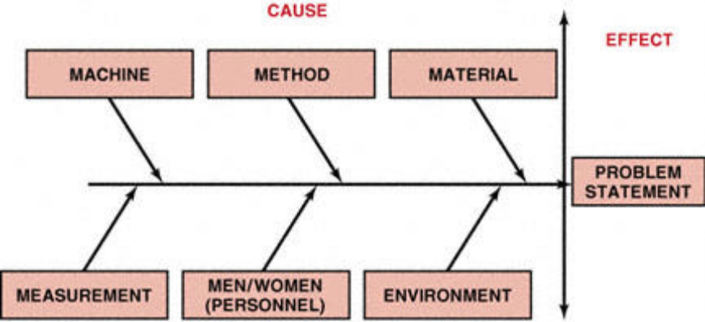
Cause-and-effect diagram.

demonstrates the basic fishbone diagram. Six steps are used to perform a cause-and-effect analysis.
Step 1. Identify the problem. This step often involves the use of other statistical process control tools, such as Pareto analysis, histograms, and control charts, as well as brainstorming. The result is a clear, concise problem statement.
Step 2. Select interdisciplinary brainstorming team. Select an interdisciplinary team, based on the technical, analytical, and management knowledge required to determine the causes of the problem.
Step 3. Draw problem box and prime arrow. The problem contains the problem statement being evaluated for cause and effect. The prime arrow functions as the foundation for their major categories.
Step 4. Specify major categories. Identify the major categories contributing to the problem stated in the problem box. The six basic categories for the primary causes of the problems are most frequently personnel, method, materials, machinery, measurements, and environment, as shown in Figure. Other categories may be specified, based on the needs of the analysis.
Step 5. Identify defect causes. When you have identified the major causes contributing to the problem, you can determine the causes related to each of the major categories. There are three approaches to this analysis: the random method, the systematic method, and the process analysis method.
Page 1107
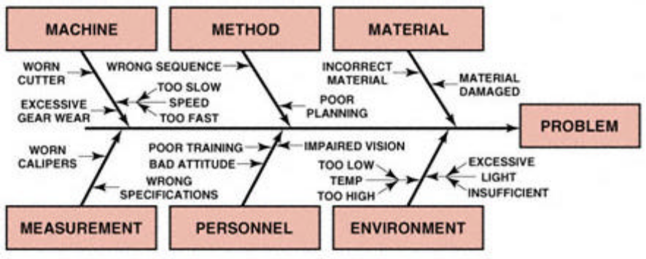
Random method.

Random method. List all six major causes contributing to the problem at the same time. Identify the possible causes related to each of the categories, as shown in Figure

Systematic method. Focus your analysis on one major category at a time, in descending order of
importance. Move to the next most important category only after completing the most important
one. This process is diagrammed in Figure

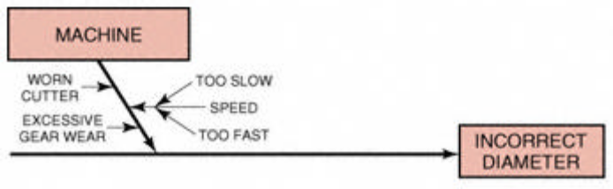
Systematic method.

Process analysis method. Identify each sequential step in the process and perform cause-and-effect analysis for each step, one at a time.
Scatter Diagrams
Another pictorial representation of process control data is the scatter plot or scatter diagram. A scatter diagram organizes data using two variables: an independent variable and a dependent variable. These data are then recorded on a simple graph with X and Y coordinates showing the relationship between the variables. Figure displays the relationship between two of the data elements from solder qualification test scores. The independent variable, experience in months, is listed on the X-axis. The dependent variable is the score, which is recorded on the Y-axis. These relationships fall into several categories, as shown in Figure. In the first scatter plot there is no correlation— the data points are widely scattered
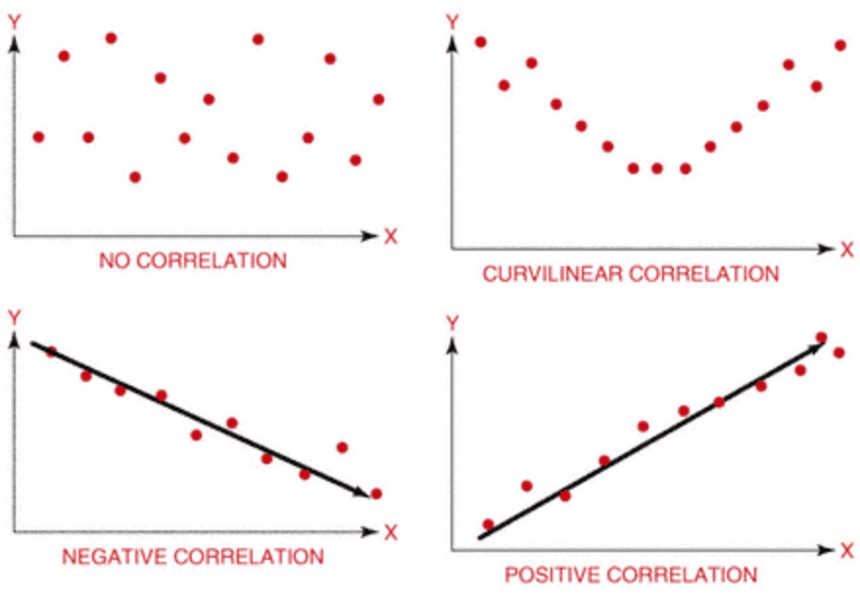
Scatter plot correlation.
with no apparent pattern. The second scatter plot shows a curvilinear correlation demonstrated by the U shape of the graph. The third scatter plot has a negative correlation, as indicated by the downward slope. The final scatter plot has a positive correlation with an upward slope.
From Figure we can see that the scatter plot for solder certification testing is somewhat curvilinear. The least and the most experienced employees scored highest, whereas those with an intermediate level of experience did relatively poorly. The next tool, trend analysis, will help clarify and quantify these relationships.
Trend Analysis
Trend analysis is a statistical method for determining the equation that best fits the data in a scatter plot. Trend analysis quantifies the relationships of the data, determines the equation, and measures the fit of the equation to the data. This method is also known as curve fitting or least squares.
Trend analysis can determine optimal operating conditions by providing an equation that describes the relationship between the dependent (output) and independent (input) variables.
The equation of the regression line, or trend line, provides a clear and understandable measure of the change caused in the output variable by every incremental change of the input or independent variable. Using this principle, we can predict the effect of changes in the process.
One of the most important contributions that can be made by trend analysis is forecasting.
Forecasting enables us to predict what is likely to occur in the future. Based on the regression line we can forecast what will happen as the independent variable attains values beyond the existing data.
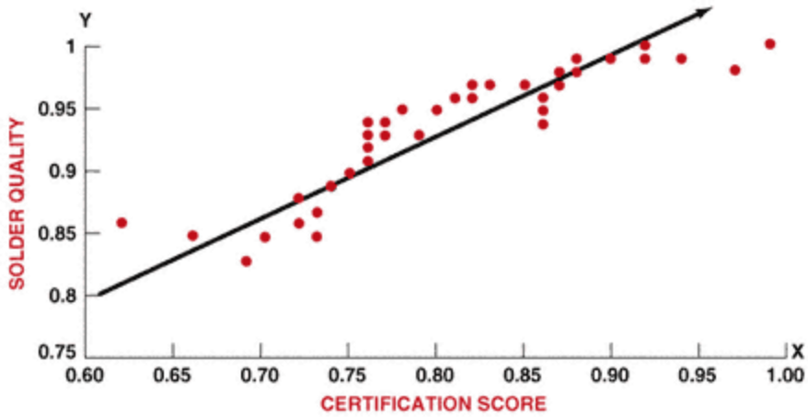
Scatter plot solder quality and certification

Chapter eight


Project communication management

- Introduction
Time and time again in post-project assessments, project teams list communication as one of the most needed areas for improvement. Many times on troubled projects, project team members feel that if the communication had been better, the project would have run smoother.
Communication not only keeps everyone up-to-date on the project progress, but also facilitates buy-in and ownership of major project decisions and milestones. To ensure the success of a project much information, including expectations, goals, needs, resources, status reports, budgets and purchase requests, needs to be communicated on a regular basis to all the major stakeholders.
Project communication can often be more difficult due to challenges unique to project management. Many projects are short-term, and therefore project communication is temporary. This means that communications systems need to be established quickly in shorter periods of time. It is just as important to develop a communication plan for the project as it is to develop task planning.
Another challenge is that projects often include cross-functional or inter-organizational teams. Project teams are not normally natural teams and sometimes do not even reside in the same geographic location. Unique delivery methods and communication devices need to be utilized to overcome this challenge. But, it is possible to quickly implement effective communications that reach all affected parties, no matter how complicated or diverse your project team may be.

Communication, as you can tell from the above, is more than just talking. Communication is also listening. When it comes to project management, communication takes up 90% of a project manager's time. That's right, 90% of your time.

- Definition
Typical literary definitions of effective communications include:

- An exchange of information.

- An act or instance of transmitting information.

- A verbal or written message.

- A technique for expressing ideas effectively.

- A process by which meanings are exchanged between individuals through a common system of symbols.
This is as kerzner

Effective communication involves both sending and receiving the message. With this in mind, a good definition of project communication management can be (Project Communications Management includes the process
required to ensure timely and appropriate generation, collection, dissemination, storage, and ultimate disposition of project information).
We can also say that Communications management is the systematic planning, implementing, monitoring, and revision of all the channels of communication within an organization.
"http://en.wikipedia.org/wiki/Communications_management"

Basically, communication is the way information is exchanged between entities. There are various components of the communication process. They include the message, source, encoding, channel, decoding, receiver, feedback, noise, context and shared meaning. One of the primary points of effective communication is that it is interactive.
- The categories of communication:
Real communication is about transferring knowledge. You know something and you tell someone else, and then they know it. But it doesn't always work that way, does it? I think that Communication is tough.
Communication during projects can be of many different types such as oral, written and non-verbal. Oral communication is mainly utilized in face-to-face meetings or over the telephone as well as in group meetings and affords a lot more flexibility to the speaker, such as the ability to communicate not only with voice but body language, attitude and nuance.
The subtle nuances that can be communicated during verbal communication are not present during written communication. Written communication, on the other hand, is usually more precise. It can be sent through correspondence such as memos, letters or notices. It can also be sent via Email or the project management information system. The key to making written communication more effective is to first grab people’s attention, and then give them a reason to want to read the rest of the communication. And I think this is a very useful technique in many projects.

- Project communications management processes
- Introduction
Project Communications Management Knowledge area provides a critical link between people, ideas, and information at all stages in the project life cycle. Project Managers should be spending about 90% of their time communicating. Formal processes aid in decision making and help to achieve a successful project.
This Communication Process helps you to undertake Communications Management for your team. If you want to keep the right people informed with the right information, at the right time, then this process will help you.

- What is a Communication Process?
A Communication Process, or Communications Management Process, is a set of steps that are taken every time formal communications are undertaken in an organization. A Communications Process is undertaken as part of Communications Management and helps to ensure that your stakeholders are kept regularly informed. For example as part of the project life cycle, the team implement a Communication Process to make sure that the entire team is kept informed of the status of the project.

- When do I use a Communication Process?
A Communication Process should be used when you wish to communicate formally within an organization. By using the Communication Process, you can ensure that no miscommunication occurs. As part of the Communication Process, you can also receive feedback on the communications which have taken place to date and. Communications Management is a fundamental part of any organization and needs to be treated with care. Using this Communications Process, you can communicate effectively at all times.

- The Project Communications Management processes
We can say that project communication management processes are:
- Communications Planning: Communications planning is the process of ascertaining the information and communication needs of project stakeholder. This process normally occurs as a part of the Planning Process Group.

- Information Distribution: Information Distribution is the process of assuring the project stakeholders have the needed information available in a timely manner. This process occurs throughout the Executing Process Group.

- Performance Reporting: Performance reporting is the process of gathering and distributing project performance information including status reporting, progress measurement, and forecasting. This process occurs within the Monitoring and Controlling Process Group.

- Manage Stakeholders: Managing Stakeholders occurs within the Monitoring and Controlling Process Group. Managing stakeholders is concerned with satisfying the requirement for the project stakeholders and resolving any issues raised by the project stakeholders.

It is a good idea to remember that activities and responsibilities under the above process will depend upon the project on hand. A smaller project obviously will not have the same communication standard as a larger project.
The important point is that all communication should be effective, accurate, and considerate of project requirements.
The project communication processes provide a methodology for successfully implementing your project communications strategy. In addition to assuring stakeholders are informed and involved in the project.

- The Communication Process will help you to:
- Identify the messages that need to be sent.
- Determine your target audience for communication.
- Decide on your message format and timing.
- Draft your message and gain approval where required.
- Communicate your message, through communications events.
- Gather feedback and improve your communication processes.

- By using this Communication Process, you can:
- Clearly identify your project stakeholders.
- Identify your stakeholder’s communications needs.
- Run any type of communications event to send out your message.
- Ensure the right people receive the right information at the right time.

Keeping your stakeholders regularly informed is a critical activity for any team. Whether it's through status reports, regular meetings or informal email, you can ensure that the right messages are distributed about the progress of your project. This will help your project team and external stakeholders to remain focused on delivery and to provide you with all of the support you need to deliver your project successfully.

Chapter nine


1. Introduction

Contracts and procurement:
In general, companies provide services or products based on the requirements of invitations for competitive bids issued by the client or the results of direct contract negotiations with the client. One of the most important factors in preparing a proposal and estimating the cost and profit of a project is the type of contract expected. The confidence by which a bid is prepared is usually dependent on how much of a risk the contractor will incur through the contract. Certain types of contracts provide relief for the contractor, since onerous risks ( unfair risk) exist. The cost must therefore consider how well the contract type covers certain high- and low-risk areas.
Prospective clients are always concerned when, during a competitive bidding process, one bid is much lower than the others. The client may question the validity of the bid and whether the contract can be achieved for the low bid. In cases such as this, the client usually imposes incentive and penalty clauses in the contract for self-protection.
Because of the risk factor, competitors must negotiate not only for the target cost figures, but also for the type of contract involved, since risk protection is the predominant influential factor. The size and experience of the client's own staff, urgency of completion, availability of qualified contractors, and other factors must be carefully evaluated. The advantages and disadvantages of all basic contractual arrangements must be recognized to select the optimum arrangement for a particular
project.

Wiley – construction management and engineering

2. Procurement Scheduling

To prevent a plan from becoming unwieldy, activities relating to preparation of contract documents, tender documents, and so on, and activities pertaining to procurement of materials are not included. It is assumed that contract documents will be ready to award contracts on time and materials will arrive on schedule. A delay in awarding a contract can jeopardize the on-time start of work. Non availability of materials results in idle men and equipment and makes the implementation of a plan almost impossible.

2. Steps of Procurement Process
The first step in the procurement process is the definition of project, specifically the requirement.
This is referred to as the requirement cycle and includes the following:

- Defining the need for the project.
- Development of the statement of work, specifications, and work breakdown structure.
- Performing a make or buy analysis.
- Laying out the major milestones and the timing/schedule.
- Cost estimating, including life-cycle costing.
- Obtaining authorization and approval to proceed.
Wiley – construction management and engineering

3. objectives for material procurement
On large projects materials must be made progressively available during the construction period. One very obvious problem that most project organizations face at one time or another is that of delays due to the late arrival of vital materials or equipment. Of course in many cases these delays are due to the factors that beyond the control of the project manager. However if sufficient information is available to the planners, these delays can be compensated for by emphasizing some other part of the project.
Another major problem is that of materials arriving too early. This may not seem like a great cause for concern, but there are a number of consequences that result from materials on the site before they are needed. First of all, some means of storing these materials must be found. If they are perishable, there is the added expense of covered storage areas. The possibility of damage and of losses due to pilferage, deterioration, and re-handling is also much higher when the materials are on the site too long. Also the organization incurs losses because it loses interest on its money.

The following objectives should be met by material procurement procedure in the construction industry, which must:
1. determine whether materials will be available on time as required by the project construction schedule. This is necessary to establish physical feasibility of the project plan.

2. produce instant information on the status of all materials at any time.

3. eliminate construction delays resulting from lack of materials when needed.

4. make economic purchasing arrangements in terms of quantity and time.
Wiley – construction management and engineering

Chapter ten
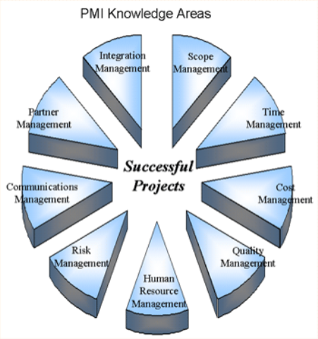

What is Project Integration Management?
Project integration management involves coordinating all of the other project management knowledge areas throughout a project’s life cycle. Three main processes involved in project integration management are as follows:
- Project plan development: involves putting the results of other planning processes into a consistent, coherent document, namely, the project plan.
- Project plan execution: involves carrying out the project plan by performing the activities included in it.
- Integrated change control: involves coordinating changes across the entire project.
Project integration management ties together all the other eight project management knowledge areas. As a result, it depends on the inputs from the rest of the knowledge areas.
Figure (1) presents a framework as to how project integration management serves as the guiding force in project management. The x-axis of the figure represents the project life cycle phases, where as the y-axis represents the other eight project management knowledge areas. As can be seen from Figure (10-1), the project integration management knowledge area is represented as an arrow that becomes more focused as the project processes through its life cycle. This indicates that project integration management pulls everything together to guide the project toward successful completion.
Project integration management is regarded by many project management professions as the key to overall project success. What project integration management is really about is to integrate the work of all of the people involved in the project by focusing on good communication and relationship management. Project integration management includes interface management, which involves identifying and managing the points of interaction between various elements of the project.
It is important to understand that project integration management must occur within the context of the entire performing organization, not just within a particular project. In other words, the objectives of one particular project must be subject to the overall interests of the entire organization.
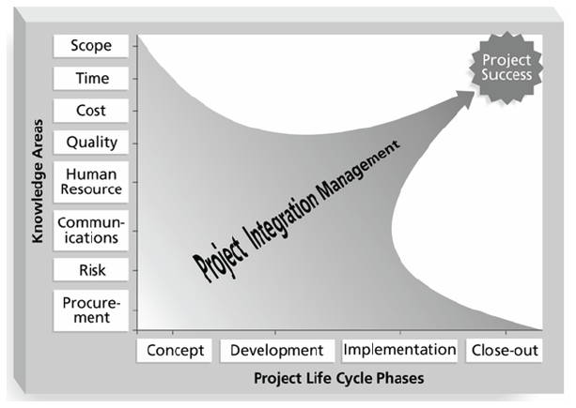Figure (1): Framework of Project Integration Management

- Project Plan Development
Good project integration management starts from a good project plan. A project plan is document used to coordinate all project planning documents and help guide a project’s execution and control
- Project plan contents
Project plans vary greatly depending on the size and nature of the projects. However, there are common elements that most project plans include:
- An introduction or overview of the project.
- A description of how the project is organized.
- The management and technical processes used on the project.
- Sections describing the work to be performed.
- Schedule.
- Budget.

The introduction or overview of the project plan should include, as a minimum, the following information:
- The project name
- A brief description of the project and the need it addresses
- The sponsor’s name
- The names of the project manager and key team members
The description of how the project is organized should include the following information:
- Organizational charts
- Project responsibilities.
- Other organizational or process related information.
The project schedule section should include the following information:
- Summary schedule
- Detailed schedule.
- Other schedule-related information.

The section of the project plan describing management and technical approaches should include the following information:
- Management objectives
- Project controls
- Risk management
- Project staffing
- Technical processes.
The budget section of the overall project plan should include the following information:
- Summary budget
- Detailed budget
- Other budget-related information.

- Using Guidelines to Create Project Plans
It is a common practice that many organizations use guidelines to create project plans. Most project management software such as Microsoft Project® 2002, Primavera P6.0 provides several project plan template files to be used as guidelines.

- Project Plan Execution

Project plan execution involves managing and performing the work described in the project plans. The majority of the project’s time as well as the budget are spent on execution, as the products of the project are produced during project execution.
Project planning and execution are viewed as intertwined and inseparable activities in project integration management. A rule of thumb to improve the coordination between project plan development and execution is those who will do the work should plan the work.
Strong leadership and a supportive organizational culture are two important factors for the success of project execution. Project managers often need to possess product, business, and application area knowledge to execute projects successfully.
There are some tools and techniques that facilitate project plan execution:
- Work Authorization System: a method for ensuring proper communications so that qualified people do the work at the right time and in the proper sequence.
- Status Review Meetings: regularly scheduled meetings used to exchange project information.
- Project Management Construction Information: can greatly assist in creating and executing the project plan.

- The Integrated Change Control Process

Table 1 lists the important inputs and outputs of the integrated change control process.
Table 1: Inputs and outputs for the integrated change control process
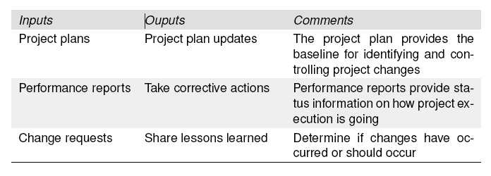
The change control system is a collection of formal documented procedures that define how project deliverables and documentation are controlled, changed, and approved. The change control system is a subsystem of the configuration management system.

Part two

Chapter one

Project overview
The project is “Health Clinic” in Borken . The building consist ground floor and first floor.
General information about building:
Total area of the building is 204.13*2=408.26 .
High of the building 3.38*2=6.67m

GOUND FLOOR AREA TABLE
NO. | AREA | Height m | Volume
1 | +(16.50*15.30)=252.45 | 3.38 | 853.28
2 | -(4.90*4.95)=-24.26 | 3.38 | -82.00
3 | -(2.90*3.90)=-11.31 | 3.38 | -38.23
4 | -(6.40*2.00)=-12.8 | 3.38 | -43.26
5 | -(3.55*4.60)=-16.33 | 3.38 | -55.195
Total | =187.75 |  | 634.595

TYPICAL STAIR CASE AREA TABLE
NO. | AREA | HEIGHT( M) | VOLUOME (
1 | (6.90*2.80)=16.38 | 2.15 | 35.217
TOTAL AREA | =16.38 |  | 35.217

TOTAL AREA TABLE
FLOOR NAME | AREA | VOLUOME
GROUND FLOOR | 187.75 | 634.595
STAIR CASE | 16.38 | 35.217
TOTAL | 204.13 | 669.812

Chapter two

Object and method of construction
Object:
The main objective of the second part of graduation project will help in understanding the project and calculating quantity of the project and know how we can use management to reach the most economy, safety, minimum duration and good quality of the project.
Assumption:
- The project was divided in several units.
- The project will performed by a local construction company.
- The electrical and mechanical work will be given to a subcontractor.
- Fixed the value of dollars with local coin (1 dollars= 3.7NIS).

The method of construction:
In the project we use two cases of construction:
First cases: construction all building then make finishing of all building.
Second cases: construction and finishing in the same time (e.g. finishing ground floor and construction first floor in the same time).

Then, we should compare between two cases and choose the best method, the best method we should create the minimum duration but the cost is the same in two cases.

Chapter three

Work breakdown structure (WBS):
As mentioned previously in part 1, the WBS is very important and basic element in all project management because that make it easier to make calculation of quantity, controlling and organizing the project.

When creating a WBS, the project manager defines the key objectives first and then identifies the tasks required to reach those goals. A WBS takes the form of a tree diagram with the “trunk” at the top and the “branches “below. The primary requirement or objective is shown at the top, with increasingly details shown as the observer reads down.
WBS of this project started from the main element which is “health clinic” as one element and then detailed to smaller elements until reach earth work.
The figure below represents the WBS of “health clinic”.

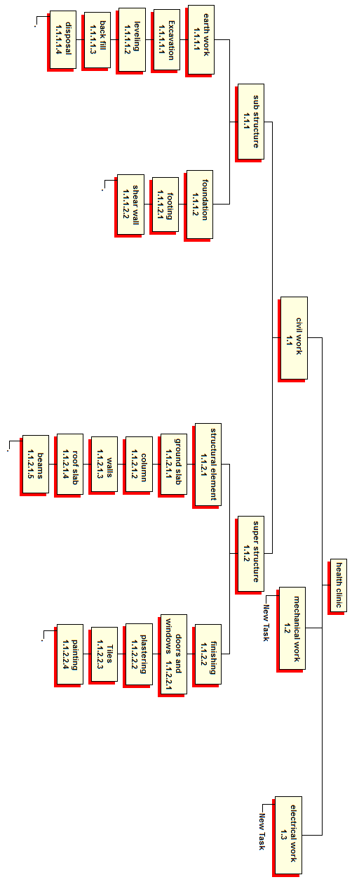

Chapter four

Activities list:
The list of activities depending upon the work breakdown structure, the activities were named according to the international method of naming and so each activity indicates directly to the activity.
The table (1) below describe is a sample of the activities list in this project:
ID | ACTIVITY LIST
1 | Health clinic
1.1 | Civil work
 | Mobilization
 | Site preparation
1.1.1 | Sub structure
1.1.1.1 | Earth work
1.1.1.1.1 | Excavation
1.1.1.1.1.1 | Excavation for reduce level
1.1.1.1.1.2 | Excavation for foundation
1.1.1.1.2 | Leveling
1.1.1.1.3 | Back fill
1.1.1.2 | Foundation
1.1.1.2.1 | Footing
1.1.1.2.2 | Shear wall
1.1.1.3 | Column neck
1.1.1.4 | Ground beams
1.1.2 | Super structure
1.1.2.1 | Structure elements
1.1.2.1.1 | Ground slab
1.1.2.1.2 | Column for basement floor
1.1.2.1.3 | Building wall
1.1.2.1.3.1 | Building external wall
1.1.2.1.4 | Ceiling
1.1.2.1.3.2 | Building internal wall
1.1.2.2 | Finishing
1.1.2.2.1 | Doors and windows
1.1.2.2.1.1 | Installing doors and windows from
1.1.2.2.2 | Plastering
1.1.2.2.3 | Tiles and flooring
1.1.2.2.4 | Painting
1.1.2.2.1.2 | Installing doors and windows
1.2 | Mechanical
1.2.1 | Mechanical work
1.2.2 | Finishing for mechanical work
1.3 | Electrical
1.3.1 | Electrical work
1.3.2 | Finishing of electrical work

Chapter five

Sample of calculation
Sample of calculation;
Column
Calculation of concrete:

Column
Name number unit dimension(m) high(m) area() volume()
C1 19 .20×.50 3.38 1.9 6.422
C2 1 .20*1.20 3.38 0.24 0.82
C3 1 0.30*.30 3.38 0.09 0.3

Volume of concrete for c1 =number×lenght×width×depth
=19×.5×.2×3.38
=6.422
Total volume for column=6.422+0.82+0.3=7.6

Calculation of steel:
Column name | Number | steel | Stirrup | High(m) | Total no. of steel | Weight  kg
C1 | 19 | 814 | 210@15cm | 3.38 | 15214 | 622
C2 | 1 | 614/m | 310@15cm | 3.38 | 1614 | 65.5
C3 | 1 | 612 | 16@10cm | 3.38 | 612 | 20.5

For C1 :
Weight=total length *weight per meter run
=514*
=514*=622 kg
Weight of stirrups
= (14*2+44*2)*22*19*
=300kg

Calculation for price:
Price for column
Quantity for columns=9 m^3
Cost for 1 m^3= 165$
Duration =3 days
Labor:
Steel fixer no.2
Forman no.3
Labor no.8
Overhead and benefit= 1.3
Price=((9*165)+((3*30)+(3*30)+(8*15))*3)*1.2/9=320$

Chapter six

Resource and network preparation
Resources:
for this project resources we should depended on local resource and most availability in order to make less cost, to decrease the risk.
At this project mechanical work and electrical work given for sub contractor to distribute risk.

Network preparation:
The relationship between activities that used at this project is finish to start and finish to finish relationship.
Critical path is determined by calculating total float and free float for each activities using computer software(primavera).

Chapter seven

Result
After determine the quantity, duration and dependency between activities the use primavera project to get this results:
Project name | Total cost ($) | Total duration
Health clinic | 184682
Case one | 184682
Case two | 184682 | 228 days

The total duration for the project equal 259 days when the method of construction is construction all building then make finishing of all building. but when use second method is construction and finishing in the same time the total duration for the project equal 228 days.
Note:
The cost is the same in the two cases. The total price of the project using primavera is 184682$.
Cost details.
1. Civil works 22% from the total cost, including finishing (13.5%) from the total cost.
2. Mechanical work is 32.7% from the total project.
3. Electrical work is 19.6% from the total project
4. Equipment and machines 25.7% from the total project.

Chapter eight

Conclusion and recommends
- After steps of researching and analyzing on this project and given all information,some of result are taken as shown previously.
- The quantity surveying for each activity most be calculated according to work breakdown structur,and then the cost for activity must be determined to calculate total cost and total duration on the project.
- The management principle must be used to determine the early start,early finish,free float, total float for each activity.
- Time and cost most be separately.
Recommendation:

As we saw there are two cases, first case construction all building then make finishing of all building. Second cases construction and finishing in the same time and we notice the difference between these cases was in duration but the cost was the same so the comparison will be about the duration.

If we notice that case one need 259 days but case two need 228 days (31 days) one month difference between the two cases, so we refer case two because we will finish this project earlier.

Chapter nine

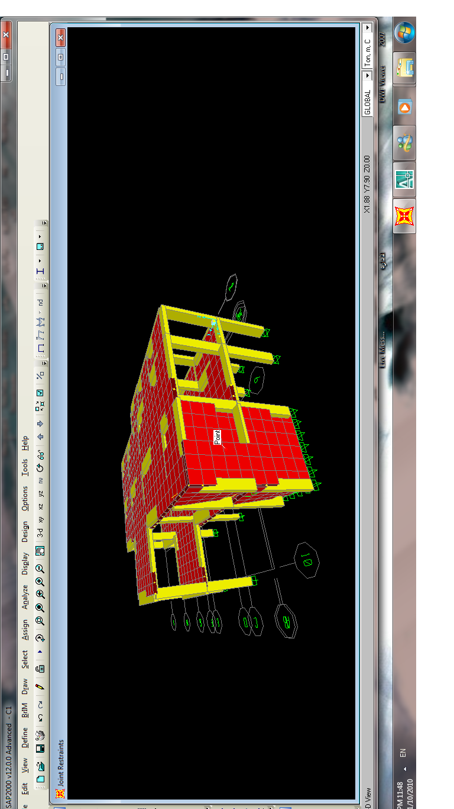

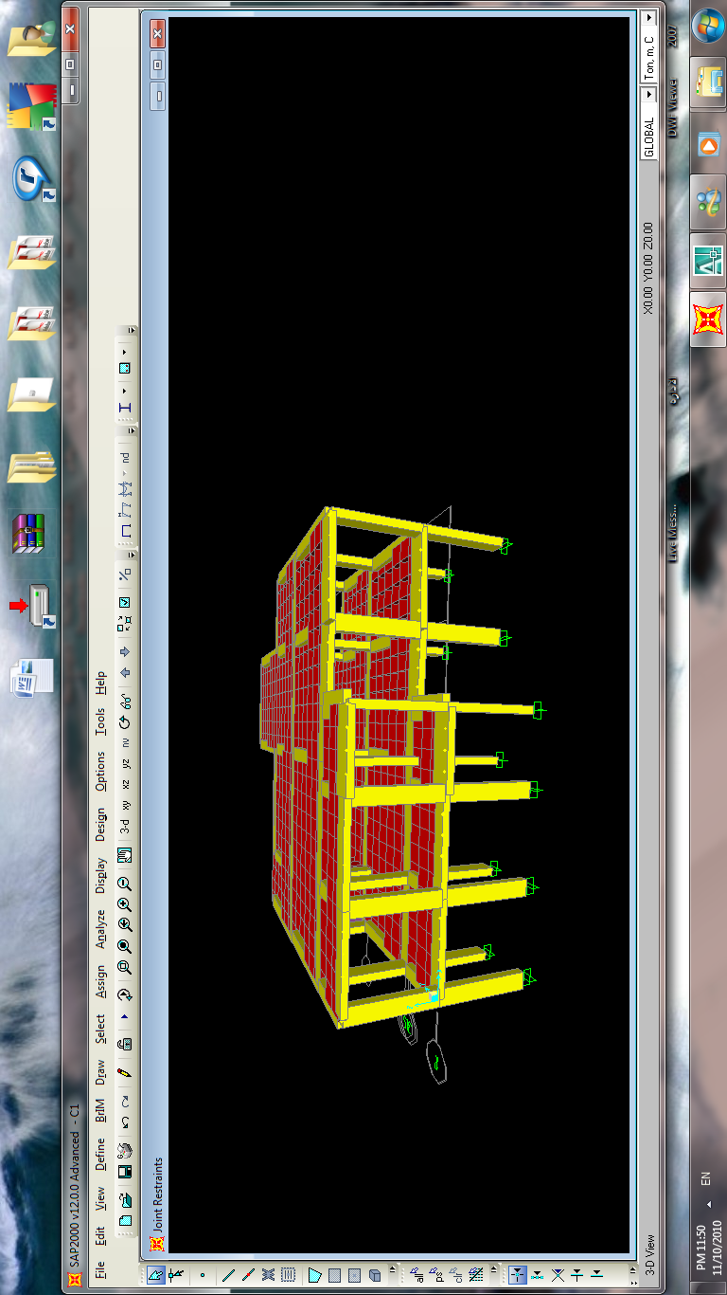

Appendix A

Appendix B

