

Novel Time Hopping M-ary Pulse Position Modulation technique
(TH-M-ary PPM)

Prepared by:
Aya Hamarsheh 10926210
Safaa Hamdan 10824362

Supervisor:
Dr. Ahmad Al-Masri

A graduation Project submitted to Communication and Electrical Engineering Departments in Partial Fulfillment of the Requirements for the Degree of B.Sc.

Communication and Electrical Departments
Faculty of Engineering & Information Technology
An-Najah National University

2014

Acknowledgment

We would like to express our greatest gratitude to the people who have helped & supported us throughout our project. We are grateful to our supervisor Dr. Ahmad Masri for his continuous support for the project, from initial advice & contacts in the early stages of conceptual inception & through ongoing advice & encouragement to this day, Not to forget to thank Dr. Yousef Dama for his useful tips, also we offer our deep appreciation for Eng. Nuha Odeh for her supporting and following up with us.

Our thanks and appreciations also go to the Head of Electrical and communication Engineering Department Dr. Maher Khammash, also to the respected doctors’ staff for monitoring us over the past five years.

Last but not the least, we would like to thank our parents who helped and encouraged us over these years to reach this day, hopefully to make them proud of us.

Contents

Abstract 6
List of abbreviations: 7
Chapter 1: Objective and Introduction 8
1.1 Objectives: 8
1.2 Introduction and Overview 8
1.2.1 PPM Applications 9
1.2.2 Advantages of TH M-ary PPM 9
1.2.3 System Model 9
1.2.3 Time hopping: 10
Chapter 2: TH M-ary PPM 12
2.1 Introduction 12
2.2 Conventional TH M-ary PPM (Variable Frame Duration PPM) 12
2.2 A Novel Method for TH M-ary PPM (Fixed Frame duration PPM) 13
Chapter 3: Simulation 16
3.1 MATLAB program 16
3.2 Conventional TH M-ary PPM (Variable Frame Duration PPM) 16
3.3 A Novel Method for TH M-ary PPM (Fixed Frame duration PPM) 28
Chapter 4: Standards, Constraints and Earlier course work 39
4.1 Standards: 39
4.2 Constraints: 39
4.3 Earlier course work 39
Chapter 5: SWOT Analysis 40
6.1 Strengths: 40
6.2 Weaknesses: 40
6.3 Opportunities: 40
6.4 Threats: 40
Chapter 6: Results and Discussion 42
6.1 SER for both conventional and Fixed TH M-ary PPM: 42
6.2 SER for conventional and proposed fixed TH M-ary PPM (noise with interference): 45
6.3 The influence of Poisson arrival rate parameter 50
7: Conclusions and Recommendations 57
7.1 Introduction 57
7.2 Conclusions: 57
7.3 Recommendations and future work 57
References 58

List of Figures:

Figure 1. 1 Pulse Position Modulation in optical fibers 9
Figure 1. 2 Illustration of the TH-PPM binary modulation [2] 10
Figure 1. 3 Time Hopping Illustration 10

Figure 2. 1 2PPM modulation scheme [4] 13
Figure 2. 2 4PPM modulation scheme 13
Figure 2. 3 2PPM modulation scheme 14
Figure 2. 4 4PPM modulation scheme 14

Figure 3. 1 Flow graph of our simulation 16

Figure 6. 1 SER for 2PPM conventional(above) and fixed (below) 43
Figure 6. 2 SER for 4PPM conventional (above) and fixed (below) 43
Figure 6. 3 SER for 8PPM conventional (above) and fixed (below) 44
Figure 6. 4 SER 16PPM conventional (above) and fixed (below) 44
Figure 6. 5 2PPM for conventional (above) and fixed (below) 46
Figure 6. 6 4PPM for conventional (above) and fixed (below) 47
Figure 6. 7 8PPM for conventional (above) and fixed (below) 48
Figure 6. 8 16PPM for conventional (above) and fixed (below) 49
Figure 6. 9 2PPM conventional (above) and proposed method (below) 50
Figure 6. 10 8PPM for conventional above and proposed method (below) 51
Figure 6. 11 2PPM for conventional (above) and proposed method (below) 52
Figure 6. 12 8PPM for conventional (above) and proposed method (below) 53
Figure 6. 13 2PPm for conventional (above) and the proposed (below) 54
Figure 6. 14 8PPM for conventional (above) and proposed method (below) 55

Abstract

The symbol error probability (SEP) and signal to noise ratio (SNR) performance of time-hopping (TH) M-ary Pulse Position Modulation (PPM) systems in the presence of multiuser interference (MUI) is deeply studied in this project. Contrary to previous studies restricted to binary modulation formats, we analyze and evaluate the performance of such multiuser TH systems employing M-ary pulse position modulation (PPM).

Saving communication resources and improving quality of service are the major aims of this project, as we propose a novel TH M-ary PPM technique that increases the transmission data rate with enhanced Symbol Error Rate (SER).

It’s worth mentioning that we were unable to continue the work of graduation project 1 “Digital Terrestrial Television”, the reason is that we were expecting the arrival of Universal Software Radio Peripheral (USRP) platform to build the digital terrestrial television system using GNU radio, unfortunately, the ministry of communication could not bring it on time, so the recommendation was to move on to this project.

List of abbreviations:

PPM: Pulse Position Modulation
UWB: Ultra Wide Band.
TH: Time Hopping.
PAM: Pulse Amplitude Modulation.
SNR: Signal to Noise Ratio.
SINR:Signal to interference Noise ratio.
SEP: Symbol Error Probability.
SER:Symbol Error Rate.
RF: Radio Frequency.
MA: Multiple Access.
PSD: Power Spectral Density.

Chapter 1: Objective and Introduction

  - 1.1 Objectives:
- Create understanding about M-ary PPM.
- Demonstrate the need for using PPM.
- Propose and analysis a novel method for implementing the TH-M-ary PPM that is more efficient in using the available bandwidth in a multiuser access system.

  - 1.2 Introduction and Overview
Ultra Wideband (UWB) technology is the primary candidate for the physical layer of the upcoming standards for wireless personal area networks, since it provides reliable high-speed data transmission at short ranges over severe multipath conditions. It also exhibits robust Multiple Access (MA) performance with little interference to other communication systems sharing the same bandwidth due to its very low Power Spectral Density (PSD). It also offers a promising solution to the RF spectrum drought by allowing new services to coexist with current radio systems with minimal or no interference. This coexistence brings the advantage of avoiding the expensive spectrum licensing fees that providers of all other radio services must pay.
The fundamental characteristic of UWB is the extremely large bandwidth, which is required since very narrow pulses of appropriate shape and sub nanosecond duration, are being used by the transmitted signal.
One of the most widely studied schemes for UWB communications employs Pulse Position Modulation (PPM) combined with Time Hopping (TH) as its multiple access technique. The UWB pulses are time hopped within a fixed time window (frame) and each transmitted symbol is spread over several pulses in order to facilitate multiple users.
In PPM the position of each pulse, in relation to the position of a recurrent reference pulse, is varied by each instantaneous sampled value of the modulating wave, it used exclusively for transferring digital signals and cannot be used with analog systems. Also it used for transferring simple data and is not effective at transferring files.

Due to the important role of the TH-M-ary PPM modulation technique, we will focus our study on its performance and propose a novel improvement for such a technique with main target of improving the overall system performance under interference dominated system.

  - 1.2.1 PPM Applications
Pulse position modulation has many purposes, especially in RF (Radio Frequency) communications. For example, pulse position modulation is used in remote controlled aircraft, cars and boats. Also it’s often used in optical communication, such as fiber optics, in which there is little or no multipath interference, in the next figure (figure 1.1) we can see how PPM is used in optical fibers, i.e. sending a laser pulse in a random location after dividing the frame into number of frames. [1]
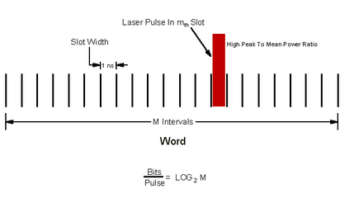
Figure 1. 1 Pulse Position Modulation in optical fibers

  - 1.2.2 Advantages of TH M-ary PPM
- PPM has the advantage over pulse amplitude modulation (PAM) in that it has a higher noise immunity.
- Requiring constant transmitter power since the pulses are of constant amplitude and duration.
- Signal and noise separation is very easy.
- More robust systems against interference.
- Used in plenty of applications, e.g. UWB for common control channels in cognitive radio networks.

  - 1.2.3 System Model
Assuming that users transmit asynchronously, the M-ary PPM signal of the nth user can be modeled as follows: [1]
$$sⁿ\left(t\right)=\sqrt{Ep}\sum_{k=-∞}^{∞}{p\left(t-r*Tf-cᵣⁿ*Tc-δ*dⁿᵥ\right)} (1)$$
Where p(t) is the reference pulse with duration Tp and Eⁿ p = Emax = Tp ・B・10^(−41.3/10) mW is the energy transmitted for each pulse from user n (1 < n < N), Tf is the frame duration and Tc is the chip duration [3]. The number G = Tf /Tc is the number of time-hopping slots, and the nth user’s hopping sequence c ⁿr is a sequence of integers in [0,G − 1]. [2] Finally, dⁿᵥ is the transmitted symbol 0 < dⁿᵥ < M − 1 of the nth user, v=(r/Np) where v is the largest integer y with y < v and $δ$ is the PPM pulse delay. Np pulses/symbol are transmitted providing a symbol rate of R = 1/(NpTf ). [1]

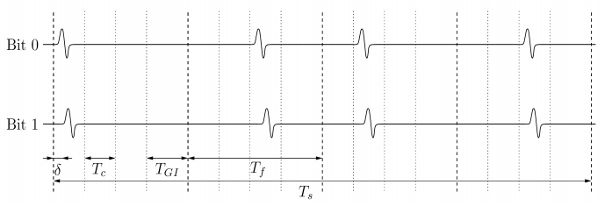
Figure 1. 2 Illustration of the TH-PPM binary modulation [2]

  - 1.2.3 Time hopping:
The technology for generating and receiving pulses on the order of a nanosecond or less in width, the transmission hops in time, [4] information is carried out by short impulse which position in time denotes the transmitted bit, these positions are not periodic, and they are “random” which leads to “Time Hopping” the power is spreaded over a larger bandwidth. [3]
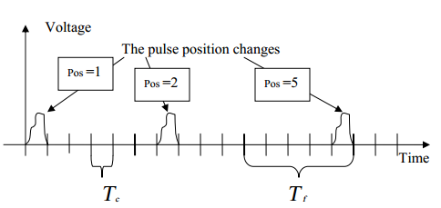
Figure 1. 3 Time Hopping Illustration

We assume that the transmitted signal has bandwidth B = 500 MHz and the transmitted PSD matches the FCC limit for the 3.1 to 10.6 GHz frequency range, which equals −41.3 dBm/MHz. [2]

In order to keep the overall signal bandwidth constant, the pulse duration is fixed to Tm = 2 ns, for any modulation order M. Also, we set the frame duration Tf = 250 ns and the symbol duration to 1 μs, again for any modulation order M.

The conventional way for implementing M-ary PPM is already used and known, which increase the frame duration when M increases, we called this method “variable frame duration”, in our proposal we will find a new method for implementing M-ary PPM by maintaining a fixed frame duration for all orders of M.

In the next two chapters we will elaborate each one of the two previously mentioned methods.

Chapter 2: TH M-ary PPM

  - 2.1 Introduction
As we described in the previous chapter, we are going to demonstrate the conventional M-ary PPM and our proposed novel fixed frame duration M-ary PPM.

  - 2.2 Conventional TH M-ary PPM (Variable Frame Duration PPM)
This method is already used in different PPM applications, the principle of this method is that the frame size will increase as the order of PPM increases, for example, Tf=0.25 us ,0.5 us and 1 us for 2PPM ,4PPM and 8PPM respectively, as it shows in next equation: [7]
$$Ts=log2\left(M\right)*Ns*Tf$$
Where Ns=4, Tf=0.25 and M is the order of PPM.

Also the number of chip will increase as frame size increase by the following equation:
$$number of chips=(floor(Tf/Tc)-1)*(\frac{M}{4})$$

So as the number of chips and frame size increases the message duration will increase too, so we expect that interference for N users will increase as the number of user’s increases. [1] [4].

The next two figures (2.1 and 2.2), shows that how the time increases in 4PPM more than 2PPM

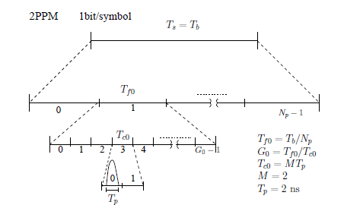
Figure 2. 1 2PPM modulation scheme [4]
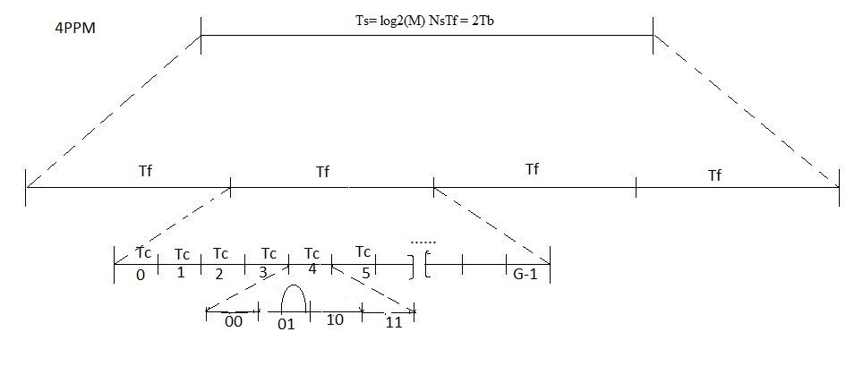
Figure 2. 2 4PPM modulation scheme

  - 2.2 A Novel Method for TH M-ary PPM (Fixed Frame duration PPM)
Fixed Frame Size PPM is a new idea that has not been implemented before, our concentration was on this type by studying it and finding the best way for implementing it, so that we can have more efficient system in bandwidth utilization, this will lead to improve data rate for data transmission in limited time, for 2, 4, 8, and 16 PPM.

In this new method the frame size will remain constant regardless of the order of PPM, i.e., as the order of PPM increases, Tf=0.25 us for 2PPM, 4PPM, 8PPM and 16PPM so we expect that interference for N users will be less than that in the variable size, the next two figures (2.3 and 2.4) explain the idea of this method and how the duration will keep constant.

Note: the parameter setting used for 2-PPM is taken as a reference.

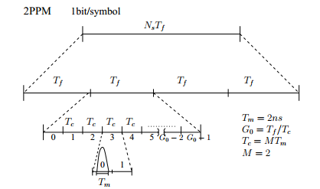
Figure 2. 3 2PPM modulation scheme

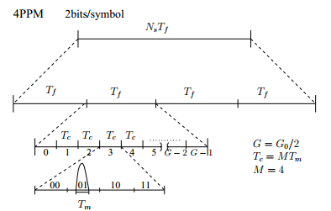
Figure 2. 4 4PPM modulation scheme

As we see from the previous figures, the basic idea of this method is treating 4, 8 and 16PPM as if we send 2PPM, i.e. sending 2 bits/symbol (4PPM) or 3 bits/symbol (8PPM) or 4 bits/symbol (16PPM) is equivalent in time for sending 1 bit/symbol (2PPM), which is why the frame size is fixed. Only number of chips in each frame will vary (decrease), as the order increase it will be reduced to the half of the previous order. For example, it is 62 for 2PPM and 31 for 4PPM … etc.

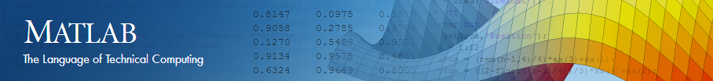

Chapter 3: Simulation

  - 3.1 MATLAB program

Matlab is a high-level language and interactive environment for numerical computation, visualization, and programming. Using MATLAB, we can analyze data, develop algorithms, and create models and applications. The language, tools, and built-in math functions enable us to explore multiple approaches and reach a solution faster than with spreadsheets or traditional programming languages, such as C/C++ or Java.

We used this program in order to simulate both the variable and fixed duration frame PPM, how to generate it with different number of users and for multiple values of orders of PPM.
Next, the flow chart demonstrates the steps of our simulation:

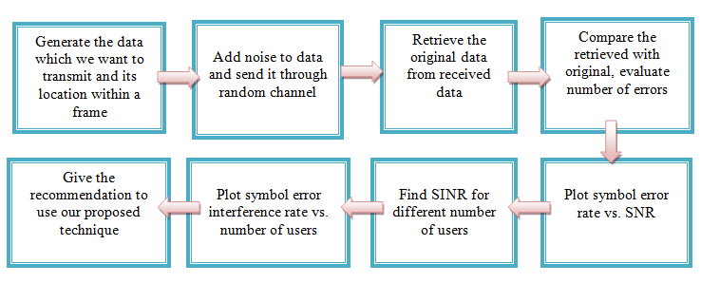
Figure 3. 1 Flow graph of our simulation

In the next two sections we will elaborate the idea of simulation in details.

  - 3.2 Conventional TH M-ary PPM (Variable Frame Duration PPM)
For a specific order (M), each symbol to be transmitted contains four frames, a frame contains specific number of chips (will be determined later), each chip contains M locations, a pulse will be sent in one of the M locations.

We built our simulation by the following steps:
- Generate the data which we want to transmit and its location.
- Add noise to data and send it through random channel.
- Retrieve the original data from received data.
- Compare the retrieved with original one and evaluate the number of errors.
- Find SINR (signal to interference noise ratio) and SER (symbol error probability) for different number of users.
Explaining each step:
- Generate the data which we want to transmit and its location.
Using the sampling frequency of 50 GHz, we concluded that sending 96 bits will be easier if we used the principle of sampling, i.e. each symbol will be equivalent to a specific number of samples, and each symbol includes four frames, so we will have a pulse in random locations in each frame, this pulse is equivalent to 100 ones (using Fc=50 GHz), we conclude that every frame has 12500 samples (50*10³/4), so we sent 100 ones (=Tm=2 ns) in the locations we found, the rest of the frame contains zeroes.
An important thing to mention is that the locations of the first four frames (1st symbol) will be repeated for the rest of the symbols.
The locations are random numbers in a vector called Cr (its values are between 1 and (G-1) where G = (Tf/Tc)), as the order of PPM (M) increases, the number of chips per symbol also increases (doubles), which leads to increase symbol duration.
So as we go from small to larger M, the transmission duration increases for the same number of bits.
The first function for our simulation will have these outputs:
- vartot: it’s the data we will transmit for all bits, i.e. we have 96 bit, vartot will have variable column numbers, and N rows where N is number of users.
- Tran: is the data we sent but every symbol is repeated for times (four frames), tran will have 4*96/log₂(M), column and N rows.
- Loc: it’s the number of chip that has a pulse which we found randomly (Cr).and its size similarly to size of tran.
function [ vartot,w,Cr,tran,loc ] = var( M,N )
%vartot : data after transmission
%w :96 bit to be transmitted
%tran : symbols transmitted (each symbol is repeated 4 times)
%loc: locations of pulses within vartot
Tm = 2e-9; % pulse duration = 2ns
fs = 5e10; % Sampling frequency (in Herz)
Tf=0.25e-6; %frame duration = 0.25 us
Tc=M*Tm; %chip duration
for m=1:N %N is number of users
n=1;
c=0;
G=(floor(Tf/Tc)-1)*(M/4); %number of time-hopping slots
Cr=randint(1,4,[0,(G-1)]);% random number determine which chip has a pulse
w=randint(1,96,[0,1]); %data to be sent
for s=1:log2(M):96
for r=1:4
%------------------------------------------------(2PPM)---------------------------------------------------%
if (M==2)-
a=(Cr(1,r)*(M)*100)+c;% to find the location of pulse
if (w(1,s)==1) %if we sent 1
a=a-100; % indicator of beginning of the pulse
vartot(m,(a:a+99))=1; %sending 100 ones represent one pulse
c=c+12500; %going to next frame
tran(m,n)=1; % sent data
loc(m,n)=Cr(1,r); %location of the pulse
n=n+1;
elseif (w(1,s)==0) %sending 0
a=a-200; % indicator of beginning of the pulse
vartot(m,(a:a+99))=1;%sending 100 ones represent one pulse
c=c+12500; %going to next frame
tran(m,n)=0; % sent data
loc(m,n)=Cr(1,r);%location of the pulse
n=n+1;
end
end
%------------------------------------------------(4PPM)---------------------------------------------------%
if(M==4)
a=(Cr(1,r)*(M)*100)+c; % to find the location of pulse
if (w(1,s)==1&w(1,1+s)==1)%sending 11 =(3)
a=a-100; % indicator of beginning of the pulse
vartot(m,(a:a+99))=1; %sending 100 ones represent one pulse
c=c+(12500*(M/2)); %going to next frame
tran(m,n)=3; % sent data
loc(m,n)=Cr(1,r); %location of the pulse
n=n+1;
elseif (w(1,s)==1&w(1,1+s)==0) %sending 10 =(2)
a=a-200;
vartot(m,(a:a+99))=1;
c=c+(12500*(M/2));
tran(m,n)=2;
loc(m,n)=Cr(1,r);
n=n+1;
elseif (w(1,s)==0&w(1,1+s)==1)%sending 01=(1)
a=a-300;
vartot(m,(a:a+99))=1;
c=c+(12500*(M/2));
tran(m,n)=1;
loc(m,n)=Cr(1,r);
n=n+1;
elseif (w(1,s)==0&w(1,1+s)==0) %sending 00=(0)
a=a-400;
vartot(m,(a:a+99))=1;
c=c+(12500*(M/2));
tran(m,n)=0;
loc(m,n)=Cr(1,r);
n=n+1;
end
end
%------------------------------------------------(8PPM)---------------------------------------------------%
if(M==8)
a=(Cr(1,r)*(M)*100)+c; % to find the location of pulse
if (w(1,s)==1&w(1,1+s)==1&w(1,2+s)==1) %sending 111=(7)
a=a-100;
vartot(m,(a:a+99))=1;
c=c+(12500*(M/2));
tran(m,n)=7;
loc(m,n)=Cr(1,r);
n=n+1;
elseif ((w(1,s)==1&w(1,1+s)==1&w(1,2+s)==0))%sending 110=(6)
a=a-200;
vartot(m,(a:a+99))=1;
c=c+(12500*(M/2));
tran(m,n)=6;
loc(m,n)=Cr(1,r);
n=n+1;
elseif (w(1,s)==1&w(1,1+s)==0&w(1,2+s)==1)%sending 101=(5)
a=a-300;
vartot(m,(a:a+99))=1;
c=c+(12500*(M/2));
tran(m,n)=5;
loc(m,n)=Cr(1,r);
n=n+1;
elseif (w(1,s)==1&w(1,1+s)==0&w(1,2+s)==0)%sending 100=(4)
a=a-400;
vartot(m,(a:a+99))=1;
c=c+(12500*(M/2));
tran(m,n)=4;
loc(m,n)=Cr(1,r);
n=n+1;
elseif (w(1,s)==0&w(1,1+s)==1&w(1,2+s)==1)%sending 011=(3)
a=a-500;
vartot(m,(a:a+99))=1;
c=c+(12500*(M/2));
tran(m,n)=3;
loc(m,n)=Cr(1,r);
n=n+1;
elseif (w(1,s)==0&w(1,1+s)==1&w(1,2+s)==0)%sending 010=(2)
a=a-600;
vartot(m,(a:a+99))=1;
c=c+(12500*(M/2));
tran(m,n)=2;
loc(m,n)=Cr(1,r);
n=n+1;
elseif (w(1,s)==0&w(1,1+s)==0&w(1,2+s)==1)%sending 001=(1)
a=a-700;
vartot(m,(a:a+99))=1;
c=c+(12500*(M/2));
tran(m,n)=1;
loc(m,n)=Cr(1,r);
n=n+1;
elseif (w(1,s)==0&w(1,1+s)==0&w(1,2+s)==0)%sending 000=(0)
a=a-800;
vartot(m,(a:a+99))=1;
c=c+(12500*(M/2));
tran(m,n)=0;
loc(m,n)=Cr(1,r);
n=n+1;
end
end
%------------------------------------------------(16PPM)---------------------------------------------------%
if(M==16)
a=(Cr(1,r)*(M)*100)+c; % to find the location of pulse
if (w(1,s)==1&w(1,1+s)==1&w(1,2+s)==1&w(1,3+s)==1) %sending 1111=(15)
a=a-100;
vartot(m,(a:a+99))=1;
c=c+(12500*(M/2));
tran(m,n)=15;
loc(m,n)=Cr(1,r);
n=n+1;
elseif (w(1,s)==1&w(1,1+s)==1&w(1,2+s)==1&w(1,3+s)==0) %sending 1110=(14)
a=a-200;
vartot(m,(a:a+99))=1;
c=c+(12500*(M/2));
tran(m,n)=14;
loc(m,n)=Cr(1,r);
n=n+1;
elseif (w(1,s)==1&w(1,1+s)==1&w(1,2+s)==0&w(1,3+s)==1) %sending 1101=(13)
a=a-300;
vartot(m,(a:a+99))=1;
c=c+(12500*(M/2));
tran(m,n)=13;
loc(m,n)=Cr(1,r);
n=n+1;
elseif (w(1,s)==1&w(1,1+s)==1&w(1,2+s)==0&w(1,3+s)==0) %sending 1100=(12)
a=a-400;
vartot(m,(a:a+99))=1;
c=c+(12500*(M/2));
tran(m,n)=12;
loc(m,n)=Cr(1,r);
n=n+1;
elseif (w(1,s)==1&w(1,1+s)==0&w(1,2+s)==1&w(1,3+s)==1) %sending 1011=(11)
a=a-500;
vartot(m,(a:a+99))=1;
c=c+(12500*(M/2));
tran(m,n)=11;
loc(m,n)=Cr(1,r);
n=n+1;
elseif (w(1,s)==1&w(1,1+s)==0&w(1,2+s)==1&w(1,3+s)==0) %sending 1010=(10)
a=a-600;
vartot(m,(a:a+99))=1;
c=c+(12500*(M/2));
tran(m,n)=10;
loc(m,n)=Cr(1,r);
n=n+1;
elseif (w(1,s)==1&w(1,1+s)==0&w(1,2+s)==0&w(1,3+s)==1) %sending 1001=(9)
a=a-700;
vartot(m,(a:a+99))=1;
c=c+(12500*(M/2));
tran(m,n)=9;
loc(m,n)=Cr(1,r);
n=n+1;
elseif (w(1,s)==1&w(1,1+s)==0&w(1,2+s)==0&w(1,3+s)==0) %sending 1000=(8)
a=a-800;
vartot(m,(a:a+99))=1;
c=c+(12500*(M/2));
tran(m,n)=8;
loc(m,n)=Cr(1,r);
n=n+1;
elseif (w(1,s)==0&w(1,1+s)==1&w(1,2+s)==1&w(1,3+s)==1) %sending 0111=(7)
a=a-900;
vartot(m,(a:a+99))=1;
c=c+(12500*(M/2));
tran(m,n)=7;
loc(m,n)=Cr(1,r);
n=n+1;
elseif (w(1,s)==0&w(1,1+s)==1&w(1,2+s)==1&w(1,3+s)==0) %sending 0110=(6)
a=a-1000;
vartot(m,(a:a+99))=1;
c=c+(12500*(M/2));
tran(m,n)=6;
loc(m,n)=Cr(1,r);
n=n+1;
elseif (w(1,s)==0&w(1,1+s)==1&w(1,2+s)==0&w(1,3+s)==1) %sending 0101=(5)
a=a-1100;
vartot(m,(a:a+99))=1;
c=c+(12500*(M/2));
tran(m,n)=5;
loc(m,n)=Cr(1,r);
n=n+1;
elseif (w(1,s)==0&w(1,1+s)==1&w(1,2+s)==0&w(1,3+s)==0) %sending 0100=(4)
a=a-1200;
vartot(m,(a:a+99))=1;
c=c+(12500*(M/2));
tran(m,n)=4;
loc(m,n)=Cr(1,r);
n=n+1;
elseif (w(1,s)==0&w(1,1+s)==0&w(1,2+s)==1&w(1,3+s)==1) %sending 0011=(3)
a=a-1300;
vartot(m,(a:a+99))=1;
c=c+(12500*(M/2));
tran(m,n)=3;
loc(m,n)=Cr(1,r);
n=n+1;
elseif (w(1,s)==0&w(1,1+s)==0&w(1,2+s)==1&w(1,3+s)==0) %sending 0010=(2)
a=a-1400;
vartot(m,(a:a+99))=1;
c=c+(12500*(M/2));
tran(m,n)=2;
loc(m,n)=Cr(1,r);
n=n+1;
elseif (w(1,s)==0&w(1,1+s)==0&w(1,2+s)==0&w(1,3+s)==1) %sending 0001=(1)
a=a-1500;
vartot(m,(a:a+99))=1;
c=c+(12500*(M/2));
tran(m,n)=1;
loc(m,n)=Cr(1,r);
n=n+1;
elseif (w(1,s)==0&w(1,1+s)==0&w(1,2+s)==0&w(1,3+s)==0) %sending 0000=(0)
a=a-1600;
vartot(m,(a:a+99))=1;
c=c+(12500*(M/2));
tran(m,n)=0;
loc(m,n)=Cr(1,r);
n=n+1;
end
end
end
end
end
end

- Add noise to data and send it through random channel.
We added Additive white Gaussian noise (AWGN) to the transmit data (tran) on different SNR values. We choose AWGN because it’s is added to any noise that might be intrinsic to the information system, has uniform power across the frequency band for the it, it’s a good model for many satellite and deep space communication links, and commonly used to simulate background noise of the channel under study.
So the output for the second function is:
varno: the data after adding noise, it has 20*N rows (every user has 20 rows for different SNR, i.e. first row for SNR=0, the second for SNR=1 … etc), and the same number of column which tran has.
function [ varno ] = varnoise( tran,N,M )
m=0;
for i=1:N
for b=0:19 % SNR values
ad=awgn(tran(i,1:4:end),b,10^-41.3) % add noise
varno((1+m),:)=ad; % data with noise
m=m+1;
end
end
end

Sending the data through the channel
function [ vf ] = varchannel( varno,N,M)
%vh :random channel
vh=rand((N*20),((96/log2(M))))+j*rand((N*20),((96/log2(M))));
vch=varno.*vh;%multiply by the channel
k=vch./vh; %getting rid of the cannel
vf=real(k);
end

- Retrieve the original data from received data.
After adding noise and sending data through the channel, now we will try to retrieve the data by using decision, i.e. setting a specific threshold and compare the received symbols with it. For example, for 2PPM a value that is smaller than the threshold then the symbol that was received is 0, if it is bigger consider it 1.
function [ vxh ] = varxhat( N,M,vf )
%vxh : received symbols
for ro=1:1:20*N
for co=1:1:((96/log2(M))*4)
%-----------------(2PPM)----------
if (M==2)
if (vf(ro,co)>=0.5) %0.5 is threshold
vxh(ro,co)=1;
elseif (vf(ro,co)<0.5)
vxh(ro,co)=0;
end
end
%-----------------(4PPM)----------
if (M==4)
if (vf(ro,co)<0.5000)
vxh(ro,co)=0;
elseif (0.5000 < vf(ro,co)&& vf(ro,co)<= 1.5000)
vxh(ro,co)=1;
elseif (1.5000 < vf(ro,co)&& vf(ro,co)<= 2.5000)
vxh(ro,co)=2;
elseif (2.5000 < vf(ro,co))
vxh(ro,co)=3;
end
end
%-----------------(8PPM)----------
if (M==8)
if (vf(ro,co)<0.5)
vxh(ro,co)=0;
elseif (0.5<vf(ro,co)&& vf(ro,co)<1.5)
vxh(ro,co)=1;
elseif (1.5<vf(ro,co)&& vf(ro,co)<=2.5)
vxh(ro,co)=2;
elseif (2.5 <(vf(ro,co))&& vf(ro,co)<=3.5)
vxh(ro,co)=3;
elseif (3.5<vf(ro,co)&& vf(ro,co)<4.5)
vxh(ro,co)=4;
elseif (5.5<vf(ro,co)&& vf(ro,co)<6.5)
vxh(ro,co)=5;
elseif (6.5 <vf(ro,co) && vf(ro,co)<7.5)
vxh(ro,co)=6;
elseif (7.5 <vf(ro,co))
vxh(ro,co)=7;
end
end
%-----------------(16PPM)----------
if (M==16)
if (vf(ro,co)<=0.5)
vxh(ro,co)=0;
elseif (0.5<vf(ro,co)&& vf(ro,co)<1.5)
vxh(ro,co)=1;
elseif (1.5<vf(ro,co)&& vf(ro,co)<2.5)
vxh(ro,co)=2;
elseif (2.5 <vf(ro,co)&& vf(ro,co)< 3.5)
vxh(ro,co)=3;
elseif (3.5<vf(ro,co)&& vf(ro,co)<4.5)
vxh(ro,co)=4;
elseif (4.5<vf(ro,co)&& vf(ro,co)<5.5)
vxh(ro,co)=5;
elseif (5.5 <vf(ro,co)&& vf(ro,co)< 6.5)
vxh(ro,co)=6;
elseif (6.5 <vf(ro,co) && vf(ro,co)<7.5)
vxh(ro,co)=7;
elseif (7.5<vf(ro,co) && vf(ro,co)<8.5)
vxh(ro,co)=8;
elseif (8.5<vf(ro,co) && vf(ro,co)<9.5)
vxh(ro,co)=9;
elseif (9.5 <vf(ro,co) && vf(ro,co)< 10.5)
vxh(ro,co)=10;
elseif (10.5<vf(ro,co) && vf(ro,co)<11.5)
vxh(ro,co)=11;
elseif (11.5<vf(ro,co) && vf(ro,co)<12.5)
vxh(ro,co)=12;
elseif (12.5 <vf(ro,co) && vf(ro,co)< 13.5)
vxh(ro,co)=13;
elseif (13.5 <vf(ro,co) && vf(ro,co)<14.5)
vxh(ro,co)=14;
elseif (14.5 <vf(ro,co))
vxh(ro,co)=15;
end
end
end
end
end

- Comparing received symbols with original symbols and evaluate the number of errors
function [ vcomp,ver ] = vcompare( vxh,tran,N ,M)
t=0;n=1;p=0;
for ro=1:20*N
for co=1:(96/log2(M))*4
if (tran(n,co)~= vxh(ro,co)) %the comparison
t=t+1;
if ((mod(co,4)==0) && (t>1))% symbol by symbol
p=p+1;
end
end
end
ver(ro,1)=p;% number of errors in each frame
vcomp(ro,1)=(p/(96/log2(M)));%symbol error rate
p=0;
if (mod(ro,20)==0)
n=n+1;
end
end
end

Now we will repeat the whole process for 50 times; to be more accurate

function [ vrun,vnum ] = vrunn( M,N )
for kk=1:50 %repeating the whole process 50 times(more accurate)
%calling the previous functions:
[ vartot,w,Cr,tran,loc ] = var( M,N );
[ varno ] = varnoise( tran,N,M );
[ vh,vch,vf ] = varchannel( varno,N,M);
[ vxh ] = varxhat( N,M,vf );
[ vcomp,ver ] = vcompare( vxh,tran,N ,M);
vrun(:,kk)=vcomp(:);
vnum(:,kk)=ver(:);
end
end

Then, taking the average for the 50 run times:

function [ vsyr ] = vavg( vrun,vnum,N )
s=1;
for d=1:20*N
vsyr(d,1)=sum(vrun(d,:)); %taking the average for the 50 run times
s=s+20;
end

Now we can plot symbol error rate versus SNR (results in Chapter 6).

- Computation of SINR (signal to interference noise ratio) and SER (symbol error probability) for different number of users.
Interference happens when two or more users send the pulse at the same time (locations of samples), in order to make our simulation more realistic, we gave the users different delays, so that they do not transmit at the same time, we used Poisson Arrival [4] that depends on a rate parameter called (lamda), Poisson arrival generates random number for each user, this number represents the time of arrival of each user (delays). The following equation [1] is to find SINR:
$$SINR=\frac{Es}{En+Ei} (2)$$
Where:
- Es =Ep*Ns and Ep=Tm*B(MHz)*10^(-41.3/10)*10^-3,Ns=4 (4 frames/symbol), and Tm=2ns.
- En=k*F*T*Tm*B; where k=1.38*10^-23 Joule/Kelvin is Boltzmann’s constant, T=300 Kelvin is the equivalent temperature, F=6 dB (10^0.6) the receiver noise figure and B=500e6 is the bandwidth. [1]
- E is the energy due to interference which is equal to Es but instead of Ns we insert the number of users causing interference within a symbol. The following equation [1] shows how we calculated SER:
$$SER=\frac{(M-1)erfc(\sqrt{(log2\left(M\right)*SINR)/2}}{2} (3)$$
Where
- erfc is the complementary error function, using this formula we calculated SER.
- M: order of PPM.
function [PER] = SINRR( lamda,N,M,loc )
poisson_arrival=zeros(N,1);
ref=1;
n=1;
Tm=2e-9; % pulse duration
Ns=4;
k=1.38*10^-23;
T=300;
F=10^0.6;
Bw=500e6;
int=0;
in=0;
error=0;
for y=1:N
R=exprnd(1/lamda);% generating poisson arrival
poisson_arrival(y,1)=ceil(R);
end
[sorted,ind]=sort(poisson_arrival,1);% ascending sorting
for t=1:N-1
location(1,:)=loc(ref,:);
dif(1,t)=sorted(t+1)-sorted(ref);
diff=zeros(1,dif(1,t));
locc=length(loc(ref,:))-length(diff);
m=loc(t+1,1:locc);
location(t+1,:)=[diff m];
end
r=1;
for j=1:(96/log2(M))*4
for i=2:N
if ((location(ref,j))==(location(i,j)))
int=int+1;
end
end
if (mod(j,4)==0)
E_p=Tm*500*10^(-41.3/10)*10^-3;
E_s=E_p*Ns;
E_n=k*F*T*Tm*Bw;
E_I=E_p*int;
sinr=E_s/(E_n+E_I);
sinrr(ref,r)=10*log10(sinr);
per=0.5*(M-1)*erfc(sqrt((log2(M)*sinr)/2));
PER(ref,r)=per;
PER_dB(ref,r)=10*log10(PER(ref,r));
int=0;
r=r+1;
end
end
end

To be more accurate, we repeated the simulation for number of times then we took the average.
The output ser is the result.
function [ ser,err,loc ] = SER( M ,lamda)
error=0;
u=rand(1,(96/log2(M)));
for N=2:20
for run=1:20
[ loc ] = var( M,N );
[PER] = SINRR( lamda,N,M,loc );
for p=1:(96/log2(M))
if (u(1,p)<PER(1,p))
error=error+1;
end
end
err(1,run)=error/(96/log2(M));
error=0;
end
ser(N-1,:)=(sum(err(1,:))/20);
end
end

  - 3.3 A Novel Method for TH M-ary PPM (Fixed Frame duration PPM)
We build our simulation by following steps:
- Generate the data which we want to transmit and its location.
- Add noise to data and send it using random channel.
- Retrieve the original data from received data.
- Compare the receive data with transmit one and evaluate the number of errors.
- Find SINR and SER for different users.

Each step will be explained in details:
- Generate the data which we want to transmit and its location.
For every user we generate random numbers in a vector called Cr (its value between 1 and (G-1) where G = (T_{f}/T_{c})), which means the number of chip that has pulse, and also random data (w) which we want to transmit. Then we have identified the data which will transmit using the random data we've created.

In order to define the transmit data we must know the location of the pulse in each chip so we deal with symbols not time. We chose the sample frequency (f_{s}) =50*10⁹, but every symbol need 1 microsecond to be transmitted, so it has just 50*10³ sample. While every symbol is divided into 4 frames (T_{f}), we conclude that every frame has 12500 samples (50*10³/4). For the chip as we clarified in sec 2.2 its number will decrease as the order increase, so the number of samples will vary (increase) as we move to high order (M). i.e. each chip is divided into number of bits that we sent (1bit, 2, 3, and 4bits for 2, 4, 8 and 16PPM respectively). While the duration of each pulse is 100 sample (Tm=2ns) then each chip will contain 100*M samples where M is the order.

In our simulation we relied on the number of samples to identify the nature of each bit. Let’s take an example to clarify this idea:
A random number Cr=4, and random data (w) for one symbol = 01, (4PPM), how can we determine the location of the pulse within the chip?
Firstly, as we transmit using 4PPM that means each chip contains 400 samples (100*4) but we have to determine the range of samples in each chip has.
a=Cr*M*100 = 4*4*100= 800 samples. Now we know that we have 400 samples in the range of (400-800). In fact for 4PPM case we have 4 possibilities for the pulses, next table shows them and also the numbers of samples for each one:
Transmitted symbols | 00 | 01 | 10 | 11
Range of samples | 400-500 | 500-600 | 600-700 | 700-800

So the first function of our simulation will have these outputs:
- Tot: it’s the data we will transmit for all bits, i.e. we have 96 bit tot will have 4800000 columns (50*10³*96) and N rows where N is number of users.
- Tran: is the data we sent but every symbol is repeated for times (four frames), tran will have 4*96/log₂(M), columns and N rows.
- Loc: it’s the number of chip that has a pulse which we found randomly (Cr).and its size similarly to size of tran.
The first function:
function [ tot,tran,loc ] = fixedd( M,N )
Tm = 2e-9; % This parameter effects our pulse shape
fs = 5e10; % Sampling frequency (in Hz)
Tf=0.25e-6; % time for frame
Tc=M*Tm;
tot=zeros(N,4800000); % matrix to add data we will send on it.
for m=1:N % loop for number of users
G=floor(Tf/Tc); % number of chips
Cr=randint(1,4,[0,G-1]); % random number,to determine which chip has a pulse
n=1;
c=0;
p=1;
w=randint(1,96,[0,1]); % generate random numbers with same numbers of bits
for s=1:log2(M):96
for r=1:4
%--------------------------------------------------(2PPM)------------------------------------------------%
if (M==2)
a=(Cr(1,r)*(M)*100)+c; % to find the location of pulse
if (w(1,s)==1) % 1
a=a-100;
tot(m,(a:a+99))=1;
c=c+12500; % move to next frame
tran(m,n)=1;
loc(m,n)=Cr(1,r);
n=n+1;
elseif (w(1,s)==0) % 0
a=a-200;
tot(m,(a:a+99))=1;
c=c+12500;
tran(m,n)=0;
loc(m,n)=Cr(1,r);
n=n+1;
end
end
%--------------------------------------------------(4PPM)------------------------------------------------%
if(M==4)
a=(Cr(1,r)*(M)*100)+c;
if (w(1,s)==1&w(1,1+s)==1) % 11
a=a-100;
tot(m,(a:a+99))=1;
c=c+12500;
tran(m,n)=3;
loc(m,n)=Cr(1,r);
n=n+1;
elseif (w(1,s)==1&w(1,1+s)==0) % 10
a=a-200;
tot(m,(a:a+99))=1;
c=c+12500;
tran(m,n)=2;
loc(m,n)=Cr(1,r);
n=n+1;
elseif (w(1,s)==0&w(1,1+s)==1) %01
a=a-300;
tot(m,(a:a+99))=1;
c=c+12500;
tran(m,n)=1;
loc(m,n)=Cr(1,r);
n=n+1;
elseif (w(1,s)==0&w(1,1+s)==0) % 00
a=a-400;
tot(m,(a:a+99))=1;
c=c+12500;
tran(m,n)=0;
loc(m,n)=Cr(1,r);
n=n+1;
end
end
%--------------------------------------------------(8PPM)------------------------------------------------%
if(M==8)
a=(Cr(1,r)*(M)*100)+c;
if (w(1,s)==1&w(1,1+s)==1&w(1,2+s)==1) %111
a=a-100;
tot(m,(a:a+99))=1;
c=c+12500;
tran(m,n)=7;
loc(m,n)=Cr(1,r);
n=n+1;
elseif (w(1,s)==1&w(1,1+s)==1&w(1,2+s)==0) %110
a=a-200;
tot(m,(a:a+99))=1;
c=c+12500;
tran(m,n)=6;
loc(m,n)=Cr(1,r);
n=n+1;
elseif (w(1,s)==1&w(1,1+s)==0&w(1,2+s)==1) %101
a=a-300;
tot(m,(a:a+99))=1;
c=c+12500;
tran(m,n)=5;
loc(m,n)=Cr(1,r);
n=n+1;
elseif (w(1,s)==1&w(1,1+s)==0&w(1,2+s)==0) %100
a=a-400;
tot(m,(a:a+99))=1;
c=c+12500;
tran(m,n)=4;
loc(m,n)=Cr(1,r);
n=n+1;
elseif (w(1,s)==0&w(1,1+s)==1&w(1,2+s)==1) %011
a=a-500;
tot(m,(a:a+99))=1;
c=c+12500;
tran(m,n)=3;
loc(m,n)=Cr(1,r);
n=n+1;
elseif (w(1,s)==0&w(1,1+s)==1&w(1,2+s)==0) %010
a=a-600;
tot(m,(a:a+99))=1;
c=c+12500;
tran(m,n)=2;
loc(m,n)=Cr(1,r);
n=n+1;
elseif (w(1,s)==0&w(1,1+s)==0&w(1,2+s)==1) %001
a=a-700;
tot(m,(a:a+99))=1;
c=c+12500;
tran(m,n)=1;
loc(m,n)=Cr(1,r);
n=n+1;
elseif (w(1,s)==0&w(1,1+s)==0&w(1,2+s)==0) %000
a=a-800;
tot(m,(a:a+99))=1;
c=c+12500;
tran(m,n)=0;
loc(m,n)=Cr(1,r);
n=n+1;
end
end
%--------------------------------------------------(16PPM)------------------------------------------------%
if(M==16)
a=(Cr(1,r)*(M)*100)+c;
if (w(1,s)==1&w(1,1+s)==1&w(1,2+s)==1&w(1,3+s)==1) %1111
a=a-100;
tot(m,(a:a+99))=1;
c=c+12500;
tran(m,n)=15;
loc(m,n)=Cr(1,r);
n=n+1;
elseif (w(1,s)==1&w(1,1+s)==1&w(1,2+s)==1&w(1,3+s)==0) %1110
a=a-200;
tot(m,(a:a+99))=1;
c=c+12500;
tran(m,n)=14;
loc(m,n)=Cr(1,r);
n=n+1;
elseif (w(1,s)==1&w(1,1+s)==1&w(1,2+s)==0&w(1,3+s)==1) %1101
a=a-300;
tot(m,(a:a+99))=1;
c=c+12500;
tran(m,n)=13;
loc(m,n)=Cr(1,r);
n=n+1;
elseif (w(1,s)==1&w(1,1+s)==1&w(1,2+s)==0&w(1,3+s)==0) %1100
a=a-400;
tot(m,(a:a+99))=1;
c=c+12500;
tran(m,n)=12;
loc(m,n)=Cr(1,r);
n=n+1;
elseif (w(1,s)==1&w(1,1+s)==0&w(1,2+s)==1&w(1,3+s)==1) %1011
a=a-500;
tot(m,(a:a+99))=1;
c=c+12500;
tran(m,n)=11;
loc(m,n)=Cr(1,r);
n=n+1;
elseif (w(1,s)==1&w(1,1+s)==0&w(1,2+s)==1&w(1,3+s)==0) %1010
a=a-600;
tot(m,(a:a+99))=1;
c=c+12500;
tran(m,n)=10;
loc(m,n)=Cr(1,r);
n=n+1;
elseif (w(1,s)==1&w(1,1+s)==0&w(1,2+s)==0&w(1,3+s)==1) %1001
a=a-700;
tot(m,(a:a+99))=1;
c=c+12500;
tran(m,n)=9;
loc(m,n)=Cr(1,r);
n=n+1;
elseif (w(1,s)==1&w(1,1+s)==0&w(1,2+s)==0&w(1,3+s)==0) %1000
a=a-800;
tot(m,(a:a+99))=1;
c=c+12500;
tran(m,n)=8;
loc(m,n)=Cr(1,r);
n=n+1;
elseif (w(1,s)==0&w(1,1+s)==1&w(1,2+s)==1&w(1,3+s)==1) %0111
a=a-900;
tot(m,(a:a+99))=1;
c=c+12500;
tran(m,n)=7;
loc(m,n)=Cr(1,r);
n=n+1;
elseif (w(1,s)==0&w(1,1+s)==1&w(1,2+s)==1&w(1,3+s)==0) %0110
a=a-1000;
tot(m,(a:a+99))=1;
c=c+12500;
tran(m,n)=6;
loc(m,n)=Cr(1,r);
n=n+1;
elseif (w(1,s)==0&w(1,1+s)==1&w(1,2+s)==0&w(1,3+s)==1) %0101
a=a-1100;
tot(m,(a:a+99))=1;
c=c+12500;
tran(m,n)=5;
loc(m,n)=Cr(1,r);
n=n+1;
elseif (w(1,s)==0&w(1,1+s)==1&w(1,2+s)==0&w(1,3+s)==0) %0100
a=a-1200;
tot(m,(a:a+99))=1;
c=c+12500;
tran(m,n)=4;
loc(m,n)=Cr(1,r);
n=n+1;
elseif (w(1,s)==0&w(1,1+s)==0&w(1,2+s)==1&w(1,3+s)==1) %0011
a=a-1300;
tot(m,(a:a+99))=1;
c=c+12500;
tran(m,n)=3;
loc(m,n)=Cr(1,r);
n=n+1;
elseif (w(1,s)==0&w(1,1+s)==0&w(1,2+s)==1&w(1,3+s)==0) %0010
a=a-1400;
tot(m,(a:a+99))=1;
c=c+12500;
tran(m,n)=2;
loc(m,n)=Cr(1,r);
n=n+1;
elseif (w(1,s)==0&w(1,1+s)==0&w(1,2+s)==0&w(1,3+s)==1) %0001
a=a-1500;
tot(m,(a:a+99))=1;
c=c+12500;
tran(m,n)=1;
loc(m,n)=Cr(1,r);
n=n+1;
elseif (w(1,s)==0&w(1,1+s)==0&w(1,2+s)==0&w(1,3+s)==0) %0000
a=a-1600;
tot(m,(a:a+99))=1;
c=c+12500;
tran(m,n)=0;
loc(m,n)=Cr(1,r);
n=n+1;
end
end
end
end
end
end

- Add noise to data and send it using random channel.
We added Additive white Gaussian noise (AWGN) to the transmit data (tran) on different SNR values. We choose AWGN because it’s is added to any noise that might be intrinsic to the information system, has uniform power across the frequency band for the it, it’s a good model for many satellite and deep space communication links, and commonly used to simulate background noise of the channel under study.
So the output for the second function is:
No: the data after adding noise, it has 20*N rows (every user has 20 rows for different SNRs, i.e. first row for SNR=0, the second for SNR=1 … etc), and the same number of column which tran has.
The function for noise is:
function [ no ] = noise( tran,N,M )
m=0;
for i=1:N
for b=0:19 % SNR values
ad=awgn(tran(i,1:4:end),b,10^-41.3); % add noise
no((1+m),:)=ad;
m=m+1;
end
end
end

After that we generate random channel which has the same size of transmit data (tran), then we send it through channel.
The next function implements what we did, the output (data) is the transmitted data with noise.
function [ data ] = channel( no,N,M )
h=rand((N*20),((96/log2(M))*4))+j*rand((N*20),((96/log2(M))*4)); % generate random channel
ch=no.*h;
k=ch./h;
data=real(k); % data with niose
end

- Retrieve the original data from received data.
In order to retrieve the original data from received data we used two for loops one for rows and other for columns, and then by using certain threshold for each PPM we approximate the data, let’s take 4PPM as example we use threshold which explain in next table:
Threshold | data<0.5 | 0.5< data<1.5 | 1.5< data<2.5 | 2.5< data
Receive data (xh) | 0 | 1 | 2 | 3

The output for this function (xh) is the data after approximate it, and it has same size of noise (no).
The next function explain how we get receive data.
function [ xh ] = xhat( N,M,data )
for ro=1:1:20*N
for co=1:1:((96/log2(M))*4)
%-----------------(2PPM)----------
if (M==2) % rounded to integer values
if (data(ro,co)>=0.5)
xh(ro,co)=1;
elseif (data(ro,co)<0.5)
xh(ro,co)=0;
end
end
%-----------------(4PPM)----------
if (M==4)
if (data(ro,co)<0.5)
xh(ro,co)=0;
elseif (0.5 < data(ro,co)&& data(ro,co)<= 1.5)
xh(ro,co)=1;
elseif (1.5< data(ro,co)&& data(ro,co)<= 2.5)
xh(ro,co)=2;
elseif (2.5 < data(ro,co))
xh(ro,co)=3;
end
end
%-----------------(8PPM)----------
if (M==8)
if (data(ro,co)<0.5)
xh(ro,co)=0;
elseif (0.5<data(ro,co)&& data(ro,co)<1.5)
xh(ro,co)=1;
elseif (1.5<data(ro,co)&& data(ro,co)<=2.5)
xh(ro,co)=2;
elseif (2.5 <(data(ro,co))&& data(ro,co)<=3.5)
xh(ro,co)=3;
elseif (3.5<data(ro,co)&& data(ro,co)<4.5)
xh(ro,co)=4;
elseif (5.5<data(ro,co)&& data(ro,co)<6.5)
xh(ro,co)=5;
elseif (6.5 <data(ro,co) && data(ro,co)<7.5)
xh(ro,co)=6;
elseif (7.5 <data(ro,co))
xh(ro,co)=7;
end
end
%-----------------(16PPM)----------
if (M==16)
if (data(ro,co)<=0.5)
xh(ro,co)=0;
elseif (0.5<data(ro,co)&& data(ro,co)<1.5)
xh(ro,co)=1;
elseif (1.5<data(ro,co)&& data(ro,co)<2.5)
xh(ro,co)=2;
elseif (2.5 <data(ro,co)&& data(ro,co)< 3.5)
xh(ro,co)=3;
elseif (3.5<data(ro,co)&& data(ro,co)<4.5)
xh(ro,co)=4;
elseif (4.5<data(ro,co)&& data(ro,co)<5.5)
xh(ro,co)=5;
elseif (5.5 <data(ro,co)&& data(ro,co)< 6.5)
xh(ro,co)=6;
elseif (6.5 <data(ro,co) && data(ro,co)<7.5)
xh(ro,co)=7;
elseif (7.5<data(ro,co) && data(ro,co)<8.5)
xh(ro,co)=8;
elseif (8.5<data(ro,co) && data(ro,co)<9.5)
xh(ro,co)=9;
elseif (9.5 <data(ro,co) && data(ro,co)< 10.5)
xh(ro,co)=10;
elseif (10.5<data(ro,co) && data(ro,co)<11.5)
xh(ro,co)=11;
elseif (11.5<data(ro,co) && data(ro,co)<12.5)
xh(ro,co)=12;
elseif (12.5 <data(ro,co) && data(ro,co)< 13.5)
xh(ro,co)=13;
elseif (13.5 <data(ro,co) && data(ro,co)<14.5)
xh(ro,co)=14;
elseif (14.5 <data(ro,co))
xh(ro,co)=15;
end
end
%---------------------------------------%
end
end
end

- Compare the receive data with transmit one and evaluate the number of errors.
To find the number of noise in each symbol we compare the transmit data (tran) with the receive (xh), for each 4 frames if there’s more than 1 error we consider that this bit wrong. After that we determine the average value by divided number of wrong bit over the number of bits.

Compare function:
function [ comp,er ] = compar( xh,tran,N ,M)
t=0;
n=1;
p=0;
for ro=1:20*N
for co=1:(96/log2(M))*4
if(tran(n,co)~= xh(ro,co)) %compare between transmit and receive data
t=t+1;
if ((mod(co,4)==0) && (t>1))
p=p+1; % evaluate the number of error bits
end
end
end
er(ro,1)=p;
comp(ro,1)=(p/(96/log2(M))); % average of error over number of bits
p=0;
if (mod(ro,20)==0) % move to next user
n=n+1;
end
end
end

Then we plot symbol error rate versus SNR but before we plot the required graphs, in order to have more accurate values we added two functions first one to run the previous function many times, the function will have two outputs, run: is the number of errors divided by numbers of symbols. And num: is number of errors. The second function is to determine the average for the error (num). After that we plot it versus SNR by using another function. The three functions will be inserted respectively:
First function: (multiple executions)
function [ run,num ] = runn( M,N )
for kk=1:50 % run all function to get more accurate values
[ tot,w,Cr,tran,loc ] = fixedd( M,N );
[ no ] = noise( tran,N,M );
[ h,ch,f ] = channel( no,N,M);
[ xh ] = xhat( N,M,f );
[ comp,er ] = compar( xh,tran,N ,M);
run(:,kk)=comp(:);
num(:,kk)=er(:);
end
end

Second function: (finding the average)
function [ syr ] = avg( num,N )
for d=1:20*N
syr(d,1)=sum(num(d,:));
end
end

Third function: (plot SER Vs SNR)
function [ figures ] = plott(syr,N )
s=1;
for o=1:N
SNR=(1:20);
subplot(N,1,o);
figures=plot(SNR,syr(s:(o*20)));
xlabel('SNR (1-20)');
ylabel('Symbol Error Rate');
set(figures,'Color','red','LineWidth',2);
title('Plot of symbol error rate');
grid on;
s=s+20;
end
end

Note: we insert all results on chapter 6.

- Find SINR for different users.
We found SINR here using the same functions used for conventional TH M-ary PPM that we created in step 5 from section 3.2.

Chapter 4: Standards, Constraints and Earlier course work

4.1 Standards:
- We assumed that the transmitted signal has a bandwidth B=500 MHz as recommended by the Federal Communications Commission (FCC) , in the 3.1 − 10.6 GHz frequency range, which equals -41.3 dBm/MHz (ref1), this limit is low enough not to cause any interference to other services sharing the same bandwidth. Cellular phones, for example, transmit up to +30 dBm per MHz, which is equivalent to 10^7 higher PSD than UWB transmitters are permitted.ref 3
- The ALOHA Access Protocol
Was used in UWB to avoid the need for synchronization, which makes the conventional variable duration frame an interference dominate system. [6]

  - 4.2 Constraints:
- Working on this topic was during this semester only, so there was lack of time.
- The memories (RAM memory) of our workstations (laptops and lab’s computers) is relatively small, e.g. 4 G, so we could not achieve large number of iterations due to this problem.
- Difficulty in handling the simulation from network point of view, the constraint number 2 limited the number of bits to be transmitted.

  - Earlier course work
Digital signal processing and Modeling courses are utilized in our project, Matlab code was studied in the Modeling course also the type of modulation schemes were discussed in digital signal course.

Chapter 5: SWOT Analysis

  - 6.1 Strengths:
- Provide high data rates
- have immunity to multipath and interference
- Used in UWB wireless communication, this is considered the first wireless communication system base.
- Provide high data rate, with low interference, which is compatible with optical fiber properties.

  - 6.2 Weaknesses:
- Hard to implement in hardware.
- Still under research.
- It only works for 2, 4, 8 and 16PPM.

  - 6.3 Opportunities:
- Adopting this new method in many applications.
- Fastens the spread of using UWB, which is considered to have potentially low complexity and low equipment cost.

  - 6.4 Threats:
- This method is still under research.
- The risk of adopting this method or not.

SWOT analysis for our project

Chapter 6: Results and Discussion

This chapter presents and discusses the results obtained by running MATLAB code. The chapter starts by showing the curves of SER versus SNR and SER versus number of users using the MATLAB code
We evaluate the performance of the Conventional and the novel TH M-ary PPM in various conditions and orders (M), its worth to mention that we did not use the built-in PPM function in Matlab; we implemented these two simulations from scratch.
Next table 6.1 shows the parameters we used for both methods in Matlab.

Table 6. 1 Simulation Parameters
 | Conventional TH M-ary PPM | A novel TH M-ary PPM
Modulation order M | 2, 4, 8 and 16 PPM | 2, 4, 8 and 16 PPM
Pulse duration Tm | 2 ns = 100 sample | 2 ns = 100 sample
Chip duration Tc | M * Tm | M * Tm
Frame duration Tf | 0.25 us *(M/2) | 0.25 us
Bandwidth | 500 MHz | 500 MHz
Poisson arrival rate parameter | 0.05, 0.85 and 2 | 0.05, 0.85 and 2
Message length | 96 bit | 96 bit
Pulses/Symbol Ns | 4 | 4

  - 6.1 SER for both conventional and Fixed TH M-ary PPM:
Firstly, after the implementation of these two methods, we plotted the curves (SER) versus (1-20) SNR values for two users as we go to higher order M.

The next figures shows these plots, each one has two curves, the first curve for convention and the second for fixed at the same order of PPM.
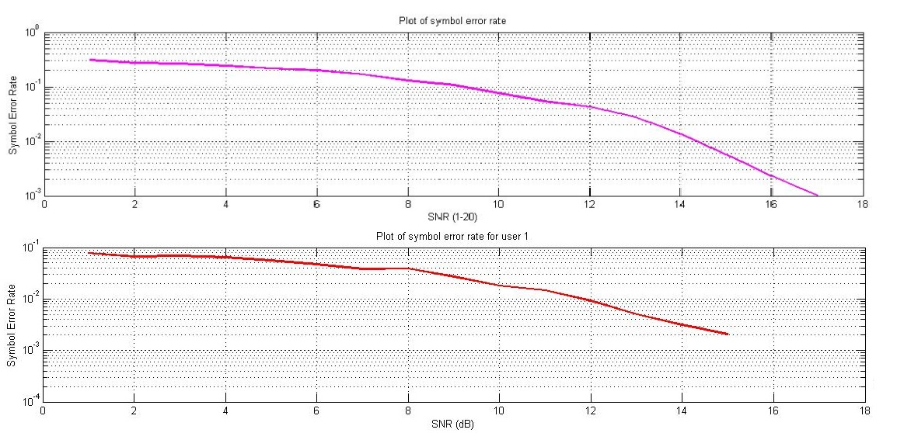
Figure 6. 1 SER for 2PPM conventional(above) and fixed (below)

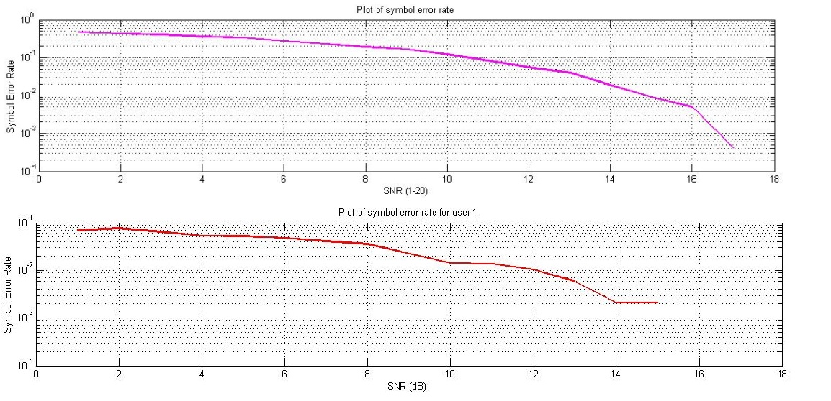
Figure 6. 2 SER for 4PPM conventional (above) and fixed (below)
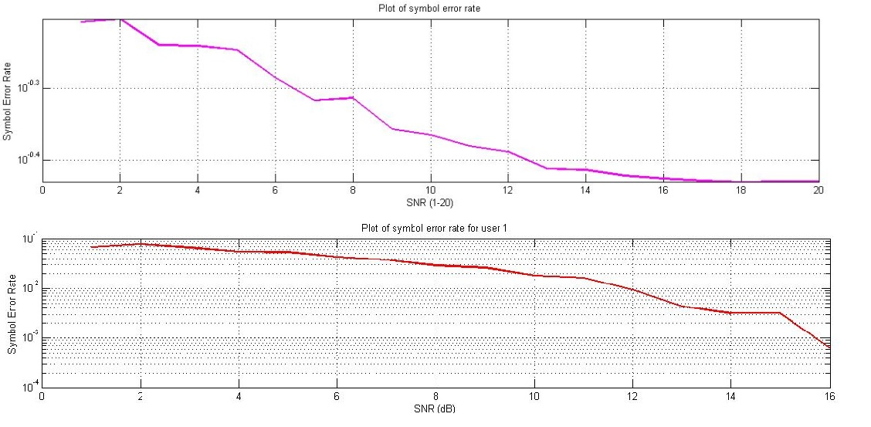
Figure 6. 3 SER for 8PPM conventional (above) and fixed (below)

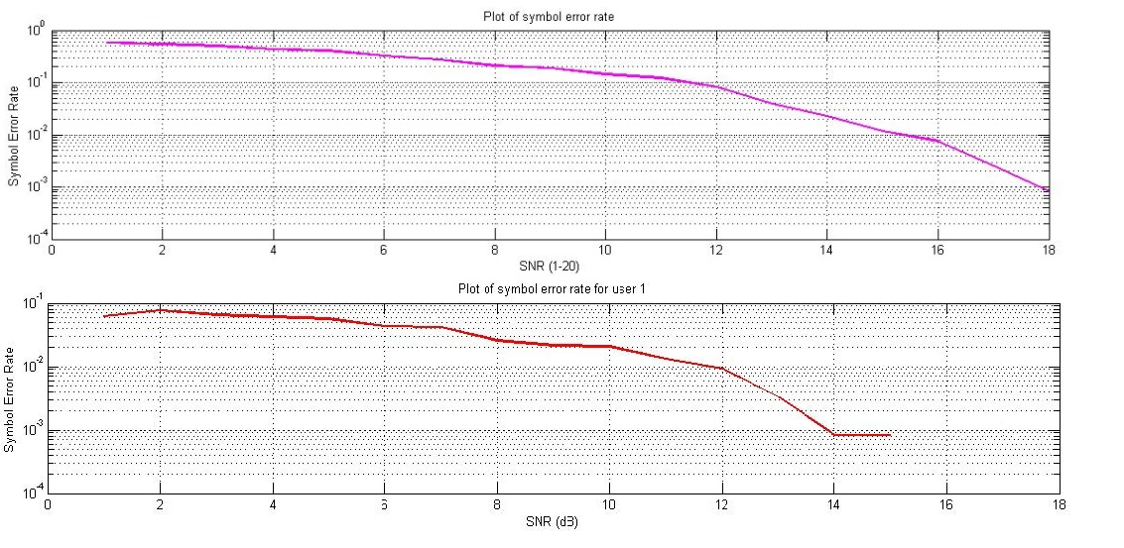
Figure 6. 4 SER 16PPM conventional (above) and fixed (below)

At first glance for the previous figures, we thought that the symbol error rate (SER) will decay as we go to larger SNR values, but in fact there will be no noticeable difference in SER between the conventional and the fixed duration TH M-ary PPM.

As a result, we conclude that there is no noticeable difference in SER as we go to higher M.

  - 6.2 SER for conventional and proposed fixed TH M-ary PPM (noise with interference):

Now we tried to reach the idea of communication network; there is a delay between users so that they do not transmit at the same time.

We expect that the SINR is much better in our proposed TH M-ary PPM method, using this approach; i.e. the time needed by any user will be less than the time needed by a user using the conventional, so he might finish transmission while other users haven’t yet begin to transmit, but in the conventional method where the user takes longer time to transmit, the probability that other users start transmission while the user is still transmitting is high.

The next figures investigate the SER performance of the conventional and fixed for 50 users at same PPM order respectively, i.e. figure 6.5 has two curves for 2PPM, the first one for conventional and the second for fixed

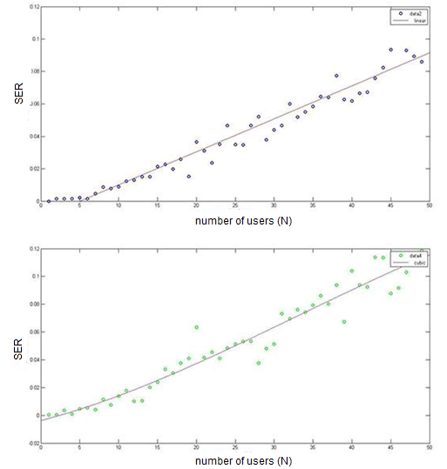
Figure 6. 5 2PPM for conventional (above) and fixed (below)

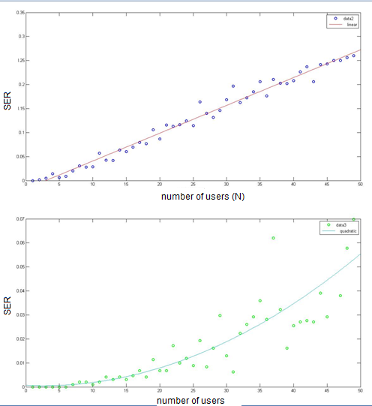
Figure 6. 6 4PPM for conventional (above) and fixed (below)

Going to the next two figures (fig. 6.7 and fig. 6.8), these outcomes show that as we go to higher M at constant λ that will increase the interference, because of the degradation of number of chips per frame in the conventional method.

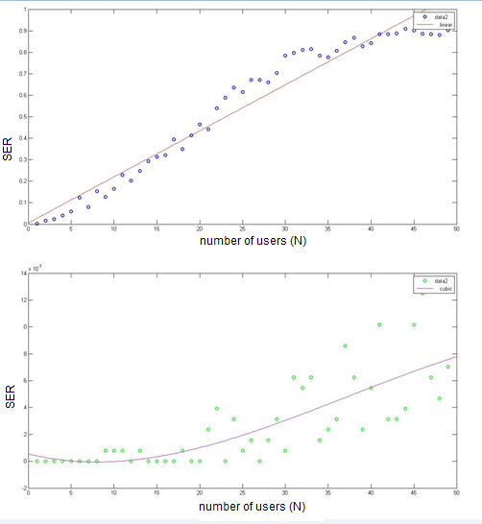
Figure 6. 7 8PPM for conventional (above) and fixed (below)

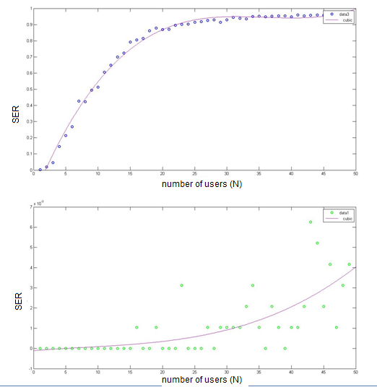
Figure 6. 8 16PPM for conventional (above) and fixed (below)

As a result of the previous MATLAB code outcomes, we conclude that for the conventional TH M-ary PPM the interference between users increases with increased M, this result is expected to occur; since the number of chips doubles when M increases, so the transmission time for users will increase though, thus increasing the probability of other users to transmit while the previous users hasn’t finished transmitting yet.

But for the proposed method we can see that interference is less, which enhance the symbol error probability to the best, the idea is why wasting our resources while we can have better behavior in our proposed method.

A second result to consider is that interference also increases when increasing number of users, our desire was to perform this code on 100 users, but unfortunately we were unable to do so due to the small size of the memory of our laptops.

  - 6.3 The influence of Poisson arrival rate parameter

Another point of view will be considered, the Poisson arrival rate parameter λ, it defines the delays for each user for transmission.
λ (Poisson arrival rate parameter) = 0.05

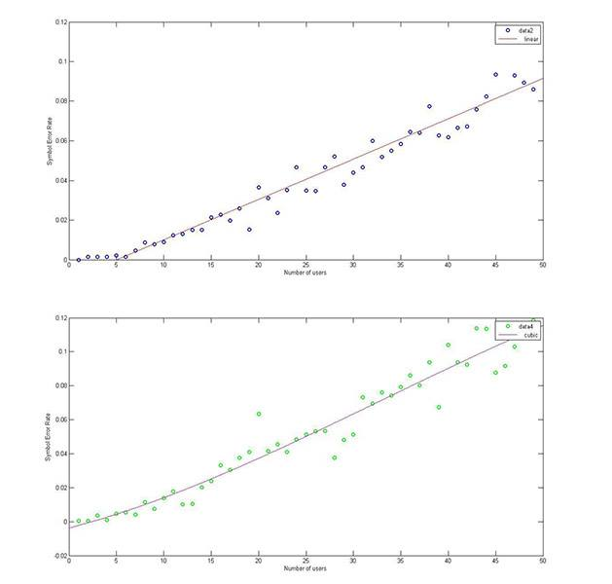
Figure 6. 9 2PPM conventional (above) and proposed method (below)

Comparing between figures 6.8 and 6.9 we conclude that at constant λ the behavior of our proposed method is better as it has lower SEP, i.e. lower interference.
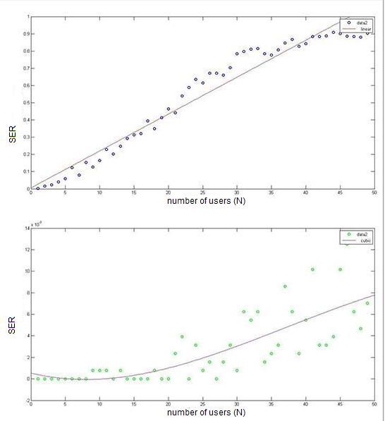
Figure 6. 10 8PPM for conventional above and proposed method (below)

At λ=0.85 (increasing Poisson arrival parameter)

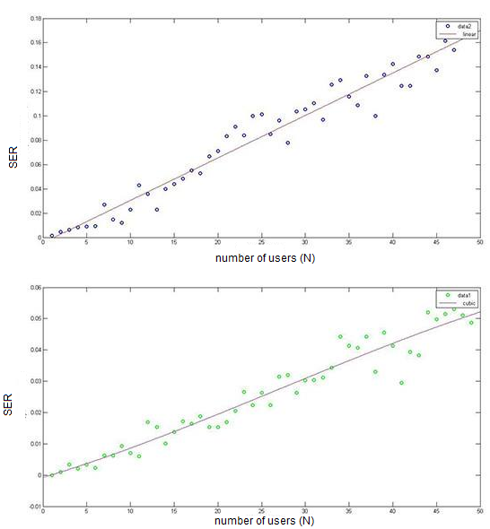
Figure 6. 11 2PPM for conventional (above) and proposed method (below)

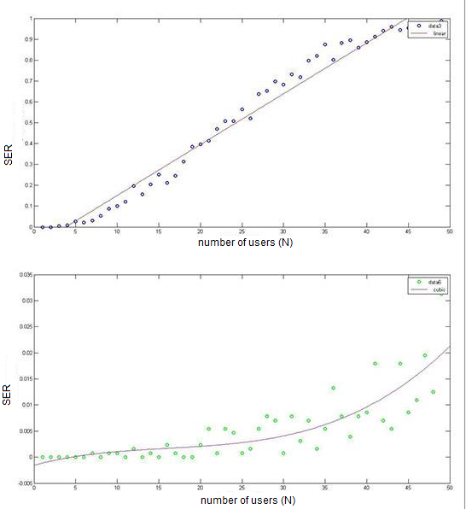
Figure 6. 12 8PPM for conventional (above) and proposed method (below)

At λ = 2 (increasing Poisson arrival parameter)

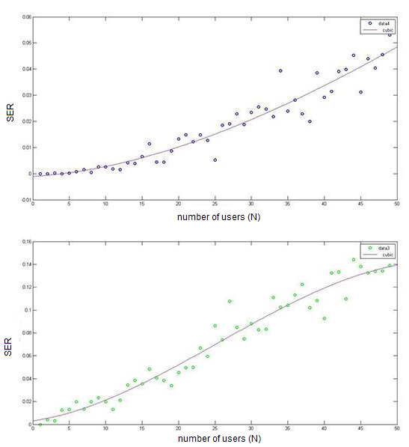
Figure 6. 13 2PPm for conventional (above) and the proposed (below)

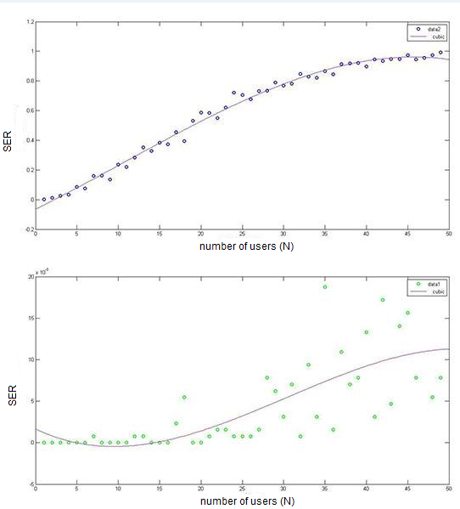
Figure 6. 14 8PPM for conventional (above) and proposed method (below)
The influence of Poisson arrival could be noticed by looking at the previous six figures, these figures compared between λ=0.05, 0.85 and 2, as we can see as λ increases the interference increases in the conventional method and stays the same in our proposed method, this is due to the longer transmission time for the conventional, which increases the probability of interference.

Results summary:

Comparing between the conventional and our proposed method, from symbol error probability due to noise, we conclude that there is no difference in their performances.

The major effect was on robustness against interference, we could prove that our proposed method achieves better performance against interferers, while in conventional method the frame duration increases with order of PPM but in our proposed method we maintain a fixed frame duration as we go to higher orders of PPM, that will lead to finishing the transmitting faster for each user, thus decreasing the probability of interference.

The Poisson arrival rate parameter has also a good influence in our simulation; as we increase this parameter the probability of interference will also increase, so there should be a good mechanism of trade off.

7: Conclusions and Recommendations

  - 7.1 Introduction
In this chapter conclusions and recommendation will be presented, no to forget to talk about future work.

  - 7.2 Conclusions:
We have crated simulation that was described in the report to include both the conventional TH M-ary PPM, and then we proposed a new novel fixed TH M-ary PPM, that is more robust against interference from other users and utilizes the channel more efficiently.
This method involves going to higher orders of PPM modulation but maintaining the duration fixed, in this way a user will finish its transmission faster, concluding that the probability of interference will decrease.
The proposed methodology was tested using MATLAB codes, which we built from scratch, the results of the code emphasizes our proposal.

  - 7.3 Recommendations and future work
The proposed method can be implemented in reality then measuring the results and comparing it with the simulated results, applying this method will definitely enhance the behavior of the system towards interference.

Hopefully to continue our work on this topic in the near future, and gain more information and understanding, we intend to publish this ne
w method into a scientific article of course with help of our respectable Dr. Ahmed Masri.

References

[1] | "NCIB," [Online]. Available: http://www.ncbi.nlm.nih.gov/pubmed/19865294. [Accessed 25 2 2014].
[2] | Ahmed M. Masri and Jussi Salami, "Low Rate/Medium Range UWB Radio for CCC in Cognitive Radio Networks under Realistic Propagation Conditions".
[3] | K. Popovski, B. J. Wysocki and Tadeusz Wysocki, "Performance Comparison of UWB Hopping Codes in a Multi-User Rich Scattering Environment," 2006.
[4] | Nikos V. Kokkalis, P. Takis Mathiopoulos,, George K. Karagiannidis and Christos S. Koukourlis,, "Performance Analysis of M-ary PPM TH-UWB Systems in the Presence of MUI and Timing Jitter," vol. 24, 2006.
[5] | S. Mohammad-Sajad, "A Tutorial on Ultra Wideband Modulation and Detection Schemes," Apr, 2009.
[6] | F. R.-M. a. R. A. Scholtz, "Multiple-Access Performance Limits with Time Hopping and Pulse Position Modulation".
[7] | R. A. Scholtz, "Multiple Access with Time-Hopping Impulse Modulation," University of Southern California, Los Angeles.
[8] | B. J. W. a. T. A. W. Peter Vial, "Direct Sequence Modified Time Hopping PPM over Ultra Wideband S-V Channel," 2006.
[9] | Ahmed M. Masri, Carla-Fabiana Chiasserini, Claudio Casetti, and Alberto Perotti, "Common Control Channel Allocation in Cognitive Radio Networks through UWB Communication".
[10] | J. Virtamo, "Poisson process".
[11] | Pedro H. J. Nardelli ,Mariam Kaynia and Matti Latva-aho, "EFFICIENCY OF THE ALOHA PROTOCOL IN MULTI-HOP NETWORKS".

